The Electromagnetic Compatibility in Wireless Charging
Mingzhou Li
School of Physical Science and Technology, Northwestern Polytechnical University, Shaanxi, China

mingzhouli@mail.nwpu.edu.cn
Abstract. In the process of wireless charging, the external environment often leads to some electromagnetic interference. These disturbances require certain electromagnetic compatibility （EMC）. This paper briefly introduces the basic principles of wireless charging. Introduce many common sources of electromagnetic interference. The implementation principle of anti-jamming technology is introduced from many angles. This paper describes the development of EMC technology based on relevant data and experiments. Introducing the EMC performance detection method around the world. Using the method of hierarchical discussion to introduce the application of anti-interference measures. Based on resonant circuits, the paper discusses the advantages of traditional circuit anti-interference design. In addition, this paper also proposes two new anti-interference design schemes with both cost-saving and environmental protection features. Topological heat dissipation structures based on natural biological structures reduce the interference emission caused by heat accumulation. The anti-jamming programming design based on computer language upgrades the electromagnetic compatibility of electronic devices in the software.

Introduction
With the continuous expansion of electric vehicles' production in recent years, wireless charging technology is getting increasing attention. The energy supply method has become increasingly popular. Devices often have electromagnetic compatibility (EMC) problems. High-frequency electromagnetic waves may cause safety risks. These risks can affect the human body and the surrounding environment. The density of power grid and communication equipment is becoming higher and higher. The voltage fluctuation can be easily generated by the operation of civil power grids and industrial power grids. Voltage pulsation may cause damage to the Wireless charging process. The operation of wireless charging equipment may interfere with the normal operation of nearby communication facilities. Therefore, EMC (electromagnetic compatibility) has become an important standard to measure the quality of wireless charging technology. EMC includes two requirements: the electromagnetic harassment (Electromagnetic Disturbance) caused by the environment of the equipment during normal operation cannot exceed a certain limit. The equipment has a certain degree of resistance to electromagnetic harassment in the environment. That ability is electromagnetic sensitivity (Electromagnetic Susceptibility, namely EMS). Since the emergence of electronic anti-noise technology in the 1970s, various anti-interference strategies and relevant rules and regulations have been developed. This paper will briefly describe the development of wireless charging technology and electromagnetic compatibility technology. Introducing the main causes of the current electromagnetic interference phenomenon. The main reasons include coupling interference and radiation interference. Describing the anti-interference measures based on electromagnetic shielding filter and component design. This paper aims to obtain the appropriate solution to the electromagnetic compatibility problems in different situations.

Basic principle of wireless charging

Electromagnetic induction and wireless charging technology
Electromagnetic induction wireless charging technology is the most used wireless charging technology. Its basic principle is like a transformer. As shown in Figure 1, the basic structure is composed of a transmission coil and a coil. However, sending a coil tong into the AC to produce an alternating magnetic field in the coil core. The Coil will produce an induced electric field. Wireless transmission of electricity is achieved.
But at the same time, the alternating magnetic field generated by the transmission coil in space will decay quickly with distance. After the distance between the two coils exceeds 15 centimetres, the magnetic flux in the transmission coil will decrease rapidly. The charging process will not proceed [1].

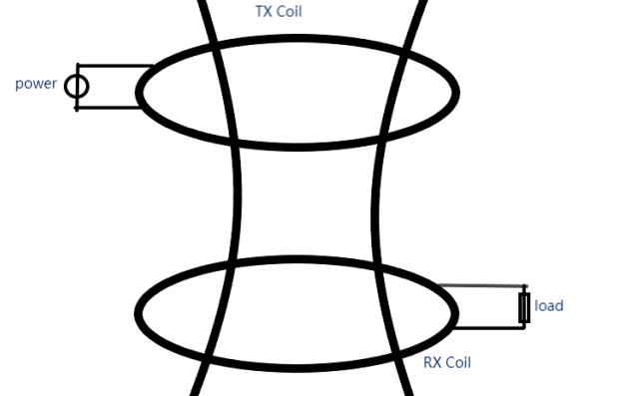
Figure 1. The fundamentals of traditional wireless charging technology

The traditional wireless transmission technology has the advantages of low technical difficulty, simple operation, and low equipment cost. However, its transmission space magnetic loss is large, and its anti-interference ability is weak. It is often suitable for some low-power near-range charging scenarios. Currently, this technology is widely used in the charging process of mobile phones, electronic watches, and laptops. Medical and industry also have their applications. With the improvement and development of technology, the efficiency and charging distance of traditional electromagnetic induction wireless charging are constantly improving. It is expected to be used in a wider range of scenarios in the future.

Magnetic resonance type wireless charging
Magnetic resonance type wireless charging is a new charging technology. Magnetic resonance type wireless charging solves the problem of the close transmission distance of traditional electromagnetic induction type wireless charging and poor anti-interference ability.
Schematic diagram of MR-type wireless charging (Fig. 2).

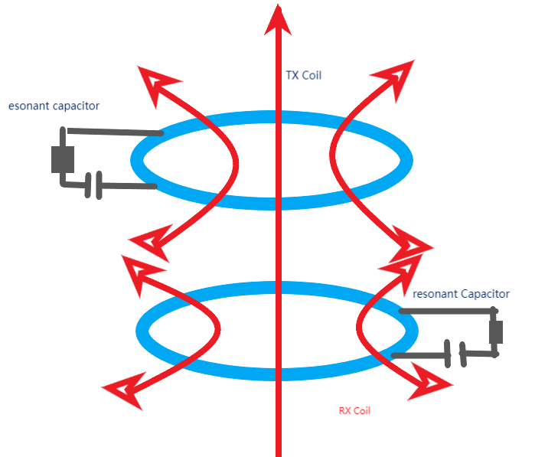
Figure 2. Magnetic resonance type wireless charging

The basic principle of magnetic resonance type wireless charging is still inductive. Compared with the magnetic induction wireless charging design, the resonant capacitor is added to the transmission coil circuit. According to the resonance principle, the induced electromotive force in the receiving coil will be greatly strengthened using the appropriate frequency. An energy transmission channel is successfully established in two sets of coils. Even if the distance between the two coils is more than 20cm, it can also ensure the effective transmission of electric energy. The addition of resonance can also increase the selectivity of the coil for the external magnetic field. Only the alternating magnetic field near the resonant frequency can contribute to the induced electromotive force. The anti-interference property of the system is greatly improved [2]. Magnetic resonance wireless charging is better than traditional induction charging in terms of efficiency and distance. It is widely used in high-power and long-distance power transmission.

Electromagnetic compatibility problem of wireless charging

EMI and its source

Generation and principle of conduction interference
Conduction interference occurs generated electronic the electronic components work. Such signals interfere with the wire propagation. It is divided into two interference modes: difference mode interference DI and common mode interference CI. Common-mode interference generally produces noise with the same phase and the same mode value. The difference mode interference produces noise with the opposite phase and the same mode value. The source of conduction interference consists mainly of four types.
First, the common-mode interference voltage is connected to the power grid. The common-mode interference voltage may be superimposed on the normal signal. The superposition of the signals will result in the waveform distortion of the normal signal. At the same time, too high a common-mode voltage may damage the internal components in the circuit. Next, the external radiation source induces common-mode interference on the signal line. That is because the alternating magnetic field produces alternating current. The loop area of the ground zero line is different from that of the connecting area. The impedance of the two different circuits is different. Third, the different grounding voltage in one of the two places of the wire leads to the potential difference between the two ends of the wire. The formation of the potential difference causes the interference signal in the circuit.
The alternating magnetic field generated by the line inside the equipment stimulates the alternating transformer field inside the line and produces co-mode interference.

Generation and principle of radiation interference
Radiation interference is the electromagnetic interference propagating in the form of an electromagnetic wave through space. Its delivery does not depend on a specific medium.
The main sources of radiation interference are as follows
First, strong external electromagnetic field interference, such as lightning. Last, the internal circuit radiates electromagnetic waves into space when working
Radiation interference can be divided into near-field interference and far-field interference according to the distance of the interference source points. If the interference source distance is less than one-sixth of the interference wavelength, it is near-field interference, and otherwise, it is far-field interference.

Hidden security risks exist in wireless charging technology

Potential effects of electromagnetic radiation on the human body
The negative effects of electromagnetic radiation on the human body are mainly divided into two kinds: thermal effects and non-thermal effects
Electromagnetic radiation is absorbed by the human body and converted into heat energy. This phenomenon is called the thermal effect. Specific absorption ratio (SAR) is a key index to quantify the thermal effect of electromagnetic radiation. Indicating the electromagnetic energy absorbed by the unit mass organization in a certain period, usually in W / kg. According to the international standard [3], the average whole-body SAR value of the human body in an ordinary environment should be <0.08 W / kg. The limit of local exposure can be moderately increased. For example, the limit can be increased to 0.4 W / kg in the occupational environment.
In the environment above the SAR limit, temperature-sensitive areas, such as the brain and eyes, are at risk of tissue damage. At the same time, the strong electromagnetic radiation may also lead to nervous system abnormalities. The possible symptoms include memory loss, attention decline, and other symptoms.
Non-thermal effect mainly refers to the direct stimulation of the electromagnetic radiation field on the nervous system. This kind of phenomenon mainly appears in the low-frequency electromagnetic field environment. Prolonged leakage in low-frequency electromagnetic fields may trigger abnormal firing of neurons. Including causing symptoms of involuntary muscle twitching and anxiety. At the same time, it may also increase the risk of cardiovascular and cerebrovascular diseases and endocrine system diseases.

Interference of high-frequency electromagnetic waves on the peripheral equipment
High-frequency electromagnetic wave brings serious problems to the operation of the surrounding electronic control system. Electromagnetic waves will invade the surrounding equipment control system. It may bring the error signal caused by conduction interference, resulting in the signal input error. This interference will reduce the efficiency of the surrounding equipment. And cause serious safety accidents.
The high-frequency electromagnetic wave will also cause damage to the surrounding communication equipment. Mainly reflected in making the signal transmission distortion rate greatly increase, the error rate greatly increases. Affecting the timeliness and accuracy of information transmission

EMC performance detection technology
Radiation emission (Radiated Emission) test is to measure the intensity of radiation harassment electromagnetic field propagation through space (Fig. 3) [3]. It can be divided into magnetic field radiation and electric field radiation. The magnetic field radiation is mainly used in lamps and induction cookers. The electric field radiation is widely used in all kinds of electronic equipment, such as mobile phones, computers, wireless routers, etc. These two tests ensure that the operation of the electronic equipment will not cause excessive interference to the surrounding environment. The radiation emission detection device includes an EMI antenna, a spectrum analyzer, and a preliminary amplifier.
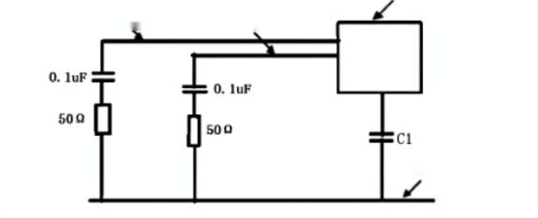
Figure 3. Schematic diagram of conduction harassment detection by the voltage method[4]

C1 distribution in the distribution of the measured equipment and grounding plate capacitor. Through a series of 0.1 uF capacitors and 50 Ω resistors, form the actual circuit diagram. Artificial power network and grounding metal plane, and power line constitute the transmission path. Grounding positive line, grounding metal plate, and capacitor C1 also constitute the conduction transmission path [4,5].
The tested device is powered by two power lines and placed on a metal ground plate. In theory, there are two possibilities for the transmission path of the tested equipment. One is the two wires supplying the tested equipment is the shuttle line transmission harassment. The path of harassment is called the difference mode. The other is the two power lines, as the harassment transmission curve, and the distribution capacitor and grounding plate provide the return path for the harassment. This path is called the common mode harassment. A nuisance current flowing through the artificial power supply network will produce a nuisance voltage. The nuisance current of the positive line of the power supply is the nuisance current of the power return line of I2. That common mode component of the disturbance current can be expressed as:
(1)
The difference-mode component can be expressed as

$ICM=\frac{I1+I2}{2}$ (2)

In this way, the strength of common-mode interference and difference-mode interference can be detected RF electromagnetic field radiation immunity (RS) test [6]. RS aims to check the working ability of the equipment in the RF radiation environment. Evaluating its stability and reliability in a complex electromagnetic radiation environment [7]. The test equipment will be placed in a radio-wave dark chamber. The test equipment will be illuminated by RF electromagnetic fields of a range of intensity and frequency. This electromagnetic field is generated by the RF signal generator and the transmitting antenna. Observing the working situation of the equipment in this environment and judging whether it is disturbed. It is widely used in all kinds of electronic equipment, especially wireless communication equipment, electronic medical equipment, and other equipment sensitive to electromagnetic radiation, Tests ensure that it can resist the surrounding radio frequency electromagnetic interference in the actual use environment.

Electromagnetic compatibility optimization method of wireless charging system

Electromagnetic compatibility requirements
The improvement of electromagnetic compatibility mainly includes two aspects: the first is to improve the ability of electronic equipment to resist external interference. The second is to reduce the interference caused by the operation of electronic equipment to the outside world. The main ways to improve the compatibility of electronic devices include electromagnetic shielding and filter design. The main idea is to eliminate interference signals, retain target signals, and screen valuable signals from the frequency of the signal and the waveform. At the same time, electromagnetic shielding and reducing the switching circuit process can reduce the interference of electronic equipment.

Improvement of electromagnetic compatibility by shielding and filtering measures

Electromagnetic shielding principle and design principle
The electromagnetic shielding effect is mainly composed of the reflection and absorption of electromagnetic waves. The Fresnel formula can be deduced from the boundary value relationship of the electromagnetic field at the interface of air and shielding material (generally a conductor).

$\frac{E⊥’}{E⊥}$=$-\frac{\sin{（θ-θ‘’）}}{\sin{（θ+θ‘’）}}$(3)

$\frac{E∥’}{E∥}$=$-\frac{tan（θ-θ‘’）}{tanθ+θ‘’）}$ (4)

This part of the electromagnetic wave cannot propagate inward through the shielding interface. The refracted electromagnetic waves decay their energy rapidly in an exponential form due to the propagation in the shielding body. High-frequency electromagnetic waves are only concentrated in a very thin layer on the surface of the shield. This phenomenon is called the skin effect. According to the above derivation, the selected shielding material should have a certain thickness to ensure that the electromagnetic wave will not penetrate the shield body. In the face of the interference of high-frequency electromagnetic waves, the metal material with high electrical conductivity should be selected [8]. Highly conductive materials can help increase the energy loss of high-frequency electromagnetic waves. In the face of the interference of low-frequency electromagnetic waves, it is necessary to choose a material with high magnetic permeability. The magnetic force line is limited in the medium. Due to the diversity of interference signals, the multilayer composite material is generally used for shielding design [9].

Principles and advantages of LC filter design
The basic idea of LC filter design is to adopt the LC circuit of different impedances to filter out the signals of specific frequencies. It can selectively transmit or prevent the different frequency components in the signal. The purpose of inhibiting and preventing interference can be The LC filter is mainly composed of inductors, capacitance, and other components. Its working principle is based on the impedance characteristics of capacitors and inductors (Figs. 4 and 5). A capacitor has the characteristics of high-frequency resistance and low low-frequency. For example, using the capacitor can be a live wire. Zero-line high-frequency interference current into the ground wire (common mode), or fire wire high-frequency interference current into the zero line (difference mode). The inductor has the characteristic of preventing the passage of high-frequency signals and allowing the passage of low-frequency signals. When the current flowing through the inductor changes, the induced electromotive force generated in the inductor coil will prevent the change of the current. Meanwhile, part of the electric energy is converted into a magnetic field and stored in the inductor.

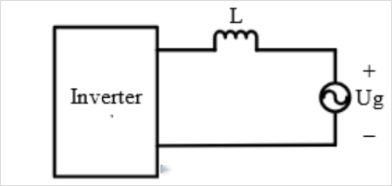
Figure 4. Type L filter[4]
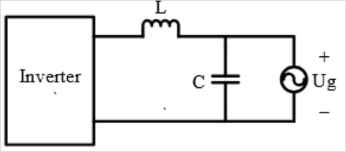
Figure 5. LC type filter[4]

LC-type filters are suitable for reducing high-frequency signal interference. The LC filter can be designed with different impedance values according to the frequency of the interference signals processed. The LC filter design has the advantages of a simple structure, small size, and low cost.

Suppression of electromagnetic noise by soft switching technology
In the process of the traditional hard switch, the current and voltage overlap. The overlap is easy to produce electromagnetic harassment emission. The following figure 6 is the voltage and current change curve of the hard switch opening.

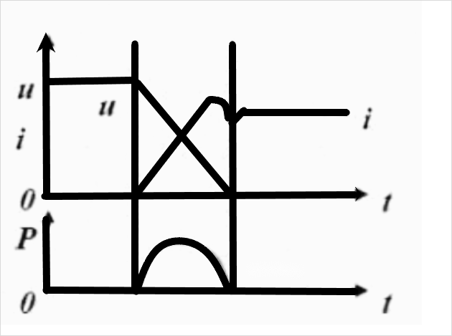
Figure 6. Hard switch current voltage variation curve

Hard-switch voltage and current time change curve
Soft switch technology is an improvement of the switch design of the traditional hard switch. Its main purpose is to realize the slow change of the current and voltage when the circuit is opened and closed. The ideal soft switch process is that the current or voltage first drops to zero, and the voltage or current then slowly rises to the off-state voltage. In that case, switching loss is approximately zero. At the same time, soft switch technology limits the change rate of voltage and current during circuit switching. The interference electromagnetic noise emission during circuit switching is significantly reduced. The electromagnetic compatibility of electronic devices has been significantly improved.
Soft switches (Fig. 7) are mainly realized through the following design. Introduction of resonance: By introducing the original capacitive resonance, the power switch is carried out in the resonance state. The electromagnetic loss caused by changes in the current and voltage is reduced. Design the buffer circuit to reduce the maximum radiation value of the voltage and current change waveform. The decline of interference significantly reduces electromagnetic loss and interference transmission. Through reasonable circuit design, the overlapping time of the voltage and current waveforms can be reduced. The electromagnetic harassment emission can be reduced.

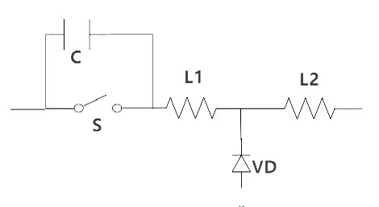
Figure 7. Soft switch schematic
Common soft-switch circuit design. The circuit above is easy to understand. The parallel soft switch capacitor Ct and the voltage and current output of the Lr inductance are phase different. This simple design reduces the voltage and current overlap.

Anti-interference programming design contribution to EMC
In electronic product design, software anti-interference also plays an important role in electromagnetic compatibility design. Software anti-interference design is an effective measure to ensure the stability and reliability of the systematic-jamming programming design is an important part of anti-jamming software design. Optimizing the error processing mechanism improves the robustness of the system. It mainly includes the following designs. Program optimization means program optimization involves reducing unnecessary calculations. Optimizing the efficiency of the algorithm is also important. Reasonably arranging the execution order of the programs is also necessary. With code review and performance analysis tools, developers can identify and fix bottlenecks and inefficient operations in the program. For example, by introducing the Fast Fourier Transform algorithm instead of direct numerical calculation, the efficiency of processing periodic signals is significantly improved. Design a new error processing mechanism to improve the error detection and recovery mechanism in the software. Those designs are key strategies to improve the stability of the system. This includes exception handling, backing up key data, and providing fault recovery measures. As shown in Figure 8, people can use the try-catch structure to capture potential runtime errors.

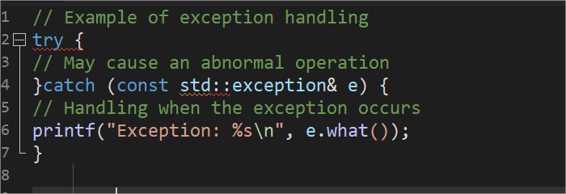
Figure 8. Try-catch structure

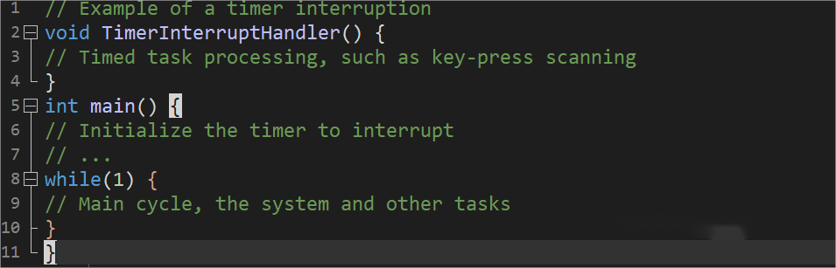
Figure 9. Timed refresh method

Detecting changes in the input state by timing refresh is an effective software anti-interference means. As shown in Figure 9, this method is widely used in key-scanning circuits. Timer breaks can regularly perform scanning tasks in response to changes in external signals. Anti-interference coding has the advantages of zero cost and significant effect. Anti-interference coding design can effectively improve the processing efficiency of the system. Wrong signals will decline. The stability of the system will be enhanced.

Reasonable heat dissipation management
The negative impact of thermal effects on electromagnetic performance cannot be ignored. The circuit works to produce heat accumulation. The accumulation of heat will change the impedance characteristics and conductive performance of the original inside the circuit. The electromagnetic force distribution state of electronic equipment will be changed.
For example, The Thermal accumulation of electronic components brings a thermal expansion effect. The thermal expansion effect will affect the distribution of the air gap magnetic field through the thermal expansion, then having a negative impact on charging efficiency and safety. Therefore, the reasonable heat dissipation management is very important in the electromagnetic compatibility design. The bionic micro-channel topology design is based on the natural bionic topological structure. Compared with the traditional air-cooling heat dissipation, the bionic micro-channel topology has the advantages of high heat dissipation strength, small volume, and easy integration. Topological structure can be compatible with nanofluid heat dissipation technology, improving the heat dissipation effect. It has a broad application prospect in the future [10].
As shown in Figure 10, the following are the various topological heat dissipation structures.

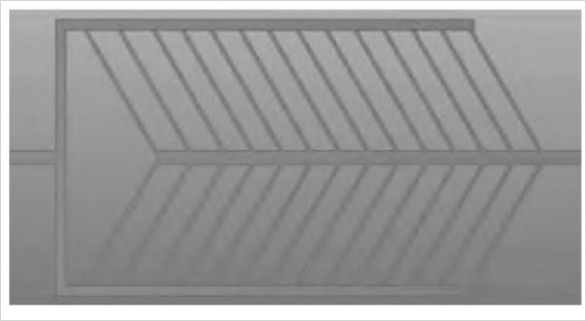
Figure 10. The various topological heat dissipation structures[10]

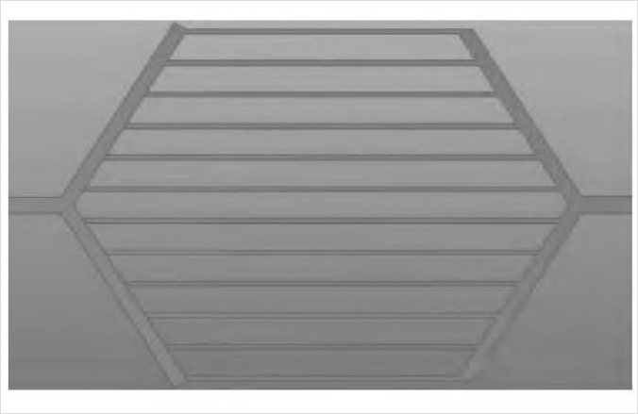
Figure 11. Anatomy wing design[10]
The imitation of leaf vein structure. Plant veins are mainly used for the delivery of nutrients. These magical structures reflect the high efficiency of the vein structure in terms of conductivity. By removing the unrelated structures, a geometric sketch of the bionic vein radiator can be built, as shown in Fig. 11. The leaf vein fork angle is positioned at about 60 degrees to improve its efficiency [10].
The insect wing structure is mainly used for heat conduction. It can concentrate energy on the pressure of wing agitation in flight. Reducing the additional energy consumption generated by the flow of body fluids in the wing. This structure is also of reference significance. Based on its topological structure characteristics, the engineering structure can be designed as shown in Figure 12.

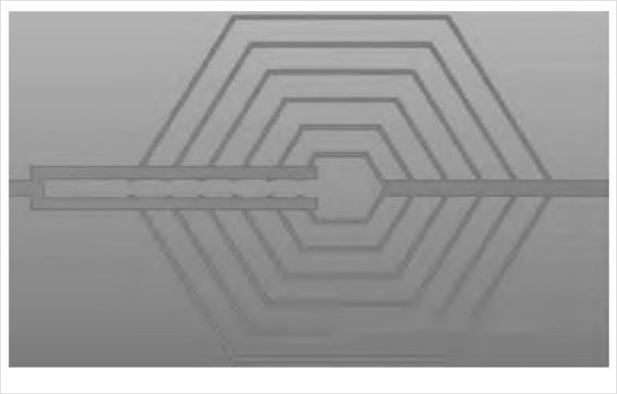
Figure 12. A Web structure[10]

Spider web structure is a very common network structure in nature. Although its main function is not material transport, it also has certain reference significance. The web polygon nesting design is retained to simulate a net-like structure. The two ends of the polygon diagonal design as the entrance and exit. Under the limit of the same boundary condition, the structure has the shortest energy transmission distance and contributes significantly to the heat dissipation effect.

Conclusion
Electromagnetic compatibility has not received much attention for a very long period. It has only limited applications in military use. It has not been taken seriously by civilian electronic equipment manufacturers. However, with the development of wireless charging technology in recent years, the electromagnetic compatibility design of wireless charging is becoming more and more important. Wireless charging devices are deployed in densely populated areas of city centres. These devices are more susceptible to the surrounding electromagnetic environment. At the same time also easier to affect the work of peripheral equipment. There are more and more relevant laws that have been introduced. Equipment that does not meet the electromagnetic compatibility requirements will lose its sales qualification. Multiple factors make electromagnetic compatibility an important research direction.
The paper draws on the frontier theories about electromagnetic compatibility at home and abroad. Stating the basic principle of wireless charging technology. Talking about the contribution of traditional circuit design to electromagnetic compatibility. Introducing and analysing the new anti-interference measures. This part focuses on the new anti-interference programming technology in the information age. At the same time, the paper also introduces a variety of bionic designs. This structure is both cost-effective and environmentally friendly, becoming a type of alternative design solution. Discussing the applicable scenarios, advantages, and disadvantages of different EMC designs. Also include its developments in the future. Because the author's ability is limited. Although this paper has achieved some research results, there are still many shortcomings.
For example, there is still a lack of more detailed data support in the elaboration of various design anti-interference performance. Due to the limited space, some circuit design details cannot be elaborated in detail. The application of biomimetic design is relatively narrow. Its contribution to electromagnetic compatibility is limited to heat dissipation management. The paper only introduces three representative topological structures. The author sincerely hopes that more professionals can contribute to the more cutting-edge designs in this field.

ReferenceS
- F. Wang, W. Zhang, L. Ye, J. Guo, K. Liu and H. Thanh, IEEE Journal of Emerging and Selected Topics in Power Electronics, Letters 9(3), 3791–3801 (2020).
- S. Sachan, Electric Power Components and Systems, Letters 49(9–10), 860–866 (2021).
- F. Ahmad, A. Iqbal, I. Ashraf, M. Marzband and I. Khan, Energy Reports, Letters 8, 2314–2333(2022)
- N. D. Hui, N. Z. Yisheng and N. Z. Baishan, IEEE Xplore, Letters 1, 1–3 (2006).
- Boukhchana, A., Flah, A., Alkuhayli, A., Ullah, R., & El-Bayeh, C. Z, Frontiers in Energy Research, Letters 12, 25–30 (2024).
- H. W. Ott, Electromagnetic Compatibility Engineering, (2009)
- H. Miloudi, M. Miloudi, S. a. E. M. Ardjoun, A. A. Nour, and I. Mahariq, Results Eng, Letters 25, 103963 (2025).
- S. Hałgas, S. Hausman, and Ł. Jopek, Electronics, Letters 14, 312 (2025).
- M. Wang, H. Wang, Y. Zhang, Y. Shi, and L. Yang, Int. J. Circ. Theory Appl. Letters 49, 415–429 (2020).
- A. Sommers, Q. Wang, X. Han, C. T’Joen, Y. Park, and A. Jacobi, Appl. Therm. Eng. Letters 30, 1277–1291 (2010).

