Application of Electromagnetic Induction-Based Wireless Charging Technology in New Energy Vehicles
Yufei Hu
Manchester Metropolitan Joint Institute, Hubei University, Wuhan, Hubei, China

202331123003084@stu.hubu.edu.cn
Abstract. With the rapid development of new energy vehicles, wireless charging technology has become an important research direction for addressing the issues of electric vehicle charging and range, due to its advantages of safety, convenience, and environmental adaptability. This paper provides a comprehensive review of the development history, application principles, and status of wireless charging technology in the field of new energy vehicles, based on a review of relevant literature. Wireless energy transfer is realized through the magnetic field coupling between the transmitter and receiver modules, based on the principle of electromagnetic induction. The core components of the system include charging control, power management, and auxiliary system modules. Current optimization solutions include compensation network design, solar photovoltaic wireless transmission, and intelligent planning. Compensation networks improve transmission efficiency through dynamic impedance matching and resonance frequency adjustment. Solar photovoltaic technology, combined with MPPT control, enables high-power transmission, while deep learning algorithms (such as S-DRL) significantly enhance dynamic charging efficiency through path optimization. Moreover, improvements in electromagnetic coupling devices, such as coil topology optimization and high-frequency inverter technology, can further reduce energy loss. Despite certain advancements in current technologies, issues such as magnetic pollution, efficiency fluctuations, and high costs remain unresolved. Future research should focus on the integration of multiple technologies and the establishment of standardized systems to promote the further development of wireless charging technology in the field of new energy vehicles.

iNTRODUCTION
The issue of energy has increasingly come into the public eye, especially in the transportation sector, where new energy vehicles have become a focal point of attention. Promoting the development of electric vehicles (EVs) has thus become increasingly important. Currently, the key challenges in electric vehicles are related to charging and range. The primary charging solutions for EVs are wired and wireless charging. Compared to wired charging, which directly connects to charging stations, wireless charging, based on electromagnetic field energy transfer, offers advantages such as safety and convenience. For example, wireless charging does not require plugging and unplugging a charging gun; the vehicle can simply be parked in a designated spot to charge automatically. From a safety perspective, wireless charging reduces physical contact, avoiding issues such as electric leakage and short circuits. Additionally, the absence of exposed interfaces means that wireless charging systems are not affected by adverse weather conditions like rain, snow, or dust storms [1].
The concept of wireless power transmission was proposed as early as the late 19th century, but it was not until the 1990s that the academic world began to explore wireless charging technologies based on electromagnetic induction and magnetic resonance. At this time, wireless charging in the automotive field was only considered for use in small electric vehicles and experimental vehicles. After entering the 21st century, wireless charging technology experienced significant breakthroughs, and more and more automakers and technology companies began investing in the research of wireless charging technology [2]. Currently, wireless charging technology includes four primary methods: electromagnetic induction, which has already been applied in small devices like smartphones; magnetic resonance, which is more suitable for electric vehicles; electric field coupling; and radio wave reception [3]. These methods have all been explored in the context of wireless charging for electric vehicles. For example, the electromagnetic induction method advocates embedding coils in the road surface and installing receivers on the underside of vehicles. The magnetic coupling model is also one of the feasible solutions being researched by various countries, although it still faces issues such as magnetic pollution affecting the surrounding environment. This paper aims to introduce several current applications of wireless charging technology in new energy vehicles, compare and analyse the differences between various technologies, discuss their respective advantages and existing problems, and explore potential future development directions.

Wireless charging principle

Wireless Charging Works
Based on the principle of electromagnetic induction, wireless charging is achieved when the transmitter and receiver establish magnetic field coupling. Once the transmitter is connected to a power source, it generates a rapidly changing magnetic field. According to Faraday's Law of Electromagnetic Induction, the changing magnetic field produces a corresponding electric field. When the receiver detects the electromagnetic waves emitted by the transmitter, the coil inside the receiver converts the magnetic energy into electrical energy and generates the corresponding electric field.
Specifically, the transmitter is responsible for converting the high frequency alternating current (AC) supplied by the power source, which carries energy signals, into magnetic field energy. This energy is then transmitted through space in the form of alternating electromagnetic fields, electromagnetic waves, or microwaves. The magnetic field propagates through space, and when the receiver captures this energy, it induces a reverse voltage. The electromagnetic induction coil inside the receiver then converts this reverse voltage into direct current (DC). The DC is subsequently rectified, filtered, and undergoes other processes, after which it can be fed into the internal circuit to charge the device.

The Principle of Wireless Charging for New Energy Vehicles
The wireless charging system for electric vehicles can be broken down into the following components: the charging control module, transmitter module, receiver module, power control module, and auxiliary system [4].
The charging control module is responsible for initiating and terminating the charging process, as well as adjusting parameters during charging. It monitors parameters such as voltage and current throughout the process. Based on the data obtained from the sampling circuits, it adjusts the charging strategy to match the actual conditions, ensuring safe charging. The transmitter module consists of a current converter connected to the power source. It is responsible for converting the current supplied by the power source into high frequency alternating current (AC) and then transmitting the electrical signal to the transmitting coil, which converts and radiates magnetic field energy. The receiver module is used to capture the magnetic field and convert it into an electrical current. This current is then rectified and filtered to produce a stable direct current (DC), which is fed into the battery power circuit to charge the battery. The power control module monitors the input voltage and current, estimates the charge level, adjusts the charging mode, and protects the battery's lifespan. The auxiliary system is responsible for electromagnetic shielding, protecting other components of the vehicle, foreign object detection within the charging device, system calibration, and other additional functions.

Wireless charging optimization

Compensating Network

The Purpose of Compensation Networks
In a wireless charging system, adding and optimizing a compensation network can improve energy transfer efficiency, reduce losses, and ensure the stable operation of the system. The compensation network compensates for the inductive and capacitive impedance, reducing reactive losses, adjusting the transmission strategy under different load conditions, and enhancing transmission efficiency. It also helps prevent oscillations and instability caused by impedance mismatching.
When the vehicle is stationary during charging, the compensation network compensates for the leakage inductance and impedance mismatch caused by the air gap between the coils, suppressing harmonics and electromagnetic interference. While the vehicle is in motion, the compensation network dynamically adjusts the resonance frequency and performs dynamic impedance matching to respond to the coupling changes caused by the vehicle's movement, maintaining high-efficiency power transfer.

Several Different Types of Compensation Networks
Based on the different connection methods of capacitors and inductors, compensation networks can be classified into several types: Series-Series Compensation, Parallel-Parallel Compensation, Series-Parallel Compensation, and Parallel-Series Compensation.
Series-Series Compensation: This configuration is simple, where the compensation capacitor is directly connected in series with the transmitting coil. It is suitable for low-power applications, but it experiences significant efficiency fluctuations with load changes.
Parallel-Parallel Compensation: In this configuration, the compensation capacitor is connected in parallel with the transmitting coil. It offers stable performance under load variations and is suitable for high-power applications, but its structure is more complex.
Series-Parallel Compensation: In this setup, the transmitting coil is in series with the compensation capacitor, while the receiver end is connected in parallel with the compensation capacitor. It is typically used for medium to high frequencies.
Parallel-Series Compensation: Here, the transmitting coil is connected in parallel with the compensation capacitor, and the receiver end is in series with the compensation capacitor. This configuration is used in specific scenarios and can maintain high efficiency over a wide load range [4].
The comparison of the characteristics of different compensation networks is shown in Table 1. People can choose different networks to use according to different needs.

Table1. Comparison of the characteristics of different compensation networks
Features | SS | SP | PS | PP
Ability of power transfer | Good | Good | Poor | Poor
PF | Less | Less | Moderate | Moderate
Displacement tolerance | High | High | Moderate | Moderate
Value of Z at resonant time | High | High | Moderate | Low
Tolerance of frequency | Low | Low | High | High
Application on EV | Low | High | Low | High

Solar PV Radio Transmission
In low-voltage environments, photovoltaic systems equipped with batteries can achieve wireless energy transfer between the photovoltaic power generation system and the load. The modular photovoltaic system with a capacitive transmission interface, combined with multi-stage Maximum Power Point Tracking (MPPT) technology based on GSS (Global Search Strategy), enables high-power transmission.

The Principle of Solar PV Radio Transmission
Solar photovoltaic wireless power transmission is a technology that converts solar energy into electrical energy and then transmits the electrical energy stored in batteries to the load end via wireless charging, thereby powering other devices. This technology will be illustrated with an example of a photovoltaic power generation system that includes a photovoltaic battery module, a Boost circuit in the DC-DC module, and an MPPT-controlled PWM module. Under ideal conditions, the system’s output power can be equated to the input power. By adjusting the duty cycle of the PWM control signal, this can be viewed as changing the circuit's resistance, thus controlling the output state of the photovoltaic battery, which in turn allows tracking of the maximum power point of the photovoltaic battery [5].
MPPT control refers to the process of observing changes in output power under varying output voltages of the photovoltaic battery. When disturbances occur, if the output power decreases, the disturbance direction is adjusted, allowing for rapid tracking of the photovoltaic battery's maximum power point, thereby enabling high-power energy transfer for wireless charging [5].

Deep Learning Intelligent Path Planning

Principle
Intelligent path selection refers to the use of deep reinforcement learning techniques to quantify and process data such as dynamic charging benefits and vehicle movement trajectories. During the vehicle’s travel, it optimizes path selection and reasonably schedules the distribution of power resources, further enhancing the wireless charging efficiency along the route.

Algorithm Examples
This paper uses the S-DRL algorithm to address the Scheduling for Wireless Charging of Electric Vehicles (SWCE) problem and compares it with the Greedy Algorithm (GA) through simulation experiments to highlight the advantages of the intelligent path selection algorithm [6].
In the S-DRL approach, the current road segment, remaining driving time, and remaining battery charge of the electric vehicle are quantified as states. The selection of the next road segment is defined as an action, and the charging amount obtained from the chosen road segment is used as the reward. As shown in Figure 1 and 2, the simulation experiment selects a subset of actual road segments in Brooklyn, New York City, and compares the remaining battery charge of the vehicles after choosing different paths based on variables such as the number of electric vehicles, the number of charging road segments, and the deadline, for both the S-DRL and GA algorithms [6].
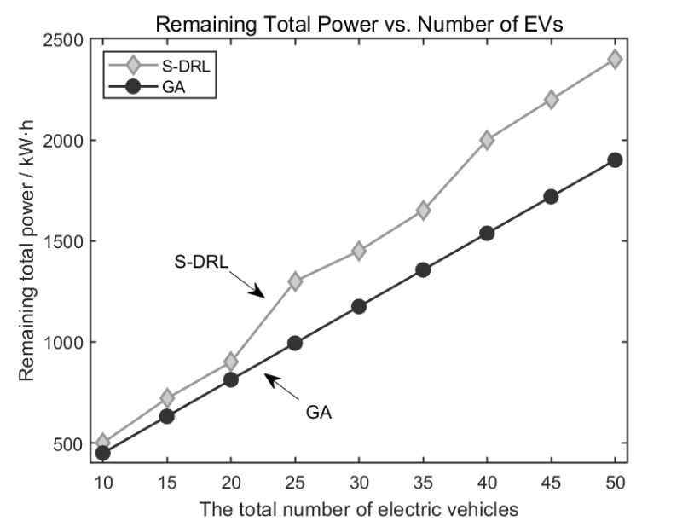
Figure1.The effect of the number of trams on the total remaining electricity
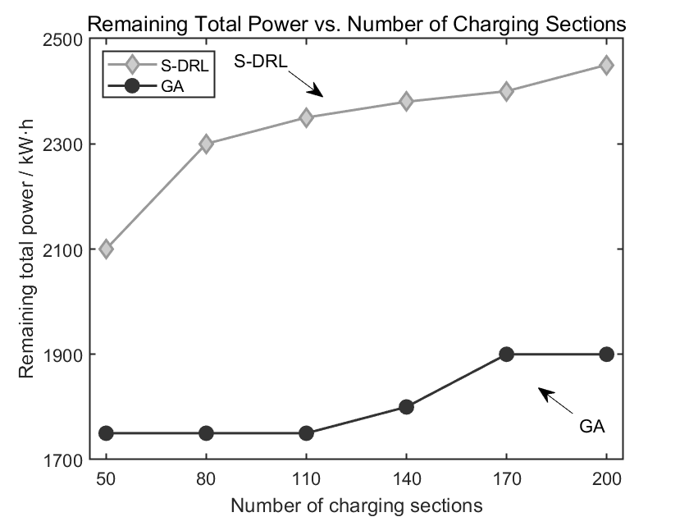
Figure2.The effect of the charging section on the total remaining power
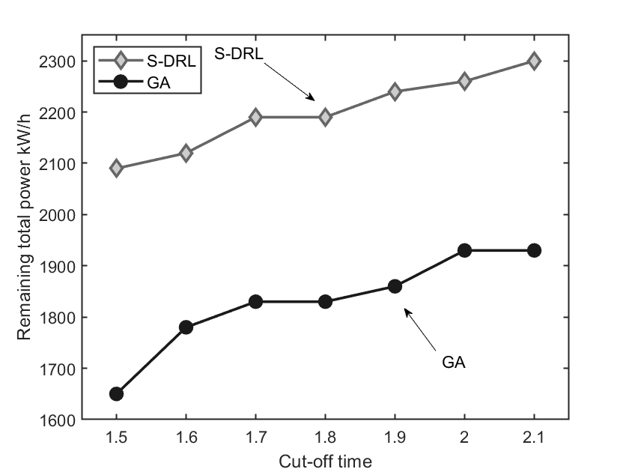
Figure3.The effect of the cut-off time on the total remaining power

As shown in Figure 3, the S-DRL algorithm demonstrates significant advantages over the GA algorithm as the number of electric vehicles, charging road segments, and deadlines increase. Path selection algorithms represented by S-DRL can plan the optimal path for electric vehicles under conditions that consider factors such as total energy consumption costs and the number of charging road segments, thereby maximizing the total remaining battery charge of the vehicles.

Optimized Coupling

Fundamentals of Electromagnetic Coupling
Electromagnetic coupling devices can transmit signals or transfer energy by controlling the current in the primary coil, which alters the magnitude and rate of change of the electromotive force (EMF) in the receiver coil [7]. In the field of communications, electromagnetic couplers are used for both energy and signal transmission [8]. These devices are widely applied in power systems and transformers used in household electricity. Common electromagnetic coupling devices also include common-mode chokes on power lines, signal lines, and data lines, which prevent electromagnetic interference [9].

Charging optimization with electromagnetic couplings
For electromagnetic coupling devices themselves, optimizing their core components, specifically the magnetic coupling coils, plays a crucial role in improving power transmission. Common coil types include planar spiral, three-dimensional spiral, and rectangular coils. Due to space considerations for receiver coils in vehicles, planar spiral coils are typically used as the receiver coil. Increasing the number of coil turns can enhance the mutual inductance between the two coils, optimizing transmission efficiency [4].
From the perspective of the overall transmission circuit of the electric vehicle, high-frequency inverter technology can be employed using the main circuit topology to reduce energy loss during transmission and improve transmission efficiency [10]. Alternatively, infrared optoelectronic automatic tracking systems can be used to precisely locate and align the coupling coils of the vehicle, ensuring optimal alignment of the coils, reducing energy wastage, and improving charging efficiency [11].

CONCLUSION
This paper provides a systematic review of the principles, applications, and enhancement strategies of wireless charging for new-energy vehicles, and has illuminated how major standards diverge in their technical requirements. IEC TS 61980-2 targets light- and medium-duty vehicles with power levels up to 11 kW, mandates a tight ±20 mm misalignment tolerance at 85 kHz for efficiencies of at least 85 %, and focuses on stable resonance under varying loads. By contrast, SAE J2954 defines the same power band but allows looser alignment of up to ±75 mm longitudinally (±100 mm laterally) while raising the aligned-state efficiency target to 94 %, trading stricter hardware guidance for higher peak performance. Meanwhile, China’s GB/T 38775-2020 standard extends the power range to 60 kW with broader ±50–150 mm alignment windows and a minimum efficiency of 90 %, yet stops short of specifying dynamic-charging frequency adaptations for vehicles in motion. A BMW 530e inductive-charging trial achieving approximately 85 % efficiency with 90 % user satisfaction and a WiTricity 50 kW dynamic system reaching 92 % in field tests—demonstrate that all three approaches can deliver high performance, albeit with different cost, hardware, and safety trade-offs. Going forward, harmonizing alignment tolerances and efficiency targets across standards, developing real-time adaptive impedance-matching algorithms, and defining unified protocols for dynamic charging will be critical. Coupled with low-cost GaN power devices and integrated multi-source energy architectures, these advances will pave the way for the reliable, efficient, and large-scale commercialization of wireless charging in the sustainable new-energy vehicle ecosystem.

ReferenceS
- P. Machura and Q. Li, Renew. Sustain. Energy Rev. Letters 104, 209–234 (2019).
- M. Amjad, M. Aamir, S. Khalil, and F. Ahmad, Renew. Sustain. Energy Rev. Letters 167, 112730 (2022).
- Y. R. Wei, Y. Wang, and X. Xu, Chin. J. Radio Sci. Letters 36, 653–660 (2021).
- Y. Zhang, K. T. Chau, and C. Liu, IEEE Trans. Magn. Letters 52, 1–4 (2016).
- J. H. Xiang, Y. Wu, and J. Zhang, Res. Explor. Lab. Letters 44, 221–224 (2025).
- Y. Jin, Z. C. Chen, and H. Z. Yang, Autom. Appl. Letters 66, 72–75 (2025).
- T. Karacolak, A. Z. Hood, and E. Topsakal, IEEE Trans. Microw. Theory Tech. Letters 56, 1001–1008 (2008).
- F. Alsolami, S. M. R. Islam, and J. R. Kelly, IEEE Access, Letters 9, 39884–39894 (2021).
- Y. Zhang, T. Yeo, M. K. Ban, and S. K. Kim, IEEE Antennas Wirel. Propag. Lett. Letters 15, 1093–1096 (2016).
- Y. Li, F. Li, and S. Zhou, Renew. Energy, Letters 241, 122334 (2025).
- C. C. Mi, G. Buja, S. Y. Choi, and C. C. Lee, IEEE Trans. Veh. Technol. Letters 68, 2891–2906 (2019).

