Research on Vehicle-to-Grid Interaction of Electric Vehicles (EVS) in Smart Grids
Yining Cao
Hertfordshire College, Changzhou Institute of Technology, Changzhou,213000, China
24260202@czu.cn
Abstract. With the rapid advancement of electric vehicles (EVs) globally, their integration into smart grids has garnered significant attention. This paper presents an in-depth investigation into the energy storage capabilities of electric vehicles within smart grids and analyzes the characteristics of EV charging systems, including the performance of various battery types and the effects of both orderly and disorderly charging on the power grid. The interactive relationship between electric vehicles and smart grids is explored, focusing on the principles and modes of vehicle-to-grid (V2G) interaction technology and its influence on grid stability. Through domestic and international project case studies, the feasibility and effectiveness of electric vehicles participating in smart grid energy storage applications have been validated. Research findings indicate that different battery types exhibit distinct advantages in smart grid energy storage scenarios. Orderly charging demonstrates clear benefits, while V2G technology achieves a mutually beneficial outcome. Appropriate control strategies enable electric vehicles to assist with grid frequency regulation. Looking ahead, it is essential to explore new battery technologies to enhance energy storage system performance and integrate 5G and edge computing technologies to optimize vehicle-to-grid interactions.

Introduction
With the development of the automotive industry and new energy technologies,electric vehicles(EVs),as a type of the clean energy transportation, have developed rapidly in the world in the recent years. Market analysis reveals that in 2022, electric vehicle sales skyrocketed, with an estimated 5.6 million EVs sold worldwide, representing a remarkable 127% growth compared to the previous year [1]. Policy drivers: learn how supportive policies are fuelling the shift, making now the opportune moment to engage with the EV industry's growth [2].However,the large number and wide distribution of EVs, as well as their large-scale integration into the smart grid, also pose significant challenges to the power grid system.The large-scale integration of smart grids has also posed enormous challenges to the power grid system. Therefore, studying the energy storage of electric vehicles in smart grids is of great significance for improving the stability of power systems and other aspects. This article aims to conduct an in-depth study of the energy storage system characteristics of electric vehicles, with a focus on analyzing the interaction between electric vehicles and smart grids, application scenarios, and potential challenges. Through the sorting and analysis of this review, the prospects for the future development of EVs will be proposed.

Analysis of the Characteristics of Electric Vehicle Energy Storage Charging System

Analysis of Battery Types for Electric Vehicles
TABLE 1. Battery performance comparison
Battery Type | Energy Density (Wh/kg) | Cycle Life (Times) | Safety for Power Grid | Low-Temperature Performance | Cost
Ternary lithium battery | 150-250 | 1500 | Higher | Better | Higher
Iron phosphate battery | 160-200 | 2000-5000 | High | Poor | Lower
Nickel-metal hydride battery | 70-100 | Long | High | Better | middle
Sodium-ion battery | 90-160 | Long | High | Better | Lower
Hydrogen fuel cell | 500-1000 | Long | High | Better | Higher

According to table1，Lithium iron phosphate battery has long cycle life, it has high security for the power grid and low cost. Although the low-temperature performance is not goodin the scene of the smart grid, by the high security and long cycle life, it can be the Stable energy storage component; Ternary lithium batteries exhibit a high energy density and superior low-temperature performance, yet their cost is relatively high. They are particularly advantageous in distributed energy storage scenarios within smart grids, where high energy density and associated costs are acceptable trade-offs; Nickel-metal hydride batteries, sodium-ion batteries and hydrogen fuel cells all have high safety requirements for the power grid. Among them, sodium-ion batteries have low costs and great potential in large-scale and low-cost smart grid energy storage; Hydrogen fuel cells have an extremely high energy density and have significant advantages in the fields of smart grids and electric vehicles where high energy density is required.

The Impact of Orderly Charging and Disorderly Charging on The Smart Grid

The concepts of ordered charging and disordered charging
The smart grid system builds an orderly charging system by integrating Internet of Things and big data technologies, for instance, real-time monitoring of power grid load conditions includes data on the use of charging piles and information on electricity price periods，then, the charging plan for electric vehicles is dynamically adjusted, and the system automatically increases the charging speed when the grid load is low，during peak hours, V2G technology is utilized to control vehicle discharge and bidirectional power flow，After a certain city in Germany adopted this system, the usage rate of night charging piles increased by 40% and the cost of grid expansion decreased by 15%，this charging method not only balances the supply and demand relationship of the power grid and reduces electricity expenses, but also helps to extend battery life and provide support for the development of green energy.
Disorderly charging is common in public charging pile concentrated area or user free charging scenario, a large number of EVs access to grid at the same time, form a "peak" in electricity consumption. In old community without intelligent management systems, every evening when the residents gather to charge their devices after work, it is easy to cause transformers to trip due to overload. In 2023, a modern city regional power grid failures were caused by disorderly charging，it caused thousands of EVs charging interruption. This charging way lacking scheduling ,not only intensifies the operational pressure on the power grid，but also cause energy loss and charging efficiency, It is estimated that in the scenario of disorderly charging, the average using rate of charging equipment is less than 30%, which seriously affects the sustainable development of the new energy vehicle industry.

The impact of orderly charging
Orderly charging has both advantages and disadvantages, it both optimize allocation of resources，and has potential challenges. It has significant positive meaning, by intelligently adjusting the charging time and power, the load pressure on the power grid can be alleviated and voltage fluctuations can be reduced, improve power quality and reduce the cost of power grid upgrading [3].
However, orderly charging also has negative effects, The initial construction cost is high, the technology is complex, it will also limit the convenience of users' charging, and there are privacy and security risks. In addition, the standards and norms are not yet complete, which affects its large-scale promotion and application.

The impact of disorderly charging on the smart grid
The penetration rate of electric vehicles refers to the ratio of the charging load to the upper limit of the system load [4].
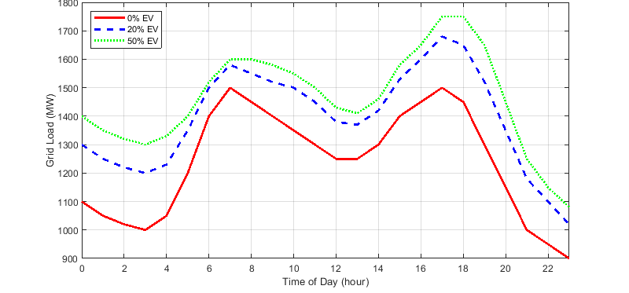
FIGURE 1.The variation curve of power grid load under the penetration rate of electric vehicles in winter(Picture credit : Original )
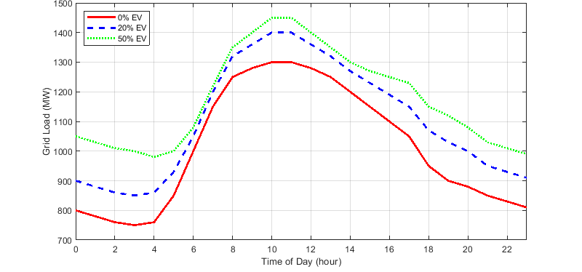
FIGURE 2. The variation curve of power grid load under the penetration rate of electric vehicles in summer(Picture credit : Original )
According to Figure 1 and Figure 2, the two different figs show the variation of grid load within a day under different penetration rates of electric vehicles (EVs), the whole is low in the night, it climbed to the peak during the day and then fell back. And with the development of EV’s permeability, the figure of grid load is larger in the most time. This is closely related to disorderly charging. During disorderly charging, the charging time of electric vehicles is arbitrary, which will further increase the peak-valley load difference of the power grid. On the one hand, it raises the peak load, puts pressure on the power supply capacity of the power grid, and increases the cost of infrastructure construction; On the other hand, it may also change the state of low load, intensify load fluctuations, affect the stability of the power grid and power quality, and pose higher challenges to the operation of the power grid.

The Interactive Relationship Between Electric Vehicles and Smart Grids

The principle and mode of Vehicle-to-Grid Interaction (V2G)
V2G is a combination of electric vehicles and power grids which can realize two-way energy transmission and information interaction. Its theory is connecting EVs and grid, in this way, it not only realizes the method of one-way charging, but also can realize bidirectional conversion. Meanwhile, the V2G system has a good communication and control system. The vehicle sends its battery status, available power supply, charging demand and other element information to the power grid control center. The power grid control center sends control instructions to the vehicle based on the overall status and power supply of the smart grid, informing the vehicle when to charge, when to discharge and the power size of charging and discharging, etc., in order to achieve optimized energy management [5].

V2G pattern
Through the dynamic information exchange and energy coordination system formed between vehicles and the power grid, combining the ordered charging and discharging modes^{[6]}. The power grid dynamically adjusts charging and discharging schemes in response to various factors, including fluctuations in power supply and demand, variations in electricity prices, and vehicle driving schedules. Vehicles autonomously determine their level of interactive participation based on their own requirements and the information provided by the power grid. This collaborative model optimizes energy transmission pathways, thereby benefiting both users and power grid operators. By strategically scheduling charging and discharging times according to electricity pricing periods, car owners can not only reduce charging costs but also achieve economic returns through reverse power supply^{[7]}. Additionally, the power grid leverages the distributed energy storage capabilities of electric vehicles to enhance system adaptability, stability, and clean energy utilization efficiency while accelerating the development of smart grid infrastructure.

The Impact on the Stability of the Power Grid
With the development of electric vehicles, large-scale integration of EVs into the grid has become the norm. However, this will lead to a continuous increase in grid load, which will have a certain impact on the stability of the smart grid, causing problems such as voltage drop and power blockage in the grid[8].However, EV plays an indispensable role in life，has two-sides，On the one hand, electric vehicles can be regulated and charged in the smart grid. On the other hand, electric vehicles are also good energy storage units.
Electric vehicles can respond quickly to the frequency regulation of the smart grid and effectively meet the frequency regulation requirements of the power grid[8]. The participation of electric vehicles in grid frequency regulation can effectively balance the frequency fluctuations caused by fluctuating renewable energy It plays a significant role in maintaining the stability of the power grid, demonstrating the advantages of electric vehicles in power grid frequency regulation and providing positive support for the stability of the power grid.
The coordinated control strategy of smart grid for electric vehicles, it is of great significance for electric vehicles to participate in power grid frequency regulation. Adopting this strategy, electric vehicles can avoid over-response, And the more vehicles participate in the response, the better the adjustment effect is. This is because the strategy enables electric vehicles to respond asynchronously, avoiding the problems caused by simultaneous actions. Conversely, if coordination is not taken into account, electric vehicles may respond simultaneously. When there are too many vehicles or when the power shortage of the power grid is small, the response power is likely to exceed the demand of the power grid and impact it. Moreover, the more vehicles involved in the response and the greater the over-response power, the more severe the side effects on the power grid will be, seriously affecting the stable operation of the power grid.

Domestic Project Cases
The coordinated development of smart grids and electric vehicle (EV) energy storage technologies is an important direction for promoting energy transformation. Electric vehicles not only serve as a means of transportation but can also become distributed energy storage units through vehicle-to-grid interaction (V2G) technology, participating in peak shaving and valley filling in the power grid[9].
For example, the "photovoltaic storage and charging" integrated demonstration station in Jiangsu Province combines photovoltaic power generation, energy storage batteries and EV charging, and reduces the load on the power grid through intelligent dispatching[10].The "photovoltaic storage and charging" integrated demonstration station in Jiangsu Province achieves deep integration of the three core systems: photovoltaic power generation, energy storage batteries, and electric vehicle (EV) charging. By utilizing high-efficiency monocrystalline silicon photovoltaic modules with maximum power point tracking (MPPT) technology, large-capacity lithium iron phosphate battery packs, and an intelligent dispatching system based on the Internet of Things (IoT), big data analytics, and artificial intelligence algorithms, it ensures efficient energy conversion and distribution. The station is characterized by high integration, intelligent interactivity, flexible adaptability, and strong scalability. It not only reduces the impact of charging load fluctuations on the power grid by over 60%, thereby enhancing grid stability, but also decreases users' charging costs and shortens waiting times through the use of off-peak electricity pricing. Additionally, a medium-sized demonstration station can reduce carbon dioxide emissions by more than 5,000 tons annually. Furthermore, the payback period for project investment has been shortened to 5–7 years, offering a replicable and scalable model for the development of new energy infrastructure and contributing significantly to the realization of the "dual carbon" goals.
Studies show that large-scale EV energy storage can increase the capacity to accommodate renewable energy by more than 10%. In the future, with the application of 5G and edge computing technologies, the response speed and accuracy of EV energy storage will be further enhanced, providing more flexible support for smart grids.

Conclusion
With the rapid advancement of electric vehicles globally, their integration with smart grids has emerged as a critical research focus in the energy domain. This study provides an in-depth examination of the characteristics of the energy storage and charging systems for electric vehicles. Various types of batteries possess distinct advantages and disadvantages, all of which are suitable for energy storage applications within smart grids. Moreover, uncoordinated charging can compromise the stability of the power grid, whereas coordinated charging offers substantial benefits in terms of alleviating power supply stress and enhancing power quality.
In the interactive relationship between electric vehicles and smart grids, V2G technology has enabled bidirectional energy transmission and information exchange, creating a win-win scenario for both vehicle users and the power grid. While the large-scale integration of electric vehicles into the grid may pose challenges to the stability of the power system, through well-designed coordinated control strategies, electric vehicles can actively contribute to the frequency regulation of the power grid. Project cases both at home and abroad have fully verified the feasibility and effectiveness of electric vehicles participating in the energy storage application of smart grids. Large-scale EV energy storage can significantly enhance the capacity to accommodate renewable energy.
Continuously explore new battery materials and technologies to further enhance the energy density and cycle life of batteries, reduce costs, and at the same time improve shortcomings such as low-temperature performance, in order to improve the overall performance of electric vehicle energy storage systems. By integrating 5G and edge computing technologies, optimize the communication and control of the V2G system, enhance the response speed and accuracy of EV energy storage, and achieve more efficient and intelligent vehicle-to-grid interaction. Develop adaptive control algorithms to facilitate the energy storage system in electric vehicles, enabling it to automatically adjust charging and discharging strategies based on grid load, renewable energy generation, and other relevant conditions. This will ensure intelligent interaction with the power grid. Additionally, enhance the safety and reliability of interactions between users' vehicles and the power grid while improving information security measures.

References
- P. Shah, "Electric Vehicle Communication Controller Market Trends and Growth Forecast to 2024," Market Research Report (2020).
- H. Cheng, Y. Ma, S. Qi et al., "Enforcing government policies: The role of state-owned enterprise in China's one child policy," World Dev. 146, 105574 (2021).
- Z. Qin, "Research on Optimization of Decision Model for Intelligent Charging Station Operation System," Electr. Power Energy 45(3), 344-346 (2024).
- S. Kang, "Research on the Impact of Unordered Charging of Electric Vehicles on Power Grid," Electr. Mater. 2023(6), 34-37 (2023).
- H. Yu, S. Yin, D. Peng et al., "A Smart Charging and Discharging Management Method for V2G Electric Vehicles in Regional Microgrids," Chinese Patent CN202010641656.7 (2025).
- T. W. Hoogvliet, "Assessing the monetary value and impacts of regulating- and reserve power provision by electric vehicles in Dutch urban areas," Energy Policy (2016).
- H. Hou, H. Fan, J. Xie et al., "Optimal Charging Strategy for Price-Rational Users under Time-of-use Electricity Pricing," China Electr. Power 51(1), 171-178 (2018).
- L. He, "Research on Frequency Response Control Strategy of Electric Vehicle Charging Load," Hunan University (2014).
- G. Cinti, A. Baldinelli, A. Di Michele et al., "Integration of Solid Oxide Electrolyzer and Fischer-Tropsch: A sustainable pathway for synthetic fuel," Appl. Energy (2016).
- Y. Miao, L. Liu, W. Wang et al., "Photovoltaic Power Generation Prediction Based on Grey Extreme Learning Machine Combination," J. Taiyuan Univ. Sci. Technol. 41(3) (2020).

