Research on Optimizing Ultraviolet Transmittance through Multilayer Glass Based on Quantum Genetic Algorithm
Hanwei Yan
School of Computer Science and Technology, Beijing Jiaotong University, Shandong, 264209, China
24722030@bjtu.edu.cn
Abstract. Under the environmental problem of global warming, the ozone layer has been severely damaged in recent years, causing a large amount of ultraviolet radiation to reach the ground instead of being absorbed by the ozone layer. This study proposes a multi-layer glass thickness optimization method based on quantum genetic algorithm (QGA) to address the harm of ultraviolet radiation (300-400nm) to the human body, aiming to minimize the transmittance of ultraviolet radiation in multi-layer glass (The minimum energy possessed by ultraviolet rays after passing through multiple layers of glass). By establishing a physical model of a three-layer glass structure, combining single qubit encoding with an adaptive rotation gate mechanism, to realize global optimization of glass thickness combination $(L1,L2,L3)$, constraining its thickness range$Li∈\left[1.3,10\right]mm(i∈\left\{1,2,3\right\})$. Research shows, the optimized multi-lens glass structure reduces the weighted average transmittance of ultraviolet light in the UV-A range to 70%, compared to single-layer glass of the same thickness, the weighted average transmittance of ultraviolet radiation has decreased by about 20%. At the same time, this study verified the global optimization ability and complex problem handling ability of the quantum genetic algorithm in multi-dimensional parameter space compared to the traditional genetic algorithm, providing a theoretical framework for the design of ultraviolet shielding glass. In the future, engineering practicality can be improved through multi-dimensional and multi-objective optimization.

Introduction
Photovoltaic power generation is one of the new energy sources vigorously developed in China, and its installed capacity has rapidly increased in recent years [1]. Meanwhile, long-term exposure to ultraviolet radiation (mainly UV-A, with a wavelength range of 300-400nm) can cause serious harm to human health, including skin cancer, photoaging, cataracts, etc [2]. This makes the research on glass that can shield ultraviolet rays an inevitable trend. In recent years, research on photovoltaic glass and glass composite materials between biological substrates has gradually become popular. Photovoltaic glass can achieve high transparency of visible light and resist ultraviolet radiation, while glass composite materials between biological substrates can enhance the bending degree and stiffness of glass, and have a good shielding effect on ultraviolet radiation. Compared with single-layer glass, multi glass with three glasses and two cavities can not only effectively filter more than 99% of ultraviolet radiation (UV-B), but also filter more than 70-85% of ultraviolet radiation (UV-A), absorb sound waves, and reduce outdoor high-frequency noise [3, 4].
Research has shown that the glass industry is a high energy-consuming industry, with an annual energy consumption of about 5-7 GJ. At the same time, the production process of glass manufacturing plants is usually energy-intensive and requires a large amount of resources. It is estimated that the world's glass production is about 100 million tons [5, 6]. Given the significant impact of manufacturing on global ecological sustainability, and considering the fiercely competitive market and the reduction of available energy, optimizing the energy efficiency of production systems has become a major issue. Meanwhile, there is little research on reducing the transmittance of ultraviolet radiation by optimizing the thickness combination of multi-layer glass. Therefore, research on optimizing the thickness combination of multi-layer glass is crucial.
Current research mainly focuses on optimizing the visible light properties and thermal insulation performance of glass by changing the material of glass or changing the air medium of polycarbonate glass, with little attention paid to optimizing the shielding efficiency of glass thickness against ultraviolet radiation. As Chen et al. studied the thermal energy transfer of three-layer glass, they proposed the physical structure of the three-layer glass and focused on exploring its thermal performance. Dickens et al.'s three-layer glass structure focuses on using biocomposite materials as the intermediate layer of three-layer glass to optimize the stiffness, bending degree, and UV shielding effectiveness of the glass. Li et al. studied the relationship between the thickness of single-layer glass and the transmittance of sunlight [7]. This provides a prerequisite for this study, ensuring that glass thickness can indeed change the transmittance of sunlight.
This study focuses on reducing ultraviolet transmittance through the combination of multiple layers of glass thickness, aiming to fill the research gap and predict the development trend of this research, providing theoretical support and practical guidance for China's light shielding technology. The main results of this study are to verify the feasibility of reducing the transmittance of ultraviolet light by changing the thickness combination of multi-layer glass, compare the advantages of quantum genetic algorithm over traditional genetic algorithm in multi-dimensional complex environments, and apply quantum genetic algorithm to a wider range of fields.

Problem Description and Challenge

Problems
Ultraviolet radiation, as an important component of solar radiation, can be further classified according to wavelength UV-A(315-400nm), UV-B(280-315nm), UV-C(100-280nm). The UV-A and UV-B bands pose significant hazards to human health, including inducing skin cancer, accelerating photoaging, and lens damage, among other pathological reactions. In today's serious environmental problems, ultraviolet radiation (wavelength range of 300-400nm) has a transmittance of 85%-90 % in traditional single-layer glass, making it difficult to effectively shield ultraviolet radiation (wavelength range of 300-400nm) and causing harm to the human body.

Challenges
The physical model used in this study is a three-layer glass model (and a three-glass-two-cavity model). In the process of establishing the model, due to the optimization objective of this study being the thickness combination of multi-layer glass, the thickness of the cavities between the glasses was not considered, which resulted in inaccurate accuracy of the physical model and increased the difficulty of the research.
In addition, light has complex interference effects, which arise from the superposition of reflected and transmitted waves at various levels, resulting in a highly linearized relationship between transmittance and layer thickness. The model is like,
$T(λ,Li)∝\frac{{(1-R)}^{2}}{{(1-R)}^{2}+4Rsin{(\frac{2πnLcosi}{λ})}^{2}}$, (1)
Among them, $T(λ,Li)$ represents transmittance, R represents reflectivity of the medium, n represents refractive index of the medium, L represents thickness of the glass, $λ$ represents wavelength of incident light, $i$ represents incident angle of light, where $\frac{2πnLcosi}{λ}$ is related to thickness and wavelength. Complex interference effects can also lead to multiple local minima in the transmittance spectrum at different thickness combinations.
This study focuses on achieving the minimum ultraviolet transmittance by optimizing the combination of multi-layer glass thicknesses. The optimization objective is to achieve a three-layer glass thickness$(L1,L2,L3)$, involving a three-dimensional continuous domain$(Li∈[1.3,10]mm)$. Traditional genetic algorithms are used, and the population size and iteration times need to exponentially increase to cover the solution space, resulting in insufficient efficiency in global search capability

Theory and Methods

The process of the quantum genetic algorithm
The process of quantum genetic algorithm mainly involves the first step of encoding the solution space using quantum bit superposition states
$∣ψ⟩=α∣0>+β∣1>,$ (2)
The $α∣0>$ and $β∣1>$ in the equation represent the probability amplitudes of $∣0>$ and $∣1>$, respectively, satisfying $α^{2}+β^{2}=1$. The second step is to use quantum rotation gates to drive the population to evolve towards the optimal solution, while quantum mutation gates prevent premature convergence. The third step is to measure the quantum population, collapse the superposition state into a classical binary solution, and finally preserve the optimal individual through a fitness function.

Transmittance Calculation
Calculation of transmittance of single-layer glass. When light comes into contact with different media surfaces, the phase delay is
$Φ=\frac{4πnL\cos{θ}}{λ},$ (3)
Where $λ$is the wavelength of the incident light in vacuum, $θ$ is the incident angle, $L$ is the thickness of the glass, and $n$ is the refractive index of the glass.
The amplitude of the total projected light is
$At=tt^{'}Ai+tt^{'r^{2}}Aie^{-iΦ}+tt^{'r^{4}}Aie^{-i2Φ}+…,$ (4)
where $t$ and $t’$ are the complex transmission coefficients of the two surfaces of the glass.
As a geometric series, obtain the sum of the series as
$At=\frac{tt'e^{\frac{-iΦ}{2}Ai}}{1-r^{2}e^{-iΦ}},$ (5)
Define$r^{2}=R,tt^{'}=T$, and obtain
$At=\frac{Te^{\frac{-iΦ}{2}Ai}}{1-Re^{-iΦ}},$ (6)
The intensity of transmitted light is $It={AtAt}^{*}$, the intensity of the incident light is $Ii=Ai{Ai}^{*}$($A^{*}$ is the adjoint matrix), then then transmittance is
$T=\frac{{(1-R)}^{2}}{{(1-R)}^{2}+4R\sin{{(\frac{Φ}{2})}^{2}}},$ (7)
The physical structure of single-layer glass is shown in Figure 1.
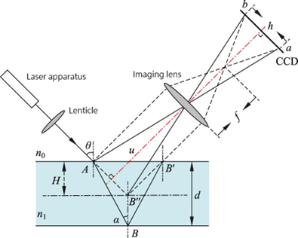
Figure 1. Single layer glass physical structure [8]

Calculation of Transmittance of Multilayer Glass Given that sunlight is vertically incident on the first layer of glass($L1$),with thickness of $L1, L2, L3$($Li∈[1.3,10]$mm), and the transmittance of each layer of glass isT1, T2 and T3, the total transmittance of the multi-layer glass is T=T1T2T3, and its weighted average transmittance is $T\left(λ\right)=I\left(λ\right)T(λ,L1,L2,L3)$, where $I(λ)$ is the weight of ultraviolet radiation at different wavelengths. As shown is Figure 2.
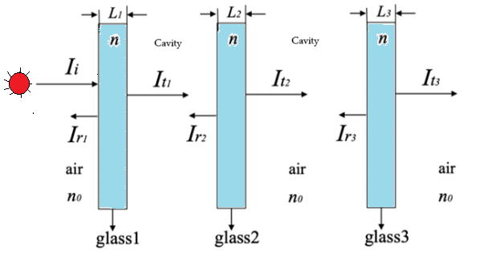
Figure 2. Multilayer glass structure (photo/picture credit: original).

Modeling process
This study is based on the AM1.5G full band guan spectrum (as shown in Figure 3), mainly focusing on the UV-A part of the spectrum (as shown in Figure 4). Setting the multi-layer glass as a three-layer glass model (three glass two cavity model), as the main optimization object of this study is the glass thickness, ignoring the thickness of the glass to glass cavity and the influence of the cavity on light, the thickness of each layer of glass $Li∈\left[1.3, 10\right]mm$ is set.
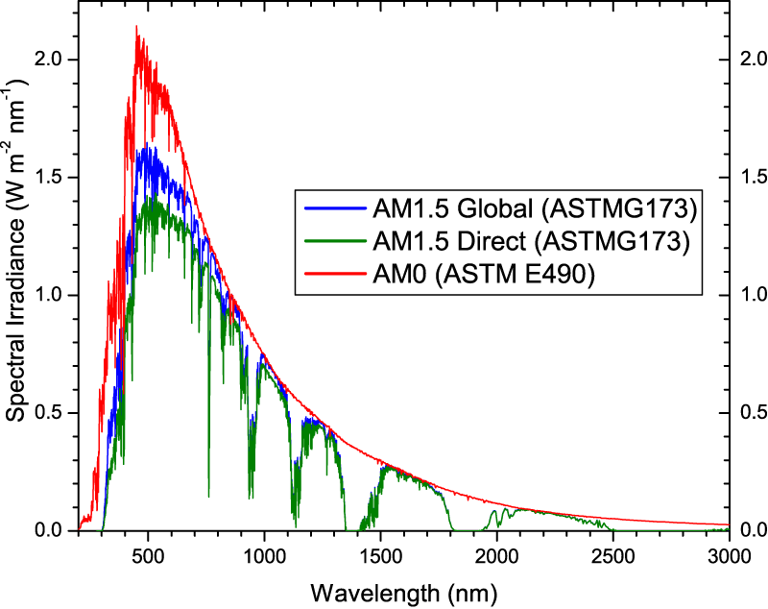
Figure 3. AM1.5G standard solar spectrum [9]

Experiment and Results

Experimental code setting
Firstly, establish a three-layer glass physical model with a thickness of $Li∈\left[1.3, 10\right]mm$ for each layer. Set population size is sizepop=100, maximum number of iterations is MAXGEN=200. Then represent the state of each quantum bit as the state of formula (2), which is $\left|Ψ>=α\right|0>+β|1>$.
Where α and β are complex probability amplitudes, satisfying ${|α|}^{2}+{|β|}^{2}=1$. Performing solution space mapping, for n-dimensional binary solutions, a quantum individual is composed of n qubits, each corresponding to a bit of the solution, and its superposition state represents that the bit may be 0 or 1. The above steps represent the qubits. By using the collapse mechanism, when measuring quantum bits, their state collapses to the ground state (0 or 1), and the probability is determined by $|α|^{2}$ and ${|β|}^{2}$. After measuring each quantum bit, a determined binary string is obtained as a candidate solution to achieve quantum measurement. Initialize the quantum bits into a uniform superposition state, with $α=β=\frac{\sqrt{2}}{2}$, ensuring that the initial population covers the entire solution space, and then adjust the quantum amplitude through a quantum rotation gate to gradually increase the ground state probability of high-quality solutions.
After collapsing the quantum bit state into binary code, a fitness function (i.e. objective function) is defined based on the objective problem, and numerical evaluation is performed on each candidate solution. Adjust the probability amplitude of quantum bits based on the fitness of each solution group to enhance the probability amplitude of quantum states corresponding to high-quality solutions [10, 11].
Finally, dynamically adjust based on high-quality solutions to increase the probability amplitude of high-quality solutions. The implementation principle is as follows
$R\left(θ\right)=\left[\begin{matrix}\cos{θ} & -\sin{θ} \\ \sin{θ} & \cos{θ}\end{matrix}\right],$ (8)
Repeat the above steps to retain the best individuals from each generation for evolution to the next generation, and then repeat the research process in the next generation until the maximum number of iterations is reached.
After completing the final generation of calculations, output the optimal thickness combination and compare it with a single-layer glass of equal thickness for ultraviolet transmittance. Then compare it with traditional genetic algorithms to obtain the conclusion.

Advantages of Algorithms and Models
The advantages of quantum genetic algorithm mainly lie in the parallelism and diversity of quantum encoding, which enables a single quantum bit to simultaneously represent multiple states and expand the scope of understanding; Quantum genetic algorithm has excellent global search ability and convergence speed due to its ability to dynamically adjust the quantum bit phase based on the optimal solution through quantum rotation gates, which increases the probability amplitude of the optimal solution; The efficiency and dynamic adjustment ability of quantum coding enable quantum genetic algorithms to perform excellently in high-dimensional space and multi-modal function optimization, with the ability to handle high-level complex problems.
The choice of multi-layer glass is due to its advantages, such as effective UV shielding, structural stability, and durability.

Experimental Result
Comparison of UV shielding results between multi-layer glass and single-layer glass and multi-layer glass.
Table 1. Statistical results of transmittance of ultraviolet radiation based on quantum genetic algorithm under different optimized thickness combinations of multi-layer glass
Data  Group | Optimal thickness combination (mm) |  |  | Weighted average transmittance | Maximum transmittance
Data  Group | L1 | L2 | L3 | Weighted average transmittance | Maximum transmittance
Result 1 | 2.1430 | 3.6505 | 8.8388 | 0.70647 | 0.81572
Result 2 | 2.5741 | 9.7904 | 4.9530 | 0.70799 | 0.84304
Result 3 | 3.9946 | 5.0793 | 8.8091 | 0.70632 | 0.87441
Result 4 | 6.9934 | 9.9638 | 3.5572 | 0.70790 | 0.88477
Result 5 | 5.1574 | 4.0858 | 5.5933 | 0.70545 | 0.82613
The data in Table 1 indicates that the weighted average transmittance of ultraviolet light through the multi-layer glass with the optimal thickness combination is approximately 70.68%, with an error range of 0.34% to 1.36%, which is within the error range. By comparing the UV weighted average transmittance under multiple optimal thickness combinations, the feasibility of optimizing the multi-layer glass thickness combination to change UV transmittance was verified.
Figures 5-9 show the comparison of transmission performance for different optimized thickness combinations. Among them, Figures 5-9 (a) shows the transmittance of multi-layer glass and single-layer glass with equal thickness at different wavelengths under the optimal thickness calculated by quantum genetic algorithm, Figures 5-9 (b) shows the weight of ultraviolet light at different wavelengths, and Figures 5-9 (c) shows the variation curve of ultraviolet transmittance with increasing iteration times.
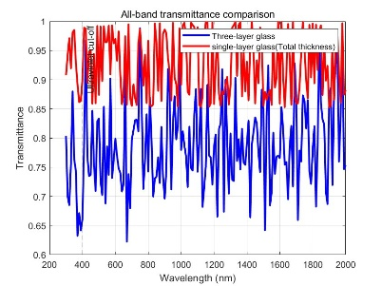 | 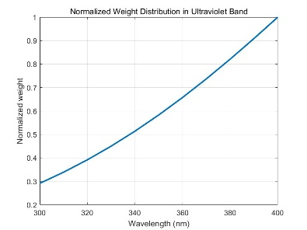 | 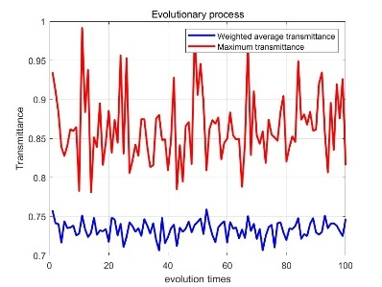
(a) | (b) | (c)
Figure 4. Comparison of transmission performance of result 1. (a) Quantum genetic algorithm calculates the transmittance of multi-layer glass and single-layer glass with equal thickness at different wavelengths under optimal thickness, (b) The weight of ultraviolet rays at different wavelengths, and (c) The variation curve of ultraviolet transmittance with increasing iteration times (photo/picture credit: original).
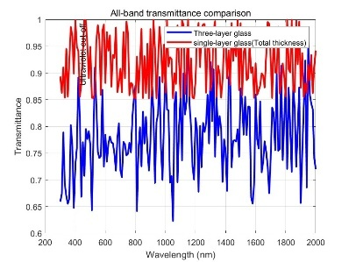 | 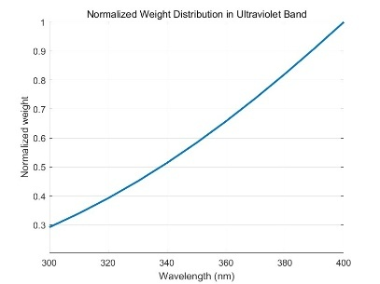 | 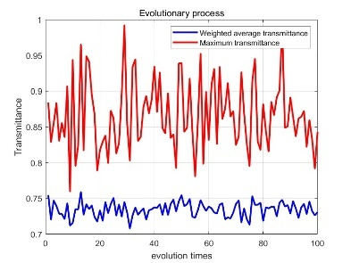
(a) | (b) | (c)
Figure 5. Comparison of transmission performance of result 2. (a) Quantum genetic algorithm calculates the transmittance of multi-layer glass and single-layer glass with equal thickness at different wavelengths under optimal thickness, (b) The weight of ultraviolet rays at different wavelengths, and (c) The variation curve of ultraviolet transmittance with increasing iteration times (photo/picture credit: original).
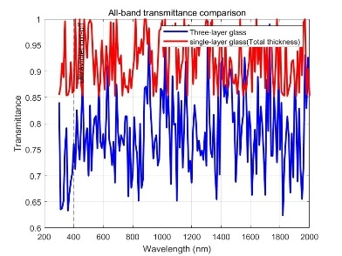 | 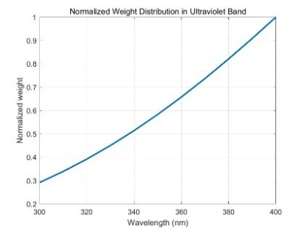 | 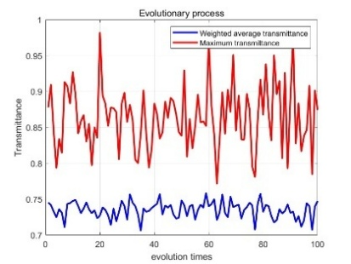
(a) | (b) | (c)
Figure 6. Comparison of transmission performance of result 3. (a) Quantum genetic algorithm calculates the transmittance of multi-layer glass and single-layer glass with equal thickness at different wavelengths under optimal thickness, (b) The weight of ultraviolet rays at different wavelengths, and (c) The variation curve of ultraviolet transmittance with increasing iteration times (photo/picture credit: original).
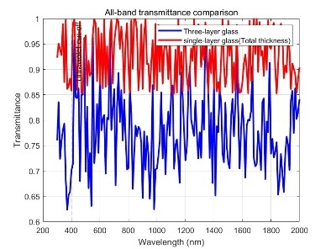 | 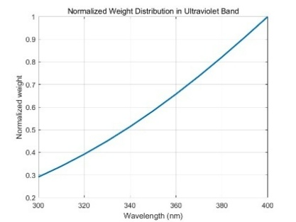 | 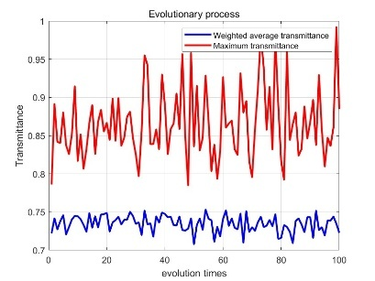
(a) | (b) | (c)
Figure 7. Comparison of transmission performance of result 4. (a) Quantum genetic algorithm calculates the transmittance of multi-layer glass and single-layer glass with equal thickness at different wavelengths under optimal thickness, (b) The weight of ultraviolet rays at different wavelengths, and (c) The variation curve of ultraviolet transmittance with increasing iteration times (photo/picture credit: original).
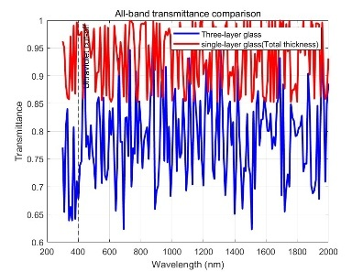 | 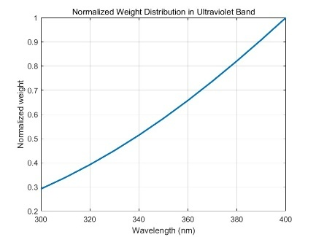 | 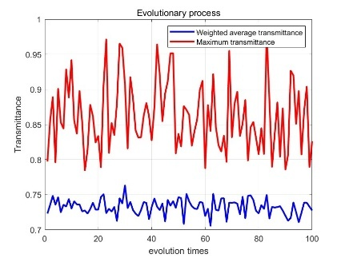
(a) | (b) | (c)
Figure 8. Comparison of transmission performance of result 25. (a) Quantum genetic algorithm calculates the transmittance of multi-layer glass and single-layer glass with equal thickness at different wavelengths under optimal thickness, (b) The weight of ultraviolet rays at different wavelengths, and (c) The variation curve of ultraviolet transmittance with increasing iteration times (photo/picture credit: original).

Comparing the image (a) in Figure 5-9, it is demonstrated that the transmittance of ultraviolet light through multi-layer glass with the optimal thickness combination is reduced by an average of about 20% compared to single-layer glass with the same thickness. This proves that multi-layer glass has better ultraviolet shielding efficiency compared to single-layer glass. In the data of Results 1, 4, and 5 in Table 1, the sum of the thicknesses of the first layer $(L1)$ and the third layer $(L3)$ in these three experiments is approximately equal (Results 1:10.9818mm, Results 4:10.5506mm, Results 5:10.5707mm), but the thickness of the intermediate layer (L2) in the three experiments differs greatly, causing a change of about 0.12% in the weighted average transmittance of ultraviolet light and a significant change in the maximum transmittance of ultraviolet light (Results 1 decreased by 6.9% compared to Results 4, decreased by 1.0% compared to Results 1 and 5, and increased by 5.9% compared to Results 4 and 5), proving that slight adjustments to the intermediate layer (L2) of multi-layer glass can have a significant impact on ultraviolet transmittance.
In the shielding results of multi-layer glass against ultraviolet radiation, the quantum genetic algorithm shows multiple peaks in ultraviolet transmittance with increasing iteration times. Compared with traditional genetic algorithms, the ultraviolet transmittance shows a gradient change with increasing iteration times, proving that the quantum genetic algorithm has excellent problem-solving ability in solving multidimensional parameter spaces. At the same time, a quantum genetic algorithm was applied in the study of ultraviolet light passing through multi-layer glass, expanding the application scenarios of the quantum genetic algorithm.

Results of the Traditional Genetic Algorithm on UV Shielding Effect
Table 2. Statistical results of transmittance of ultraviolet light based on a traditional genetic algorithm under different optimized thickness combinations
Data  Group | Optimal thickness combination (mm) |  |  | Weighted average transmittance | Maximum transmittance | Minimum transmittance
Data  Group | L1 | L2 | L3 | Weighted average transmittance | Maximum transmittance | Minimum transmittance
Result 1 | 8.0110 | 9.3621 | 2.0068 | 0.76263 | 0.94861 | 0.6283
Result 2 | 2.4185 | 3.2185 | 2.3587 | 0.75856 | 0.94186 | 0.62139
Result 3 | 9.5533 | 9.6105 | 3.2855 | 0.75701 | 0.92724 | 0.62722
Result 4 | 5.9050 | 4.3934 | 9.4078 | 0.75331 | 0.94262 | 0.62884
Result 5 | 5.2678 | 9.8265 | 3.4405 | 0.76184 | 0.96407 | 0.62575
Figures 10-14 show the UV shielding effect under different optimized thickness combinations. Figures 10-14 (a) show the transmittance of different wavelengths of ultraviolet light under the optimal thickness combination calculated by the traditional genetic algorithm, and Figures 10-14 (b) show the variation of ultraviolet transmittance with increasing iteration times.
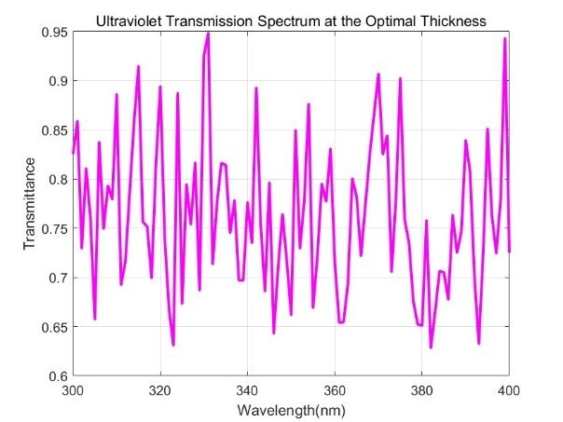 | 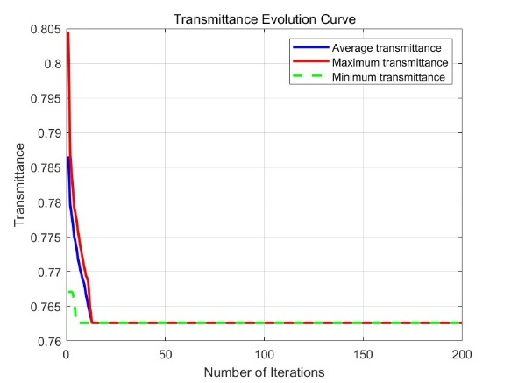
(a) | (b)
Figure 9. UV shielding effect of result 1. (a) Under the optimal thickness combination calculated by traditional genetic algorithm, the transmittance of different wavelengths of ultraviolet light, (b) The variation of ultraviolet transmittance with increasing iteration times (photo/picture credit: original).
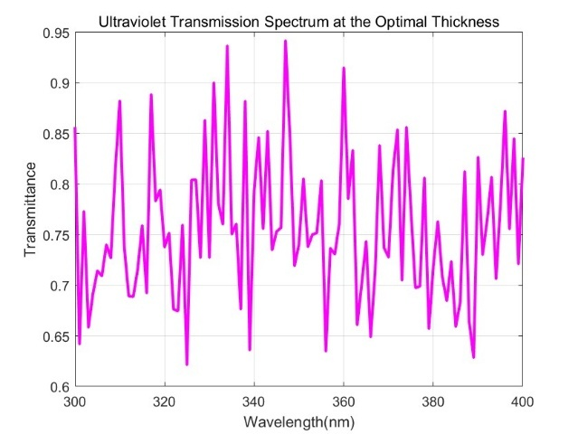 | 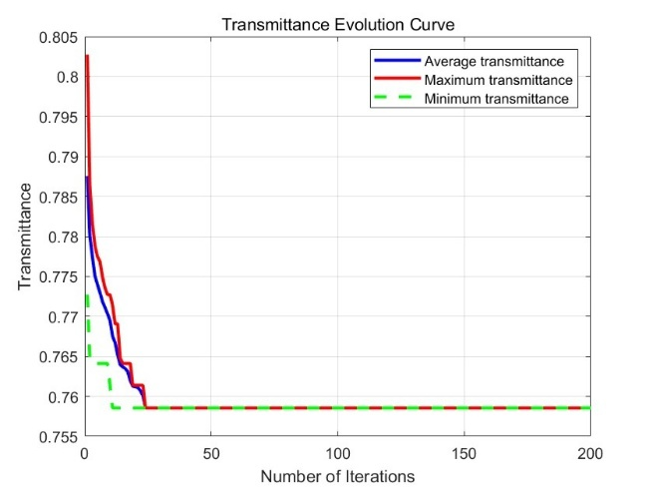
(a) | (b)
Figure 10. UV shielding effect of result 2. (a) Under the optimal thickness combination calculated by traditional genetic algorithm, the transmittance of different wavelengths of ultraviolet light, (b) The variation of ultraviolet transmittance with increasing iteration times (photo/picture credit: original).
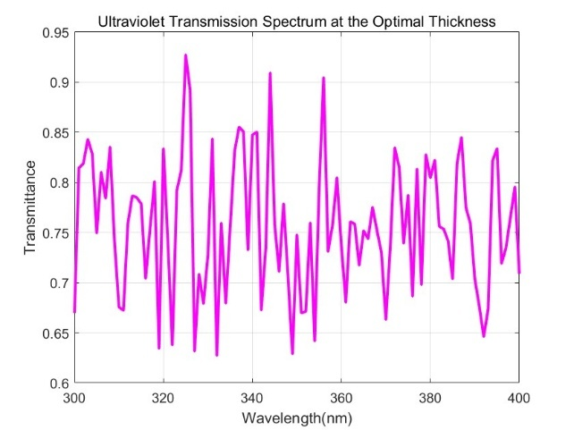 | 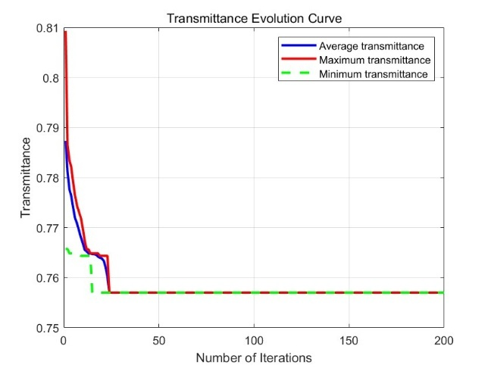
(a) | (b)
Figure 11. UV shielding effect of result 3. (a) Under the optimal thickness combination calculated by traditional genetic algorithm, the transmittance of different wavelengths of ultraviolet light, (b) The variation of ultraviolet transmittance with increasing iteration times (photo/picture credit: original).
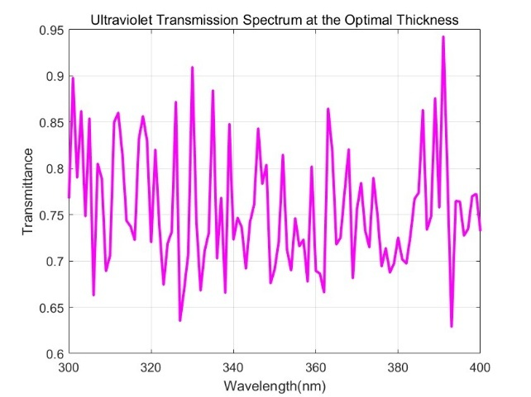 | 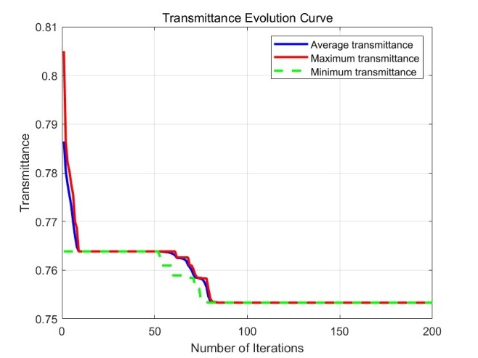
(a) | (b)
Figure 12. UV shielding effect of result 4. (a) Under the optimal thickness combination calculated by traditional genetic algorithm, the transmittance of different wavelengths of ultraviolet light, (b) The variation of ultraviolet transmittance with increasing iteration times (photo/picture credit: original).
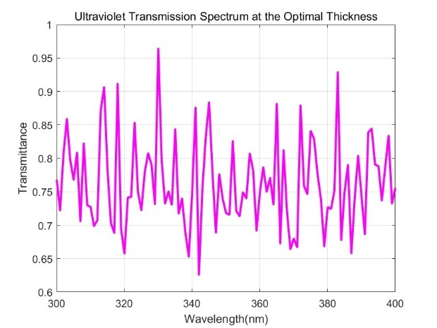 | 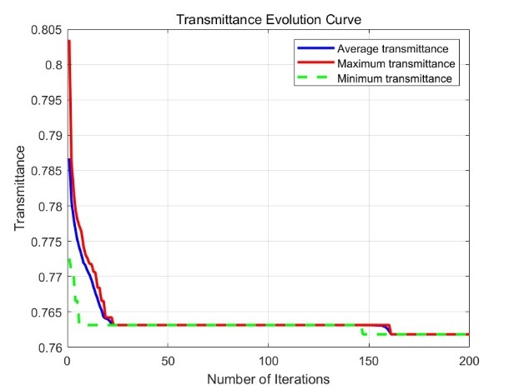
(a) | (b)
Figure 13. UV shielding effect of result 5. (a) Under the optimal thickness combination calculated by traditional genetic algorithm, the transmittance of different wavelengths of ultraviolet light, (b) The variation of ultraviolet transmittance with increasing iteration times (photo/picture credit: original).

Combining the data from Tables 1 and 2, by comparing the weighted average transmittance and maximum transmittance of ultraviolet light under different optimal thickness combinations, it was found that the quantum genetic algorithm reduced the weighted average transmittance by about 5% compared to the traditional genetic algorithm. This proves that the quantum genetic algorithm is superior to the traditional genetic algorithm in exploring the solution space and can avoid the poor quality solutions caused by premature convergence. That is, the quantum genetic algorithm has stronger advantages in global optimization ability, solution quality, and search efficiency.
Comparison of running time between quantum genetic algorithm (QGA) and traditional genetic algorithm (GA)
Table 3. Statistical results of QGA and GA in running time
Group  Algorithm | Group 1 | Group 2 | Group 3 | Group 4 | Group 5
QGA | 0.837s | 0.796s | 0.766s | 0.814s | 0.799s
GA | 3.396s | 3.297s | 3.345s | 3.285s | 3.384s
The comparison of the running time between the QGA algorithm and the GA algorithm in Table 3 proves that the quantum genetic algorithm has excellent global search ability, and confirms the feasibility of the quantum genetic algorithm in the optimization process of complex problems.

Conclusion
This study focuses on optimizing the thickness combination of multi-layer glass to change the UV transmittance and enhance the UV shielding efficiency. The research has shown that changing the thickness combination of multi-layer glass can effectively reduce the UV transmittance. Compared with single-layer glass of equal thickness, the optimized thickness combination of multi-layer glass reduces the UV transmittance by an average of 20%. The optimal thickness given by the study is within the actual processing range, which provides theoretical preparation for the practical manufacturing of UV shielding glass. During the research process, it was found that changing the intermediate layer $(L2)$of multi-layer glass can significantly alter the ultraviolet transmittance, providing a preliminary theoretical direction for the study of glass with controllable changes in ultraviolet transmittance by changing the thickness of the intermediate layer $(L2)$.
This study is based on the quantum genetic algorithm, and during the research process, it has been demonstrated that the quantum genetic algorithm has the ability to handle multidimensional processing and optimize complex problems, which expands the application of the quantum genetic algorithm in solving complex problems.
In the future, research can be conducted on multi-layer glass with more than three layers of glass, and the direction of the incident angle can be changed to achieve multidimensional, practical, and practical problems. In-depth research can be conducted on how multi-layer glass can reduce ultraviolet transmittance by optimizing the thickness combination of multi-layer glass under different directions of sunlight incidence. On the basis of this study, further consideration can be given to the influence of cavities on light, combining reality with research to develop multifunctional glass. At the same time, based on this study, research on the transmission of different wavelengths of sunlight through glass, such as visible light, infrared light, etc., can be explored to achieve the manufacturing of multifunctional and selectively shielding glass from sunlight, and further achieve more controllable functions on existing energy-saving glass.

ReferenceS
- W. David, and D. J. Brenner, Photochem. Photobiol. 97, 498-504 (2020).
- Y. P. Huang, X. X. Tian, Y. Yuan, Sol. Energy 4, 4148(2024).
- F. Chen, X. R. Xu, S. F. Liu, Glass 52, 59-62 (2025).
- D. A. O., Bijender, Opt. Mater. 133, (2022).
- L. G. A., V. Sandra, and C. S. D., Plant-Environ. Interact. 3, 203-211 (2022).
- A. C., L. Leonardo, S. F., Processes 10, 2653 (2022).
- T. Li, S.L. Tan, L.H. Guo, Glass 40, 10-12 (2013).
- Q. Tang, Phys. Eng. 32, 176-179+182 (2022).
- L. H. Zhao, Q. H. Tang, Equip. Environ. Eng. 14, 65-70 (2017).
- N. J. Xing, W. Z. Zhou, Y. Z. Liu, Min. Saf. Environ. Prot. 51, 38-45 (2024).
- A. Braghin, L. Galuppi, G. Royer-Carfagni, Compos. Struct. 354, 118773 (2025).

