Multi-Layer Glass Thickness Design for Maximizing Solar Energy Gain in Cold Climate Applications Based on Neural Network
Yuanzhi Zhu
International College of CQUPT, Chongqing University of Posts and Telecommunications, Chongqing, 400065, China
2279257@brunel.ac.uk
Abstract. In order to optimize the high proportion of external window heat loss in cold regions of northern China, this study proposes a collaborative optimization method based on a back-propagation neural network and a genetic algorithm. The optimization objective of this study is a model of a three-layer glass structure, aimed at maximizing the solar spectral transmittance through optimizing the glass layer thickness to enhance the photothermal synergy performance. This study established a physical model by combining ASTM G173 standard spectral data and the Fresnel optical formula through programming, generating a thickness/transmittance dataset to train a BP neural network. Using a trained neural network as a GA proxy model can significantly improve optimization efficiency. Compared to using physical models for repetitive calculations, the efficiency can be improved by up to 600 times. The optimized glass thickness combination shows significantly better energy transmission performance than traditional thickness combinations, with a transmittance of 80.2% in the wavelength range of 300nm to 2000nm, while the transmittance of conventional structures is about 75%. This study provides an efficient optimization framework for energy-saving window design in cold regions. In the future, multi-objective optimization can be further combined with gradient refractive index materials and hollow layer parameters to enhance engineering practicality.

Introduction
In northern China, the cold winter has always been a major problem that troubles people. Considering the air infiltration, heat consumption, and the temperature difference of the window frames and other factors, the heat consumption of external windows accounts for over 40% of the heat consumption of the building [1]. Therefore, it is crucial to maximize the solar energy through windows to improve indoor thermal comfort and reduce heating energy consumption. A traditional design - the multi-layer windows have already been used to deal with this problem. However, though it is effective in insulation, their thickness combinations remain a major problem to maximize solar transmittance across the whole solar spectrum (from 300nm to 2000nm), which includes both visible light and near-infrared light that are crucial for indoor lighting and passive heating [2]. Recent studies mainly focus on thermal insulation properties like the U-value optimization or narrow-band optical analysis [3, 4]. There is relatively little research on the global optimization of photo-thermal transmission. According to these existing studies, this study proposes a framework for the triple-layer glass thickness design, based on a back propagation neural network, offering a promising way to dynamically optimize the layer configurations while considering both optical and thermal performance.
Multi-layer glass design advances have shown potential in improving energy efficiency. Garlisi et al. theoretically discussed the significant advantages of multi-layer glass structures in terms of anti-reflection and energy saving [5]. Zavala-Guillén et al. conducted thermal analysis on single-layer, double-layer, and three-layer glass windows under the climate conditions in Mexico, and found that compared with SGW and DGW, TGW saved up to 33% and 15.5% of energy, respectively [6]. Ma combined aerogel and phase-change materials into multi-layer windows. The energy-saving rate achieved by equivalent modelling was 19.38%, but the photo-thermal synergy effects were overlooked [7].
Also, in recent studies, the back propagation neural network has changed the complex system optimization. Fan et al. used GA-BP to estimate the health status of lithium batteries at different data lengths; the error in the results was very small [8]. Lyu et al. reduced the prediction error of torsional strength of reinforced concrete beams by 30% through GA-BP and K-fold cross-validation [9]. Tian et al. Enhanced smog prediction accuracy by 15% using a deep belief-BP hybrid model [10]. Wang has proposed an aerodynamic shape optimization design method for rotor blades of helicopters using neural networks, which can get global optimization results with small computational complexity [11]. He et al. Used a BP neural network to optimize the different types of power chip energy consumption, including switch energy consumption and leakage energy consumption [12]. However, these approaches have not been extended to multi-layer glass photothermal optimization.
To fill in this gap, this paper proposes a framework and a Fresnel optical model for triple-layer glass modulation based on a BP neural network. The research will implement the algorithm, generate transmittance-thickness curves, and benchmark against traditional optimization approaches.

Experimental Materials and Methods

Experimental Tools and Techniques
This study uses MATLAB R2024a as the main computing platform, using its Deep Learning Toolbox and Global Optimization Toolbox to construct a Back Propagation (BP) Neural Network model and genetic optimization algorithm (GA). The hardware configuration is an Intel i7-12700H CPU and 16GB RAM, utilizing MATLAB's parallel computing capabilities to accelerate the training and optimization process.

Spectral Data Source
This study cited ASTMG173 spectral data, a standard document developed by the American Society for Testing and Materials (ASTM), titled "Standard Tables for Reference Solar Spectral Irradiances at Air Mass 1.5: Direct Normal and Hemispherical for a 37 Degree Tilted Surface". It provides ground solar spectral irradiance distribution data, including direct normal spectral irradiance and hemispherical solar irradiance (including direct and scattered components) on a 37 ° inclined surface facing the sun, covering the wavelength range of 280-4000nm. However, this study selected the 300-2000nm band to match the dominant solar radiation in northern winter (UV band accounts for less than 5% and is significantly absorbed by the atmosphere).
The wavelength interval of the original data is uneven (Δ λ fluctuates between 0.5-5nm), and cubic spline interpolation is used to standardize it into discrete points with Δ λ=1nm. The key spectral features include the Visible light region (400-700nm), where the peak power is located at 555nm, accounting for 43.2% of the total incident energy. Near infrared region (700-2000nm), contributes 48.7% of energy, and its transmittance has a significant effect on indoor passive heating. Shortwave attenuation zone (<400nm), accounting for only 8.1% of energy, but high-energy ultraviolet radiation can easily cause glass aging and requires partial shielding. This model automatically suppresses its transmission through the material refractive index.
All spectral data will ultimately be converted into row vectors ($I_{i}∈R^{1701}$) to adapt to matrix operations.

Optical Models and Formulas
Fresnel reflectivity R,
$R={(\frac{n-n_{0}}{n+n_{0}})}^{2}$ (1)
The refractive index of glass is $n=1.5$ (in reality, the refractive index of glass varies from 1.45 to 1.6 depending on different materials, and this study does not specify a specific glass material, so the refractive index of glass is tentatively set at 1.5), and the refractive index of air is considered to be $n_{0}=1.0$.
Wave vector calculation k,
$k=\frac{2πn}{λ}$ (2)
Convert wavelength $λ$ to meters ($m$) and participate in the calculation. Multi-layer transmittance T, L represents the thickness of the glass layer,
$T_{single-layer}=\frac{{(1-R)}^{2}}{{(1-R)}^{2}+4R\sin^{2}(kL)}$ (3)
The total transmittance of three-layer glass is the product of the transmittance of each layer,
$T_{total}=T_{1}⋅T_{2}⋅T_{3}$ (4)
The multiplication between transmittance needs to take into account the wave vector. Energy integration E, the total transmitted energy is calculated by integrating the full spectrum,
$E_{total}=\sum_{λ=300}^{2000}{I_{i}(λ)⋅T_{total}(λ)⋅Δλ}$ (5)
Figure 1 shows the approximate structure of the physical model.
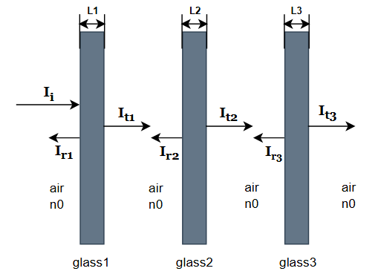
Figure 1. The transmission and reflection model of sunlight on a three-layer glass surface (Photo/Picture Credit: Original).

This model only simulates the scenario where sunlight passes vertically through glass under ideal conditions. There may be errors in the measured values in reality.

BP Neural Network Training
To generate data, call the “generateTrainingData” function to generate data consisting of a thickness combination and transmitted energy. Sampling follows the principle of random sampling, including ordinary basic samples, thin-layer specialized samples, symmetric structure samples, and extreme combination samples, to ensure the universality of sampling. Next, the sampled data will be vectorized to obtain the transmittance value T. Here, loops are avoided, and the built-in parfor is used for acceleration. Finally, store the obtained data as a “.mat” file for the neural network code module to call.
For the data processing part, before formally using the data for training neural networks, normalization is performed to eliminate dimensional differences and accelerate network convergence, and the training set and validation set are in an 8:2 ratio.
The neural network is designed with two hidden layers, each layer consisting of 15 nodes, and achieves the training objective with an error of less than $1×{10}^{-6}$. Among them, the maximum epoch is set to 500.
For the activation function, tansig is used for the hidden layer and purelin is used for the output layer.
$tansig(N)=\frac{2}{(1+exp(-2∙N))-1}$ (6)
The tansig function, also known as the hyperbolic tangent sigmoid transfer function, has its nonlinear part mainly concentrated between [-1.7, 1.7], outside of which the function gradually approaches saturation. This means that within the active range of the activation function, neurons can be more sensitive to input changes, while in the saturation range, even if there are significant changes in the input, the output will not fluctuate too much, which helps improve the stability of the network.
The Purelin function is a linear transfer function that takes an S × Q matrix N consisting of net input column vectors and returns an S × Q matrix A equal to N. The characteristic of this function is that the output value is the same as the input value.
$A=Purelin(N)=N$ (7)
After starting training, the training cycle roughly consists of forward propagation → calculating MSE → back-propagation (Levenberg-Marquardt Algorithm) → updating weights. The training will stop after reaching 500 epochs or verifying that the error is less than 1e-6.

Genetic Algorithm Optimization
After generating candidate solutions in GA, use the trained BP network to predict their energy values, and the fitness function is as follows.
$fitness=-energy$ (8)
The GA algorithm defaults to minimizing the fitness value, and by taking a negative value, the maximization problem is transformed into a minimization.
After continuous fine-tuning and testing, while considering both optimization effectiveness and efficiency, the population size was set to 300, and the maximum number of generations was set to 100. Based on the actual situation, the constraint condition is set to ensure that the total thickness of the three-layer glass does not exceed 80mm. At the same time, a crossover fraction of 0.7 and a mutation rate of 0.3 are set to avoid the final optimization result falling into local optima and increase the diversity of the algorithm.
After completing all steps, GA optimization obtains the thickness combination with the highest final energy and generates corresponding result display charts, which will be discussed in the Results and Analysis module.

Result and Analysis

Thickness Optimization Result
Representative optimized thickness combinations,
$L1=8.91mm, L2=25.47mm, L3=7.52mm, L_{total}=41.9mm$ (9)
The total irradiance before incidence is $963.91 W/m^{2}$, and the total irradiance after transmission through the thickness optimized structure is $775.03 W/m^{2}$, with a transmittance of $T=\frac{773.03 W/m^{2}}{963.91 W/m^{2}}≈80.3\%$. Here, this study specifically calculated the transmittance of conventional glass structures 5+6A+5 and 6+12A+6 on the market for comparison (5+6A+5 represents a 5mm glass layer and a 6mm hollow layer structure, while 6+12A+6 represents a 6mm glass layer and a 12mm hollow layer structure). Under the same testing environment, the post-transmission irradiance of the 5+6A+5 thickness combination is 762.3, and the post-transmission irradiance of the 6+12A+5 thickness combination is 763.8, with a transmittance of approximately 78%. As can be seen in Figure 2, the optimized glass thickness structure outperforms the other two structures in terms of energy transmission performance. (The horizontal axis represents "conventional structure 5+6A+5", "efficient structure 6+12A+6", and "optimized structure" from left to right, respectively. The vertical axis is measured in $W/m^{2}$).
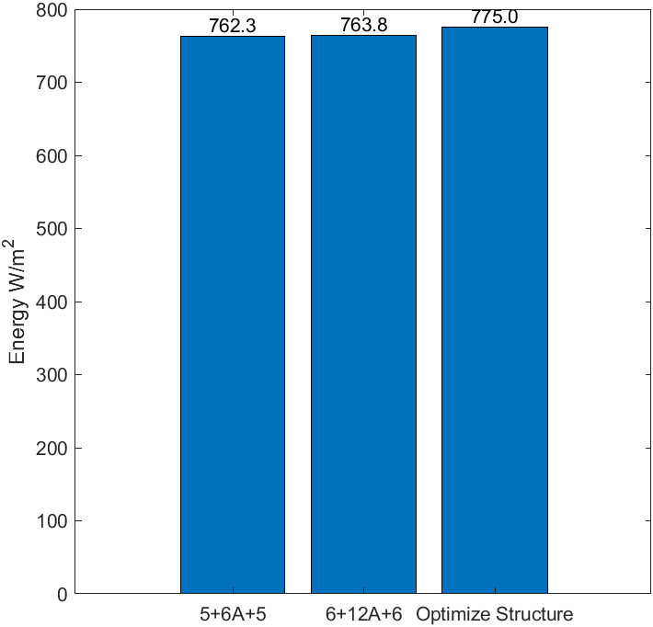
Figure 2. Comparison of energy transmittance of three thickness structures (Photo/Picture Credit: Original).

Neural Network Optimization Result
The neural network achieved convergence with a Mean Squared Error of less than $1×{10}^{-6}$ during the 27th round of training. The horizontal axis in Figure 3 represents the training epochs, and the vertical axis represents the mean square error.
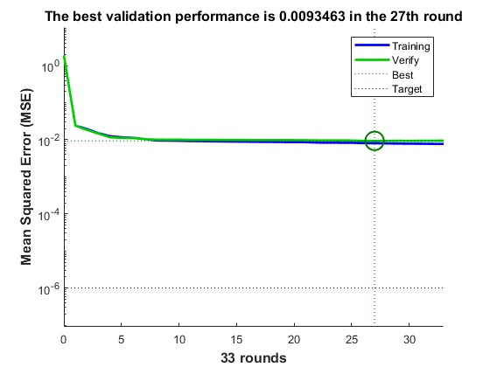
Figure 3. Neural network convergence curve (photo/picture credit: original).

The neural network predicts good data quality. As shown in Figure 4, the prediction error roughly follows a normal distribution, with most samples having small prediction errors. The vertical axis in Figure 4 represents the number of samples, and the horizontal axis represents the prediction error.

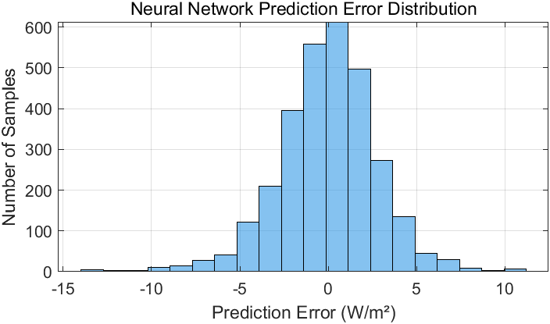
Figure 4. Neural network prediction error (photo/picture credit: original).

Genetic Algorithm Optimization Result
The GA algorithm significantly improves optimization efficiency when using a BP neural network as a proxy model. A single fitness calculation takes about $1.8 seconds$. In the GA parameter setting,
$300 generations × 300 individuals=90000 fitness calculations$ (10)
For using the BP neural network proxy model for prediction, a single prediction takes about $0.003 seconds$. Based on the above data, the calculation of the overall efficiency improvement ratio can be summarized as the following formula.
$efficiency ratio=\frac{Proxy model computation time}{Physical model computation time}=\frac{90000×1.8}{90000×0.003}=600$ (11)
Through rough calculation, using a BP neural network as a surrogate model can increase optimization efficiency by approximately 600 times. On top of this, parallel computing or GPU acceleration can be used to improve efficiency, but physical models cannot take advantage of GPU acceleration because the calculation is a wavelength by wavelength cycle, and the number of wavelengths (2000 points) directly affects the physical model's time consumption, but the proxy model's prediction time is independent of the number of wavelengths.
From the GA optimization iteration results, it can be seen that the GA optimization algorithm achieved the optimal results with fewer iterations. This study considered the situation where GA was trapped in a local optimal solution, and after multiple parameter adjustments, it was found that the result was acceptable for the following reasons. The optimization variable is the thickness of three layers of glass, which belongs to a three-dimensional continuous space. Compared to high-dimensional problems, low-dimensional problems are easier to converge quickly. The calculation of transmitted energy is based on the Fresnel interference formula, and there may be multiple local maxima, but the introduction of a surrogate model (BP neural network) may smooth the objective function and accelerate convergence. The BP network replaces time-consuming physical models, reducing the single fitness calculation time from 1.8 seconds to 0.003 seconds, allowing the algorithm to quickly explore more regions. If the proxy model can accurately predict high-energy regions, GA can quickly locate the optimal solution in the proxy space without requiring too many generations. When generating training data, sampling strategies such as thin layers, symmetry, and extreme combinations are included (as mentioned in the BP neural network training module), and the initial population may have already covered the potential optimal region.
Based on these speculations, Figure 5 shows the convergence curve of the GA algorithm, which can find the optimal solution with fewer iterations. The horizontal axis in Figure 5 represents the iteration algebra, and the vertical axis represents the optimal fitness value.

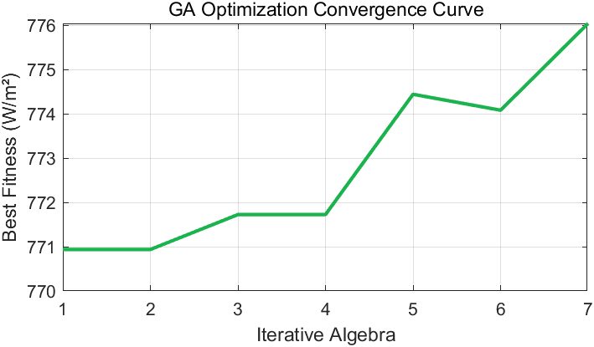
Figure 5. Genetic algorithm iteration curve (photo/picture credit: original).

Figure 6 shows the transmittance image from 300nm to 2000nm, with the horizontal axis representing wavelength and the vertical axis representing transmittance. The red image represents the optimized structure, while the blue image represents the conventional structure mentioned earlier for comparison. The shaded area in Figure 6 represents the visible light band. It can be seen that the optimized structure in Figure 6 exhibits better transmittance in the range of 300nm to 2000nm compared to conventional structures.
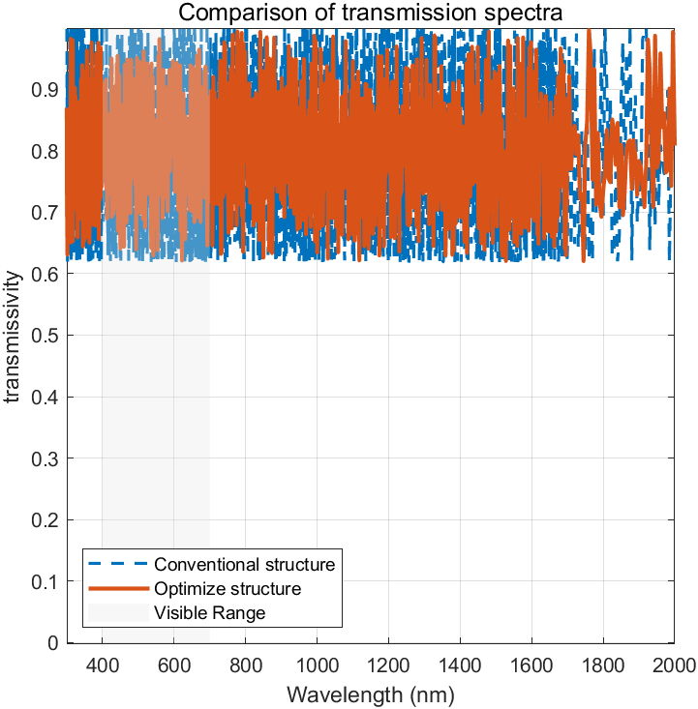
Figure 6. Comparison of transmission spectra (photo/picture credit: original).

Conclusion
This study proposes a three-layer glass thickness optimization framework based on the BP-GA hybrid algorithm, using the Fresnel refractive index formula and the light transmittance formula to construct a physical model. Use the physical model to train a BP neural network, and then use the BP neural network as a surrogate model to optimize the optimal glass thickness combination using the GA algorithm. This dual algorithm combination method effectively improves computational efficiency. After adjusting based on the application situation, it can be applied in the design of photovoltaic integrated systems in the future to analyze the performance of the system under different environmental conditions.
However, there are still some areas for improvement in this study. A few optimization points are discussed below. In reality, the refractive index of glass is usually between 1.45 and 1.6, and this study sets the refractive index of glass to a constant of 1.5. In the future, the latest refractive index gradient materials (such as gradient refractive index glass) can be introduced.
Compared to the BP-GA algorithm, there have been many algorithms with better performance recently, such as the Adam and RMSProp algorithms. In future research, algorithms with higher efficiency and accuracy will be compared and replaced to construct models.
In this study, the influence of the glass hollow layer on the photothermal conditions was not considered. The hollow layer has a significant impact on various parameters of the glass, such as filling argon gas to reduce the pressure inside the glass, thereby improving the sound insulation and thermal insulation effect of the glass. Also, making the glass more solid and extending its service life. In future research, optimization design of the hollow layer should be incorporated to make the model more practical.

References
- Z. Songying, X. Jianguang, and L. Xingyu, J. Jilin Jianzhu Univ. 38, 39–43 (2021).
- A. Rodriguez-Ake, J. Xamán, I. Hernández-López, Energy 239, 122075 (2022).
- J. Huang, X. Chen, J. Peng, Renew. Energy 163, 1238–1252 (2021).
- Q. Lv, J. Cui, H. Jarimi, Int. J. Low-Carbon Technol. 15, 574–582 (2020).
- C. Garlisi, E. Trepci, X. Li, Appl. Energy 264, 114697 (2020).
- I. Zavala-Guillén, D. Barrera-Román, F. Noh-Pat, Energy Build. 329, 115259 (2025).
- Y. Ma, “Optimization and Performance Study of Thermal Insulation Phase Change Multilayer Glass Windows,” Ph.D. thesis, Northeast Petroleum University, 2023.
- Z. Fan, X. Zi-xuan, and W. Ming-hu, J. Energy Storage 57, 106277 (2023).
- Z. Lyu, Y. Yu, B. Samali, Materials 15, 1477 (2022).
- J. Tian, Y. Liu, W. Zheng, Urban Clim. 41, 101078 (2022).
- Q. Wang, B. Lu, and L. Wang, J. Aeronaut. Dyn. (2025).
- Y. He, C. Xu, M. Xin, Mech. Des. Manuf. Eng. 53, 139–142 (2024).

