Research Report on Thickness Optimization and Transmission Performance of Triple Glazing Based on the Classical Genetic Algorithm
Chen Yang
National University of Malaysia, Lingkungan Ilmu, 43600 Bangi, Selangor, Malaysia
A199843@siswa.ukm.edu.my
ABSTRACT. With the increasing demands for green buildings and indoor health, achieving high transmittance in the visible and infrared regions while effectively blocking harmful ultraviolet radiation has become a major focus in glass material research. Although current multi-layer glazing systems exhibit some degree of spectral selectivity, there remains significant potential for further optimization in terms of energy efficiency and visual comfort. In this study, a triple-glazing structure is investigated. An optical transmission model based on wavelength-dependent absorption coefficients is developed, incorporating both a Gaussian-distributed incident spectrum and the experimentally measured ASTM G173 standard AM1.5 solar spectrum, thereby enhancing the physical accuracy and regional adaptability of the model. The thickness of each glass layer is optimized using a classical genetic algorithm to identify representative structural configurations under various lighting conditions. Simulation results demonstrate that, under a Gaussian spectral input, the optimized structure achieves an ultraviolet (UV) transmittance below 38% while maintaining high transmittance in the visible and infrared regions. Under the standard AM1.5 solar spectrum, the proportion of transmitted UV energy is limited to just 1.8%, with visible and infrared transmittance reaching 46.1% and 52.1%, respectively. These findings validate the effectiveness of the proposed optimization strategy in enhancing multi-band light transmission, providing a theoretical basis and technical pathway for the design of energy-efficient architectural glazing.

INTRODUCTION
In northern China, where winters are harsh and cold, solar energy—an abundant and renewable natural resource—serves as an indispensable heat source for building heating. Introducing an appropriate amount of solar radiation through exterior windows can not only effectively raise indoor temperatures but also reduce the energy consumption of artificial heating systems, thereby achieving both building energy savings and environmental sustainability. However, solar radiation contains a certain proportion of ultraviolet (UV) light, particularly radiation with wavelengths below 400 nm. Excessive indoor transmission of UV can be harmful to human skin and eyesight, and can also accelerate the aging and degradation of furniture and building materials, posing potential health and safety risks. Therefore, how to suppress UV transmission while harnessing solar heat has become a critical issue in building energy-efficient designs.
The impact of glass thickness on thermal performance has been the subject of extensive research under various climatic conditions. For example, Anita optimized the thermal performance of double and triple glazing systems for the Slovenian climate by analyzing glass thickness as a key variable and found that glass thickness significantly affects both window heat transfer and solar transmittance [1]. Sanghoon et al. proposed a hybrid triple glazing system combining vacuum and CO₂-filled gaps, and, through numerical simulations, analyzed its energy transmission performance under different climatic scenarios, finding the system to be highly effective in improving energy efficiency [2]. Rodriguez et al., using numerical modeling, studied triple glazing windows in hot Mexican climates, focusing on the influence of glass thickness on the window system’s internal temperature and aiming to optimize interlayer thicknesses for enhanced solar energy utilization [3]. Ranaa et al. conducted field measurements and experiments comparing double and triple glazing and demonstrated that triple glazing, with its increased number of layers and optimized thickness, significantly outperforms double glazing in reducing heat loss and maintaining comfortable indoor temperatures [4]. Tao Qi applied a particle swarm optimization algorithm to investigate the effects of varying glass thicknesses on the transmittance and reflectance of energy-efficient glazing, finding that reasonable thickness selection can effectively maintain visible light transmittance, indirectly supporting the strategy of maximizing solar energy utilization by adjusting the thicknesses within triple glazing [5].
The literature indicates that glazing systems, as the interface between indoor and outdoor environments, play a pivotal role in thermal flux and spectral management. Compared to single or double glazing, triple glazing—with its more complex interlayer structure—offers enhanced advantages in energy transfer. By optimizing layer thicknesses, it is possible to balance visible light transmission and UV shielding, thus improving both daylighting and indoor thermal effects. However, most existing studies focus on optimizing a single performance metric and lack systematic multi-objective modeling approaches.
To address this gap, this paper develops a triple glazing light transmission model based on wavelength-dependent absorption coefficients, integrating measured solar spectra and a genetic algorithm to systematically analyze energy transmission characteristics across different spectral regions. Through multi-objective optimization, the study explores coordinated strategies for solar energy utilization, visible light transmission, and UV suppression, providing a theoretical foundation and design guidance for high-performance building envelope systems.

METHODOLOGY
The objective of this study is to achieve spectral-selective control in triple glazing systems across the solar spectrum, maximizing transmittance in the visible and infrared regions to enhance indoor daylighting and solar heat gain, while minimizing transmittance in the ultraviolet range (300–400 nm) to protect human health. To this end, an optical model for triple glazing was constructed, which accounts for multiple reflections and interference effects under normal incidence. The layer thickness distribution was globally optimized using a classical genetic algorithm, thereby targeting both energy efficiency and occupant safety.
A wavelength-dependent transmittance model for the triple glazing system was developed based on the Beer–Lambert law. For any single glass pane, the transmittance at wavelength λ is expressed as:

$T=exp(-absorption.*Li)$ (1)

where absorption is the absorption coefficient of the material at different wavelengths, and Li is the thickness of the i-th glass layer. In setting the absorption coefficients, a high absorption value (absorption = 50) is assigned to the UV range (300–400 nm) to account for its potential harm to human health, while a uniform value of 0.5 is used for other regions to ensure good transmittance for visible and infrared light, resulting in physically realistic and interpretable simulation results.
The total system transmittance is calculated as the product of the transmittances of the three layers:

${Total}_{transmission}=T1.*T2.*T3$ (2)

In the optical model, the thicknesses of the three glass layers are denoted as T1, T2, and T3, corresponding to the three panes from the incident to the exit surface. These serve as the principal design variables in the optimization process, critically affecting multiple reflections, interference path lengths, and spectral transmittance characteristics in different bands. Thus, they are key parameters for achieving spectral selectivity. Two types of spectral models are incorporated in this study. The first is a Gaussian spectrum model, constructed as a Gaussian distribution centered at 700 nm with a standard deviation of 300 nm, and used as the idealized input during the optimization stage. The second is the experimentally measured ASTM G173 standard AM1.5 solar spectrum published by the National Renewable Energy Laboratory (NREL), which serves as the physical validation input for the optimized structure. Figure 1 shows the approximate distribution of the Gaussian spectrum, with wavelength on the x-axis and normalized spectral intensity on the y-axis. The spectral range can be roughly divided into three regions: ultraviolet (UV, 300–400 nm), visible (400–700 nm), and infrared (IR, 700–2000 nm), facilitating the analysis of energy contributions in different bands.
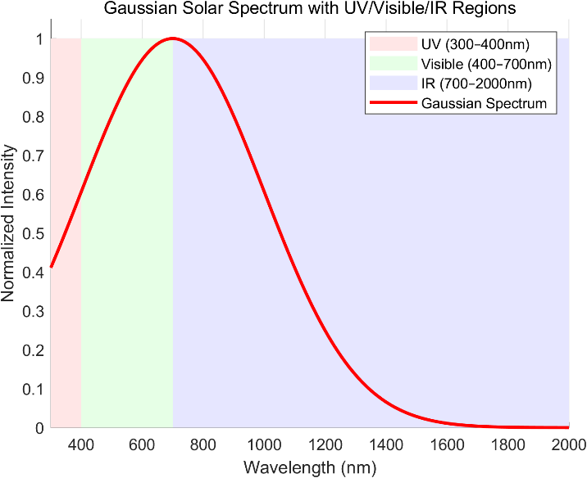
Figure 1. Approximate distribution curve of the gaussian spectrum (photo/picture credit: original).

The second input, the AM1.5 standard solar spectrum, is based on the ASTM G173-03 standard data from NREL, covering the 250–4000 nm range and representing typical ground-level solar irradiance under an air mass of 1.5. This standard spectrum includes extraterrestrial irradiance (Etr), global tilt, and direct plus circumsolar components, and is widely used for the performance evaluation of photovoltaic materials, architectural glazing, and solar thermal systems. Among these, the global tilt data most realistically reflects the solar input received by actual building façades.
Spectral energy distribution analysis shows that solar irradiance peaks near 500 nm (corresponding to green light in the visible range). Within the 300–2500 nm range, solar irradiance remains relatively high, encompassing the UV, visible (VIS), and near-infrared (NIR) bands. The UV region (250–400 nm) is particularly harmful to humans and materials; the visible band determines indoor daylight quality; and the NIR band carries substantial thermal energy, which is critical to the thermal performance of building envelopes.
To ensure simulation results closely approximate actual irradiation conditions, the Global tilt component of the standard spectrum was interpolated to the 300–2000 nm range used in this study and adopted as the basis for structure optimization and spectral performance simulations. This enables a comprehensive assessment of the transmittance and energy control capabilities of multilayer glazing systems across different spectral regions, supporting the coordinated design objectives for optical and thermal performance.
The dual optimization objective of this study is to “maximize solar energy transmission” while “minimizing ultraviolet transmission.” The objective function is defined as follows:
$y=-({vis_ir}_{energy}-β*{uv}_{energy})$ (3)
where ${vis_ir}_{energy}$ denotes the transmitted energy in the visible and infrared regions, ${uv}_{energy}$ denotes the transmitted energy in the ultraviolet region, and β = 5 is a weighting factor introduced to emphasize the importance of UV suppression. This objective function enhances UV blocking while ensuring adequate daylighting and passive solar heating. In addition, a penalty term for thickness uniformity is included to prevent the layer thicknesses from converging to the same value, thereby maintaining band selectivity. The global optimization process is implemented using the ga function in MATLAB, with the three glass layer thicknesses [L1, L2, L3] as variables, each constrained to a range of 3 mm to 10 mm. The optimization procedure involves population initialization, fitness selection, crossover, and mutation operations, ultimately yielding the optimal thickness combination and corresponding performance metrics. After optimization, the resulting thickness parameters are validated under the AM1.5 spectral model and compared with the optimization-stage objective function values to verify the robustness of the structure. To comprehensively evaluate the spectral control performance of the triple glazing system, two performance metrics are introduced. The first is the average transmittance in the UV region (300–400 nm):
${UV}_{avg}=\frac{1}{N}\sum_{λ≤400}^{n}{T_{total(λ)}}$ (4)
where ${UV}_{avg }represents the average transmittance in the ultraviolet range，T_{total(λ)}$ is the total transmittance at wavelength $λ$ and N is the total number of sampling points in the UV band. This metric reflects the UV blocking capacity of the glazing. The second is the UV suppression rate:
${uv}_{blocking_rate}=（1-{uv}_{avg_transmission})*100$ (5)
where ${UV}_{blocking_rate}$ is the UV suppression rate, ${UV}_{avg_transmission}$ is the average UV transmittance obtained from Equation (4). This indicator quantifies the improvement in UV protection, with higher values indicating stronger UV suppression. The final optimization results not only provide the optimal thickness parameters, but also quantify the performance trade-off between UV shielding and visible light transmission, thereby offering a methodological basis for intelligent multilayer glazing design.

RESULTS & DISCUSSION
In this study, the thickness optimization of the triple glazing structure was first performed using a constructed Gaussian spectral distribution (centered at 700 nm, with a standard deviation of 300 nm). The optimization objective was to maximize solar energy transmittance while minimizing the transmission of ultraviolet radiation (300–400 nm). After 127 generations of iteration with the genetic algorithm, the optimal thickness configuration obtained was: L1 = 0.01 m, L2 = 0.0032454 m, and L3 = 0.0066227 m, yielding an objective function value of 22,532.1981. For this structure, the average transmittance in the UV range was 37.03%, and the UV suppression rate reached 62.97%, indicating a significant blocking effect against harmful UV wavelengths.
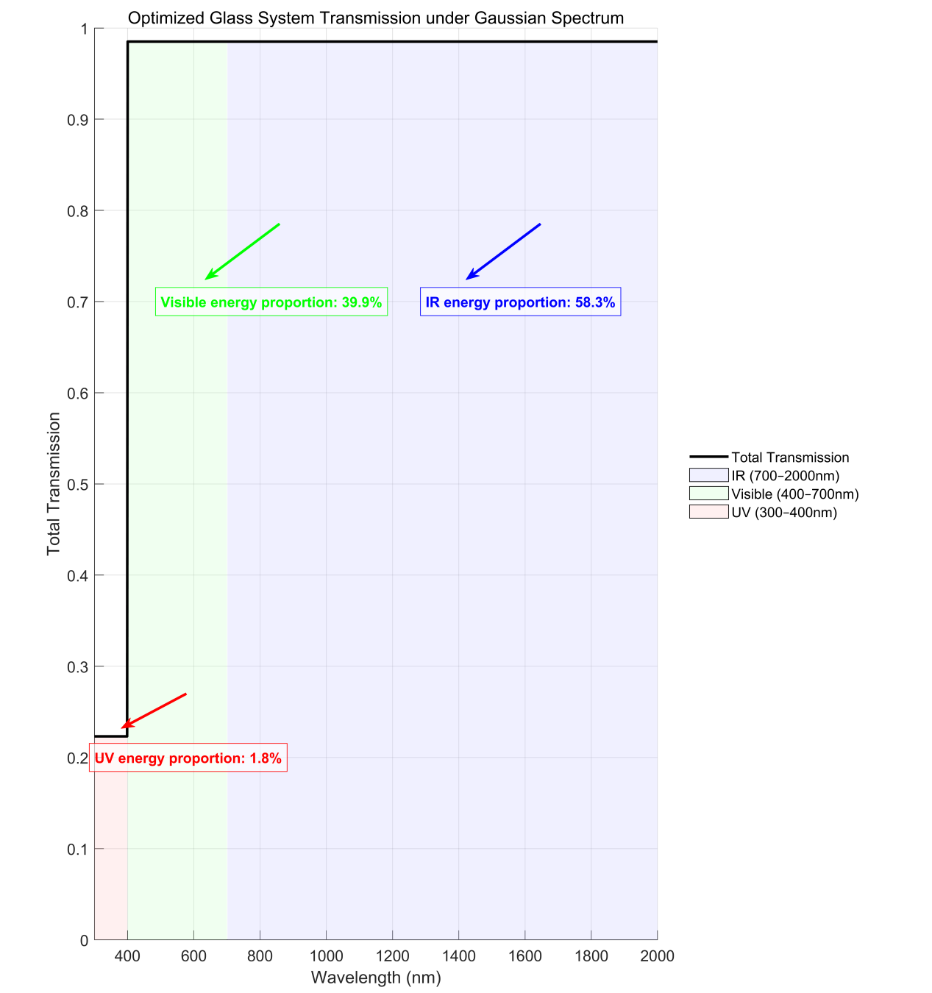
Figure 2. Total transmission and energy distribution by spectral band under Gaussian spectrum input (photo/picture credit: original).

Figure 2 illustrates the total transmission curve and the proportion of energy in each spectral band for the optimized glass structure under Gaussian spectrum input. The x-axis represents wavelength (in nm), covering the full range of solar radiation from ultraviolet to infrared (300–2000 nm), while the y-axis denotes the total transmission, reflecting the system’s ability to transmit solar energy at each wavelength. As shown, the proportions of transmitted energy in the visible (400–700 nm) and infrared (700–2000 nm) regions were 39.9% and 58.3%, respectively, while the UV region accounted for only 1.8% of the total energy. This result demonstrates that the optimized triple glazing structure can significantly suppress UV penetration while effectively transmitting most of the beneficial solar radiation, thereby meeting the combined requirements of daylighting, heating, and occupant health and safety.
To assess the adaptability of the optimized structure under real-world solar irradiation conditions, its performance was further evaluated using the standard AM1.5 G (Global Tilt) solar spectrum published by NREL. Under this measured spectrum, the structure exhibited an average UV transmittance of 37.03% and a suppression rate of 62.97%, closely matching the results under the Gaussian spectrum and confirming the robust spectral performance of the optimized thickness configuration. The recalculated weighted objective function value was -484.3232, aligning with the goal of enhancing visible and infrared transmission while suppressing UV transmission.

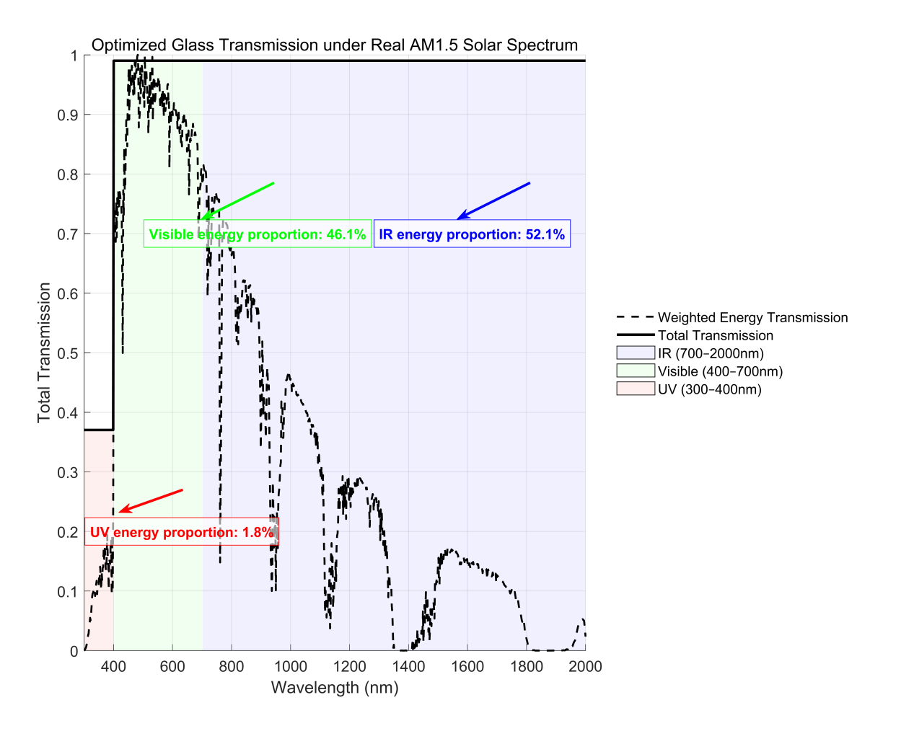
Figure 3. Total transmission and energy distribution by spectral band under AM1.5 spectrum input. (photo/picture credit: original).

Figure 3 presents the weighted transmission curve and energy distribution for the optimized structure under AM1.5 spectral input. Under actual solar conditions, the proportion of energy in the UV (300–400 nm), visible (400–700 nm), and infrared (700–2000 nm) regions was 1.8%, 46.1%, and 52.1%, respectively. Compared to the Gaussian spectrum, the AM1.5 spectrum exhibits a higher energy density in the shorter wavelength regions, yet the optimized glazing structure still effectively suppresses UV transmission while improving the collection of useful spectral bands.
After completing the optimization and performance assessment under both the ideal Gaussian and the real AM1.5 solar spectra, a comparative analysis of the two spectral models was performed.
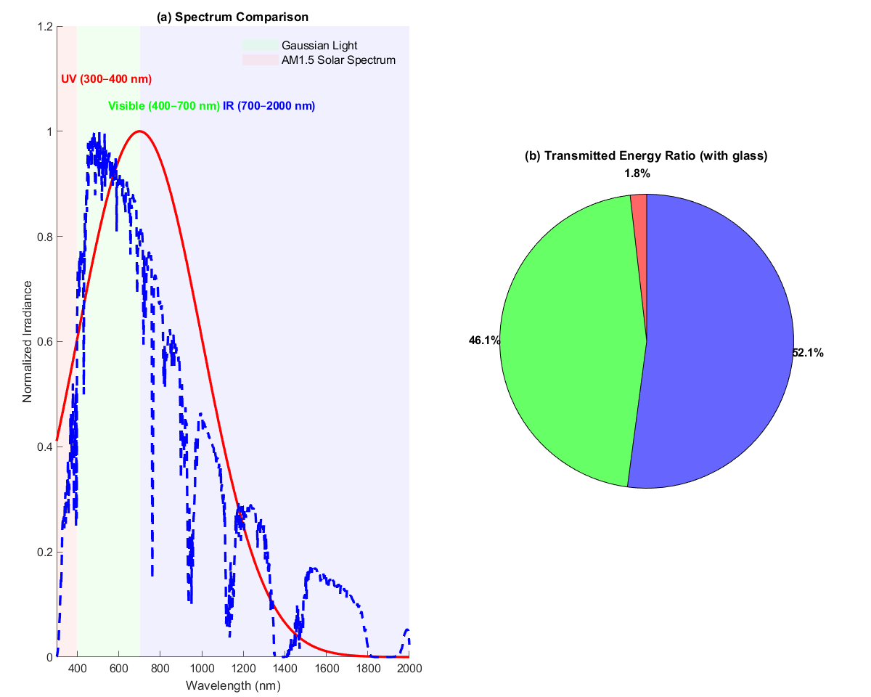
Figure 4. (a) Comparison of normalized transmission under AM1.5 and Gaussian spectra; (b) proportion of transmitted energy in each spectral band under AM1.5 input. (photo/picture credit: original).

Figure 4 compares the irradiance distributions of the Gaussian and AM1.5 spectra, highlighting significant differences in wavelength distribution and energy density. The Gaussian spectrum is concentrated in the visible and near-infrared regions, making it suitable for theoretical optimization modeling. In contrast, the measured AM1.5 spectrum features multiple atmospheric absorption valleys and fluctuations, representing real-world radiation inputs. Despite the spectral differences, the optimized thickness configuration exhibits consistent performance characteristics under both models, confirming the method’s adaptability and robustness for practical engineering applications.

OUTLOOK
Although this study has achieved promising initial results, there is still significant scope for further improvement in terms of model accuracy, parameter expansion, and practical validation. Future research may incorporate region-specific measured irradiance data or standard spectra with higher spectral resolution as inputs, thereby enhancing the model’s precision and design relevance for various geographic and climatic conditions. It is also recommended to integrate multiphysics mechanisms—such as heat conduction, radiative heat transfer, and air convection—into coupled models, thus establishing a comprehensive performance evaluation framework encompassing thermal, optical, and fluid processes. This approach would more realistically reflect the energy-saving performance of glazing systems under actual service conditions. Beyond glass thickness, future optimization should also account for additional variables such as the performance of low-emissivity (LOW-E) coatings, material refractive indices, and the type of gas-filled interlayers, enabling a multivariable synergistic optimization mechanism to improve structural tunability and environmental adaptability. Empirical studies have shown that thermal comfort performance of windows is influenced not only by material properties, but also by window opening area, seasonal climate conditions, and natural ventilation effects; hence, the overall thermal efficiency of triple glazing in specific environments requires further systematic evaluation [6, 7].
Moreover, it is advisable to integrate the optimized structures into building energy simulation platforms (such as EnergyPlus) to conduct energy-saving simulations and applicability validation across different building orientations, functional uses, and climatic backgrounds, thereby enhancing the engineering value of the research outcomes [8]. Regarding optimization algorithms, future work could explore the combination of genetic algorithms with other intelligent approaches such as particle swarm optimization (PSO) or differential evolution (DE), in order to improve solution efficiency and stability. Related research indicates that PSO demonstrates strong global search capabilities and structural adaptability in the thickness optimization of multilayer glass and may provide valuable technical support for the advanced design of green building materials [9]. To further improve the engineering applicability of the optimization model, future studies may also combine measured data and simulation analyses to validate the light transmission performance of glass structures under real solar irradiation. For instance, Wu et al. conducted systematic tests on multilayer glass configurations using integrating spheres and spectrometers, with measured solar data from different locations and periods, and confirmed the suitability and accuracy of the model under natural lighting [10]. Such a “measured data + simulation” approach will offer more practical guidance for the regional design of high-performance glazing systems and provide a viable pathway for translating theoretical research on energy-saving materials into practical application.

CONCLUSION
This study focused on the light transmission performance of triple glazing under the solar spectrum, aiming to optimize the thickness of each glass layer to achieve the dual objectives of enhancing visible and infrared transmittance while effectively suppressing ultraviolet penetration. This approach addresses both building energy efficiency and indoor health and safety requirements. A wavelength-dependent optical transmittance model was developed, with a Gaussian-distributed spectrum as the theoretical input and the ASTM G173 standard AM1.5 measured solar spectrum from the National Renewable Energy Laboratory (NREL) introduced to improve physical accuracy and regional adaptability. By combining this model with genetic algorithm-based optimization of layer thickness parameters, a series of representative glazing configurations were obtained for different lighting conditions.
Simulation results indicated that, under the Gaussian spectrum, the optimized structure exhibited an average UV transmittance below 38% and a UV suppression rate exceeding 62%, while maintaining high transmittance in the visible and infrared bands. Under standard AM1.5 illumination, the optimized structure delivered a UV energy fraction as low as 1.1%, and visible and infrared transmittance rates of 46.4% and 52.5%, respectively, demonstrating both the adaptability and practical application potential of the proposed optimization strategy.
Overall, the designed structures demonstrated robust and stable spectral control performance, making them well-suited for implementation in green, energy-efficient buildings across various climatic regions. Future research integrating empirical validation, thermal performance analysis, and multi-objective intelligent optimization will provide a more solid theoretical and data foundation for the engineering realization of high-performance building envelope systems.

REFERENCES
- P. Brdnik, Sustainability 13, 11857 (2021).
- S. Baek and S. Kim, Sustainability 11, 5543 (2019).
- A. Rodriguez-Ake, J. Xamán, I. Hernández-López et al., Energy 239, 122075 (2022).
- A. Ranaa, M. S. Alama, K. Charlesa, in 1st International Conference on New Horizons in Green Civil Engineering (2018), p. 236.
- T. Qi, "Research on Spectral Selective Coatings for Energy-Saving Glass," Ph.D. thesis, Harbin Institute of Technology, 2020.
- National Renewable Energy Laboratory (NREL), "Reference Air Mass 1.5 Spectra," (available at https://www.nrel.gov/grid/solar-resource/spectra-am1.5.html).
- Y. Chen, D. Li, D. He, Sci. Rep. 15, 7890 (2025).
- J. Huang, J. Liu, and H. Shen, Appl. Comput. Eng. 94, 40–48 (2024).
- Y. Ling, Appl. Comput. Eng. 94, 64–70 (2024).
- K. Sadko and J. Z. Piotrowski, Struct. Environ. 14, 126–141 (2022).

