Research on Optimization of Anti-ultraviolet Thickness of Multi-layer Glass Based on Genetic Ant Colony Combined Algorithm
Yankai You
Sydney Smart Technology College, Northeastern University, Northeastern University at Qinhuangdao, Qinhuangdao, Hebei, 066000, China
202412352@stu.neuq.edu.cn
Abstract. Aiming at the design problem of minimizing ultraviolet transmission and maximizing visible light transmission in building window glass, this study proposes a genetic ant colony combined algorithm to achieve efficient optimization of triple-layer glass thickness. First, this paper integrates the AM1.5 solar spectrum data of ASTM G173-03 standard, and divides the ultraviolet (280–400nm) and visible-near infrared (400–2000nm) bands through preprocessing. On this basis, a multi-layer glass transmission model including reflection and interference effects is constructed based on the Fresnel formula to quantify the optical performance of different thickness combinations. Then, a genetic algorithm (GA) global search-ant colony algorithm (ACO), and a local optimization two-stage strategy are designed. GA locates the high-quality solution area through continuous parameter encoding, weighted fitness function, and genetic operations. ACO takes it as a starting point and searches finely in the local neighborhood through pheromone guidance and perturbation strategy, forming a collaborative mechanism of global exploration and local development. Comparative experiments show that the algorithm has better UV blocking and visible light retention performance than the ant colony algorithm, particle swarm algorithm, and genetic algorithm at the same computational efficiency. Spectral intensity analysis directly verifies its optimization effect on the target band. The research provides a data-driven intelligent solution for the design of smart building glass. In the future, it can be further combined with dynamic parameter adjustment, multi-physics field coupling, and deep learning to promote the application of the algorithm in the optimization of new materials.

INTRODUCTION
As the core source of indoor natural lighting, the efficient transmission of visible light is crucial to improving environmental comfort. However, long-term exposure to ultraviolet (UV) light may cause serious harm to human health, such as skin damage, decreased vision, and even an increased risk of cancer. Therefore, the design of building window glass thickness needs to achieve a precise balance between minimizing ultraviolet transmission and maximizing visible light transmission. Traditional design methods rely on experience or simple models, and it is difficult to take into account dual-objective optimization in a complex parameter space. The genetic ant colony combined algorithm can efficiently find the optimal solution in the parameter space of three-layer glass thickness (L1, L2, L3) by integrating the strong global search capabilities of the genetic algorithm, such as selection, crossover, and mutation, with the pheromone-guided local optimization mechanism of the ant colony algorithm. This method breaks through the limitations of traditional design, provides theoretical support and technical paths for the functional upgrade of intelligent building glass, and has important scientific value and engineering practical significance for promoting the development of new low-radiation, high-transmittance building materials and the development of low-energy intelligent buildings.
Scholars have conducted a series of studies on the application of intelligent algorithms in optimization problems. Zhu et al. integrated particle swarm and improved ant colony algorithms in AUV path planning, and balanced multi-objective constraints by dynamically adjusting weights. The results showed that the path-finding ability of the PSO-ACO algorithm was significantly improved in the early stage of planning. The first complete path could be found after 25 iterations, and the final path found was better than that of the ACO algorithm. The effectiveness of the hybrid algorithm in dealing with multi-physics field coupling problems was verified [1]. Li et al. proposed an evolutionary ant colony algorithm and introduced genetic operators to optimize the initial path of ants [2]. The average running time of the optimization algorithm was 1.6765s in a 40x40 grid map, while the average running time of the ant colony algorithm was 2.7401s [2]. The optimal path length optimized by the algorithm was 55.7401m, while the optimal path length of the ant colony algorithm was 76.8284m, indicating that the evolutionary algorithm significantly improved the success rate of mobile robot path planning [2]. In the study of intelligent logistics distribution path optimization, Liu used the ant colony algorithm to optimize the input logistics distribution path node data, and used the genetic algorithm to obtain the final improved ant colony algorithm calculation results through multiple genetic iterations, which significantly reduced the distribution cost and time of logistics vehicles [3].
In terms of UV resistance optimization. Yan et al. used a simple sol-gel reaction to prepare a double-shell hollow DHTS with controllable size, and incorporated it into the WPU matrix to prepare a WPU/DHTS composite film as a glass coating. The results showed that the DHTS composite film has excellent thermal insulation and good UV shielding properties [4]. Agumba et al. proposed a bio-based interlayer glass composite material that can enhance the bending strength and stiffness of glass as well as UV protection. The laminated glass shows an excellent transparency of more than 75% in the visible light range while effectively shielding broadband UV radiation. This study achieves strong UV shielding and glass strengthening in a simple and cost-effective way [5].
Existing algorithm research focuses on discrete optimization and a single field, and there is still a gap in multi-objective collaborative optimization for continuous parameter space (such as multi-layer glass thickness). In addition, existing research on glass anti-ultraviolet thickness optimization focuses on coating materials, and there is still a gap in glass thickness optimization, which provides a starting point for this study.
On this basis, this study constructs a three-layer glass thickness optimization model based on genetic ant colony algorithm, taking 280-2000nm solar spectrum as input, integrating genetic algorithm global search and ant colony algorithm local optimization capabilities, and optimizing the glass's anti-ultraviolet ability and visible light transmittance by adjusting the thickness of the three-layer glass.

RESEARCH METHODS

Acquisition of Real Solar Spectrum Data

Data Sources and Characteristics
This study utilized the AM1.5 solar spectrum data according to the ASTM G173-03 standard as the input, covering a wavelength range of 280-2000nm, including the spectral irradiance corresponding to each wavelength [6]. As shown in Figure 1, the abscissa represents the wavelength, with the unit being nanometers (nm), reflecting different wavelength bands, ranging from 280nm to 2000nm, covering the ultraviolet, visible, and near-infrared bands. The ordinate is the spectral irradiance, with the unit being W/m²/nm, indicating the solar radiation power received per unit area within each wavelength interval, reflecting the distribution of solar radiation energy at different wavelengths.
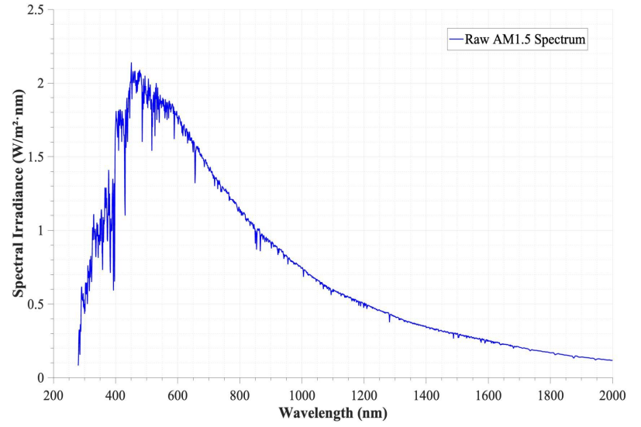
FIGURE 1. AM1.5 solar spectrum data (original).
This data serves as the authoritative benchmark for evaluating the optical performance of buildings, accurately reflecting the wavelength distribution of solar radiation on the Earth's surface and ensuring that the optimization goals are consistent with the actual application scenarios.

Data Cleaning and Band Division
Data cleaning aims to remove data with invalid wavelengths or irradiance values, ensuring that the input data is complete and valid. The target band division is based on the optimization objective, dividing the spectrum into two key regions. The ultraviolet (UV) band (280 - 400nm) needs to minimize its transmittance as much as possible to block harmful radiation, while the visible light-near-infrared (Vis - NIR) band (400 - 2000nm) needs to maximize its transmittance as much as possible to retain natural lighting.

Construction of Multi-layer Glass Optical Transmission Model
Based on the Fresnel formula, an optical model is established. The calculation formula for the transmission rate of light is as follows:
$R={\left(\frac{n-n_{0}}{n+n_{0}}\right)}^{2}$ (1)
Here, $R$ represents the reflection rate of light at the air-glass interface, $n$ represents the refractive index of the glass, and $n_{0}$ represents the refractive index of the air. In the study, to simplify the physical model, it is assumed that the incident light enters the three layers of glass perpendicularly, and the air refractive index $n_{0}$ is set to 1, and the glass refractive index $n$ is set to 1.5.
Based on the phase difference formula of light, the phase difference is calculated. For the calculation formula of the phase difference of light, it is as follows:
$δ=\frac{4πnlcosθ}{λ}$ (2)
Here,$δ$represents the phase difference, $l$ represents the geometric distance that light travels in the medium, $θ$represents the angle between the direction of light propagation and the normal of the interface, and $λ$ represents the wavelength of light in a vacuum.
The transmittance can be calculated using the ratio of transmitted light intensity/incident light intensity. The formula is as follows:
$T=\frac{I_{t}}{I_{i}}=\frac{A_{t}A_{t}^{*}}{A_{i}A_{i}^{*}}={\left|\frac{A_{t}}{A_{i}}\right|}^{2}=\frac{{(1-R)}^{2}}{{(1-R)}^{2}+4R\sin^{2}(\frac{δ}{2})}$ (3)
Here, $T$ represents transmittance, $I_{t}$indicates the intensity of transmitted light, $Ii$ represents the intensity of incident light, $A_{t}$indicates the complex amplitude of transmitted light, $A_{i}$indicates the complex amplitude of incident light, $A_{t}^{*}$represents the conjugate complex number of $A_{t}$, and $A_{i}^{*}$represents the conjugate complex number of $A_{i}$.
The schematic diagram of the model construction is shown in Figure 2:
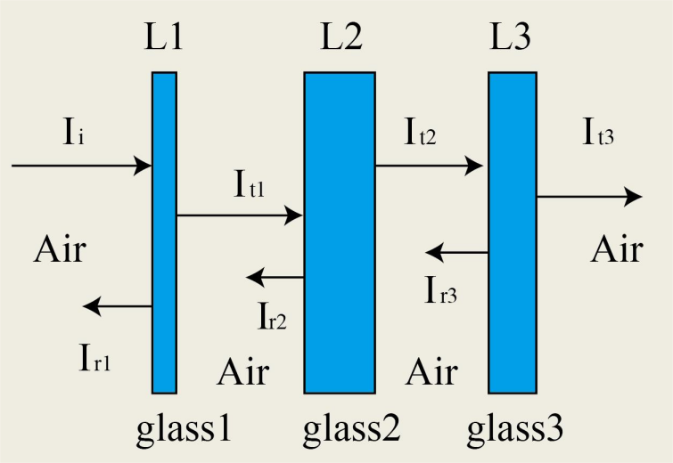
FIGURE 2. Schematic diagram of three-layer glass model (original).

The total transmittance formula can be obtained as follows:
$T_{total}=T_{1}*T_{2}*T_{3}$ (4)
Here, $T_{total}$ represents the total transmission rate of the three-layer glass, while $T_{1}$, $T_{2}$, and $T_{3}$ represent the transmission rates of the first, second, and third layers of glass, respectively.

Calculation of Baseline Integral Value
For the dual-objective optimization problem of minimizing the ultraviolet transmission and maximizing the visible light transmission of the three-layer glass in buildings, this paper quantifies and normalizes the two objectives.
For the ultraviolet transmission rate (UV Ratio), it is defined as the ratio of the integrated intensity of ultraviolet wavelengths (280 - 400 nm) transmitted through the glass to the integrated intensity of the incident light, that is:
$UV Ratio =\frac{\int_{UV}{I(λ)}· T_{total}(λ)dλ}{\int_{UV}{I(λ)}dλ}$ (5)
Among them, $I(λ)$represents the spectral irradiance at wavelength, and $T_{total}(λ)$is the total transmission rate of the three-layer glass at wavelength. Similarly, for the visible light transmittance (Vis Ratio), it is defined as the ratio of the integral of the transmitted light intensity in the visible light-near-infrared band (400 - 2000 nm) to the integral of the incident light intensity:
$Vis Ratio =\frac{\int_{Vis-NIR}{I(λ)}· T_{total}(λ)dλ}{\int_{Vis-NIR}{I(λ)}dλ}$ (6)
Through this normalization process, the absolute light intensities of different bands are converted into relative proportions, enabling the two targets to be comparable on the same scale.

Design of Genetic Ant Colony Combination Algorithm
The algorithm flow is shown in Figure 3.
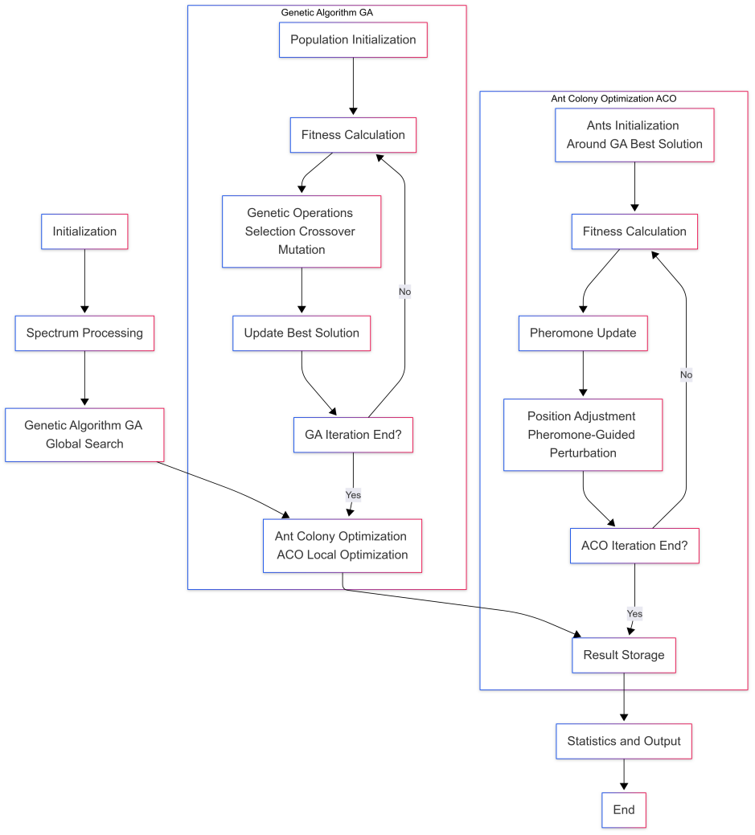
FIGURE 3. Flowchart of genetic ant colony algorithm (original).

Hybrid Algorithm Collaboration Framework
The hybrid algorithm adopts a two-stage progressive architecture, as shown in Figure 3. In the first stage, GA quickly locates the approximate optimal solution within the global solution space
($L∈{[L_{min},L_{max}]}^{3}，L_{min}=0.003m$,$L_{max}=0.01m$) of the glass thickness. In the second stage, starting from the optimal solution of GA, the local development ability of ACO is utilized to finely adjust and improve the accuracy of the solution. The two stages share a unified fitness function to ensure the consistency of the optimization objective.

Design of the Global Search Module of Genetic Algorithm
The genetic algorithm serves as the core for global exploration, responsible for extensive search within the solution space. It uses real number encoding to represent the combinations of three-layer glass thicknesses $X=[L_{1},L_{2},L_{3}]$. The initial population is randomly generated within the solution space, and the formula is:
$X_{i}^{(0)}=L_{min}+(L_{max}-L_{min})·rand(3),i=1,2,...,N_{GA}$ (7)
Here, $N_{GA}$ represents the population size, and $rand(3)$is a 3-dimensional uniformly distributed random vector (with element ranges [0,1]).
The fitness function is directly related to the optimization objective and is defined as:
$Fitness(X) = ω_{vis}·T_{vis}(X) - ω_{uv}·T_{uv}(X)$ (8)
Here, $T_{vis}(X)$represents the normalized transmittance in the visible light band, $T_{uv}(X)$ represents the normalized transmittance in the ultraviolet band (280-400nm); $ω_{vis}$ is the weight for visible light, and $ω_{uv}$ is the weight for ultraviolet light. All of these are target-oriented parameters.
In the genetic operation stage, the 4 individuals with the highest fitness are retained (the number of elite individuals to be retained$E=4$). The remaining individuals are selected according to their fitness probabilities, and the probability formula is:
$P(X_{i})=\frac{Fitness(X_{i})}{\sum_{j=1}^{N_{GA}}{Fitness(X_{j})}}$ (9)
Using arithmetic crossover to generate offspring individuals, for parents $X_{i}$ and $X_{j}$, the following are generated:
$\left\{\begin{aligned}X_{i}^{‘}=α·X_{i}+(1-α)·X_{j} \\ X_{j}^{’}=(1-α)·X_{i}+α·X_{j}\end{aligned}\right.$ (10)
Here, $α∈(0,1)$ represents the random coefficient and the crossover rate$P_{c}=0.65$. Add perturbations using Gaussian variation. The formula is:
$X_{i}^{'}=X_{i}+σ(L_{max}-L_{min})·Ν(0,1)$ (11)
In the formula, $σ=0.01$represents the variation intensity and variation rate $P_{m}=0.18$, while $Ν(0,1)$ is a random number from the standard normal distribution. When the GA reaches the maximum iteration number $T_{GA}=150$, it terminates and outputs the global optimal solution $X_{GA}^{*}=[L_{1}^{*},L_{2}^{*},L_{3}^{*}]$ and the corresponding transmittance ($T_{uv,GA},T_{vis,GA}$).
Ant Colony Algorithm Local Optimization Module
The ant colony algorithm starts from the optimal solution of the genetic algorithm and makes fine adjustments within a local range. In terms of the initialization of ant positions, the initial positions of the ants are generated around $X_{GA}^{*}$ and small perturbations are added. The formula is:
$X_{ant,k}^{(0)}=X_{GA}^{*}+r_{k}·R_{search}·(2u-1)$ (12)
Here, $k=1,2,...,N_{ACO}$,$r_{k}∈(0,1)$represents a random coefficient, $u$is a 3-dimensional uniformly distributed random vector, and $R_{search}=0.003$ is the search radius. During the initial pheromone update, the initial pheromone $τ_{k,d}=1$ (where $k$represents the ant index and $d=1,2,3$ represents the thickness dimension).
After each iteration, the pheromone decays according to the $ρ=0.45$ evaporation coefficient and is enhanced based on the fitness, and the formula is:
$τ_{k,d}^{(t+1)}=(1-ρ)·τ_{k,d}^{(t)}+Q·Fitness(X_{ant,k}^{(t)})$ (13)
Here, $Q=120$ represents the intensity of pheromone enhancement. In terms of position adjustment, the top 30% of ants with high fitness are retained as elites, and their positions are directly inherited. The non-elite ants move towards the high-pheromone areas and add perturbations that decay with each iteration. The formula is:
$X_{ant,k}^{(t+1)}=X_{ref}+s·(2v-1)$ (14)
Here, $X_{ref}$ represents the reference position of the ant (selected based on the probability of pheromones); $s$ is the perturbation scale (decreasing with the number of iterations $t$ and the fitness of the reference ant); $v$ is a 3-dimensional uniformly distributed random vector. When the ant colony algorithm reaches the maximum iteration number $T_{ACO}=250$, it terminates and outputs the final optimized solution $X_{ACO}^{*}=[L_{1}^{**},L_{2}^{**},L_{3}^{**}]$ and the corresponding throughput ($T_{uv,ACO},T_{vis,ACO}$).

RESULTS AND ANALYSIS

Comparative Analysis of Algorithm Performance
TABLE 1. Comparison of results obtained from 100 runs of different algorithms ($ω_{vis}=1$ $ω_{uv}=3$)
Algorithm | Average ultraviolet transmission rate | Average visible light transmittance | Average fitness function value | Average single-run duration
GA+ACO | 76.40% | 78.69% | -1.5015 | 2.94s
ACO | 76.44% | 78.79% | -1.5052 | 3.05s
PSO | 76.39% | 78.80% | -1.5036 | 3.07s
GA | 76.40% | 78.78% | -1.5043 | 3.09s
TABLE 2. Comparison of data under the optimal fitness of each algorithm after 100 runs ($ω_{vis}=1$ $ω_{uv}=3$)
Algorithm | Optimal fitness function value | The ultraviolet transmission rate under the optimal fitness function value | The visible light transmittance under the optimal fitness function value
GA+ACO | -1.4867 | 75.83% | 78.00%
ACO | -1.4948 | 76.09% | 78.81%
PSO | -1.4881 | 75.76% | 78.46%
GA | -1.4896 | 75.95% | 78.88%
TABLE 3. Comparison of results obtained from 100 runs of different algorithms ($Ω_{VIS}=1$ $Ω_{UV}=10$)
Algorithm | Average ultraviolet transmission rate | Average visible light transmittance | Average fitness function value | Average single-run duration
GA+ACO | -6.8488 | 76.40% | 78.66% | 3.04s
ACO | -6.8570 | 76.43% | 78.64% | 3.16s
PSO | -6.8495 | 76.36% | 78.70% | 3.15s
GA | -6.8542 | 76.41% | 78.64% | 3.17s

In the comparison of algorithm performance, the GA+ACO algorithm demonstrates comprehensive advantages. As shown in Table 1, its average fitness function value (-1.5015) is the best, and its average single run time (2.94s) is the shortest. It also has superior performance in both running efficiency and average performance. In Table 2, the optimal fitness function value (-1.4867) still leads, verifying its optimization accuracy. When the parameters are adjusted to focus more on reducing the ultraviolet transmission rate (Table 3), the average single run time of GA+ACO (3.04s) remains the shortest, and the fitness function still remains the largest. The parameter adaptability and robustness are strong.
By combining the three tables, it can be seen that under different weight configurations, GA+AOC always optimizes the average and optimal fitness based on the shortest running time (Tables 1 and 2), and further expands the advantage of visible light transmittance in the high ultraviolet weight scenario (Table 3), achieving a triple breakthrough in efficiency, accuracy, and adaptability. Its performance comprehensively surpasses single algorithms such as ACO, PSO, and GA. Regardless of how the weights are adjusted, it can efficiently balance the computing speed and optimization quality, providing a reliable solution with both speed and accuracy for complex optical optimization problems. It demonstrates significant comprehensive advantages in multiple performance indicators.

Spectral Intensity Contrast Analysis
The graphs showing the variation of incident light intensity and outgoing light intensity with wavelength after optimization by GA + ACO algorithm are presented in Figures 4 and 5. Figures 4 and 5 respectively, illustrate the changes in irradiance in different wavelength bands before and after optimization. The abscissa represents the wavelength (nm), and the ordinate represents the irradiance (W/m²/nm). The blue line represents the original irradiance, and the red line represents the irradiance after optimization.
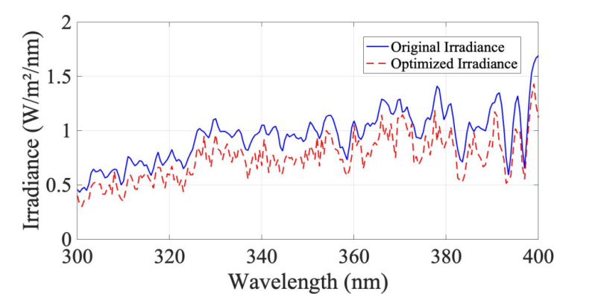
FIGURE 4. UV band (300-400nm) irradiance comparison (original).
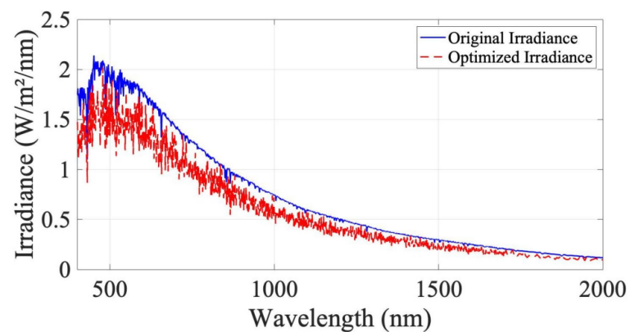
FIGURE 5. Vis-NIR band (400-2000nm) irradiance comparison (original).

From Figures 4 and 5, it can be concluded that after optimization by the GA + ACO algorithm, the irradiance can be precisely adjusted in the 280-400nm ultraviolet wavelength band and the 400-2000nm visible light-near-infrared wavelength band. The maximum visibility transmission rate of 78.42% was successfully achieved, while the ultraviolet transmission rate was minimized to 75.30%, fully demonstrating the significant advantages of this algorithm in optimizing radiation characteristics and achieving specific transmission rate targets.

Research Limitations and Improvement Directions
Although this research has achieved certain results, there is still room for optimization. For instance, at the level of algorithm parameter setting, the currently used fixed parameters are difficult to adapt to complex and variable optimization scenarios. In the future, dynamic adjustment of algorithm parameters can be carried out, such as adaptively adjusting the crossover and mutation probabilities of the genetic algorithm based on the iterative process, and the evaporation coefficient of pheromones in the ant colony algorithm [7]. In the early stage of the algorithm, appropriately increasing the mutation probability of the genetic algorithm and the evaporation coefficient of pheromones in the ant colony algorithm can enhance the global search ability. In the later stage, relevant parameters can be reduced to focus on local fine optimization. At the same time, the current research uses a linear weight setting method for the fitness function, which makes it difficult to accurately depict the complex nonlinear relationships between different objectives, and is sensitive to noise and parameter fluctuations. In the future, non-linear functions or neural networks can be introduced to construct a dynamic weight adjustment mechanism to improve the fitting accuracy of the fitness function for practical problems [8].
From the perspective of optimization objectives, this study mainly focuses on the optimization of glass optical properties. In the future, multi-physical field models such as heat conduction can be introduced to comprehensively consider the optical, thermal insulation, and strength properties of glass, and conduct multi-objective and multi-constraint optimization for architectural glass. The multi-objective conflicts can be handled using the Pareto frontier method or the target layering method to provide decision-makers with more comprehensive optimization solutions.
In terms of algorithm integration innovation, it is possible to attempt to combine deep learning with genetic algorithms. By leveraging the powerful nonlinear fitting ability of neural networks, the relationship between glass thickness and optical performance can be rapidly predicted, replacing the time-consuming numerical simulation calculations. This will further enhance the optimization efficiency [9]. At the same time, exploring more hybrid strategies of intelligent algorithms, such as combining the simulation annealing algorithm, particle swarm optimization algorithm with existing algorithms, can overcome the premature convergence and local optimal problems of algorithms, and enhance the adaptability and robustness of algorithms in complex architectural glass optimization problems [10].

CONCLUSION
This study proposes a genetic ant colony combined algorithm to optimize the thickness of three layers of glass, aiming to balance the anti-ultraviolet performance and the visible light transmittance. A model was constructed based on the AM1.5 solar spectrum data, and the algorithm was optimized through a collaborative search of the genetic algorithm and the ant colony algorithm. The results show that when ABC is used, the average fitness value of the algorithm is -1.5015, and the average single run time is 2.94 seconds. These are superior to the ant colony algorithm, particle swarm algorithm, and genetic algorithm. The optimal solution corresponds to an ultraviolet transmittance of 75.83% and a visible light transmittance of 78.00%. Spectral analysis indicates that the irradiance in the 280-400nm ultraviolet wavelength band has significantly decreased, while the irradiance in the 400-2000nm visible light-near-infrared wavelength band has been effectively retained. This verifies the optimization effect of the algorithm on the target wavelength band. The study provides a data-driven solution for the design of intelligent building glass, and has important scientific value and engineering practical significance for promoting the research and development of low-emission, high-transmittance new building materials and the development of low-energy consumption intelligent buildings.
However, this study has limitations in terms of algorithm parameters and the analysis dimensions of the physical field. It only uses preset parameters and does not consider the coupling of multiple physical fields, such as heat conduction. In the future, the algorithm can be optimized by dynamically adjusting the crossover and mutation probabilities of the genetic algorithm, the evaporation coefficient of the pheromone in the ant colony algorithm, and by introducing multi-physical field models, expanding application scenarios, and integrating deep learning to improve the optimization efficiency and applicability.

References
- J. Zhu and M. Gao, Comput. Eng. Appl. 57(6), 267-273 (2021).
- T. Li and H. Zhao, Control Decis. 38(3), 612-620 (2023).
- L. Liu, Comput. Inform. Mech. Syst. 7(6), 10-14 (2024).
- B. Yan, G. Ruyue, K. Qiaoling, et al., Ceram. Int. 47(17), 24597-24606 (2021).
- O. Agumba Dickens, K. Bijender, S. Panicker Pooja, K. Jaehwan, Opt. Mater. 133, (2022).
- ASTM International, Standard G173-03 (2012). Available: https://www.astm.org/g0173-03.html
- W. Xin and Z. Huangqiu, Electronics 12(6), 1455 (2023).
- A. Gifalli, D. M. L. H. Amaral, B. A. Neto, et al., Appl. Syst. Innov. 7(5), 100 (2024).
- X. Shuangfei, B. Wenhao, Z. An, et al., Int. J. Mach. Learn. Cybern. 15(5), 1795-1814 (2023).
- J. Liang, X. Yin, and M. Lin, Biomed. Phys. Eng. Express (2025).

