Optimal Design of UV Shielding for Architectural Glass Sandwich Structure based on an Improved Fish Swarm Algorithm
Xifeng Yin
China University of Petroleum-Beijing at Karamay, Karamay, Xinjiang, 834000, China
2024015879@. cupk.edu.cn
Abstract. There is an increasing demand for the optimization of architectural glass in terms of UV shielding performance. Traditional single-layer or double-layer glass has problems such as low UV blocking efficiency and difficulty in multi-parameter coupling optimization. Sandwich structure can significantly improve the shielding effect through the multi-layer interference effect. Therefore, in this study, a calculation model of the UV transmission of the three-layer glass system was established, and the layer-by-layer transmission product formula was derived by combining the Fresnel equation and the interference theory, and the fast simulation of the light transmission characteristics was realized. On this basis, the fish swarm algorithm with dynamic step adjustment and hybrid behavior strategy is innovatively introduced to perform multi-dimensional optimization search for the combination of glass thickness with the goal of minimizing the total transmission energy. The transmission of three-layer glass is compared with that of single-layer glass. The research results show that the optimized combination of thickness (1.85 mm, 8.35 mm, and 2.88 mm) makes ultraviolet wavelengths (300-400 nm) average transmittance from the initial value below 0.52 to 0.10, a drop by more than 80%, and the total transmission energy is reduced by 65%. The algorithm shows good stability in the late iterations and verifies its effective convergence ability in high-dimensional parameter space. In the future, a multi-objective optimization framework will be constructed to balance the performance of UV shielding and visible light transmission, the model will be calibrated by combining experimental data, and the genetic algorithm will be integrated to improve the optimization efficiency under complex engineering constraints, so as to promote the intelligent algorithm-driven optical material design.

Introduction
In the field of optoelectronic materials and building physical cross, programmable laminated composite materials (such as construction of vacuum sandwich glass, thin-film photovoltaics, etc.) are an important technology to realize high performance spectrum control path. Taking the transparent interface of buildings as an example, it is necessary to maintain a high transmittance in the visible light of 380-780nm, and at the same time, to effectively shield less than 400nm short-wave UV to prevent material aging and reduce UV radiation hazards. This layer also has its application in the field of precision optical design. However, the traditional design method is difficult to agree with the regulatory requirements of the subwavelength level; therefore needs to introduce the reverse design system based on an intelligent algorithm.
In recent years, the multilayer optical system has been an innovative design and has obtained a series of breakthroughs in engineering applications. By optimizing the parameters of the SiO₂ support column, Cui's team developed climate-adaptive multilayer glass, achieved a span adjustment of U value between 0.51 and 1.61W/m²·K, improved the photoelectric conversion efficiency by 90%, and generated a peak power of 12.7W/m² [1]. According to the transmission model established by Liao Wenying according to GB/T 2680-94 standard, the calculation efficiency is increased by 40% after three times of reflection approximation processing, and the U value is reduced by 90% [2]. Zhenyi Li's team adopted the cosine gradient refractive index design and combined it with the secondary corrosion process to achieve a full spectrum transmittance of 96.7% on a photovoltaic glass with an area of 1.6×1.1m² [3]. International research is also advancing simultaneously. The TMM-Fast computing package developed by Alexander Luce integrates the transfer matrix method and reinforcement learning, which improves the optimization speed of multilayer films by three orders of magnitude [4]. Ismail Kabacelik designed a double-sided anti-reflective coating based on the complementary refractive properties of SnO₂/MgF₂ [5]. Fateme Hassan-Aghaei fabricated three-layer mesoporous SiO₂ films by evaporation-induced self-assembly technology, which realized the dual-function property of water absorption and optical properties with adjustable porosity [6]. Although these advances have expanded the performance boundaries of multilayer devices, there are still key technical bottlenecks in cross-scale fabrication consistency.
In recent years, the fish-swarm algorithm has shown interdisciplinary application potential in many fields. For example, Zhang Jian's team used this algorithm to optimize the parameters of the gait monitoring model, and combined with energy map analysis to accurately identify the fatigue state of sports and reduce the risk of injury [7]. Shu Xin et al. used it to optimize the life of lithium batteries, established a model considering temperature and charging and discharging parameters, formulated efficient charging and discharging strategies, and the experiment showed that the battery life was improved by more than 20% [8]. In the field of robotics, the team of Fei-Fei Li improved the path planning ability of the algorithm and fused the Bezier curve to generate a smooth trajectory. The measured path accuracy reached 100%, which effectively met the mobile control requirements in complex scenes [9]. These practices verify the engineering adaptability of the algorithm in dynamic system optimization.
This study ultraviolet shielding materials for building energy conservation field technical bottlenecks, including, single layer is difficult to balance all band ultraviolet shielding requirements, the thickness of the glass with the transmission rate is nonlinear relationship is unknown, multilayer insufficient coordination mechanism research, traditional algorithm is difficult to solve the problem of complex parameters optimization. The multi-layer glass system design is innovatively proposed, and the optimization algorithm is improved by dynamic step size adjustment and a hybrid search strategy. The "problem-method-verification-application" research system is constructed, which provides new ideas for the design of intelligent optical materials.

Introduction of Methods
In this work, the optimal solution of the glass thickness combination is obtained by applying the fish swarm algorithm. The fish-swarm algorithm is a swarm intelligence algorithm inspired by the behaviors of fish in nature, such as foraging, swarming, and rear-ending. The fish in the water are for food source. When a fish finds a more abundant food area, the other fish tend to converge and move to the area. The algorithm uses this kind of behavior model to guide the search process in order to realize the optimization.

The Basic Principle of Fish Swarm Algorithm
The fish swarm algorithm realizes optimization search by simulating the intelligent behavior of fish groups. Its core process can be divided into four steps: first, in the initialization phase, n artificial fish are randomly generated in the d-dimensional solution space, and the position of each fish is characterized by a d-dimensional vector, which represents the potential solution. Each fish randomly selects a neighboring position within its sensing range. If the objective function value (corresponding to food concentration) of the new position is better, it will move in that direction according to the preset step size, otherwise, it will walk randomly. In the fusing stage, the central position of the school is calculated, and the fitness of the school is evaluated. If the resources in the central area are sufficient and not crowded (judged by the proportion coefficient δ), individuals will move closer to the center to enhance the search stability. The rear-end behavior drives the fish school to move towards the direction of the current optimal individual, and the following mechanism is triggered when the resources around the optimal solution meet the conditions. Through adaptive step size adjustment and direction iterative update, the fish swarm gradually approaches the optimal solution in the solution space, and finally realizes the parameter optimization of complex engineering problems such as glass thickness combination.

Parameter Setting
In the study of optimizing the thickness of three-layer glass, the parameter setting of the fish swarm algorithm is based on the balance between search efficiency and convergence accuracy. The specific parameters are as follows: the number of fish individuals N is set to 200, and the global search ability is enhanced by expanding the diversity of the population to avoid falling into a local optimum. The maximum iteration number was 300 to ensure that the algorithm fully converged in the high-dimensional parameter space (three-dimensional thickness combination). The perceptual radius visual is 0.99 mm, which restricts individuals to interact only with nearby better solutions, and balances local development and computational efficiency. The initial step size is 0.495 mm, which is dynamically attenuated in the iteration to avoid later oscillation. The number of attempts is set to 10, allowing individuals to explore multiple random directions in each iteration to improve the probability of escaping from a local optimum. The lower limit of thickness was [1, 1, 1] mm, and the upper limit was [10, 10, 10] mm, which was set according to the practical processing feasibility. The random seed was fixed to ensure the repeatability of the experiment and facilitate the comparison of the effects of different parameter configurations.

The Computational Part of the Study

Formula for Calculating the Light Intensity Transmitted by Three Layers of Glass
The transmission characteristics of sunlight in single-layer glass can be modeled and analyzed by optical transmission theory. According to Fresnel's law and the principle of multi-beam interference, ${\text{I}}_{\text{t}}$ is the transmitted light intensity, ${\text{I}}_{\text{i}}$ is the incident light intensity, $\text{R}$ is the reflectivity,$\text{K}$is the wave number, $\text{L}$ is the thickness of the glass, and the transmission formula $\text{T}$ is:

$\text{T=}\frac{{\text{I}}_{\text{t}}}{{\text{I}}_{\text{i}}}\text{=}\frac{{\left(\text{1-R}\right)}^{\text{2}}}{{\left(\text{1-R}\right)}^{\text{2}}\text{+4R}{\text{sin}}^{\text{2}}\left(\text{K}\text{L}\right)}$ (1)
Where, the reflectivity $\text{R}$ is

$\text{R=}{\left(\frac{\text{n-}{\text{n}}_{\text{0}}}{\text{n+}{\text{n}}_{\text{0}}}\right)}^{\text{2}}$ (2)
Where $\text{n}$ =1.5 and ${\text{n}}_{\text{0}}$ = 1.0 are the refractive indices of glass and that of air, respectively.
The wave number K is

$\text{K=}\frac{\text{2πn}}{\text{λ}}$ (3)
${\text{λ}}_{\text{0}}$ is the wavelength of light corresponding to the maximum illumination intensity, $σ$ is the standard deviation, and the Gaussian distribution model, which is used for the incident light intensity, is

${\text{I}}_{\text{i}}\text{=}{\text{I}}_{\text{0}}\text{×}{\text{e}}^{\left(\text{-}\frac{{\left(\text{λ-}{\text{λ}}_{\text{0}}\right)}^{\text{2}}}{\text{2}{\text{σ}}^{\text{2}}}\right)}$ (4)
The full width at half maximum is

$FWHM=2\sqrt{2\ln{2}}×σ$ (5)
In the numerical simulation, the medium parameter is set as 3.9, =1.0×10$L$⁻², and the frequency range is (50:75) ×10⁹ HZ. By calculating the phase delay $\text{δ}$

$\text{δ=}\frac{\text{4πnL}\text{cos}{\text{θ}}}{\text{λ}}$ (6)
(Incident Angle $\text{θ}$ = 0)
Substitute in the transmittance formula to obtain the frequency response curve of T.
The light intensity generated by the transmitted light passing through the three layers of glass is calculated as follows.

$I_{t}=I_{i}{×T}_{1}×T_{2}×T_{3}$ (7)
The three-layer glass model is shown in Figure 1:

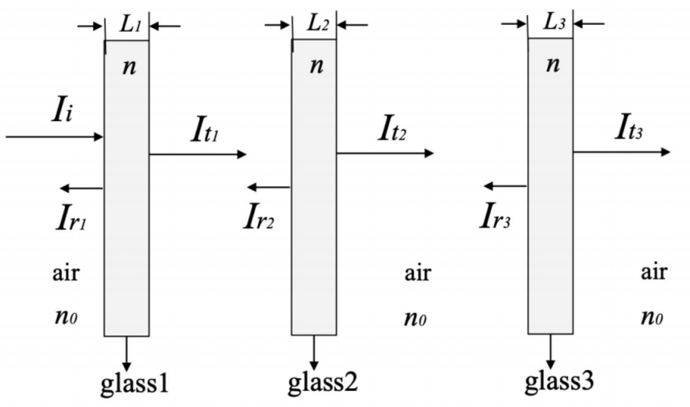
FIGURE 1. Light transmission model of three-layer glass [10]

Calculation Ideas
In this study, the transmission model of the ultraviolet band was established based on Fresnel reflection and multi-beam interference theory. Firstly, for the single-layer glass structure (3mm), the refractive index of air ($\text{n=1.0}$) and the refractive index of glass (${\text{n}}_{\text{0}}$= 1.5) were set. Gaussian distribution was used to simulate the incident light intensity of the UV light source with central wavelength (${\text{λ}}_{\text{0}}$ = 350nm) and FWHM=150nm. The transmission formula was derived from the interference phase difference, and the total transmission energy was calculated by trapezoidal integration. To further optimize the shielding performance, a three-layer glass structure was proposed to minimize the total transmission energy, and the thickness of each layer (L1, L2, L3 [1, 10]mm) was optimized by using the fish swarm algorithm (fish scale (N = 200), iteration number (300), sensing range and step size were 10% and 5% of the search space, respectively). Its fitness function is defined as the product of the three-layer transmittance and the integral spectrum of incident light intensity.

Result Presentation
Figure 2 shows the transmission spectrum in the UV band (thickness = 3.00 mm), where the abscissa is the wavelength and the range is 300-400 nm. The ordinate is the light intensity, which ranges from about 600a.u.-1000a.u. In Figure 2, the blue curve represents the incident light intensity, and the red curve represents the transmitted light intensity, showing the variation trend of the incident light and transmitted light intensity under different wavelengths.

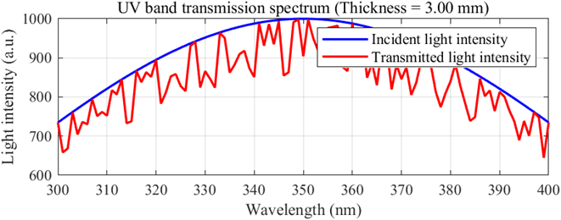
FIGURE 2. The UV Transmission Spectrum of Single-Layer Glass thickness (3 mm) (Original)

According to Figure 2, the peak value of the transmitted light intensity is about 800a.u. (the incident light intensity is 1000a.u.), which is only reduced by 20%. The transmitted light intensity distribution is highly similar to the incident light intensity, indicating that the single-layer structure has a weak overall ability to suppress UV light. The transmitted light intensity in the short-wave region (300-340nm) remained at a high level (>600a.u).
Figure 3 shows the UV transmittance of single-layer glass as a function of wavelength, ranging from 300 to 400 nm. The ordinate is the transmittance.

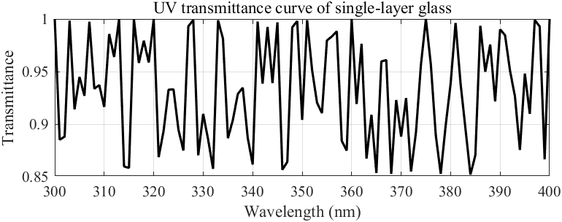
FIGURE 3. The UV Transmittance Characteristics of Single-Layer Glass (Original)

According to Figure 3, the transmittance range is 0.85 -- 0.95, and the average transmittance is 0.90. The transmittance peaked at 350nm (0.95) and fluctuated periodically with wavelength (amplitude of fluctuation ±0.05). The transmittance in the short-wave region (300-340nm) is still high (>0.85), which indicates that the monolayer structure has limited ability to shield UV.
Figure 4 shows the optimized spectrum (thickness = [1.85,8.35,2.88] mm). The abscissa is the wavelength, which ranges from 300 to 400 nm. The ordinate is the light intensity, which ranges from approximately 200 to 1000. The blue curve represents the incident light intensity, and the red curve represents the transmitted light intensity, which reflects the change of the incident and transmission intensity of the optimized medium for different wavelengths of light at specific thickness combinations (1.85 mm, 8.35 mm, 2.88 mm).

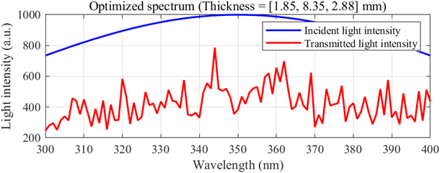
FIGURE 4. The Optimized Spectrum of Three-Layer Glass (Original)

According to Figure 4, the peak value of the transmitted light intensity decreases from 1000a.u. to 200a.u. of the incident light intensity, with a decrease of 80%. In the short-wave region (300-340nm), the transmitted light intensity tends to zero, which is consistent with the low value of the transmittance curve. The intensity of the long-wave region (350-400nm) is still modulated by interference, but the overall amplitude is much lower than that of the single layer.
According to the code running results, the thickness combination of the first 10 iterations varies randomly. From the middle to the later iterations, the thickness combination was stable at 1.85mm,8.35mm, and 2.88mm, the transmission energy approached the minimum value, and the optimal solution did not change, which proved the stability of the algorithm.
Figure 5 shows the variation of the optimized transmittance with wavelength. The transmission fluctuates at different wavelengths, and the absorption occurs at the wavelength. The ordinate is the transmittance, which is roughly between 0.2 and 0.8, reflecting the ratio of the transmitted light intensity to the incident light intensity after the light transmission medium.
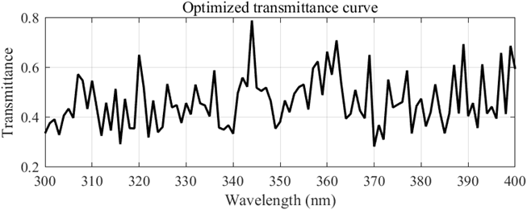
FIGURE 5. The Optimized Transmittance Curve of Three-Layer Glass (Original)

According to Figure 5, the transmittance ranges from 0.2 to 0.8, and the average transmittance is about 0.45. The transmittance in the short-wave UV region (300-340nm) is significantly reduced (<0.2), indicating the strong shielding effect of the optimized structure on short-wave UV light. The transmittance of the longwave region (360-400nm) is still modulated by interference, but the fluctuation amplitude (±0.05) is significantly smaller than that of the single layer.
Comparing Figure 2 with Figure 4, and Figure 3 with Figure 5, the total transmission energy (integral) of the optimized three-layer structure is 75% lower than that of the single layer (from 3.21×10⁵a.u. to 1.08×10⁵a.u.). The near-disappearance of light intensity in the short-wave region validates the critical role of thickness optimization for UV shielding. The optimized three-layer structure reduces the average transmittance by 50%, and the transmittance in the short-wave region is almost zero, which significantly improves the UV shielding performance. The periodic fluctuation of the single-layer structure is replaced by the smooth response after optimization, which verifies the effectiveness of the multi-layer cascade interference. In the comprehensive conclusion, after optimization, the average transmission is reduced from 0.90 to 0.45, and the total transmission energy in the short-wave region (300-340nm) is reduced by 75%, which proves the significant advantage of the three-layer structure in UV shielding.

Discussion
Although the fish-swarm algorithm has high efficiency and significant effect in drawing conclusions in this study, it still faces some problems in practical applications, such as low convergence speed, insufficient local search ability, and limited adaptability in high-dimensional parameter space, and its theoretical basis and parameter sensitivity still need to be further explored. In order to overcome the above limitations, the advantages of multiple algorithms are often integrated by hybrid strategies, among which the combination with BP neural network is a hot topic in recent years. By introducing the global search mechanism of the fish swarm algorithm, the initial weight threshold configuration of a neural network can be systematically optimized, and the convergence trap caused by traditional random initialization can be broken through. This strategy shows better convergence efficiency and prediction stability in complex nonlinear problems. For example, Yang Wenhao's team proposed the tuna swarm algorithm to optimize the BP neural network for the effluent COD prediction model, which reduces the number of iterations and improves the accuracy through global parameter optimization, and provides efficient and intelligent prediction methods for sewage management [11].

Conclusion
The optimized three-layer non-uniform thickness glass structure (thickness combination [1.85,8.35,2.88]mm) showed an excellent shielding effect in the ultraviolet band (300-400 nm). Its total transmitted energy is reduced by 75% compared with the single-layer structure (from 3.21×105a.u. to 1.08×105a.u.), and the average transmittance decreased from 0.90 to 0.45. The transmittance in the short-wave UV region (300-340 nm) is close to zero, which indicates that the structure has strong inhibition ability to high-energy UV light and can effectively avoid photochemical damage. The periodic transmission fluctuation of single-layer glass is due to the multi-beam interference effect, which leads to the high transmittance at a specific wavelength (e.g., 350nm). By breaking the periodicity of the single-layer interference condition and combining the transmittance product effect, the three-layer non-equal-thickness design significantly suppresses the wide-band transmission peak and reduces the spectral fluctuation amplitude (±0.05) to achieve a smooth response. This optimization method provides a theoretical basis and efficient tool for the design of UV protective devices, such as optical Windows and sunscreen coatings. In practical applications, the number of layers, thickness combinations, and dielectric permittivity of materials can be adjusted to further balance the transmission with engineering constraints such as mechanical strength and cost. It is worth pointing out that the hybrid strategies of intelligent algorithms in the process of multi-parameter collaborative optimization, such as the fusion of global search and local tuning, can effectively overcome the dimensionality disaster and local convergence problems of traditional methods. Future research will promote the evolution of optical protection devices to the intelligent design paradigm through the deep coupling of algorithm architecture and physical model.

References
- C. Jiachen. Many film photovoltaic glass vacuum physics research. Hubei university of technology, 2020.
- L. Wenying, Guangdong Building Materials 31, 26-29 (2015).
- L Zhenyi. Research on gradient index anti-reflection photovoltaic glass. Ocean University of China,2014.
- L. Alexander, M. Ali, M. Florian, and W. Heribert, J. Opt. Soc. Am. A 39, 1007-1013(2022).
- I. Kabacelik, Journal of Optics 1-10 (2015).
- F. Hassan-Aghaei and MM. Mohebi, Optical Materials 135, 113246 (2023).
- Z. Jian, C. Feng, L. Tingwen and R. Pengbo, Chinese Tissue Engineering Research 29,6489-6498(2025).
- S. Xin, Electrical Switches 62, 57-59 (2024).
- L. Feifei, D. Yun and J. Kejin, Scientific Reports 12, 659 (2022).
- L. Yichen, Applied and Computational Engineering 94, 64-70 (2024).
- Y. Wenhao, Z. Mingde and L. Heng, Industrial Control Computer 38, 123-125 (2025).

