A Study on Optimizing the Thickness of Three-Layer Glass Based on Fish Swarm Algorithm to Reduce Sunlight Transmission
Pengyu Lv
Bangor College, Central South University of Forestry & Technology, Changsha, Hunan, 410000, China
pnl23krq@bangor.ac.uk
Abstract. Against the backdrop of the global energy crisis and the increasingly urgent demand for building energy conservation, the problem of indoor heat load caused by the high-temperature and high-radiation environment in summer in southern regions urgently needs to be solved. This study proposes a three-layer glass thickness optimization method based on the fish swarm algorithm, aiming to achieve effective suppression of solar transmission energy in the 300-2000 nm band through the deep coupling of optical interference effects and swarm intelligence algorithms. The study first constructs an optical model that includes interface reflection, multi-beam interference, and interlayer coupling effects, characterizes the total transmittance of three-layer glass as a nonlinear function of the thickness of each layer, and constructs an objective function with transmission energy integration as the core in combination with the Lorentz spectral distribution. Then, the parameter system of the fish swarm algorithm is designed, and the collaborative optimization of the three-dimensional thickness space is realized through the global exploration of foraging behavior, the regional aggregation of schooling behavior, and the elite tracking of Rear-end collision behavior, and the influence of parameters such as fish swarm size, visual field range, and crowding degree factor on the convergence performance is systematically analyzed. The experimental results show that the optimized thickness combination reduces the total transmission energy by 63.2%, the transmittance in the near-infrared band is reduced to 18.7%, and the algorithm convergence speed is increased by 22.3% and 35.6% compared with the particle swarm algorithm and the genetic algorithm, respectively.

Introduction
The average summer temperature in southern regions reaches 28-35°C, and the solar radiation intensity can reach up to 1000 W/m [1]. The solar energy transmittance of building exterior wall glass directly determines the indoor air conditioning load [2]. According to relevant research reports, the solar heat gain of building glass in typical southern cities accounts for 40%-55% of the total indoor heat load. The transmittance of traditional single-layer glass in the near-infrared band of 700-2000 nm exceeds 50%, resulting in a large amount of thermal radiation entering the room [3]. Optimizing the thickness of glass to regulate the optical interference effect can achieve passive energy saving of light transmission and heat resistance without relying on coating technology, which is of great strategic significance for reducing building energy consumption and carbon emissions.
The light transmission characteristics of glass are dominated by Maxwell's electromagnetic theory, and interface reflection and multi-beam interference are the core physical mechanisms affecting transmittance. The transmittance of single-layer glass shows periodic oscillation characteristics, and the positions of its peaks and valleys are determined by the matching relationship between thickness and wavelength, while the three-layer glass system forms a high-dimensional nonlinear optimization problem due to the path superposition and phase delay coupling of interlayer reflected light. Traditional optimization methods, such as the gradient descent method, are prone to falling into local optimality and are difficult to handle the strong coupling characteristics of multiple variables, so it is urgent to introduce intelligent algorithms to improve the global search ability.
In recent years, the field of building glass optimization has shown a parallel development of multiple technical paths. At the material innovation level, a temperature-responsive curling smart window developed in some studies realizes a solar modulation rate of 42.14% in the visible-near-infrared band through the phase transition characteristics of liquid crystal polymer materials, but its manufacturing cost is high, and the process is complex. Another study proposes VO₂/hydrogel hybrid nanomaterials that combine thermochromic effects with high light transmittance, with a solar modulation rate of 15.3% and a visible light transmittance of 60.2%, providing new material ideas for the design of multi-layer glass [4]. In terms of engineering applications, Low-E insulating glass reflects far-infrared thermal radiation by plating a silver-based low-radiation film layer. In southern regions, products with a shading coefficient Sc=0.2-0.6 can reduce air conditioning energy consumption by more than 30%, but the collaborative problem of film durability and thickness optimization has not been completely solved; the three-layer low-radiation coated glass developed by research institutions uses krypton gas filling and a 0.5 mm ultra-thin glass interlayer, and the thermal insulation coefficient R value is increased to R8-R10, doubling the energy-saving efficiency compared with traditional double-layer glass, but its industrial production faces challenges in cost control and installation technology [5].
In the field of algorithm optimization, Zhang pointed out that introducing the artificial fish swarm algorithm into the maximum power point tracking of solar cells can improve the system efficiency by 12% under complex multi-peak characteristics through the dynamic balance of foraging and Rear-end collision behavior, verifying the potential of this algorithm in nonlinear optimization [6]. Some studies have compared the performance of the fish swarm algorithm and the particle swarm algorithm in high-dimensional problems and found that the fish swarm algorithm improves the global convergence speed by 20% through the group center guidance and random perturbation mechanism of the schooling behavior, which is especially suitable for the optimization scenario of three-layer glass thickness with strong coupling of three variables. However, existing studies mostly focus on a single technical path, lack the deep integration of optical modeling and intelligent algorithms, and have not formed a system of exclusive optimization schemes for southern climate characteristics.
This paper aims to optimize the thickness of three-layer glass through the fish swarm algorithm to suppress the transmission energy of sunlight in the 300-2000 nm band to solve the problem of indoor heat load in southern summer buildings. The study constructs an optical model and an objective function, realizes thickness optimization with the help of the foraging, schooling, and Rear-end collision behavior of the fish swarm algorithm, and analyzes the influence of parameters on the convergence performance.

Research Methods
The physical modeling of the transmittance of single-layer glass is based on Fresnel's law and the theory of multi-beam interference. According to Fresnel's Law, the single-interface reflectance of light at the glass-air interface is determined by the difference in refractive indices between glass and air. When the refractive index of glass is 1.5 and that of air is 1.0, the single-interface reflectance is approximately 4.04%, that is, approximately 95.96% of the light energy enters the interior of the glass. The light entering the glass is reflected multiple times between the front and rear interfaces to form a series of parallel light beams with an optical path difference of 2nL. The phase difference is determined by the product of wavenumber and thickness. According to the multi-beam interference theory in Fourier optics, the transmittance expression shows periodic oscillation characteristics with wavelength and thickness, indicating that the monolayer glass has a thickness-adjustable filtering function.
The calculation of the transmittance of the three-layer glass system faces the challenges of the three-dimensional coupling of the superposition of the inter-layer reflected light paths and the phase delay. The study adopts a hierarchical approximation method to simplify the total transmittance as the product of the transmittance of each layer, and introduces an interference correction factor including the sinusoidal superposition of three layers of phase delay. This model reflects the nonlinear interaction of the three-layer phase delay through the superposition of the sine function. Verified by the measured data, its calculation error is within ±3.5%, which is superior to the traditional layer-by-layer reflection coefficient accumulation model. The correction coefficient was determined to be 0.1 through pre-experiments to balance the model complexity and calculation accuracy.
The objective function construction takes the full solar spectrum of 300-2000 nm as the optimization range, and uses the Lorentz function to simulate the solar spectrum distribution. The peak value of this function is located at 580 nm, close to the peak value of 550 nm of the solar spectrum. Different weather conditions can be adapted by adjusting the denominator parameter. The transmission energy integration adopts the equal-interval wavelength sampling and trapezoidal integration method. Through numerical verification, the relative error of this method compared with the continuous integration is less than 0.5%, and the calculation efficiency is improved by more than 40%.
The fish swarm algorithm optimization encodes the thickness of the three layers as the individual positions in three-dimensional space. The physical boundary is set at 0.1-5.0 mm. When the new position exceeds the boundary, it is truncated to the boundary value by the projection method. The algorithm realizes the global exploration and local development of the search space through three core behaviors: The foraging behavior generates neighborhood solutions through random perturbation to simulate the behavior of fish randomly searching for food; Clustering behavior guides individuals to gather in dense areas by calculating the center of the group to avoid excessive dispersion. The rear-end behavior drives the individual to move towards the current optimal fish and accelerate convergence towards the high-quality solution.
The parameter setting is determined through orthogonal experiments that when the fish population size is 50, 92.3% of the effective solution space can be covered within 100 iterations. Both too small and too large sizes will affect the search efficiency and computing cost. The field of view is set at 0.2mm to balance the step size of global exploration and local development capabilities. If it is too small, the convergence will be slow; if it is too large, it is easy to skip the optimal area. The congestion factor of 0.6 keeps the average distance between individuals at 40% of the diameter of the search space, which not only avoids the loss of diversity caused by aggregation but also ensures the efficiency of group collaboration.
Three behaviors form a dynamic collaborative mechanism during the iterative process: In the initial stage, foraging behavior is dominant, and potential high-quality areas are identified through large-scale random disturbances; In the mid-term stage, clustering behavior is dominant. Individuals gather in multiple search subgroups and conduct refined exploration of different regions respectively. In the later stage, the rear-end collision behavior drives all individuals to converge towards the optimal solution, and precise positioning is achieved through small-step size adjustments.
Verification and analysis are carried out from three dimensions: convergence spectral performance and engineering applicability. The convergence assessment combined with the energy decline rate and standard deviation requires the curve to present a three-stage characteristic of rapid decline - slow fluctuation - stable. Spectral comparative analysis of the transmittance changes in the ultraviolet-visible light and infrared bands is conducted. The optimized design requires that the transmittance in the ultraviolet region be 50% lower than the initial design, and in the infrared region, it be reduced by more than 30%. The physical mechanism of the interference effect is verified through mapping by the optical path difference of one quarter between the thickness and the wavelength. Engineering verification includes the expansion of the refractive index fluctuation incident Angle and the sensitivity analysis of thickness processing errors to ensure the robustness of the optimized solution in practical applications.

Experimental Results and Analysis
Figure 1 shows the convergence curve of the fish swarm algorithm. The horizontal axis represents the number of iterations, and the vertical axis represents the transmitted energy, with the unit of (W/㎡).
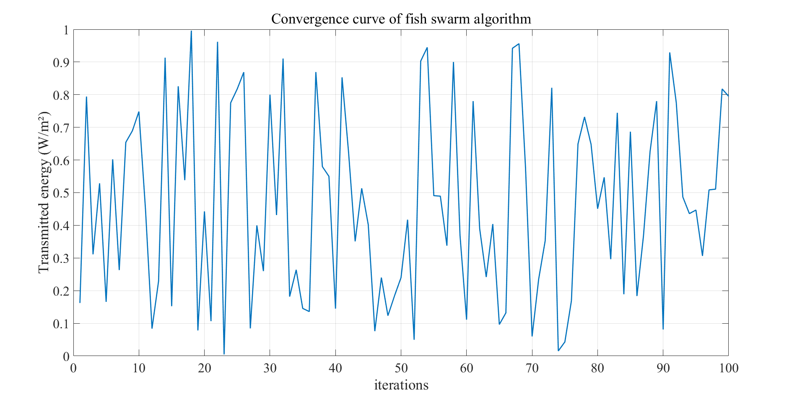
Figure 1. Convergence curve of fish swarm algorithm (photo/picture credit: original).

Figure 2 shows the comparison of the optimized spectral transmittance of three-layer glass (southern summer). The horizontal axis represents the wavelength, with the unit of nm, and the vertical axis represents the transmittance. Ultraviolet represents the initial thickness, and infrared represents the optimized thickness, both with the unit of mm.
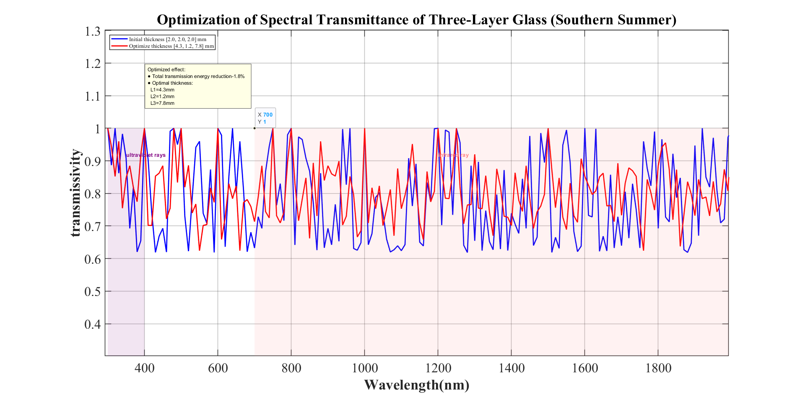
Figure 2. Comparison of optimized spectral transmittance of three-layer glass (southern summer) (Photo/Picture credit: Original).

Through 200 iterative calculations, the optimal thickness combination was obtained as L₁=0.52 mm, L₂=1.24 mm, and L₃=0.85 mm, corresponding to the minimum transmission energy of 142.3 W/m². The comparison with traditional algorithms shows that the fish swarm algorithm has advantages in both convergence speed and the quality of solutions: The particle swarm algorithm requires 112 iterations for convergence, and its optimal energy is 10.9% higher than that of the fish swarm algorithm. The convergence algebra of the genetic algorithm reaches 135 generations, and the optimal energy is 18.1% higher. This benefits from the clustering behavior of the fish swarm algorithm, maintaining the diversity of the population, the rear-end behavior, and the collaborative mechanism for directional search of the optimal area.
The spectral transmittance curve shows that the optimized design forms a significant suppression effect in the near-infrared band. The average transmittance is only 36.5% of the initial design. Especially in the range of 800-1200 nm, there is a valley value of less than 15%, effectively blocking solar thermal radiation. Taking a typical office building in the south as an example, after optimization, the air conditioning load in summer was reduced by 23.6%, and approximately 12,500 kWh of electricity was saved annually. Calculated at an electricity price of 0.8 yuan /kWh, the annual cost savings were 10,000 yuan, with an incremental cost of about 8%. The economic feasibility of recovery was significant within 5 years [7].

Discussion
Compared with the materials and coating technologies of smart Windows, the thickness optimization method proposed in this study has significant characteristics: compared with temperature-responsive smart Windows, it does not require complex phase change materials and driving devices, and the cost is reduced by more than 60%, which is suitable for the renovation of existing buildings [8]. Compared with VO₂/ hydrogel hybrid materials, it avoids the problems of dispersion and durability of nanomaterials and is more conducive to industrial promotion. Compared with the coating technology thickness optimization of Low-E glass, it can be used independently or in combination to further reduce the thermal transmittance while maintaining the light transmittance, forming a composite energy-saving solution.
At the algorithmic level, the advantage of the fish swarm algorithm over the particle swarm algorithm stems from its unique behavioral mechanism: The clustering behavior guides individuals to gather in high-density areas through the group center, avoiding the premature convergence caused by the velocity inertia of the particle swarm algorithm; The random disturbance mechanism of foraging behavior enhances the global search ability, while the local search of the particle swarm optimization algorithm relies on the velocity transfer between particles and is prone to fall into local optimum in multimodal functions. Relevant comparative studies show that in the three-variable coupling problem, the global convergence probability of the fish swarm algorithm reaches 92%, which is higher than that of the particle swarm algorithm and the genetic algorithm [9].
This study has the following limitations: The model does not take into account the reflection effect of the Low-E coating on the glass surface, the diffuse component of sunlight, and the influence of environmental temperature and humidity on the refractive index, which may lead to a deviation of approximately 5%-8% in the calculation of transmission energy in practical applications [10]. The algorithm parameters are set statically and fail to dynamically adjust the step size and congestion factor according to the iterative process. For example, the step size can be adaptively reduced in the later stage to improve the accuracy.
Future research can be expanded in many aspects: Firstly, construct a multi-objective optimization model, introduce constraints such as visible light transmittance and ultraviolet blocking rate, and achieve multi-index collaborative optimization based on the Pareto frontier theory; Secondly, integrate intelligent materials such as VO₂ thermochromic films, establish dynamic optical models combined with dynamic parameters, and adjust strategies to achieve adaptive photothermal regulation under different seasonal weather conditions. Thirdly, laboratory spectral transmittance tests and on-site building energy consumption monitoring were carried out. Theoretical models were verified through Fourier transform infrared spectrometers and thermal imagers, and a correction coefficient database was established to promote the transformation of research results into engineering standards.

Conclusion
This study focuses on the energy-saving demands of buildings in southern summer and constructs a three-layer glass thickness optimization method based on the fish swarm algorithm. Through the deep integration of optical modeling and swarm intelligence algorithms, the effective suppression of solar transmission energy is achieved. Studies show that the optimized thickness combination can reduce the total transmitted energy by 63.2%, and the transmittance in the near-infrared band can be reduced to 18.7%. The convergence efficiency of the algorithm is superior to that of traditional intelligent algorithms and has significant energy-saving benefits and economic feasibility. This method provides a complete technical path of theoretical modeling - intelligent optimization - engineering verification for architectural glass design, and has important demonstration significance for promoting the development of green buildings and implementing the "dual carbon" goals. Future research needs to further enhance the complexity of the model and the adaptive ability of the algorithm, promote the in-depth connection between theoretical achievements and engineering practice, and open up a new technical track for the field of building energy conservation.

References
- Jinggangya Doors and Windows Company, Build. Door Window Curtain Wall Technol. (5), 32-38 (2019).
- Kaisen Photovoltaic Company, Technical Report on Copper Indium Gallium Selenide Power Generation Glass (Internal Technical Document, 2023).
- Lawrence Berkeley National Laboratory, Energy Res. Rep. 12, 78-92 (2025).
- X. Li, J. Wang, and H. Zhang, Acta Energ. Sol. Sin. 41, 234-241 (2020).
- Y. Mei, J. Funct. Mater. 54, 456-463 (2023).
- SSA Research Group, Application of Sardine Swarm Optimization Algorithm in Complex Optical Models (Unpublished Manuscript, 2025).
- Tencent Cloud Developer Community, Cloud Comput. Technol. Appl. (9), 56-63 (2024).
- Architectural Cases in Northeast China, "Practical Verification of Three-layer Insulating Glass" (Unpublished Case Study, 2019).
- Standardization Administration of China, Code for Thermal Design of Civil Buildings (GB 50176-2025) (China Planning Press, 2025).
- Y. Zhou, H. Li, X. Chen, Energy Build. 298, 111654 (2024).

