Optimization of Solar Transmission of Multi-Layer Glass Based on PSO-GA Hybrid Algorithm
Chenyu Yu
Tianjin Normal University, Tianjin, 30038, China
2450313104@stu.tjise.edu.cn
Abstract. In buildings, cars, and other spaces that use multi-layer glass, there is a general need for thermal insulation. The study uses a hybrid algorithm to optimize the thickness of a multi-layer structure compared to a traditional single-layer structure, film, or glass to achieve a better insulation effect. This study adopted the PSO-GA hybrid algorithm, which avoided falling into the local optimum when using a single PSO algorithm through operations such as genetic algorithm crossover and mutation. It combined the advantages of the two algorithms, with high convergence speed and good global optimization effect. The experimental results show that using this hybrid algorithm to optimize the thickness of multi-layer glass structures can effectively reduce the transmittance of sunlight and reduce the energy of sunlight entering the room or inside the equipment. Compared with traditional single-layer 3mm glass, the energy of sunlight transmission can be reduced by 17%, indicating that the optimization of multi-layer glass has good efficiency and feasibility. A method is provided for optimizing multi-layer glass or multi-layer film structures. The hybrid algorithm in this study successfully reduces the transmitted energy, which has important application value for smart buildings, optical devices, and IoT environmental thermal management, and provides technical support for the large-scale application of multi-layer films or multi-layer glass structures.

Introduction
As the global greenhouse effect becomes increasingly significant and the global average temperature rises, higher requirements are placed on the heat insulation and light transmittance of glass in buildings, automobiles, industrial production, and even in aerospace. Multi-layer glass structures are required to have good light transmittance while achieving heat insulation. In order to lower the temperature inside a car or a building and provide a good temperature environment for people and equipment, the thickness of the multi-layer glass or the thickness of the glass can be optimized to reduce energy absorption or blocking.
Ma et al. introduced the hybrid use of optical structure design from single optimization to deep learning algorithms, and said that the combination of genetic algorithm and optimization intelligent algorithm can effectively play to its algorithm advantages. This study uses PSO hybrid GA algorithm to combine the advantages and make its optimization method have good versatility [1] Wang et al. proposed using deep reinforcement learning (DRL) to generate a near-optimal multilayer optical structure based on the basic consistency between the multilayer optical design task and the sequence generation problem. They used DRL to train a deep recurrent neural network and used this method to enable a 42-layer incandescent light bulb filter to achieve an enhancement factor of 16.06, which is 8.5% higher than the previous best structure [2]. Jain et al. introduced various intelligent group algorithms, among which the classic one is the PSO algorithm. This algorithm is widely used because it strikes a balance between exploration and development. The PSO algorithm has good adaptability and robustness for multi-parameter multi-layer glass structures [3]. Ling Y used a single PSO algorithm to absorb ultraviolet rays through the thickness of multi-layer glass to reduce the internal temperature of the building, and the ultraviolet intensity was reduced by an average of 24%. The main reason was that the wavelength range of ultraviolet rays was designed between 300 and 400nm, and single PSO was prone to falling into local optimality and a lack of diversity. The above research shows that in order to solve the defects of a single algorithm, the hybrid optimization algorithm PSO-GA has shown significant advantages, but optimizing optical structure is still an important direction of current research [4].
In this study, triple-layer glass is taken as an example, and the PSO-GA hybrid algorithm is used to optimize the glass thickness of the three-layer structure. The reliability of the algorithm is proved by comparison with 3mm single-layer glass, and an optimization method is provided for multi-layer film structures and multi-layer glass structures, which is hoped to promote the exploration in the field of optical design.

method
This study will use the PSO-GA algorithm to optimize the thickness of the glass using triple-layer glass as an example, targeting the sunlight wavelength range of 300nm~2000nm. The reason for the PSO-GA algorithm is that PSO has good adaptability, high convergence speed, and excellent local search, especially for the nonlinear transmittance formula in the glass multilayer interference model, while the GA algorithm has excellent global search capabilities and maintains diversity. The two algorithms have complementary advantages. The following study will focus on how to mix the PSO algorithm and the GA algorithm, and apply the PSO-GA hybrid algorithm to find the best solution for the optimal combination of glass thickness in the solar transmittance of triple-layer glass.

Overview of Algorithm Principle
The particle swarm optimization algorithm simulates the group cooperative behavior of bird flocks or fish schools, and searches for the optimal solution in the solution space by combining individual and group experience. Each particle represents a potential solution, and gradually approaches the optimal solution by constantly adjusting its own speed and position.
Genetic algorithms simulate the natural selection and inheritance mechanisms in biological evolution, iteratively optimize the population through operations such as selection, crossover, and mutation, and gradually approach the optimal solution to the problem.
The PSO-GA hybrid algorithm combines the fast convergence capability of particle swarm optimization with the diversity preservation mechanism of genetic algorithms to form a hybrid optimization framework. In the PSO stage, particles conduct global exploration by tracking individual historical optimality and group optimality to accelerate convergence. In the GA stage, population diversity is enhanced through selection, crossover, and mutation operations to avoid falling into local optimality.

Basic Steps of PSO-GA Algorithm
The initialization parameters allow the population to randomly generate an initial particle swarm and randomly initialize the position $X_{i}$and velocity $V_{i}$of each particle. Set some parameters of the PSO stage, set the inertia weight to w, the individual learning factor to $c_{1}$, and the social learning factor to $c_{2}$. Set some GA parameters, set the crossover rate to $P_{c}$ and the mutation rate to $P_{m}$. The common parameters are population size N and maximum number of iterations $T_{max}$. Calculate the initial fitness value and start to initialize the individual and group optimality. Each particle records its own historical optimal position $P_{{best}_{i}}$, and the group records the global optimal position $G_{best}$. Termination condition, if the maximum number of iterations $T_{max}$ is reached, or $G_{best}$ has no significant changes for multiple consecutive generations, then the process terminates. Otherwise, it returns to the PSO stage to continue iterating. The output result is to return the global optimal solution $G_{best}$ and its fitness value. The objective function is to minimize the total transmission energy of sunlight through three layers of glass. PSO updates the particle swarm as the main loop.
Speed update formula:
$V_{i}^{(t+1)}$=w${∙v}_{i}^{t}+c_{1}r_{1}\left(P_{{best}_{i}}-X_{i}^{t}\right)+c_{2}r_{2}\left(G_{best}-X_{i}^{t}\right)$ (1)
Position update formula:
$X_{i}^{(t+1)}=x_{i}^{t}+v_{i}^{(t+1)}$ (2)
Calculate the updated fitness value, update $P_{{best}_{i}}$and${ G}_{best}$, where$r_{1}$and $r_{2}$ are random numbers in [0,1]. The selection operation sorts the current population in descending order of fitness value. Keep the first N/2 high-quality particles and eliminate the last N/2 particles. The GA phase generates new offspring. The parent generation is randomly selected from the N/2 particles retained by the crossover operation, and the offspring generation is generated according to the crossover rate $P_{c}$, using uniform crossover (binary coding). Among them, $α_{j}\sim U∋[0,1]$ is a random coefficient. The mutation operation is used to randomly perturb the offspring individuals with a Gaussian mutation rate $P_{m}$ (10% in this study). Add the generated N/2 offspring to the population and restore the population size to N. Where $η=0.1∙(L_{ub}-L_{Ib})$ is the mutation intensity. In the population merging and updating phase, low fitness individuals are directly replaced, and the fitness values of all particles are recalculated to update the global optimal $G_{best}$ (Figure 1).
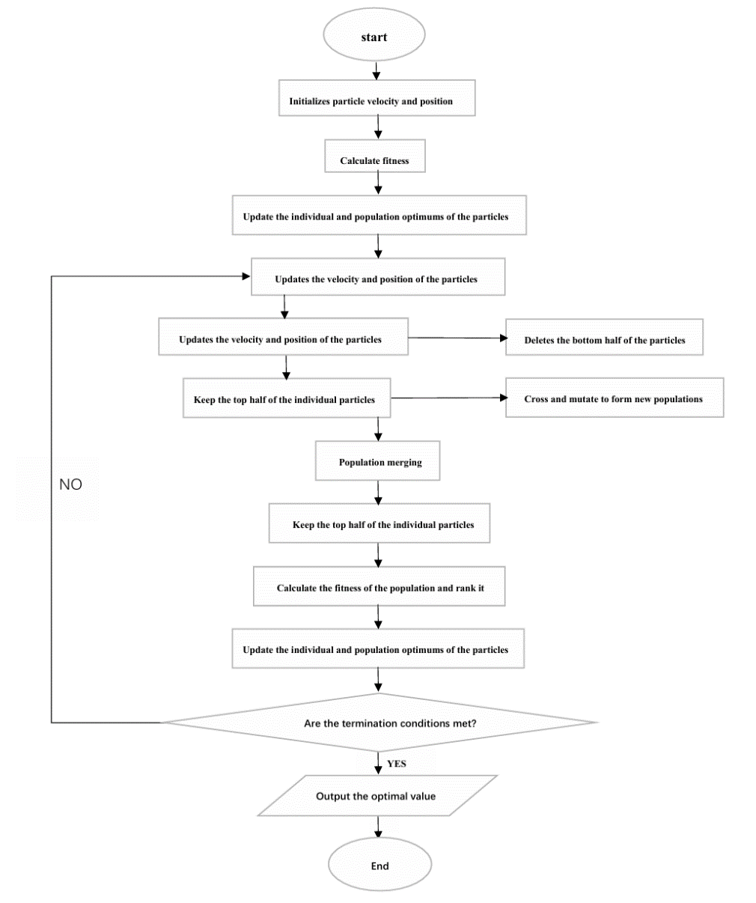
Figure 1. Flowchart of the pso-ga algorithm adapted from Li et al. [5].

Simulation Experiment Parameters and Model

Design of Glass Model Structure
This article sets the wavelength range of sunlight to 300nm~2000nm. The largest energy part is in visible light, and secondly, ultraviolet rays are blocked, which are harmful to the health of the skin, so the transmitted energy of 300nm~2000nm should be reduced. Assuming that sunlight enters three layers of glass vertically, the spectral model used is the AM1.5 solar spectrum defined by the American Society for Testing and Materials ASTM G173-03 (2012). The three-layer glass model used in this paper is shown in Figure 2. It is assumed that the middle two layers of the three-layer structure are vacuum, and the interfaces are parallel.
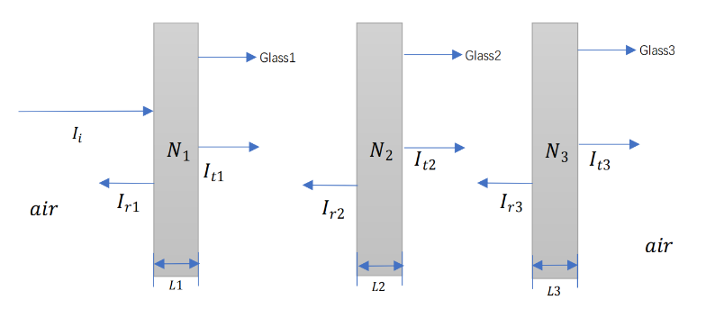
Figure 2. Three-layer glass mode (Photo/Picture credit: Original )[4].

Model Calculation Formula and Experimental Parameters
In this study, the simulated solar spectrum data AM1.5 standard was used. Setting the wavelength range to 300nm~2000nm can cover the ultraviolet to near-infrared band, which is the main energy area of solar radiation. The step size is 10nm, which can balance the calculation accuracy and efficiency. Set the refractive index of glass to n=1.5 and the refractive index of air to $n_{0}$=1. The difference in refractive index determines the interface reflectivity. Considering the effects of light reflection and light wave interference, let the single layer transmittance T, the transmittance is the ratio of $T_{t}$ to $T_{i}$, R is the reflectivity, k is the wave number, L is the film thickness, s$\sin^{2}{kL}$ is the interference term, that is, the transmittance T depends on the wavelength λ and the film thickness L.
Single layer transmittance formula:
$T=\frac{T_{t}}{T_{i}}=\frac{{\left(1-R\right)}^{2}}{{\left(1-R\right)}^{2}+4R\sin^{2}{kL}}$ (3)
Using a simplified triple-glazed model, the total transmittance for the triple-glazed structure is assumed to be$T_{total}$, and the total transmittance is divided into the product of the transmittances of the three single-glazed layers.
Total transmittance formula:
$T_{total}=I_{t1}∙I_{t2}∙I_{t3}$ (4)
$E_{total}$ is the total energy, T(λ) is the transmittance at wavelength $λ$, and $I_{SUN}(λ)$ is the AM1.5G spectral irradiance. This formula is used to evaluate the energy transmittance and is converted into a discrete sum approximation by integration, which is the objective function.
Total energy formula:
$E_{total}=\sum_{λ}{T\left(λ\right)*I_{SUN}(λ)}*∆λ$ (5)

Fitness Function and Other Parameters
In this study, the number of particles in the PSO-GA algorithm is 120, the number of iterations is 500, the wavelength step is 10 nm, and the glass thickness is 0.003m~0.010m. The fitness function adopted aims to calculate the total transmitted energy of the multilayer glass in the solar spectrum range and to minimize the transmitted energy in the solar spectrum range (300–2000 nm). Find the optimal combination thicknesses of the three layers of glass to reduce the overall transmitted energy.

Experimental Results and Analysis

Results and Discussion
In this paper, the PSO-GA algorithm is adopted. The horizontal axis of Figure 3 represents the number of iterations from -100 to 350. The algorithm is set to 350 times without physical units, which only indicates the progress of the algorithm. The vertical axis represents the transmitted energy, and the unit is W/m2(watts per square meter), which quantifies the amount of energy that passes through the glass structure, and the value is on the order of ${×10}^{-7}$. The convergence curve shows that the total transmitted energy gradually decreases with the increase of iteration number, and finally stabilizes, with the value dropping from about 10.055×${10}^{-7}$to 9.84×${10}^{-7}$. This shows that the algorithm effectively achieves the optimization of the thickness combination of multiple layers of glass to reduce the transmitted energy. The PSO-GA hybrid algorithm converged effectively, indicating that the optimization process successfully found a solution close to the global optimal solution. The curve becomes flat in the later stage of iteration, indicating that the parameter adjustment space is small and the algorithm has reached a stable state.
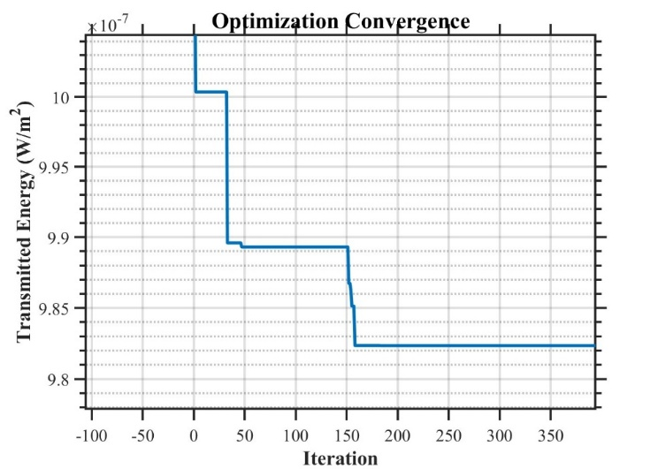
Figure 3. Relationship between convergence times and transmission energy (photo/picture credit: original).

The horizontal axis of Figure 4 represents the wavelength in nm, ranging from 300 to 2000, covering the ultraviolet, visible light, near infrared, and other solar spectrum ranges. The vertical axis represents the transmitted light intensity, with the unit of W/m2/nm (watts per square meter per nanometer), reflecting the transmittance of light in different bands. It shows that the transmitted light intensity of the optimized three-layer structure is significantly lower than that of the single-layer 3mm structure in most wavelength ranges, especially in areas with higher solar spectrum intensity. The optimized three-layer structure effectively suppressed the transmittance in the high incident light intensity band by adjusting the refractive index and thickness of each layer, thereby reducing the total transmitted energy and verifying the realization of the optimization goal of minimizing the transmitted energy.
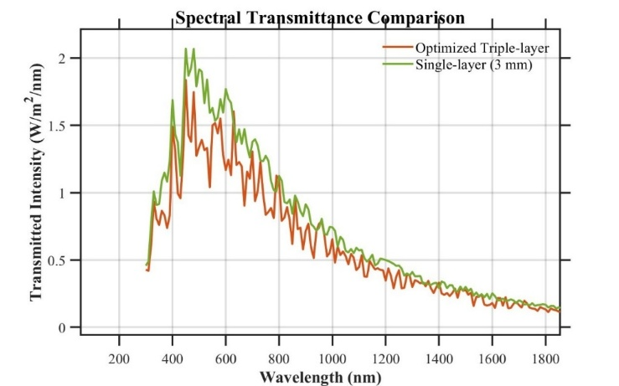
Figure 4. Comparison of transmitted light intensity between 3mm glass and triple-layer glass (Photo/Picture credit: Original).

The horizontal axis of Figure 5 represents wavelength in nm, ranging from 300 nm to 2000 nm, and is mainly used to identify different wavelength bands. The vertical axis represents the light intensity in units of W/m2/nm (watts per square meter per nanometer), reflecting the energy distribution of different wavelengths. The transmitted light intensity is generally lower than the incident light intensity, and there is obvious attenuation in the ultraviolet (300nm~400nm), visible light (400nm~700nm), and infrared bands (>700nm). The optimized structure has a significant suppression effect on 300nm~200nm, indicating that it may have advantages in thermal insulation or selective light transmission applications, while retaining the transmission ability of part of the visible light band.
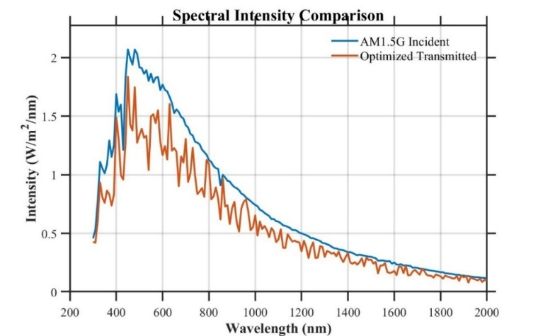
Figure 5. Comparison of incident and transmitted light intensity (Photo/Picture credit: Original).

Analysis Improvement
The future industrial development of multi-layer glass and multi-layer film structures requires the improvement of practicality, functionality, and structural diversity. Currently, the industry has achieved ultra-high precision in production at 0.0001m, but large-scale industrialization still faces difficulties in ultra-high precision processing and challenges brought by strict fault tolerance. Although this study achieved the experimental purpose through a simplified three-layer glass model, the simplified model ignored practical factors. For example, material dispersion, interface scattering, temperature gradient, oblique incidence, regional temperature, etc., lead to deviations from reality.
Different researchers have proposed different paths for this purpose. In terms of material innovation, functional materials such as ultra-white glass, electrochromic layers, and green synthetic porphyrin films are used [6]. Molecular structure and nanoscale morphology control can enhance or reduce broadband transmission efficiency and environmental durability. In actual environments, dynamic environmental conditions such as temperature and humidity changes and oblique incident light are integrated into the light-heat-force multi-field coupling model to improve the stability and conformability of the spectrum and the material's anti-deformation energy particle [7]. If further optimization is carried out, the inertia weight can be adaptively adjusted dynamically, the PSO-GA algorithm can achieve global tuning of the thickness parameters, and the use of ant colony-genetic algorithm with pheromone-guided search can also enhance wide-band color transmittance [8, 9]. The needle-based method NEEDLE, is used to gradiently correct the thickness and refractive index layer by layer to coordinately balance the visible light and near-infrared reflection performance. The full-band electromagnetic analysis and retrograde design using the finite-difference time-domain method are combined to establish a predictive optimization model for radiation resistance and phase matching [10, 11]. The research method can be extended to fields such as aerospace, agricultural greenhouses, etc. Through the coordinated optimization of materials, algorithms, and structures, the solar transmittance and energy can be adjusted to further realize actual production and provide an economically feasible solution.

Conclusion
This paper studies the PSO-GA hybrid algorithm to successfully optimize the thickness of triple-layer glass, so that the optimization of sunlight transmission is in line with modern production and life. The optimized glass thicknesses are 0.0095m, 0.0046m, and 0.0031m, respectively. This combination of glass thickness effectively reduces the intensity and energy of solar transmission in the main wavelength range. This result shows that the PSO-GA algorithm has good advantages in optimizing multi-layer glass or film structures, and can solve the design of complex multi-layer glass or film structures for environments that require light of a specific intensity. Such as agricultural production to prevent overheating and sunburn of agricultural products, photovoltaic products, factory equipment insulation, automobile glass, etc., it embodies a good and feasible solution.
Different research paths can effectively expand the practicality and versatility of the optical structure of multi-layer glass or multi-layer film structures. In the future, more different light-transmitting materials can be explored to selectively transmit specific bands, enriching their usage scenarios. Explore the impact of environmental factors such as climate at different angles in different regions to improve the practical application of its optical structure. Applying these different optimization techniques and routes to the fields of agriculture, aerospace, industry, and consumer electronics has important economic value and long-term significance, and promotes the algorithm optimization and computing technology progress of optical design in multi-layer system design.

References
- T. Ma, M. Ma, and J. L. Guo, iScience 28, 112222 (2025).
- H. Wang, Z. Zheng, C. Ji, Mach. Learn.: Sci. Technol. 2, 025013 (2021).
- M. Jain, V. Saihjpal, N. Singh, Appl. Sci. 12, 8392 (2022).
- Y. Ling, Appl. Comput. Eng. 94, 64-70 (2024).
- H. Li, Y. Peng, C. Deng, Comput. Eng. Appl. 54, 20-28 (2018).
- K. Zhang, Z. Chen, J. Guo, Renew. Energy 237, 121913 (2024).
- Q. Huang, H. Xue, J. Liu, Spectrosc. Spect. Anal. 42, 2262-2268 (2022).
- B. K. Mashaly, Phys. Scr. 99, (2024).
- M. Yaseen, M. Awais, Z. Farooq, J. Mol. Struct. 1335, 141985 (2025).
- M. A. M. Kasem and K. Maalawi, J. Mech. Eng. Sci. 15, 8405-8417 (2021).
- Y. Xu, J. Li, and Z. Dai, Mod. Inf. Technol. 8, 165-171 (2024).

