Massive Electric Vehicle Charging Demand Access Implications for the Smart Grid
Xinyuan Zhao
College of Automation, Jiangsu University of Science and Technology, Zhenjiang, Jiangsu 212100, China
232210302303@stu.just.edu.cn
Abstract. In recent years, the electric vehicle industry has been developing rapidly, and the charging facilities supporting it are also expanding in scale, which has a significant and multi-dimensional impact on the utility grid. In terms of load characteristics, the stochastic nature of electric vehicle charging makes the peak and valley changes of the grid load more prominent, especially in the concentrated charging time of residents, is easy aggravate the burden of the evening peak, and increases the complexity of load forecasting. In terms of power quality, the harmonic currents generated by power electronic devices in charging facilities will cause grid voltage distortion, and the high power demand during rapid charging may also trigger voltage fluctuations and flicker, affecting the normal operation of other power-using equipment. From the perspective of utility grid planning, in order to adapt to the power consumption of charging facilities, the distribution network needs to reassess the capacity and optimize the layout, which involves many aspects such as line modification and equipment renewal, and many practices and researches have been carried out at home and abroad in the related fields. The purpose of this study is to analyze these impacts in depth and propose targeted strategies to help EV charging facilities and the grid achieve coordinated and sustainable development, and to ensure the safe and stable operation of the power system.

Introduction
Driven by the dual drive of global energy structure transformation and carbon neutrality targets, the electric vehicle industry is experiencing explosive growth.In the initial six months of 2023, China's new energy vehicle sector achieved a production and sales volume exceeding 3.7 million, with sales accounting for 28.3% of China's automobiles, and ownership has also accounted for 4.9% of the total number of automobiles, which reached a total of 16.2 million, and the purely electric vehicles grew to 12,594,000 units [1]. This transformative development, while injecting kinetic energy into the decarbonization of the transportation sector, has also brought unprecedented challenges to the power system: the spatial and temporal agglomeration characteristics of massive EV charging loads are reshaping the load pattern of the traditional power system, and putting forward a brand-new proposition for the planning, operation and control of the smart grid.
The development and management of EV charging infrastructure play a crucial role in ensuring the convenience and cost-effectiveness of electric vehicle usage. With the rapid growth in the number of electric vehicles, the scale of charging facilities is also expanding, which not only puts forward new requirements on the load management of the utility grid, but also has far-reaching impacts on the stability of the utility grid, power quality, and utility grid planning. Especially at times of peak energy consumption, mass EV charging may cause a rapid escalation in utility grid demand, which may cause problems such as voltage fluctuations and frequency deviations, and in severe cases, may even lead to grid collapse [2]. In addition, the nonlinear characteristics of EV charging facilities also introduce harmonic pollution, which affects the power quality of the grid [3]. At the same time, the access of EV charging facilities also requires the grid to carry out corresponding planning and construction modifications to adapt to the new load demand, which includes capacity expansion and modification, optimization of the grid structure and so on. Therefore, how to meet the demand of electric vehicle charging facilities while ensuring the stable operation of the utility grid has become an urgent problem in the field of power system.
This paper will comprehensively analyze the impacts of EV charging facilities on grid load, voltage stability, power quality and grid planning, and explore possible optimization strategies, with a view to providing theoretical basis and practical guidance for the rational planning of EV charging facilities and the efficient management of utility grids. By analyzing the current status of related research at home and abroad and combining with my own understanding, this paper aims to provide scientific and reasonable solution suggestions for the harmonious coexistence of electric vehicle charging facilities and smart grid.

Characterization of electric vehicle charging loads and analysis of the theoretical basis for load forecasting

Characteristics of Electric Vehicle Charging Loads

Spatial Distribution Characteristics
Charging demand shows significant regional differences: high density charging hotspots are formed around urban business districts and office buildings due to the concentration of commuting and operating vehicles; slow charging at night in residential areas is prone to localized grid overload; high-speed service areas face short-term grid pressure caused by instantaneous ultra-fast charging on holidays; and charging blind zones exist in suburbs and rural areas due to the lack of facilities. Differences in the layout of facilities exacerbate the regional imbalance; public fast-charging piles are concentrated in areas that are prone to increase the load on the utility grid, while the popularity of private slow-charging piles is limited by the carrying capacity of the utility grid in residential areas.

Temporal Distribution Characteristics
Charging time distribution and user behavior are highly correlated: commuting group charging peaks and traffic morning and evening peaks superimposed, exacerbating the peak-valley difference of the grid; family night charging, although partially matched with the electricity consumption of the valley, may still form a new load peaks; high-speed charging on holidays is a pulse outbreak, a serious test of the grid's frequency regulation capabilities. Studies have shown that peak charging is prone to grid overload and efficiency degradation [4][5]. The data in this paper is derived from the electric vehicle charging records in Yangjiang City, South China, with reference to Figure 1 for specific data The city has a weak cab industry due to the popularity of motorcycles, the rise of online cars and a small geographical area, and residents' travel is dominated by private cars, public transportation, motorcycles and car-sharing, and the data cover three types of public transportation, private cars and car-sharing.
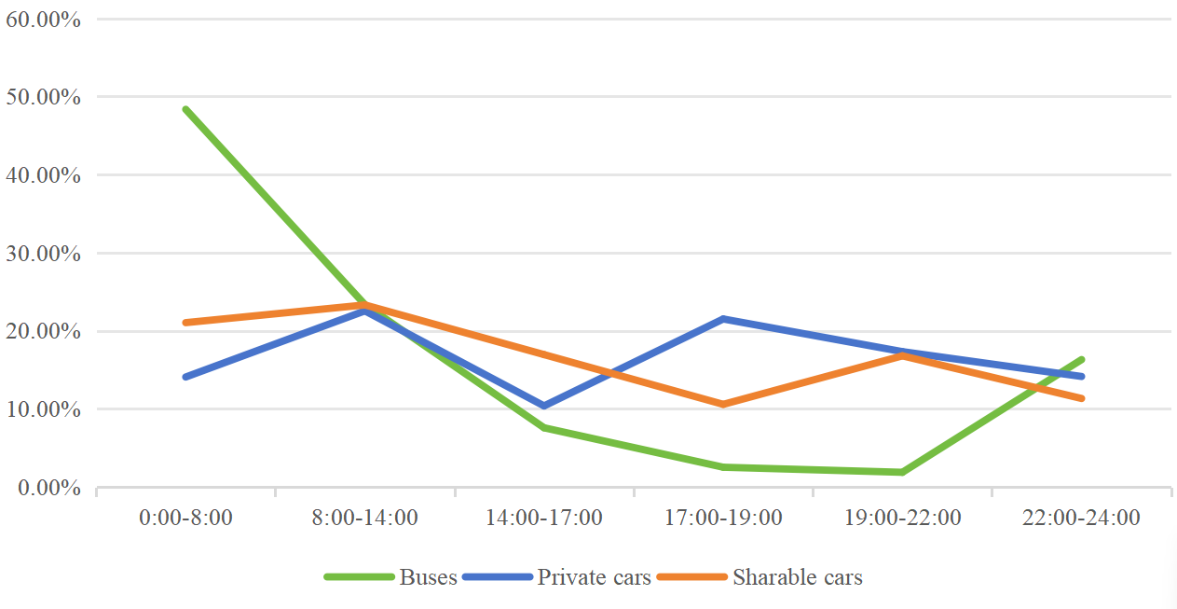
Figure 1.2023 Electric Vehicle Charging Time Statistics for Yangjiang City
From the figure 1, it can be seen that public transportation charging is concentrated in the night after 22:00 at the end of the operation period, and some vehicles need to be replenished during the day to maintain operation; the charging peaks of private cars overlap with the low valley of the electricity price, but more than half of the users are still relying on the public charging facilities due to the limitations of the old neighborhoods; the number of shared cars is small and charging hours are scattered, random and strong, and are mostly used for traveling to play the scenario.

Power Demand Characteristics
Charging pile according to power is divided into two categories: low-power AC pile is suitable for home slow charging, charging time 6-8 hours, although can match the nighttime electricity trough, but the scale of use easy to make the distribution transformer long-term high load, reshaping the grid load curve to form a new steady state peak; high-power DC pile is dedicated to high-speed service areas and other fast charging scenarios, 30 minutes can be charged to 80% of the power, its MW-level instantaneous load will cause voltage dips, harmonic distortion and other problems, and by the battery charge state presents nonlinear power fluctuations, the need for the grid to have a dynamic adjustment capability to cope with sudden changes [6].

Theoretical Basis of Electric EV Charging Electricity Consumption Prediction
Monte Carlo simulation is a numerical computation technique based on probabilistic modeling with random sampling that approximates the solution of complex system problems and quantifies uncertainty by generating a large number of random samples and analyzing them statistically [7][8].
The typical means of describing electric vehicle charging load by probabilistic statistical methods is to draw samples of charging load influencing factors through Monte Carlo methods. Calculating the EV charging electricity consumption, on the basis of obtaining the EV ownership, establishing the probability model of the starting charging moment and the starting charging state, calculating the daily charging load of each electric vehicle by repeatedly sampling the starting charging moment and the starting charging state for many times, then calculating the overall charging demand of the two categories of models, namely, private cars and electric buses. The whole day is divided into 1440 calculation nodes, and the charging load is calculated once every minute, then the charging power is calculated as in equation (1), where P is the total charging power, and Pi is the charging power of the ith vehicle in the t min.
$P=\sum_{t=1}^{1440}{\sum_{i=1}^{n}{P_{i}}}$ (1)
In practical applications of Monte Carlo algorithms, the solution process typically follows these fundamental phases: First, construct the probability distribution function of the stochastic process based on historical data. Then, improve the design according to the problem requirements and model characteristics to reduce the variance and improve the computational efficiency. Then, selects the random number generation method and simulates the problem scenario through sampling. Finally, calculates the statistical estimates and variance of the simulation results [9]. The flowchart refers to Figure 2.
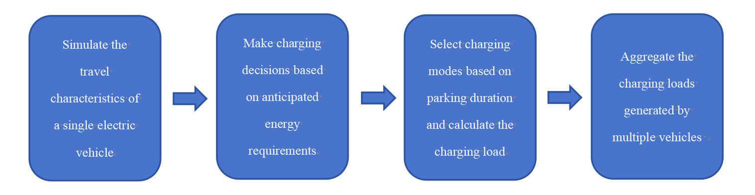
Figure 2.Flowchart for Predicting Electric Vehicle Charging Load Using Monte Carlo Simulation

Impact Analysis of EV Charging Facilities on the Grid

Impact of on Grid Load Characteristics

Increased Variability in Load Peaks and Valleys
The charging time of electric vehicles has a certain randomness, especially in the case of predominantly residential users, many owners will choose to start charging in the evening when they arrive home after work, which is likely to coincide with the peak hours of power consumption of the grid, making the original peak-to-valley difference of the grid load further expand. For example, in the distribution network area where some old neighborhoods are located, when a large number of EVs concentrate on charging, there will be a sharp increase in the evening peak load, which brings a huge test to the power supply capacity of the distribution network. During periods of peak electricity demand, the simultaneous charging of multiple electric vehicles may induce excessive current draw from the grid, potentially causing system overloads. This phenomenon not only necessitates higher spinning reserves but also compromises overall grid operational efficiency [10]. During the peak summer period of 2023-2024, the Hainan utility grid, due to the concentration of EV users who use the valley hours (0:00-2:00) for charging, led to a steep increase of the grid load in the 20 minutes following the zeroth hour of by more than 50 The load of the grid increased by more than 500,000 kilowatts within 20 minutes after the zero hour, which is equivalent to the load of 680,000 air-conditioners running at the same time. This phenomenon makes the original grid valley time into a new peak, exacerbating the peak-valley difference, and even led to the grid regulator load 13 times to create a new record high.

Increased Difficulty in Load Forecasting
EV charging demand is affected by a variety of factors, including vehicle owners' travel habits, vehicle usage, and charging facility distribution. These complex and dynamically changing factors make it difficult for grid operators to accurately predict the total load, including EV charging load, which in turn affects the rationality and accuracy of the grid's power generation plan and scheduling arrangement. State Grid Hebei Power has integrated data from 120,000 charging piles through its independently developed electric vehicle charging facility planning and decision-making support platform, and found that residents' charging behaviors show the random characteristics of "low-frequency, short- and medium-term charging" and "low-frequency charging, pre-holiday charging". For example, a region in Shijiazhuang has a highly decentralized charging time, resulting in an error rate of more than 20% for the traditional load prediction model. The platform optimizes the prediction through AI algorithms, reducing the error rate to less than 5%, but it still needs to dynamically adjust the grid scheduling strategy.

Impact on Power Quality

Harmonic Problems
The power electronics in EV charging facilities generate harmonic currents during their operation. The harmonics mainly come from the rectifier module of the charger, and the main circuit of the EV charging facility mainly consists of four parts, namely, the rectifier module, the DC-DC power conversion module, the output filtering module and the power factor correction module [11]. The injection of these harmonic currents into the power system results in voltage waveform distortion, thereby degrading overall grid power quality. Especially when a large number of charging piles are concentrated in a local area and run simultaneously, the harmonic superposition effect may exceed the permissible range of the grid power quality standard and interfere with the normal operation of other sensitive equipment in the grid, such as adversely affecting some high-precision industrial automation control equipment. A V2G charging station in Hefei, Anhui Province, suffered frequent failures of precision instruments in the surrounding industrial area due to harmonics generated by the charging pile rectifier module, resulting in a total harmonic distortion rate (THD) of up to 12%. Later, an integrated harmonic suppression and reactive power compensation device was introduced to offset the interference by generating inverse harmonics through the inverter, reducing the THD to less than 3% and significantly improving the power quality.

Voltage Fluctuations and Flicker
During the charging process of electric vehicles, especially during rapid charging, the instantaneous demand for high-power charging will cause fluctuations in the voltage of the grid nodes. If the charging facilities are not reasonably distributed or the grid's voltage regulation capacity is insufficient, frequent voltage fluctuations may further evolve into voltage flicker, affecting the surrounding users' power experience, and causing damage to the service life of some lighting equipment and electronic appliances. A commercial complex in Handan, Hebei Province, next to the "light storage charging and discharging" charging station, in 2024 after the commissioning of the super-charging pile short-term high power charging voltage fluctuations, resulting in adjacent office building lighting equipment strobe. Later, the charging power curve was adjusted through intelligent sequential charging technology, and dynamic reactive power compensation devices were installed on the distribution side to reduce the voltage fluctuation range from ±10% to ±3%, solving the flicker problem.

Implications for Grid Planning

Changes in Distribution Network Capacity Requirements
The integration of electric vehicle charging poses multifaceted challenges to distribution networks, extending beyond mere load balancing issues. Specifically, clustered EV charging behaviors may induce localized power supply constraints, while the temporal concentration of charging activities during peak demand periods can significantly exacerbate distribution system stress. Studies have shown that EV loads are likely to be aggregated in certain localized areas, which will cause local overloading problems in the distribution network [12]. In order to meet the electricity demand of EV charging facilities, the distribution network needs to be expanded and modified. The original distribution network lines, transformers and other equipment designed according to traditional loads may not be able to carry the new charging loads, and it is necessary to reassess and plan the distribution network capacity, add new lines, replace high-capacity transformers, etc., which involves a large amount of capital investment and engineering construction.

Demand for Optimization of Grid Layout
Different distribution locations of charging facilities have different impacts on various nodes of the utility grid. Reasonable planning of the layout of charging facilities in the utility grid, so that their distribution with the utility grid, substations, etc. is coordinated, to reduce grid losses, balanced grid load has an important significance. Therefore, the layout of electric vehicle charging facilities should be fully considered in the utility grid planning, and the overall layout of the utility grid should be optimized and adjusted. Jiaxing Industrial Park, Zhejiang Province, in order to solve the problem of local overload caused by uneven distribution of charging piles, the use of "photovoltaic + energy storage + charging" synergistic planning mode. For example, a park in Tongxiang supporting the construction of 504kW photovoltaic power station and 1400kW energy storage system, the use of energy storage system in the valley time storage, peak time discharge, local consumption of charging load. This model reduces the peak load of the main grid by 18% and reduces line losses by about 12%.

Strategies for Addressing Grid Impacts of EV Charging Facilities

Enhancing Intelligent Management of Charging Facilities
Develop an intelligent charging management system that realizes real-time communication with electric vehicles and the utility grid through vehicle networking, Internet of Things and other technologies. It can dynamically adjust the charging power and reasonably arrange the charging time according to the load condition of the utility grid, and guide users to charge in the low valley time of the utility grid, for example, by giving economic incentives such as preferential charging tariffs in the low valley time, so as to smooth out the load curve of the utility grid and reduce the pressure on the peak of the utility grid. The "High-speed Station Busy Analysis Kanban" system deployed by State Grid Tianjin Power during the Spring Festival in 2024 monitors the use of charging piles in highway service areas in real time through Telematics, dynamically releases information on charging station waiting, and guides users to charge at night during the low-trough hours in conjunction with the electricity pricing policy. The system also plans charging routes for vehicle owners through the app and flexibly dispatches charging resources in combination with emergency charging pods, significantly easing the charging pressure during the Spring Festival.

Improving Power Quality Performance of Charging Facilities
In the R&D and production process of charging facilities, it is strictly required that they adopt advanced power electronic technologies and have built-in effective power quality improvement modules such as harmonic suppression and reactive power compensation, so as to minimize the impact of charging facilities on the power quality of the utility grid from the source. At the same time, strengthen the power quality monitoring of charging facilities that have been put into operation, timely detection and treatment of existing power quality problems. The harmonic and reactive power comprehensive improvement device collects grid voltage and current signals in real time through the signal detection module, and combines with the inverter to generate reverse compensation current, effectively reducing the total harmonic distortion rate from 12% to less than 5%, and at the same time, solving the problem of "backward transmission of reactive power". Capacitive compensation is mainly used to provide reactive power to the system by connecting capacitors in parallel in the circuit, thus improving the power factor of the grid, reducing line losses and improving power quality [13]. The device has been applied in some charging stations on a pilot basis, which has significantly improved the power quality.

Optimizing Grid Planning and Layout
At the stage of utility grid planning, the development scale and distribution of future EV charging facilities are fully considered, sufficient capacity margins are reserved, and utility grid facilities such as substations and lines are reasonably laid out. At the same time, combined with the layout of distributed power sources, we explore the synergistic planning of distributed power sources and EV charging facilities, utilizing distributed power sources to dissipate charging loads locally to a certain extent and reduce the impact on the main utility grid. The "light storage and charging" integrated charging station constructed in Baodi Hot Spring City Service Area of Tianjin Jinji Expressway integrates photovoltaic power generation, energy storage system and full liquid-cooled supercharging technology, with a maximum power of 720 kW, which utilizes distributed photovoltaic power to locally consume charging loads and suppresses power fluctuations through the energy storage system, thus reducing the impact on the main utility grid.

Promote the Application of Two-way Charging Technology
V2G (Vehicle-to-Grid) technology is an innovative technology that realizes flexible scheduling and optimization of the power system through bidirectional energy interaction between electric vehicles (EVs) and the grid. Its core lies in considering the power battery of EVs as a distributed energy storage unit, which can both charge from the grid and reverse discharge to the grid when the vehicle is idle, thus participating in the grid's auxiliary services such as frequency regulation, peak shifting, and standby [14]. Further research and development and promotion of two-way charging technologies such as V2G, so that electric vehicles are not only power-using devices, but also can be used as mobile energy storage units to feed power back to the grid when needed by the grid. Through reasonable control strategies, the two-way interaction of energy between EVs and the grid can be realized, the flexibility and reliability of the grid can be improved, and the peak and trough changes of the grid load can be effectively dealt with.
Industry innovators continue to explore the technical boundaries, such as Azera relying on 5G communication and virtual power plant architecture, the first to realize the millisecond response and accurate regulation of the power station, to build a distributed energy system close to the function of the traditional power plant; its Hefei demonstration project even more innovative introduction of quantum encryption communication technology, under the premise of guaranteeing information security will be the system of regulating delay compression of 60%, and significantly improve the reliability of utility grid interaction. Practice has proved that through the digital platform to open up the "car - pile - network" data chain, to build the energy flow and information flow deeply coupled management system, has become the core path of the scale of the development of car network interaction. With the continuous iteration of technological innovation and business models, China's car network interaction industry is accelerating towards a new stage of scale and market-oriented development [15].

Promotion of Harmonic Suppression Measures
The harmonic problem is the focus of research on the technical aspects of charging station construction, and the harmonics mainly come from the rectifier module of the charger, and the main circuit of the electric vehicle charging equipment mainly consists of 4 parts, i.e., the rectifier module, the DC-DC power conversion module, the output filtering module and the power factor correction module [11]. For the management of harmonic pollution, the following 2 ways are mainly referred to: optimizing the circuit principle of the charger to reduce the generation and output of harmonic components; and adopting harmonic suppression measures for the charging station as a whole to avoid harmonic pollution from being transmitted to the utility grid. Currently, the incidence of harmonic problems in utilities and power systems is increasing; thus, the use of active power filters has attracted attention and is expected to be an effective remedial measure [16].

CONCLUSIONS
At present, China's electric vehicle industry has stepped into a period of rapid development, and the charging behavior of a large number of electric vehicles will have a greater impact on the utility grid, while the energy storage characteristics of electric vehicles will also provide new opportunities for the safe and economic operation of the power system.
In EV charging infrastructure development, the short-term planning focus resides in optimal allocation of charging facilities within distribution networks. Long-term considerations must address distributed residential charging impacts, particularly as EV penetration increases alongside advancements in smart charging and metering technologies. China also has in-depth research and practical exploration in this field, however, with the continuous increase in the number of electric vehicles, there is still a need to continuously improve the relevant technologies, management strategies and standards and norms, to further promote the coordinated and sustainable development of electric vehicle charging facilities and utility grids, to ensure the safe, stable, and efficient operation of the electric power system, and to provide strong support for China's energy transformation and green transportation development.

REFERENCES
- F. Ziyue, Spatio-temporal charging load prediction of electric vehicles and its impact on power system. Zhejiang University (2023).
- M. R. Khalid, I. A. Khan, et al., A comprehensive review on structural topologies, power levels, energy storage systems, and standards for electric vehicle charging stations and their impacts on grid. IEEE Access 9, 128069–128094 (2021).
- S. D. Vasconcelos, J. F. D. C. Castro, F. Gouveia, et al., Assessment of electric vehicles charging grid impact via predictive indicator. IEEE Access 12 (2025).
- L. Cai, Q. Zhang, N. Dai, et al., A review on the research progress of scaled electric vehicle access to active distribution network. Smart Power 49(6), 75–82 (2021).
- B. Liu, Impact of electric vehicle charging behavior on regional grid currents. Guangdong University of Technology (2020).
- X. Tian, Research on charging technology of electric vehicles. Automobile Repair and Maintenance 12, 50–51 (2024).
- C. Xiao, X. Liu, X. Wang, et al., Electric vehicle charging load prediction with multiple power levels in large communities. J. Power Syst. Autom. (2025).
- R. Wang, X. Gao, J. Li, et al., Electric vehicle charging load prediction method based on cluster analysis. Power Syst. Prot. Control 48(16), 37–44 (2020).
- Q. Sun, Research on the load demand and its impact of large-scale electric vehicles connected to the utility grid. Shanghai Electric Power University (2021).
- G. A. Abiassaf, A. A. Arkadan, Impact of EV charging, charging speed, and strategy on the distribution grid: a case study. IEEE J. Emerg. Sel. Top. Ind. Electron. (2024).
- D. Chen, Q. Qiu, X. Yang, et al., Research on harmonic suppression methods of different types of electric vehicle charging stations. Electromech. Eng. 34(8), 922–926 (2017).
- F. Zeng, Research on distribution network planning considering the impact of electric vehicle charging load. South China University of Technology (2022).
- M. Xiang, Research on reactive power compensation and harmonic management technology of distribution network. Electr. Switchgear 63(1), 59–62 (2025).
- S. Meraj, S. Mekhilef, M. Mubin, et al., Bidirectional wireless charging system for electric vehicles: a review of power converters and control techniques in V2G application. IEEE Access.
- Y. Jiang, Opportunities, challenges and suggestions for the development of vehicle-to-grid interaction (V2G). Shanghai Energy Conserv. 12, 1901–1905 (2024).
- F. Liu, H. Wu, B. Yang, Research on harmonic compensation characteristics of shunt-type active power filter. Shanghai Electr. Technol. 17(4), 79–81 (2024).

