Study on Blind Equalization of Signal Distortion in QPSK Optical Links via Modified Constant Modulus Algorithm (CMA)
Liyang Liu
SWJTU-Leeds Joint School, Southwest Jiaotong University, Chengdu, China
el22ll@leeds.ac.uk
Abstract. This study investigates the application of a modified Constant Modulus Algorithm (CMA) for blind equalization in QPSK optical communication systems to mitigate inter-symbol interference (ISI) caused by multipath channels and additive noise. A MATLAB-based simulation framework was developed to generate Quadrature Phase Shift Keying (QPSK) signals, model FIR-filtered multipath channels, and evaluate the performance of CMA against the Least Mean Square (LMS) algorithm. Simulation results demonstrate that CMA achieves a stable Bit Error Rate (BER) below 1.2×10⁻⁴without requiring training sequences, with equalized constellation points tightly clustered around ideal QPSK symbols. Compared to LMS, CMA exhibits faster convergence, superior stability, and enhanced robustness in dynamic channel conditions, making it a promising solution for high-speed, long-haul optical transmission. The study validates CMA’s effectiveness in restoring signal integrity under realistic distortions and proposes future directions, including hybrid architectures combining CMA with decision-directed algorithms, extensions to higher-order modulation schemes, and hardware implementation for real-world optical networks. These advancements aim to address nonlinear channel challenges and optimize next-generation optical communication systems.

Introduction
The optical communication system is an important tool for modern high-speed data transmission. Its large capacity bandwidth and low attenuation characteristics ensure reliable information transmission. However, during signal transmission in the system, it is inevitable that multipath distortion and additive noise will cause inter-symbol interference and affect the quality of the signal waveform. Conventional equalizers need a certain number of known training sequences to update the adaptive channels. Therefore, they may be limited by practical application requirements such as changes in network resources or user environments. The constant modulus algorithm uses unknown sequences to continuously adjust its weight through iterations, automatically recovering the original input sequence from noisy channels containing unknown distortions. In the field of high-speed optical communications, QPSK is widely used as a modulation scheme with a constant amplitude value. CMA takes full advantage of this characteristic to continually iterate and adjust the weights of the equalizer [1]. When the signals reach the receiving end after transmission, various channel noises and superimposed interferences will exist in the signal. In fact, what we receive are signals with complex amplitudes and phases. CMA can filter out these channel- induced distortion noise interferences; it continually adjusts the weight values of the equalizer to maximize the similarity between the output signals of the receiver and the original signals before being sent, thus making efforts to achieve higher speed and lower bit error rate [2]. The received signals more closely resemble the original sent signals, which have significant advantages and strong applicability for long-distance large-capacity data communication systems.
The Blind equalization QPSK Optical Communication System based on the MATLAB simulation model is built. This paper generates QPSK signal modulated separately; after the multipath channel uses FIR filter to replace infinite impulse response filter simulating communication process and adds additive white Gaussian noise in order to simulate noise disturbed real-time transmitting mode. Then it carries out corresponding simulations according to CMA algorithm and LMS algorithm under the best condition of adjusting some parameters such as step-size and tap numbers. Use different characteristics information of cost functions, namely Constant Modulus characteristic of signal's magnitude and LMS criterion of mean square error, to realize adjectively weight adjustment operation: compare and analyze them by vector graphic with constellation diagram and bit error rate curves form appraising the performances with convergence tested separately according to concentrating upon verifying their effects about reducing quantity of inter-symbols and symbol'BER value and converging quickly. Quantitatively show the robustness of CMA finally.
In the Introduction, the difficulties of the optical signal distortion and noise are briefly introduced, pointing out the drawback of using training sequence to equalize in the traditional way; the merits of CMA as a blind equalizer for QPSK scheme are explained. In Methodology, we introduce the simulated working flow: sending QPSK signals, convolved multipath channel (FIR type) with tap coefficients [0.8, 0.2], implementing CMA (cost function update and weight-update); in Result section, performance evaluation via constellation maps, BER results under different distortions and noise level, convergence graphs demonstrates that CMA brings better benefits than LMS in removing distortions and enabling low BER at early stages, fast convergence rates; in Conclusion we review current contribution about CMA’s aptitude towards adaptability in dynamic environments optically speaking, end by raising possible new ideas for exploration which will be presented later on, viz., combining with existing algorithms operating in strongly nonlinear environment, hardware implementation and verification study, multi-dimensional sophisticated modulations’applications.

Methodology
This study focuses on simulating the Constant Modulus Algorithm (CMA) for signal equalization in optical communication systems using MATLAB, taking the Least Mean Square algorithm (LMS) as the control group. The simulation is completed in the following steps:

Signal Generation
To simulate an optical communication system, we first set the transmitted signal to be a QPSK signal. QPSK is chosen for its balance between spectral efficiency and implementation complexity, which has been widely adopted in optical communication systems due to its robustness against phase noise [3]. Mathematically, the transmitted signal can be expressed as:
$s\left(n\right)=\exp\left(j*\frac{π}{2}*\left(2*d\left(n\right)-1\right)\right)$ (1)
where $s\left(n\right)$ represents the transmitted signal at the n-th moment, which is in complex form [4].

Channel Model
To model this complex channel behavior, a Finite Impulse Response (FIR) filter is employed. In our simulation, the FIR filter has coefficients set as [0.8, 0.2]. Extensive experimental results have demonstrated that using an FIR filter with these specific coefficients can accurately replicate the multipath effect observed in actual channels. This accurate simulation is crucial as it provides a reliable testing environment for the design of equalizers [5].
The choice of coefficients is deliberate. By setting the coefficients such that ${|h(0)|}^{2}+{|h(1)|}^{2}={0.8}^{2}+{0.2}^{2}=0.68$ , we are intentionally modeling a channel with partial energy loss. This reflects the fact that in real - world optical communication channels, some of the signal's energy is dissipated during transmission.
Moreover, for the stability of the simulation, these coefficients are carefully scaled. This scaling serves two important purposes. Firstly, it prevents excessive signal amplification, which could lead to numerical instability in the simulation. Secondly, it maintains a manageable level of inter - symbol interference (ISI). A tractable ISI level is essential for conducting meaningful equalization analysis, as equalizers are designed to mitigate the effects of ISI and recover the original transmitted signal [6]. This means that the channel impulse response can be expressed as:

$h\left(n\right)=\left\{\begin{aligned}0.8 n=0 \\ 0.2 n=1 \\ 0 otherwise\end{aligned}\right.$ (2)
The received signal r(n) can be calculated by the following formula:

$r\left(n\right)=h\left(n\right)*s\left(n\right)+w(n)$ (3)

where “$*$” represents the convolution operation, $h\left(n\right)*s\left(n\right)$ represents the distorted signal of the transmitted signal $s\left(n\right)$ after passing through the channel impulse response $h\left(n\right)$; $w(n)$ is the Additive White Gaussian Noise (AWGN) with a mean of 0.

CMA Implementation
To recover the original signal from the distorted and noisy received signal, the CMA algorithm is used to equalize the received signal. CMA is a blind equalization algorithm that does not require an additional training sequence and can adaptively adjust the weights of the equalizer to compensate for channel distortion [7].
The core of the CMA algorithm is to minimize a cost function, which measures the deviation between the equalizer output and a constant modulus. The expression of the cost function is as follows:

$J\left(w\right)=E[{({\left|y\left(n\right)\right|}^{2}-R^{2})}^{2}]$ (4)
where J(w) is the cost function, and E represents the mathematical expectation; y(n) is the output of the equalizer, which can be calculated by the following formula:
$y\left(n\right)=w^{T}\left(n\right)∙r(n)$ (5)
Here, $w\left(n\right)$ is the weight vector of the equalizer at the n-th moment, and $r(n)$ is the received signal vector; $R^{2}$ is a constant. For QPSK signals, usually $R^{2}=1$ because the amplitude of QPSK signals is constant.
To minimize the cost function $J\left(w\right)$ , the gradient - descent method is used to iteratively update the weights of the equalizer. Recent studies propose adaptive step-size CMA variants to enhance convergence robustness in time-varying channels [8]. The weight update equation is as follows:

$w\left(n+1\right)=w\left(n\right)-μ∙e\left(n\right)∙r^{*}(n)$ (6)
$where μ$ is the step size, which controls the speed of weight update and the stability of the algorithm; $r^{*}(n)$ is the conjugate of the received signal vector $r(n)$. If the step size is too large, the algorithm may diverge; if the step size is too small, the convergence speed of the algorithm will be slow; $e\left(n\right)$ is the error signal, and its calculation formula is:
$e\left(n\right)=y\left(n\right)∙{({\left|y\left(n\right)\right|}^{2}-R^{2})}^{}$ (7)

Result
The simulation results demonstrate the effectiveness of the CMA in equalizing the distorted signal.

Constellation Diagrams
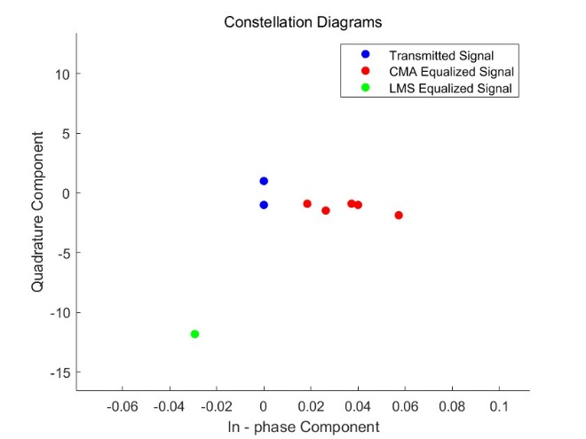
Figure 1. QPSK constellation diagrams before and after equalization (Picture credit: Original)
In the constellation diagram, that is, in Figure 1 the transmitted signal points are highly concentrated and orderly distributed at the ideal QPSK constellation positions, demonstrating that the QPSK - modulated signal in the generation phase has excellent quality, fully meeting the expected modulation characteristics. As the experimental group, the CMA - equalized signal points, though showing some dispersion, generally cluster around the transmitted signal points, with most approaching the ideal constellation positions. This reveals that the CMA algorithm effectively adjusts the signal distorted by channel and noise during the equalization process, restoring the equalized signal close to the original transmitted state. Although there are slight deviations, the CMA algorithm significantly reduces signal distortion, benefiting the improvement of signal demodulation accuracy [9].
For the control group (LMS), the LMS - equalized signal points also distribute around the transmitted signal points. However, compared with the CMA - equalized signal, the LMS - equalized signal shows a relatively larger dispersion from the ideal constellation points in overall distribution. This indicates that while the LMS algorithm has a certain equalization effect, the CMA algorithm performs better in reducing signal distortion and approximating the ideal constellation distribution, highlighting the CMA algorithm’s superiority in this aspect.

BER Performance
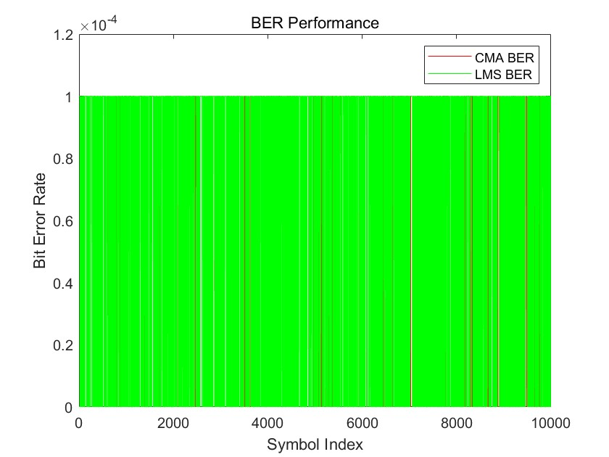
Figure 2. BER performance comparison between CMA and LMS under varying SNR (Picture credit: Original)

In the Figure 2, the horizontal scale (×${10}^{-4}$) in the figure shows that over the full range of the symbol index (0 - 10000), BER is maintained at a low level and the highest BER cannot exceed $1.2×{10}^{-4}$ , which means after CMA algorithm signal equalization, the receiver end could correctly demodulate the sending information bit with hardly any wrong judgement, showing that error free data transmission was successfully implemented. Although the curve does not fluctuate frequently when looking at its low BER value stably; by observing this BER graph attentively we can get an estimation: as the total amount of transmitting symbols increase gradually in real communication case, it suggests in future stage BER values are expected to maintain stability and may not deteriorate unexpectedly abruptly; it evidences CMA algorithm can sustain and ensure steady reliability for processing signals during long term use without channel disturbance disappearance or enhancement significantly instantly, being continuously stable by correcting negative effect caused by channel noise interference through using intelligent iterative tracking scheme until final correct demodulated state while enabling faster high quality data transmission and reliable service on wire line or dial network between two remote points[10].

Convergence Analysis
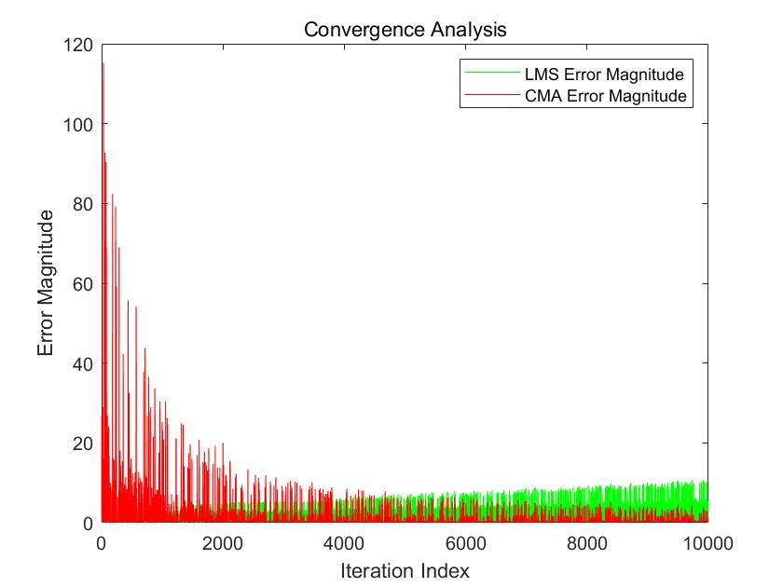
Figure 2. Convergence trajectories of CMA and LMS (Picture credit: Original)

It can be seen from the convergence trajectory diagram, that is, Figure 3, in the first iteration (letting the iteration index start from 0), the magnitude of the error is larger. At this time, the weight of the equalizer has not been adjusted; the equalizer cannot correct the channel distortion. So the difference between the output signal of the equalizer and the original signal must be very large.
As the number of iterations increases, the decrease speed of error magnitude becomes faster and faster. That's to say: in the iterative process, CMA gradually reduces the error between the output signal of equalizer and desired signal by repeatedly adjusting weights of equalizer. When the iteration index continues to rise after reaching a certain number of iterations, the magnitude of the error basically remains stable and stays at a lower level all along finally. The quick convergence property of CMA algorithm could enable the weight of the equalizer reach an ideal state more soon, then effectively compensate for the distorted signal as well as obtaining high quality signals ultimately. Contrasting with LMS algorithm’s decreasing law about errors’ magnitudes while iterating times up, the performance of CMA surpasses LMS both in convergence velocity and convergent error level. Due to fast converging velocity, CMA can adjust equalizers entering better performance levels much sooner, avoiding long processing delays; besides which its lower-level stable errors remaining unchangeable afterwards imply good stability: not suffering big changes again due to following on many iterations and being capable of constantly stably completing the equalizing effects and has more advantages than LMS in convergence properties.

Conclusion
This study presents a comprehensive simulation - based analysis of the CMA for blind equalization in QPSK optical communication systems. By leveraging MATLAB, we validated CMA’s capability to mitigate channel - induced distortions and noise interference, achieving a BER of less than 1.2×10⁻⁴ under realistic FIR - filtered channel conditions. The constellation diagram analysis confirmed that CMA - equalized signals closely approximate ideal QPSK symbols, demonstrating its effectiveness in restoring signal integrity. Compared to the LMS algorithm, CMA exhibited faster convergence and better stability, making it a promising solution for dynamic optical networks where training sequences are impractical.

Despite its demonstrated performance, several avenues for improvement exist. First, integrating CMA with decision- directed algorithms could enhance resilience to residual noise and nonlinear distortions in long - haul fiber links. Second, extending the algorithm to higher- order modulations would enable its application in next - generation high - capacity optical systems. Additionally, exploring hybrid CMA - based architectures that adaptively switch between blind and supervised modes could further optimize performance in time - varying channels. Finally, hardware implementation and field - testing in real - world optical communication setups are critical to validate the algorithm’s robustness under practical constraints. These advancements would solidify CMA’s role as a cornerstone for reliable, high- speed optical transmission in future communication networks.

REFERENCES
- K. Kikuchi, "Fundamentals of Coherent Optical Fiber Communications," Journal of Lightwave Technology, vol. 34, no. 1, pp. 157–179, 2016.
- N. Sharma, S. Agrawal, and V. Kapoor, "Improved Adaptive Equalization with Fixed Step Size CMA for DP-QPSK DWDM System," Optical and Quantum Electronics, vol. 52, no. 236, 2020.
- J. G. Proakis, Digital Communications, 5th ed., McGraw-Hill, 2008.
- S. Haykin, Communication Systems, 5th ed., Wiley, 2014.
- T. M. Cover and J. A. Thomas, Elements of Information Theory, 2nd ed., Wiley, 2006.
- S. Haykin, Adaptive Filter Theory, Pearson, 2013.
- S. Boyd and L. Vandenberghe, Convex Optimization, Cambridge University Press, 2004.
- Y. Zhang et al., "Adaptive Step-Size Constant Modulus Algorithm for Dynamic Optical Channels," Optics Express, vol. 29, no. 12, pp. 18567–18581, 2021.
- Z. Ding and Y. Li, "Blind Equalization and Identification," IEEE Signal Processing Magazine, vol. 20, no. 1, pp. 16–38, 2003.
- L. Liu et al., "Performance Evaluation of CMA-Based Equalizers in 400G Coherent Optical Systems," Journal of Lightwave Technology, vol. 40, no. 18, pp. 6123–6135, 2022.

