Design of A Simulation System for Coherent and Envelope Demodulation Based on LabVIEW
Yizhou Yu
Faculty of Electronic and Information Engineering, School of Information and Communication Engineering, Xi'an Jiaotong University, Xi’an, China

2233311457@stu.xjtu.edu.cn
Abstract. In the evolution of modern communication technology, signal demodulation has always been at the core. Coherent demodulation and envelope demodulation, as two basic and important demodulation methods, are widely used in many fields such as signal transmission and signal processing. Accurately mastering the demodulation process is crucial to improving communication quality and optimizing spectrum utilization efficiency. Based on this, this study used the LabVIEW platform to design a coherent and envelope demodulation simulation system for Amplitude Modulation (AM) signals and Double Sideband Suppressed Carrier (DSB) signals. Through LabVIEW's rich function resources and flexible programming architecture, the program flowchart design was completed, and a simple and intuitive front panel was built. With the help of this system, users can clearly observe the waveform changes of the signal in the time domain, the spectrum characteristics in the frequency domain, and the final result after demodulation. Simulation experiments have verified that the system has high simulation accuracy for the modulation and demodulation process of AM and DSB signals, and can clearly show the characteristics and differences of different demodulation methods, providing users with a powerful tool for in-depth research on AM and DSB signal demodulation technology.

Introduction
Coherent demodulation and envelope demodulation are two important demodulation methods. Coherent demodulation can accurately restore the original signal information and is widely used in neural image compression, underwater wireless optical communication, radar detection, and other fields [1-3]. Envelope demodulation has the characteristics of simple circuit, low cost, and can be used for weak signal detection. It is widely used in fields such as mechanical fault diagnosis [4]. However, the processes of these two demodulation methods are easy to confuse, and the principles are relatively abstract. People's understanding and analysis of them are often limited by complex mathematical derivations and difficult hardware construction. Therefore, it is very meaningful to design a simulation signal demodulation system to verify them.
Taking AM and DSB signals as examples, this paper designs a coherent, envelope demodulation system based on LabVIEW software. Users can understand the demodulation principle by designing parameters and observing simulation waveforms on the front panel, and can also further clarify the general process of coherent and envelope demodulation by analyzing the visualization program on the rear panel.

Rationale

The Basic Principles of Signal Demodulation

Coherent Demodulation of AM and DSB Signals
Coherent demodulation is the process of multiplying the received modulated signal with a local carrier that has the same frequency and phase as the transmitting carrier, and then filtering out the high-frequency components through a low-pass filter to obtain the original baseband signal [5].
Assume an AM signal

where is the DC component, is the carrier signal, and is the baseband signal.
After introducing the local carrier , we get

After passing through the low-pass filter, the component is retained. Then the DC component can be removed to obtain the baseband signal.
Similarly, let the DSB signal be

After introducing the local carrier, we get

After passing through the low-pass filter, the output of the filter is .The baseband signal is thus obtained.

Envelope demodulation of AM and DSB signals
Envelope demodulation is the process of recovering the original baseband signal by detecting the envelope changes of the modulated signal. For amplitude modulated signals, the amplitude changes with the baseband signal. Envelope demodulation is to extract this amplitude change and obtain a signal that is proportional to the original baseband signal. Envelope demodulation can be performed by an envelope detector [6]. AM signals can be directly envelope demodulated, but DSB signals cannot be directly envelope demodulated due to the existence of the inversion point. A large-amplitude carrier signal must be inserted first, and then the signal with the added carrier can be envelope detected to obtain the baseband signal.

Features of LabVIEW Platform
LabVIEW is based on virtual instrument (VI) technology and has significant advantages over traditional instruments. Virtual instrument is the use of customizable software and modular hardware to create user-defined measurement systems [7]. In the simulation system designed in this paper, the virtual instruments integrate functions such as signal generator and spectrum analyzer, and use the powerful computing power of computers to quickly process and analyze signal data.
The LabVIEW program consists of two parts: the front panel program and the program flowchart. The front panel is the interface for users to interact with the virtual instrument, simulating the operation panel of a real instrument [8]. It provides a variety of controls, such as switches and text boxes, to facilitate users to input signal frequencies and various parameters of the VI. At the same time, a variety of indicators can be used to display measurement results, allowing users to intuitively observe signal changes and system operating conditions.
The back panel is the program code area, which connects function modules and controls through graphical programming to form a program flow [9]. The function modules come from the rich function library of LabVIEW, covering areas such as signal processing and mathematical operations. In the AM and DSB signal simulation system, the back panel program logic includes signal generation, modulation, demodulation, filtering and other links, which can realize the complete process from original signal generation to the final demodulation result output.

LabVIEW demodulation system design

Demodulation of AM Signals
In the AM coherent demodulation program, the baseband signal and carrier signal are first generated through the simulation signal VI, and then AM modulation is performed. The AM signal is then multiplied by the carrier signal through a multiplier. After the signal output by the multiplier passes through a low-pass filter, the signal obtained contains only the baseband signal component and the DC signal component. The high-pass filter can filter out the DC component in the signal to achieve coherent demodulation, and can compensate for the phase shift caused by the low-pass filter to facilitate analysis after demodulation. Finally, the signal amplitude is normalized by the normalized waveform function to obtain the demodulated signal.
In the envelope demodulation process of AM signals, since there is no ready-made envelope detector in LabVIEW software, the Hilbert transform method or the absolute value plus low-pass filtering method can be used as an equivalent substitute [10]. The AM signal is passed through the absolute value function, low-pass filter, high-pass filter and normalized waveform function in sequence to achieve envelope demodulation. The function of the high-pass filter is still to filter out the DC component and compensate for the phase offset.
To make the modulation and demodulation process more intuitive, use the Waveform Graph VI to present the baseband, carrier, AM, and demodulated signals, respectively.
The demodulation effect is evaluated by using the mean square error and correlation coefficient between the baseband signal waveform and the demodulated signal waveform. The results are displayed on the front panel through numerical display controls.
In order to better demonstrate the demodulation principle, the Fast Fourier Transform (FFT) function is used to analyze the spectra of the AM signal and the demodulated signal, and then the spectra are displayed using the Waveform Graph VI. The specific program flowchart is shown in Figure 1.

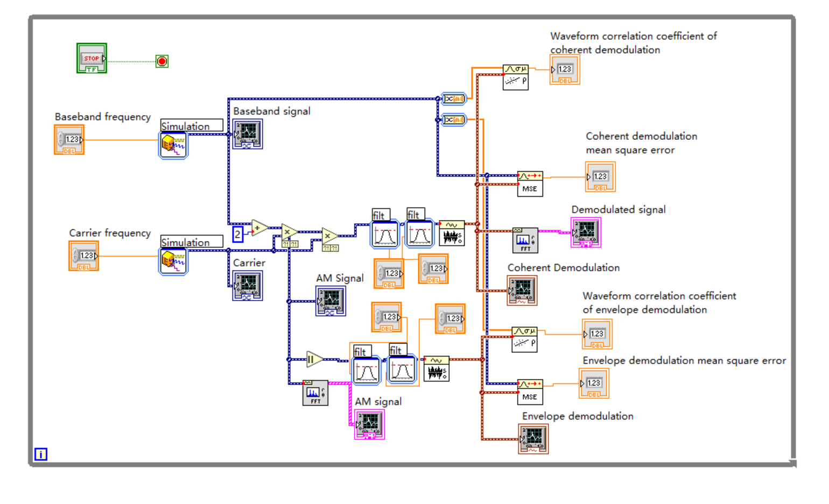
Figure 1. AM signal demodulation program flowchart (Picture credit: Original)

Demodulation of DSB Signal
In the DSB coherent demodulation procedure, DSB modulation is first performed to generate a DSB signal, which is then passed through a multiplier, a low-pass filter, a high-pass filter, and a normalization function in sequence to achieve coherent demodulation. Since the signal output by the low-pass filter only contains baseband components, the role of the high-pass filter is only to compensate for the phase.
In the DSB envelope demodulation program, a large-amplitude carrier signal is first added, then the adder output signal is envelope demodulated, and finally the amplitude of the demodulated signal is normalized by the normalized waveform function. Similarly, the demodulation process is presented using the waveform graph VI, and the demodulation effect is evaluated using the mean square error and correlation coefficient between the baseband signal waveform and the demodulated signal waveform. The result is presented on the front panel through the numerical display controls, and the spectra of the DSB signal and the demodulated signal are analyzed using the FFT function and displayed using the waveform graph VI. The specific program flowchart is shown in Figure 2.

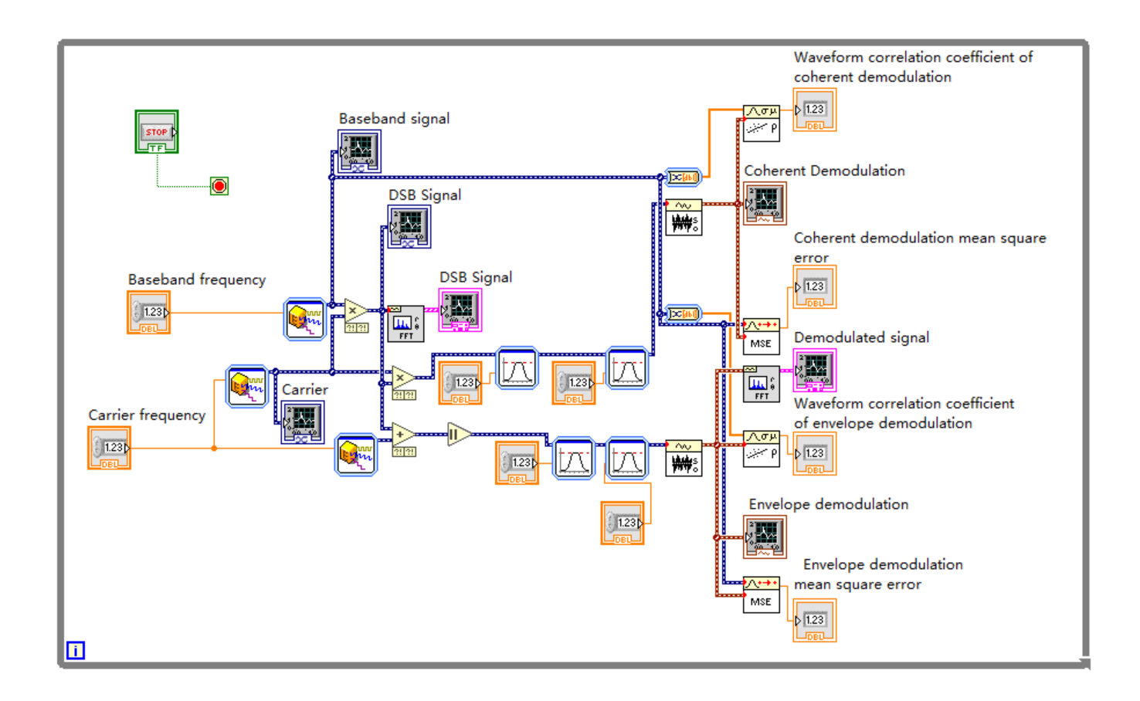
Figure 2. DSB signal demodulation program flowchart (Picture credit: Original)

LabVIEW Simulation Results
Before simulation, input the frequencies of the simulation signals and the parameters of the filters on the front panel input controls according to the theory, and then observe the waveforms for fine-tuning. The signal demodulation simulation results are shown in Figures 3 and 4.

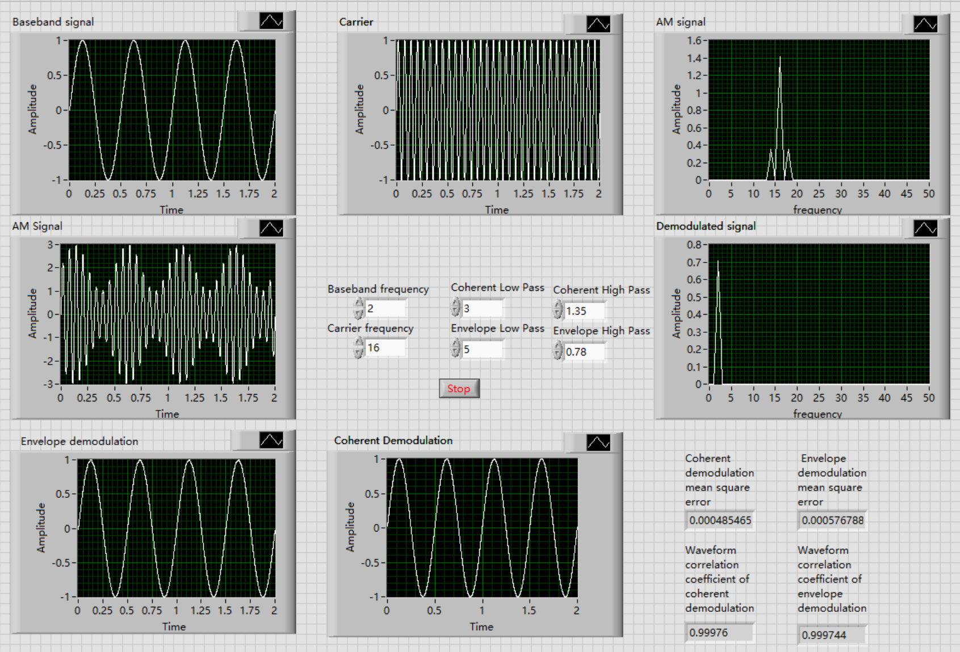
Figure 3. Simulation results of AM signal coherent demodulation and envelope demodulation (Picture credit: Original)

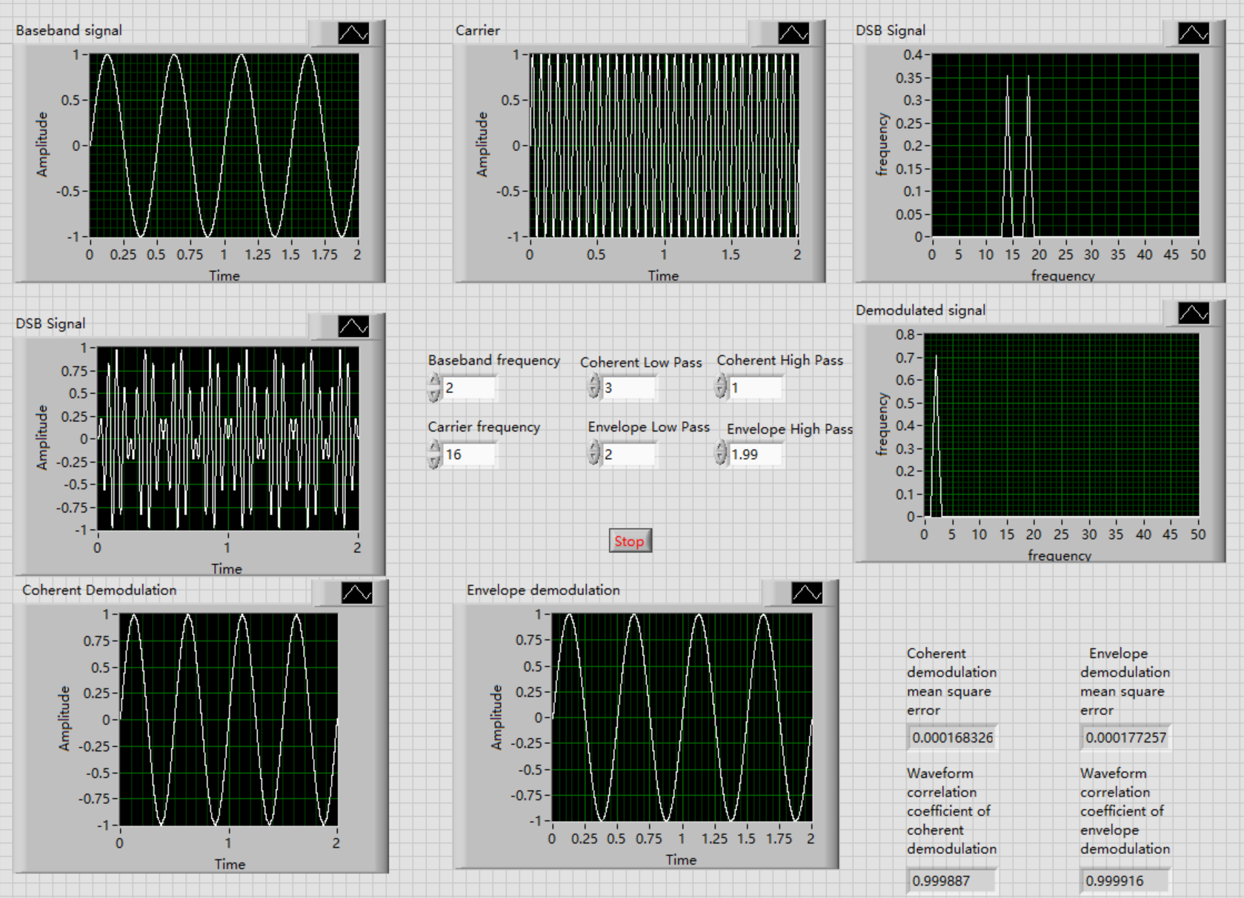
Figure 4. Simulation results of DSB signal coherent demodulation and envelope demodulation (Picture credit: Original)

As can be seen from the waveform diagrams, in the demodulation process of the two signals, both coherent demodulation and envelope demodulation successfully extracted the baseband signal components. As can be seen from the spectrum diagrams, the demodulation process successfully restored the high-frequency DSB and AM signals to the low-frequency original signals, removed the 16Hz carrier frequency, and completed the signal demodulation function. The experimental results show that the mean square errors between the demodulated signals and the original signals reach the order of${ 10}^{-4}$, and the correlation coefficients are close to 1, indicating that the demodulation process has a high degree of restoration of the original signal.

CONCLUSION
This paper designs a coherent and envelope demodulation system for AM and DSB signals based on LabVIEW. Users can better understand the principles of the above two demodulation methods by observing and comparing the waveforms and spectrum diagrams on the front panel. The program flowchart on the back panel clearly shows the general process of signal demodulation, which is convenient for users to analyze. The system has an excellent demodulation effect and a clear and intuitive human-computer interface, which is suitable for teaching and scientific research.
Finally, the demodulation methods studied in this paper are relatively basic. In the future, more demodulation methods such as differential coherent demodulation and maximum likelihood demodulation can be studied and simulated.

References
- Y. N. Bao, et al, "Stable successive Neural Image Compression via coherent demodulation-based transformation," in Signal Processing, pp. 227.
- Z. Y. Wang, et al, "Coherent demodulated underwater wireless optical communication system based on convolutional neural network," in Optics Communications, pp. 534.
- J. Wang, et al, "Performance analysis of Radar detection for fluctuating targets based on coherent demodulation," in Digital Signal Processing, pp. 122.
- B. Manuel, et al, "Comparison of envelope demodulation methods in the analysis of rolling bearing damage" in Journal of Vibration and Control, 2023, 29(21-22), pp. 5009-5020.
- B. Bai, “Research on Separation Method of Moiré Signals Feature of Turntable Based on Demodulation” Ph.D. thesis, China Jiliang University, 2022.
- J. H. Zhang, “Design of Modulation and Demodulation Scheme Based on Miniaturized Acoustic Excitation Antenna” Ph.D. thesis, Xidian University, 2023.
- O. Adrian, O. Serban, “Virtual LabVIEW” in IJMERR, 2017, 6(3), pp.170-177.
- Y. Li and Z. G. Feng, “Design of Virtual Experiment Platform for Communication Principle Based on LabVIEW”, in Modern Information Technology, 2023,7(01), pp. 182-185+190.
- P. T. Yang, “Fatigue Diagnosis of marine bearing based on LabVIEW”, Ph.D. thesis, Huazhong University of Science and Technology, 2017.
- Y. Kim, J. Park, and H. Kim, “Signal-Processing Framework for Ultrasound Compressed Sensing Data: Envelope Detection and Spectral Analysis” in APPLIED SCIENCES-BASEL, 2020, 10(19), pp. 6956.

