Optimization Research on Dispersion Compensation in Wavelength-Division Multiplexing
Jiayue Xue
China University Of Petroleum(East China), College Of Science, Qingdao, Shandong, China
Corresponding author: 2209030203@s.upc.edu.cn
Abstract. Through theoretical analysis of the dispersion compensation mechanism, a single-pulse and multi-channel simulation model is constructed by combining with the OptiSystem platform. The fiber parameters (length, dispersion coefficient) are optimized to achieve the goal of making the total dispersion approach zero. The experimental results show that in a 16-channel Dense Wavelength Division Multiplexing system that features a channel spacing of 0.1THz, after compensation, the Bit Error Rate of each channel is lower than 10⁻⁹, the Q value is ≥ 6.5 (the Q value of the edge channel is ≥ 10), and there is no crosstalk phenomenon in the system. The research further proposes a DCF (Dispersion Compensating Fiber) configuration strategy applicable to different transmission scenarios, verifies the effectiveness of the dispersion compensation technology in improving the signal quality of optical fiber communication systems with long transmission distances and large capacities, and provides a theoretical basis and technical support for engineering deployment.

INTRODUCTION
Wavelength Division Multiplexing (WDM) is a technology for multiplexing multiple optical signals of different wavelengths in the same optical fiber [1]. With the widespread application of WDM technology and the continuous increase in data transmission rates, losses [2], dispersion [3], and nonlinear effects [4] in optical fiber transmission have become three important factors affecting signal quality and system performance. Due to these factors, optical signals experience pulse broadening during long-distance transmission, causing intersymbol interference, increased bit error rate, signal distortion, and degrading transmission performance. Erbium-doped fiber amplifiers have solved the loss problem in communication systems, making the optimization of dispersion compensation in WDM systems crucial for improving signal transmission quality, extending transmission distance, and increasing system capacity [5].
This paper aims to optimize the dispersion compensation technology in WDM systems. By theoretically verifying the compensation mechanism of Dispersion Compensating Fiber (DCF) and constructing single-pulse and multi-channel simulation models with the OptiSystem platform [6], fiber parameters (length, dispersion coefficient) are optimized to make the total dispersion approach zero. The performance indicators of a multi-channel Bit Error Rate (BER) below 10⁻⁹ and a Q value ≥ 6.5 (≥ 10 for edge channels) [7] are finally achieved. The study further validates the feasibility and crosstalk-free characteristics of the dispersion compensation scheme in a 16-channel Dense Wavelength Division Multiplexing (DWDM) system (channel spacing of 0.1 THz) and proposes compensation configuration strategies for different transmission scenarios, providing theoretical and technical support for improving the signal quality and engineering deployment of long-distance and large-capacity optical fiber communication systems.
The first chapter of the paper expounds on the research background of WDM technology, the challenges of the dispersion problem, and the research significance. The second chapter systematically analyzes the dispersion compensation principle of the WDM system, including DCF technology, optical transceiver module design, and the WDM system simulation scheme. The dispersion compensation effect is verified by OptiSystem simulation, the performance indicators of single-pulse and multi-channel systems are compared and analyzed, and the limitations and improvement directions of the scheme are discussed based on the experimental results. The third chapter summarizes the research achievements of the full text and looks forward to future development directions.

DISPERSION COMPENSATION FOR DIVISION MULTIPLEXING SYSTEMS

WDM System
WDM is an optical fiber communication technology. By simultaneously transmitting multiple optical signals of different wavelengths on the same optical fiber, it improves the transmission capacity of the optical fiber communication system. Each wavelength carries an independent signal, enabling the parallel transmission of multiple channels of information in a single optical fiber. The basic principle of a WDM system is to utilize suitable optical devices to multiplex multiple optical signals with varying wavelengths and inject them into the optical fiber. After being transmitted through the optical fiber, the signals of each wavelength are separated by a demultiplexing device and restored into independent signals for processing [8].
A WDM system is usually composed of a light source, optical fiber, multiplexer (MUX), demultiplexer (DEMUX), receiver, and amplifier. Laser diodes are commonly used as light sources, which stably generate monochromatic light of different wavelengths with high brightness and high frequency through different modulation techniques. As the transmission medium of the WDM system, the optical fiber plays a role in transmitting optical signals. The characteristics of the optical fiber directly affect the performance of the WDM system, mainly including low loss, wide bandwidth, and low dispersion, etc. Multiple optical signals of different wavelengths are combined into a single optical fiber for transmission by making use of the multiplexer, while the demultiplexer separates these signals of different wavelengths at the receiving end for separate processing. The receiver receives the signals transmitted through the optical fiber and converts them into electrical signals, and it can amplify, demodulate, and decode the received signals to restore the original information. In long-distance transmission, the optical signals will attenuate, and optical amplifiers are used to enhance the intensity of the optical signals. A commonly used optical amplifier is the Erbium-doped Fiber Amplifier (EDFA) [9], which can effectively amplify signals of multiple wavelengths.
In a wavelength division multiplexing system, the dispersion of the optical fiber results from the fact that light waves of varying frequencies propagate at different speeds within the fiber. Dispersion will lead to the broadening of optical pulses, causing signal interference and reducing the transmission quality.

Dispersion Conpensated Fibers
The optical signals of different wavelengths have different speeds during the propagation process. Over a relatively long propagation distance, this will lead to the phenomenon of dispersion, causing the waveform of the signal to expand, reducing the transmission quality, and even resulting in data transmission errors.
The Dispersion Compensating Fiber (DCF) is a special type of optical fiber with dispersion characteristics opposite to those of communication optical fibers. Through specific design, its function is to compensate for the waveform expansion caused by dispersion. It can restore the signal state to a certain extent and reduce signal distortion and the bit error rate [10]. In order to change the dispersion characteristics, DCF adopts two ways, that is, reducing the radius of the core and increasing the refractive index difference between the core and the cladding. When the conventional standard single-mode fiber shows a positive dispersion coefficient, a section of fiber with negative dispersion coefficient is introduced, and the total dispersion can be zeroed by adjusting the dispersion coefficient and length of the fiber reasonably.
Based on the above content, the basic optical fiber dispersion compensation system shown in Fig.1 is simulated using OptiSystem. This system designs the dispersion broadening and compensation of a single pulse. The designed input signal frequency is 193.1 THz, and the input power is 1 mW. After this signal passes through a single-mode fiber (SMF) with a dispersion coefficient of 16 and a length of 12 kilometer, theoretically, the phenomenon of signal spectrum broadening will occur. Therefore, a section of optical fiber with a dispersion coefficient of -96 and a length of 2 kilometer is added behind the system to make the total amount of signal dispersion zero, so that the dispersion is compensated and the signal is restored to its original shape.
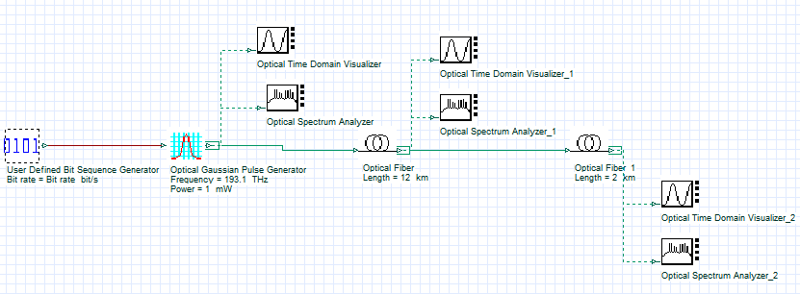
FIGURE 1. Dispersion Compensated Fiber Optic System

Fig.2 shows the signal spectrum diagrams in the time domain. Fig.2.a represents the initial signal, Fig.2.b is the spectrum of the signal after passing through the single-mode fiber, and Fig.2.c is the spectrum of the signal after passing through the dispersion compensating fiber. It can be observed that after the signal passes through the single-mode fiber, the spectrum broadening occurs, that is, the dispersion phenomenon. After passing through the dispersion compensating fiber, the dispersion is offset, and the signal returns to its initial state, which is in line with the theoretical expectations.

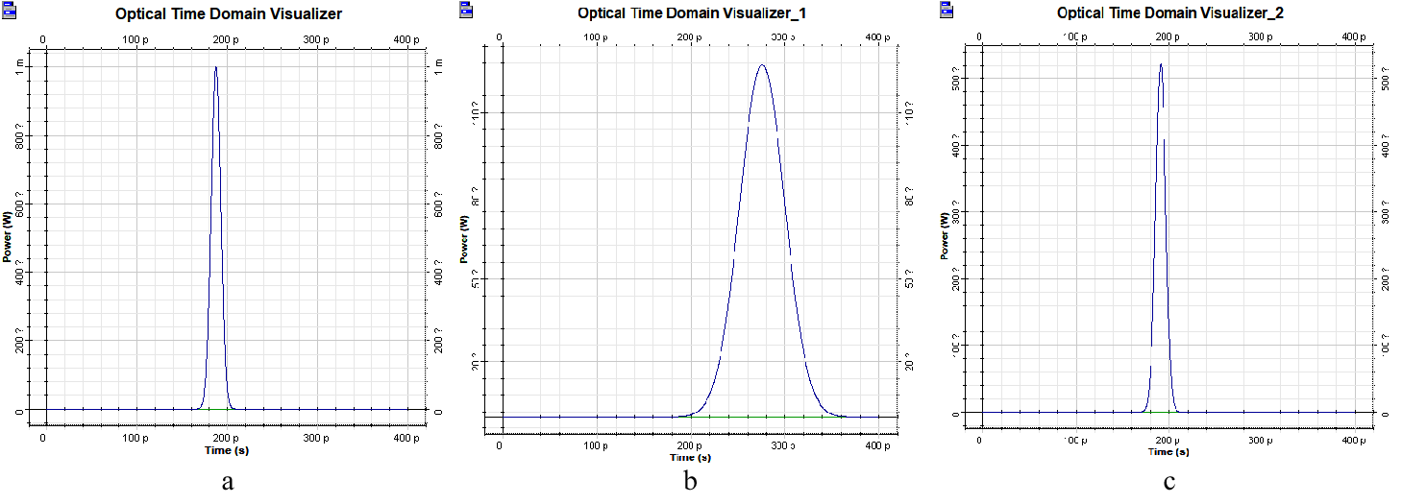
(a) | (b) | (c)
FIGURE 2. (a) The Initial Signal; (b) The Signal after passing through the Single-mode Fiber; (c) The Signal after passing through the DCF

The Design Of The WDM System

The Design Of The Optical Transmitter
The module design of the optical transmitter is shown in Fig.3.a. The bit sequence generated by the pseudo-random bit sequence generator is used as the input signal. After shaping, it is converted into a Non-Return-to-Zero (NRZ) pulse signal and input into the Mach-Zehnder modulator, which modulates the continuous-wave optical signal emitted by the laser with an output frequency of 193 THz and a power of 1 mW (0 dBm). The final waveform of the single channel is shown in Fig.3.b.
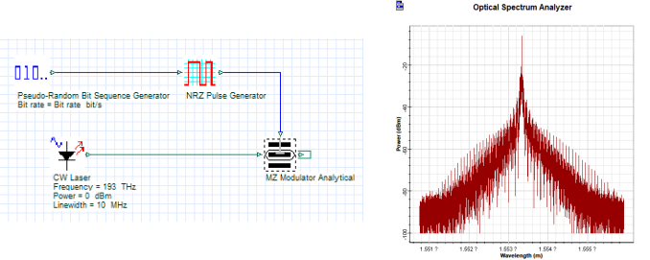
(a) | (b)
FIGURE 3. (a) Optical Transmitter Module; (b) Single-channel Waveform

The Design Of The Optical Receiver
The design of the optical receiver is shown in Fig.4, which is composed of a PIN diode, a low-pass Bessel filter, and a 3R regenerator. It is then connected to a bit error rate analyzer, which is used to analyze the transmission performance of the system. The PIN diode is responsible for converting the incident optical signal into an electrical signal. The low-pass Bessel filter filters out high-frequency noise and interference to reduce signal distortion. The 3R regenerator recovers and reshapes the electrical signal, further improving the signal-to-noise ratio.
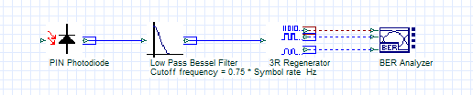
FIGURE 4. Optical Receiver Module

The Design Of The WDM System
The simulation design structure diagram of the WDM system is shown in Fig.5. At the transmitting end, sixteen optical signals with an optical power of 1 mW (0 dBm), an output frequency ranging from 193.0 THz to 194.5 THz and a spacing of 0.1 THz are multiplexed and transmitted into the optical fiber line. These signals are transmitted through a single-mode optical fiber measures 100km in length and has a dispersion coefficient of 16.75 ps/nm/km to an optical amplifier featuring a gain coefficient of 20 dB, and then connected to a section of dispersion compensating fiber with a length of 19.7 km and a dispersion coefficient of -85 ps/nm/km. After the multiplexed signals are transmitted into the demultiplexer, they are divided back into sixteen signals again. The PIN diodes are used for photoelectric conversion, and the low-pass Bessel filter serves the purpose of eliminating noise and interference. At the receiving end, a Bit Error Rate (BER) analyzer is connected to analyze the performance of the system.
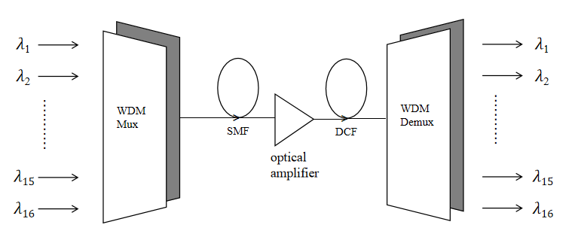
FIGURE 5. Schematic Diagram Of The Simulation Structure Of The WDM System

The results of the bit error rate analyzers for channels 1, 2, 8, 9, 15, and 16 are shown in Fig. 6:
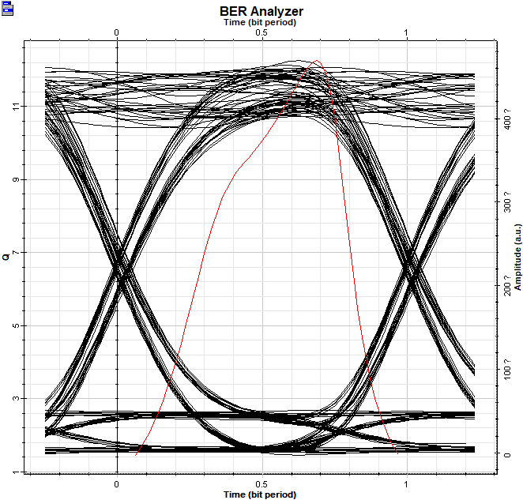 | 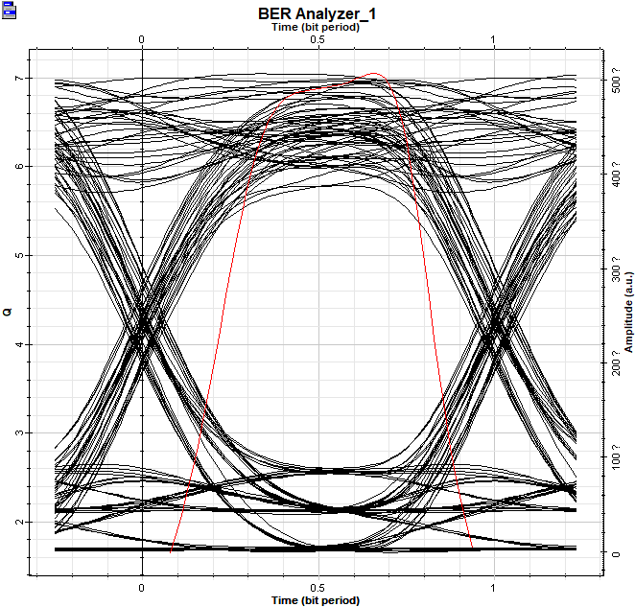 | 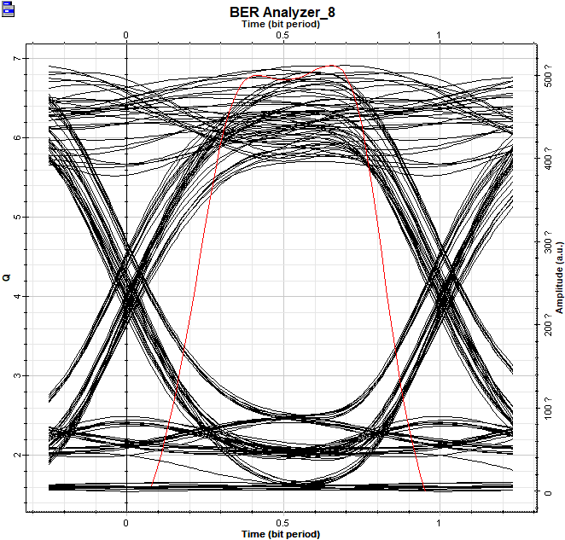
(a) | (b) | (c)
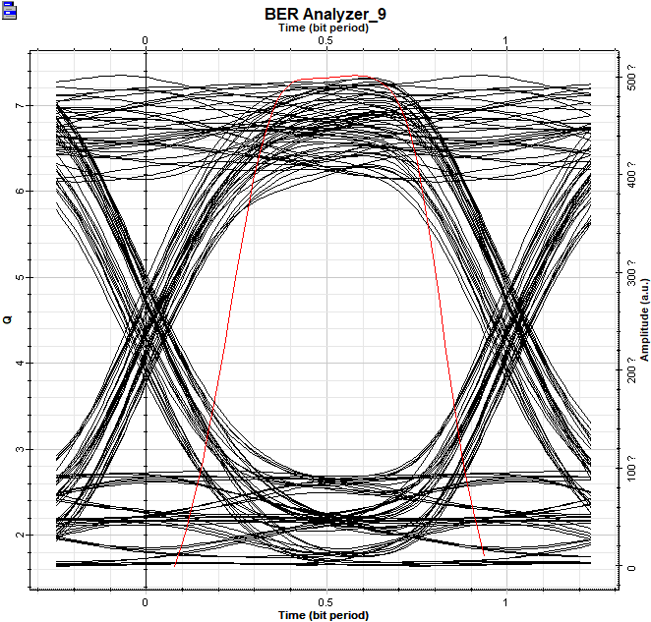 | 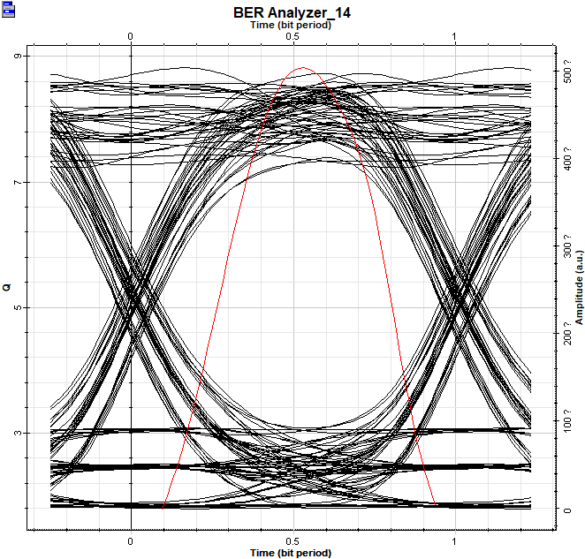 | 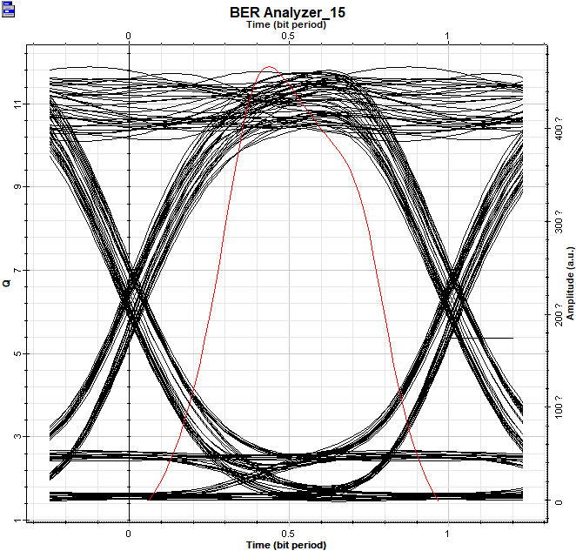
(d) | (e) | (f)
FIGURE 6. (a) Eye Diagram Of Channel 1; (b) Eye Diagram Of Channel 2; (c) Eye Diagram Of Channel 8;
(d) Eye Diagram Of Channel 9; (e) Eye Diagram Of Channel 15; (f) Eye Diagram Of Channel 16

The results of the bit error rate analyzer show that the Q value of each channel is above 6.5, indicating that the overall signal quality is good. Among them, the Q values of Channel 1 and Channel 16 reach above 10, indicating that the signal transmission at both ends is very clear. The bit error rate of all channels is lower than 10⁻⁹, which is significantly reduced compared to the case without the dispersion compensating fiber. It can be considered that the system achieves better signal transmission performance after the dispersion compensating fiber is added.

CONCLUTION
This study verifies the effectiveness of the dispersion compensation scheme based on DCF in the wavelength division multiplexing system through theoretical modeling and simulation experiments. The optimized system achieves that the total dispersion approaches zero, the bit error rate of multiple channels is lower than 10⁻⁹, the Q value meets the requirements of communication standards, and the performance of the edge channels is significantly improved. In addition, the DCF parameter configuration strategy proposed in this study provides a flexible technical reference for different transmission scenarios.
There are still some deficiencies and limitations in the simulation of this paper. For example, idealized sinusoidal wave signals are used in the simulation, without considering the nonlinear effects (such as four-wave mixing) in actual optical fibers and the interference from complex environments (such as temperature fluctuations). Secondly, the DCF compensation relies on the precise matching of dispersion coefficients, and the deviation of optical fiber parameters in actual engineering may lead to a decline in the compensation effect.
In the future, in-depth research can be carried out in the direction of combining Chirped Fiber Bragg Grating (CFBG) and Electronic Dispersion Compensation (EDC) to improve the compensation accuracy in complex scenarios. Moreover, models of nonlinear effects and temperature influences can be introduced to optimize the comprehensive performance of the long-distance transmission system.

References
- Zhao Fengxia, Liu Yongjing. Research on WDM Optical Network Technology and Development [J]. China New Communications, 2020, 22(16): 77.
- Chakresh K ,Ghanendra K .Enhancement of Signals Characteristics with Least Effect of Optical Communication Losses for Dense Optical Communication Systems[J].Journal of Optical Communications,2019,0(0):113-117.
- Liu Xiaolei, Xiong Xuejuan. Performance analysis of photoelectric dispersion compensation technology based on OptiSystem[J].Electronic Measurement Technology,2017,40(11):114-119.
- Gopalan R S ,Chandran H ,Ranganath S B , et al.Nonlinear effects on WDM optical communication system[J].Journal of Optical Communications,2024,45(4):845-852.
- Tamer F.Hussein,M. R. M. Rizk,Moustafa H. Aly. A hybrid DCF/FBG scheme for dispersioncompensation over a 300 km SMF[J]. Optical and Quantum Electronics,2019,51(4).
- Wang Yuhan. Design and Simulation of WDM System Based on OptiSystem[J]. Software, 2022, 43(07): 151-154.
- Li Junqi. Optimization of DCF Dispersion Compensation Scheme Based on New Modulation Format [D]. Shenyang: Shenyang University of Technology, 2019
- Ghosh C, Vishnu P. Suppression of four-wave mixing in a 22 x 10 Gbps dense wavelength division multiplexed system by linearly chirped fiber bragg gratings[J]. Optic Quantum Electron, 2019, 51(1):1-14.
- Rashed Z N A ,Altahan R B ,Manasavenna T , et al.Design and analysis of high-speed data optical fiber communication system through EDFA amplifier system[J].Journal of Optical Communications,2022,45(s1):s801-s810.
- Malek Z A ,Ariffin N S ,Hambali A N , et al.Optimization of Output Coupling Ratio for Multi-Wavelength Brillouin Fiber Laser Employing FBG and DCF as Gain Medium[J].Materials Science Forum,2016,3950(857-857):608-612.

