Based on Wavelength Division Multiplexing Technology in The Current Development of Optical Communication Applications
Zihao Han
College of Mechanical Engineering, University of shangye, Tianjin, China.

Corresponding author: hzh20050328@outlook.com
Abstract. With the increasing demand of optical communication for ultra-large capacity transmission, wavelength division multiplexing (WDM) is a technique that utilizes the simultaneous transmission of two or more optical signals of different wavelengths in the same fiber, the basic principle is to use the different wavelength of light, multiple optical signals are multiplexed at the sending end, and then these optical signals are separated by the demultiplexer at the receiving end, so as to realize the parallel transmission of multiple signals, can achieve ultra-large capacity transmission, and save fiber resources and other features, received wide attention from people. However, with the deepening of technical research, WDM technology has also encountered different problems, such as optical cable requirements, high demand for technology, cost issues and with the continuous increase of various functions, the development of drivers becomes more and more complicated. Then this paper will draw from recent years of experiments in transmission capacity, the transmission distance and transmission stability are compared, and discuss the future development direction.

introduction
With the development of The Times increasingly accelerated, the demand for communication in all fields is also growing, like city management, traffic monitoring, public safety, etc., need communication technology to provide support [1]. Therefore, it is urgent to solve the need for long-distance communication and save relay equipment and cost. Save fiber resources and realize ultra-large capacity transmission of optical communication, WDM Technology research will be the future trend, now the typical transmission capacity of single fiber based on WDM technology has reached 20 Tbit/s [2].WDM is a technology that multiplexes optical signals of different wavelengths into the same optical fiber for transmission. The basic principle is to take advantage of the difference in the wavelength of light, Multiple optical signals are multiplexed at the sending end, and then separated by the demultiplexer at the receiving end, so as to realize the parallel transmission of multiple signals [3]. In the WDM system, the optical signal generated by the light source is first modulated by the modulator, and then the multiple optical signals of different wavelengths are combined into one road through the multiplexer and sent to the optical fiber for transmission. At the receiving end, the optical signal is separated by the demultiplexer to separate the optical signal of each wavelength, and then restored to the original signal by the demodulator. WDM technology faces many challenges in its application, such as technical complexity, high requirements of optical cable and power supply. For example, in long-distance transmission, the loss and dispersion problems of optical cables need to be solved by new optical fiber materials and dispersion compensation technology.
In this paper, the technical complexity of WDM technology in the application, the high requirements of optical cable and power supply requirements are summarized. The advantages and disadvantages are compared from the aspects of transmission capacity, transmission distance and transmission stability, and the future development direction is expounded.

Methods to improve the efficiency of WDM system
In order to save fiber resources and realize ultra-large capacity transmission of optical communication, and test the influence of covariates on this mode, we start with WDM technology. By using the different wavelength of light, multiple optical signals are multiplexed at the sending end, and then separated by the demultiplexer at the receiving end, so as to realize the parallel transmission of multiple signals.

Increase transmission capacity
Among them, increasing transmission capacity is the mainstream method: Using the high-speed large-capacity short-range optical transmission system in the traditional OM2 fiber through the use of 80 channels (40 WDM channels ×2 mode channels) combined with PDM-16QAM signals to achieve a single channel rate of 480 Gbit/s, a total capacity of 38.4 Tbit/s data transmission, In addition, 2×2 MIMO is required for polarization demultiplexing at the receiving end. Finally, the bit error rate performance of 80 channels is measured, and the average bit error rate is lower than 20% soft decision forward error correction (2.7 ×10-2) [4]. Then the low-mode fiber transmission experimentIn this experiment, as shown in Figure 1, 32 GBaud 16QAM signals with two modes LP11a and LP11b are transmitted in two polarization directions of 80 wavelength channels by using WDM, PDM and MDM multiplexing technologies. The core algorithm of the experiment is MIMO equalization demultiplexing. When the total transmission length is 1000 km, the net rate of the system is still as high as 32.768 Tbit/s. After 1000km transmission through the test, the bit error rate of the two modes meets the 25% LDPC soft decision threshold (4.2 ×10-2) [5].In addition to the application of free space optical communication, the experiment uses a real-time multi-carrier free space optical coherent communication system, which uses a self-designed circuit board based on field programmable logic gate array (FPGA). The final experiment results achieve error-free transmission of 8×10Gb/s real-time spatial optical signal under 1m spatial optical channel. Under the limitation of 7% forward error correction code (FEC) overhead, the system receive sensitivity of close to -50dBm is achieved [6].

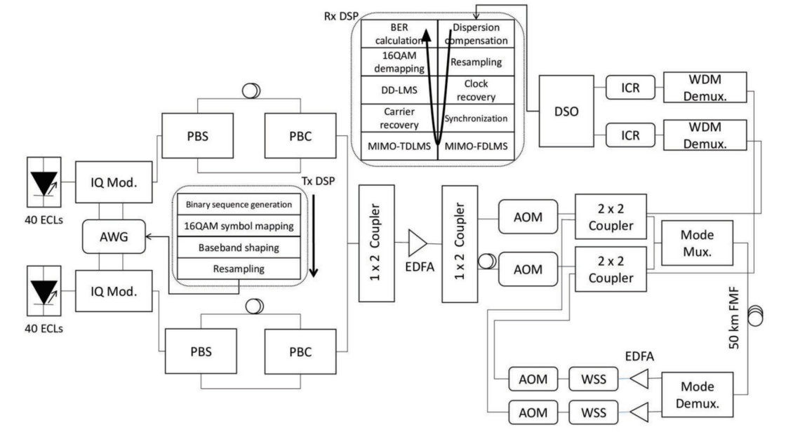
Figure 1 Experimental equipment

Improve the stability of the transfer
For example, in the optical fiber time-frequency transmission system studied, the method of dual-wavelength bidirectional comparison compensation at the remote end is adopted for time transmission, the method of single-wavelength pre-compensation is adopted for frequency transmission, and the method of phase detection and compensation is adopted at the local end, which meets the requirement of long-distance comparison between time-frequency datum with hydrogen atom clock as the punctual clock. The time-frequency simultaneous transmission test was carried out on the 102 km long field optical fiber link, and the 10 MHz frequency transmission with the stability of 3. 4 × 10-14@1 s and 1. 5 × 10-15 @104 s was achieved, as shown in Figure 2 [7].
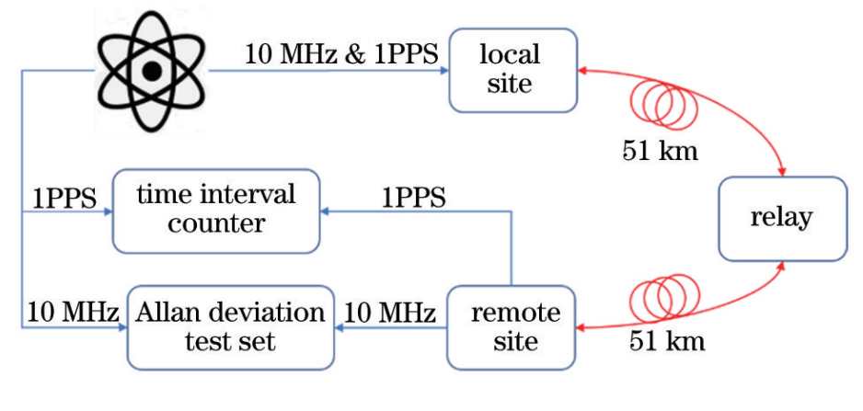
Figure 2 Fiber optic video transmission experiment

TABLE 1 Statistics of different experimental effects
Method | Year | Effects
High-speed large-capacity short-range optical transmission system with traditional OM2 fiber | 2024 | It achieves data transmission with a single channel rate of 480 Gbit/s and a total capacity of 38.4 Tbit/s
Photonic crystal optical division multiplexer | 2023 | The leakage of light wave on the main waveguide and the mode mismatch loss at the port are reduced, so that the insertion loss and the crosstalk of each end port are less than 0.51 dB and -29.54 dB respectively
Low-mode fiber transmission experiment | 2023 | When the total transmission length is 1000 km, the net rate of the system can reach 32.768 Tbit/s
Fiber optic time-frequency transmission system | 2023 | The time-frequency transmission test was carried out on a 102km long field optical fiber link, and the 10 MHz frequency transmission with stability of 3. 4 × 10-14@1 s and 1. 5 × 10-15 @104 s was achieved
Mode-wave division hybrid demultiplexer | 2021 | The demultiplexing function of TE0 and TE1 is realized at the wavelength lengths of 1570.0 nm and 1573.2nm, the insertion loss is less than 0.37dB, and the channel crosstalk is less than -18.4dB
Real-time multi-carrier free space optical coherent communication system | 2022 | Under 1m spatial optical channel, the system realizes error-free transmission of 8×10Gb/s real-time spatial optical signal

The photonic crystal optical division multiplexer is composed of two AubryAndreHarper (AAH) resonators and two photonic crystal waveguides. The structure model is established by coupling mode theory, and the structural parameters such as the reflection cavity are optimized. The crosstalk difference between the insertion loss and each end port is smaller than 0.51 dB and -29.54 dB, and the overall length of the device does not exceed 20μm and the spectral line width is only 0.2 nm, which has great potential in large-capacity communication systems [8]
In addition, the hybrid demultiplexer developed by other researches can be applied to the MOD-coarse wavelength division multiplexing system and photonic integrated circuit. The device consists of WDM module and MDM moduleThree-dimensional finite Difference Time domain (3D-FDTD) method was used for simulation analysis. The device can realize the demultiplexing function of four basic mode (TE0) and first-order mode (TE1) channels at the wavelength of 1570.0nm and 1573.2nm, and the insertion loss is less than 0.37dB, in which the main source is from two parts, including the loss in the WDM module (0.28dB) and loss (0.1dB) in the MDM module, channel crosstalk is less than -18.4dB, free spectral range can reach 400nm, and device size is about 85μm×12μm [9].The final results of the said experiment are summarized as shown in Table 1.
Among them, comparing the transmission capacity under different distances, the high-speed large-capacity short-range optical transmission system of traditional OM2 fiber has the highest total capacity of 480 GBIT/S × 80 = 38.4 TBIT/S in the transmission system research of traditional multi-mode fiber. And greatly reduce the calculation amount only 2×2 MULTIPLE INPUT MULTIPLE OUTPUT (MIMO) algorithm to complete the polarization demultiplexing, without the corresponding digital signal processing algorithm. But only over short distances. Compared with the high-speed large-capacity short-range optical transmission system of traditional OM2 fiber, the transmission distance is greatly improved in the low-mode fiber transmission experiment, and the transmission capacity is also at the leading level. However, due to the use of three composite methods, the types of calculation algorithms are complicated and crosstalk is very serious. There is also the application of free space optical communication. Under the 1M spatial optical channel, the system realizes the error-free transmission of 8×10GB/S real-time spatial optical signal. Compare the orthogonal frequency division multiplexing (OFDM) transmission system with a transmission rate of 10GB/S over a 2.5KM free space optical link [10]. The amount of computation is greatly increased, but the distance is shortened a lot. In terms of transmission stability, the optical fiber time-frequency transmission system on the 102 KM long field optical fiber link, The 10 MHZ frequency transmission with a stability of 3. 4 × 10-14@1 S and 1. 5 × 10-15 @104 S was realized. The experimental results published in 2019 showed that the stability fraction on the 110 KM optical fiber chain road was 1.7 × The 1GHZ frequency transmission of 10-14@1S and 5.9 × 10-17@104S has little difference in transmission distance and smaller stability. The experimental results show that the insertion loss and crosstalk of each port are less than 0.51 DB and -29.54 DB respectively, and the insertion loss of MOD-WDM is less than 0.37DB and the crosstalk of channel is less than -18.4DB, In general, it is larger than the MOD-WD hybrid demultiplexer, but the size is smaller than the MOD-WD hybrid demultiplexer.

CONCLUSION
In this paper, the advantages and disadvantages of different experiments are obtained by comparing different transmission capacity, transmission distance, stability, insertion loss and each end crosstalk. Which transmission capacity and distance, The high-speed large-capacity short-range optical transmission system of traditional OM2 fiber has the highest transmission capacity, less computation, but shorter distance. Low-mode fiber transmission experiment, transmission distance is long, transmission volume is large, but the calculation amount is also increased. To sum up, the future research direction of the high-speed large-capacity short-range optical transmission system of traditional OM2 fiber is to improve the transmission distance while maintaining the transmission capacity, and it is suggested to try to use OM3 or OM4 fiber. The experiment of low-mode fiber transmission is to reduce the computation while maintaining the transmission quantity and transmission distance.

References
- Current situation and trend of modern Wireless Communication technology [J]. Electronic Technology and Software Engineering, 2021, 10: 23-24.
- Zhao W Y. High Speed optical transmission technology and standardization progress [J]. Information and Communication Technology and Policy, 2020, 46(8): 5.
- Wang Chuanlin, Yu Chongxiu, Xin Xiangjun, et al. Principle and application of wavelength division multiplexing Technology and key Components in optical communication [J]. Physics, 2002, 31(09)
- Yu Xinguo, Li Jianping, Qin Yuwen, et al. Research on Large-capacity MODM Transmission System based on traditional OM2 fiber [J]. Acta Electronica Sinica, 2024, 52(7): 2461-2467.
- Ju Zhou, Wang Chen, Wang Kaihui, et al. A 32.768 Tbit/s net rate 1000 km low-mode fiber WDM system [J]. Acta Optica Sinica, 2023, 43(10): 1006004-1006004-8.
- Ao Xueyuan, Yang Qi, Dai Xiaoxiao, et al. Research on real-time free space optical communication [J]. Chinese Journal of Lasers, 2022, 49(12): 1206004-1206004-8.
- Li Bo, Xue Yanrong, Kong Weicheng, et al. Time-frequency transmission method of high precision fiber based on Wavelength division multiplexing [J]. Acta Optica Sinica, 2023, 43(7): 0706001-0706001-7.
- Hu Yuchen, Chen Heming. Photonic crystal optical diplex multiplexer for dense wavelength division multiplexing systems [J]. Acta Optica Sinica, 2023, 43(2): 0223002-0223002-10.
- Pan Wanle, Chen Heming, Zhuang Yuyang, et al. A hybrid MOde-wave division demultiplexer based on nanowire waveguide and one-dimensional photonic crystal nanobar cavity [J].Acta Optica Sinica, 2021, 41(4): 0413001.
- Cvijetic N, Qian D, Wang T. 10Gb/s free-space optical transmission using OFDM[C]//Optical Fiber Communication Conference. Optica Publishing Group, 2008: OThD2.

