The Research on Wavelength Division Multiplexers and Optical Amplifiers in Wavelength Division Multiplexing
Buwei Guo
School of Communication Engineering, XiDian University, Xi`an, China

24019100321@stu.xidian.edu.cn
Abstract. WDM(Wavelength Division Multiplexers ) and optical amplifiers work collaboratively in Wavelength Division Multiplexing systems. The WDM enables the simultaneous transmission of multiple optical signals with different wavelengths over a single optical fiber, while the optical amplifiers amplify these optical signals of varying wavelengths, facilitating efficient and long-distance optical signal transmission. This paper introduces the composition, principles, and functionalities of the key components in WDM systems - WDM and optical amplifiers. Through a comprehensive comparison of the performances of AWG(Arrayed Waveguide Gratings) and MRR(Micro-Ring Resonators) in WDM, as well as EDFA(Erbium-Doped Fiber Amplifiers), SOA(Semiconductor Optical Amplifiers), and FRA (Fiber Raman Amplifiers), it's more accurate to refer to it generally as "Raman Amplifiers" or specify as "Fiber Raman Amplifiers" if necessary, but "FRA" is understandable in context in optical amplifiers, the paper highlights their respective advantages and disadvantages, underscores their vital roles in WDM systems, and ultimately proposes solutions to existing problems and offers future prospects for this technology.

INTRODUCTION
With the widespread application of cloud computing technology, its demand for bandwidth has witnessed explosive growth. As can be clearly seen from the relevant cloud computing demand curve graph, the volume of data has been increasing exponentially over the past few years. Meanwhile, due to the rapid development of AI technology, the demand for computing power has surged dramatically. The AI training and inference processes require handling massive amounts of data, which is reflected in the AI computing power demand curve graph as a steeply rising line [1]. This has led to an unprecedentedly enormous bandwidth pressure on data center interconnections, necessitating more efficient communication technologies. Regarding how to conserve optical fiber resources and enhance network transmission efficiency, the emergence of wavelength division multiplexing technology, as an efficient optical fiber communication technology, has been widely applied in modern communications.
This paper will discuss the composition, principles, and operational advantages of wavelength division multiplexers (arrayed waveguide gratings and micro-ring resonators) and three kinds of optical amplifiers in wavelength division multiplexing. By comparing their similarities and differences, the paper will highlight the significant roles they play in wavelength division multiplexing systems. Additionally, it will point out the existing issues in various technologies, propose solutions to address these problems, and provide an outlook for future development, thereby helping readers gain a better understanding of this technology.
The first part introduces the working principles and advantages of two types of wavelength division multiplexing units in wavelength division multiplexing technology -- arrayed waveguide gratings and micro-ring resonators, and points out their respective issues. Through cascading effects, they enhance signal transmission efficiency in wavelength division multiplexing. The second part introduces another device -- optical amplifiers which are crucial in wavelength division multiplexing. This paper mainly elaborates on the working principles and respective advantages of three kinds of optical amplifiers. These various optical amplifiers collaborate, leveraging their individual strengths to significantly reduce signal loss. Finally, the paper summarizes the existing problems in the application of wavelength division multiplexers and optical amplifiers in wavelength division multiplexing technology, and proposes improvement methods and directions for future development.

RESEARCH PROGRESS of WAVELENGTH DIVISION MULTIPLEXERS
Common unit wavelength division multiplexers include AWG and MRR, which play significant roles in WDM systems and can achieve more functionalities through cascading [2]. The following TABLE 1 introduces some important research progress on arrayed waveguide gratings.

Arrayed Waveguide Gratings
TABLE 1. Important Research in the Development of AWG

Time | Method | Research achievements
2004 |  | To realize the wavelength demultiplexing function of 34 channels [3]
2006 | The two free propagation zones of the AWG overlap | Ultra-compact AWG Demultiplexer Layout [4]
2006 | Introduction of curved waveguides inserted in the arrayed waveguide region | Design a super miniaturized AWG[5]
2018 | Laser direct writing lithography | An AWG with a central wavelength of 850 nm and a channel spacing of 1 nm was prepared [6].
2023 | based on silicon-on-insulator (SOI) platform (N+3) × (N+3) array waveguide grating | A wavelength division multiplexer with 81 channels and a channel wavelength spacing of 0.4 nm was demonstrated using 32 × 32AWG [7].
2004 |  | The application of dynamic gain equalizers and variable optical attenuators (VOA) in thermally unheated and high contrast waveguides and AWGs, MUX/DEMUX.

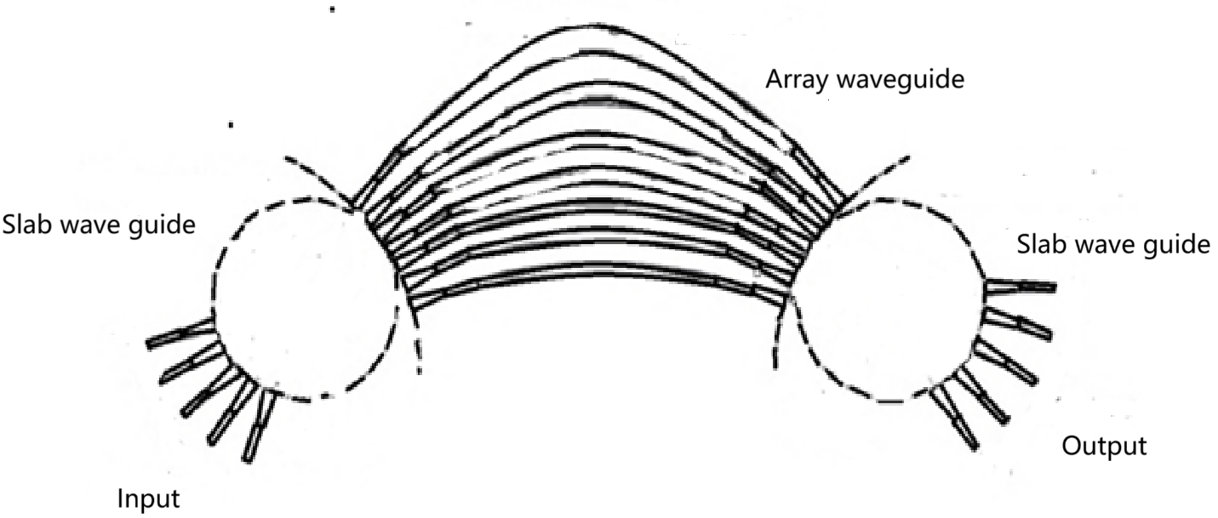
Figure 1. Schematic diagram of the Arrayed Waveguide Grating (AWG) structure
As shown in the structural schematic diagram of Figure 1: Arrayed Waveguide Gratings consist of input/output rectangular channel waveguides, planar waveguides, and arrayed waveguides [3]. Their operating principle is based on the dispersion characteristics and interference effects of optical waveguides. When an optical signal passes through an optical waveguide, due to the different propagation speeds of light of various wavelengths within the waveguide, i.e., the presence of dispersion, different wavelengths of light will experience different transmission delays. AWG utilizes this property to separate the input optical signal by wavelength. Moreover, when optical signals of different wavelengths meet at the output waveguide, interference occurs. By rationally designing the length of the optical waveguides and the spacing between the waveguides, interference can be produced for optical signals of different wavelengths at the output waveguide, thereby achieving wavelength separation and demultiplexing. However, traditional AWGs have certain limitations in terms of integration density and power consumption. With increasing demands for wavelength division multiplexing systems, they struggle to meet the growing needs. For instance, in large-scale integration applications, issues related to size and power consumption gradually become prominent. This necessitates a better wavelength division multiplexer to address these problems.

Microring Arrays
By utilizing microring resonators, multiple microring arrays are coupled with a bus waveguide, achieving four-channel and eight-channel wavelength division multiplexing functionality. This low-loss tunable ring-shaped wavelength division multiplexing filter is beneficial for enhancing the bandwidth density of silicon photonics interconnects.

The advantages of the combined effect of AWG and MRR
Cascading the design of AWG and MRR can achieve higher integration in terms of integration, reducing the system volume; in terms of power consumption, it is lower compared to traditional solutions, while ensuring advantages such as narrow linewidth, good stability, and low loss, bringing better performance to wavelength division multiplexing systems [3].

DEVELOPMENT of OPTICAL AMPLIFIERS
In the traditional signal transmission process, it is necessary to go through an optical-electrical-optical conversion, which often causes a decrease in the Signal-Noise Ratio. However,the attenuated signal can be directly amplified by light optical amplifiers without such a conversion. This article mainly introduces the first type, which is the erbium-doped fiber amplifier, the second type is the semiconductor amplifier, and the last type is the Raman fiber amplifier. The principles of the first two types are both to achieve gain effects by continuously transitioning carriers to produce stimulated radiation [9,10].

Fiber Amplifier
As shown in Figure 2, the pumping mechanism of the erbium-doped fiber amplifier：Er-doped fiber amplifiers work by incorporating erbium (Er) which is a trivalent metallic element of the rare earth group into the core of a silica fiber, forming an erbium-doped fiber. Under the influence of pumping light, Er3+ ions transition to a higher energy level. When stimulated by the signal light, they transition back to the ground state, emitting photons . This process makes the number of photons increase, thereby amplifying the signal[11]. Particles in the metastable state will spontaneously emit to the ground state when the signal light is being amplified. Additionally, this spontaneous emission is intensified, causing noise and pump light depletion.[12,13]. Therefore, suppressing spontaneous emission noise is an important research direction for Er-doped fiber amplifiers.
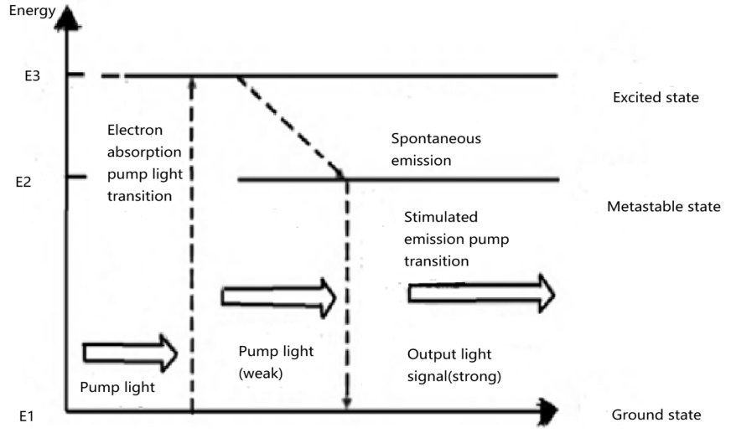
Figure 2. An erbium-doped fiber amplifier's pumping mechanism

After reviewing the current state of research both domestically and internationally, it has been found that research on erbium-doped fiber amplifiers mainly focuses on the following aspects: improving amplifier performance by enhancing the gain, noise figure, and power conversion efficiency of erbium-doped fiber amplifiers. Seeking to achieve higher output power and energy, exploring new fiber core structures and materials, and researching fiber amplifiers that can cover the C+L bands. While research on erbium-doped fiber amplifiers has made certain progress, there are still shortcomings that require further study.

Semiconductor Amplifier
Semiconductor optical amplifiers possess characteristics such as small size, high gain, and wide bandwidth, enabling the amplification of picosecond-level high-speed optical pulses and the amplification of output signals. Semiconductor optical amplifiers have various nonlinear characteristics, which can achieve signal conversion between multiple bands in all-optical communication systems, can add multiple converters in optical networks, and are closely related to the development of wavelength division multiplexing technology [9]. The principle behind semiconductor amplifiers is the same as that of erbium-doped fiber amplifiers, except that electron-hole pairs are the light-emitting medium instead of rare elements.
After reviewing the current state of research both domestically and internationally, it has been found that the study of semiconductor optical amplifiers mainly focuses on the aspects as follows: developing new materials and optimizing the structure of the amplifiers to enhance their optical performance. Improving the conversion efficiency of the amplifiers. The research on semiconductor optical amplifiers continues to improve their performance, bandwidth, noise characteristics, power output, and reliability to meet the ever-growing demands of optical communication.
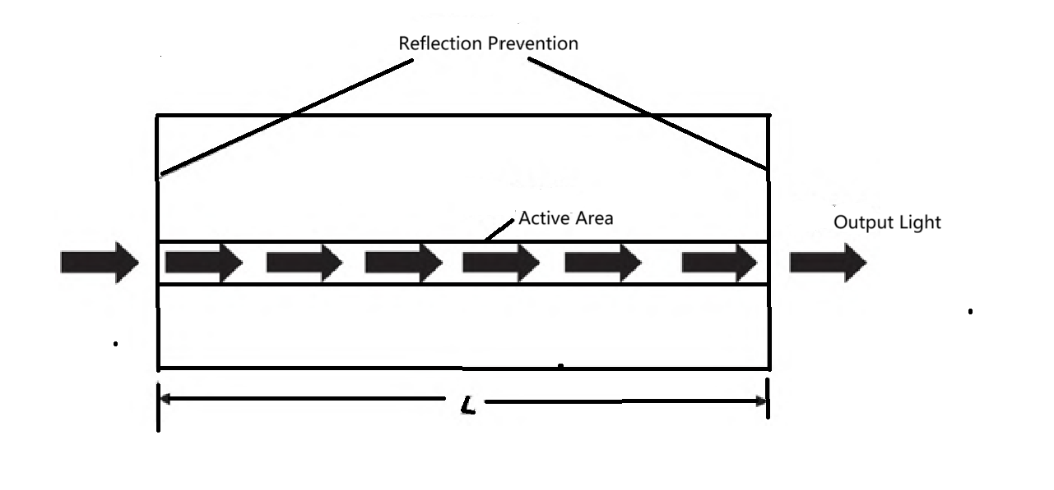
Figure 3. Semiconductor Optical Amplifier

Figure 3 illustrates the working principle of a semiconductor amplifier. A new type of optical amplifier based on the stimulated emission light amplification mechanism is semiconductor amplifiers, which generate gain through semiconductor media. The simultaneous injection of electrons and holes into the excitation region using current injection causes electron-hole pairs to undergo particle inversion on this basis, thereby producing stronger light in the excitation region [9].

Raman Amplifier
A Raman amplifier is a type of fiber amplifier that utilizes the Stimulated Raman Scattering effect to amplify optical signals. Within the pump light's Raman gain range, both low-frequency signal light and the high-frequency strong pump light are transmitted simultaneously through the fiber. When the frequency shift between the two falls within the bandwidth of the Raman gain spectrum of the fiber, Stimulated Raman Scattering occurs, causing some of the pump light's power to be transferred to the signal light at a lower frequency, thereby amplifying the signal light[8]. Initially, the Raman medium particles are located at the ground state energy level. The pump light is used to excite electrons in the fiber, causing them to transition from a lower to a higher energy level. On this basis, when the signal light irradiates its virtual energy level, the electrons at the virtual energy level will emit Stokes photons to a higher vibrational energy level, and the remaining energy will be absorbed by the material in the form of phonons, thereby achieving a transition between two vibrational states. According to the law of conservation of energy, the internal energy of the molecule increases. This process of energy transfer constitutes the mechanism of Raman optical amplification. The high-frequency pumping light induces nonlinear scattering within the propagation medium, resulting in a Stokes frequency shift of the incident light. This shift's extent is determined by the molecular vibrational energy states, and its amplitude governs the spectral bandwidth of the stimulated Raman scattering.[9].
Optical amplifiers can amplify signals that have attenuated after transmission through optical fibers in wavelength division multiplexing systems, ensuring clear transmission quality for each signal. They allow amplification over multiple wavelengths, saving more costs in large-scale communications. By using optical amplifiers instead of the original repeaters, the transmission distance of signals can be extended, the transmission performance of the system can be improved, and the structure of signal transmission can be simplified.

CONCLUSION
This article reviews the research progress of wavelength division multiplexing technology, demonstrating working principles and significant roles of WDM multiplexers and optical amplifiers in enhancing the efficiency of fiber optic communications. The Erbium-Doped Fiber Amplifier is characterized by high gain, flat gain within the passband, high output power, wide bandwidth, and low noise. It has been widely used in WDM experimental systems and commercial systems, becoming the mainstream of optical amplifiers at this stage. At the same time, cascaded designs of Arrayed Waveguide Gratings and Micro-ring Resonators have greatly improved communication efficiency. However, they also have some issues. For example, EDFA exhibits spontaneous emission noise while amplifying signals, which leads to the loss of pump light and reduces the signal-to-noise ratio. AWG is sensitive to temperature changes, and thermal drift can cause wavelength shifts and performance degradation. Future developments in WDM technology should focus on solving these problems. The research and development of silicon-based hybrid materials, two-dimensional materials, and new optical materials may reduce losses. The rapidly evolving WDM technology will undoubtedly support the new requirements of 6G communications.

REFERENCES
- CHANG F. Datacenter connectivity technologies： principles and practice［M］. New York： River Publishers，2018.
- Compact low-loss coarse wavelength division multiplexing chip [J].Wang Liangliang; Zhang Jiashun; An Junming; Li Shaoyang; Hu Yanzhang;Chang Xiasen. Acta Optica Sinica, 2021(09).
- Liang Jiaqi. Design and preparation of polymer/silica hybrid integrated multiplexing devices [D]. Jilin University, 2024.[4] Integrated switchable mode exchange for reconfigurable mode-multiplexing optical networks.[J]. Sun Chunlei;;Yu Yu;;Chen Guanyu;;Zhang Xinliang.Optics letters.
- Integrated switchable mode exchange for reconfigurable mode-multiplexing optical networks.[J]. Sun Chunlei;;Yu Yu;;Chen Guanyu;;Zhang Xinliang.Optics letters.2016.
- Electro-optic mode switch based on lithium-niobate Mach-Zehnder interferometer.[J]. Zhang Mengruo;;Chen Kaixin;;Jin Wei;;Chiang Kin Seng.Applied optics.2016.
- PLC-based LP₁₁ mode rotator for mode-division multiplexing transmission.[J]. Saitoh Kunimasa;;Uematsu Takui;;Hanzawa Nobutomo;;Ishizaka Yuhei;;Masumoto Kohei;;Sakamoto Taiji;;MatsuiTakashi;;Tsujikawa Kyozo;;Yamamoto Fumihiko.Optics express.2014.
- H. Uetsuka, "AWG technologies for dense WDM applications," in IEEE Journal of Selected Topics in Quantum Electronics, vol. 10, no. 2, pp. 393-402, March-April 2004.
- Han Feng, Zhang Jiashun, Wang Liangliang, et al. Design and Fabrication of O-Band Silicon-Based Silica AWG for Dense Wavelength Division Multiplexing [J]. Acta Photonica Sinica,2024, 53(08): 109-118.
- Li Zheng, Liu Xinyu, Ke Xizheng. Principles and Development of Optical Amplifiers [J]. Laser Journal, 2024, 45(05): 1-14.
- Optimization Design of Second-Order Tellurium-Based Fiber Raman Amplifier Based on Cooperative Search Algorithm [J]. Gong Jiemin; Jin Ku; Zhang Yi; Liu Shanghui; Liu Haiyang;Wei Xumeng. Laser and Optoelectronics Progress, 2024(05).
- Silica-Based L-Band Extended Erbium-Doped Fiber and Its Amplification Performance [J].He Le; Chu Yingbo; Dai Nengli; Li Jinyan. Acta Physica Sinica, 2022(15)
- Wavelength Conversion Characteristics of Quantum Dot Semiconductor Optical Amplifiers Based on Photonic Crystals [J]. Li Xiaobo; Wang Hailong; Ma Linan; Gong Qian. Acta OpticaSinica, 2022(02)
- Optimization Design of Low-Gain Low-Noise Gain-Clamped Bidirectional Erbium-Doped Fiber Amplifier [J]. Chen Wenjia; Cheng Chunfu; Ou Yiwen. Optical Communication Technology,2021(10)

