Applications and Development of Optoelectronic Technology in Modern Communication and Smart Devices
Jiayi Hu
College of Physics and Electronics, Hunan Normal University, Changsha, Hunan, 410081, China

202230132113@hunnu.edu.cn
Abstract. Optoelectronic technology has emerged as a transformative force in modern communication and smart devices, driven by its unparalleled advantages in speed, bandwidth, and versatility. This review systematically examines the evolution, applications, and challenges of optoelectronics, spanning from foundational principles to cutting-edge innovations. Traditional limitations, such as silicon's narrow bandgap and fibre-optic material losses, are contrasted with breakthroughs in spatial-division multiplexing (SDM), wavelength-division multiplexing (WDM), and hollow-core fibres, which enable terabit-level data transmission. In smart devices, optoelectronics underpins critical functionalities like 3D sensing and under-display cameras (UDC), while in healthcare, it enables non-invasive monitoring via photoplethysmography (PPG) and flexible organic photodetectors (OPDs). The historical trajectory of optoelectronics is mapped across three generations: quartz fibres and distributed feedback (DFB) lasers (1970–2000), silicon photonics and vertical-cavity surface-emitting laser (VCSEL) arrays (2000–2020), and the current era of 2D materials and quantum dots. Despite progress, challenges persist in environmental stability, thermal management, and scalable manufacturing. Future advancements hinge on interdisciplinary collaboration and real-world validation of emerging technologies.

INTRODUCTION
Optoelectronic technology is an emerging field with irreplaceable significance in modern society. However, its evolution continues to face many challenges. First, limitations of traditional materials persist. Silicon, the conventional material for optoelectronic devices, has a fixed bandgap width (~1.1 eV), which restricts silicon-based semiconductors from efficiently absorbing or emitting light across a broad wavelength spectrum [1]. Additionally, traditional optical fibre materials (e.g., silicon dioxide) exhibit sharply increased losses at high-frequency bands, hindering ultra-high-speed data transmission. Second, integration and miniaturization present critical hurdles. High-density integration raises power consumption per unit area, and inadequate thermal management can lead to localized overheating, compromising material stability and device longevity. Miniaturization also narrows waveguide spacing, increasing risks of crosstalk between adjacent optical channels and degrading sensing accuracy [2]. Compared to traditional electronic technologies, optoelectronics offers distinct advantages. In terms of speed and bandwidth, breakthroughs in Space Division Multiplexing/Wavelength Division Multiplexing (SDM/WDM) technologies for submarine cables and hollow-core fibre innovations enable unprecedented data transmission rates and communication bandwidth. Meanwhile, optoelectronics plays a pivotal role in mobile devices and life sciences. It underpins 3D sensing modules in smartphones and provides viable solutions for challenges in under-display cameras (UDC). In healthcare, photoplethysmography (PPG)-based vital sign monitoring exemplifies its successful application, enabling real-time tracking of patients’ or infants’ physiological states. Since the first realization of gallium arsenide (GaAs) semiconductor lasers in 1962, optoelectronics has evolved through three key phases. The first generation of optoelectronic technology, spanning from 1970 to 2000, cantered on quartz optical fibres and Distributed Feedback (DFB) lasers, driving the digital transformation of telecommunication networks [3]. The second generation is the silicon-based photonic integration and VCSEL (Vertical-Cavity Surface-Emitting Laser) array technology (such as Apple's FaceID system) from 2000 to 2020, which has propelled the revolution of optical interconnection in data centres. The third generation, which has been ongoing from 2020 to the present day, marked by 2D materials and quantum dot technologies, ushered in an era of ultra-high-speed, low-power optoelectronic systems. This work systematically reviews the developmental trajectory, core strengths, challenges, and future trends of optoelectronic technology, offering academia a robust technical reference. Beginning with fundamental principles, it explores optoelectronics’ diverse applications in modern communications, smart devices, and healthcare.

FUNDAMENTALS OF OPTOELECTRONIC TECHNOLOGY

Basic Concepts of Optoelectronics

Basic Concepts of Optoelectronics
Light exhibits both electromagnetic wave properties (governed by Maxwell's equations) and particle-like behaviour (photon energy $E=hν$) [4]. The general laws of electromagnetic waves are summarized in Maxwell's equations, which Maxwell generalized from the fundamental principles of steady electromagnetic fields to time-varying electromagnetic fields [5]. The electromagnetic wave nature of light determines its propagation speed in a vacuum as:

$c=1/{\sqrt{μ_{0}ε_{0}}}$

Where $ε_{0}$ and $μ_{0}$ are the vacuum permittivity and vacuum permeability, respectively. When light propagates through a medium, its speed becomes

$n=\frac{c}{v}=\sqrt{\frac{εμ}{ε_{0}μ_{0}}}=\sqrt{ε_{r}μ_{r}}$

Where $ε_{r}$ and $μ_{r}$ are the relative permittivity and relative permeability of the medium, and n is its refractive index. As electromagnetic waves are transverse waves, light inherits their characteristics. The oscillation directions of the electric field vector (E) and magnetic field vector (B) are always perpendicular to the wave’s propagation direction, and these vectors are mutually perpendicular to each other. To illustrate, consider a light wave propagating along the z-axis with the electric field oscillating in the $xOz$ plane. This configuration can be represented schematically in Figure 1.

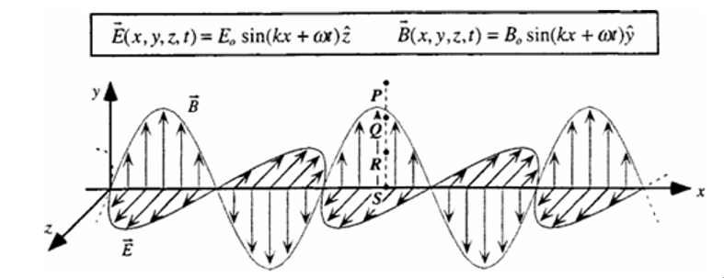
FIGURE 1. A plane simple harmonic wave that propagates along the z-axis and whose electric vector vibrates in the $xOz$ plane

Interaction Between Light and Electrons
In the photoelectric effect, a photon with sufficient energy transfers its energy to a single electron at a time. After absorbing a photon’s energy, the electron uses part of it to overcome the metal’s binding forces (work function), while the remaining energy becomes the electron’s kinetic energy as it escapes the metal surface. Einstein’s photoelectric equation describes this relationship [6]:

$hν=\frac{1}{2}mv^{2}+W$

In stimulated emission, if two energy levels $E_{1}$ and $E_{2}$ in an atomic system satisfy the selection rules for radiative transitions, an electron in the higher energy level $E_{2}$ can be stimulated by an incident photon with energy $hν=E_{2}-E_{1}$to transition to the lower energy level $E_{1}$. During this process, the electron emits a photon that is identical in frequency, phase, polarization, and propagation direction to the incident photon, as illustrated in Figure 2 [7].
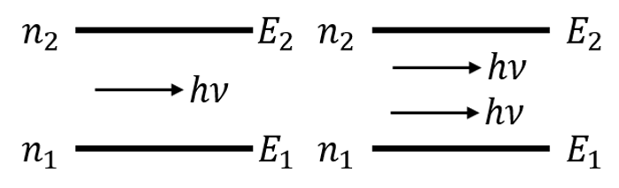
FIGURE 2. The process of stimulated emission of light

Photodetectors: APD vs. SPAD Technologies
This paper compares SPAD (Single-Photon Avalanche Diode) and APD (Avalanche Photodiode) technologies from two perspectives. First, sensitivity under dark conditions. SPADs excel in low-light environments due to their ability to detect single photons [8]. In darkness, a SPAD array achieves a bit error rate (BER) of 7.9×10⁻⁴ with approximately 15 photons per bit, whereas APDs require an optical power of 3.44 µW/m² (equivalent to -50 dBm) to achieve the same BER. Consequently, APDs exhibit 22 dB lower sensitivity than SPADs in dark conditions[9]. Second, the impact of ambient light on SPADs and APDs. SPADs are susceptible to Poisson noise under ambient light, necessitating a significant increase in signal power to maintain the same BER. In contrast, APDs are less affected by ambient light due to their lower sensitivity to shot noise and better tolerance to background illumination [10]. For identical transmitter and ambient light conditions, the signal-to-noise ratio (SNR) of SPAD-based receivers versus APD-based receivers can be expressed as:

$\frac{{SNR}_{SPAD}}{{SNR}_{APD}}=\sqrt{\frac{m^{x}.PDE(λ)}{QE\left(λ\right).PP}}$ (4)

APPLICATIONS OF OPTOELECTRONIC TECHNOLOGY IN MODERN COMMUNICATION

Fiber Optic Backbone Networks

SDM/WDM Technologies in Submarine Cables
The core concept of SDM (Space-Division Multiplexing) is to achieve parallel transmission of multiple signals by expanding the spatial dimension, primarily through two implementations: multi-core fibre (MCF) and few-mode fibre (FMF). In 2020, NTT Laboratories conducted a transoceanic transmission experiment using a 12-core fibre, achieving a single-fibre capacity of 1 Pbps[11]. WDM (Wavelength-Division Multiplexing) enables parallel transmission of multiple signals over a single fibre by assigning distinct wavelengths (optical frequency bands). Its principle involves allocating optical signals to different wavelengths, combining them via a multiplexer (Mux) for joint transmission, and separating them at the receiver using a demultiplexer (Demux). For example, the MAREA submarine cable, jointly deployed by Microsoft and Facebook, employs DWDM (Dense WDM) technology, delivering a single-fibre capacity of 20 Tbps and a total design capacity of 160 Tbps[12].

Breakthroughs in Hollow-Core Fiber Technology
Hollow-Core Fiber (HCF) is a specially structured optical fibre where the core is a hollow channel (typically filled with air or specific gases), enabling light signals to propagate through the air core rather than the solid glass core of traditional fibres [13]. Photonic Bandgap Fiber (PBGF), a key subtype of HCF, is emphasized here. PBGF is designed based on photonic crystal principles, leveraging periodic microstructures to create a photonic bandgap that confines light within the hollow core. Recent advancements in PBGF technology have achieved significant breakthroughs. For instance, in 2021, a research team at the University of Southampton, UK, reported a novel PBGF design exhibiting an ultra-low loss of 0.28 dB/km at the 1.55 μm telecommunications band—performance approaching that of conventional solid-core fibres[14].

Free Space Optical Communication

Laser-based Satellite Constellation Interconnections
Laser-based satellite constellation interconnections refer to the use of laser communication technology to link multiple satellites into a network for data transmission, thereby building a global space-based communication infrastructure. This technology replaces traditional microwave communication with near-infrared light, transmitting data by modulating laser signals [15]. Satellites in space are equipped with optical terminals (e.g., SpaceX’s "Inter-satellite Link" system) to enable satellite-to-satellite or satellite-to-ground communications. Laser satellite constellation interconnections offer advantages such as ultra-high speed, low latency, interference resistance, and enhanced security. However, at the same time, it is faced with problems such as the link being interfered with by cloud layer turbulence, difficulties in heat dissipation due to high laser power, and excessively high costs.

UAV-based Emergency Communication Nodes
UAV-based emergency communication nodes are a technology that utilizes unmanned aerial vehicles (UAVs) to rapidly deploy temporary communication networks. This technology has numerous application scenarios. In the event of natural disasters such as earthquakes and floods, drones can quickly take off into the air to establish communication coverage. Drones can provide covert and mobile communication relay services during military operations. However, the technology faces challenges, including short endurance (limited flight time), insufficient payload capacity (restricting hardware options), and the need for robust signal stability in dynamic environments.

APPLICATIONS OF OPTOELECTRONIC TECHNOLOGY IN SMART DEVICES AND HEALTHCARE

Optoelectronics in Mobile Devices

3D Sensing Modules
3D sensing modules are critical components in modern mobile devices, enabling functionalities such as facial recognition and gesture interaction. Their core technology relies on high-precision optical design and efficient light sources, particularly the application of vertical-cavity surface-emitting lasers (VCSELs) [16]. By emitting specific dot patterns via VCSEL arrays, the modules capture scattered light from target surfaces using cameras, then reconstruct 3D contours through algorithms. These modules employ two methods for distance calculation: indirect Time-of-Flight (iToF), which measures distance by detecting the phase difference between emitted modulated light pulses and their reflections, and direct Time-of-Flight (dToF), which directly measures photon round-trip time using single-photon avalanche diode (SPAD) arrays for high-precision ranging. Figure 3 illustrates the 3D imaging system based on the iToF method.

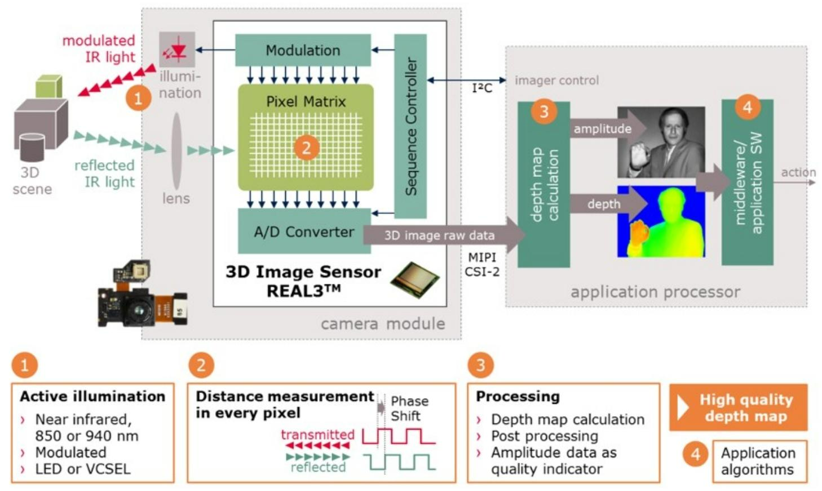
FIGURE 3. The 3D imaging system of the iToF method

Under-Display Camera (UDC) Optoelectronic Solutions
Before the advent of optoelectronic solutions, under-display cameras (UDCs) grappled with critical challenges such as insufficient light transmittance, astigmatism, and field curvature—optical distortions caused by the structural interference of display layers. Optoelectronic technologies have emerged to address these limitations. For instance, applying anti-reflective (AR) coatings to UDC surfaces enhances light transmission efficiency by minimizing reflection losses. Additionally, replacing traditional lenses with nanostructured meta-surfaces enables subwavelength optical phase manipulation, achieving ultra-thin form factors, wide-field imaging, and simultaneous correction of astigmatism and field curvature induced by screen architectures. Table 1 shows the current mainstream solutions for handling UDCs adopted by some manufacturers.

TABLE 1. The mainstream solutions adopted by some manufacturers for dealing with UDC
Manufacturer | Samsung（Galaxy Z Fold5） | Xiaomi（MIX Fold 3） | Apple (Patent / Not Commercially Available)
Technical Solution | Low-resolution pixel area,  Transparent pixel gap | Micro-drilling arrangement,  Transparent wiring | Dynamic pixel compensation,  Local light transmittance adjustment
Light Transmittance | ~10%（Visible light band） | ~15%（Optimized for the green light band） | Patent target >20%（Based on dynamic adjustment）
Imaging Quality | Usable for video calls, with obvious noise in low light | Clear under daily lighting, relying on AI restoration in low-light conditions | Patent simulation shows it is close to traditional cameras (Laboratory data)

Wearable Health Technologies

PPG-based Vital Sign Monitoring
Photoplethysmography (PPG)-based vital sign monitoring is a non-invasive, low-cost technology widely employed in wearable devices and medical supervision. PPG operates by emitting specific wavelengths of electromagnetic waves from a light-emitting diode (LED) into the skin, with a photodetector capturing the reflected or transmitted signal [17]. Fluctuations in blood volume caused by cardiac activity alter the absorbance of haemoglobin, and PPG detects these variations to generate pulse waveforms, enabling continuous monitoring of physiological states such as heart rate (HR), blood oxygen saturation (SpO2), and respiratory rate (RR). This technology supports real-time health tracking in diverse scenarios, from smartwatches that monitor HR and SpO2 to clinical settings where it ensures postoperative patients or newborns maintain stable vital signs.

Flexible Organic Photodetectors
Organic photodetectors (OPDs) are optoelectronic conversion devices based on organic semiconductor materials, such as perovskites. When exposed to light of specific wavelengths, OPDs generate excitons (electron-hole pairs), which are separated via electrodes to form a photocurrent. Compared to traditional photodetectors, OPDs offer unique advantages, including compatibility with flexible substrates for integration into curved or deformable surfaces, making them ideal for wearable applications. Additionally, certain organic materials are non-toxic and biodegradable, enabling their use in implantable or skin-mounted electronic devices.

CONCLUSION
This paper highlights the pivotal role of optoelectronic technology in reshaping communication infrastructures, consumer electronics, and healthcare systems. The main achievements include the following three aspects: SDM/WDM-enabled submarine cables achieve 1 Pbps/fibre capacity via 12-core fibre architecture. Second, Hollow-core fibres with 0.28 dB/km loss at 1.55 μm, rivalling conventional fibres while enabling air-guided transmission[11,14]. Third, miniaturized photonic modules integrating VCSEL arrays and SPAD sensors, powering 3D facial recognition with <1 mm ranging accuracy. In healthcare, breakthroughs like flexible perovskite-based OPDs and PPG sensors exemplify optoelectronics’ transformative potential. The field has progressed through three eras: quartz fibre dominance (1970–2000), silicon photonics integration (2000–2020), and the current 2D material/quantum dot paradigm, each marked by order-of-magnitude improvements in bandwidth and energy efficiency. However, challenges remain in three domains: First, the service life of quantum dot devices does not exceed 500 hours under the conditions of 85°C and 85% relative humidity[18]. Second, for ultra-dense photonic circuits in a 10⁴-channel system, the isolation degree is required to be greater than 40 dB. Third, the errors caused by motion artifacts in wearable PPG sensors reach 30%, resulting in clinical unreliability[17]. In the future, workers in the field of optoelectronic technology will focus their work on the following aspects: First, material innovation: heterogeneously integrating III-V semiconductors with silicon photonics to overcome the bandgap limitations. Second, system optimization: constructing neuromorphic photonic networks for AI - AI-accelerated signal processing (aiming to achieve an energy consumption efficiency of 1 pJ per bit). Third, sustainability: developing biodegradable optoelectronic devices using cellulose substrates (with a degradation time of less than 30 days).

REFERENCES
- R. Soref, MRS Bull. Letters 23, 20–24 (1998).
- Y. Aryanfar, A. Keçebaş, H. Fardinnia, H. Bashtalim, A. Mammadova, A. Mammadova, and S. M. Ghasemlou, Breaking Boundaries: Pioneering Sustainable Solutions Through Materials and Technology (Springer Nature Singapore, Singapore, 2025), pp. 37–66.
- F. P. Kapron, D. B. Keck, and R. D. Maurer, Appl. Phys. Letters 17, 423–425 (1970).
- M. O. Scully and M. Sargent, Phys. Today, Letters 25, 38–47 (1972).
- J. C. Maxwell, Philos. Trans. R. Soc. Lond. Letters 155, 459–512 (1865).
- 25A. Einstein, Ann. Phys. Letters 17, 132–148 (1905).
- B. S. Ambrose, P. R. Heron, S. Vokos, and L. C. McDermott, Am. J. Phys. Letters 67, 891–898 (1999).
- H. Zimmermann, Proc. 15th Int. Conf. Telecommun. (ConTEL), Letters 3, 1–5 (2019).
- Huang S, Safari M. Hybrid SPAD/PD receiver for reliable free-space optical communication[J]. IEEE Open Journal of the Communications Society, 2020, 1: 1364-1373.
- L. Zhang, D. Chitnis, H. Chun, S. Rajbhandari, G. Faulkner, D. O'Brien, and S. Collins, J. Lightwave Technol. Letters 36, 2435–2442 (2018).
- Sakamoto T, Wada M, Aozasa S, et al. Characteristics of randomly coupled 12-core erbium-doped fiber amplifier[J]. Journal of lightwave technology, 2020, 39(4): 1186-1193.
- Varughese S, Bennett G, Lavery D, et al. Optimizing Optical Engine Features for Subsea Cable Systems[J]. Journal of Lightwave Technology, 2024.
- M. Komanec, D. Dousek, D. Suslov, and S. Zvanove, Radioengineering, Letters 29, 417–430 (2020).
- Zhang H, Kavanagh N, Li Z, et al. 100 Gbit/s WDM transmission at 2 µm: transmission studies in both low-loss hollow core photonic bandgap fiber and solid core fiber[J]. Optics Express, 2015, 23(4): 4946-4951.
- J. E. Mulholland and S. A. Cadogan, IEEE Trans. Aerosp. Electron. Syst. Letters 32, 1011–1020 (1996).
- M. Dummer, K. Johnson, S. Rothwell, K. Tatah, and M. Hibbs-Brenner, Proc. SPIE, Letters 116, 42–55 (2021).
- J. Allen, Physiol. Meas. Letters 28, 38-41 (2007)
- Yang X, Xie B, Luo X. Resisting oxygen/moisture permeation in quantum dots converted optoelectronic devices[J]. Journal of Physics D: Applied Physics, 2024, 57(48): 483001.

