Structural Research on Bandgap Reference Sources
Zihan Zhao
Eastern Michigan Joint College of Engineering, Beibu Gulf University, Qinzhou, 535000, China
zzhao9@emich.edu
Abstract. Voltage references are critical for precision analog/mixed-signal circuits, with bandgap references (BGRs) being the dominant solution due to their temperature stability. This paper analyzes BGR design principles, focusing on temperature compensation through bipolar transistor (BJT) and CMOS-based architectures. We compare conventional BJT-based BGRs (offering low drift but higher power) with CMOS variants (area-efficient but threshold-voltage-sensitive), alongside advanced techniques like subthreshold operation and curvature correction. Key trade-offs in power, accuracy, and process robustness are evaluated. Findings reveal BJT designs achieve <50ppm/°C drift but require microamp-level biasing, while CMOS alternatives reduce power to nanoamps at the cost of increased trimming complexity. Subthreshold operation enables ultra-low-power BGRs (<100nW), and higher-order compensation can suppress nonlinear errors to <20ppm/°C. The study provides a design methodology for selecting BGR topologies based on application-specific requirements, highlighting future trends toward PVT-robust, self-calibrating architectures in advanced nodes. This study provides valuable insights into optimizing bandgap reference (BGR) designs for modern analog/mixed-signal systems, addressing the growing demand for energy-efficient yet precise voltage references in IoT, biomedical devices, and sensor interfaces.

Introduction
With the continuous development of integrated circuit technology, the design of bandgap reference sources is also evolving. From the traditional BJT (Bipolar Transistor) -based bandgap reference, to CMOS technology based bandgap reference, and then to the new bandgap reference with low power consumption, high precision and high stability appeared in recent years, various structures emerge in an endless stream. For example, nano-scale BGR based on subthreshold design, high-order temperature compensation BGR, Time-Domain BGR, full CMOS BJT-free BGR, adaptive power rejection (PSR) enhanced BGR, Memristor based reference, ultra-low voltage (Sub-1V) BGR. Each structure has its unique advantages and limitations, and they are suitable for different application scenarios. Therefore, it is of great significance to understand and design high performance voltage reference sources by deeply analyzing the types, basic principles and advantages and disadvantages of various mainstream structures of bandgap reference sources.
This article will first introduce the basic principle of bandgap reference source, and then a detailed analysis of several mainstream band gap reference source structure and its advantages and disadvantages. For example: Classical Bandgap Reference sources (including Widlar Bandgap reference voltage sources, Kuijk bandgap reference voltage sources, Brokaw bandgap reference voltage sources), Low-Voltage bandgap reference sources, Curvature-Compensated Bandgap Reference,etc. Finally, the future development trend of the bandgap reference source is prospected.

Literature Review
The types of bandgap reference sources include CMOS bandgap reference sources and bipolar bandgap reference sources. Compared with other reference circuits, its performance has been improved in many aspects, and it is extremely important in all kinds of integrated circuits and integrated system of the module [1]. It is capable of operating at low power supply voltages and features advantages such as a low temperature coefficient and a high power supply rejection ratio. Moreover, it can also be matched with CMOS processes. In addition, it can provide reference voltages that meet the requirements for circuit systems with different precision requirements, and the types of circuits it can cover are also relatively broad. The bandgap reference source can not only meet the characteristic requirements of general integrated circuits, but also be well used in low-power circuit systems due to its very small static operating current, and the cost is moderate [2].
The fundamental concept of a bandgap reference voltage source involves creating two opposing voltage-temperature coefficients via thoughtful circuit design. Subsequently, by fine-tuning the parameters of the components within the circuit, the temperature coefficient of the output reference voltage can be set to zero [3]. For example, in a conventional bandgap voltage reference, the temperature coefficient of voltage V+ is positive, while that of voltage V- is negative [4].
+ =0 (1)
As long as the values of α and β in the formula are matched to make the equation hold, the output voltage of the bandgap reference voltage source has a zero temperature coefficient. Its principle can be seen in figure 1.[4]
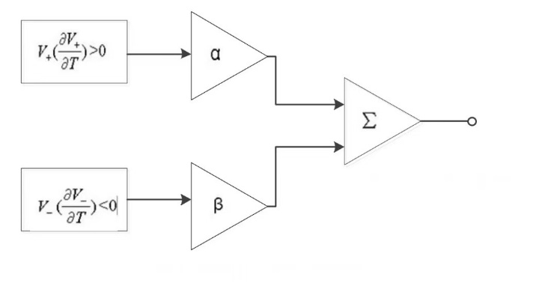
FIGURE 1. General principle of bandgap voltage reference
The basic expression of the reference voltage is:
(2)
The base-emitter voltage of a bipolar transistor corresponds to a voltage V- that decreases with absolute temperature. Meanwhile, the voltage difference between bipolar transistors having different emitter area ratios (or equivalently, different collector currents) generates a voltage V+ that increases with temperature. Consequently, bipolar transistors play a central role as key components in the design of bandgap reference circuits [5].
The initial category is the conventional bandgap reference source, which has a structure that relies on the weighted sum of the positive temperature coefficient voltage (VBEVBE) and the negative temperature coefficient voltage (ΔVBEΔVBE) from the bipolar junction transistor (BJT) [6]. Its advantages are simple structure, easy implementation, good temperature stability, usually within ±1%, and strong robustness to process changes. On the contrary, it also has many disadvantages: Firstly, the output voltage typically stabilizes at approximately 1.25V, which imposes constraints on low-voltage application scenarios. Secondly, the device exhibits a significant dependence on the supply voltage, coupled with a relatively limited power supply rejection ratio (PSRR). In addition, in high-precision applications, additional circuit tuning may be required [7]. Among them, the traditional bandgap reference sources include the following structures.

Widlar Band Gap Reference Source
The output reference voltage Vref of the Widlar bandgap reference voltage source circuit is formed by combining the base-emitter voltage V of Q3 with the voltage drop across resistor R. Its structure is shown in Figure 2.
（3）
（4）
So： （5）
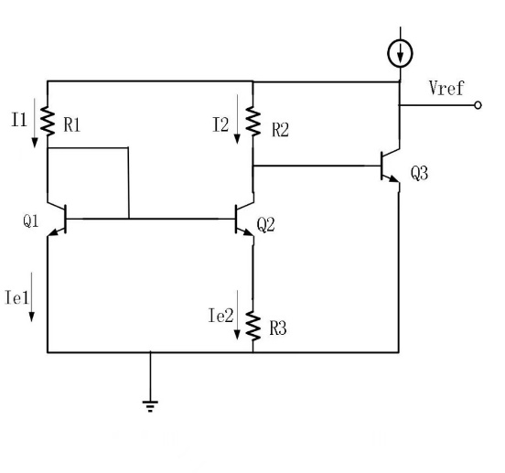
FIGURE 2. Structure diagram of Widlar bandgap reference voltage source
This circuit structure diagram is an improved design by Robert Widlar based on the classic bandgap reference. Through the clever combination with positive temperature coefficient of thermal voltage and has a negative temperature coefficient of PN junction voltage drop. Implements the near zero temperature coefficient of the reference voltage of about 1.2 V (typical values). Widlar's circuit optimizes the resistance ratio and transistor operating point, further reducing the influence of high-order temperature terms. The temperature drift coefficient can be as low as below 10ppm/°C.

Kuijk Bandgap Reference Source
Following the development of the Widlar bandgap reference voltage source, Kuijk further enhanced its design by improving the structure of the bandgap reference voltage source. In 1973, he incorporated operational amplifiers into his design, leading to the creation of the Kuijk bandgap reference voltage source structure. The architecture of the Kuijk bandgap reference source is illustrated in Figure 3.
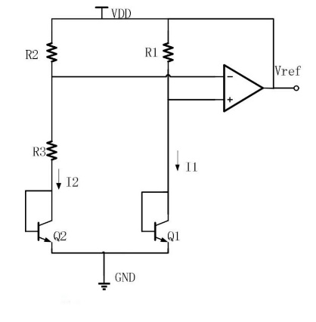
FIGURE 3. Structure diagram of the Kuijk bandgap reference voltage source
Significantly different from the Widlar bandgap reference voltage source structure, the Kuijk reference source makes the current flowing through resistors R1 and R2 almost equal through the "clamping" function of the operational amplifier. That is:
(6)
(7)
(8)
Since an operational amplifier is introduced in this structure, the op-amp offset voltage will have an impact on the reference output.

Brokaw Bandgap Reference Source
Following Kuijk's work, Brokaw introduced an additional new bandgap reference source circuit in 1974. This innovative design aims to reduce the influence of the power supply voltage on the output of the reference circuit. The architecture of its circuit is illustrated in Figure 4. From Figure 4, it is evident that the base-emitter voltage of transistor Q1, when added to the voltage drop across resistor R2, results in the output reference voltage Vref. That is:
（9）
In this configuration, the resistance values of resistors R3A and R3B are identical. Owing to the clamping action of the operational amplifier, the voltage drops across these two resistors are also the same, resulting in equal currents flowing through resistors R3A and R3B.That is:
（10）
（11）
It can be obtained
（12）
So Vref is:
（13）
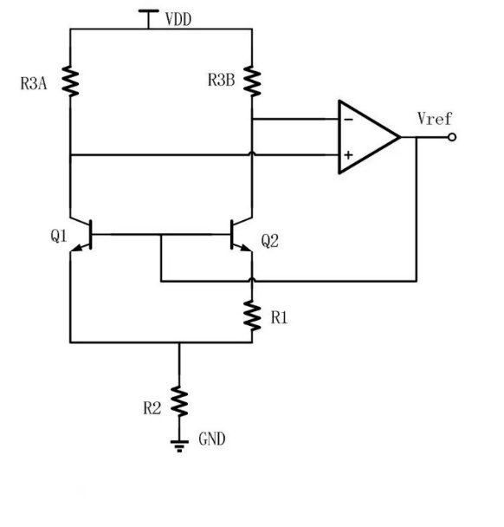
Figure 4. Circuit structure diagram of Brokaw bandgap reference source
The reference voltage output terminal of this source is produced internally within the circuit. This design not only streamlines the circuit architecture but also minimizes the circuit's power consumption. However, the incorporation of operational amplifiers may lead to the output reference voltage being influenced by the amplifier's offset voltage, which in turn decreases the output accuracy of the reference source [4].

Bandgap Reference Source with Low Voltage
Figure 5 illustrates the structure of the Low-Voltage Bandgap Reference source. By employing resistive voltage division or current mirror techniques, it enhances the precision of the bandgap reference by lowering the output voltage to less than 1V [1]. Low-voltage bandgap reference sources based on current mode typically utilize two-stage operational amplifiers for voltage clamping. The current source bias circuit provides a stable bias, while an RC filter is integrated to improve the power supply rejection ratio. In certain instances, the operational principle of the DTMOST low-voltage bandgap reference entails inputting a voltage with a negative temperature coefficient into the OVF module, where it produces a voltage with a positive temperature coefficient. Therefore, a voltage with a low temperature coefficient can be obtained. Low-voltage bandgap reference sources often have the following advantages: On the one hand, they are suitable for circuits with low-voltage power supplies (such as 1.8V or lower). On the other hand, its power consumption is relatively low. The disadvantages are that the temperature coefficient and power supply rejection ratio may be poor, and it requires a more complex design to ensure stability.

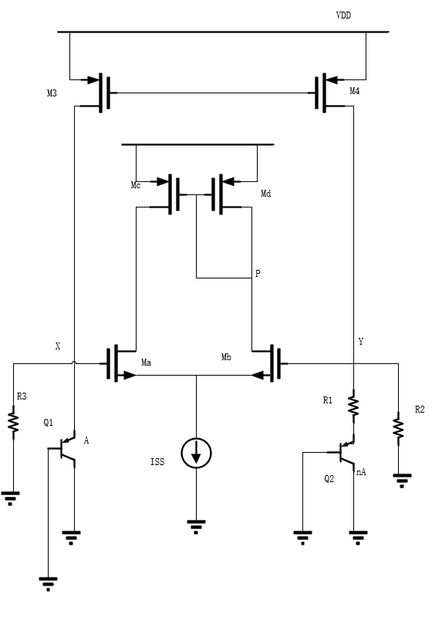
FIGURE 5. Structure diagram of the low-voltage bandgap reference source

Reference Source for Curvature Compensation Band Gap
The Curvature Compensated Bandgap Reference source improves the temperature characteristics of the traditional bandgap reference source by adding nonlinear compensation circuits (such as high-order temperature compensation) [5]. Generally, it features a significantly reduced temperature coefficient, reaching the ppm/°C level, and is suitable for high-precision applications. Its disadvantages are the increased complexity of the circuit, larger area and power consumption, as well as the high design difficulty, which requires an accurate process model.Its structure is shown in Figure 6.
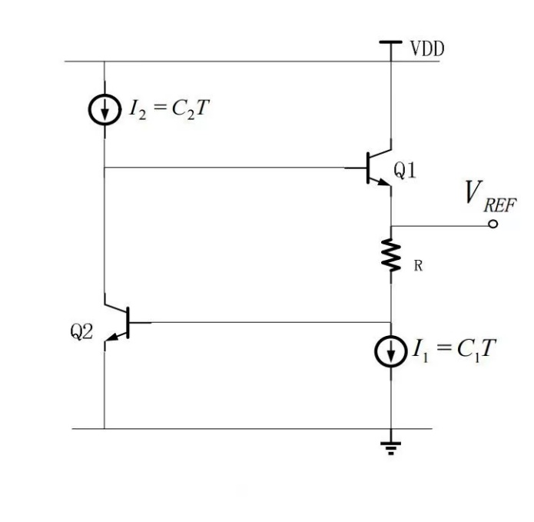
FIGURE 6. Structure diagram of the reference source for curvature compensation band gap

Subthreshold Bandgap Reference Source
The Subthreshold Bandgap Reference produces a reference voltage by leveraging the characteristics of MOS transistors functioning in the subthreshold region [2]. This type of reference typically exhibits extremely low power consumption, making it ideal for ultra-low-power applications, while also offering a broad adjustable range for output voltage. Nevertheless, it is highly sensitive to variations in process and temperature. Additionally, it tends to have relatively high noise levels and lacks stability. Its architecture is depicted in Figure 7.
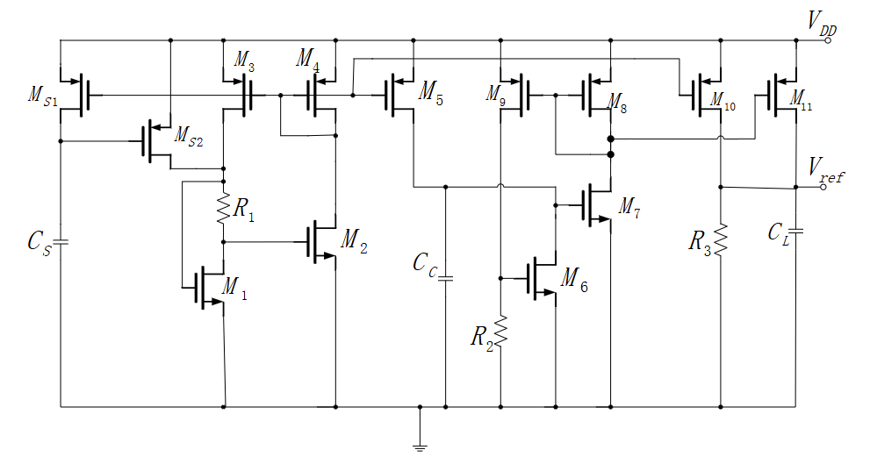
FIGURE 7. Diagram of the sub-threshold bandgap reference source structure

Bandgap Reference Source Based on Cmos Technology
The CMOS Bandgap Reference source based on CMOS, its structure is shown in Figure 8. It is fully implemented using CMOS technology, avoiding the use of BJT, compatible with standard CMOS technology, and has a low cost.[8] It is more suitable for low-voltage and low-power consumption designs, but its temperature coefficient and power supply rejection ratio are usually poor, and complex compensation circuits are required.
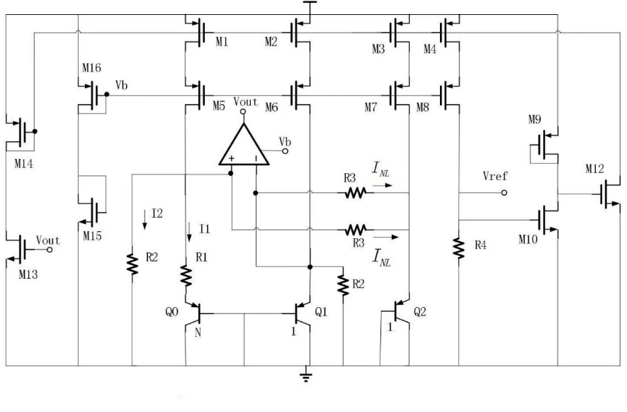
FIGURE 8. Diagram of the CMOS-based bandgap reference source structure

Piecewise Linear Compensation Band Gap Reference Source
The piecewise-linear Compensation Bandgap Reference source compensates for the temperature characteristics through Piecewise linearization technology. It has a relatively low temperature coefficient, is suitable for wide temperature range applications, and has high design flexibility. However, it not only has a complex circuit, a large area and high power consumption, but also requires precise temperature sensors and tuning circuits.[9] The linear compensation circuit diagram for its two temperature segments and the circuit diagram for generating INL are shown in Figure 9.
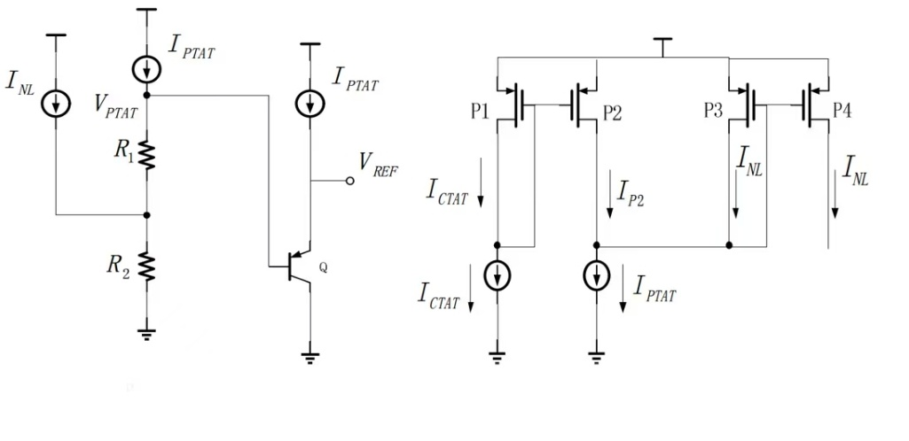
FIGURE 9. Structure diagram of the piecewise linear compensation bandgap reference source

Digital Tuning Band Gap Reference Source
The Digitally-Trimmed Bandgap Reference is shown in Figure 10. It calibrates the output voltage through digital tuning techniques such as DAC or OTP [10]. Its temperature coefficient and initial accuracy are extremely high, making it suitable for high-precision and high-reliability applications. However, digital tuning of bandgap reference sources requires additional tuning circuits and storage units, and is costly and complex in design.
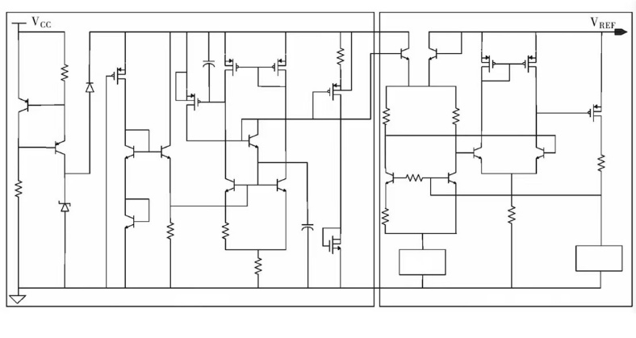
Figure 10. Diagram illustrating the structure of the digitally adjustable bandgap reference source
According to the mathematical order of temperature compensation and the complexity of the circuit structure, the above seven bandgap reference sources can also be classified into first-order and high-order categories.
The primary characteristic of the first-order bandgap reference source is its reliance on first-order linear temperature compensation, resulting in a relatively straightforward structure. It mainly offholds the first-order linear term of the temperature. It includes the following four types: Traditional bandgap reference source: First-order compensation is achieved through linearly weighted negative temperature coefficients and positive temperature coefficients. Low-voltage bandgap reference source: It reduces voltage through a voltage divider/current mirror on the basis of the traditional structure, and the temperature compensation remains first-order linear. Subthreshold bandgap reference source: It generates the reference voltage by utilizing the characteristics of the MOSFET in the subthreshold region without introducing high-order compensation. And the CMOs-based bandgap reference source: It is fully implemented using CMOS technology and relies on first-order compensation similar to traditional methods, such as the PTAT/CTAT current combination. A shared limitation among the four is the presence of residual high-order temperature terms, like curvature error, with a typical temperature coefficient ranging from 10 to 100 ppm/°C.
The core feature of high-order bandgap reference sources is that they suppress high-order temperature terms such as curvature errors through nonlinear compensation or complex structures, and the temperature coefficient can reach below ppm/°C. It includes the following three types: Curvature compensation bandgap reference source: By introducing nonlinear circuits, such as high-order current or voltage compensation, it directly offsets the high-order terms of temperature. Piecewise linear compensation bandgap reference source: It divides the temperature range into segments and adopts different linear compensation strategies in different intervals to approximately achieve high-order compensation. And digital adjustment of bandgap reference sources: Through digital calibration, such as DAC and OTP dynamic adjustment parameters, high-order temperature errors are indirectly suppressed. They simultaneously have the disadvantages of significantly increased circuit complexity, area and power consumption, as well as high design difficulty.

Conclusion
The fundamental concept of the bandgap reference source involves leveraging the bandgap energy properties of semiconductor materials. By employing the mutual compensation of voltages with positive and negative temperature coefficients, a temperature-independent stable output voltage is attained. This principle is universal in the design of various bandgap reference sources. Whether it is a design based on BJT or CMOS processes, it cannot do without this fundamental principle.
With the development of integrated circuit technology, the structure of bandgap reference sources shows a diversified trend. The conventional BJT-based bandgap reference source offers high accuracy and stability, yet it comes with relatively high power consumption. The bandgap reference source based on CMOS technology has obvious advantages in terms of low power consumption and high integration. In addition, the emergence of new bandgap reference sources with low power consumption, high precision and high stability in recent years, such as bandgap reference sources based on subthreshold operation, has further expanded the application scope of bandgap reference sources.
Each bandgap reference source structure has its unique advantages and limitations. For example, the bandgap reference source based on BJT performs well in terms of accuracy and stability, but has a relatively high power consumption. The bandgap reference source based on CMOS technology has advantages in low power consumption and high integration, but it may be slightly inferior in terms of accuracy and stability. Therefore, in practical applications, it is necessary to select the appropriate bandgap reference source structure according to specific requirements.
With the rise of low-power applications such as the Internet of Things and wearable devices, bandgap reference sources with low power consumption, high precision and high stability will become the focus of future research. Furthermore, with the continuous advancement of process technology, how to achieve high-performance bandgap reference sources at smaller process nodes will also be an important research direction in the future.

References
- G. A. Rincon-Mora, Low-Voltage Bandgap Reference Design. IEEE Trans. Circuits Syst. II 45, 436–441 (1998).
- M. D. Ker and J. S. Chen, A CMOS Bandgap Reference Circuit with Sub-1V Operation. IEEE J. Solid-State Circuits 34, 586–591 (1999).
- B. Razavi, Design of Analog CMOS Integrated Circuits. (2001).
- R. J. Widlar, New Developments in IC Voltage Regulators. IEEE J. Solid-State Circuits 6, 2–7 (1971).
- K. N. Leung and P. K. T. Mok, A CMOS Voltage Reference Based on Weighted ΔVGS for Curvature Compensation. IEEE J. Solid-State Circuits 38, 146–150 (2002).
- Ma Lin, Design of Bandgap Reference Source Based on CMOS Process. Heilongjiang University, (2015).
- Qi Ying, Low-voltage Bandgap Reference Circuit. Anhui University, (2015).
- Wang Jian, Research and Application of CMOS Bandgap Reference Source. Nanjing University of Posts and Telecommunications, (2015).
- J. F. Witte et al., A CMOS Bandgap Reference with Piecewise-Linear Curvature Correction. IEEE J. Solid-State Circuits 42, 700–713 (2007).
- P. Malcovati et al., Digitally-Trimmed Bandgap References with 0.1% Accuracy. IEEE J. Solid-State Circuits 38, 1349–1353 (2003)

