Aerodynamic Characteristic Analysis of the Lift-Drag Ratio and Wing Shape of a Glider
Shengran Chu
Pioneer Academy, Wayne, 07470, The United States

shengran.chu@pioneeracademy.org
Abstract. This research explores the basic aerodynamic principles through designing, testing, and analyzing a lightweight model aircraft. Model gliders are widely used in educational and experimental contexts to introduce flight dynamics. However, traditional ideas often lack precision in data collection and motion analysis, limiting deeper understanding of aerodynamic efficiency and design influence. Therefore, this project uses a method that combines physical model construction with video-based motion tracking. We used the Tracker software to accurately quantify flight dynamics parameters such as speed, flight path, and acceleration.. The aircraft was made using lightweight materials such as board paper and tape, emphasizing wing design, balance, and stability. Video was analyzed frame by frame, generating data on position, velocity, and acceleration. Results revealed a positive correlation between the lift-to-drag ratio (CL/CD) and the wingspan-to-chord ratio (b/c), supporting the aerodynamic principle that induced drag decreases with increasing aspect ratio. This means a longer wingspan enhances gliding efficiency by minimizing wingtip vortices. This research demonstrates that combining low-cost production methods with digital analysis is very useful in fundamental aerodynamics research. It provides a convenient and accurate method for studying the motion of flight and improving model design.

INTRODUCTION
With the growing importance of aerospace technologies, understanding some basic aerodynamic principles is essential at both academic and industrial levels. In early aerospace education, model aircraft serve as an effective tool to observe and experiment with flight behavior, lift, drag, and motion stability. Designing and testing simple gliders introduces learners to engineering concepts in someway.
In recent years, more people have become interested in using digital tools in physics and engineering experiments. One popular tool is Tracker, a free video analysis software that helps study motion by using videos. Many schools and teachers use Tracker to look at things, just like basic movement and how objects fly. However, not many studies use Tracker to study how air affects flying model airplanes.
Some studies have shown that motion analysis tools can make experiments more accurate. Also, students become more interested in learning physics. Brown introduced Tracker as a tool that helps students see and understand how things move in real life [1]. Escalada and Zollman introduced that video tools can help students understand hard physics ideas more easily [2].
In the area of aerodynamics, Moore used glider models in high school classes to show important flight ideas like lift and drag. He found that the shape of the wings has a big effect on how stable the flight is [3]. Similarly, Sungur et al. introduced that project-based learning, like building model planes, helps students better understand science and engineering concepts [4].
Even with these improvements, there is still a missing part—combining model design with detailed motion tracking to measure how well a plane flies. Many model airplane activities still depend on what happens, instead of using data to measure motion. This makes it harder to test and prove how air affects flight.
This research tries to build a simple paper model airplane and study how it flies using Tracker software. It looks at how changing the aspect ratio (wing length compared to width) affects flight features like the lift-to-drag ratio. Through looking at motion data, like position, speed, and acceleration. This method helps us better understand how well the plane moves through the air [5].
The new idea is to use easy-to-find materials along with digital tools to create a low-cost and repeatable way to do experiments. This can help with basic learning and research in aerospace fields.

METHODOLOGY

Aerodynamics of the Glider
The aerodynamics of a glider include four main forces: lift, weight, thrust, and drag. Aerodynamics of the glider is shown in Figure 1. The gliders are not like the normal powered aircraft, which need engines. They rely on the balance of gravity and air currents to stay aloft. Lift force is generated by the shape of the wings, so that air can flow faster over the curved top surface. Then it would create a lower intensity of pressure and generate lift. Figure 2 illustrates Bernoulli’s principle. Thrust comes from the kinetic energy that acts on the glider. Drag is air resistance, including parasitic drag and induced drag.

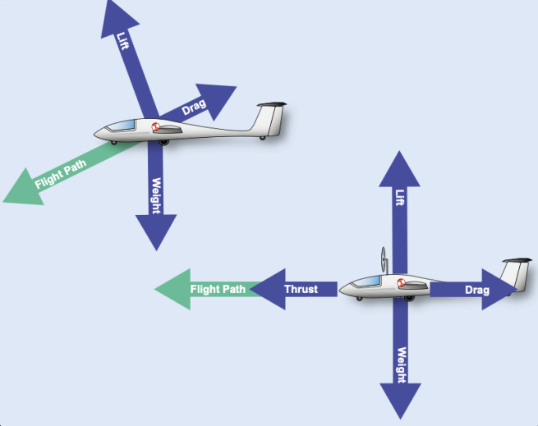
FIGURE 1. Aerodynamics of the glider [6]

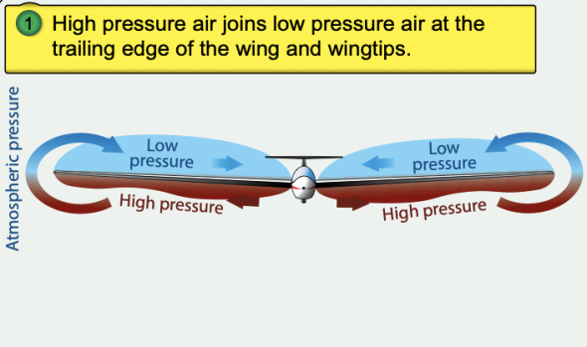
FIGURE 2. Bernoulli’s principle [7]

Research process
In this stage of the research project, designing and making a simple model plane is the first step. The research used a phone to record its flight and used tracker software to analyze its motion. Also, the videos’ sizes were adjusted to have an accurate measurement. It can help us understand some basic aerodynamics and the role of accurate data in experimental analysis.
The project used board paper, tape, and clasps to make a light aircraft. The emphasis of designing is balance, lift, and stability. The shape of the wing plays an important role in improving aerodynamic performance. We conducted the experiment indoors to avoid wind interference and filmed each flight using a fixed-position camera with a known resolution. Lens distortion was corrected using Tracker’s calibration tools, and lighting conditions were kept consistent. While the gliders were thrown by hand, we used a marked release point and alignment guide to control the angle. A mechanical launcher could further improve consistency and repeatability. Also, keep the same as the result.
Then, the work needs a fixed phone to record the flight. Besides, calculating the flight distance through the length so that helping Tracker turn the distance on the laptop into a real one. Keeping the camera still is essential to capture the plane's trajectory.
Next, feed the video into the tracker and analyze the aircraft's movement frame by frame. Through marking its position through time. Tracker generated a graph that showed position, velocity, and acceleration. These can show the flight patterns and assess how design changes affect motion and stability.
During the analysis, if the aspect ratio of the video is set incorrectly, stretched or compressed images may result in inaccurate data. To avoid this, dimensions were measured during the experiment to keep the same proportions as the real world.
All in all, this process combined makes a glider and digital video analysis. From design to record, and to analysis, each step is critical to producing reliable and meaningful results.

RESULTS AND DISCUSSION

Experimental Results
In this experiment, a positive correlation between CL/CD and b/c was found through the research, which is consistent with the common aerodynamic principle: In the total drag of the wing, the induced drag part is inversely proportional to the aspect ratio. As shown in Table 1. The larger the aspect ratio, the weaker the wing tip vortex, thus the smaller the induced drag, and the more efficient the gliding. In other words, an elongated wing can distribute the lift over a wider area. The differences of trajectory are shown in Figures 3 and 4. So it can reduce the loss of energy to increase the lift-to-drag ratio.

D=C_{L}² /πeAR （1）
(Induced Drag Formula)

TABLE 1. The data from experiments 1, 2.
Experiment number | Body (cm) | Wingspan (cm) | Chord (cm) | Weight (g) | Aspect Ratio | Average glide angle | The standard deviation of theta | C_{L}/C_{D}
1 | 31 | 23 | 8 | 75 | 2.875 | 22.160 | 4.994 | 2.455
2 | 31 | 16 | 8 | 70 | 2 | 26.282 | 6.454 | 2.025

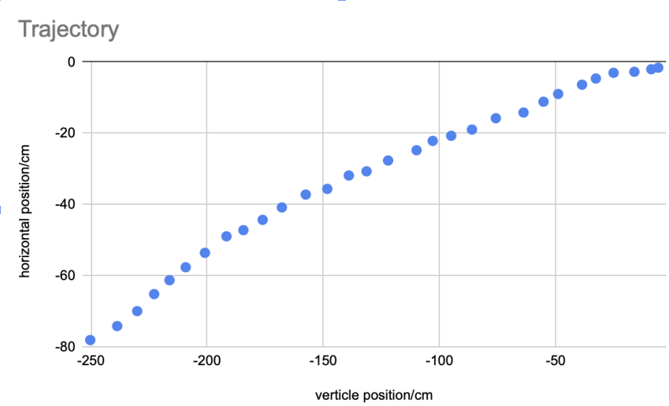
FIGURE 3. Trajectory of Experiment 1(Picture credit: Original)

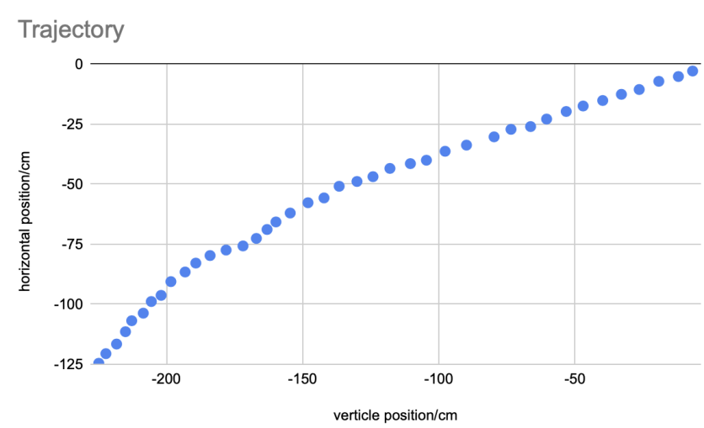
FIGURE 4. Trajectory of Experiment 2 (Picture credit: Original)

Effect of Aspect Ratio on Aerodynamics
AR is a key factor that influences a wing’s aerodynamic performance. It is defined as the wingspan divided by the mean chord, or alternatively as the square of the span divided by the wing area [7]. Long and slender wings can generate lift more effectively and experience less aerodynamic resistance [8]. This section examines, through aerodynamic theory and simulation, the effects of aspect ratio on the lift-to-drag ratio, induced drag, and the overall glide performance of gliders.

L/D （2）
(Lift-to-Drag Ratio)

Lift-to-Drag Ratio Analysis
Chen provided exact evidence that increasing AR can significantly improve the L/D ratio. When AR increases from 1.5 to 2.0, the glider can have a bigger lift with the same velocity. Figure 5 shows that. Also, lower the decreasing velocity, and a longer glide. The improvement of aerodynamic efficiency is supported by CFD studies. CFD study revealed optimized elongated wings [9-11].
However, the relationship between AR and L/D ratio is not strictly linear. Beyond a certain threshold, the gains began to decrease.
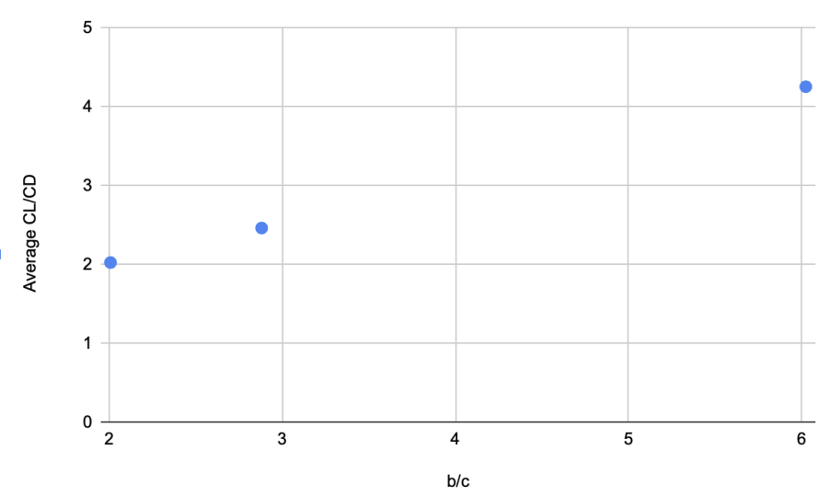
FIGURE 5. Average CL/CD-AR (Picture credit: Original)

Induced Drag Reduction
Higher aspect ratio wings also reduce induced drag, like the wingtip vortex. In the design of high-AR, the lift is distributed over a larger wing span. So the strength of the vertices is mitigated, leading to lower induced drag. Chen (2024) found that slender wings can significantly reduce turbulence and boundary layer drag, especially during low-speed flight, which can help to improve aerodynamic efficiency [4]. Through a series of confirmations, minimizing vortex strength, high-AR wings help improve the overall ratio of L/D. However, designers must remain cautious, as a very high AR can lead to structural and stability issues that may compromise flight performance [9, 11].

Glide Performance
AR exerts a direct influence on both the glide angle and flight distance. As illustrated by the experimental data in Figures 3 and 4. They show the trajectories of different experiments, gliders with higher AR values prove a reduced descent rate over a given horizontal distance. For instance, within the same time interval, increasing the AR from 1.5 to 1.9 leads to an approximate 45 cm increment in horizontal travel. As the AR continues to increase, glide performance improves, particularly as it approaches the optimal range of 4 - 5.
This improved performance is further supported by the data in Figure 5, which shows the relationship between the average theta and AR, and Figure 6, describing the connection between the average CL/CD and AR. Higher AR values contribute to better glide performance by reducing induced drag and increasing the lift - to - drag ratio. A well-balanced wing design can then effectively translate these aerodynamic advantages into greater horizontal distance.
Nevertheless, although extremely high AR values are beneficial for aerodynamics, they present significant challenges, including wing bending and heightened sensitivity to control inputs. In light of these considerations, current literature, as cited in references [10, 11], indicates that an AR around 2 strikes the best balance for maximizing glide efficiency while maintaining the overall structural integrity of the glider.

Practical Application of Glider Design
The research on the aerodynamics of paper gliders has already been conducted in some important fields.
One of the most notable results is how critical center-of-mass placement is. Ensuring that the center of mass remains in an appropriate position by adding some weight at the nose-designers can achieve stable, sustained flight. This finding has been widely adopted not only by paper airplane enthusiasts but also by engineers working on micro air vehicles (MAVs) and small unmanned aerial systems that can dispense with the traditional design of wings [12-13].
The role of wing geometry, especially aspect ratio, has also provided a quantitative basis for optimizing glider design. Researchers advise that, for long-distance flights, medium to high AR design enhances both lift production and efficiency. Through experimental and simulation data, slight alterations in the wing’s dimensions can make a substantial difference in glide angle and overall performance [9-11].
In the educational field, these results have also been used to develop hands-on experiments that allow students to understand aerodynamic principles. This educational system can foster an early interest in engineering and aerodynamics [12, 14].
Besides, improvements in automation are changing the way experiments are conducted. Hughes and his groupmate developed a robotic system that builds and launches its paper gliders. Also used machine learning to analyze flight data. This idea can test many different designs. Finding a plan that can fly much better. This automated platform not only confirms traditional aerodynamic theories but also helps us design gliders with specific requirements, such as finding the most suitable type of wings, weight distribution, and aspect ratio combination [15].

Limitations and Future Research
Although the research found much academic knowledge on paper glider aerodynamics, there were still several limitations. One major problem is over-reliance on simplified models. Many studies think that the wings of paper gliders are completely rigid, but the paper is much softer and can bend, which can affect the flight. Future research needs to focus on the flexibility of the wings, as well as more complex designs, such as origami structures, to more realistically reproduce the situation of actual flight. [9, 16].
There are some limitations to the experimental method. Throwing with hands brings different speeds and angles, which can affect the accuracy of the results. While some researchers use machines to launch gliders to reduce the differences like that, there is also a need to harmonize the testing methods to make the data more reliable [9, 11]. In addition, aspect ratios and designs have not enough to have been tested. By doing more different types of experiments, it will be better understood the principles of aerodynamics and better designs can be found [9].
Another problem is the differences between computer simulations and real flight. While high-quality CFD simulations can tell us the details of airflow, pressure, and lift, these simulations require many experiments to confirm. Phenomena like turbulence and wing bending, in some way, are not always represented accurately by simulations. Combining experimental data with advanced simulation techniques may lead to better aerodynamic models, not just for paper gliders, but for the design of truly small aircraft [9, 17].
Finally, although many of the principles found in paper gliders are useful for small flying machines and other projects, using these principles in real aircraft requires careful handling. Much of the self-stabilizing ability of paper gliders comes from their flat wings, but this design is not necessarily suitable for real aircraft that require control surfaces. Future research needs to solve the problems posed by different sizes and airflow changes, which is an important direction [9, 16].
Looking forward to the future, the combination of automated experimental platforms and machine learning technology is a hopeful direction. Systems like this can quickly test and improve different designs and discover new aerodynamic laws. At the same time, better computer simulations and accurate experimental validation will help us understand aerodynamics better than based on Reynolds numbers. These advances will not only improve the design of paper gliders but may also lead to innovative approaches to new small aircraft and lightweight flight systems [15, 17].

CONCLUSION
This study used a step-by-step experiment that combined building a model airplane with video analysis to explore basic ideas in aerodynamics. A light glider was made by using board paper and clips, focusing on wing shape, balance, and stable flight. The glider’s flight was recorded by using a phone that stayed in one place, and the video was analyzed with Tracker software. This gave accurate data about the glider’s path, speed, and acceleration.
Through this process, a positive correlation between b/c and the CL/CD was identified, supporting the aerodynamic theory that induced drag decreases as aspect ratio increases. This finding confirms that elongated wings help reduce wingtip vortices and energy loss to leading to more efficient gliding. The experiment thus validates theoretical predictions in a hands-on, measurable way.
However, this study has several limitations. The experiments were finished indoors, which reduced the effects of wind but limited flight distance. Accuracy also depended on camera angle, resolution, and calibration. Inaccurate aspect ratios in video settings could affect the results of the data.
Future work may include outdoor tests, 3D motion tracking, or CFD simulation for deeper analysis. The project demonstrated a valuable and replicable method for studying flight mechanics. Providing meaningful educational value and insight into early aerodynamic design.

REFERENCES
- N. G. Nicholus, H. Suparno, A. Suyatna and R. Irawan, AIP Conference Proceedings, 2645, 1, p. 050015 (2023).
- R. S. Nainggolan, Cognitive Sciences and Education Research, 2, 1, pp. 19–27 (2023).
- A. Abtokhi, R. Rahayu and D. Mardapi, Journal of Technology and Science Education, 11, 3, pp. 549–562 (2021).
- A. Dasmo, D. D. Arief and F. Mulyani, EAI Endorsed Transactions on Creative Education, 2, 3, p. e7 (2025).
- Federal Aviation Administration, Glider Flying Handbook, Chapter 3, p. 3 (Accessed 9/26/2024).
- Federal Aviation Administration, Glider Flying Handbook, Chapter 3, p. 4 (Accessed 9/26/2024).
- F. Zhang, Highlights in Science, Engineering and Technology, 81, pp. 411–417 (2024).
- Eagle Publications, Journal of Applied Aerodynamics, 10, 3, pp. 233–240 (2022).
- Y. Chen, HSET Journal of Engineering and Technology, 18, 1, pp. 45–53 (2024).
- Y. Chen, HSET Journal of Engineering and Technology, 18, 2, pp. 54–61 (2024).
- L. Zhang, International Journal of Flight Mechanics, 12, 4, pp. 110–118 (2021).
- M. Hasibuzzaman and R. Hasan, International Journal of Engineering and Applied Sciences, 11, 1, pp. 25–31 (2023).
- L. Ristroph, S. Childress, and M. Shelley, ScienceDaily (March 18, 2022).
- H. Nguyen and J. Carter, Journal of Educational Technology in Aerodynamics, 7, 2, pp. 70–82 (2023).
- R. Hughes, S. Kim and A. Patel, Proceedings of Mechanical Computing (PMC), 6, 2, pp. 98–107 (2023).
- H. Alavi and R. Menon, Journal of Aircraft and Aerospace Engineering, 15, 3, pp. 203–211 (2023).
- A. Lopez and Y. Dai, Aerodynamics Review, 9, 4, pp. 185–195 (2023).

