Enhancing Glider Performance: An Empirical Study on the Impact of Wing Aspect Ratio on Lift-to-drag Efficiency
Hongyu Chen
Dundee International Institute, Central South University, Changsha, 410083, China
2617606@dundee.ac.uk
Abstract. In the aerodynamic design of gliders and small unmanned aerial vehicles (UAVs), the lift-to-drag ratio serves as a key indicator of flight efficiency and stability. As a critical geometric parameter of the wing, aspect ratio (AR) has a significant impact on this ratio. While most existing studies rely primarily on simulations and theoretical analysis, there remains a lack of empirical data based on physical glider models operating in real-world conditions. To address this gap, this study established a controlled experimental system with AR and material type (foam board and thin plywood) as independent variables. Under consistent conditions, such as airfoil shape and mass, standardized manual launches, video tracking, and trajectory analysis were employed to calculate glide angles and estimate lift-to-drag ratios. The experimental results show that increasing AR significantly improves the lift-to-drag ratio. This trend remained consistent across both material groups and aligned with theoretical expectations. The study confirms the positive aerodynamic effect of higher ARs and introduces a low-cost, visualized, and replicable experimental method with practical value for both educational and engineering contexts. Additionally, it acknowledges that material flexibility and human-induced errors may influence data accuracy. Future research could incorporate mechanized launch systems and multi-variable design methods to further refine analysis and improve experimental precision.

Introduction
With the rapid development of low-altitude flight platforms, lightweight UAVs, and biomimetic flying devices, gliders and small UAVs have gained increasing attention due to their advantages in structural simplicity, low energy consumption, and strong adaptability. These characteristics enable wide-ranging applications in fields, such as aerospace education, path planning, disaster rescue, auxiliary communication, and artificial intelligence [1-3]. During gliding flights, an aircraft experiences both lift and drag forces. As such, lift-to-drag ratio—defined as the ratio of lift force to drag force at a given angle of attack—has become a core metric for evaluating flight efficiency, range capability, and attitude stability [4]. Improving this ratio can significantly enhance the aerodynamic performance of flying vehicles.
AR, defined as the square of the wingspan divided by the wing area, is a critical geometric parameter in wing design and is closely related to lift-to-drag ratio [5]. However, most current research on the influence of AR focuses on numerical simulations, theoretical analyses, or the aerodynamic optimization of large aircraft. There is a lack of empirical data based on physical glider models operating under real-world conditions. Under low-stiffness materials, unstable manual launches, and low Reynolds number conditions, conventional aerodynamic models often fail to accurately predict the actual lift-to-drag performance [6]. This reveals both a methodological gap and a need for experimental validation of AR’s influence on aerodynamic performance in such flight regimes.
To address these limitations, this study designed and constructed three types of glider models with different ARs, using two commonly accessible engineering materials—foam board and thin wooden board—as the primary structural substrates. While maintaining consistency in airfoil shape, material thickness, and overall mass, a standardized gliding experiment system was established. By capturing flight trajectories through video recording and analyzing them with Tracker software, glide angles were extracted and lift-to-drag ratios estimated using Excel-based tools. This allowed for the quantitative investigation of the relationship between AR and lift-to-drag ratio, as well as an assessment of the consistency and generalizability of this relationship across different material contexts.
The novelty of this study lies in its integration of fundamental aerodynamic theory with a visualized, video-based experimental method. Conducted under low-cost and high-controllability conditions, the research provides a replicable and scalable approach to investigating how AR, as a key geometric parameter, influences gliding performance. This method offers pedagogical value in flight mechanics education and practical implications for early-stage UAV design and aerodynamic engineering optimization. Moreover, by comparing how material type affects experimental consistency, the study also provides empirical insights for future investigations into the interplay between material stiffness, structural deformation, and aerodynamic stability.

Methodology

Force Analysis and Formula Derivation
To investigate the effect of AR on the lift-to-drag ratio of a glider, this study first conducted a two-dimensional force analysis based on the principles of aerodynamics under steady gliding conditions. On this basis, a theoretical relationship between AR and lift-to-drag ratio was derived, providing both a physical foundation and quantitative reference for subsequent physical experiments.
It was assumed that the glider descends at an angle $θ$ in a downward-right direction under unpowered flight conditions. During the glide, the glider was primarily subjected to three forces: gravitational force (W), lift (L), and drag (D). Furthermore, it was assumed that the gliding process is in a state of force equilibrium, meaning that the velocity, angle of attack, and glide angle remain constant. Environmental disturbances such as air viscosity, compressibility, and wind were neglected. Under these assumptions, the glider descended at a constant speed along a fixed glide angle. The corresponding force analysis diagram of the glider during descent is shown in Figure 1.

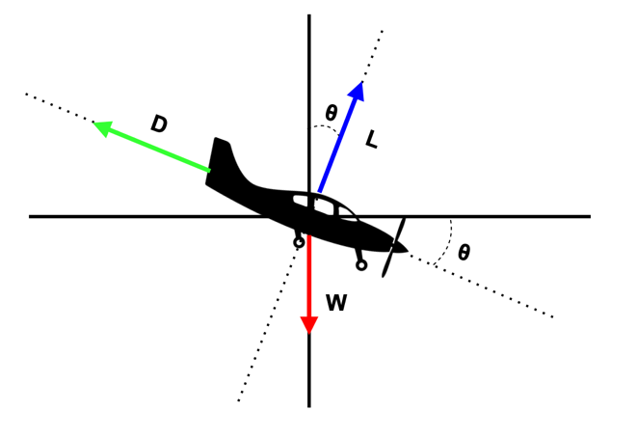
FIGURE 1. Force analysis of the glider during steady glide (Photo credit: Original)

By defining the rightward and upward directions as positive, the forces acting on the glider are orthogonally decomposed along the horizontal and vertical axes:
Horizontal:
$L\sin{θ}-D\cos{θ}=0$ (1)
Vertical:
$L\cos{θ}+D\sin{θ}-W=0$ (2)
From the force balance in the horizontal direction, the following expression can be derived:
$\frac{L}{D}=\frac{1}{\tan{θ}}$ (3)
According to relevant literature, the formulas for lift L and drag D are given as follows:
$L=\frac{1}{2}ρv^{2}SC_{L}$ (4)
where $ρ$ is the fluid density; $v$ is the relative velocity of the object and the fluid; $S$ is the reference area, generally refers to the wing area; $C_{L}$ is the lift coefficient [7].
$D=\frac{1}{2}ρv^{2}SC_{D}$ (5)
where $ρ$ is the fluid density; $v$ is the relative velocity of the object and the fluid; $S$ is the reference area, generally referring to the windward area of the object; $C_{D}$ is the drag coefficient [8].
Strictly speaking, the reference area $S$ in the two equations is not the same. However, in most practical applications, especially in the field of aeronautics, they can be approximated as equal when calculating the lift-to-drag ratio [9]. Based on this approximation, the following relationship can be derived:
$\frac{L}{D}=\frac{\frac{1}{2}ρv^{2}SC_{L}}{\frac{1}{2}ρv^{2}SC_{D}}=\frac{C_{L}}{C_{D}}$ (6)
Based on Equation (6), the relationship between lift-to-drag ratio and the gliding angle is obtained as follows:
$\frac{C_{L}}{C_{D}}=\frac{1}{\tan{θ}}$ (7)
According to additional relevant literature [10], the formula for AR can be derived as follows:
$AR=\frac{b^{2}}{S}=\frac{b}{l}$ (8)
where $b$ represents the wingspan, $S$ is the wing area, and $l$ denotes the mean aerodynamic chord length.

Experiment Design
This study aims to empirically analyze the influence of different ARs on lift-to-drag ratio of a glider through physical flight experiments. To achieve this, a series of glider models with varying ARs were designed. Using the method of controlled variables, other factors—such as mass, launch angle, and initial launch velocity—were kept constant to ensure fair comparison during flight tests. Experimental data were collected using the software tools Tracker and Excel, enabling both data recording and visualization. This approach facilitates the analysis of experimental results and helps to verify the relationship between lift-to-drag ratio and AR.
To ensure the rigor of the experimental procedure, the tests were conducted in an enclosed indoor environment to eliminate wind interference. Additionally, two types of gliders made from different materials were used to enhance the robustness and generalizability of the results. By varying the wingspan length—bearing in mind that the wing sections closer to the fuselage are wider, leading to a slight increase in the mean aerodynamic chord as the wingspan decreases—each material type included three different ARs (high, medium, and low). This design helped to make the variation trend between the lift-to-drag ratio and AR more evident.
Furthermore, for each AR configuration of each glider, five repeated trials were performed. The average and variance of the lift-to-drag ratios from these five trials were calculated to minimize experimental error. The basic specifications of the experimental gliders are shown in Table 1.

TABLE 1. Initial parameters of experimental glider groups
No. | Repetitions | Materials of gliders | Wingspan (cm) | Chord (cm) | AR
1 | 5 | Light foam board | 12.5 | 5 | 2.50
2 | 5 | Light foam board | 8.5 | 5.2 | 1.63
3 | 5 | Light foam board | 4.5 | 5.5 | 0.82
4 | 5 | Thin wooden board | 15.5 | 4 | 3.88
5 | 5 | Thin wooden board | 11.5 | 4.3 | 2.67
6 | 5 | Thin wooden board | 7.5 | 4.5 | 1.67

Experiment Procedure

Glider Design and Manufacturing
Based on fundamental principles of aerodynamics, this study designed and fabricated two types of glider models with identical structural configurations but made from different materials, to enhance the robustness and generalizability of the experimental results. The materials used were lightweight foam board and thin wooden board, both of which offer good formability and structural stability. The models are shown in Figure 2.
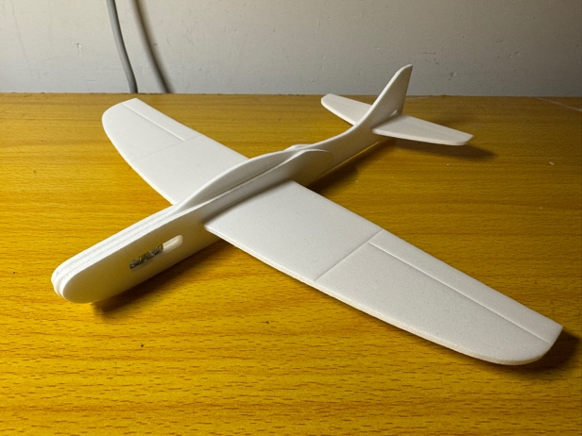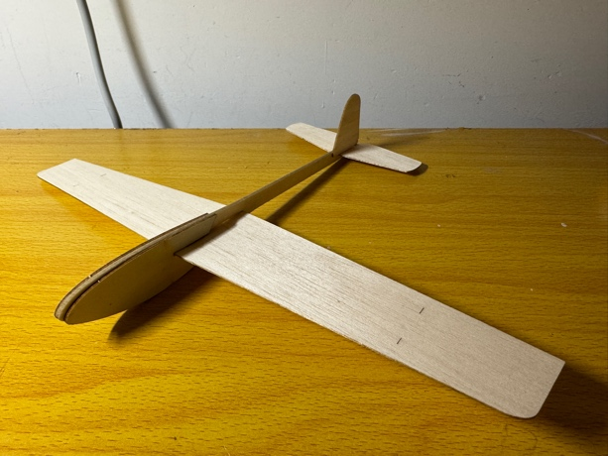
(a) (b)
FIGURE 2. Two types of experimental gliders (a) Foam board glider, (b) Wooden board glider. (Photo credit: Original)

Standardized Throwing Gliders and Video Recording
Each gliding flight was conducted by the same experimenter using a standardized posture and angle, to maintain consistency in launch height, direction, and initial velocity. The initial launch angle of the glider was controlled to be approximately horizontal, to avoid noticeable parabolic throwing. For each combination of AR and material, at least five test trials were conducted.
To enable quantitative analysis of the flight process, a camera mounted on a tripod was used to record the entire glider trajectory from the side view. The camera position remained fixed throughout the experiment, with the recording height aligned with the launch point to ensure clear documentation of both horizontal and vertical displacement. The standardized launch procedure is illustrated in Figure 3.


(a) 0 ms

(b) 200 ms
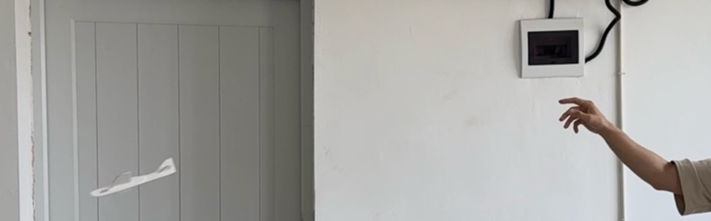
(c) 360 ms
FIGURE 3. Standardized launch procedure captured at (a) 0ms, (b) 200ms, (c) 360ms. (Photo credit: Original)

Trajectory Extraction based on Tracker
The Tracker software was used for video-based trajectory analysis. After importing the recorded flight videos into the software, spatial calibration was first performed by setting a reference scale. The glider’s flight path was then marked frame by frame, allowing for the extraction of displacement data in both the horizontal and vertical directions.

Calculation Data
All raw displacement data extracted by Tracker were subsequently imported into Excel for further processing. Using built-in mathematical functions in Excel, the glide angle was calculated, and the lift-to-drag ratio was estimated based on the formula$:$
$\frac{C_{L}}{C_{D}}=\frac{1}{\tan{θ}}$ (7)
Each combination of AR and material was tested multiple times. Finally, basic statistical analysis and visualization of the relationship between lift-to-drag ratio and AR were conducted in Excel to reveal the overall trend between the two variables.

Analyzing the Relationship between Lift-to-drag Ratio and AR
By comparing the magnitude and direction of changes in the lift-to-drag ratio under different AR conditions, this study further analyzes whether a stable and consistent relationship exists between the two. This provides experimental evidence for determining whether a positive correlation can be established between AR and lift-to-drag ratio.
The overall experimental procedure is illustrated in Figure 4.

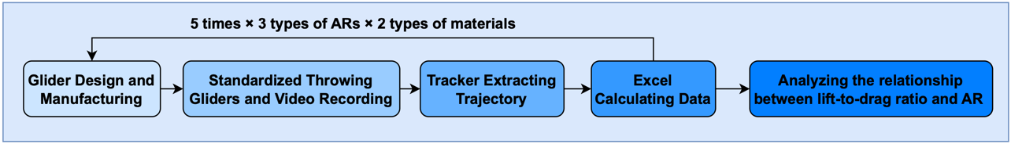
FIGURE 4. Flowchart of the experimental procedure (Photo credit: Original)

Results and Discussions

Empirical Results of Experiments
Through multiple sets of experimental measurements and data calculations, the average lift-to-drag ratios corresponding to three ARs (high, medium, and low) under two material conditions (foam board and thin wooden board) were obtained. For each experimental condition, five independent flight trials were conducted, and the arithmetic mean of the resulting lift-to-drag ratios was taken as the final value. The experimental data are presented in Table 2.

TABLE 2. Experimental results of lift-to-drag ratio at different ARs
No. | Materials of gliders | AR | Average Gliding angle | C_{L}/Cd
1 | Light foam board | 2.50 | 21.23$°$ | 2.84
2 | Light foam board | 1.63 | 26.48$°$ | 2.39
3 | Light foam board | 0.82 | 38.76$°$ | 1.83
4 | Thin wooden board | 3.88 | 18.93$°$ | 4.06
5 | Thin wooden board | 2.67 | 24.67$°$ | 3.27
6 | Thin wooden board | 1.67 | 31.96$°$ | 2.64

In addition, the relationship between lift-to-drag ratio and AR was visualized using a scatter plot, with a dashed straight line indicating a proportional trend added as a visual aid. This is shown in Figure 5, providing an intuitive representation of the numerical differences and overall trend between the two variables.
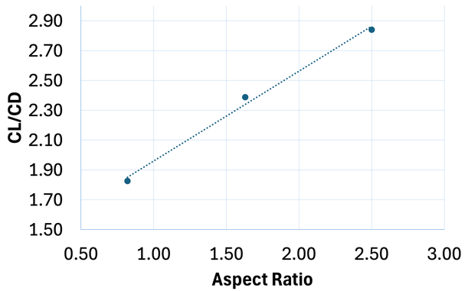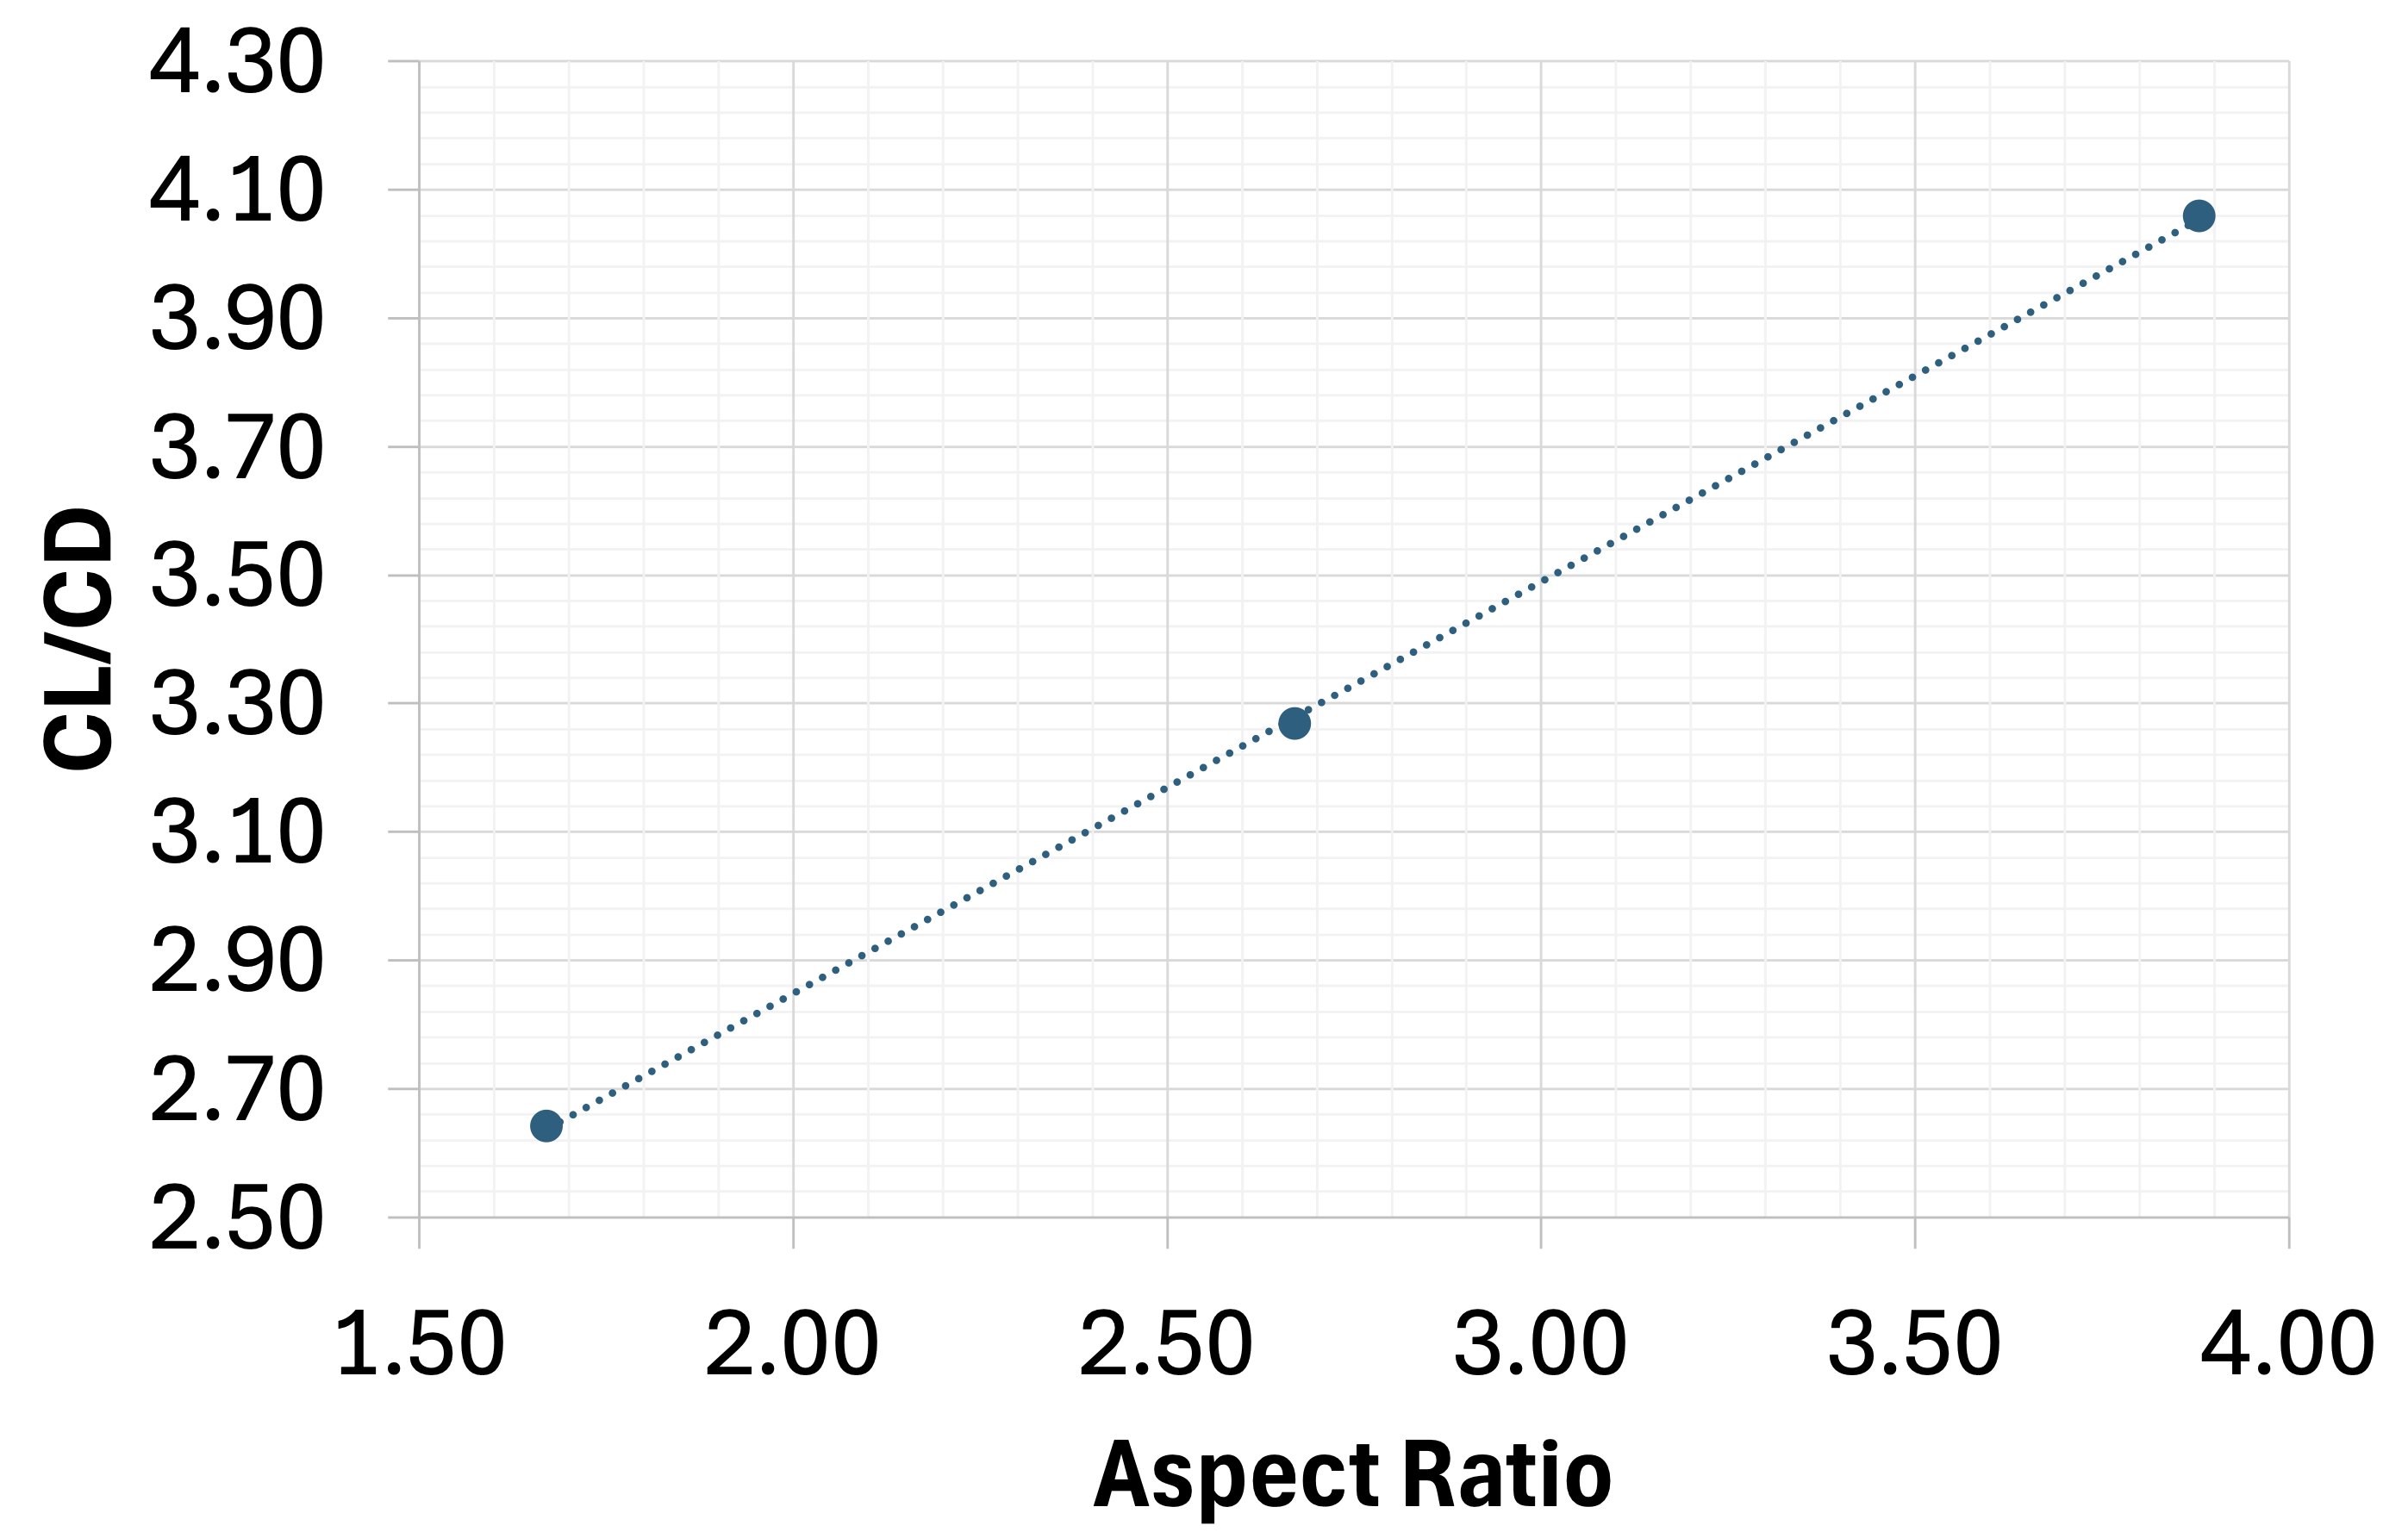
(a) (b)
FIGURE 5. The relationship between lift-to-drag ratio and AR (a) Experiment 1, (b) Experiment 2. (Photo credit: Original)

Relationship Analysis Between AR and Lift-to-drag Ratio

Experimental Analysis of the Foam Board Group
In the experimental group using foam board as the material, the three glider models with increasing ARs were labeled as short, medium, and long. The experimental results (Table 2) indicate that as AR increases, the glide angle decreases noticeably, leading to a progressively increasing lift-to-drag ratio. Specifically, the average lift-to-drag ratio was 1.83 for the low AR model, 2.39 for the medium AR model, and 2.84 for the high AR model.
This trend was further confirmed through scatter plot visualization and linear fitting (Figure 5a). Visually, the three data points exhibit a clear upward trend, suggesting that, under consistent material and geometric control conditions, AR has a significant effect on improving the lift-to-drag ratio. Moreover, the overall distribution of the data points closely follows a positively correlated linear trend line, indicating a good fit. This finding may provide valuable insights for future research on the specific functional relationship between lift-to-drag ratio and AR.

Experimental Analysis of the Thin Wooden Board Group
In the experimental group using thin wooden board as the material, the same AR design was applied. The experimental data (Table 2) also demonstrated a similar trend: the lift-to-drag ratio increased progressively with a rising AR. The average lift-to-drag ratios for the low, medium, and high AR models were 2.64, 3.27, and 4.06, respectively, showing an overall distribution pattern consistent with that observed in the foam board group.
Under the same AR conditions, the lift-to-drag ratios in the thin wooden board group were slightly higher than those in the foam board group, although the range of variation was comparable. This suggests that while the material type does exert some influence on flight performance, AR remains the dominant factor. The positive correlation between AR and lift-to-drag ratio was evident in both experimental groups. Figure 5b illustrates the trend distribution for the thin wooden board group, where the data points also exhibit a strong linear consistency.

Theoretical Justification and Interpretation of Findings
The experimental results have verified that, under otherwise constant conditions, appropriately increasing AR can lead to a higher lift-to-drag ratio, thereby improving the aerodynamic performance of the glider. From an aerodynamic perspective, lift-to-drag ratio is influenced by a combination of different types of drag, including induced drag, skin friction drag, and form drag [11]. Among these, induced drag is a unique form of drag associated with three-dimensional wings and is closely related to AR.
According to established aerodynamic theory, increasing AR effectively reduces the strength of wingtip vortices, thereby decreasing the additional induced drag generated by lift. As a result, the wing can achieve the same amount of lift with lower total drag. Theoretically, induced drag decreases inversely with increasing AR, leading to a significant improvement in the overall lift-to-drag ratio. This effect is particularly evident during low-to-moderate speed gliding or in-flight conditions requiring high lift [5].

Discussions

Reflection on the Limitations and Constraints of Experiments
Although this study adopted standardized procedures, repeated trials, and dual-material controls to ensure the reliability and generalizability of the data, certain limitations still existed in the experimental design and implementation.
First of all, since the gliders were launched manually, slight inconsistencies in throwing posture, height, and initial velocity were unavoidable, despite the experimenter’s efforts to maintain uniformity. Next, the experimental gliders were made of foam board and thin wooden board—both low-density materials. These materials generally have lower stiffness and are more susceptible to deformation under aerodynamic loads, potentially causing irregular shifts in flight attitude and resulting in flight instability [12]. These factors may have introduced unavoidable systematic errors.
In addition, although video capture and analysis using Tracker software offer a reasonable level of precision, the process of manually marking trajectory points at the pixel level remains prone to subjective error. Each reference point in the video frames was selected manually, and any image blurriness or slight lateral deviation of the glider could affect the accuracy of the markings. Such issues may lead to random errors in the data.
While the above limitations do not affect the overall trend between AR and lift-to-drag ratio, future studies should adopt more rigorous methods to improve experimental reliability. For instance, a mechanical launching device could be introduced to minimize variations in release conditions; gliders could be constructed from stiffer materials to reduce deformation during flight; and higher-precision video analysis software could be used to minimize errors in reference point marking. These improvements would help enhance the stability and accuracy of the experimental system, thereby providing a more robust empirical foundation and greater academic credibility for the research conclusions.

Reflection on the Influence of Additional Geometric Variables
The core objective of this study is to investigate the influence of AR—a key geometric parameter—on the lift-to-drag performance of a glider. To ensure the singularity of the experimental variable and the interpretability of the results, all other geometric parameters, including airfoil shape, sweep angle, wing thickness, and wing surface configuration, were kept nearly identical throughout the experimental models. This controlled variable approach allows for a direct attribution of changes in lift-to-drag ratio to variations in AR, thereby establishing a clear correspondence between the two variables.
However, in the practical aerodynamic design of gliders, aircraft, or UAVs, wing performance is not determined solely by AR. Instead, it is influenced by a combination of geometric parameters, such as airfoil type, sweep angle, thickness-to-chord ratio, wingtip structure, and surface smoothness. These parameters interact in complex ways, often producing significant effects on lift, drag, critical angle of attack, and flow separation behavior [13-15].
Previous research has shown that the geometric configuration of winglets—particularly their cant angle—can alter the formation of wingtip vortices and significantly affect lift, induced drag, and the overall lift-to-drag ratio. The study further emphasized that even small modifications to wingtip geometry can trigger nonlinear responses in aerodynamic characteristics. Therefore, relying solely on AR adjustments is insufficient for aerodynamic optimization, wingtip design must also be considered [14].
Additionally, taper ratio and sweep angle are also important geometric factors influencing gliding aerodynamic efficiency. Ribeiro et al. used direct numerical simulation to study the wake evolution behavior of wings with various taper and sweep configurations following laminar stall [15]. They found that wing geometry had a significant impact on flow separation characteristics, vortex system structure, and the recovery capability of the lift-to-drag ratio. The study indicated that under high angles of attack or stall conditions, complex coupling exists between taper ratio, sweep angle, and AR, and aerodynamic performance should not be attributed to a single geometric parameter alone.

Practical Implications of UVA and Model Glider Design and Future Design Improvement
Through empirical analysis of gliding performance across models with different ARs, this study has confirmed the positive correlation between AR and lift-to-drag ratio. This finding holds practical significance for the aerodynamic optimization of small UAVs, model gliders, and low-speed flying platforms. Given the positive relationship between these two variables, a reasonable increase in AR during the initial design phase of lightweight or long-endurance gliders can effectively improve aerodynamic efficiency, extend glide distance, and enhance attitude controllability and flight stability—all without significantly increasing structural complexity [16]. This is particularly valuable for applications that rely on passive gliding, such as emergency rescue drones, aerial surveying UAVs, and biomimetic flight platforms.
In the context of emergency rescue, increasing the AR allows for lower energy consumption and reduced structural weight, which in turn extends flight endurance. This enables a single aircraft to cover a larger search area, thereby providing broader aerial visibility for disaster response. Furthermore, a higher AR can enhance the endurance of aircraft operating in areas with disrupted communication infrastructure, allowing them to serve as stable aerial communication relays. This improves both the signal coverage and transmission stability in remote or disaster-affected regions, contributing to more effective auxiliary communication capabilities [17].
However, it should be noted that using AR as the sole optimization variable for improving gliding performance has clear limitations, and blindly pursuing a higher AR may result in unintended adverse outcomes. On one hand, increasing AR often leads to a decrease in structural strength, reduced bending stiffness, and increased manufacturing complexity, potentially shortening wing lifespan or causing wing failure and flight instability [12]. On the other hand, wing aerodynamic performance is inherently determined by the interplay of multiple geometric and material parameters. These parameters exhibit complex nonlinear coupling, and single-variable experiments are insufficient to capture the full scope of aerodynamic responses. Moreover, excessive increases in AR may unintentionally alter other geometric and material characteristics, which can in turn degrade overall aerodynamic performance [5].
From a more forward-looking perspective, the aerodynamic design of future gliders and UAVs should prioritize multi-parameter collaborative optimization. The aerodynamic performance of a gliding device or aircraft is essentially the result of combined influences from multiple geometric and physical parameters—including AR, airfoil shape, sweep angle, wing thickness, and wingtip configuration. Optimizing a single variable cannot comprehensively reflect its true aerodynamic behavior [13]. Therefore, in the design of future wings and related components, it is imperative to establish a design framework based on holistic multi-factor considerations to achieve greater performance integration and broader application adaptability.
Hence, future studies could incorporate advanced analytical techniques such as multi-parameter response surface modeling and fluid–structure interaction (FSI) simulations to systematically explore the nonlinear coupling and aerodynamic response characteristics among different geometric parameters [18]. By developing a multi-objective optimization framework tailored to real-world application scenarios, it is possible to achieve comprehensive improvements in aerodynamic efficiency, structural rationality, and mission-specific suitability for gliding platforms.

Conclusion
This study focused on the aerodynamic performance optimization of gliding vehicles by examining the practical influence of AR on the lift-to-drag ratio. A physical experimental system was constructed based on dual-material control groups, and standardized trajectory extraction and quantitative data analysis methods were employed to explore the correlation between AR and lift-to-drag ratio.
The experimental results demonstrate that in both material groups, the lift-to-drag ratio increases significantly with rising AR, following an approximately linear trend. This confirms the stable and positive impact of AR on the efficiency of gliding. The empirical findings align well with existing theoretical models, indicating that increasing AR effectively reduces induced drag, thereby improving aerodynamic efficiency, extending glide distance, and enhancing flight attitude controllability. Furthermore, although the absolute values of the lift-to-drag ratio vary slightly between the two materials, the consistent trend suggests that the influence of AR is broadly applicable, while material stiffness primarily affects absolute performance rather than the relative relationship between variables.
The contributions of this study are threefold: First, it establishes a low-cost, easily replicable experimental framework for assessing gliding aerodynamic performance, which can be widely applied in aerospace education and entry-level aircraft design evaluation. Next, it provides empirical validation of the quantitative relationship between AR and lift-to-drag ratio, offering practical design reference for small UAVs, model gliders, and long-endurance platforms. In addition, the study analyzes and reflects on potential sources of error, including material flexibility, manual throwing variability, and subjectivity in image processing, offering pathways for improving experimental precision and methodological rigor in future research.
Nevertheless, the study has certain limitations. Manual launching introduces inconsistencies in initial velocity and height; low-stiffness materials may deform slightly during flight; and the marking of video reference points involves minor subjective judgment. Although these factors do not affect the overall trend between variables, they pose challenges to measurement accuracy and model extrapolation. Future studies could address these issues by employing mechanized launching systems, high-frame-rate cameras, and novel high-stiffness materials to enhance control and precision.
Ultimately, while AR significantly influences lift-to-drag ratio, the aerodynamic performance of a flight vehicle results from the combined effects of multiple factors, including airfoil shape, wingtip configuration, sweep angle, thickness-to-chord ratio, and material distribution. Future research should build on single-variable experiments by introducing multi-parameter coupled optimization strategies to develop a comprehensive aerodynamic design framework that balances performance, stability, and structural efficiency across diverse application scenarios.

References
- K. Messaoudi, O. S. Oubbati, A. Rachedi, A. Lakas, T. Bendouma, and N. Chaib, J. Netw. Comput. Appl. 216, 103670 (2023).
- F. Ahmed, J. C. Mohanta, A. Keshari, and P. S. Yadav, Arab. J. Sci. Eng. 47, 8121–8138 (2022).
- K. Telli, O. Kraa, Y. Himeur, A. Ouamane, M. Boumehraz, S. Atalla, and W. Mansoor, Systems 11, 400 (2023).
- S. Khan, M. Danish, M. Ayaz, A. Husain, S. Saeed, S. Abdulla, S. Shaheen, A. Saeed, and A. Thaher, Sci. Rep. 15, 11998 (2025).
- W. Zhao, J. Huang, M. He, F. Ma, and K. Zhong, Shanghai Aerosp. 41, 36–44 (2024)
- K. Koca, M. S. Genç, E. Bayır, and F. K. Soğuksu, Energy 239, 121887 (2022).
- H. Schlichting and K. Gersten, Boundary-Layer Theory, 9th ed. (Springer, Berlin, 2016), Chap. 4.
- D. Elger, B. LeBret, C. Crowe, and J. Roberson, “Drag Force,” in Engineering Fluid Mechanics, 11th ed. (Wiley, Hoboken, NJ, 2016), Chap. 9.
- J. Anderson, “Airfoils, Wings, and Other Aerodynamic Shapes,” in Introduction to Flight, 9th ed. (McGraw-Hill Education, New York, 2005), Chap. 5.
- J. Anderson, “Incompressible Flow over Finite Wings,” in Fundamentals of Aerodynamics, 5th ed. (McGraw-Hill Higher Education, New York, 2011), Chap. 5.
- J. Wu, W. Kong, G. Li, and S. Tian, Acta Aerodyn. Sin. 42, 35–59 (2024).
- S. Saha and Y. Takahashi, AIAA J. 62, 4589–4604 (2024).
- Z. Han, Z. Gao, W. Song, and L. Xia, Acta Aerodyn. Sin. 39, 1–36 (2021).
- E. Vaezi, S. Madani, and A. Keshmiri, Sci. Rep. 15, 1467310 (2025).
- J. Ribeiro, J. Neal, A. Burtsev, M. Amitay, V. Theofilis, and K. Taira, J. Fluid Mech. 976, A6 (2023).
- Z. Yuan, J. Han, and G. Chen, Sci. China Technol. Sci. 67 (2024). DOI: https://doi.org/10.13374/j.issn2095-9389.2024.06.20.002
- B. Varghese, P. Kannan, R. Jayanth, J. Thomas, and K. Shibu Kumar, Comput. 11, 139 (2022).
- Z. Wang, L. Du, L. Cheng, and X. Sun, Adv. Mech. 53, 713–739 (2023).

