Aerodynamics Numerical Simulation of a Rotating Brake Disk in Ground Proximity
Bochao Xu
School of Engineering, Worcester Polytechnic Institute, Worcester, 01609, The United States

bxu1@wpi.edu
Abstract. This study investigates the aerodynamic behavior of a rotating brake disc using steady-state computational fluid dynamics (CFD). While brake system research has traditionally focused on thermal and structural aspects, the aerodynamic effects of disc rotation, such as flow separation, wake formation, and surface pressure distribution, remain less explored. To address this, a simplified disc at 800 RPM was modeled within the ground-proximity air domain with a uniform inlet of 100 km/h. The k-ω SST turbulence model was applied to resolve near-wall effects and predict the wake behavior behind the rotating surface. Results reveal a front-face stagnation region, a radial decline in surface pressure, and increasing wall shear stress toward the outer edge of the disc, along with a symmetric wake featuring central velocity deficit, and turbulence concentrated in outer shear layers. These findings provide a fundamental understanding of the bluff body flow under rotation and insights relevant to brake system design and aerodynamic efficiency.

INTRODUCTION
In high-performance engineering systems such as automotive brakes, rotating components interact with surrounding airflows in complex ways that influence aerodynamic, thermal, and structural performance. Among these, the brake disc plays a crucial role in not only converting kinetic energy into heat but also disturbing the freestream, generating wake structures, and affecting surrounding aerodynamic fields. While brake systems are traditionally designed focusing on heat dissipation and mechanical durability, the aerodynamic behavior of the disc, particularly under rotation, has become increasingly relevant in modern vehicle design.
Numerous studies have applied computational fluid dynamics (CFD) to investigate airflow behavior around the brake disc system. Thuresson focused on the flow characteristics of ventilated brake discs, illustrating the aero-thermal flow behavior of brake discs [1]. Pulugundla analyzed the influence of different vented designs of rotating brake discs’ mass air flow and heat dissipation in still air [2]. Rajkumar et al. analysed the influence of disc geometry on heat management by evaluating airflow patterns and thermal energy dissipation [3]. While these works put a heavier focus on cooling efficiency, they also demonstrate the broader aerodynamic implications of the rotating disc geometry.
Some studies have taken a more targeted look at external flow and aerodynamic loading around rotating bodies. While focusing on convection cooling, Marin and Marin used CFD to investigate the airflow trajectory near the rotating disc and wheel assembly in a steady external flow, showing the deflector and rim geometry’s influence on the direction and effectiveness of cooling air flow [4]. Boujo and Cadot examined the fluid structure interaction between circular discs and turbulent wake and developed a low-order stochastic model [5]. Yang et al. studied the wake pattern behind a short rotating cylinder and found the influence of rotation on the development of wake instabilities [6]. Islam et al. simulated the flow over rotating disc projectiles using various turbulent models, analyzing the flow separation and wake structure [7]. Yates and Richards studied the wake of an isolated rotating wheel typical of open-wheel motorsports and found that it creates a T-shaped wake zone with significant vortex deformation in the unsteady flow [8].
Although the aerodynamic role of brake disc design is becoming more relevant in vehicle design, it remains insufficiently studied compared to the disc’s thermal and structural aspects. Most existing analyses focus on heat transfer performance, but less on the aerodynamic influence of the disc. Furthermore, experiments on rotating components often suffer from limited resolution and the complexity of replicating realistic boundary conditions. Many previous CFD studies simplified the rotation effects or used unsteady models without clearly resolving steady-state wake patterns, pressure gradients, and near-wall flow behavior.
To address these challenges, this study presents a CFD-based study of a simplified solid brake disc rotating in open air near the ground. To truly focus on the external aerodynamic influence of disc rotation, a solid, unvented brake disc rotating at 800 RPM is placed within a simplified air domain with a 100 km/h inlet velocity. The simulation using the k-ω SST turbulence model was applied to precisely resolve near-wall effects and predict the wake behavior behind the rotating surface. Steady-state conditions are imposed to allow for a clear analysis of consistent aerodynamic structure.
Unlike prior works that primarily focus on cooling performance, this study delivers a CFD-based analysis capturing steady-state wake structure, pressure distribution, and near-wall shear behavior, and highlights how rotation alters flow patterns, surface loading, and downstream turbulence. The research aims to establish a clear aerodynamic baseline for rotating disc systems, provide a fundamental understanding of the bluff body flow under rotation, and provide insights relevant to brake system design and aerodynamic efficiency.

Methodology
Geometry and Physical Model
In this study, a simplified model of a solid brake disc was constructed to investigate the aerodynamic behavior of airflow around a rotating disc near the ground (Figure 1). The brake disc has an outer diameter of 264 mm and consists of two parallel plates connected by internal straight radial vanes. The internal structure was designed about validated CFD-based studies and observations on real-world applications, approximating realistic disk geometry while maintaining computational tractability [9, 10]
The height of the disk center was set to be 0.264m above ground, equal to its diameter, aligning with the typical height of a passenger vehicle hub observed [10]. The internal ventilation gap was set to be 10 mm, with straight radial vanes to represent air flow channels between the plates. The number of vanes was chosen to be 8, to maintain geometric accuracy while ensuring meshing feasibility. These internal structures were excluded from the final computational model to focus solely on external aerodynamic effects.

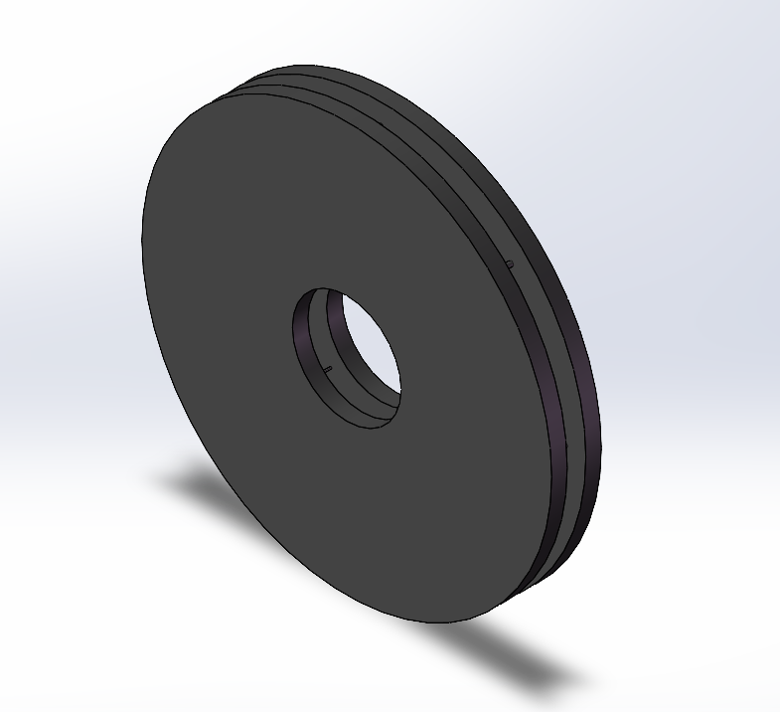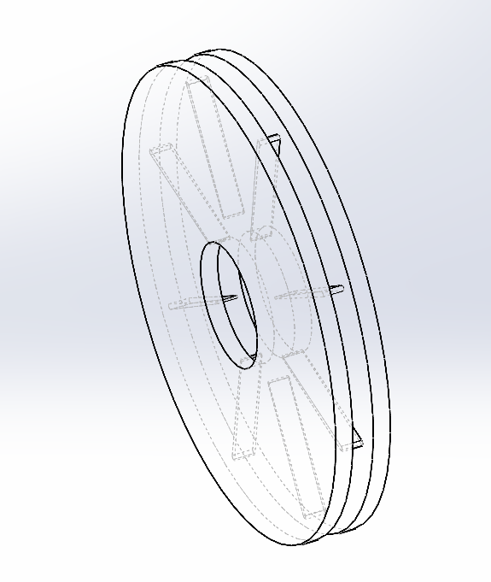
(a) (b)
FIGURE 1. Designed brake disk in (a) isometric view and (b) transparent view. (Picture credit: Original)

Boundary Conditions and Simulation Setup
To analyze the aerodynamic behavior of a rotating brake disk in ground proximity, a steady-state CFD simulation was performed using ANSYS Fluent. The disc was placed in a box-shaped air domain constructed to represent the external flow conditions. The brake disc was modeled as a rotating solid body. A rotational speed of 800 RPM was applied to simulate the wheel hub in moderate-speed driving conditions, and the surrounding air was treated as stationary.
To simulate freestream air approaching the disc, a velocity inlet boundary condition was applied to the front face of the domain at a uniform velocity of 27.78 m/s, corresponding to the wheel rotational speed. The rotation of the disc was simulated using a rotating wall boundary condition. The rear face was set as the pressure outlet with zero gauge pressure. All remaining surfaces were treated as stationary non-slip walls to prevent airflow from exiting through unintended boundaries, replicating the realistic vehicle brake structures and ensuring proper wake formation behind the disk (shown in Figure 2).

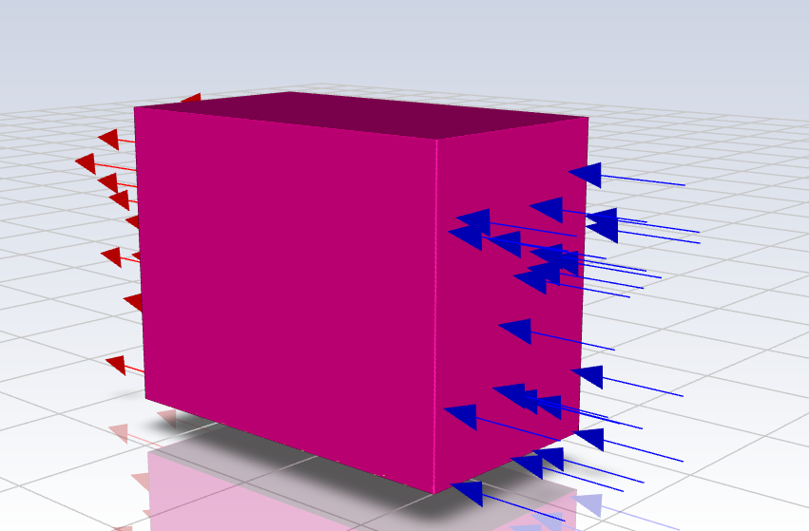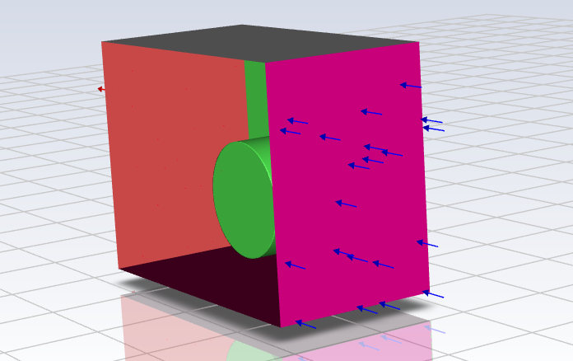
(a) (b)
FIGURE 2. Air boundary conditions of the simulation domain. (a)Full view of boundary conditions; (b) Internal view showing the rotating wall boundary condition on the disc. (Picture credit: Original)
Meshing and Turbulence Modeling
Meshing was performed using the Watertight Geometry workflow in Fluent Meshing. A surface mesh was first generated on all boundary faces, including the brake disk, ground plane, and enclosure walls, defining the brake geometry’s interfaces. Volume meshing was then performed to fill both the fluid and solid regions for simulation. The mesh density was moderately refined near the brake disc surface to better resolve boundary layer interactions, while coarser cells were applied farther from the disc for lower computation cost. The disk and the surrounding fluid region were treated conformal.
The simulation employed the k-ω SST (Shear Stress Transport) turbulence model, which is widely applied in external aerodynamics and rotating body simulations due to its accurate prediction of boundary layer separation and flow separation. Hybrid initialization was used, and the simulation was carried out in steady-state conditions until convergence was achieved.

Results and Discussions
Simulation Results of the Flow Field
The flow field around the rotating brake disc reveals key aerodynamic interactions driven by both the incoming freestream and the disc’s rotational motion. As shown in Figure 3, velocity vectors in the central YZ midplane show that air flow approaching the disc is redirected shapely outward near the disc edges, while a stagnation region develops at the front face of the disk where the incoming air directly impinges the surface. A well-defined wake region forms immediately behind the disc, where the airflow slows down and begins to spread outward, as a result of flow separation caused by the disc rotation.
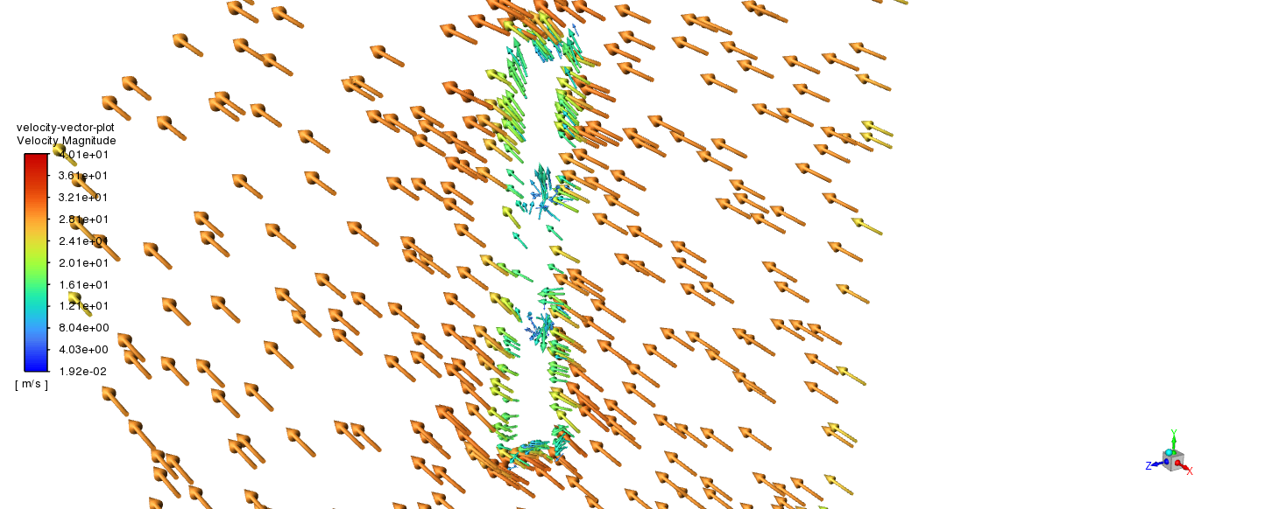
FIGURE 3. Velocity vector plot of the brake disc. (Picture credit: Original)

This wake region is elongated and primarily symmetric, indicating that the disc rotation deflects the flow evenly, without introducing major imbalance. However, local disturbances in the flow direction near the outer edge of the disc suggest the influence of rotational motion on flow paths. As shown in Figure 4, the effect is more evident in the zoomed-in vector plot, which highlights the accelerated air flow along the disc’s outer radius before separating behind the disc. The separation leads to a drop in velocity magnitude and the formation of weak recirculation zones in the wake.

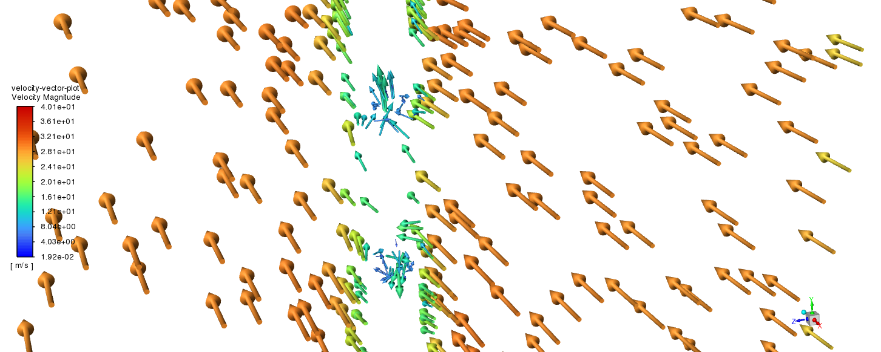
FIGURE 4. Velocity vector plot of brake disc zoomed. (Picture credit: Original)

At the top half of the disc, flow deflection becomes more evident due to the combined influence of disc rotation and incoming velocity. The velocity vector curvature increases near the disc surface, confirming stronger velocity gradients in the region. This is consistent with the expected behaviors in rotating bluff body flows, where centrifugal effects and boundary layer interaction cause the outward deflection of the airflow and thinning of the near-wall flow.
Overall, the velocity vector field clearly shows that the rotating disc significantly alters the initially uniform inlet profile. Key features include a stagnation zone at the front face of the disc, outward acceleration around the outer edge, and a well-defined wake characterized by a local velocity drop. These flow behaviors form the basis for the pressure distribution, wake structure, and turbulence intensity discussed in the subsequent sections.
Pressure and Wake Analysis
The aerodynamic influence of the rotating disc is further examined through analyzing the pressure distribution, wake structure, and turbulence intensity. These results help illustrate how the disc interacts with the incoming airflow and how its rotation contributes to the downstream energy loss through flow separation and turbulence generation.
Surface Pressure Distribution
The static pressure distribution on the disc surface is shown in Figure 5. The highest pressure appears near the center of the disc’s front face, where it makes direct contact with the incoming flow. This region represents the stagnation zone where the airflow impinges and loses its momentum, resulting in a higher local pressure. The pressure then decreases radially outward as the flow accelerates along the surface toward the disc’s edges.
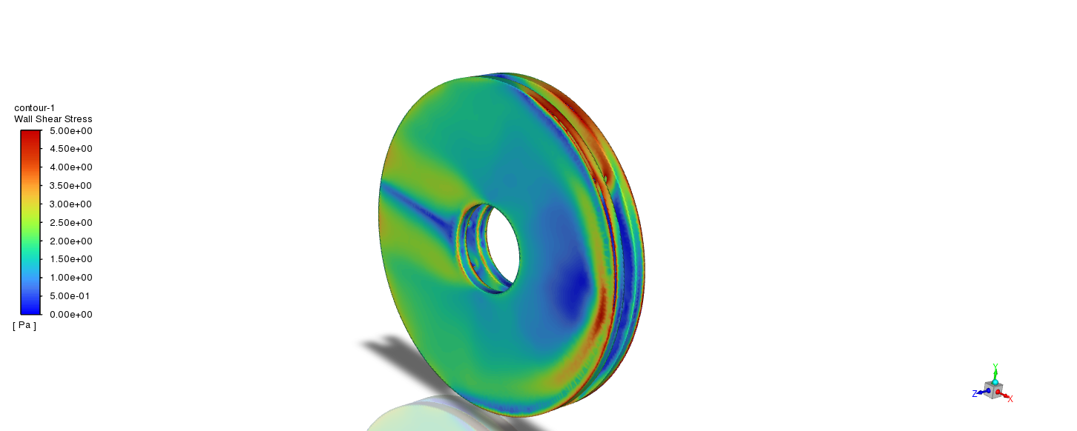
FIGURE 5. static pressure distribution on the rotating disc surface. (Picture credit: Original)

The pressure distribution remains mostly symmetric about the disc’s midplane, confirming that the freestream and rotation interact do not introduce significant imbalance into the flow. Near the disc perimeter, the pressure drops further as the flow is deflected around the curved edges of the disc. The transition from high to low pressure indicates how the disc surface modifies the incoming flow momentum and contributes to the overall aerodynamic reaction of the system.
Although the simulation assumes steady-state conditions, the resulting pressure contours suggest dynamic flow near the disc surface. The pressure gradients reflect the combined influence of front impact and rotational motion, where pressure builds up ahead of the rotating face and dissipates as flows are distributed outward.
Wake Formation and Flow Separation
A clearly defined wake forms behind the disc because of the separation and speed decrease of the airflow caused by the rotating disc. As shown in Figure 6, the wake region is characterized by a noticeable drop in flow velocity and a gradual outward spread of the streamlines. The core of the wake region exhibits the lowest velocity, while the surrounding region gradually increases towards the edges, due to the mixing with the surrounding freestream. The observed behavior is typical of bluff body flows, where separation and energy loss occur behind a blunt surface.
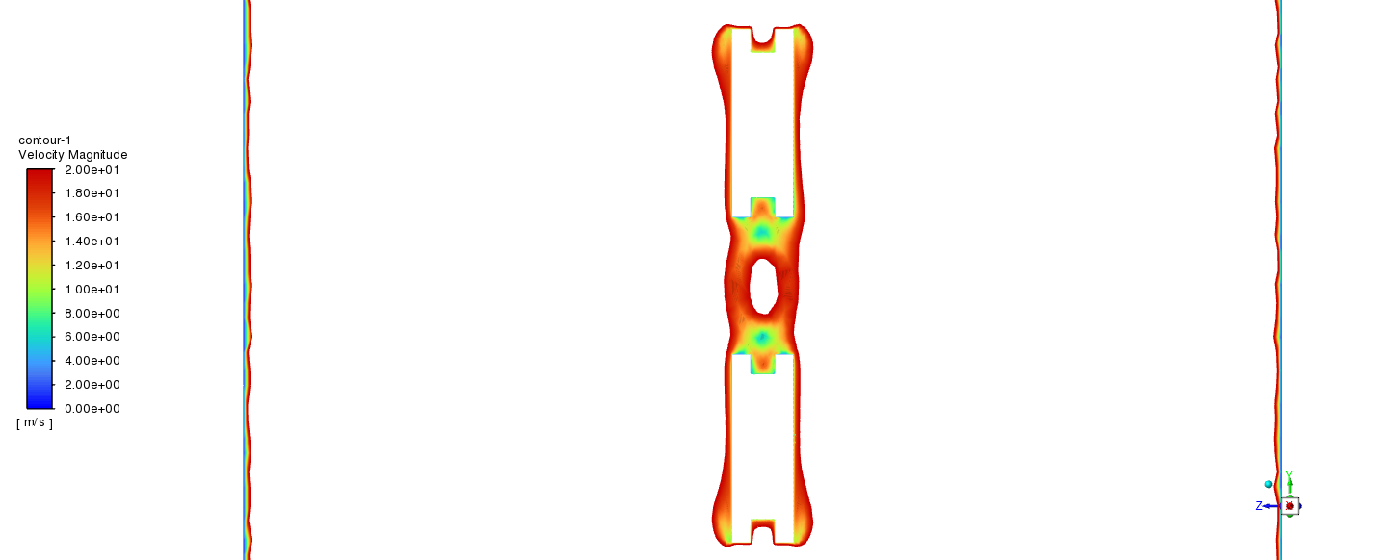
FIGURE 6. Velocity magnitude contour of the brake disc. (Picture credit: Original)

The wake maintains mostly symmetric along the vertical axis, suggesting that while rotating introduces flow curvature near the disc surface, the rotation doesn’t significantly disrupt the global symmetry of the flow. However, some localized differences in velocity are noticeable near the top and bottom edges of the wake, likely due to the interaction between the rotational effects and the decelerating flow behind the disc. These small variations may signal the early stages of unsteady behavior, although not captured in the steady-state conditions.
To gain further insight into the turbulence in the wake, the distribution of turbulent kinetic energy (TKE) is shown in Figure 7. Higher values of TKE are found along the outer shear layers of the wake, indicating regions of strong shear where turbulence is actively generated due to the interaction between the slow-moving wake and the faster surrounding freestream.

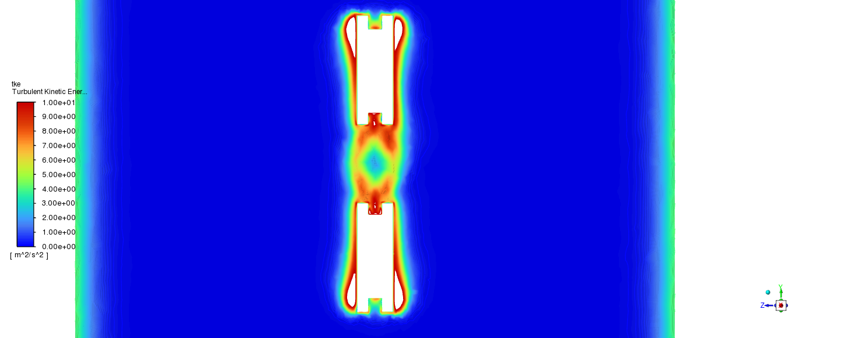
FIGURE 7. Turbulent kinetic energy distribution of the brake disc. (Picture credit: Original)

The velocity and TKE results confirm that the rotating disc produces a low-momentum wake and promotes the development of turbulence through separation-induced shear. Even under steady-state simulation conditions, the flow exhibits key features of wake dynamics, including velocity deficit, flow spreading, and elevated turbulence intensity along the wake boundary.
Aerodynamic Characteristics
To gain further insight into how the disc affects the surrounding airflow, the wall shear stress distribution was examined. Figure 8 shows the variation of shear stress across the surface of the rotating disc. The highest values occur near the outer edge, where the tangential velocity is the greatest due to the disc’s rotation. In contrast, the center region of the disc exhibits much lower shear stress, consistent with a slower surface velocity and the stagnation zone near the disc face.
FIGURE 8. Shear stress distribution on brake disc surface. (Picture credit: Original)

This radial pattern reflects the centrifugal effects in rotating systems. Surface velocity increases with distance from the center, creating stronger velocity gradients near the wall. These gradients produce a greater shear stress, particularly when the flow along the edge interacts with the redirect and locally accelerated fluid nearby. The symmetry in the shear stress distribution also verifies that disc rotation does not cause major lateral imbalance and exhibits that the flow remains largely axisymmetric under steady-state conditions, consistent with the symmetric wake observed behind the disc.
While the overall aerodynamic drag was not explicitly calculated in this simulation, the shear distribution gives insight into how the disc interacts with the air around it. The outer rim that experiences the most shear is likely where the surface-driven drag forces are most intense.
Combined with pressure and wake analysis, the shear stress profile completes the picture of how the rotating disc alters airflow. It reinforces the interpretation that disc rotation enhances surface loading at the outer edge and contributes to downstream wake development and energy loss through boundary layer interactions.

Conclusion
This study presented a steady-state CFD simulation of a rotating near-ground brake disc to understand the aerodynamic behavior under incoming flow conditions. The results showed that the disc significantly alters the surrounding airflow, creating a distinct stagnation region at the front, a well-defined, symmetric wake downstream, and accelerated flow around the edge.
The velocity vector field demonstrated clear flow deflection near the disc surface, confirming the rotational motion’s disturbances to the freestream profile. The surface pressure distribution exhibits a higher pressure near the center and a gradual decrease towards the rim, reflecting the influence of centrifugal effects and rotational acceleration on the disc surface. Wall shear stress was highest at the outer radius, further showing that the rotating surface generates stronger aerodynamic loading along the edge. In the wake region, the simulation showed reduced velocity and elevated turbulent kinetic energy, especially along the outer shear layers, demonstrating the key features of separated flow behind bluff bodies. The wake remains largely symmetrical, exhibiting rotating discs that do not introduce significant lateral imbalance in overall aerodynamic behavior. These results provide a reliable numerical basis for understanding how rotating discs interact with airflow under steady conditions.
The findings of the study have practical relevance for the aerodynamic design and thermal management of the brake system. By characterizing the flow field, pressure loading, and shear distribution around a simplified disc geometry, this work offers insight that can guide further development of improved designs of braking components.
Further research can build on this research by introducing unsteady simulations to capture transient flow behavior. Additionally, incorporating thermal modeling would allow for the coupling analysis of heat transfer and aerodynamic performance, providing a more complete picture of brake disks in real-world operating conditions.

References
- A. Thuresson, “CFD and Design Analysis of Brake Disc,” B.Sc. thesis, Chalmers University of Technology, Gothenburg, 2014.
- G. Pulugundla, “CFD design analysis of ventilated disc brakes,” M.Sc. thesis, Cranfield University, 2008.
- R. Rajkumar, I. Sirajudeen, and S. Raja, Design and CFD Analysis of Brake Disc, Int. J. Manag. Technol. Eng. 9, 3155–3157 (2019).
- F.-B. Marin and M. Marin, CFD Modeling of Aerodynamic Car Brake Cooling System, Ann. “Dunarea de Jos” Univ. Galati, Fascicle IX, Metall. Mater. Sci. 4, 44–47 (2021).
- E. Boujo and O. Cadot, Stochastic Modelling of a Freely Rotating Disk Facing a Uniform Flow, arXiv:1901.06397 (2019).
- Z. Yang, J. Sun, and C. Liang, Three-Dimensional Global Instability of Flow Past a Short Rotating Cylinder, arXiv:2311.07902 (2023).
- R. A. Lukes, J. Hart, J. Potts, and S. Haake, A CFD Analysis of Flow Around a Disc, Procedia Eng. 72, 685–690 (2014).
- D. Patel, A. Garmory, and M. Passmore, On the Wake of an Isolated Rotating Wheel: An Experimental and Numerical Investigation, J. Wind Eng. Ind. Aerodyn. 227, 105049 (2022).
- C. Li and H.-I. Yang, Optimized Shape for Improved Cooling of Ventilated Discs, Alex. Eng. J. 79, 556–567 (2023).
- R. Krüsemann and G. Schmidt, Analysis and Optimization of Disk Brake Cooling via Computational Fluid Dynamics, SAE Trans. 104, 1475–1481 (1995).

