Research on Gait Recognition and Planning of Lower Extremity Exoskeleton Robots
Boyuan Liu
School of Mechanical Engineering, Wuhan University of Science and Technology, Wuhan, China

202221176006@wust.edu.com
Abstract. Against the background of the intensification of population aging and the expansion of the group with lower limb dysfunction, the lower limb exoskeleton robot integrating biomechanics and intelligent control has important application value in the fields of rehabilitation treatment and movement assistance. This paper systematically reviews the core technical system of gait recognition and planning for lower extremity exoskeleton robots, and focuses on analyzing the innovative applications of intelligent algorithms such as machine learning and deep learning. Given the bottleneck problems existing in the current technology, such as lagging real-time response, strong dependence on training data, and insufficient accuracy of individual adaptation, it is proposed that in the future, hybrid models such as CNN-LSTM should be integrated to improve the algorithm efficiency, and the dynamic parameter tuning mechanism of multimodal perception and reinforcement learning should be combined. Meanwhile, it is necessary to promote the collaborative optimization of ontology-driven sensing hardware, construct a standardized clinical verification system, break through the existing limitations through multi-dimensional technological innovation, and ultimately achieve the large-scale application of lower extremity exoskeleton robots in the fields of medical rehabilitation and daily walking assistance.

INTRODUCTION
Against the background of accelerating global population aging and industrial upgrading, the group of people with lower limb dysfunction continues to expand. By the end of 2023, the proportion of the population aged 60 and above in China reached 21.1%, among which those aged 65 and above accounted for 15.4% [1]. Neurological diseases (such as stroke and spinal cord injury) are highly prevalent among the elderly population, which can easily lead to loss of motor function [2]. Meanwhile, the total number of cerebral palsy patients exceeds 6 million, and 30% of them are children under the age of 12. Insufficient intervention during the golden rehabilitation period will lead to lifelong disability [3]. Long-term reliance on wheelchairs can cause metabolic disorders, bone density loss, and muscle atrophy, accelerating the process of functional disorders. Studies show that prolonged sitting is prone to cause metabolic syndrome, significantly increasing the risk of cardiovascular diseases and diabetes. Traditional rehabilitation methods have limited effect on this [4, 5]. In addition, occupational injuries in heavy physical industries such as logistics and construction have increased, becoming an important factor restricting the health of workers.
In response to this complex public health challenge, the lower extremity medical rehabilitation exoskeleton robot, as a cutting-edge medical equipment integrating biomechanics and intelligent control, is demonstrating unique clinical value. This device, through a bionic mechanical structure and precise electronic control system, can provide customized gait training for patients with lower limb dysfunction caused by different etiologies. Among them, gait recognition and planning, as the core of lower limb exoskeleton robot technology, directly affect the motion performance of the robot and the user experience. For instance, wang et al. studied and designed a 5-degree-of-freedom lower extremity exoskeleton. By establishing a D-H model and analyzing the changes in joint angles through inverse kinematics, optimizing joint displacement and rotation parameters in combination with an optical dynamic capture system, and verifying the consistency between walking data and experimental collected data based on ADAMS simulation, Provide theoretical and data support for the simulation of human gait and the development of physical prototypes [6]. Zhao et al. designed a wearable lower limb exoskeleton rehabilitation robot driven by ropes through bionics, and proved that the rehabilitation robot they designed had a good effect through a series of simulation experiments [7].
Although certain progress has been made in the existing research, there is a lack of specific analysis at the algorithmic level. This paper aims to systematically review the research progress of gait recognition and planning for lower limb exoskeleton robots at the algorithmic level, analyze the advantages and disadvantages of the existing methods, and explore the future development direction, providing a reference for further research in this field.

GAIT RECOGNITION
Gait recognition and planning are one of key technologies for achieving human-machine collaboration in lower limb exoskeleton robots. It accurately identifies the current gait pattern by analyzing the user's movement characteristics and intentions, providing a basis for subsequent gait planning and control. Gait recognition based on sensor data is one of the most commonly used methods. Usually, inertial measurement units (IMUs), force sensors, electromyography sensors, etc., are utilized to collect the motion information of users [8, 9]. Through the fusion and processing of sensor data, features such as gait cycle, joint Angle, and ground reaction force can be extracted, thereby achieving gait recognition, as shown in Figure 1.
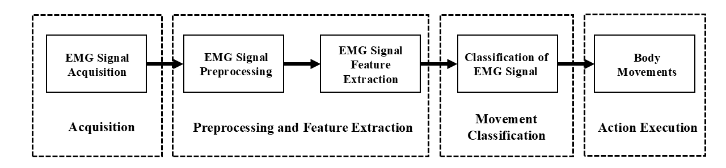
FIGURE 1. Flow of EMG signal acquisition (photo credit: original)

In recent years, machine learning and deep learning technologies have been widely applied in the field of gait recognition. Gait recognition methods based on machine learning usually adopt traditional algorithms such as Support Vector Machine (SVM) and random forest, and achieve gait pattern recognition by training classifiers [10]. The methods based on deep learning, such as Convolutional Neural Networks (CNN) and Long Short-Term Memory Networks (LSTM), can automatically extract gait features and exhibit superior performance on large-scale datasets. Then, based on the gait recognition results and task requirements, appropriate motion trajectories and control strategies are generated [11].

RANDOM FOREST ALGORITHM

Principle of the Random Forest Algorithm
Random forest is an ensemble learning algorithm based on decision trees. It improves classification accuracy and robustness by constructing multiple decision trees and integrating their prediction results (such as majority voting or mean), as shown in Figure 2. Its core advantages include feature randomness and data randomness. Feature randomness refers to the fact that each tree is trained using only the features of a random subset, thereby reducing the risk of overfitting. Data randomness is achieved through Bootstrap sampling to generate diverse training sets, enhancing the generalization ability of the model. Furthermore, random forests can quantify the contribution of each sensor signal to gait classification based on the Gini index or information gain, thereby providing a basis for feature selection.
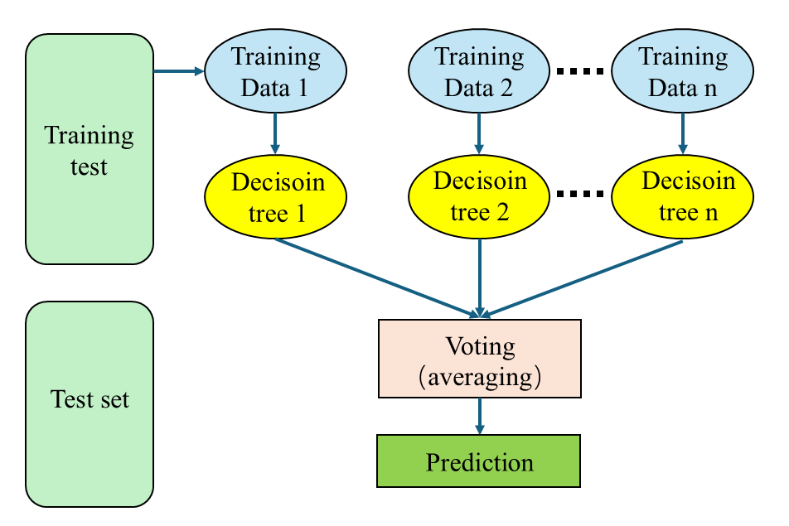
FIGURE 2. Schematic diagram of the random forest algorithm (photo credit: original)

Application of Random Forest Algorithm
In lower limb exoskeleton robots, the random forest algorithm is mainly used for motion intention classification and gait planning. The goal of motion intention classification is to identify the user's current actions (such as walking, going up and down stairs, and remaining stationary) and gait stages (such as the support period and swing period), while gait planning is to dynamically adjust the joint torque or gait trajectory of the exoskeleton based on the classification results to achieve efficient assistance [12].
The lower limb exoskeleton robot collects biomechanical signals such as muscle activity, joint Angle, ground reaction force (GRF), acceleration, and angular velocity in real time through electromyography sensors (EMG), inertial measurement units (IMU), pressure, and joint Angle sensors [13]. After denoising (low-pass filtering), normalization, and signal segmentation preprocessing, effective data is provided for subsequent analysis. Furthermore, to train the supervised learning model, it is also necessary to label the data. For example, the gait labels of users (such as gait stages and action categories) are synchronously recorded through optical motion capture systems to provide true values for subsequent model training[14].
The preprocessed data need to extract features in the time domain (mean, variance, peak), frequency domain (power spectral density), and frequency domain (wavelet transform coefficients) to characterize the gait dynamics characteristics in multiple dimensions and support model training. In terms of feature extraction, Wang et al. found that the rate of change of joint angles can reflect the stability of gait, while Zhang et al. could analyze the intensity of muscle activity through the spectral characteristics of electromyography signals [13, 15].
In the online recognition stage, the real-time collected sensor data stream is input into the trained random forest model, and the current gait category and stage are output. For instance, Shi et al. concluded and found that the model can determine whether the user is currently in the support period or the swing period of walking, or identify whether the user is going up and down stairs [12]. These classification results provide a crucial decision-making basis for exoskeleton controllers. In the gait planning stage, the controller dynamically adjusts the joint torque or gait trajectory of the exoskeleton based on the classification results. For example, during the support period, the exoskeleton can provide additional assistance to reduce the load on the user's lower limbs; During the swing period, the exoskeleton can adjust the joint Angle to optimize the naturalness of the gait.
In addition, the random forest can also conduct multi-tree voting in combination with environmental feedback (such as slope and obstacles) to further optimize the control strategy. For example, when an uphill is detected, the exoskeleton can increase the assisting torque of the knee joint; When an obstacle is detected, the exoskeleton can adjust the step size to avoid a collision. Finally, the random forest algorithm was integrated with the hardware system of the lower extremity exoskeleton and experimentally verified. System integration includes the collaborative design of algorithm embedding and controllers. For example, Novak et al. proposed a machine learning algorithm to detect the start and end of gait, which can detect the start and end of gait relatively accurately [16]. Li et al. collected the voltage data at the wrist boundary using sensor devices and classified the collected voltage data using deep learning at the same time. The correct recognition rate of posture by this method reached more than 90% [17].
These studies show that the lower limb exoskeleton robot based on the random forest algorithm can achieve the classification of motion intentions such as walking and going up and down stairs, as well as the precise identification of gait stages such as the support period/swing period by fusing multiple sensor data and combining multi-dimensional feature extraction in the time domain, frequency domain and time-frequency domain. Its decision-making is based on the multi-tree voting mechanism of joint Angle change rate, electromyography spectrum characteristics, and environmental feedback, and dynamically optimizes the joint torque or gait trajectory. The real-time performance and reliability of control can be further enhanced through system integration.

CONVOLUTIONAL NEURAL NETWORK (CNN)

Principle of the CNN Algorithm
As a hierarchical deep learning model, the core feature of CNN lies in the introduction of the convolution kernel operation and down sampling processing mechanism. Compared with traditional models such as backpropagation networks or extreme learning machines, CNN achieves layer-by-layer abstraction of input features and local feature capture through multi-level filters. The core advantages of this network are reflected in two dimensions: reducing the number of parameters through the local perception area and combining the parameter sharing mechanism to lower the model complexity, thereby significantly improving the computational efficiency and alleviating the risk of overfitting [18].
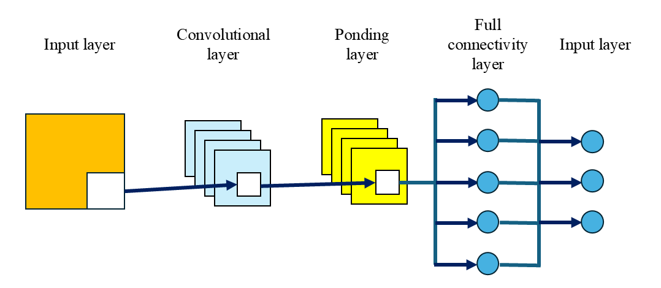
Figure 3. CNN algorithm schematic (photo credit: original)

As shown in Figure 4, CNN achieves efficient mapping from raw data to feature learning through a hierarchical structure of the input layer, convolutional layer (including nonlinear activation), pooling layer, fully connected layer, and output layer [13]. In the gait recognition and planning stage, its convolution-pooling operation can extract multi-scale gait features. After being integrated by the fully connected layer, they are used for gait stage classification and motion intention prediction, and drive the kinematic model to generate joint torque trajectories. Finally, personalized gait support is completed through the actuator.
The core principle of the CNN algorithm in gait recognition and planning of lower extremity exoskeleton robots lies in its multi-level spatiotemporal feature extraction ability and end-to-end learning framework. Specifically, CNN can automatically capture local features from the original sensor data (such as joint angles, inertial measurement units (IMUs), and plantar pressure signals) through the sliding operation of convolutional kernels in the temporal or spatial dimensions. For example, 1D-CNN extracts gait spatial features by processing temporal signals (such as the rate of change of knee flexion Angle), while 2D/3D-CNN captures spatio-temporal features based on gait energy maps (GEI) or bone sequences, becoming an important preprocessing form for CNN input [19]. In terms of spatio-temporal modeling, the method combined with Graph Convolutional Network (GCN) further enhances the model's understanding of skeletal relationships [20].

Application of CNN Algorithm
Cao et al. found that the proposed selectable Multi-scale graph convolutional Network (SMS-GCN) models the multi-scale dependency relationship between joints by constructing a multi-scale channel topology refinement adjacency matrix (MS-GC module), and combines selectable multi-scale temporal convolution (SMS-TC module) to dynamically extract temporal features. The Top-1 recognition accuracy rates of 96.9% (across perspectives) and 90.7% (across Settings) were achieved respectively on the NTU-RGB+D and NTU-RGB+D 120 datasets, verifying the advantages of the model in joint feature extraction in terms of time and modeling [21]. This model adopts a data fusion strategy of four streams: joint, bone, joint movement and bone movement, significantly improving the generalization ability of complex movements. Furthermore, the introduction of the attention mechanism enables the model to adaptively focus on key joints and key frames, thereby enhancing its robustness against noise or occlusion. Multimodal data fusion is another core principle. CNN can process visual information, mechanical signals, and bioelectrical signals simultaneously. Through a multi-stream architecture, the features of different modalities are weighted and fused to achieve more robust gait intention recognition [22]. For instance, Li et al. found that the Halfconstm model improved based on CNN and LSTM, by integrating MATLAB simulation data, C3D gait library and WISDM real data, improved the accuracy of gait recognition tasks by 3.683% and 2.101% respectively compared with the traditional CNN/LSTM models. Among them, the time-frequency domain feature module contributes a performance gain of 1.298% [23].
These studies show that the CNN algorithm has high recognition accuracy and strong generalization ability in gait recognition and planning of lower extremity exoskeletons. Among them, the spatio-temporal modeling method based on multi-scale graph convolutional networks (such as SMS-GCN) can effectively capture the inter-joint dependencies and combine the fusion of the four streams of joints, bones, and motion with the attention mechanism. It can enhance the robustness of the model against noise/occlusion. Meanwhile, the multimodal data fusion strategy has improved the accuracy of gait recognition compared with the traditional CNN/LSTM, verifying the effectiveness of the multi-stream architecture in the weighted fusion of cross-modal features.

PROBLEMS AND PROSPECTS

Existing Problems
Random forests and CNNS are highly sensitive to input features. Especially in gait recognition, the noise and nonlinear features of sensor data may affect the classification accuracy. The existing data acquisition methods mainly rely on the deployment of multiple sensors. Although they can accurately capture the characteristics of human movement, they also have problems such as complex hardware, high cost, and limited experimental environment. This not only increases the complexity of the experimental design but also limits the promotion and application of related technologies in actual scenarios [23].
Gait recognition needs to meet the real-time requirements. However, when random forests process high-dimensional data (such as multi-sensor fusion information), feature screening and model reasoning take a long time. For instance, the research conducted by Kunming University of Science and Technology improved the random forest through particle swarm optimization (PSO) and hierarchical clustering. Although the accuracy was increased to 94.03%, the computational complexity, optimization time, and recognition time significantly increased, making it difficult to meet the real-time control requirements of exoskeletons [24]. However, the single CNN algorithm has a relatively weak processing ability for temporal signals. The existing methods extract spatial features by stacking convolutional layers and then capture temporal dependencies through temporal pooling or recursive structures, but the fusion efficiency is low, and it is difficult to achieve accurate gait phase segmentation [25].
Most of the existing studies train models for specific scenarios (such as walking on flat ground and going up and down stairs), but individual differences among patients (such as muscle strength and the degree of gait abnormalities) lead to an insufficient generalization ability of the models. For example, the non-periodic gait changes (such as falls and turns) of stroke patients require dynamic adjustment of the classification threshold, while the traditional random forest lacks an adaptive parameter optimization mechanism, and CNN relies on large-scale labeled data [26]. Most existing studies are based on datasets of healthy people (such as CASIA-B), resulting in an insufficient generalization ability of the model for pathological gait [23].

Future Development Directions
Combining the advantages of different algorithms, a hybrid model is constructed to improve the real-time performance and accuracy of gait recognition and planning, and at the same time, the model compression technology is adapted to embedded devices. For instance, Zhou et al. trained the exoskeleton control strategy through a pure simulation environment and directly transferred the strategies generated by reinforcement learning to real robots without the need for parameter adjustment with real user data, significantly shortening the development cycle [27]. Or, a CNN-LSTM hybrid model can be constructed. CNN is used to extract the spatial features of electromyography signals, and LSTM captures the temporal dynamics to achieve accurate prediction of joint movement intentions [28].
Develop a dynamic parameter tuning framework based on reinforcement learning to enable the model to adjust the gait planning strategy according to real-time user feedback (such as electromyography signals and pressure sensor data). Combined with the biomechanical feedback of wearable devices, a multimodal fusion model of "human-machine-environment" is constructed to optimize the timing and intensity of assistance.

Conclusion
The lower extremity exoskeleton robot provides important rehabilitation and motor assistance means for patients with lower extremity dysfunction through precise gait recognition and planning technology. Existing studies, based on algorithms such as random forests and convolutional neural networks, have made significant progress in motion intention classification, spatio-temporal feature extraction, and dynamic gait planning. However, breakthroughs still need to be made in terms of algorithm efficiency, real-time performance, and cross-scene generalization ability. The advantages of random forest in feature selection and parallel computing are limited by the delay problem in dynamic data processing, while the high requirements of CNN for hardware resources and the insufficiency of timing signal processing capabilities restrict its embedded applications. The future development direction should focus on the integration of multimodal algorithms and model lightweighting, combining simulation transfer learning, personalized dynamic parameter tuning, and bionic drive technologies to achieve more efficient human-machine collaboration. Meanwhile, the energy consumption optimization of the hardware system, the integration of flexible sensors, and the establishment of a standardized clinical data system will be the keys to promoting the lower limb exoskeleton robot from the laboratory to actual medical and industrial scenarios. Through interdisciplinary cooperation and technological innovation, lower limb exoskeleton robots are expected to play a more profound role in an aging society and industrial upgrading.

REFERENCES
- P. Wangping, “The total population has declined, but high-quality population development has achieved results,” China Information News, 2024-01-19.
- Y. Zhang and H. Yuan, Medical Information 35(06), 21–23 (2022).
- K. A. Dickins, S. W. Buchholz, T. Rivero, International Journal of Older People Nursing 13(4) (2018).
- F. W. Booth, C. K. Roberts, and M. J. Laye, Comprehensive Physiology 2(2), 1143–1211 (2012).
- Z. Cao, C. J. Xu, P. J. Zhang, EClinicalMedicine 48 (2022).
- K. Wang and X. Tan, Mechanical Engineer (06), 67–70, 5 (2024).
- X. Zhao and Z. Quan, Technological Innovation and Productivity 45(01), 109–111, 115 (2024).
- T. S. Zhang, M. Yuan, L. Q. Wang, IEEE Sensors Journal 24(16), 26278–26289 (2024).
- Q. He, C. Peng, B. Wu, Journal of Biomedical Engineering 20(3), 488–490 (2003).
- X. W. Yang, Q. Z. Yu, L. F. He, Neurocomputing 113, 1–7 (2013).
- X. Li, X. Liu, Y. Li., Journal of Biomedical Engineering 37(4), 596–601 (2020).
- Z. Shi, C. Wu, and W. Li, Modern Manufacturing Technology and Equipment 59(05), 95–97, 101 (2023).
- X. Zhang, “Research on Recognition and Prediction of Human Lower Extremity Motion Intention Based on sEMG,” Ph.D. thesis, 2023.
- H. Lamine, S. Bennour, M. Laribi., Computer Methods in Biomechanics and Biomedical Engineering 20, 111–112 (2017).
- P. Wang and W. Xing, Clinical Orthopedic Journal 28(01), 66–68 (2025).
- D. Novak, P. Rebersek, S. M. M. De Rossi, Medical Engineering & Physics 35(12), 1713–1720 (2013).
- X. Li, Z. Liu, Q. Wang, Journal of Scientific Instrument 40(10), 192–199 (2019).
- D. Bhatt, C. Patel, H. Talsania, Electronics 10(20) (2021).
- X. Zhao and X. Dai, Modern Computers 29(13), 60–64 (2023).
- F. Shang, Z. Li, Z. Xu, Sensors and Microsystems 44(03), 138–142 (2025).
- Y. Cao, J. Li, P. Ye, Journal of Electronics and Informatics, 1–11 (n.d.).
- Hoover, “Research on Lower Extremity Behavior Recognition Algorithm Integrating Multimodal Signal Features,” Ph.D. thesis, 2022.
- W. Li, P. Cong, and D. Zhou, Modeling and Simulation 14(1), 9 (2025).
- C. Cai, “Human Gait Recognition and Predictive Control for Knee Exoskeleton Robots,” Ph.D. thesis, 2024.
- L. Tang, X. Yang, X. Wang, “Data Acquisition and Processing of Lower Extremity Knee Joint Angle Prediction in CNN-LSTM Network Based on Attention Mechanism,” 39(04), 996–1008 (2024).
- L. Cheng and X. Xia, Robot 44(6), 750–768 (2022).
- Z. C. Zhou, Y. X. Lu, P. E. Torto, Frontiers in Bioengineering and Biotechnology 12 (2024).
- F. Dao, Y. Zeng, and J. Qian, Energy 290 (2024).

