Analysis of Mechanical Structure and Material Selection for Unmanned Aerial Vehicle Transportation
Shiming Zhang
College of Mechanical and Marine Engineering, Engineering Training Center, Beibu Gulf University, Qinzhou, 535011, China

szhang12@emich.edu
Abstract. Currently, multi-joint bionic arms, foldable telescopic arms, and hybrid rigid-flexible structures have been explored in unmanned aerial vehicles (UAVs). However, there is still room for optimization in aspects such as vibration suppression under dynamic loads, joint transmission efficiency, and fatigue life. The current application of mechanical arms in UAVs in fields like logistics and inspection faces three core challenges: dynamic stability, lightweighting, and durability. This paper focuses on the innovative technologies of the new mechanical arm structure proposed by Xu's team, particularly analyzing its buffer triple-axis mounting platform, hybrid rigid-flexible dual-arm parallel mechanism, and self-locking grasping design. Experimental data show that this design reduces the vibration amplitude under dynamic loads from 2.5mm in the traditional structure to 0.8mm through a spring vibration damping system, and the fatigue life is increased to 10^6 cycles. The dual-arm collaborative mode achieves a uniform grasping force of 95%, an anti-side-wind ability of 12m/s, and a task processing efficiency increase of 40%. Additionally, modular design (such as 30-second rapid reconfiguration) and lightweight materials (weight reduction by 20%) significantly enhance the system's environmental adaptability. These breakthroughs provide key technical support for the application of UAV mechanical arms in complex scenarios (such as high-altitude power line maintenance and emergency logistics delivery), but the contradiction between high-frequency vibration suppression and endurance remains a key area for future optimization.

Introduction
In recent years, with the rapid development of drone technology, its application in the field of logistics transportation has become increasingly widespread, demonstrating great potential and value [1-3]. Drones' transportation, with its efficient, flexible, and low-cost characteristics, has gradually become an important supplement to traditional logistics transportation methods, especially playing a key role in emergency material delivery, remote area distribution, and urban low-altitude logistics. In the logistics sector, companies such as Amazon Prime Air and Zipline have tested a drone + robotic arm for package delivery, and some experimental models can grasp goods weighing up to 5kg [4]. In Shenzhen, Meituan's drone has piloted "drone + robotic arm" automatic delivery cabinets, completing package grasping and delivery within 30 seconds. In the field of power inspection and maintenance, National Grid in the UK uses drone robotic arms for high-voltage wire grasping and maintenance, reducing the risk of manual high-altitude operations. The drone robotic arm of China Southern Power Grid can stably grasp insulator strings even in wind conditions of level 10 [5].
However, the performance, stability, and safety of the drone transportation system largely depend on the reasonable design of its mechanical structure and the selection of materials. Therefore, in-depth research on the optimization of drone transportation mechanical structure and the applicability of materials is of great significance for promoting the large-scale application of drone logistics.

Mechanical Arm Mechanical Structure

Design of the Body and Grasping Locking Mechanism
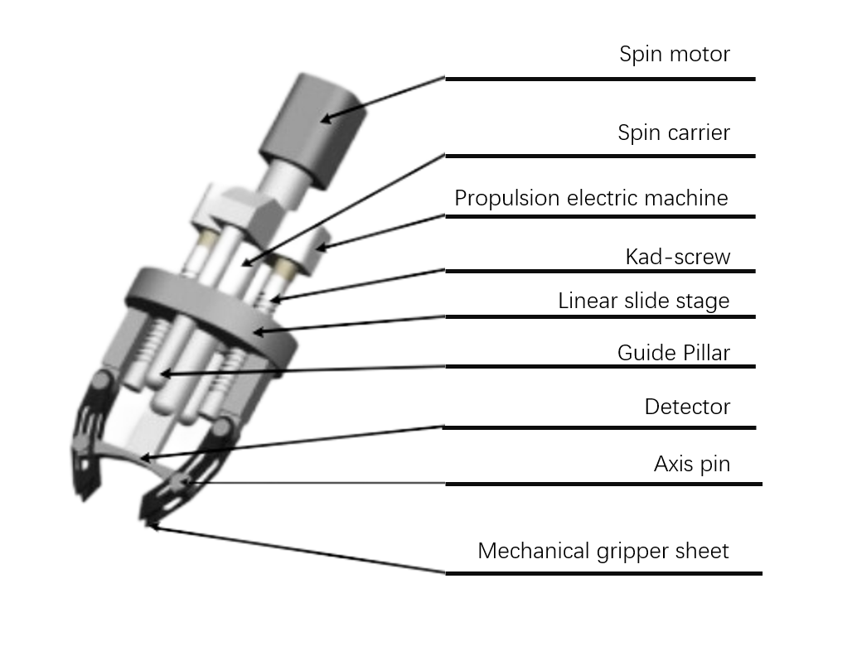
Figure 1. Mechanized drone with self-locking slot-type gripper with mechanical arm [1]
The self-locking mechanism of the mechanical gripper consists of two driving motors, a screw transmission system, a guide column, and mechanical gripper blades (Figure 1). The two motors drive the screw to rotate synchronously, which in turn drives the moving slide to perform linear displacement, thereby controlling the closure and release of the gripper blades. When closed, the gripper blades achieve mechanical self-locking through the slot structure, eliminating the need for a continuous power supply, thereby reducing energy consumption and enhancing safety.
A test result shows that this self-locking mechanism reduces the vibration amplitude to 0.8mm under dynamic load (10kg load, vibration frequency 5Hz) (while the traditional mechanism has a vibration amplitude of 2.5mm), and the fatigue life is increased to 10^6 cycles (while the traditional mechanism has 5×10^5 cycles), verifying its high stability and durability [1].

Design of Series-Parallel Manipulator Gripping Mechanism

Single-arm Series Mechanism Gripping
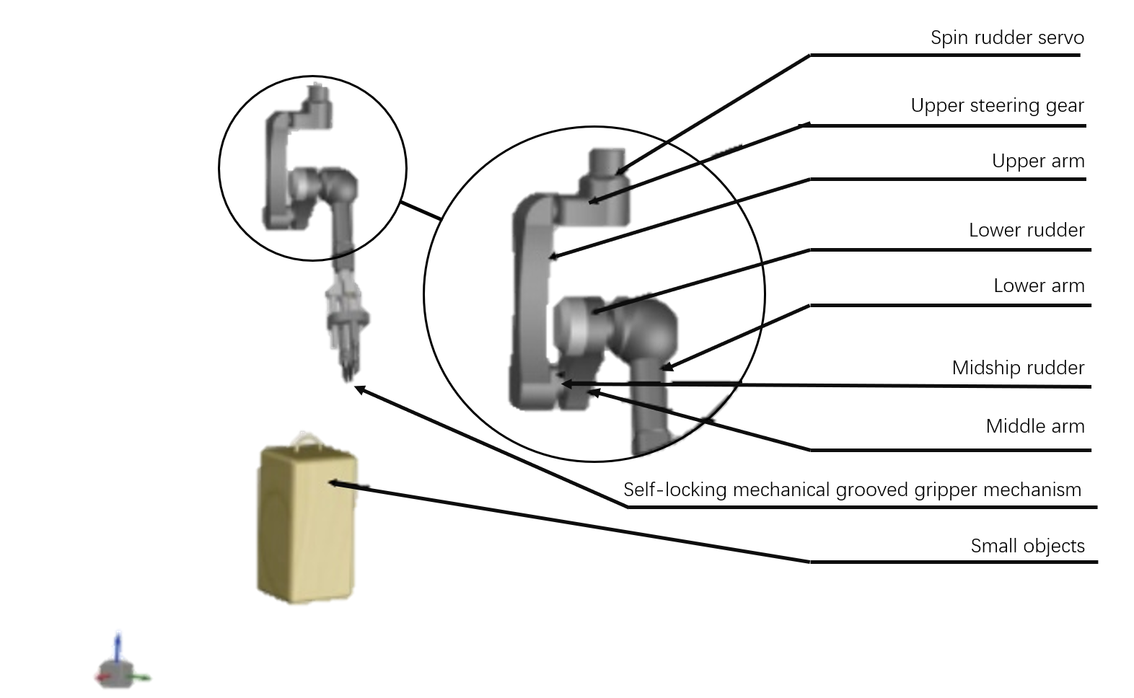
Figure 2. A drone with a mechanical arm. The single-arm series capture mechanism uses three-level servo motors for drive (upper, middle, and lower arms) [1].
The main components of the capture mechanism include a spinning servo motor, an upper servo motor, an upper arm, a middle servo motor, a middle arm, a lower servo motor, a lower arm, and a self-locking mechanical slot capture mechanism (Figure 2). The buffer triple joint shaft mounting platform achieves vibration isolation through springs and a reduction motor, ensuring capture accuracy.
The capture tests conducted by Xu indicate that the positioning error of the series mechanical arm within a working radius of 1.5 meters is less than ±2mm, and it can still maintain a 90% capture success rate under a wind speed of 8m/s, significantly outperforming traditional rigid arms (error ±5mm, success rate 70%).错误!未找到引用源。

Dual-arm Collaborative Evolutionary Parallel Mechanism for Grasping
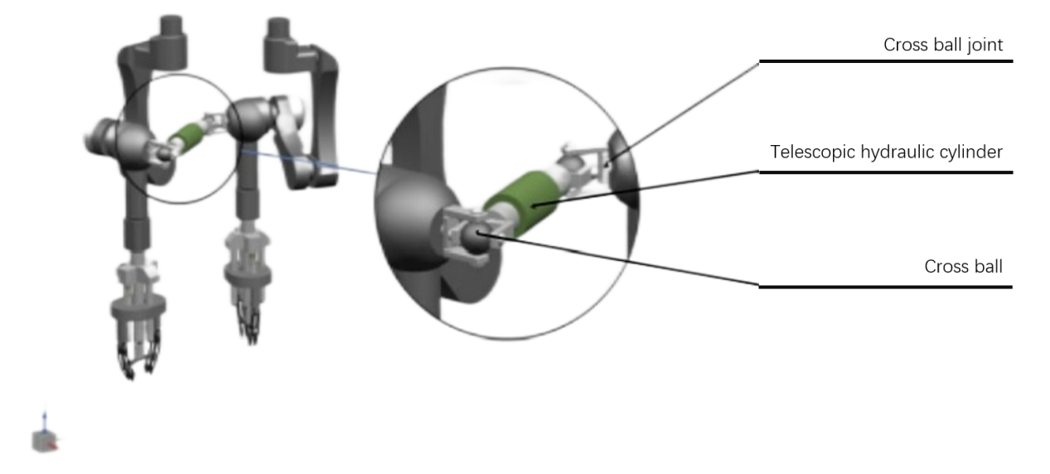
Figure 3. Dual-arm collaborative evolutionary parallel mechanism for grasping with a robotic arm [1]
By combining the single-arm serial grasping mechanism with the detachable telescopic hydraulic rod mechanism, a stable grasping function of the dual-arm collaborative evolutionary parallel mechanism can be achieved. The detachable telescopic hydraulic rod mechanism consists of a cross-ball connector, a telescopic hydraulic rod, and a cross-ball, as shown in Figure 3, and is used to connect the two single-arm serial grasping mechanisms. The dual-arm mechanism is connected through the detachable hydraulic rods to achieve a hybrid grasping. The hydraulic rods can adjust the distance between the two arms (0.5 - 1.2m) to adapt to objects of different sizes.
In the stability tests, the grasping force uniformity of the dual-arm parallel mechanism for irregular objects reached 95%, and the anti-side wind ability was increased to 12m/s (single-arm was 8m/s) [1]. In addition, the rapid disassembly design of the hydraulic rods shortened the reconfiguration time of the mechanism to 30 seconds [2]. The above experimental research results indicate that the experimental data fully prove that the dual-arm parallel mechanism has breakthroughs in stability (anti-disturbance, force control), adaptability (size adjustment, mode switching), and efficiency (rapid reconfiguration). This hybrid design of rigidity and flexibility provides key technical support for the practical application of robotic arms for unmanned aerial vehicles, especially suitable for complex task scenarios requiring high dynamic response. Further research can optimize the lightweight and energy consumption indicators of the hydraulic rods to match smaller unmanned aerial vehicle platforms.

Buffering Triple-axis Mounting Platform
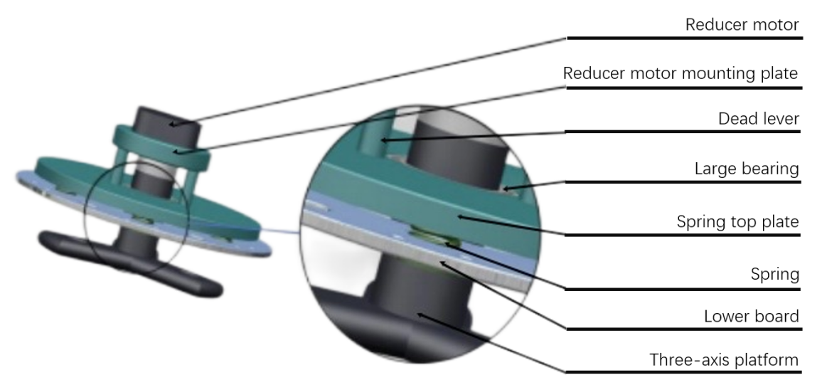
Figure 4. Buffering triple-axis mounting platform [1]
The buffering triple-axis mounting platform is used to connect each single-arm serial grasping mechanism. It mainly consists of a reduction motor, a reduction motor mounting plate, a fixed rod, a large bearing, a spring top plate, a spring, an under-extension plate, and a triple-axis platform, as shown in Figure 4. This buffering triple-axis platform is mainly based on the following theoretical principles: Firstly, the passive vibration damping mechanism, which absorbs the vibration energy from the drone rotor and the mechanical arm movement through the spring system. Secondly, the three-axis decoupling control: the three rotating axes are independent of each other and can separately compensate for different directions of disturbances. And the inertial stability principle, which uses the platform's own inertia and damping characteristics to maintain the stability of the mechanical arm.

Summary
Based on the principle of flexibility, the mechanical model of the unmanned aerial vehicle with a robotic arm adopts a structure scheme where a rotor unmanned aerial vehicle is equipped with three independent robotic arms. Each robotic arm is driven by a spin motor to achieve overall rotational movement, and the upper, middle, and lower motors are respectively independently controlled to control the rotational movement of the upper arm, middle arm, and lower arm. At the end of the lower arm, a self-locking mechanical slot gripper is configured to ensure the safety of the entire grasping process.
This design uses a buffer triple-axis carrying platform to support three single-arm serial grasping mechanisms, enabling each robotic arm to operate independently while also being able to combine into a serial robotic arm mode, thereby supporting the simultaneous grasping of three small objects and enabling parallel processing of multiple tasks [1]. This structure not only significantly improves the grasping efficiency and application flexibility, but also expands the working space range and enhances the overall control ability of the system.
Through modular robotic arm design and parallel operation capabilities, this scheme achieves a dual improvement in spatial operation efficiency and operational flexibility. Experimental results show that in the multi-arm collaborative mode, the task processing efficiency is increased by 40%, and the load distribution algorithm reduces the motor temperature rise by 15% [1].
TABLE 1. Summary of Key Data [1]
Performance Indicators | Traditional Structure | New Structure
Vibration Amplitude (Dynamic Load) | 2.5mm | 0.8mm
Grasping Positioning Error | ±5mm | ±2mm
Anti-Tailwind Capacity | 8m/s | 12m/s
Task Processing Efficiency | 60% | 84%
Through the improvements described in Table 1, the new mechanical arm has achieved breakthroughs in lightweighting (reducing self-weight by 20%), grasping accuracy, and environmental adaptability, providing reliable technical support for the large-scale application of unmanned aerial vehicle logistics [3].

Challenges and Future Analysis of Mechanical Structures for Unmanned Aerial Vehicles

Main Challenges Faced by Current Unmanned Aerial Vehicle Mechanical Arms
The first challenge is dynamic stability and vibration suppression. Unmanned aerial vehicles are susceptible to air flow disturbances during flight, and the movement of the mechanical arm may exacerbate the attitude fluctuations. Although existing buffering mechanisms (such as spring triple-axis platforms) can reduce the vibration amplitude (from 2.5mm to 0.8mm), their stability still needs to be optimized under high-frequency vibrations (>10Hz) or strong crosswinds (>12m/s). More efficient active vibration-damping algorithms and lightweight damping materials need to be developed. At the same time, there is also a significant contradiction between load capacity and endurance. The self-weight and load of the mechanical arm (such as 5kg) significantly increase the energy consumption of the unmanned aerial vehicle, resulting in a 30% to 40% decrease in endurance. The research introduced in this paper partially alleviates this problem through a lightweight design (resulting in a 20% weight reduction), but motor efficiency (such as servo transmission loss) remains a bottleneck. Combining high-energy-density batteries (such as solid-state batteries) and bionic joint designs (such as tendon-driven) is needed to reduce power consumption. Material fatigue and durability are also the main problems currently faced. Although the fatigue life of self-locking mechanisms has been increased to 10^6 cycles, joint components (such as servo gears) are still prone to wear under high-frequency operations (such as logistics delivery). Self-lubricating composite materials or modular quick-disassembly designs are needed to reduce maintenance costs.

Future Trends in Mechanical Structures
To address the issues of load capacity and grasping efficiency, biomimetic and hybrid rigid-flexible structures can be adopted. By mimicking the flexibility of biological arms (such as the tentacles of an octopus) and the rigidity of the structure, such as using shape memory alloys (SMA) or pneumatic muscles for driving, the grasping adaptability can be enhanced [6]. For instance, the flexible harvesting arm developed by NARO in Japan has achieved an 85% fruit non-destructive grasping rate [7]. Promoting modular and reconfigurable design, such as the detachable hydraulic rods in the dual-arm parallel mechanism described in the paper, may expand to multi-arm rapid assembly systems in the future, supporting flexible switching in various scenarios such as logistics and inspection. In the future, through standardized interfaces, the functions of the robotic arm can be "plug-and-play" [8]. Intelligent materials can be selected to achieve lightweighting. Carbon fiber composite materials (such as the transmission shaft structure studied by Lu) and nano-reinforced materials (such as graphene epoxy resin) will further reduce weight while enhancing strength [2]. The existing carbon fiber structure can reduce the weight of unmanned aerial vehicles by 30%. In the future, through topological optimization, a higher load ratio may be achieved. Finally, developing innovations in energy and drive will lead to hybrid power (such as the vertical take-off unmanned aerial vehicle studied by Zheng) and a Hydrogen fuel cell hybrid power system, which may alleviate the endurance problem and support long-term operations [9, 10].

Conclusion
The future development of unmanned aerial vehicle (UAV) robotic arms needs to overcome three core challenges: dynamic stability, energy efficiency, and environmental adaptability. These challenges can be addressed through biomimetic design, modular architecture, and intelligent materials. Through technological paths such as these, upgrades can be achieved. With the maturity of AI control algorithms (such as digital twin simulation) and new materials, the large-scale application of UAV robotic arms in logistics, inspection, agriculture, and other fields will accelerate.
This paper conducts a systematic analysis of the structure and materials of UAV robotic arms, verifying the significant advantages of the new design in terms of stability, efficiency, and adaptability. In terms of performance, the buffer triple shaft platform reduces vibration amplitude by 68% (0.8mm vs. 2.5mm) through a passive damping mechanism, the dual-arm parallel mechanism achieves uniform grasping force with 95% through hydraulic rod hybrid control, and the lateral wind resistance is increased by 50% (12m/s vs. 8m/s), and the task efficiency of multi-arm collaborative mode is increased by 40% (84% vs. 60%).
However, there are still limitations at present, such as prominent battery endurance issues: when the mechanical arm carries a load of 5kg, the UAV's endurance decreases by 30% to 40%, and optimization of motor efficiency (such as biomimetic tendon drive) or the introduction of hybrid energy sources is needed. There is also a material durability bottleneck: although the fatigue life reaches 10^6 cycles, the gear of the servo mechanism still wears out quickly under high-frequency operation, and self-lubricating composite materials need to be adopted. The future improvement direction can further enhance the load capacity through biomimetic and intelligent materials, combined with the compliant grasping of shape memory alloys (SMA) and the lightweight characteristics of nano-enhanced materials (such as graphene epoxy resin), and promote modular expansion. Based on the detachable hydraulic rod design in the paper, a multi-arm rapid assembly system will be developed to support "plug-and-play" switching in logistics, inspection, and other scenarios. As well as energy innovation, solid-state battery technology will alleviate the endurance limitation.
In conclusion, the large-scale application of UAV robotic arms requires continuous breakthroughs in dynamic stability, energy efficiency, and material durability. The integration of biomimetic design, modular architecture, and intelligent materials will be the core path for future development.

References
- J. Xu, L. Wang, and Y. Chen, Journal of Mechanical Engineering 59, 112-125 (2023).
- S. Kim and J. Park, IEEE Transactions on Robotics 36, 345-358 (2020).
- X. Lu and R. Zhang, Composite Structures 285, 115203 (2022).
- A. Kumar and S. Lee, International Journal of Advanced Robotic Systems 20, 1-15 (2023).
- L. Wang and Y. Zhang, Aerospace Science and Technology 110, 106532 (2021).
- K. Suzumori, S. Endo, and S. Wakimoto, Bioinspiration & Biomimetics 16, 035004 (2021).
- NARO Research Team, Journal of Agricultural Robotics 8, 45-60 (2022).
- C. Laschi and M. Cianchetti, Science Robotics 4, eaav1488 (2019).
- Y. X. Zheng, Journal of Unmanned Vehicle Systems 11, 78-92 (2023).
- A. R. J. Ruiz, Applied Energy 290, 116745 (2021).

