A Review of The Current Status of OLED Substrate Preparation
Xinzhe Wang
Metallurgical Engineering, School of Metallurgical and Ecological Engineering, University of Science and Technology Beijing, Beijing 100083, China
xinzhewang@uok.edu.gr
Abstract. Organic light-emitting diodes (OLEDs) possess characteristics such as high display quality, low display energy consumption, and mechanical flexibility, which have enabled this material to be widely used in the display industry. With the continuous deepening of research on OLED devices, an increasing variety of OLED structures have been explored. A large number of reports have revealed the development of OLED devices with excellent performance, covering aspects such as the overall structure, active layer materials, electrode materials, and packaging technology. Currently, the generally low external quantum efficiency (EQE) is an important issue faced by OLEDs. In order to improve the efficiency of OLEDs, enhancing the EQE has become a crucial factor in the current development of OLEDs. There are numerous factors affecting the EQE at present, mainly including total internal reflection of light on the substrate, waveguide effect, surface plasmon effect, and metal loss. Among them, the total internal reflection of light can be mitigated by improving the substrate material. Therefore, improving the performance of OLED substrate materials has become one of the methods to enhance the light output efficiency of OLEDs. This paper systematically discusses the types and processing methods of OLED device substrates, and expounds on their different research statuses and development prospects for different substrate types.

introduction
Since the 21st century, information technology has developed rapidly, and the display of images has become the main way of information transmission with the development of information technology. Consequently, flat panel display technology has become ubiquitous in daily life, emerging as the most prevalent display technology and a focal point of research. As the first-generation display, cathode ray tube (CRT) has a large volume, high energy consumption, and radiation, so it is no longer the mainstream display method. The second generation of displays, represented by LCD, is still the main display method for some screens today. However, due to the inability of LCD technology to produce flexible screens, it is now difficult to fully meet people's daily needs [1]. OLED display technology, as the third generation display method, has the characteristics of high contrast, high color gamut, low response time, simple structure, thin thickness, flexible display, controllable brightness, low energy consumption, and faster response time. It has become an important display technology in people's lives and is also a popular research field in display technology [2].
Figure 1 is a schematic diagram of the structure of a conventional OLED. The main structure of OLED is divided into anode, cathode, and organic active layer. In multi-layer OLED, the organic active layer can be further divided into electron injection layer, electron transport layer, luminescence layer, hole transport layer, and hole injection layer. The electron hole pairs in the organic active layer combine to form excitons, which then release energy to the luminescent molecules, causing the electrons of the luminescent molecules to transition from the ground state to the excited state, and then emit photons during the process of falling back to the ground state. The light is emitted to the outside through the transparent anode and substrate, so OLED can emit light as an electrical appliance [3].
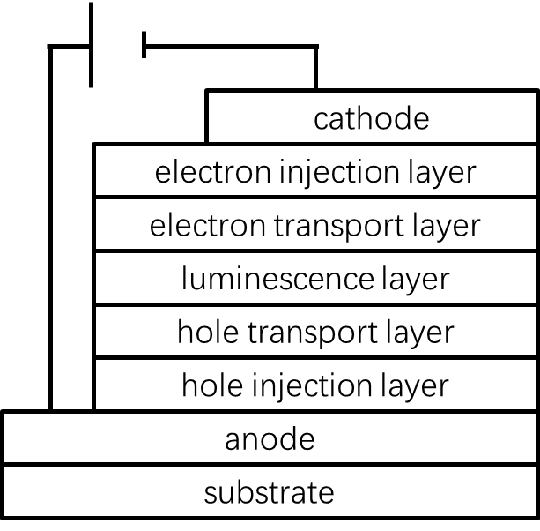
Figure 1. Common OLED Structure Diagram. Picture Credit: Original

Currently, indium tin oxide (ITO) is commonly employed as the anode [4]. The substrate serves as the component that connects to the ITO and supports the entire OLED structure. Conventional OLED devices can use conductive glass substrates, while flexible OLEDs require the use of flexible substrates. With the application of new phosphorescent materials, the internal quantum efficiency of OLEDs gradually improves and approaches 100%. However, the external quantum efficiency (EQE) is generally low, with OLED materials on glass substrates only reaching around 20% EQE [5,6], while materials on other types of substrates have lower EQE. Therefore, in order to improve the efficiency of OLED, the improvement of EQE has become an important factor in the development of OLED today. There are many factors that currently affect EQE, mainly including total internal reflection of light on the substrate, waveguide effect, surface plasmon effect, and metal loss. Among them, total internal reflection of light can be alleviated by improving the substrate material. Therefore, improving the performance of OLED substrate materials has become one of the methods to enhance the light output efficiency of OLEDs. For example, in a glass substrate, due to the refractive index difference between air and the substrate, part the loss in bottom emitting OLEDs comes from total internal reflection at the air substrate interface [6]. Therefore, the improvement of substrate performance can reduce the loss of light reflection, thereby enhancing the EQE of OLED to a certain extent.
This essay reports the research status and performance advantages and disadvantages of glass substrate, polymer substrate, and metal substrate materials based on different OLED usage conditions and performance requirements. It also introduces the usage background, research status, and difficulties of each material, as well as the advantages and disadvantages that can be achieved by this material and the remaining problems.

Progress of Three OLED Substrate Materials
The selection and preparation of substrate materials greatly affect the production cost and display quality of OLEDs. As the basic component of OLED, the substrate needs to meet the following conditions: (1) The visible light transmission ability of the substrate is strong, with a transmission coefficient greater than 90%; (2) The substrate should have appropriate roughness, with R_{RMS} less than 2nm and R_{max} less than 20nm; (3) There should be low permeability for water and oxygen. At 380 ℃ and 30% relative humidity, the oxygen permeability should not exceed 10⁻⁴cc/m² and the water vapor permeability should not exceed 10⁻⁶gm/m² within one day; (4) The base work function should be between 4.0-5.5eV [7].
Typical non flexible OLEDs use glass as the device substrate. Glass substrates have low water and oxygen permeability, high light transmittance, and are not prone to expansion during processing, so they can withstand higher processing temperatures. However, at the same time, glass substrates are fragile, have poor flexibility, and are also difficult to prepare. In contrast, flexible OLEDs often use various substrate materials as flexible substrates, mainly including polymer substrates and metal substrates. The polymer substrate has good flexibility, high transparency, and light weight, but it can withstand low processing temperatures and has poor water oxygen barrier ability. Metal substrates have low water and oxygen permeability, can withstand high processing temperatures, but are opaque and have rough surfaces [8].

Glass Substrate
Although the internal quantum efficiency of OLED has been improved to a maximum of 100%, the external quantum efficiency is still low relatively. Although the surface plasmon polariton mode (SPP) at the interface of organic metal electrodes is also a cause of this phenomenon, other factors such as total internal reflection (TIR) and waveguide effect still exist. In OLED structure, the different materials of each layer will result in different refractive indices. The refractive index of air is n=1, the refractive index of glass substrate is n ≈ 1.5, the refractive index of organic layer is ≈ 1.7-1.8, and the refractive index of ITO is ≈ 1.9[6]. The different refractive indices of these different materials can lead to total internal reflection (TIR) of OLED multilayer structure, resulting in a total loss of 20% -30% of light in the substrate layer and organic active layer [6]. To this end, efforts have been made to enhance the performance of OLEDs by improving external quantum efficiency. The additional insertion, patterning, and micro lens array of external scattering layers can solve the TIR problem at the glass substrate air interface, which has a direct effect on improving the EQE of glass substrates.
Geun Su Choi et al. improved the light extraction efficiency of OLEDs by inserting metal materials between glass substrates and alternative transparent conductive oxide (TCO) materials. TCO plays a crucial role in device display, as it requires high transparency while conducting electricity. However, ITO has poor mechanical properties, graphene has high preparation costs, and silver nanowire technology has issues with the uniformity of nanowire networks. Therefore, the concept of transparent composite electrode (TCE) has been proposed, and a thin metal layer can be inserted into the TCO layer [9]. On the one hand, this method can reduce the total thickness, improve conductivity, while ensuring transparency and maintaining the optical properties required for the substrate. On the other hand, by introducing scattering elements in the TCE layer and changing the direction of light propagation, the possibility of light escaping from the OLED can be increased, thereby reducing internal reflection, and increasing light extraction efficiency [10]. Therefore, in this experiment, Geun Su Choi et al. used reactive ion etching (RIE) technology. As shown in Figure 2, a scattering structure was constructed in the TCE metal layer of the dielectric metal dielectric (DMD) structure; Adopting a dry etching process by changing the plasma gas type and etching conditions to form a light extraction structure; And use RF to deposit an IZO layer. By comparing three different processing schemes, namely the DMD layer without dry etching, the DMD layer treated with dry etching for 60 seconds, and the DMD layer treated with dry etching for 150 seconds, they observed that the DMD layer treated for 150 seconds exhibited smaller cluster distributions, which would facilitate light extraction. Meanwhile, there are significant differences in the transmittance of the three samples. The DMD without scattering structures has a total transmittance of no more than 40% in the visible wavelength range, while the total transmittance after plasma treatment is higher. The Ar treated structure has a maximum total transmittance of 52.1%, while the O₂ treated structure has a maximum total transmittance of over 70% [11]. Overall, the DMD layer treated with long-term dry etching and O₂ plasma exhibits better transmittance, which greatly improves the light extraction efficiency of OLED and thus enhances its display performance. However, higher light extraction efficiency can still be achieved in design or other advanced materials and structures can be developed to improve OLED performance.
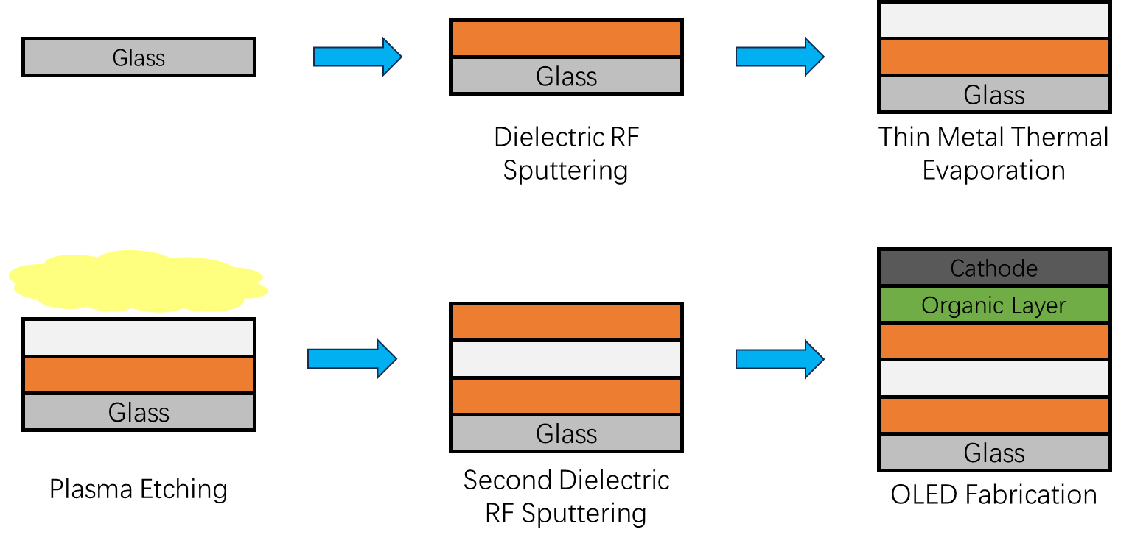
Figure 2. Schematic Diagram of OLED Manufacturing Process with DMD Structure. Picture Credit: Original

In addition to studying external scattering structures, people have also explored other methods that can enhance EQE, such as patterning processes. The patterning process is relatively mature, but graphene as a patterned sample is an emerging technology. Jin Wook Shin et al. improved the flexibility and stretchability of OLEDs by using graphene as a transparent electrode and photolithography patterning of graphene. Graphene is a planar structure that can be regarded as a two-dimensional material with high electron mobility, transparency, and mechanical compliance, making it an excellent transparent electrode material [12,13]. However, the difficulty in making this material into a transparent electrode lies in processing. Usually, in order to ensure the use of graphene and its ability to withstand standard photolithography processes, the adhesion between graphene and the substrate needs to be strong enough, but most methods result in the inability to simultaneously guarantee its strong adhesion and surface quality. The single-layer graphene on the surface of copper foil obtained by chemical vapor deposition (CVD) showed fragmentation and peeling after photolithography [14]. In addition, the vacuum deposition method requires physical transfer of graphene from its growth surface to the substrate, and the weak adhesion between graphene and the substrate results in an uneven surface structure, making it difficult to achieve photolithography in subsequent steps [14]. Therefore, in this study, Jin Wook Shin et al. used liquid bridging as a bridge for material transport, connecting two solid surfaces with liquid. Choosing water as the bridge for transporting graphene allows water to penetrate into the pores between graphene and the substrate. After graphene is transported to the surface of the substrate, water is removed and graphene is stretched, achieving the elimination of pores, structural stretching, and sufficient physical contact with the substrate. The results showed that compared to untreated graphene, graphene treated with liquid bridging method had twice the effective adhesion energy. This enhances the adhesion between graphene and the substrate, providing the possibility for industrial applications of graphene photolithography patterning. After successfully attaching the graphene film, the film was patterned using photolithography: a positive photoresist (PR) was coated on the graphene surface, baked at 90 ° C for 120 seconds, and then the remaining portion was exposed to ultraviolet light under the protection of a mask aligner [14]. Etching was performed using a 40 watt, 30 sccm oxygen plasma, and finally PR residue was removed using a PR remover to obtain a photolithography patterned graphene electrode [14]. At present, there is no case of large-scale utilization of patterned graphene in industry, but Jin Wook Shin et al.'s research provides feasible technology for the industrialization of graphene patterning.
Micro lens arrays can also enhance the EQE of OLED devices. Jiho Roh et al. used the imprinting method to prepare a micro lens array on a glass substrate, which improved the transparency of OLED substrates. Usually, when the incident angle between light and the substrate is greater than the critical angle, photons will undergo total reflection at the glass substrate air interface, causing the light to be trapped inside the device. The micro lens array (MLA) reduces the incident angle of some of the photons, and when the incident angle is less than the critical angle, the light can smoothly leave the glass substrate. Jiho Roh et al.'s research field is microcavity top emitting OLED (TEOLED), which means a decrease in color purity and efficiency, especially on large screens where viewing angle dependence is very evident [15]. Therefore, in this study, Jiho Roh et al. used the method of imprinting random micro lens array (IRMLA), as shown in Figure 3. The dimethylsiloxane (PDMS) mold was manufactured with the random patterned microlens array diffuser of a commercial company, then the mold was bonded to the substrate, NOA81 was stamped and demolded, and then metal and organic layers were successively deposited on the microlens array treated substrate, and the final packaging was completed with gel. By introducing the Lambert correction factor (LCF) to calculate the accurate EQE, the measurement of the normal was corrected using a spectral radiometer (CS-2000). Finally, it was found that under the treatment of a microlens array, the red microcavity TEOLED combined with an IRMLA substrate improved the EQE by about 40% [16]. Meanwhile, the color coordinate offset does not exceed 0.005, and the chromaticity offset is also not significant [16]. Overall, Jiho Roh et al.'s research effectively improved EQE and performance on high-definition large displays while ensuring a low degree of chromatic shift. Therefore, the study of micro lens arrays still has great potential in the commercial OLED field.
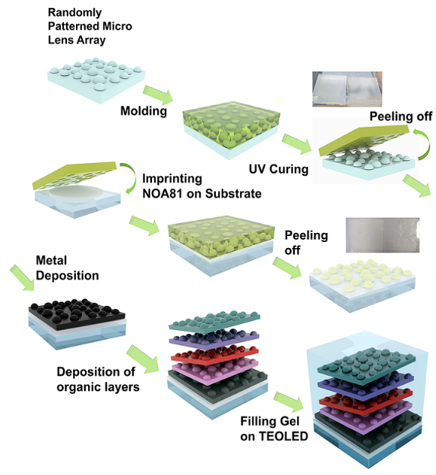
Figure 3. MLA Device Manufacturing Diagram [16]

Polymer Substrate
Traditional OLEDs use glass substrates with poor flexibility, but in recent years, the development of flexible OLEDs has made it difficult for glass substrates to meet the demand for flexibility. Therefore, OLED substrates made of polymers have become a popular research direction. Compared to glass substrates, polymer substrates have several advantages. Firstly, the polymer substrate is thin in appearance and lightweight, with PET based OLED devices weighing only one-third of glass-based OLED devices. This reduces the weight and thickness of displays of the same area, making them more portable. Secondly, polymer-based OLEDs have better flexibility. Compared to glass-based devices, they are more impact resistant, less prone to damage, and have better physical durability. Thirdly, the polymer substrate is a flexible material, so it can be bent into any shape, which provides the possibility for the manufacturing of curved display screens.
As the main raw material for flexible OLED substrates, PET material has low quality and high transparency, making the OLED components flexible. Therefore, OLEDs based on PET can be used for wearable applications [17], which not only require the above requirements, but also human adaptability: they will not experience mechanical failure or conductivity loss under 50% large strain, have a stable structure that can withstand repeated stretches, and have sufficient waterproofness to ensure that wearable devices can still work normally after water cleaning [18-20]. However, polymer materials usually have poor water and oxygen barrier properties, so waterproof operations need to be carried out on PET materials, while ensuring that the material has high stretchability. Some people have adopted the method of applying stretchable materials to all components to achieve stretchability of OLED devices, but this will result in poor stability and loss of conductivity in the stretched state. Some people use the method of attaching OLED devices on pre stretched substrates and then releasing the substrate to form wave patterns, in order to achieve excellent stretchability performance, but this method is difficult to achieve uniform light emission of OLED devices. Minwoo Nam et al. used an island-based OLED pixel method, which is a hybrid platform approach. On this platform, the OLED pixels on the island undergo only minor deformation, with only stretchable electrodes participating in the deformation. However, this method still faces some difficulties: although laser patterned substrates have been used after deposition to ensure a simple manufacturing process, the high sensitivity of organic and metal layers to oxygen and water in OLEDs requires packaging technology in the OLED production process. Packaging technology that meets this requirement will reduce the efficiency of patterning, and current packaging technology is difficult to achieve high stretchability. Therefore, finding a highly stretchable material that efficiently isolates oxygen and water as a substrate and developing packaging technology for stretchability has become a necessary requirement. Therefore, Minwoo Nam et al. used PET adhered to a stress release column platform, vacuum evaporation, organic-inorganic hybrid film encapsulation, and non selective laser patterning to achieve the method of island OLED pixels, and manufactured an OLED device with 95% maximum strain capacity [21]. At an initial brightness of 1000cd/m², the device has a lifespan of 753 hours and a waterproof lifespan of over one month [21]. This technology provides a longer lifespan method for OLED devices in wearable devices, promoting the development of stretchable displays. However, compared to glass-based OLED materials, this method has a shorter working lifespan and faces the problem of insufficient lifespan in practical applications.
Although PET material is an organic material and does not cause pollution problems such as excessive heavy metal content or nitrogen and phosphorus content in the environment, the difficult degradability of plastics still leads to environmental damage. Therefore, people have begun to study biodegradable or biologically sustainable polymer materials, such as Massimo Cocchi et al. reporting an OLED material made of biopolymer substrates. There are considerable difficulties in the research of biopolymer materials: common renewable resource derived materials that can be used for OLED substrates include cellulose, chitin, and silk fibroin. However, due to the requirements for the mechanical stability and conductivity of the substrate, only chitin nanofibers, wood nanofibers, cellulose derived from bacteria, and cellulose nanofibers are actually used in OLED substrates [22,23]. However, these materials are incompatible with the roughness of OLED devices due to their large roughness, and as a flattened material, polymethyl methacrylate (PMMA) is not a renewable resource and cannot be processed using environmentally friendly methods; Amorphous cellulose that can reduce roughness will decrease the transparency of the green blue visible light region; Cellulose nanocrystal films can also reduce surface roughness, but their mechanical structure is fragile [23]. Therefore, Massimo Cocchi et al. prepared as cast biopolymer flexible substrates using sodium alginate (SA) as raw material and allowed OLEDs to be directly grown on the substrate. Sodium alginate is derived from brown algae, soluble in water and amorphous, and is a biodegradable polymer. The substrate made from this raw material can reach the level of high-performance cellulose substrate in terms of flexibility, mechanical stability, and transparency, and has a high refractive index, which contributes to the efficient light extraction of OLEDs. SA foil was obtained by placing SA aqueous solution in a polystyrene Petri dish, followed by evaporation and drying. The maximum brightness at 18V was measured to be 1100cd/m², while as shown in Figure 4, the maximum EQE at 10mA/cm² was 2.3%, which is the highest EQE level in biopolymer substrates [23]. The research results of Massimo Cocchi et al. provide a new high-performance material for OLED biopolymer substrates. However, compared to the EQE of about 20% that glass based OLEDs can achieve [5,6], the EQE performance of this biopolymer substrate is lacking. At the same time, the EQE test voltage of SA substrate is higher than that of glass substrate, which means that EQE cannot be directly compared. Although modified Child's law can be used for simulation under the same voltage, it is still not a real result and the accuracy is unknown. The huge gap between biopolymer substrates and glass substrates in EQE means that currently, OLED materials based on this substrate are difficult to become more energy-efficient alternatives on a large scale. However, its inherent biodegradability is still its biggest advantage. Therefore, research on improving its EQE, such as continuing to search for new high transparency, high stability, and high flexibility materials, or researching process treatment methods to improve performance, still has broad development space.
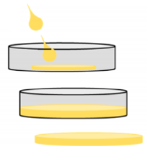
Figure 4. Preparation Process of SA Substrate [23]

Metal Substrate
In recent years, there has been relatively little research and application of metal foil substrates in OLED devices. The production of metal foil requires high-purity metal materials, making it difficult to process into thin sheets. The transparency of metal foil is poor, and the mature industrial chain of glass and polymer substrates reduces production costs. These reasons have led to the direction of metal foil substrates not being popular. However, there are still cases where opaque substrates and opaque anodes replace ITO, such as top emitting OLEDs (TEOLEDs). The substrate of TEOLED does not need to have transparency, only the opaque anode and organic active layer need to be separately deposited on the substrate, and then the transparent or semi-transparent cathode material needs to be deposited to allow photons to be emitted from the top cathode. TEOLED pixels can be directly manufactured on thin film transistors without affecting the aperture ratio, making it easy to achieve a TA transmittance of over 30% [24], which is beneficial for transparency performance. This means that displays manufactured using this technology are very transparent and can be used for product development in this area. Overall, although metal foil substrates are not a hot research topic, TEOLED devices with opaque substrates still have broad development potential due to their excellent performance.
The function that the anode needs to undertake is the hole transport layer (HTL), which plays a crucial role in determining the performance of OLED devices. The HTL of TEOLED has been extensively studied, and HTL deposited using traditional gas-phase or liquid-phase processes is usually an amorphous thin film, which results in low charge mobility of the film and therefore requires an extremely thin thickness. However, the thin film under this thickness requirement cannot be uniformly covered on the substrate surface, and uneven thickness can affect device performance [25]. Meanwhile, the large roughness of amorphous thin films will result in poor adhesion between the electrode and substrate, leading to water and oxygen permeation and electrode delamination [26]. In general, there are issues with the stability and charge transfer efficiency of amorphous thin film HTL. Therefore, Gao Da Ye et al. reported an organic single crystal semiconductor (OSC) as an OLED device for HTL (SC-OLED). The uniform thickness, smooth surface, compact arrangement structure of OSC results in excellent water and oxygen isolation performance and high charge carrier mobility, making OSC have great potential for HTL fabrication. Therefore, they prepared a 400nm thick p-type BSB Me SC film, which achieved a hole mobility of 0.2 cm²/V/s with Ag as the metal substrate (amorphous film is approximately 10⁻³-10⁻⁴ cm²/V/s) and obtained an EQE of 12.64% in the phosphorescent emission OLED with OSC film as HTL, which is the highest EQE among SC-OLEDs to date [26]. The research results of Gao Da Ye et al. provide new high-performance materials for HTL, but compared to the EQE of about 20% that mainstream OLEDs can achieve [5,6], the EQE performance of this SC-OLED is still lacking.

CONCLUSION
This article introduces the research status, performance advantages and disadvantages, and still existing problems and difficulties of glass substrate, polymer substrate, and metal substrate materials under different OLED usage conditions and performance requirements. The different physical and chemical properties of glass substrates, polymer substrates, and metal substrates determine their different application areas. For example, glass substrates with poor flexibility are less commonly used for flexible displays, while polymer substrates can be used for flexible displays. TEOLEDs generally use opaque substrates such as metal substrates. On EQE, compared to glass substrates, there is still a significant gap between polymer substrates and metal substrates. Therefore, there is still a lot of room for improvement in the widespread application of energy-saving trends. Improving the transparency of light transmitting materials, reducing internal reflection of devices, and ensuring the overall stability of the device's working state are still the key to improving OLED performance. Although glass-based OLED devices have achieved relatively high EQE, various technologies have found ways to significantly improve efficiency. Applying these methods to industrial production at low cost and ensuring device stability are also key to improving OLED performance. The display industry has remained a popular industry for a long time, and improving performance and environmentally friendly device technology will continue to be the focus of development in this field, with broad development space.

References
- H. W. Chen, J. H. Lee, B. Y. Lin, S. Chen, & S. T. Wu, Light: Science & Applications 7(3), 17168-17168 (2018).
- E. Tankelevičiūtė, I. D. Samuel, & E. Zysman-Colman, The Journal of Physical Chemistry Letters 15(4), 1034-1047 (2024).
- R. Liguori, F. Nunziata, S. Aprano, & M. G. Maglione, Electronics 13(7), 1299(2024).
- E. B. Aydın, & M. K. Sezgintürk, TrAC Trends in Analytical Chemistry 97, 309-315 (2017).
- G. Cheng, S. C. Kui, W. H. Ang, et al, Chemical Science 5(12), 4819-4830 (2014).
- C. H. Park, S. W. Kang, S. G. Jung, D. J. Lee, Y. W. Park, & B. K. Ju, Scientific reports 11(1), 3430 (2021).
- J. Bauri, R. B. Choudhary, & G. Mandal, Journal of Materials Science 56(34), 18837-18866 (2021).
- N. Sun, C. Jiang, Q. Li, D. Tan, S. Bi, & J. Song, Journal of Materials Science: Materials in Electronics 31, 20688-20729 (2020).
- L. Kinner, T. Dimopoulos, G. Ligorio, E. J. List-Kratochvil, & F. Hermerschmidt, RSC advances 11(28), 17324-17331 (2021).
- S. Lee, J. Y. Park, J. Park, et al, Advanced Electronic Materials 9(4), 2201264 (2023).
- G. S. Choi, E. J. Bae, B. K. Ju, & Y. W. Park, Nanomaterials 13(15), 2253 (2023).
- P. Avouris, Z. Chen, & V. Perebeinos, Nature nanotechnology 2(10), 605-615 (2007).
- J. Moon, J. Hwang, H. K. Choi, et al, In Organic Light Emitting Materials and Devices Xvi 8476, 68-72 (2012).
- J. W. Shin, J. H. Han, H. Cho, et al, 2D Mater. 5, 014003 (2018).
- N. S. Kim, D. Y. Kim, J. H. Song, & M. C. Suh, Optics Express 28(21), 31686-31699 (2020).
- J. Roh, A. Nimbalkar, & M. C. Suh, ACS Photonics 11(11), 4606-4615 (2024).
- H. Cho, B. Lee, D. Jang, J. Yoon, S. Chung, & Y. Hong, Materials Horizons 9(8), 2053-2075 (2022).
- E. W. Obropta, & D. J. Newman, In 2015 IEEE Aerospace Conference, 1-9 (2015).
- R. Matsuda, S. Mizuguchi, F. Nakamura, T. Endo, Y. Isoda, G. Inamori, & H. Ota, Scientific Reports 10(1), 12666 (2020).
- G. H. Lee, H. Kang, J. W. Chung, et al, Science Advances 8(15), eabm3622 (2022).
- M. Nam, J. Chang, H. Kim, et al, npj Flex Electron 8, 17 (2024).
- J. Jin, D. Lee, H. G. Im, et al, Advanced Materials 28(26), 5169-5175 (2016).
- M. Cocchi, M. Bertoldo, M. Seri, et al, ACS Sustainable Chemistry & Engineering 9(38), 12733-12737 (2021).
- S. W. Jung, K. S. Kim, H. U. Park, et al, Advanced electronic materials 7(4), 2001101 (2021).
- G. Liu, Z. Li, X. Hu, et al, Nature Photonics 16(12), 876-883 (2022).
- G. D. Ye, R. Ding, S. H. Li, et al, Light: Science & Applications 13(1), 136 (2024).

