Research Progress of Stretchable OLEDs: Material Innovation and Disruptive Potential for Future Wearable Electronic Devices
Pengju Bai
Department of Physics, Fudan University, No. 220 Handan Road, Yangpu District, Shanghai 200433, China

22307110249@m.fudan.edu.cn
Abstract. In recent years, traditional hard-screen displays have increasingly failed to keep up with the development of the times and are not very suitable for many emerging application scenarios. This is because people now pay more attention to whether the screen can be bent, is durable, and comfortable to use. At this time, stretchable organic light - emitting diode (OLED) screens stand out particularly. They have an unprecedented new form and are extremely versatile. Due to their unique flexibility, durability, and high performance, stretchable OLEDs are widely used in wearable electronic devices. Researchers are constantly innovating in materials science and manufacturing technology, paving the way for the widespread application of stretchable OLEDs in daily life. Future work will focus on improving the efficiency, durability, and scalability of the devices, thus creating new opportunities for the integration of wearable technology in various industries. This paper aims to explore the latest discoveries in stretchable OLED materials and how they will be applied to wearable devices, hoping to provide some useful ideas for future design and development.

INTRODUCTION
Stretchable electronics now are developing rapidly. As the consumer electronics market continues to expand, wearable devices are facing increasingly high requirements for display technology that can meet complex shapes and mechanical deformations[1]. Traditional rigid displays are no longer able to meet the needs of applications that require flexibility, durability, and user comfort. Stretchable organic light-emitting diodes (OLEDs) are a promising solution that are both smaller and more versatile than ever before.
In the consumer electronics space, stretchable OLEDs are expected to revolutionize devices such as foldable smartphones, smartwatches, and virtual reality (VR) headsets. These displays can bend, twist, and conform to curved surfaces to enhance the user experience[3]. In the healthcare space, stretchable OLEDs can be integrated into wearable health monitoring devices such as heart rate and blood oxygen sensors to provide real-time data visualization[4][5][6]. In addition, the automotive industry is exploring the use of stretchable OLEDs in car displays, which can improve safety and aesthetics[7][8].
In addition to consumer electronics and healthcare, stretchable OLEDs are also widely used in smart clothing and soft robotics. For example, by integrating stretchable OLEDs into fabrics, it is possible to develop clothing that can display information such as weather updates or personalized messages[9][10]. In the field of soft robotics, these displays can provide visual feedback for human-machine interactions. Stretchable OLEDs are considered to be a core technology for future wearable electronics due to their versatility and adaptability[11][12].
Now that the consumer electronics market is developing rapidly, people's research on stretchable OLED materials and structures is getting deeper and deeper, and there have been many important advances in this regard. Scientists have recently been working on a new type of stretchable material, which should maintain good performance in natural conditions and can work normally when stretched by a lot of external forces.
This new display can be particularly lightweight and soft, and can adapt to various curved shapes, which may make a lot of changes in wearable electronic products. In terms of medical treatment, with light treatment patches made of stretchable OLEDs can be better attached to the body to provide patients with uniform light treatment. Usually, we will also benefit from the electronic products we use, such as the future of smart clothes and accessories with this material, which can be used more easily and the function will become more powerful.
In short, stretchable OLED represents a major advancement in display technology. It is widely used in wearable electronic devices because of its unique flexibility, durability and high performance. Researchers are constantly innovating in materials science and manufacturing technology, paving the way for the widespread application of stretchable OLED in daily life. Future work will focus on improving the efficiency, durability and scalability of the equipment, thereby creating new opportunities for the integration of wearable technology in various industries. This study aims to explore the latest innovations in stretchable OLED materials, analyze its potential applications in wearable electronic devices, and provide theoretical and technical insights for future design and development.

OVERVIEW OF STRETCHABLE OLED TECHNOLOGY
In today's display technology, OLED has become one of the important development directions of display technology due to its self-luminous, high-contrast, fast response and thin and lightweight features, etc. The basic structure of OLED is similar to a ‘sandwich’ which involves a layered structure comprising a substrate, a cathode, an anode, an emission layer, a conductive layer, etc and gives OLEDs a significant advantage in terms of display effect and energy consumption. However, with the rise of wearable devices and flexible electronics, the rigid structure of traditional OLEDs is gradually difficult to meet the demand. Stretchable OLED technology has emerged, which gives OLEDs higher flexibility and stretchability through innovative structural design and material application. The structural design of OLED and stretchable OLED not only reflects the progress of display technology, but also brings infinite possibilities for the shape and application scenarios of future electronic devices.

Fundamentals and Advantages of OLED
The basic composition of an OLED is a thin film filled with organic material between two electrodes. The organic electroluminescent material acts as an insulator and emits light due to the recombination of holes and electrons after injection at the electrodes. The anode is usually transparent ITO, while the cathode is a reflective metal. When a voltage is applied to the very thin organic layer (100-150nm), carriers are injected and combine to form excitons, which emit photons after diffusion. The color of the photon is determined by the energy difference between the highest occupied state and the lowest unoccupied state in the molecule, which can be controlled by adjusting the conjugated properties of the molecule [13].
To optimize the hole injection effect, transparent conductive oxide (ITO) is chosen as the anode due to its excellent work function and transparency, and its properties can be improved by treating it with oxygen plasma. On the negative electrode side, for electron injection, low work function metals such as calcium or magnesium may be selected, but these materials are very sensitive to moisture. More stable cathode materials can be selected, such as magnesium/silver alloys or aluminum combined with alkali metal compounds. The common aluminum-coated thin LiF film effectively acts as a cathode for electron injection, and its penetration and band bending mechanisms can improve the electron injection efficiency. The typical current-voltage-brightness characteristic curve of OLED shows that when the voltage exceeds the critical value, the current increases exponentially, while the luminous intensity is positively correlated with the current density[14].

Features of Stretchable OLED
The working principle of tensile OLED is actually similar to that of ordinary OLED, all of which rely on the characteristics of edible light-emitting organic materials, but it adds materials that can be stretched and special structural design, so that the screen can become soft and lengthen. For this screen to work normally, the most difficult thing is to ensure that the material can stretch and not destroy the basic principle of light. Specifically, it is mainly from these places: first, it must find the right substrate material, which can be stretched; then the electrode material must be used to be deformed.
This new display technology can be stretched OLED using PDMS, which is both soft and flexible, as the substrate, so that when the screen is stretched, the light layer will not be destroyed, and the entire screen structure can be kept intact. Compared with the traditional OLED of the previous rigid glass substrate, the biggest advantage of this flexible substrate is that even if it is pulled very badly, the display effect of the screen will not be worse.
There are several commonly used materials, such as polysulfol derivatives in conductive polymers, as well as carbon nanotubes and graphene. These materials have a great advantage in that their electrical conductivity will not be greatly affected when they are stretched or bent. As for the luminous layer, they can be used to make the properties of these materials more flexible, even if they are elongated.
The paper focuses on the structural design of the stretchable OLED screen. There is a special structure called the "island bridge", which combines the hard OLED elements with the soft elastic bridge so that the inner components can remain stable and not deformed when the screen is stretched. There is also a multilayer elastomer structure, which is a layer of elastic material in the organic layer and the electrode, which can absorb the stress generated by the tension and protect the organic layer. Stretch and deformed, the luminous efficiency will not be reduced too much, so as to ensure that the screen can also emit normally under the condition of bending and stretching.
In summary, stretchable OLEDs achieve stable luminescence in stretched states using flexible substrates, electrodes, and organic layers, combined with special designs. This technology retains the high-efficiency light emission of traditional OLEDs while adding flexibility and stretchability, making it suitable for wearable devices and flexible displays.

MATERIAL INNOVATION FOR STRETCHABLE OLEDS
In order to further improve the stretchability and luminescence performance of stretchable OLEDs, researchers have been exploring novel materials, technical approaches, design concepts, and manufacturing processes, in order to achieve breakthroughs in the molecular structure of the material, the internal structure of the device and the overall performance, so as to meet the growing demand for high-performance stretchable OLEDs in the fields of flexible electronic devices, wearable technology and smart health monitoring.

Stretchable Electrode Materials
In the innovation of electrode materials, we mainly introduce silver nanowires and some of their derivative methods. Among the many stretchable OLED electrode materials, nanowires stand out due to its unique physical and chemical properties and has become a highly promising innovative material. The high specific surface area and surface activity of nanowires enable them to provide more conductive channels, thereby significantly improving the conductivity of the electrode. Its conductivity is second only to the precious metals’ platinum and gold, but its cost is much lower than them. In addition, there are various methods for preparin nanowires, including chemical and physical methods, among which chemical methods such as the polyol method can achieve large-scale production. In addition, nanowires also have good flexibility, light transmittance, antioxidant, and weather resistance. In the application of stretchable OLEDs, devices based on nanowires electrodes exhibit excellent optoelectronic properties and mechanical stability. These properties make it show great application potential in flexible electronic devices.
In a 2018 study, D.J. Lee, Y. Oh, and J.M. Hong et al. highlighted the outstanding advantages of using nanowires in the field of stretchable electrodes, especially in terms of conductivity and flexibility [15]. As shown in Fig.1, by fusing silver nanowires (AgNWs) into polyvinyl butyral (PVB) materials, a flexible, transparent composite film with good conductivity, uniformity, and ultra-smoothness can be obtained without the need for pressure or high-temperature annealing. By combining AgNWs with PVB, their adhesion properties were significantly improved, and the surface smoothness and sheet resistance (Rs) were optimized using intense pulsed light (IPL) technology, achieving efficient welding of AgNWs in a short time without the need for heat or pressure. Using composite film technology, after AgNWs were incorporated into PVB, the measured sheet resistance was 12.6 ohms/square, and the transmittance at a wavelength of 550nm reached 85.7%; after bending and taping the substrate, the sheet resistance remained stable, showing excellent flexibility. For the PAI material, after 2000 bending tests, its sheet resistance changed by only 2.6%, and the bending radius remained less than 1mm. When the IPL was treated with PVB/AgNWs, the number of advantages increased by 2.36 times compared to the untreated state. Ultimately, the flexible OLED made with PAI material showed similar or better electro-optical performance than other common flexible electrode devices (such as rubidium-zinc oxide based on polymer plastics), showing its great potential in the field of flexible optoelectronics. This study explores how to solve the manufacturing problem of highly conductive and flexible electrodes when manufacturing flexible electronic devices, especially in related applications of flexible organic light-emitting diodes.
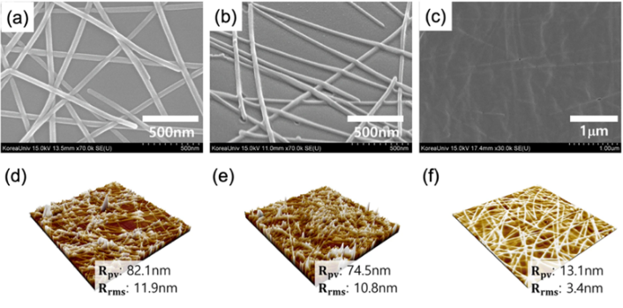
Figure 1. (a) Glass/AgNWs, (b) Glass/AgNWs after IPL treatment, (c) PVB/AgNWs. Atomic Force Microscopy (AFM) topography images of (d) Glass/AgNWs, (e) Glass/AgNWs treated with IPL, (f) PVB/AgNWs. [15]

To improve the conductivity and light output efficiency, researchers have explored the integration of various materials into nanowires, among which graphene is one of the attempts. Researchers such as H. Li, Y. Liu and A. Su mentioned in their research papers that graphene is widely used as a transparent conductive electrode (TCE) in optoelectronic devices because of its high transparency, excellent carrier mobility and thermal conductivity [16]. However, common graphene films have vacancy defects, grain boundaries and superimposed wrinkles, which lead to a decrease in carrier concentration and an increase in resistance, thus limiting its performance in practical applications. This study demonstrates a novel approach to improve the conductivity and carrier concentration of single-layer graphene (SLG) by combining it with silver nanowires (AgNWs), as shown in Fig.2. The silver nanowires provide connections to the grain interfaces of graphene, thereby promoting the conduction of charge carriers. In this study, the resistance of SLG dropped significantly from 650Ω/m to 27Ω/m after using AgNW, and this improvement can still maintain a transmittance of up to 86.7% at a wavelength of 550 nm. By combining silver nanowires with graphene, the research team successfully developed a flexible organic light-emitting diode with a maximum brightness of 15,000 cd m−2. This study effectively overcomes the application limitations of graphene as a transparent conductive electrode due to insufficient carrier concentration and high resistance. The improvement of this material is expected to significantly reduce the resistance value and enhance its stability and environmental adaptability in long-term use. At the same time, it is started to develop a production process suitable for industrialization and study compatibility with other flexible electronic components, which will help promote the widespread use of flexible optoelectronic devices.
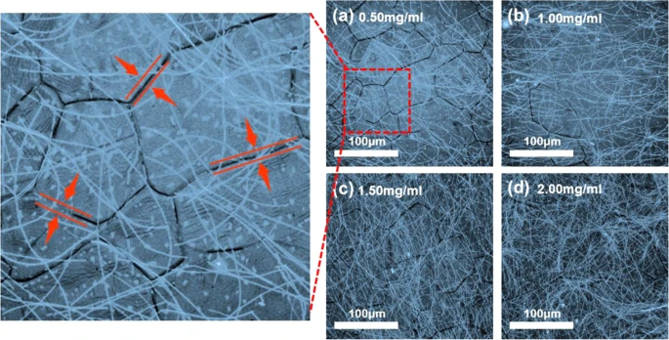
Figure 2. Three-dimensional laser scanning microscope images of SLG/AgNWs composite films with varying concentrations of AgNWs: (a) 0.5 mg/ml, (b) 1.0 mg/ml, (c) 1.5 mg/ml, and (d) 2.0 mg/ml. High-magnification microscope images showing the grain boundaries of SLG. [16]

Innovations in Luminescent Materials
In addition to electrode materials, luminescent materials are equally important. Stretchable luminescent materials play a key role in realizing skin-like displays and photocatalytic biostimulation. They have the ability to be seamlessly integrated with the human body and show wide application potential in wearable devices and medical technologies. According to the data currently known, most of the existing stretchable luminescent materials rely on electroluminescent polymers with a single exciton, so their theoretical quantum yield is limited to 25% at most. In this context, the stretchable properties can be transplanted into an electroluminescent polymer that can utilize all excitons through thermally activated delayed fluorescence, thereby achieving a theoretical quantum yield close to unity.
According to the research of W. Liu, C. Zhang, R. Alessandri et al. (2023), the strategy of inserting flexible linear units into the polymer backbone can significantly improve its performance in mechanical stretching without interfering with the basic process of electroluminescence [17]. Finally, the synthesized polymer achieved a stretchability of 125% and an external quantum efficiency of 10%. In addition, this is a fully stretchable OLED, demonstrating that the explored stretchable thermally activated delayed fluorescence polymer opens up new possibilities for simultaneously achieving desirable electroluminescent effects and mechanical properties, including high efficiency, brightness, fast switching capability, and stretchable properties at low voltage.

Transmission Materials and Device Structures
In addition to the above-mentioned materials, structural innovation of stretchable flexible OLEDs seems to have made great progress.
Stretchable organic light-emitting diodes (OLEDs) show great potential and exhibit high flexibility. However, OLEDs in a stretched state tend to reduce the geometric fill factor (FF), which means that the ratio of active area to total area decreases, hindering their prospects for widespread application. To address these issues, D. Lee, SB. Kim, T. Kim et al. proposed a three-dimensional (3D) structure with a hidden emission region in 2024, which acts as both a light-emitting region and a connecting element [18]. Therefore, the ultrathin OLED is first firmly fixed to the 3D rigid island array by secondary stretching to ensure its precise and deformation-free docking. As shown in Fig.4, in the initial unstretched state, some areas of the ultrathin OLED allow it to be "folded" between adjacent island structures, thereby being hidden, and gradually revealed during the stretching process. This structural design enables the proposed stretchable OLED to maintain a relatively high luminous efficiency after undergoing large deformations of up to 30% biaxial strain, demonstrating its excellent performance in both the initial state and after deformation. At the same time, passive-matrix OLED displays based on this structure can be adjusted to compensate for the resolution loss caused by stretching, thus verifying the effectiveness of the developed method in fully tapping the potential of stretchable OLEDs.
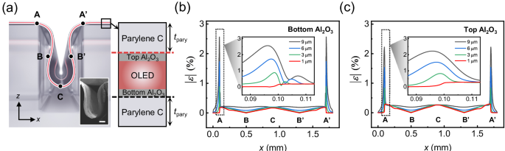
Figure 3. (a) Diagram illustrating the proposed HAA structure and potential distortion concentration points (A, B, C, A', B'). In the layer structure depicted on the right, the red dashed line marks the location where distortion is extracted from the upper Al₂O₃ layer, while the black dashed line indicates the extraction point for distortion in the lower Al₂O₃ layer. (Inset: SEM image of HAA. The scale bar corresponds to 100 μm.) Simulated equivalent distortion along the x-axis for (b) the lower Al₂O₃ layer and (c) the upper Al₂O₃ layer. (Inset: Magnified view of the equivalent deformation concentration near part A (x = 0.1 mm)) [18]

Advances in wearable technology have led to an increasing demand for flexible, stretchable organic light-emitting diodes (OLEDs) that can be integrated with the human body. Conventional intrinsically elastic OLEDs (is-OLEDs) often suffer from performance degradation due to problems with the use of orthogonal solvents and imperfect lamination processes, which leads to product defects and layer separation. To address these issues, an important study was conducted by researchers Y. Jeon, HR. Choi, and J.H. Kwon et al. (2024) to develop a sequentially coated flexible OLED, as shown in Fig.5, and to verify the design morphology of each layer and the stability of the highly stretchable metal flexible cathode [19]. This flexible OLED can achieve a peak brightness of 3151 cd m^{–2} and a total current efficiency of 5.4 cd A^{–1}. It still shows excellent durability after 40% tensile strain and retains 80% of its brightness after 300 cycles. This study is of great significance for improving the performance and life of flexible OLEDs, and also provides a more reliable option for wearable technology and other flexible electronics, thereby promoting the marketization and popularization of this field. This advance heralds a bright future for strong and efficient flexible electronics.
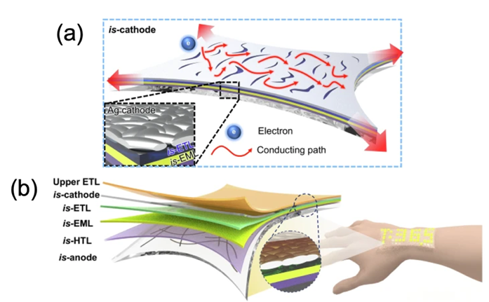
Figure 4. Illustration of a free-form OLED using STOLED:(a) Diagram showing the structure of the anode OLED, extending from the anode to the top ETL (electron transport layer).(b) Diagram depicting the morphology of the cathode and the electron conduction mechanism under stretched conditions. [19]

In summary, material innovation serves as the pivotal driving force behind the development of stretchable OLED technology, while structural innovation acts as the cornerstone for facilitating the practical applications of stretchable OLEDs. Through continuous innovation in electrode materials, luminescent materials, and device structures, researchers have not only significantly improved the flexibility, luminous efficiency, and mechanical stability of stretchable OLEDs, but also laid a solid foundation for their wide application in flexible electronic devices, wearable technology, and smart health monitoring. These breakthroughs not only meet the market demand for high-performance stretchable OLEDs, but also provide more possibilities for the development of future smart devices, demonstrating the huge potential and broad prospects of stretchable OLED technology.

DEVELOPMENT PROGRESS AND POTENTIAL OF FLEXIBLE OLEDS IN WEARABLE ELECTRONIC DEVICES
In recent years, flexible OLED technology has made significant progress in the field of wearable electronic devices and has shown great application potential. With the increasing demand for lightweight, flexible, and high-performance display devices, flexible OLED has gradually become a key display technology in the field of wearable devices due to its unique physical properties, such as lightness, low energy consumption, high brightness, and excellent flexibility.
In terms of the progress of stretchable OLED devices, scientists from South Korea are undoubtedly pioneers in this direction, and their achievements show a flourishing trend. For example, Pohang University of Science and Technology in South Korea has developed the world's first self-sounding OLED panel that can change shape freely [20]. This panel is ultra-thin and soft, and can adjust its shape through electrical signals without relying on mechanical structures (such as hinges, sliders or electric arms). It can not only stretch and deform, but also make sounds as a speaker, laying the foundation for the next generation of smart displays. These innovations not only enhance the flexibility and versatility of devices, but also promote the widespread application of flexible electronic technology in fields such as smart wearables and flexible displays, providing more possibilities for the development of future electronic devices.
LG Display has launched a display with a stretchability of 50%, which is currently the highest stretchability in the industry. The 12-inch screen can be stretched to 18 inches, providing a high resolution of 100ppi and full RGB color. By improving the performance of special silicon material substrates and developing new wiring design structures, its durability has been enhanced and can be stretched repeatedly for more than 10,000 times. Samsung demonstrated a Micro LED stretchable concept screen at CES 2025, which can present 3D effects without wearing glasses. The screen can be deformed from a flat surface to a convex fisheye shape, demonstrating the flexibility and immersion of future display technology. A number of sliding OLED screen device prototypes were launched, including: “Slidable Flex Duet”“Slidable Flex Solo”“Slidable Flex Vertical”
These innovative devices demonstrate the great potential of stretchable OLED technology in display form, functional integration and application scenarios, bringing more possibilities to the design and user experience of future smart devices.
With the continuous advancement of science and technology, the application potential of flexible OLED technology in wearable electronic devices is gradually being explored and expanded. Flexible OLED is becoming a key display technology in the field of wearable devices due to its unique physical properties, such as lightness, low energy consumption, high brightness and excellent flexibility.
In terms of health monitoring equipment, flexible OLED can not only serve as a display terminal for biosensors to present health data in real time, but also can be directly integrated into sensors through its stretchability and biocompatibility to achieve continuous monitoring of physiological signals such as heart rate, blood oxygen, and blood pressure. For example, the stretchable OLED display developed by researchers can still maintain luminescence and clear images when stretched to more than twice its length, which provides a broader application space for wearable health monitoring devices.
In 2019, Y. Jeon, HR. Choi, J.H. Kwon et al. demonstrated that it is possible to create transferable OLEDs for medical applications in ultrathin transferable structures with a thickness of 4.8 μm, while the thickness of OLEDs is 10 μm [21]. The results show that the developed transferable OLED (STOLED) exhibits the same excellent efficiency performance on different materials, including cylindrical materials, textiles, and paper, as shown in Fig.6(a). Since the neutral axis can be freely adjusted using a sandwich structure, the textile-based OLED achieves folding reliability and washing reliability, as well as a long service life (150 hours). When red STOLED light source is irradiated to keratinocytes, cell proliferation and migration are observed to increase by 26% and 32%, respectively. In an equivalent model of skin, the epidermal thickness increases by 39%. In organ culture experiments, the skin area increases by 14%, and the degree of epithelial regeneration is also significantly improved. Research shows that STOLED technology has the potential to be used in a variety of wearable and disposable optical medical devices, see Fig.6(b).

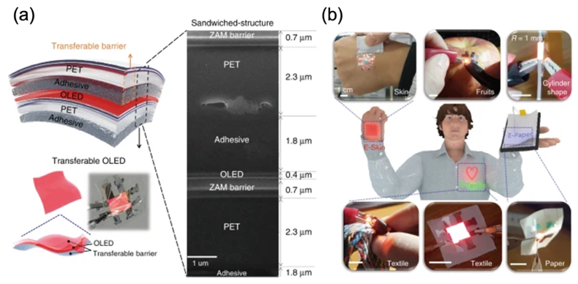
Figure 5. Illustration of freeform OLEDs using STOLED: (a) The structure of STOLED along with its FIB-SEM cross-sectional image. (b) Images of various freeform OLEDs featuring different materials and geometries. [21]

In the field of smart clothing, the integrated application of flexible OLED is constantly advancing. By combining stretchable OLED display technology with textiles, future smart clothing will have display functions that can display information, images and even videos in real time while maintaining the comfort and flexibility of clothing. This multifunctional smart clothing can not only enhance the user's interactive experience, but also open up a new path for the integration of fashion and technology.
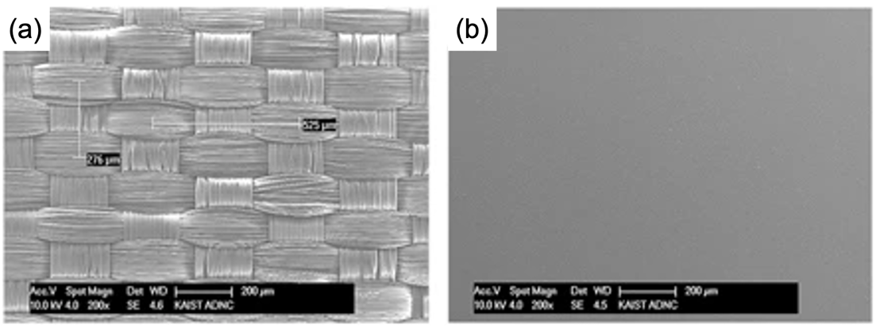
Figure 6. SEM image of the fabric surface (a) before planarization, and (b) after planarization.[22]

One approach to displaying real clothing contour information is to integrate the transmission device directly into the fabric. According to the results of S. Choi, S. Kwon, H. Kim et al. in 2017, this strategy may show significant advantages because the elasticity of the fabric is not significantly affected by the display because the substrate is not made of plastic but is made of real fabric material as shown in Fig.7. In previous experiments, the brightness of 44 cd/m² was achieved by operating AC powder electroluminescent (EL) devices on polyethylene terephthalate (PET) grids at 440 V and 40 Hz. Subsequent studies have shown that the performance of light-emitting diode displays on flexible fabrics has been significantly improved, with brightness and current efficiency exceeding 6000 cd/m2 and 8 cd/A respectively, and also confirmed the excellent long-term stability of fabric-based display technology.
In addition, in human-computer interaction and virtual reality (VR)/augmented reality (AR) devices, flexible OLED technology also shows great application potential. Its high contrast, fast response time and bendable characteristics can provide users with a more immersive visual experience. With the continuous advancement of technology, flexible OLEDs are expected to be more widely used in these fields, promoting the development of wearable electronic devices towards a more intelligent, humanized and multifunctional direction.

CONCLUSION
In simple terms, stretchable OLED technology has become a big breakthrough in the field of wearable electronic devices, because it is particularly soft, very durable, and it performs quite well in actual use. In recent years, scientists have been studying how to improve the material of this display, and they have done a lot of experiments and adjustments, and finally made the display effect brighter and clearer, and the most important thing is that it can withstand a variety of bending and stretching.
The results of this paper tell us that stretchable OLEDs may completely change the way we use electronic devices. This material can adapt to various complex shapes and work properly when bending and deformation, so it is particularly suitable for wearable devices in the future. Now there are smart clothes, health monitoring devices and flexible screens that stretchable OLEDs, indicating that it is really versatile. Now, stretchable OLED technology has indeed made a lot of progress, and this technological breakthrough may make wearable electronics different. Researchers and large companies are working hard to study new materials and improve device design, and they are making wearable technology more practical and convenient. In this way, our future life may be more intelligent, and various devices can work better together, which is also helpful for environmental protection and resource conservation.

REFERENCES
- S. H. Han, J. H. Shin & S. S. Choi, Analytical investigation of multi-layered rollable displays considering nonlinear elastic adhesive interfaces. Sci. Rep. 13, 1–12 (2023).
- D. W. Kim, et al. Fabrication of practical deformable displays: advances and challenges. Light Sci. Appl. 12, 61 (2023).
- G. M. Choi, et al. Flexible hard coating: glass-like wear resistant, yet plastic-like compliant, transparent protective coating for foldable displays. Adv. Mater. 29, 1–7 (2017).1
- H. Jinno, et al. Self-powered ultraflexible photonic skin for continuous bio-signal detection via air-operation-stable polymer light-emitting diodes. Nat. Commun. 12, 2234 (2021).
- W. Lee, et al. Universal assembly of liquid metal particles in polymers enables elastic printed circuit board. Science 378, 637–641 (2022).
- Y. Lee, et al. Standalone real-time health monitoring patch based on a stretchable organic optoelectronic system. Sci. Adv. 7, eabg9180 (2021).
- T. Kim, Y. Kim, H. Jeon, C.-S. Choi, & H.-J. Suk, Emotional response to in-car dynamic lighting. Int. J. Automot. Technol. 22, 1035–1043 (2021).
- Y. Lee, et al. Computational wrapping: a universal method to wrap 3D-curved surfaces with nonstretchable materials for conformal devices. Sci. Adv. 6, 1–9 (2020).
- W. Weng, P. Chen, S. He, X. Sun & H. Peng, Smart Electronic Textiles. Angewandte Chemie International Edition 55, 6140–6169 (2016).
- K. Cherenack & L. van Pieterson, Smart textiles: challenges and opportunities. J. Appl. Phys. 112, 091301 (2012).
- C. Larson, et al. Highly stretchable electroluminescent skin for optical signaling and tactile sensing. science 351, 1071–1074 (2016).
- R.-H. Kim, et al. Waterproof AlInGaP optoelectronics on stretchable substrates with applications in biomedicine and robotics. Nat. Mater. 9, 929–937 (2010).
- Y. Huang, E. L. Hsiang, M. Y. Deng, Mini-LED, Micro-LED and OLED displays: present status and future perspectives. Light Sci Appl 9, 105 (2020).
- A. Salehi, X. Fu, D.-H. Shin, F. So, Adv. Funct. Mater. 2019, 29, 1808803.
- D. J. Lee, Y. Oh, JM. Hong, et al. Light sintering of ultra-smooth and robust silver nanowire networks embedded in poly(vinyl-butyral) for flexible OLED.Sci Rep 8, 14170 (2018).
- H. Li, Y. Liu, A. Su, et al. Promising Hybrid Graphene-Silver Nanowire Composite Electrode for Flexible Organic Light-Emitting Diodes. Sci Rep 9, 17998 (2019).
- W. Liu, C. Zhang, R. Alessandri, et al. High-efficiency stretchable light-emitting polymers from thermally activated delayed fluorescence. Nat. Mater.22, 737–745 (2023).
- D. Lee, S. B. Kim, T. Kim, et al. Stretchable OLEDs based on a hidden active area for high fill factor and resolution compensation. Nat Commun 15, 4349 (2024).
- J. H. Oh, K. H. Jeon, & J. W. Park, Intrinsically stretchable OLEDs with a designed morphology-sustainable layer and stretchable metal cathode. npj Flex Electron 8, 43 (2024).
- J. Y. Park, J. H. Shin, I. P. Hong, et al. Dynamic bendable display with sound integration using asymmetric strain control of actuators with flexible OLED.npj Flex Electron 9, 24 (2025).
- Y. Jeon, H. R. Choi, J. H. Kwon, et al. Sandwich-structure transferable free-form OLEDs for wearable and disposable skin wound photomedicine. Light Sci Appl 8, 114 (2019).
- S. Choi, S. Kwon, H. Kim, et al. Highly Flexible and Efficient Fabric-Based Organic Light-Emitting Devices for Clothing-Shaped Wearable Displays. Sci Rep 7, 6424 (2017).

