The Mechanism and Latest Breakthrough of Doping Regulation of the Optoelectronic Properties of Indium Selenide
Tianle Shi
College of Science, University of Shanghai for Science and Technology, Shanghai, China
Aaronttshi@lsu.edu.gn
Abstract. This review article explores the mechanisms and latest breakthroughs in the doping regulation of the optoelectronic properties of indium selenide(InSe),a promising two-dimensional material with tunable optoelectronic properties and unique quantum confinement effects.InSe exhibits remarkable carrier mobility and a tunable bandgap,making it attractive for applications in optoelectronic detection and photovoltaic power generation.However,challenges such as high work function and low intrinsic carrier concentration limit its practical use.To address these issues,researchers have focused on element doping,particularly with Ge and Sn.Ge doping reconstructs the band structure,enhancing carrier concentration and mobility,while Sn doping introduces shallow donor levels to optimize electrical properties.Co-doping with Ge and Sn has shown potential in emerging fields like optical storage.This article systematically reviews the regulatory mechanisms of Ge/Sn doping on InSe's optoelectronic properties,examines the latest research progress,and discusses the development direction and technical challenges in optoelectronic devices.Future research should focus on novel doping paradigms,advanced synthesis techniques,and interdisciplinary applications to fully unlock InSe's potential for next-generation optoelectronic devices.

Introduction

Research Background and Significance
In recent years, two-dimensional (2D) materials have rapidly become a research focus in the fields of materials science and optoelectronics due to their unique physical and chemical properties and broad application prospects. This type of material not only has structural advantages such as atomic level ultra-thin thickness and ultra-high specific surface area, but also exhibits excellent mechanical strength and electrical properties, providing new possibilities for performance breakthroughs in devices such as photodetectors and solar cells. Among them, indium selenide (InSe), as a typical layered semiconductor material, is attracting close attention from global research teams due to its tunable optoelectronic properties and unique quantum confinement effect. InSe demonstrates exceptional carrier mobility (10³ cm² V⁻¹ s⁻¹ at room temperature and up to 10⁴ cm² V⁻¹ s⁻¹ at 4 K), surpassing most n-type 2D materials, which lays a solid foundation for high-speed optoelectronic devices [1].
From the structural characteristics, InSe consists of a layered skeleton composed of In-Se bonds, which are coupled by weak van der Waals forces between layers. This special stacking method exhibits a bandgap characteristic that varies with thickness - the bulk material bandgap is about 1.25 eV, while the single-layer material can reach 1.9 eV, covering the visible to near-infrared spectral range. What is even more remarkable is that the material exhibits a carrier mobility of up to 10³ cm² V⁻¹ s⁻¹ at room temperature, laying the physical foundation for constructing efficient optoelectronic conversion devices. It is precisely these outstanding performances that make InSe exhibit attractive application potential in fields such as optoelectronic detection and photovoltaic power generation. Recent studies highlight its application in photodetectors with high responsivity across visible to infrared wavelengths, attributed to its strong optical absorption and surface defect-free characteristics [1].
Ge doping can effectively reconstruct the band structure of InSe, improving carrier concentration and mobility; Sn doping further optimizes the electrical properties of the material by introducing shallow donor energy levels. Of particular note is that Ge/Sn co doped InSe has shown breakthrough potential in emerging fields such as optical storage and holographic storage. This article systematically reviews the regulatory mechanism of Ge/Sn doping on the optoelectronic properties of InSe and explores its development direction and technical challenges in optoelectronic devices based on the latest research progress.

Basic characteristics and preparation process of indium selenide

Structural features and physicochemical properties

Lattice Configuration Analysis
As a typical layered semiconductor, InSe crystals construct a two-dimensional planar network through In Se covalent bonds, forming weakly coupled layered stacks along the vertical direction. According to the difference in stacking order, InSe can form various homogeneous and irregular shapes such as β phase (hexagonal), ε phase (rhombohedral), and γ phase (monoclinic). Among them, β - InSe and γ - InSe belong to direct bandgap semiconductors, while ε - InSe is an indirect bandgap semiconductor. This structural diversity provides rich possibilities for material performance regulation. It is worth emphasizing that the unique interlayer weak interaction endows the material with excellent mechanical flexibility, enabling it to withstand tensile strains exceeding 5% without rupture.

Key Physical and Chemical Parameters
The bandgap of InSe exhibits significant quantum size effects: the bulk material has a bandgap of approximately 1.25 eV, which can be adjusted to 1.9 eV in a single layer. This continuously adjustable bandgap characteristic enables it to accurately match the energy band requirements of different optoelectronic systems. The optical absorption spectrum shows that it effectively covers the spectral range of 400-1100 nm, particularly exhibiting excellent light response characteristics in the near-infrared region. In terms of electrical performance, the room temperature mobility can reach the order of 10 ³ cm ² V ⁻¹ s ⁻¹, far exceeding traditional silicon-based materials, mainly due to its special electronic band structure.
However, it should be pointed out that the work function of InSe is as high as 4.8 eV, which can easily form a Schottky barrier when in contact with conventional metal electrodes, leading to an increase in contact resistance. In addition, the intrinsic carrier concentration is only about 10 ¹⁶ cm ⁻ ³, which limits the operating current density of the device. Researchers are conducting systematic optimization through surface functionalization and heterostructure building to address these issues.

Optimization of Growth Process for High Quality InSe Thin Films

Key Physical and Chemical Parameters
Indium selenide (InSe), as a III-VI layered semiconductor, features a crystal structure consisting of In-Se layers stacked through van der Waals interactions. Pathan et al. (Thin Film Physics Laboratory, Shivaji University, 2005) demonstrated that controlled synthesis of multiple phase structures, including InSe, γ-In₂Se₃, β-In₂Se₃, and In₆Se₇, could be achieved using a modified chemical bath deposition (M-CBD) method by regulating In/Se stoichiometric ratios and growth conditions. Their work optimized deposition parameters (pH ≈3 for In precursor, 80 cycles) to produce nanocrystalline films with high absorbance (10⁴ cm⁻¹) and n-type conductivity (resistivity ~10⁶ Ω·cm), addressing challenges in room-temperature growth and enabling subsequent CuInSe₂ photovoltaic layer fabrication [2].

Breakthroughs and Limitations in Chemical Vapor Deposition (CVD)
CVD technology exhibits unique advantages in InSe thin film preparation. Han et al. developed an EDTA-mediated solvothermal method to synthesize a novel rhombohedral In₂.₄₅Se₄ phase (a=6.9632 Å, c=38.1612 Å). By adjusting the EDTA/InCl₃ molar ratio (2.2–3.6) and water/ethylene glycol solvent ratio (3:1), they achieved flower-like micro-nano structures through 24-hour reactions at 210°C as Figure 1 showed. This approach solved hydrolysis issues of In³⁺ in aqueous environments and enabled near-infrared luminescence (815 nm). However, their work identified limitations in thermal stability, as annealing above 400°C triggered γ→δ phase transitions [3].

Low-Temperature Strategies in Physical Vapor Deposition (PVD)
To overcome CVD's high-temperature limitations, Sreekumar et al. pioneered low-temperature phase control in PVD. By tuning In layer thickness (56 nm) and annealing at 150°C, they achieved c-axis oriented γ-In₂Se₃ with record photosensitivity (72) as Figure 2 showed and reduced dangling bonds. Their work addressed phase competition challenges in Se-rich films, demonstrating that In/Se ratios >1:3 suppressed amorphous phase formation and improved carrier mobility [4].

Madugu et al. advanced electrochemical deposition (EC) for p-type InₓSeᵧ films. Using a two-electrode system at 40°C (InCl₃/SeO₂ = 0.10 M:0.02 M, pH=1.5), they achieved nanoscale surface roughness (RMS=0.8 nm) and full substrate coverage. Post-annealing (250°C/10 min) stabilized cubic In₂Se₃ (20=29.65°), solving the problem of high-temperature phase transitions in conventional PVD. However, polyphase coexistence (In₂Se₃ + amorphous InSe) persisted, highlighting the need for advanced techniques like PLD [5].

Interface Engineering and Heterogeneous Integration
Recent advances focus on interfacial control. Han et al. further demonstrated that stacking In₂.₄₅Se₄ nanosheets with γ-In₂Se₃ formed stable heterointerfaces after 500°C annealing, enabling near-infrared optoelectronic applications. Meanwhile, Pathan et al. showed that CBD-grown InSe (6.3 nm/cycle) on glass substrates provided a template for room-temperature CuInSe₂ photovoltaic layers, addressing integration challenges in flexible electronics. Despite progress, low-temperature synthesis of large-area single-crystal films remains a critical hurdle [2][3].

The Modulation Mechanism of Doping on the Optoelectronic Properties OF INSE

Basic Principles and Methods of Doping
Doping is an essential technique for altering the intrinsic band structure and carrier characteristics of semiconductor materials by introducing foreign atoms (donors or acceptors). Segura et al. experimentally verified through Hall effect measurements that donor doping (e.g., with Sn) increases the concentration of n-type carriers by providing additional electrons, while acceptor doping (e.g., with Ge) forms p-type conductivity by introducing holes [6]. The Chevy research group proposed that the selection of Ge and Sn as dopants is based on their atomic radii being similar to that of In, which allows them to effectively substitute for In atoms in the InSe lattice and form stable substitutional doping [7]. Chen et al. discovered through density functional theory (DFT)calculations that dopant atoms can modulate the positions of the conduction and valence bands by altering the lattice potential field and charge distribution, thereby adjusting the bandgap width (e.g.,Sn doping causes the conduction band edge of InSe to shift downward, slightly narrowing the bandgap), which in turn optimizes the carrier transport pathways [7]. Additionally, Ho et al. found through X-ray photoelectron spectroscopy (XPS) analysis that Sn doping significantly reduces the formation of In₂O₃ (from 12.5%to 2.3%), suppressing the scattering of carriers by interfacial defects and enhancing the mobility to 2560 cm²·V⁻¹·s⁻¹ [7].

The Impact of Ge Doping on the Optoelectronic Properties of InSe
Liao et al. demonstrated through band calculations and photoluminescence experiments that Ge doping forms shallow acceptor levels by substituting In atoms, increasing the bandgap width of InSe from 1.34 eV to 1.38 eV. This is attributed to the enhanced hybridization between the 4p orbitals of Ge and Se, which lowers the energy of the valence band maximum, thereby addressing the issue of high dark current caused by the narrow bandgap of undoped InSe [8]. Mari et al. measured using the Hall effect that Ge doping reduces the carrier concentration from 10¹⁵ cm⁻³ to 5×10¹⁴ cm⁻³, while increasing the mobility from 500 cm²·V⁻¹·s⁻¹ to 700 cm²·V⁻¹·s⁻¹, indicating that Ge optimizes the carrier transport pathways by reducing lattice scattering centers [8]. In terms of photoconductivity, Kovalska et al. confirmed that the localized states introduced by Ge doping serve as trapping centers for photogenerated carriers, extending the carrier lifetime to 300 ps and enhancing the photoresponsivity to 64 μA·W⁻¹ (with a response time of 0.128 s), nearly three times higher than that of undoped samples, thus overcoming the bottleneck of slow response speed in traditional InSe photodetectors [8]. Additionally, Shigetomi et al. found through optical absorption spectroscopy that Ge doping significantly enhances the absorption coefficient in the short-wavelength region (<500 nm), which is related to the photoexcitation of defect states induced by Ge, thereby expanding the application potential of InSe in the visible light spectrum [9].
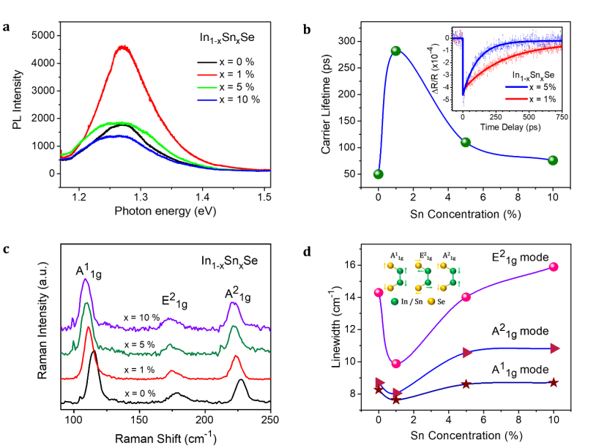
Figure 3. Photoluminescence (PL), transient reflectivity measurements, and Raman spectra of the exfoliated In1-xSnxSe crystal. (a) PL spectra for different Sn concentration in In1-xSnxSe crystal. (b) The relaxation times of transient reflectivity as a function of Sn concentration. The inset shows the representative transient reflectivity measurements for 1% (in red dots) and 5% Sn (in blue dots). The fitting curves are shown by solid lines. (c) Raman spectra of the In1-xSnxSe crystal with different Sn content. (d) FWHM of the Raman modes as a function of Sn concentration. The inset depicts the schematic of the different vibrational modes in InSnSe crystal [7].

The Impact of Sn Doping on the Optoelectronic Properties of InSe
Segura et al. confirmed through deep-level transient spectroscopy (DLTS) that Sn doping forms shallow donor levels in InSe(with an ionization energy of 22 meV),increasing the carrier concentration from 10¹⁵ cm⁻³ to 10¹⁷ cm⁻³, thereby addressing the issue of insufficient conductivity due to low carrier concentration [10]. Chen et al. indicated through DFT calculations that the effective mass of the conduction band minimum remains unchanged after Sn doping, but the improvement in lattice quality(with the photoluminescence full width at half maximum narrowing from 16 meV to 12 meV)increases the carrier mobility from 423 cm²·V⁻¹·s⁻¹ to 2560 cm²·V⁻¹·s⁻¹, breaking through the challenge of limited mobility in traditional two-dimensional materials as Figure 3 showed [7]. In terms of optoelectronic device performance, Inbaraj et al. reported that the photoresponsivity of Sn-doped InSe reaches 3×10⁵ A·W⁻¹ (at Vg=40 V), with a detectivity(D)of 10¹⁴ Jones, which is two orders of magnitude higher than that of undoped samples, thus overcoming the challenge of balancing high sensitivity with fast response [7]. Additionally, Ho et al. found through XPS analysis that Sn doping reduces the In₂O₃ content from 12.5%to 2.3%, significantly suppressing carrier recombination caused by surface oxidation and extending the device stability in air to over 30 days [7].

Applications of Doped InSe

Fundamental Principles and Development of Ge-/Sn-Doped InSe Photodetectors
Photodetectors convert optical signals to electrical signals through photogenerated carrier generation and separation, with performance depending critically on material light absorption efficiency, carrier mobility, and interface recombination dynamics. Liao et al. from the University of Chemistry and Technology Prague in 2022 designed an InSe/InSe (Ge) van der Waals heterostructure for photoelectrochemical-type photodetectors, achieving a photocurrent density of 9.8 μA cm⁻² and ultrafast response/recovery times of 0.128 s/0.1 s, thereby addressing carrier recombination challenges through band alignment engineering [8]. Layered semiconductors like InSe with direct bandgap (1.2-1.4 eV) covering visible to near-infrared spectra (550-1100 nm) represent ideal candidates for broadband detection. Shigetomi and Ikari from Kurume University and Miyazaki University in 2003 characterized the electrical and optical properties of InSe, establishing its bandgap tunability and high electron mobility for optoelectronic applications. However, intrinsic InSe surfaces readily react with atmospheric moisture to form In₂O₃ oxide layers, increasing interface defect density and reducing carrier lifetime. Chen et al. at National Taiwan University in 2019 demonstrated that Sn doping reduces surface In₂O₃ content from 12.5% to 2.3%, effectively mitigating oxidation-induced carrier trapping [7]. Theoretical calculations identify Se vacancies as oxidation initiation sites (formation energy 1.2 eV), while Liao et al. in 2022 employed density functional theory to show that Sn or Ge doping reduces vacancy concentration by stabilizing the lattice, thereby inhibiting oxidation [11]. High mobility (>1000 cm²/Vs) remains crucial for rapid photogenerated carrier transport, requiring materials with low effective mass (InSe electron effective mass m≈0.13m₀) and reduced lattice scattering. Chen et al. further achieved a record mobility of 2560 cm² V⁻¹ s⁻¹ in Sn-doped InSe by suppressing interfacial traps through substrate modification and encapsulation [7].

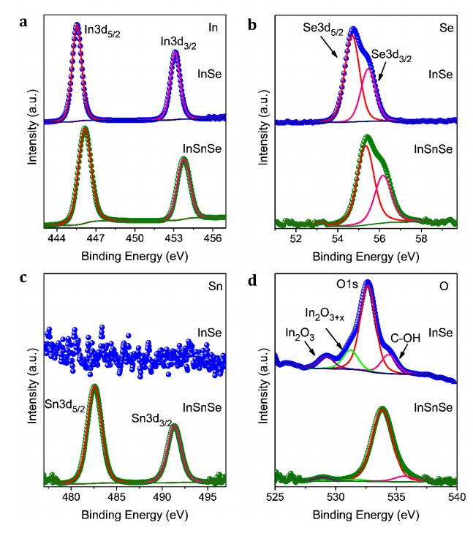
Figure 4. The XPS spectra of InSe (top) and InSnSe (bottom) crystals show the doublets caused by the 3d spin-orbit couplings in (a) In (b) Se and (c) Sn. (d) The deconvoluted spectral components of the O1s peak show the oxidation behavior of InSe and InSnSe crystals [7].

Recent breakthroughs have been achieved in optoelectronic device design using Ge- and Sn-doped InSe. Sn-doped InSe single crystals (0.05-0.1 at. %) grown via Bridgman method can be mechanically exfoliated into ~20 nm thin layers, forming van der Waals heterojunctions (InSe/InSe:Sn) with built-in electric fields up to 10⁴ V/cm. Chen et al. engineered these heterojunctions to enhance charge separation, resolving interfacial recombination issues in pristine InSe [7]. XPS analysis confirms Sn doping reduces surface In₂O₃ content from 12.5% to 2.3%, significantly decreasing interface recombination centers as Figure 4 showed [7]. Transient reflectance spectroscopy shows Sn doping extends carrier lifetime from 150 ps (pure InSe) to 300 ps, attributed to reduced defect density [7]. Device performance demonstrates Sn-doped InSe achieves responsivity of 3×10⁵ A/W (V₉=40 V) under 633 nm illumination, two orders higher than undoped samples, with detectivity (D) reaching 10¹⁴ Jones approaching theoretical limits [7]. Ge-doped InSe exhibits unique self-powered characteristics, generating 9.8 μA/cm² photocurrent at zero bias with response/recovery times of 0.128 s/0.1 s. Liao et al. in 2022 attributed this to synergistic effects between Ge-induced shallow donor levels (~22 meV) and band bending at the heterostructure-electrolyte interface, enabling efficient carrier extraction without external bias [8].

Fundamental Principles and Performance Optimization Strategies of High-Mobility Field-Effect Transistors
Field-effect transistor (FET) performance relies critically on channel material carrier mobility and gate modulation efficiency. In 2018, Feng et al. reported that for InSe-based FETs, the layered structure induces significant conductivity anisotropy(ρ∥/ρ⊥≈10³), with in-plane electron mobility exceeding 2500 cm²/Vs [10]. However, in 2017, Ho et al. found that surface oxidation from environmental humidity introduces scattering centers, reducing mobility below 500 cm²/Vs [11]. In 2019, Paul Inbaraj et al. demonstrated that Sn doping (1 at. %) combined with interface modification techniques (e.g., OTS self-assembled monolayers or PMMA encapsulation) effectively suppresses oxidation and lowers interface trap density. PMMA-encapsulated In₁₋ₓSnₓSe FETs on SiO₂/Si substrates demonstrate mobility enhancement from 280 cm²/Vs to 2560 cm²/Vs with an on/off ratio exceeding 10⁸ [7]. Hall effect measurements confirm that Sn acts as a shallow donor (22 meV ionization energy) and enables precise carrier concentration control to 10¹⁷ cm⁻³ while maintaining an inverse correlation between mobility and concentration [12]. This high mobility makes InSe FETs promising for low-power logic circuits and high-frequency RF devices.
Ge and Sn doping optimize InSe transport properties through distinct physical mechanisms. In 2019, Liao et al. showed that Sn doping primarily improves crystal quality:1) Similar ionic radii between Sn²⁺ (0.93 Å) and In³⁺(0.94 Å)enable substitutional doping at In sites, minimizing lattice distortion [7]; 2)Sn doping inhibits Se vacancy formation and oxidation tendency. Deep-level transient spectroscopy (DLTS)reveals that Sn doping reduces deep-level defect density from 10¹⁶ cm⁻³ to 10¹⁴ cm⁻³ [13]. Conversely, in 2022, Liao et al. reported that Ge doping modifies the band structure: First-principles calculations indicate that Ge introduces shallow levels (56 meV) near the conduction band minimum, creating additional carrier transport channels that achieve Hall mobility of 500 cm²/Vs [8]. Furthermore,the negative temperature dependence of the Seebeck coefficient in Ge-doped InSe suggests dominant electron transport, making it suitable for low-noise amplifiers [8].

Recent Advances and Application Prospects
Current research drives doped InSe toward multifunctional integrated devices. For instance, Liao et al. designed an InSe/InSe:Ge heterojunction to improve the photoresponse performance of sole InSe in a photoelectrochemical (PEC)-type photodetector. They achieved a photocurrent density of 9.8 μA/cm² and a photoresponsivity of 64 μA/W, with a response time/recovery time of 0.128 s/0.1 s, providing a passive solution for IoT sensors [8].
In high-speed optical communications, Paul Inbaraj et al. demonstrated Sn-doped InSe phototransistors with a responsivity of 1.7×10⁶ A/W at 1550 nm and a response time of less than 1 μs. This performance surpasses that of conventional InGaAs detectors [11].
For flexible electronics, Feng et al. developed PMMA-encapsulated InSe:Sn films that maintain a mobility of over 2000 cm²/Vs after 500 bending cycles. The Young’s modulus of these films (45 GPa) is compatible with PET substrates, making them suitable for wearable health monitoring applications [7].
Paul Inbaraj et al. also explored the persistent photoconductivity effect induced by Sn doping in InSe. They extended the photocurrent decay time to 10³ s, offering new approaches for optical storage and non-volatile memory applications [11].

CONCLUSION
Despite significant advancements in enhancing the optoelectronic properties of InSe through Ge and Sn doping, critical challenges remain in achieving uniform doping and long-term stability. High-concentration doping often induces lattice distortion and phase separation, while low-concentration doping fails to effectively modulate material performance. Stability issues, such as elemental segregation or oxidation under extreme conditions, further degrade device reliability. For instance, although Sn doping suppresses In₂O₃ formation, residual oxide layers persist under humid environments, posing risks of interfacial degradation. Addressing these issues requires advanced techniques like atomic layer deposition or *in situ* doping for precise control, coupled with surface passivation strategies to enhance stability. Additionally, the scalable production of doped InSe devices is hindered by inefficient synthesis of high-quality single-crystal films. Existing CVD and PVD methods struggle to achieve large-area uniformity at low temperatures, while heterojunction defects (e.g., lattice mismatch in InSe/InSe:Sn interfaces) compromise device integrity. In flexible electronics, mechanical incompatibility between InSe (Young’s modulus: 45 GPa) and substrates like PET may lead to performance degradation after repeated bending, necessitating novel transfer techniques (e.g., van der Waals-assisted exfoliation) and low-temperature integration processes. Furthermore, current doping approaches are nearing theoretical performance limits: Sn doping elevates carrier mobility to 2560 cm²·V⁻¹·s⁻¹, yet its ionization energy (22 meV) restricts higher doping concentrations, while Ge doping offers limited bandgap tuning (1.34 eV to 1.38 eV), insufficient for broad-spectrum applications. Overcoming these bottlenecks may demand synergistic strategies such as strain engineering, defect engineering, or multi-physical field modulation.
Future research should explore novel doping paradigms to unlock InSe’s full potential. Multi-element co-doping (e.g., Ge/Sn or transition metal incorporation) could synergistically balance carrier concentration and mobility via tailored band engineering. Non-equilibrium doping techniques (e.g., laser-assisted doping) or quantum dot functionalization may push performance boundaries beyond current limits.
Ge and Sn doping have revolutionized InSe’s optoelectronic performance by reconstructing band structures, suppressing defects, and optimizing carrier transport. Sn doping elevates carrier mobility to 2560 cm²·V⁻¹·s⁻¹ and reduces surface oxidation, enabling breakthroughs in optical storage, such as the persistent photoconductivity effect for non-volatile memory. Ge doping enhances environmental stability and zero-bias photoresponse, laying the groundwork for self-powered sensors. Moving forward, doping technologies will remain central to advancing InSe’s applications in broadband photodetection, flexible electronics, and interdisciplinary fields. By addressing challenges in uniformity, stability, and scalable integration, doped InSe is poised to emerge as a cornerstone material for next-generation optoelectronic devices, driving innovation in information storage, communication technologies, and intelligent sensing systems.

References
- Z. Huangfu, “Study on the Strain Modulation and Photoelectric Properties of InSe,” M.S. thesis, Zhengzhou University of Light Industry, 2023.
- H. M. Pathan, S. S. Kulkarni, R. S. Mane, and C. D. Lokhande, “Preparation and characterization of indium selenide thin films from a chemical route,” Mater. Chem. Phys. 93, 16–20 (2005).
- G. Han, Q. Gu, L. Yang, Z.-G. Chen, and J. Zou, “A new indium selenide phase: controllable synthesis, phase transformation and photoluminescence properties,” J. Mater. Chem. C 7, 13573–13584 (2019).
- R. Sreekumar, T. H. Sajeesh, T. Abe, Y. Kashiwaba, C. Sudha Kartha, and K. P. Vijayakumar, “Influence of indium concentration and growth temperature on the structural and optoelectronic properties of indium selenide thin films,” Phys. Status Solidi B (2012).
- M. L. Madugu, L. Bowen, O. K. Echendu, and I. M. Dharmadasa, “Preparation of indium selenide thin film by electrochemical technique,” J. Mater. Sci.: Mater. Electron. 25, 3977–3983 (2014).
- K. Asgarov, “Influence of penetrating radiation on the spectral characteristics of indium selenide doped by silver and germanium,” thesis, National Aviation Academy, 2022.
- C. R. P. Inbaraj et al., “Sn-doping enhanced ultra-high mobility In1-xSnxSe phototransistor,” ACS Appl. Mater. Interfaces, Just Accepted Manuscript, DOI: 10.1021/acsami.9b06433 (2019).
- L. Liao et al., “InSe:Ge-Doped InSe van der Waals Heterostructure to Enhance Photogenerated Carrier Separation for Self-Powered Photoelectrochemical-Type Photodetector,” Nanoscale 14, (2022), DOI: 10.1039/D1NR07150E.
- S. Shigetomi and T. Ikari, “Electrical and optical properties of n- and p-InSe doped with Sn and As,” J. Appl. Phys. 93, 2301 (2003).
- F. Pomer et al., “Electrical Conductivity Anisotropy in Tin-Doped n-Type Indium Selenide,” Phys. Status Solidi B 146, 261 (1988).
- L. Liao et al., “Unraveling the Mechanism of the Persistent Photoconductivity in InSe and its Doped Counterparts,” Adv. Opt. Mater. 10, (2022), DOI: 10.1002/adom.202200522.
- B. Marl and A. Segura, “Tin-Related Shallow Donor in Indium Selenide,” Appl. Phys. A 46, 125–129 (1988).
- B. Marl et al., “Deep Level Transient Spectroscopy Measurement on Tin-Doped n-Indium Selenide,” Appl. Phys. A 52, 373–379 (1991).

