Method of Controlling the Temperature of a Deposition-melt Oriented 3D Printing Nozzle
Wenxi Luo
School of Automation, Guangdong University of Technology, Guangzhou, Guangdong, 11845, China
outlook_18333E05B364C13F@outlook.com
Abstract. 3D printing, as a new manufacturing method emerging in recent years, is widely used in many fields such as aerospace, construction materials, biomedical and so on, for its efficient prototyping capability, ability to customize complex structures and sustainable manufacturing model. However, the quality of the printed model is closely related to the model construction, layering and slicing parameters, and process parameters. Therefore, how to control the relevant parameters is crucial to improve the quality of 3D printing. The paper presents a variety of surveys of methods for controlling the temperature of deposition-melt oriented 3D printing nozzles in recent years, including algorithmic control and model prediction. The mentioned methods are fuzzy proportional-integral-derivative (PID) algorithm, fuzzy PID algorithm based on particle swarm optimization, hot-end model, etc., and their main advantages are that they can accurately control the temperature in nonlinear environments and have better robustness. After describing the above mentioned methods this paper predicts the trends and future prospects in the field of temperature control mainly related to particle swarm optimization algorithms and model prediction.

Introduction
In the past, 3D printing has been widely used in various fields such as industry, medicine, etc., which has greatly promoted the development of design and manufacturing and effectively improved production efficiency. However, ordinary 3D printers usually use conventional PID temperature control prevails in the printer nozzle real-time temperature changes are too large, often causing the printer nozzle clogging, material outflow and the shape of the different phenomena, resulting in unsatisfactory printing results and even leading to material warping. At the same time, the error between the output temperature and the set temperature varies with the type of molten material when printing on different materials[1-3].In order to solve the above problems, Zhang and other scholars designed a fuzzy PID control system to control the nozzle temperature, using PLC plastic filament as the raw material[4]. At the same time, it will be the traditional PID control in the three parameters of the fuzzy, so as to be able to further improve the smoothness of the output of the printing material in the 3D printer nozzle system to improve the printing accuracy, and get a satisfactory printing effect[4]. By adding a fractional-order subordinate function and an online parameter update mechanism, Liu et al.'s fuzzy fractional-order PID control algorithm for a general-purpose industrial temperature control system greatly enhances the system's dynamic performance and robustness[5]; In contrast, by performing a hybrid experimental, numerical investigation of the elements impacting nozzle temperature, Gkertzos and other researchers offered a data-driven model with precise nozzle temperature prediction to help with the selection of ideal slicing parameters[6]. Recently, with the continuous progress of science and technology, Liu and other scholars proposed a new control method - particle swarm optimization fuzzy control, which is perhaps one of the best control methods at present[7]. By using fuzzy reasoning, fuzzy control, an efficient nonlinear control technique, can address the system's uncertainty and nonlinear features.
Particle swarm optimization (PSO), as an evolutionary algorithm based on population intelligence, can quickly converge to the optimal solution space of the objective function globally by iteratively updating the individual position and velocity vectors of the population by virtue of its parameter self-organized collaborative search mechanism, which is particularly suitable for the optimal configuration of control parameters of complex systems [8][9].
Through global search, the PSO method can be used to optimize the controller's settings in temperature control system design, improving the system's performance in challenging environments.
The research objective of this paper is to investigate the printing nozzle temperature control methods in recent years and come up with the best current control method and make predictions and suggestions for the future development of the temperature control field, which will greatly help to improve the product quality of the 3D printing process and upgrade the production line equipment in the whole industrial manufacturing industry.

Conventional PID Controller
Early 3D printers typically used conventional PID controllers (Figure 1 for a rough block diagram), which adjusted the power output of the heating elements according to the signals sensed by the temperature sensors through a real-time feedback mechanism to minimize the deviation of the actual temperature from the set temperature. However, there are many non-linear factors in the actual process and the traditional PID control can not quickly adjust the parameters to compensate for the deviation from the set temperature, so it is necessary to find ways to improve its anti-interference and self-regulation ability[10].

Developmental Stage
Intelligent control strategies begin to be introduced at this stage, with fuzzy logic control being added to PID control. Fuzzy control, on the other hand, does not require an accurate mathematical model and is based only on the operator's experience and knowledge, and is robust to nonlinear system control by means of linguistically-described rules and a chosen affiliation function. After combining with PID, it can adjust the parameters of PID in real time based on fuzzy rules according to the information of system deviation and rate of change of deviation, which has stronger self-adaptive ability. What’s more, it can better adapt to and maintain a better control effect in the case of system parameter change or existence of external interference. In the experiments of Zhang and Wu et al, the nozzle temperature under fuzzy PID control not only reached the set temperature faster, but also had a higher stability afterward than conventional PID control[4][11].To achieve dynamic parameter modification, Liu et al. added a fuzzy logic controller in front of the fractional-order controller in their fuzzy fractional-order PID control method (FFuzzy PID) for a general-purpose industrial temperature control system[5].The gain coefficients of the suggested fractional-order PID controller are updated online using a set of fractional-order fuzzy rules that adhere to the fat-tailed distribution and are described by the Mittag-Leffler affiliation function. The parameters that are set together control the thickness of the tails to increase the sensitivity to the extreme errors.
It is experimentally verified that the FFuzzy PID control method achieves more desirable dynamic performance and robustness compared to the traditional optimal PID (OPID) and fractional order PID (FOPID),in figure 1[5].
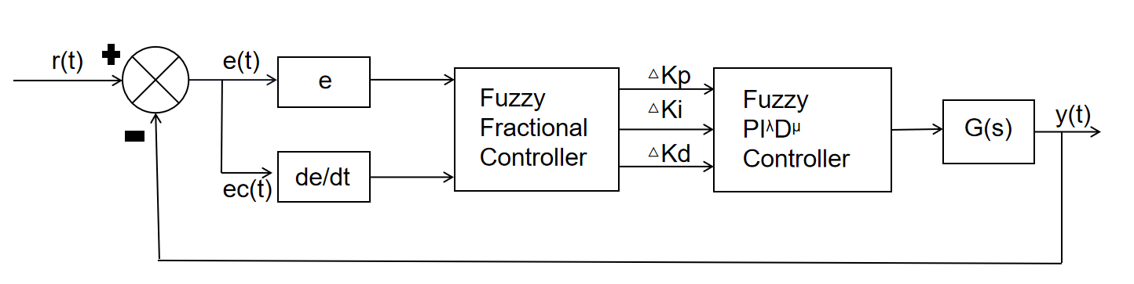
Figure 1.Block diagram of fuzzy fractional order PID control[5]
In addition, another effective method is to determine the PID parameters by Particle Swarm Optimization (PSO) algorithm. Particle swarm optimization algorithm combines other optimization algorithms or strategies (e.g., genetic algorithm GA, differential evolution DE) on the basis of particle swarm algorithm as a way to further enhance the global search capability and avoid local optimal solutions.
For instance, when creating a temperature control system for a solid-state hydrogen storage bottle made of magnesium, Xu et al. suggested a particle swarm optimization approach based on a dynamic nonlinear strategy[12].
This strategy is mainly used to rationalize the exploration time of the particle swarm algorithm at different iteration stages by dynamically adjusting the inertia weights ω during the search process of the algorithm. At the very beginning, ω is assigned a large value, which means that the algorithm has a strong global convergence at this point. It helps each “particle” to explore the global space quickly.
Then, as the exploration continues, the value of ω decreases nonlinearly, and the algorithm becomes more capable of converging locally. It ensures that in the later stages of the search, each “particle” can search the area around the extreme point in a more detailed manner, thus greatly increasing the probability that the algorithm will converge to the location of the global optimal solution[12].
Without a doubt, there are many more such optimization algorithms. Xia et al. proposed a Multi-Swarm Particle Swarm Optimization (MSPSO) method, which cooperates with the Dynamic Number of Subgroups Strategy (DNS), the Subgroup Reorganization Strategy (SRS), and the Purposeful Detection Strategy (PDS) to classify the particle swarm into multiple subgroups. The number of particles in each tiny population is then continuously updated, and information sharing across populations is improved, in order to hunt for the global best solution[13]. Although the algorithm has not yet been applied to printhead temperature control, the search capability it exhibits has great potential.
The control effect of the PID parameters derived from the optimization of such algorithms can quickly reach the given temperature compared with the traditional PID controller. It can also effectively inhibit the temperature overshoot, prevent the actual temperature error is too large on the material adhesion and strength, and solve the control problem of a nonlinear system.

Innovation Phase
Based on the previous main techniques, a variety of optimized control techniques have gradually emerged. For example, the particle swarm optimization fuzzy PID control technique proposed by Liu et al. It is based on a particle swarm optimization algorithm to form an accurate control method for a temperature control system[7]. This method not only optimizes the PID parameters but also iteratively optimizes the quantization and scaling factors of the fuzzy controller and dynamically adjusts the weighting factors. The host computer imports the temperature controller's optimum parameters to achieve precise temperature control for particle 3D printing[7].
The particle swarm algorithm is the same as the traditional formula. Each particle represents a combination of PID parameters, and the quantization and scaling factors are iteratively optimized to obtain the optimal weighting factors.The addition of ADRC technology, meanwhile, improves the system's anti-interference capabilities and reduces the impact of outside disturbances (like changes in the surrounding temperature) on the flowability of molten particles, improving the sample's overall mechanical characteristics and surface quality[7].
In addition to innovations in control technology, Gkertzos and other scholars in the field of temperature prediction have proposed a prediction model based on the analysis of large amounts of data[6]. The method first establishes a hotend model by ANSYS (Figure. 2) to analyze the effects of parameters such as print temperature, fan speed, and ambient temperature on the nozzle temperature, and then predicts the nozzle temperature by using models such as regression trees, random forests, Gaussian process regression (GPR), and neural networks. In general, the method is mainly through the adjustment of the printer's environmental parameters to obtain the optimal temperature, such as adjusting the fan speed, the use of closed printers to increase the ambient temperature in order to reduce heat loss, etc. Then on the basis of real-time measurement of the actual temperature, the use of a neural network model based on the input environmental parameters to predict the actual nozzle temperature, and then reverse optimization of parameter combinations. The intelligence may be lower than the previous methods, but the control is just as significant.
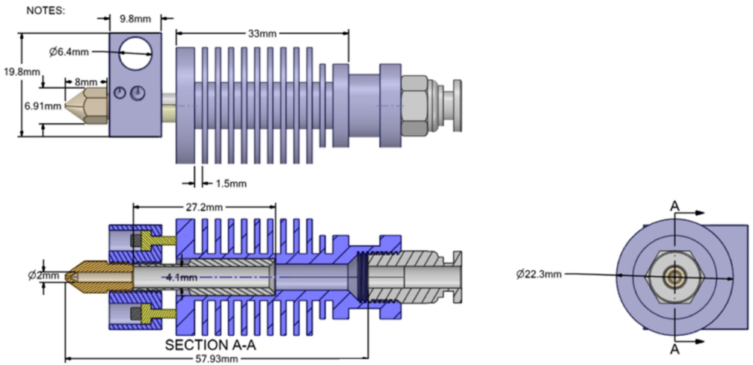
Figure 2. Hotend design diagram[5]

Challenges and developments
Surely, the methods mentioned above still have limitations. For example, the methods described above are centered around control effectiveness and ignore factors such as energy efficiency and sustainability, maintenance costs, and the number and distribution of temperature sensors. In addition, many of the methods are more complicated to realize, and further experiments are needed to verify their control effects in the face of high-precision and large-range scenes. Therefore, the selection of control methods needs to pay more attention to details and comprehensively screen the most appropriate temperature control methods.
However, particle swarm optimization intelligent algorithms have been shown to have excellent search capabilities and great potential. In the future, it can combine with more strategies and intelligent algorithms to maximize the possibility of breaking through the local optimal solution dilemma that is easy to fall into. Temperature control is evolving from single-device control to intelligent, multi-objective synergistic systems engineering. In the future, it is necessary to break through the synergistic innovation of materials, algorithms, and energy efficiency, and at the same time, combine with the carbon neutral goal to promote the scale application of green temperature control technology.

Conclusion
In this paper, after the study of modern methods of controlling the nozzle temperature, it is found that the main reason for the large deviation between the actual temperature and the set temperature is that the parameters of the control system can not be dynamically adjusted to the optimal parameter combinations with the influence of external nonlinearities, the limitations of the selected optimization algorithms can not be further optimized, and there is not enough understanding of the key factors that affect the actual temperature of the nozzle.
The method of controlling the temperature is generally optimized on the combination of intelligent algorithms for dynamic adjustment of PID parameters, and the control algorithm with the best fit compared to other optimization algorithms is the particle swarm optimization algorithm. It combines simplicity, efficiency, and flexibility. Therefore, this paper suggests that particle swarm optimization algorithms can be used as a key object to improve the optimization in combination with other strategies in recent years. At the same time in the future, the field of temperature control can be considered based on the model prediction of the temperature control method, according to the actual situation of the choice of prediction model and focus on the fan speed, ambient temperature, and other key factors of the control. It is believed that this will greatly contribute to the development of the temperature control field and the contribution of additive manufacturing to industrial manufacturing and mankind.

References
- Y. Xiaojian, W. Liansheng, Z. Kai, et al., "Effect of 3D printing filament temperature on PLA section morphology and mechanical properties," Plastics Industry 49, 67–71+159 (2021).
- M.-H. Hsueh, C.-J. Lai, K.-Y. Liu, C.-F. Chung, S.-H. Wang, C.-Y. Pan, W.-C. Huang, C.-H. Hsieh, and Y.-S. Zeng, "Effects of Printing Temperature and Filling Percentage on the Mechanical Behavior of Fused Deposition Molding Technology Components for 3D Printing," Polymers 13, 2910 (2021).
- J. Ramian, J. Ramian, and D. Dziob, "Thermal Deformations of Thermoplast during 3D Printing: Warping in the Case of ABS," Materials 14, 7070 (2021).
- Y. Zhang, C. Liang, Z. Sun, et al., "PID temperature control of 3D printing nozzle based on fuzzy algorithm," Journal of Guangxi University of Science and Technology 30, 70–76 (2019).
- L. Liu, D. Xue, and S. Zhang, "General type industrial temperature system control based on fuzzy fractional-order PID controller," Complex Intell. Syst. 9, 2585–2597 (2023).
- P. Gkertzos, A. Kotzakolios, G. Mantzouranis, et al., "Nozzle temperature calibration in 3D printing," Int J Interact Des Manuf 18, 879–899 (2024).
- B. Liu, B. Qian, Y. Liang, P. Dai, R. Li, and Q. Wei, "Fast and accurate auto-disturbances-rejection temperature control system based on particle swarm optimized fuzzy control: Applied for particle three-dimensional (3D) printing prosthetic orthotic plate," Additive Manufacturing 101, 104704 (2025).
- G. Gad, "Particle swarm optimization algorithms and their applications: a systematic evaluation," Arch Computat Methods Eng 29, 2531–2561 (2022).
- X. Wang, D. Yang, and S. Chen, "Particle swarm optimization based leader-follower cooperative control in multi-agent systems," Applied Soft Computing 151, 111130 (2024).
- H.-M. Chen, K.-H. Lin, S.-H. Jheng, T.-J. Wang, Y.-R. Huang, and X.-J. Huang, "Precision Temperature Sensors for 3D Printing Technology," *2016 IEEE International Conference on Consumer Electronics-Taiwan (ICCE-TW), Nantou, Taiwan (2016).
- X. Wu, X. Wang, and G. He, "A Fuzzy Self-tuning Temperature PID Control Algorithms for 3D Bio-printing Temperature Control System," 2020 Chinese Control And Decision Conference (CCDC), Hefei, China, pp. 2846–2849 (2020).
- J. Xu and M. Fei, "Magnesium hydrogen storage: Temperature control via particle swarm with nonlinear inertia strategy," International Journal of Hydrogen Energy 82, 25–35 (2024).
- X. Xia, L. Gui, and Z.-H. Zhan, "A multi-swarm particle swarm optimization algorithm based on dynamical topology and purposeful detecting," Applied Soft Computing 67, 126–140 (2018).

