Review of The In-Layer Filling Algorithm in Additive Manufacturing Technology for Improving Printing Efficiency
Muxi Huang
School of Mechatronic Engineering, Guangdong Polytechnic Normal University, 510665 Guangdong, China
huangmuxi@stu.gpnu.edu.cn
Abstract. At present, the most widely used 3D printing method is Fused Deposition Modeling (FDM). The advantage of this technology over other 3D printing technologies is that it is relatively easy to operate and offers a wide range of material options. However, during the printing process, the nozzle needs to extrude the material point by point and layer by layer, and the printing time is relatively long. in order to shorten the printing time, the printing route needs to be reasonably planned when printing layer by layer. This article aims to introduce various traditional algorithms, such as parallel scanning paths, contour parallel paths, spiral scanning paths, as well as algorithms that combine them for optimization. Meanwhile, other schemes that can improve the printing efficiency are also introduced, such as changing the inclination angle of filling, voxel-based variable width continuous spiral path planning, generating paths by using spatial curve filling, and printing the curved layer by taking advantage of multi-axis volume printing. Optimizing the printing path not only improves printing efficiency and reduces production costs but also enhances the mechanical properties and surface quality of printed parts, which is crucial for advancing the application of FDM technology in industrial production and personalized manufacturing.

Introduction
3D printing technology, also known as additive manufacturing technology, is a new and unique manufacturing technology. This technology is now widely used in various fields such as automobiles, clothing, construction and other industries. With the development of 3D printing technology, many different types of technologies have emerged， including: Three-Dimensional Printing, Fused Deposition Modeling, Stereo Lithography Appearance， Selected Laser Sintering， etc. Although the technical types are different, they all use the principle of discrete stacking. They first separate the designed model on the computer into surfaces, lines and points with software, and then print them layer by layer until they are made into physical objects [1]. This is different from traditional manufacturing techniques. Traditional manufacturing can produce in batches quickly, but 3D printing manufacturing takes longer than traditional manufacturing techniques. Therefore, people are now also studying how to improve printing efficiency. In 3D printing, the function of the filling algorithm is to analyze two-dimensional surfaces and then plan the filling patterns inside the model. And the most common way to generate paths is to decompose the two-dimensional polygon into countless sub-polygons, then fill each sub-polygon with patterns, and finally connect the sub-polygons together. Another way is to have the nozzle print up and down between layers instead of printing each layer in sequence[2]. After consulting the literature, various studies on filling algorithms within planar layers can be found, such as: parallel scanning paths, spiral scannning paths[3]. The common point of these algorithms is to optimize the filling method of each layer, making the path traveled by the nozzle more continuous and shorter, thereby reducing the forming time. Therefore, it is widely utilized along with the above-mentioned several paths. With the gradual maturation of current technological development, there are more and more algorithms and their related optimizations. However, there are still some new methods in the development stage. This article aims to introduce and classify traditional algorithms and some newly proposed algorithms in recent years.

Traditional filling method
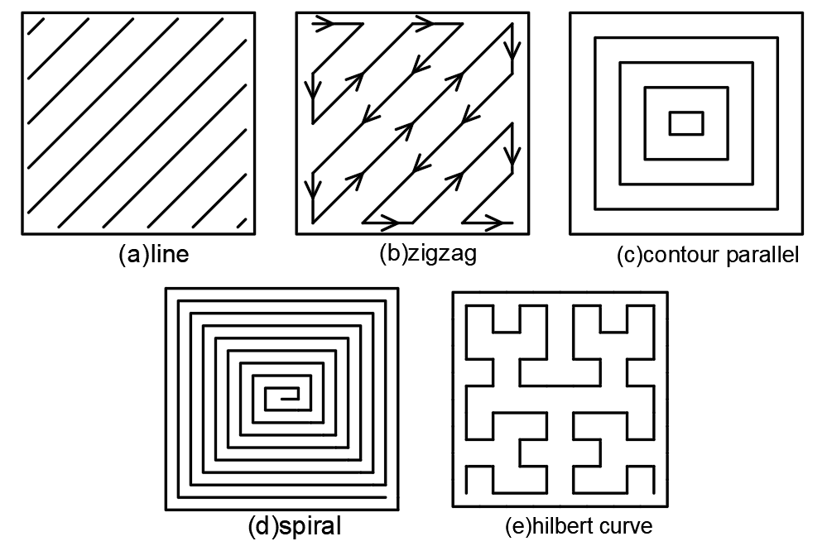
Figure 1. (a)line(b)Zigzag(c)contour parallel(d)spiral(e)Hilbert curve

Parallel Scanning Paths
Both linear scanning and zigzag scanning belong to parallel scanning, as shown in Figure 1 (a) (b). The various paths of linear scanning are parallel to each other, and during the printing process, each straight line is printed in sequence[4]. Zigzag paths is more complex than linear scanning, but the scanning path is more continuous compared to linear scanning. However, its efficiency in processing complex graphics is still relatively low. Therefore, in 2001, Rajan V et al. proposed that the optimal solution for zigzag direction scanning could be sought in a two-dimensional region to improve the printing efficiency. For example, the sawtooth shape scanning in the horizontal direction will increase the number of starts and stops of the nozzle, while scanning in the vertical direction can effectively reduce the number of scanning lines and shorten the printing time[5].

Contour Parallel
At present, this method is also widely used. This method mainly takes the surface boundary as the initial curve, offsets it by a certain distance along the normal direction of the curve, then repeats this process until the entire plane is covered. It can be seen in Figure 1 (c). In the article published in 2013, xu et al. mentioned the contour parallel algorithm and optimized it. They remove the self-intersecting loop that appears after the offset. The advantage of it is the good printing quality, but the printing efficiency is still relatively low[6].

Spiral Filling

Traditional Spiral Filling
The path generated by the spiral filling is similar in shape to the path generated by the contour parallel. The difference lies in that the path formed after filling is more coherent. However, the spiral line filling algorithm has relatively high requirements for hardware[3]. This method has only one starting point and one ending point, so it greatly increases the continuity during printing It can be seen in Figure 1 (c). In the study of Yang et al. . , the longer the single path makes the greater the average speed of the nozzle. Therefore, the efficiency of the spiral line will be higher than that of the parallel scanning paths. However, the traditional spiral line algorithm has not been widely used due to the strength issue of the printed workpieces[3] [7].

Hilbet Curve
In March 1994, Jordan J. et al. proposed that space-filling curves could be used for tool-path planning[8]. Therefore, in November of the same year, J. G. Griffiths et al. first proposed to use the Hilbert curve for filling, in order to reduce the ineffective path of the nozzle when no material is extruded[9]. In two dimensions, the Hilbert curve has ths following properties: divide a box into countless small squares. , and the Hilbert curve can pass through the center of each small square without repeating until the entire box is filled, It can be seen in Figure 1 (c). Therefore, the single path generated by the Hilbert curve has strong connectivity, saving a lot of time for the nozzle to lift up and then lower down. However, there are many sharp turns. So the acceleration and deceleration movements of the nozzle during the printing process will lead to poor coherence.

Hybrid method
At present, many hybrid methods have been proposed. The advantage of the hybrid method lies in that it can better utilize the advantages of a certain method in a certain aspect to improve the printing efficiency.

Contour Parallel and Linear Scanning
The characteristic of the contour parallel path is that its processing accuracy is higher than that of the linear scanning path. However, due to the need to handle the intersection of polygons, the processing time is longer than that of the linear scanning method[10]. Therefore, in 2010, Zhu Chuanmin et al. filled the external contour and the internal structure respectively, based on the contour parallel method and the linear scanning method[10]. This method uses the contour parallel method to ensure processing accuracy and uses the linear method to simplify the path to save processing time. So in terms of operational efficiency, it is faster than using the contour parallel method alone.

Contour Parallel and Zigzag Scanning
In 2018, Wang Jian et al. proposed a hybrid method that utilized contour parallel and zigzag scanning. They not only combine the two methods, but also sort and optimize the specified starting point, so that the path starts from the biased path and ends at the Z-shaped path, and both the starting point and the ending point are located in the solid part[11]. They printed the same model of 45mm*45mm*55mm respectively using contour parallel, zigzag scanning and their hybrid algorith. It is proved that the optimized algorithm is higher than using only one of them. The algorithm developed by Minghao BI et al. in 2022 also used the contour parallel method to generate the main contour, then used the zigzag scanning method to handle the unfilled areas. Finally, the global continuous path is formed by using contour layer-wise connection, group-wise connection and boundary connection[12]. Since the conventional offset al. gorithm will simultaneously generate unfilled areas, overfilled areas and sharp corners caused by the bottleneck effect. So they adopt a double-offset scheme to generate filling paths in order to eliminate sharp corners. Their algorithm has achieved a significant improvement in print quality, especially in terms of underfill rate, overfill rate and the number of large gaps, It can be seen in Figure 2. However, this method sacrifices printing efficiency and is slightly slower than connected Fermat spirals and continuous zigzag path.
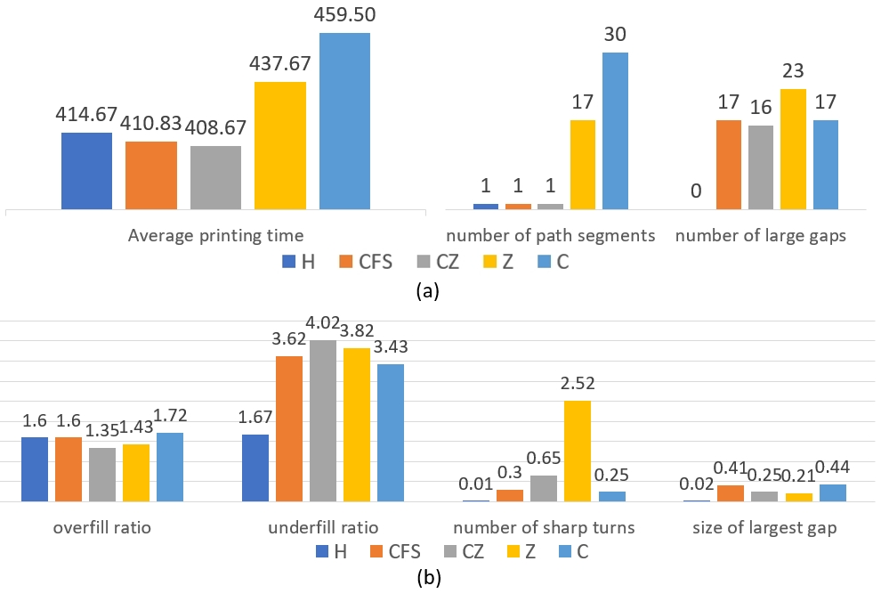
Figure 2. (a)Comparison of the average value of time(s), the number of paths and the number of large gaps by using hybrid method(H), Connect Fermat spiral (CFS), Continuous zigzag(CZ), Zigzag path(Z), contour parallel(C) (b) the average values of the overfilling rate(%), underfilling rate(%), number of sharp turns (%) and size of largest gap(%)[12]

Contour Offset and Helical Processing
Shang Wen et al. first carried out isometric offset processing based on the contour offset method, and then found adjacent contour rings for helical processing. When printed rectangular with holes of 81mm*53mm*39m, the number of jumps between scan lines is much smaller than that of equidistant offset, grid filling and linear scanning[13]. In the subsequent period, Zhou Zude et al. optimized this and proposed a new spiral processing algorith. Unlike the traditional spiral processing algorithm, when processing the inner layer, they directly fill in by replacing the end point of the previous contour ring with the starting point of the next contour ring. When printing that two models, their efficiency increased by nearly 12% compared with the original[14].

Other methods

The Inclination Angle of Zigzag Filling
In 2014, Jin et al. proposed determining the print inclination based on the priorities of both print efficiency and print quality[15]. Because the feed rate during the processing is affected by the path, especially the Angle at the corner has a significant impact on the acceleration and deceleration of the feed rate. Therefore, in the scheme that prioritizes print efficiency, they made these specific inclinations of 0°, 30°, 90° and 180° along with their tool paths and feed rate curve. After obtaining the path length and construction time, these data are used to interpolate the curves, thereby obtaining the optimal Angle for printing efficiency[15].

Voxel-Based Variable Width Continuous Spiral Path Planning
In 2023, Wenpeng X et al. proposed voxel-based variable width continuous spiral path planning[16]. They use Euler circuits to generate continuous sub-paths and connect the sub-paths through depth traversal algorithms to form continuous paths. After their verification, their algorithm has a shorter printing time than the connected Fermat spiral. Because the sharp turn rate of the connected Fermat spiral is slightly higher than that of their algorithm, and it takes time to slow down the operation during sharp turns. Therefore, although the path length connecting the Fermat spiral is relatively short, the sharp turn rate has a greater impact on the printing speed.

Non-planar Decomposition
In 2018, the algorithm of Ben Ezair et al. broke through the limitations of traditional printing methods. It was no longer limited to parallel planes but used spatial curves to fill and generate paths. This can increase the flexibility of printing, but the frequent movement of the Z-axis during printing affects the printing efficiency. Therefore, in-depth research is still needed in the direction of printing[17].
Although this method utilizes non-planar decomposition, it still requires support. Therefore, in 2019, XU et al. took advantage of the fact that multi-axis printing can change the direction of the nozzle and proposed a five-axis processing scheme based on the principle of surface layer decomposition. The interior of their slices is still a printed path with parallel contours, but the contours and the filling inner surface form a curved layer. Using their algorithm on a five-axis printer enables it to complete manufacturing without support, saving the materials and time required for printing support[18]. In 2022, Li et al. proposed surface layer slicing and print path planning for free-form surface parts using multi-axis printing. They proved through experiments that the printed model is superior to the existing algorithms under the factors of balance, unsupport, no collision and mechanical performance[19].

Conclusion
This article introduces several types of traditional algorithms, mentions several types of hybrid methods and the influence of some factors on printing efficiency. These algorithms have considerable influences on the printing efficiency in factors such as the number of sharp turns, the distance moved of the nozzle, the number of paths, and the direction of path filling. Among them, the number of sharp turns and the number of paths have the most obvious impact on efficiency in most algorithms. Meanwhile, this article also introduces several newly proposed printing schemes in recent years, including the inclination Angle of path filling, the generation of global continuous paths and non-planar decomposition. These schemes have more directly improved the efficiency, especially the non-planar decomposition schemes, which have broken through the disadvantage of the original algorithm being limited to the plane and achieved the reduction or elimination of support.
The current problem with the filling algorithm is that it is necessary to shorten the printing time as much as possible while ensuring the mechanical properties of the workpiece. Therefore, various algorithms need to strike a balance between printing accuracy and printing time. At present, the first solution to these problems is to optimize the existing algorithms and develop adaptive algorithms. Especially, the potential of using machine learning to develop adaptive algorithms is relatively large. The second approach is to leverage the advantages of multi-axis printing through algorithm optimization to reduce supporting materials and thereby shorten the printing time.

References
- L. Shan, C. Tie, and L. Mei, "Introduction to 3D Printing Technology," Util. Rubber Plast. Resour. 5, 23-27 (2014).
- X. A. Nguyen et al., "A continuous toolpath strategy from offset contours for robotic additive manufacturing," J. Braz. Soc. Mech. Sci. Eng. 45, 622 (2023).
- B. Li, "Path Planning Based on 3D Additive Manufacturing," Ph.D. dissertation, Harbin Engineering University, 2023.
- X. Han et al., "Research on Path Optimization Algorithm for Fused Deposition 3D Printing," Trans. Chin. Soc. Agric. Mach. 49(3), 393-401 (2018).
- V. T. Rajan, V. S. Vijay, and K. A. T. Konstantinos, "The optimal zigzag direction for filling a two-dimensional region," Rapid Prototyp. J. 7(5), 231-241 (2001).
- J. X. Jinting, S. Yuwen, and W. Shunke, "Tool path generation by offsetting curves on polyhedral surfaces based on mesh flattening," Int. J. Adv. Manuf. Technol. 64(9-12), 1201-1212 (2013).
- Y. Yang et al., "Equidistant path generation for improving scanning efficiency in layered manufacturing," Rapid Prototyp. J. 8(1), 30-37 (2002).
- J. J. Cox et al., "Space-filling curves in tool-path applications," Comput.Aided Des. 26(3), 215-224 (1994).
- J. G. Griffiths, "Toolpath based on Hilbert's curve," Comput.-Aided Des. 26(11), 839-844 (1994).
- C. Zhu, T. Xu, and Q. Zhu, "Fused Deposition Manufacturing with Composite Path Filling Algorithm," Mod. Manuf. Eng. 8, 89-92 (2010).
- J. Wang et al., "Research on Scanning Path Generation Method in FDM Molding Technology," Manuf. Technol. Mach. Tools 1, 107-110 (2018).
- M. Bi et al., "Continuous contour-zigzag hybrid toolpath for large format additive manufacturing," Addit. Manuf. 55, 102822 (2022).
- W. Shang, "Research on 3D Printing Slicing Processing of Carbon Fiber Long Fibers and Its Implementation on the Service Platform," M.S. thesis, Wuhan University of Technology, 2017.
- Z. Zhou et al., "Efficient Helical Offset Filling Algorithm for Continuous Carbon Fiber 3D Printing," J. Wuhan Univ. Technol. 39(12), 81-87 (2017).
- Y. Jin et al., "Optimization of tool-path generation for material extrusion-based additive manufacturing technology," Addit. Manuf. 1-4, 32-47 (2014).
- W. Xu et al., "Voxel-based variable width continuous spiral path planning for 3D printing," J. Manuf. Processes 107, 226-239 (2023).
- B. Ezair, S. Fuhrmann, and G. Elber, "Volumetric covering print-paths for additive manufacturing of 3D models," Comput.Aided Des. 100, 1-13 (2018).
- K. Xu et al., "Curved layer based process planning for multi-axis volume printing of freeform parts," Comput.-Aided Des. 114, 51-63 (2019).
- Y. Li et al., "Vector field-based curved layer slicing and path planning for multi-axis printing," Robot. Comput.-Integr. Manuf. 77, 102362 (2022).

