Biomedical-Oriented Innovations in Constituent Materials and Device Integration of Organic Photodetectors
Zhenning Wang
Queen Mary University of London Engineering School, Northwestern Polytechnical University, Xi’an, Shaanxi 710072, China

wangzhennng@mail.nwpu.edu.cn
Abstract. Inorganic photodetectors are widely used in the biomedical field due to their excellent performance such as high sensitivity. However, disadvantages such as rigidity and low biocompatibility make inorganic devices difficult to work with wearable devices. Therefore, organic photodetectors (OPDs) have become a hot research topic in recent years due to their advantages of flexibility and customization. The development of OPDs in biomedical fields is moving from the laboratory to practical applications, including but not limited to full spectrum recognition sensors, implantable health monitoring systems for the human body, and even devices for enhancing vision in the eyes. This article has mainly introduced some new materials which can be used as various components of OPDs, including the active layer, electrodes, substrate and other functional structures. The following part of the article focused on the topic of device integration and external circuits, showcasing their performances and related applications of OPDs integrated with LEDs and OFETs respectively.

INTRODUCTION
After the photoelectric phenomenon was discovered by German physicist Hertz in 1887 and the correct explanation was proposed by Einstein in 1905, phototubes (vacuum tubes) and photoconductive materials (such as selenium) gradually became practical. Before the 18th century, doctors had got low degree of accuracy and non-real time monitoring of blood flow, blood oxygen, and other parameters about human body only relying on traditional methods of mechanical or chemical means. At present, due to the non-invasive and precise characteristics, photodetection has gradually become one of the indispensable technologies for qualitative and quantitative judgment in the field of medical diagnosis. Optical analytical instruments based on different spectral bands are also widely used, such as Pulse Oximeter, optical coherence tomography, OCT, Raman scattering, and so on. Some photodetection applications can date back to twentieth century, for example, photodetection was used to fluorescently label and even therapy tumors through attached to the hematoporphyrin and porphyrins molecules in 1950s [1].
Organic photodetectors (OPDs) have gradually drawn much attention to researchers for manufacturing novel photodetectors. Inorganic photodetectors, mainly single elements such as Silicon (Si), Germanium (Ge), or InGaAs, InGaN and other III-V compound materials have the disadvantages of small detection range for different wavelengths of light and brittleness stemming from high intensity. Furthermore, most of their structures have complex manufacturing processes and their raw materials are rare metals, which might be toxic and cannot achieve large scale commercial processes. The counterpart part, OPDs show versatile potential due to their excellent flexibility, wide variety, and bendability, which make them flourish in applications that associated with the human body. The structure of OPDs can be altered in various ways, such as molecular weight, different groups, configurations, etc. Therefore, the band gap of OPDs can change with transformations in functional groups and spatial structure. More importantly, organic detectors have higher biocompatibility in the fields of human health and pharmaceutical safety, making them suitable for long-term exposure to the human body and even implantation into an organism.
However, OPDs have some drawbacks at the same time caused by their intrinsic properties, such as poor environmental stability leading to performance degradation, low carrier mobility resulting in slow response rates, and irregular crystal defects bringing about high dark currents. In the future, these limitations need to be overcome through different measurements, such as material innovation (stabilizing non fullerene acceptors by side-chain engineering), packaging technology upgrades (atomic layer deposition (ALD) for forming films), and process optimization (using Run-to-Run (R2R) standardization) [2,3].
The materials of OPDs are usually based on polymers and small molecules, and the processing methods are more flexible and easier compared to inorganic photodetectors. The various components of OPDs are mainly manufactured by low-cost solution processing method and vapor deposition method which is suitable for multi-layer structures: solution processing methods mainly includes spin coating, inkjet printing, blade coating, etc., which are easy to operate but suffer from serious losses. The vapor deposition method mainly uses physical methods such as hot and press or other chemical methods to deposit organic layers on the substrate surface, which is suitable for high-precision device manufacturing and the formation of complex patterned surfaces [4-6]. Other special processes such as 3D printing and electrochemical deposition have also been studied [7].
In this work, we have discussed the materials acted as different roles in various structures of OPDs used in the biomedical field in recent research as well as their enhancement of detector performance. Subsequently, the performances and applications of OPDs integrated with other photo-devices have also been introduced.

MATERIALs
In biomedical applications, OPDs must fulfill specific criteria, including high sensitivity, biocompatibility, flexibility, low toxicity, and environmental stability. Organic materials including polymers, oligomers and small molecules act as active layers mostly, as well as serve as electrodes and other specialized functional layers incorporated into the overall structure of photodetectors. The following will explore the latest research progress around these parts.

Electrode
The electrode serves as a collection terminal for charge carriers (electrons and cavities), ensuring the effective export of photogenerated charges to external circuits. In special construction, organic phototransistors (PT-OPDs), the gate electrode also forms an electric field by applying an external bias voltage, driving exciton separation and accelerating carriers’ migration towards the electrodes.
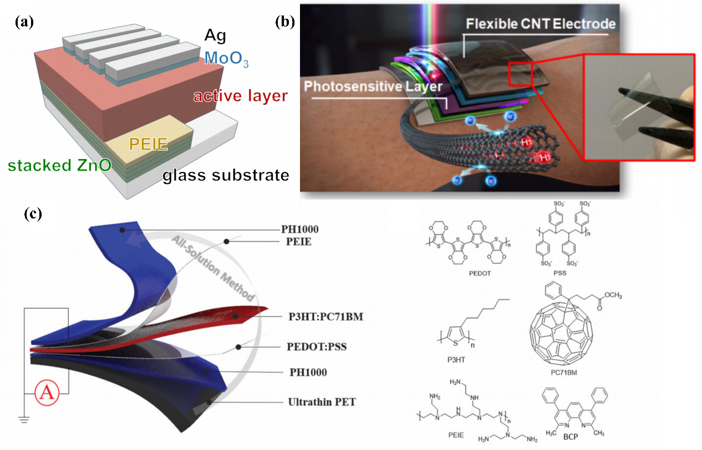
Figure 1. Three novel electrodes have been reported. (a) stacked ZnO electrode; (b) flexible CNT electrode; (c) PH1000 electrode [8-10].
In biomedical applications, electrodes need to be able to withstand mechanical stress such as bending and stretching without breaking or conductivity decreasing. Traditional indium tin oxide (ITO) materials are not suitable for implantation or wearable scenarios due to their high brittleness. Therefore, Jiang W. et al. fabricated carbon nanotubes (CNT) transparent electrodes shown in Fig. 1 (b)[8]. Due to the trade-offs between transparency and conductivity of CNT materials, the team calculated and selected the density of showing an average visible transmission (AVT) of 90% in the visible light range as the optimal packing density and conducted performance comparison experiments with ITO materials and commercial poly (3,4-ethylenedioxythiophene): poly (styrene sulfonate) (PEDOT: PSS) materials. The dark current of the CNT is very weak, with a detection rate surpassing 1014 Jones under -1 V bias. At the same time, in the 500 bending tests, CNT also maintained 80% of its performance.
Electrode materials must be harmless to the human body and not trigger immune reactions or toxicity. Traditional Ag electrodes may release a large amount of Ag⁺ ions, causing cytotoxicity. Yan T. et al. introduced PH1000 instead of the material of top, bottom electrode ITO, Ag, forming a vertical multi-layer structure, which can detect changes in blood vessel volume and the overall health of the human body [9]. PH1000 film has extremely high transparency and maintains its original resistance value in bending experiments from 0° to 180° shown in Fig. 1 (c). It is worth noting that the polarity and magnitude of the photocurrent of the battery will change with the folding angle of this all-organic-constituent photodetector, which may have potential applications in the field of motion detection.
In body fluids or humid environments, electrode materials should not be easily corroded or oxidized and maintain long-term stable performance. However, currently widely used organic electrodes have disadvantages such as easy degradation and short service life. Considering the inorganic oxide materials that are not easily decomposed, Chen Z. et al proposed a strategy to improve the performance of ZnO electrodes made by sol-gel method [10]. The team used ultraviolet irradiation and sequential deposition strategy to grow multi-layer stacked ZnO to enhance its conductivity while maintaining transparency requirements. This multi-layer ZnO material shown in Fig. 1. (a) which can be produced by solution method on a large scale has essential implications for the industrialization and commercialization of OPDs.

Active Layer
Compared with most traditional inorganic materials, organic semiconductor materials have a higher light absorption coefficient. Hence, the thin film structure that can reduce the transport distance of charge carriers to overcome the disadvantage of slightly lower charge migration in OPDs has become a research focus. The thin film structure not only helps optimize the penetration and distribution of light, improve light absorption efficiency, but also meets the requirements of large-scale production, solution processing technology. In the field of biomedicine, the active layer of OPDs needs to have characteristics such as high sensitivity, biocompatibility, flexibility, and wide spectral response as well. The following part will introduce the materials of OPDs active layer studied in recent years.

Perovskites
Perovskite materials have become popular in the field of photovoltaics in recent years due to their strong designable ability and excellent optoelectronic properties. Perovskite materials which always have direct bandgaps, bipolar transport, and low exciton binding energy, can achieve efficient optoelectronic detection in the form of a single active layer without the need for donor acceptor structures. Organic inorganic hybrid perovskites (OIHPs) have attracted the attention of many researchers. These types can control the bandgap by halogen composition adjustment or cation doping, thus meeting the requirements of multispectral applications.
Lead halide perovskite semiconductors have become a hot issue in the field of optoelectronics due to their advantages of high efficiency, low cost, and flexibility. Sakhatskyi K. et al. developed a single photon detection X-ray OPD with the single crystal MAPbI₃ as the active layer, which maintained performance without significant degradation for one year in a zero applied bias (XPV) working environment [11]. This detector aims to reduce the dose received by patients during medical X-ray imaging and providing a foundation for the development of low-cost detector technology. Girolami M. et al. conducted another X-ray high-sensitivity detector using FAPbBr₃ as the active layer, replacing MA (methylammonium) cations with more stable FA (formamidinium) cations under X-ray irradiation [12]. This OPD can operate without the need for external bias, and with the advantage of maintaining stability under long-term exposure to radiation, it can be applied in extreme environmental conditions, such as being installed on a space suit as a portable detector.
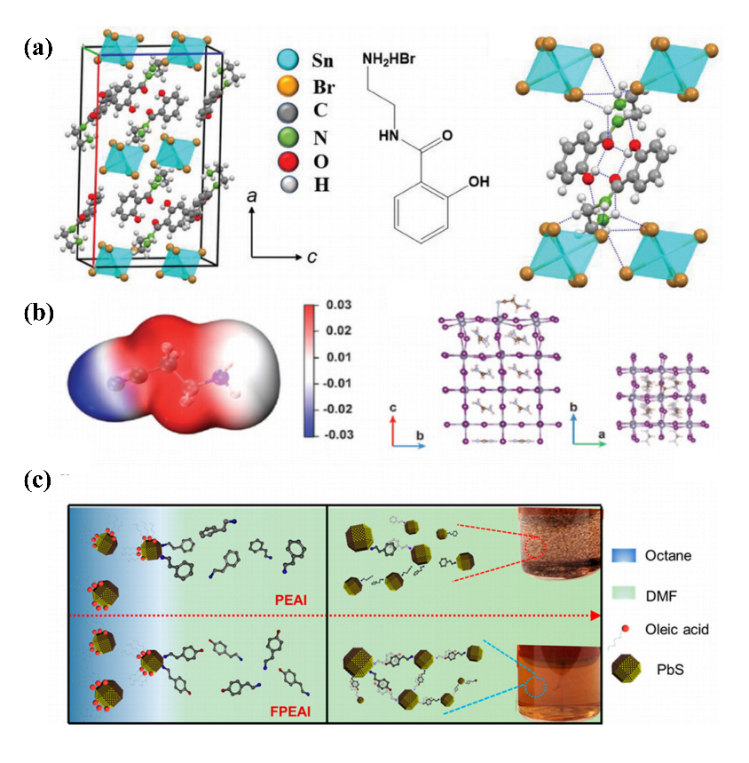
Figure 2. A schematic diagram of the microstructures of three perovskite materials (a) CNI; (b) (AEHB)₂SnBr₆; (c) (PEA)₂MA₂Pb₃I₁₀ [13-15].
However, the use of lead containing perovskite materials is not ideal in the biomedical field. This is because toxic lead ions accumulated in the body after decomposition can affect multiple organs, systems in vivo and cause environmental pollution. Therefore, the production of lead-free halide perovskites without sacrificing excellent optoelectronic performance has been widely studied. Tin is located in Group IV of the periodic table and has similar chemical properties to lead, with higher concentrations in the Earth's crust. Tin halide perovskite has advantages such as narrow bandgap and high carrier mobility, making it one of the commercially feasible directions in lead-free perovskite research. However, due to the inherent properties of Sn²⁺, this type of perovskite is easily oxidized, generating a large number of defects resulting in high dark current and low detection rate. Liu T. et al. introduced an organic compound 2-cyanoethan-1-aminium iodide (CNI) shown in Fig. 2 (a), which contains a cyanide group, adding into the tin halide perovskite film to suppress the oxidation of Sn²⁺ [13]. This detector solved the above problems and demonstrated fast response speed and stability as well, which can be used for wearable heart rate detection.
Low dimensional perovskites typically include one-layer films (2D), nanowires (1D), and quantum dots (0D). Compared to 3D structures, the advantages of low dimensional structures may include better stability, as the large volume of organic cations can provide protection against moisture and oxygen erosion, enhancing resistance to harsh environments. Moreover, the low dimensional structure suppresses the migration of halide ions and metal cations, slowing down material decomposition and device performance deterioration. In addition, the defective density of low dimensional materials may be lower because the organic cations in the structure can passivate surface defects and reduce non radiative recombination. More importantly, due to the quantum confinement effect, low dimensional structures can regulate the bandgap through size and number of layers, covering ultraviolet to near-infrared spectra and meeting multi-scene requirements. For example, Ajayakumar A. et al. synthesized a 0D tin halide perovskite detector for ultraviolet detection, with excellent device parameters [14]. The active layer material, (AEHB)₂SnBr₆ (AEHB: N-(2-aminoethyl)-2-hydroxybenzamide) thin film shown in Fig. 2 (b) has special properties: a quantum-well-like structure, Type IIb exhibits band alignment characteristics, larger carrier active regions compared to 3D structures, and anisotropic charge transfer performance. These may all be potential reasons for significantly increasing the carrier lifetime, thus improving photoconductivity.
The use of low dimensional perovskite materials is very flexible, and good optoelectronic properties can be achieved through special designs, such as Pan W. et al. coupling PbS colloidal quantum dots (CQDs) modified with F-atom ligands with a quasi-two-dimensional perovskite material matrix (PEA)₂MA₂Pb₃I₁₀ (n=3, PEA=phenylethylammonium and MA=methylammonium) shown in Fig. 2 (c)[15]. Through the design of quantum dot surface ligands and organic matrix, the OPD achieves high gain detection in the near-infrared (NIR) region related to vivo biological imaging, with external quantum efficiency (EQE) exceeding 1000%, and maintains 90% responsiveness after 150 days of storage.

Fullerene Acceptors
Fullerenes (such as C₆₀, C₇₀) are enclosed cage-like structures composed of sp² hybridized carbon atoms with high symmetry and the delocalized π electron cloud on the surface of the carbon cage endows it with strong electron acceptance ability. Typically, the LUMO energy level of fullerenes is significantly lower than the HOMO energy level of donors, thus creating an energy level gradient which drives exciton separation and forms a continuous permeation channel for electron transport. For fullerene derivatives, PC₆₁BM ([6,6]-phenyl-C₆₁-butyric acid methyl ester) and PC₇₁BM ([6,6]-phenyl-C₇₁-butyric acid methyl ester), they can enhance solubility and expand absorption spectra by grafting phenyl butyric acid methyl ester side chains. The charge absorption of fullerene acceptors can also be altered by modifying the donor molecule. Vanderspikken J. et al. replaced the alkyl side chain of poly[2,5-bis(3-tetradecylthiophen-2-yl)thieno[3,2-b]thiophene] (PBTTT) with an alkoxyalkyl (-OR-R) side chain, allowing the fullerene acceptor material to be insertable while driving the mixed active layer towards absorbing NIR light [16]. Despite the inevitable increase in dark current after modification, the detector exhibits excellent detection rates from 1000 to 1340 nm, making it possible to become a wearable micro medical diagnostic device. Kim H. et al. co-deposited a kind of donor-linker-acceptor (D-π-A) structure merocyanines with C₆₀ as a mixed film and developed a novel high-performance green selective OPD [17]. Due to the unique chalcogen bonding interaction within the molecule, the molecule is forced to flatten, thereby reducing donor strength and widening the optical bandgap. This strategy provides new ideas for designing high-performance optoelectronic materials.
Some study aims to enhance the optoelectronic performance of devices by adding a third component to binary mixed films containing fullerene acceptors. Nanayakkara MPA. et al. doped bismuth oxide (Bi2O3) nanoparticles into Poly(3-hexylthiophene-2,5-diyl) (P3HT): PC₇₁BM bulk heterojuction (BHJ), trying to promote X-ray attenuation, improve photocurrent, and enhance signal-to-noise ratio (SNR) [18]. At the same time, the self-forming HTL function through vertical component gradient demonstrated in the article significantly reduced dark current. A study has introduced other Non-fullerene acceptors structures to form a ternary active layer, Zhang S. et al. developed another ternary mixed membrane consisting of a D-A-D structured NIR absorber (2TT-oC6B), poly(N,N′-bis-4-butylphenyl-N,N′-bisphenyl)benzidin (PolyTPD), and PC61BM. PolyTPD and PC₆₁BM serve as electron blocking layers and electron transport layers respectively in the device, significantly reducing dark current and increasing photocurrent [19]. Compared to binary BHJ without PolyTPD, the charge separation time is shortened, and the responsiveness is increased by 10 times, making it effective for medical diagnosis in the NIR band.

Non-fullerene Acceptors (NFAs)
NIR light has strong penetration and low scattering in biological tissues, making it suitable for deep tissue imaging (such as tumor detection, angiography) and non-invasive monitoring in vivo. NFAs can absorb NIR and SWIR (short wave infrared) light through molecular design, while the absorption of fullerene acceptors (such as PCBM) is mainly limited to the visible light region (<700 nm). Moreover, fullerene acceptors tend to spontaneously aggregate into larger particles or clusters due to strong π-π interactions between molecules, instead of being uniformly dispersed in the active layer, resulting in device performance degradation. NFAs, such as Acceptor Denor Acceptor (A-D-A) structures, enhance the ordered arrangement of molecules and inhibit aggregation. More importantly, the molecular structure of NFA is tunable, and the flexibility and solution processability of organic materials make them easier to integrate with biological systems, making them suitable for wearable or implantable medical devices.
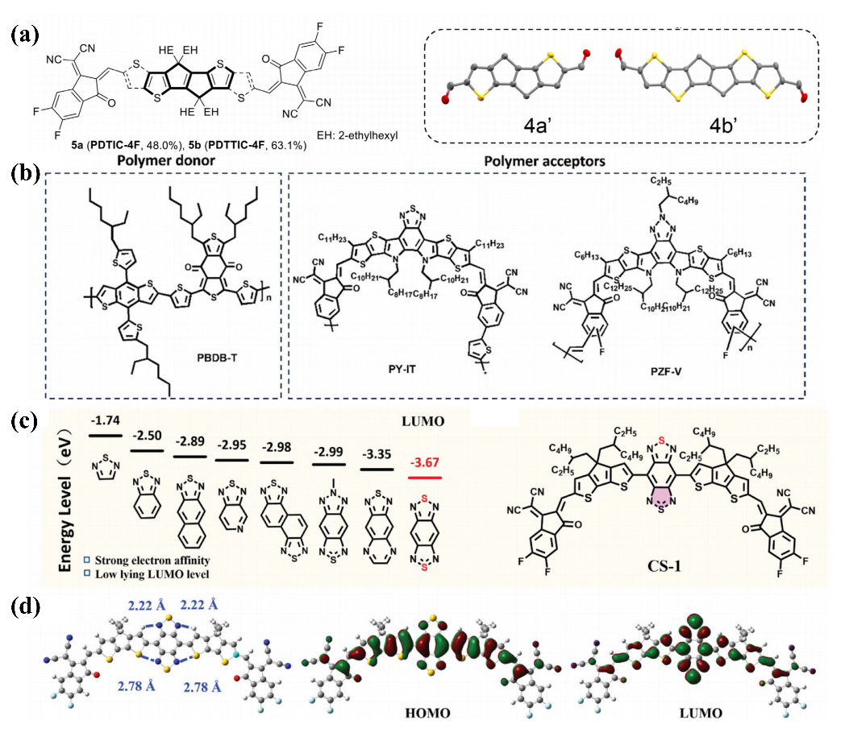
Figure 3. A schematic diagram of the microstructures of NFA acceptors and their donors with chain structures (a) PDT(T)IC-4F and the donor; (b) PBDB-T: PZF-V:PY-IT; (c) the constitution of CS-1; (d) the optimal conformation and HOMO/LUMO distribution for CS-1 [20-22].

Next, we will introduce NFAs with A-D-A structures or more complex A-D-A’-D-A structures that have emerged in recent research. Shown in Fig. 3 (a), Chen Y. et al. used 4,8-dihydropentaleno[1,2-b:4,5-b′] dithiophene (PDT) and PDTT (with an additional pair of fused symmetrical thiophene rings compared to PDT) as the electron donor core, and installed 2-(5,6-difluoro-3-oxo-2,3-dihydro-1H-inden-1-ylidene)malononitrile (DFIC) acceptor terminals to obtain the NFA molecule of PDT(T)IC-4F [20]. Based on poly[(2,6-(4,8-bis(5-(2-ethylhexyl-3-fluoro)thiophen-2-yl)-benzo[1,2-b:4,5-b′]dithiophene))-alt-(5,5-(1′,3′-di-2-thienyl-5′,7′-bis(2-ethylhexyl)benzo[1′,2′-c:4′,5′-c′]di-thiophene-4,8-dione)] (PM6):PDT(T)IC-4F, the OPD has the characteristics of low dark current and high responsivity, reaching a responsivity of over 1013 Jones from 430 to 980 nm, similar to commercial silicon-based photodetectors. A novel A-D-A NFA 3TT-FIC was developed by Huang YC et al. 3TT-FIC is centered around three fused thieno[3,2-b] thiophene, and external difluoro substituted indanone [23]. After forming an active layer with PM6, the thin film structure exhibits low dark current, high detection rate, and fast response in the NIR region. 2,2′-((2Z,2′Z)-((12,13-bis(2-ethylhexyl)−3,9-diundecyl-12,13-dihydro-[1,2,5]thiadiazolo[3,4-e]thieno[2,′′3″:4′,5′]thieno[2′,3′:4,5]pyrrolo[3,2-g]thieno[2′,3′:4,5]thieno[3,2-b]indole-2,10-diyl)bis(methanylylidene))bis(5,6-difluoro-3-oxo-2,3-dihydro-1H-indene-2,1-diylidene))dimalononitrile (Y6) is a typical NFA with an A-D-A configuration, which rapidly reduces its photoresponse to longer NIR regions. Ha JW. et al. developed YOR1 (asymmetrically) and YOR2 (asymmetrically) molecules with extended NIR absorption spectra by changing the original design framework and adding one and a pair of branched aluminum thiophene (BAT) units, achieving high detection rates and providing a strategy for developing NFAs with extended absorption spectra [24].
OPDs containing NFAs can also use ternary hybrid structures, for example, Qin M. et al. adding spatially modularizable-assembled elastic (SMAE) elastomer to a D: A mixed matrix of PM6:Y6 to form a uniform spatial distribution network [25]. Its elasticity and conductivity provide the foundation for skin-like photodetectors such as remote medical diagnosis and biometric technology. Chandran HT et al. introduced PY-IT as the second acceptor material and constructed a device with three components, PBDB-T: PZF-V:PY-IT shown in Fig.3 (b), which achieved a high detection rate of almost 1013 Jones and a fast response of 220 kHz, suitable for being used in non-implantable blood pressure monitoring systems [21].
The A-D-A’-D-A structure is formed by inserting another acceptor unit in the middle of the A-D-A structure. A novel narrow bandgap NFA studied by Cong J. et al, CS-1, is a typical A-D-A'- D-A material. Shown in Fig. 3 (c), it consists of a benzobisthiadiazole as A 'component, with cyclopentathiophene (CPDT) as the donor, and 2-(5,6-Difluoro-3-oxo-2,3-dihydro-1H-inden-1-ylidene) malononitrile (IC-2F) as the terminal [22]. This design achieves an ultra-wide absorption range of 300-1550 nm from UV to SWIR, demonstrating high detection rate and fast response in the SWIR region, making it one of future choices for low-cost medical imaging technology. Another SWIR OPD is composed of Yin B. et al [26]. It also has an electron acceptor molecular structure of A-D-A'-D-A, called TBzIC. TBzIC uses [1,2,3] triazolo[4,5-f]−2,1,3-benzothiadiazole (TBz) as the core acceptor structure, and CPDT as the graft bridge, capped with 2- (5,6-dichloro-3-oxo-2,3-dihydro-1H-inden-1-ylidene) malononitrile (IC-2Cl), demonstrating good solubility and thermal resistance. This OPD performs well in the application of wearable photoplethysmography (PPG) detection devices, capturing clear images of different blood vessel hardness, serving as a model in the biomedical field.

Other Structures
Specific structural components in certain OPDs have also been studied in recent years. In the biomedical field, the substrate materials of OPDs need to meet the requirements of flexibility, biocompatibility, and specific optical properties. The current mainstream substrate selection is mainly based on flexible polymers, such as polydimethylsiloxane (PDMS) and its derivatives, which are a type of processable polymer with pliability, optical transparency, and biosafety. Among them, the newly conceptualized integrated flexible OPDs have revolutionary significance, combining the high sensitivity of organic materials, the adaptability of flexible substrates, and multimodal sensing capabilities, which show benefits for development of intelligentized wearable OPDs. Wu X. et al. studied a green and sustainable OPD based on border ester polymers (BPs) [27]. In this study, the TBVA portion of the active layer material TBVA-CuPc was formed by a TB crosslinking agent containing boron acid (BA) and a polyvinyl alcohol (PVA) solution. The electrode material is made of the TBVA solution and silver nanosheets, which amalgamated a printable ink. The wearable OPD ensures unchanged photo responsiveness performance for 2000 cycles under 50% stretching.
Transmission cavity (TC) is a novel technology used in OPDs to enhance light absorption efficiency and regulate spectral response. Its core is to localize specific wavelength light fields within the active layer through optical resonance effect, thereby improving the external quantum efficiency (EQE) and detection sensitivity of the device. TC in OPDs usually adopts Fabry-Pérot (F-P) cavity design: the top and bottom metal layers sandwich the optical spacer layer and the intermediate active layer. Xing S. et al. fabricated an OPD based on TC, which consists of two semi-transparent silver sheets, a 4,7-Diphenyl-1,10-phenylanthroline (BPhen) spacer layer, and an active layer containing fullerene acceptors [28]. The OPD with a special structure can achieve continuous light response from the visible light region to the NIR region by simply changing the thickness of the spacer layer, while also having the advantages of low dark current, high detection rate, and fast response. This study provides the possibility for a close-fitting heart rate and blood oxygen sensor to dynamically adjust by sensing real-time contextual information such as the environment, target, or user status.

DEVICE INTEGRATION AND EXTERNAL CIRCUITY
In practical biomedical engineering applications, OPDs can be connected to other instruments and circuits to achieve performance optimization and functional expansion, meeting the needs of practical situations. This combination device is mainly used for optical detection of blood flow changes using PPG technology. PPG is a non-invasive technology for monitoring changes in blood volume through optical sensing. Its principle is to use a specific wavelength light source (especially green or infrared light) to irradiate skin tissue and detect changes in the intensity of reflected or transmitted light signals through photoelectric sensors. When the heart beats, the blood flow in the blood vessels fluctuates periodically, causing changes in light absorption and generating PPG waveforms. This technology is widely used in wearable devices such as smartwatches to monitor physiological parameters like heart rate, blood oxygen saturation, and vascular elasticity in real-time, with the advantages of convenience and low cost.

Light-emitting Diode (LED) - Integrated Device
LED is a semiconductor based optoelectronic device with a PN junction as its core structure. When a forward voltage is applied, electrons and cavities recombine in the PN junction region, releasing energy and emitting light in the form of photons. The emission color is determined by the bandgap of semiconductor materials, such as GaAs and GaP materials, which can produce infrared and visible light, respectively. LED has the characteristics of high efficiency, energy saving, long lifespan (up to tens of thousands of hours), environmental protection and pollution-free. It has been widely used in lighting, display, backlight and other fields, such as indoor lighting fixtures, screens and optimization of quantum dot technology. When used in combination with OPDs, LEDs serve as controllable light sources which can accurately output specific wavelength light signals, while OPDs are responsible for converting the light signals into electrical signals. This combination forms a closed loop in optoelectronic integrated systems, such as in biosensing, environmental monitoring, or wearable devices, where LED emits detection light and OPD receives feedback signals in real-time, achieving high-sensitivity analysis of light intensity, spectroscopy, or chemical substances. In addition, the combination of the two can optimize system energy efficiency, promoting the development of compact and low-power solutions in fields such as visual perception and health detection which require flexible electronics and intelligent optoelectronic devices.
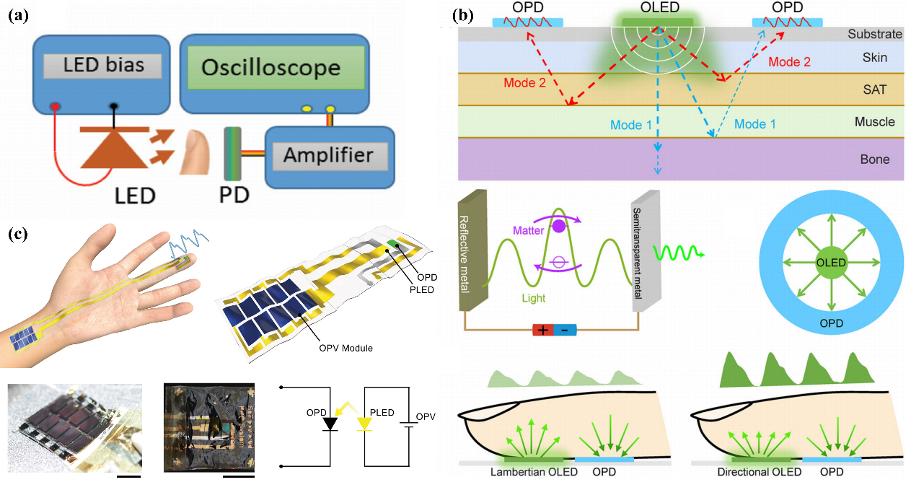
Figure 4. The working mechanism after combining with LED (a) a PPG sensor; (b) monitoring plot of a PPG sensor shown in details; (c) the self-power circuit [29-31].
Integrating LED devices with OPD can achieve SWIR visualization functionality. The prospects of this type of device are mainly to be mounted on the eyeball or even the retina, expanding the range of human visual recognition. The detection and visualization of SWIR in the biomedical field have significantly improved the accuracy of disease diagnosis and treatment through advantages of deep tissue penetration, high contrast imaging, and non-invasion. For example, real-time navigation of blood vessels and tumor boundaries during surgery, tracking drug metabolism, monitoring blood glucose and cerebral oxygen status, etc. These are important technological directions for promoting the development of precision medicine. In 2020, Li N. et al. developed an up-transition device which can convert SWIR to green light. The luminescent CsPbBr3 perovskite LED shown in Fig. 4 (a) absorbs the electrical energy generated by SWIR OPD and produces the most sensitive visible light to the human eye with a peak at 516 nm [29]. This study is based on the BHJ active layer OPD, which is a mixture of diketopyrrolopyrrole-dithienylthieno[3,2-b] thiophene (DPP-DTT) and a dye, ensuring low dark current and high detection rate while also considering the expansion for retina-like structures. In 2021, Li N. et al improved the previous up-transition structure by using N,N′-bis(napthalen-1-yl)-N,N′-bis(phenyl)benzidine (NPB) as an intermediate layer to physically isolate the OPD and the LED [32]. This interface layer plays a role in blocking electron transfer, allowing for cavity transfer, thus greatly reducing dark current and improving the optical output efficiency from SWIR light to visible light image presentation. The team has met the expectation of expanding SWIR applications to human vision by simply modifying the OPD external structure and manufacturing it at a low cost.
Another type of LED, OPD combined devices works in different mechanisms: LED devices emit light as a source, and some of the light is reflected by tissues or microstructures (mainly blood vessels and pulses) in the human body. After detecting the light signal, nearby OPDs calculate the health level of the human body by analyzing the intensity of the received light signal at different time points. Jinno H. et al. reported a close-fitting PPG sensor capable of detecting continuous biological signals, which is self-powered by multiple connected organic solar cells shown in Fig. 4 (b)[30]. The ultra-flexible LED has an inverted structure of ITO/ZnO/Polyethyleneimine ethoxylated (PEIE):8-quinolinolato lithium (Liq)/Superyellow (SY)/Molybdenum oxide (MoOX)/Al, which shows the advantages of long service life and almost ideal diffuse reflection surface. The OPD uses BHJ mixed with 2,5-bis(3-(2-ethylhexyl-5-(trimethylstannyl) thiophen-2-yl)thiazolo[5,4-d]thiazole-2-butyloctyl (PTzNTz-BOBO) and PC71BM as the active layer, which can effectively cover the spectral range generated by the corresponding LED. However, the detector observed significant noise and unstable signals in actual measurements, which means more improvements in power supply optimization and filtering installation are needed to truly participate in practical applications. Zhu H. et al. also invented a miniature PPG sensor with the same mechanism [31]. This sensor consists of a ring-shaped OPD assembled on a polyethylene naphthalate (PEN) substrate and a circular light-emitting LED device surrounding it shown in Fig. 4 (c), perfectly capturing the biological signals of the blood flow from the fingers placed on it, with an extremely low power of 9.96 µW. Moreover, the use of directional light emitting LEDs in research has increased the probability of the emitted light being received by OPDs, without the need for additional noise reduction structures such as filters.

Organic Transistor - Integrated Device
Transistors, especially organic field-effect transistors (OFETs), achieve high gain signal processing through transconductance amplification mechanisms. The emphasis control ability of its gate voltage on channel current can directly amplify the weak photocurrent generated by the detector by several orders of magnitude, breaking through the sensitivity bottleneck of traditional passive circuits. Meanwhile, the three port characteristic of the transistor supports in-situ impedance conversion, dynamically matching the high output impedance of the detector to the low input impedance of the backend circuit, reducing signal transmission losses. In an array system, the switch amplifier dual-mode characteristic of transistors not only enables selective reading of pixel level signals but also compensates for signal delay caused by low-pass filters formed by long wires through distributed transconductance gain, ultimately achieving ultra-high SNR while maintaining low light conditions.
In order to develop a highly sensitive PPG detector, Song J. et al. connected a perovskite detector with an OFET that can amplify signals, converting the current in the poly(2-(3,3′-bis(2-(2-(2-methoxyethoxy)ethoxy)ethoxy)-[2,2'-bithiophen]-5-yl)thieno[3,2-b]thiophene) (p(g2T-TT)) channel [33]. Under low light intensity, a fast response of 0.89 ms and a high gain of 2.4 × 102 Jones were achieved. By adjusting the bandgap of the active layer material, the PSC gated ECT exhibits a broadband response from UV to NIR region. Conclusively, the detector shows a significant advantage for long-distance PPG detection suitable for special populations such as the elderly and infants. Zhong Y. et al. also studied a combination sensor using a similar principle, connecting the gate of OFET to the cathode of OPD [34]. This study proposes three organic compounds that can be used as channel materials and finally selects p(g1T2-g5T2) modified by hydrophilic side chains due to faster response and lower noise. The detector also can detect weak light signals. Stability tests were conducted on the detector in the study, found that the performance decreased significantly after 3 hours of continuous operation. This will be a major obstacle to overcoming the lifespan limitation to achieve commercialization.
Circuit modification is another method to further improve detector performance. Based on the assembly of OPD and OFET, Luo G. et al. made series connection between OPD composed of P3HT: PC₆₁BM and organic resistance made by P3HT, with the voltage applied to the gate [35]. This OPD achieves a SNR of 4.6×10⁵ under weak light of 10 µW/cm² by approaching the theoretical limit of transconductance gain (37.1 S/A) and distributed noise suppression technology (dark current only 0.18 pA/µm²). At the same time, relying on the snake shaped electrode topology and ultra-thin packaging (strain<0.07%), the performance degradation after 3000 bending cycles at a bending radius of 14 mm is less than 0.8%. The solution printing process also makes the manufacturing cost extremely low. By combining the dual wavelength differential algorithm with 70 Hz bandwidth signal reconstruction, medical grade physiological monitoring accuracy has been successfully achieved, providing a disruptive solution for wearable electronics that combines ultra-high sensitivity, mechanical flexibility (curvature radius ≈ vascular scale), and industrial grade stability.

CONCLUSION
The exploration of flexible electronic devices containing small molecules or polymers in the field of optoelectronic detection is prosperously progressing, owing to the multiple advantages like low-cost manufacturing and tunable bandgap of organic materials: By utilizing the flexibility and biocompatibility of organic materials, biosensors that fit the skin can be developed for monitoring human physiological signals and even forming human eye structures such as the retina; The detection of NIR and SWIR region light provides new research directions for high-precisional and non-invasive diagnostic imaging instruments in hospitals; Combined with technologies such as transistors and LEDs, low-power portable medical detection systems could be integrated and constructed, suitable for remote medical care and personalized health management.
Although numerous studies have greatly improved the response speed and detectivity of OPDs, the short lifespan and poor resistance to complex environmental interference of organic materials remain a major obstacle to industrialization and commercialization. Moreover, the process of large-scale solution manufacturing of organic materials is also prone to introducing structural defects, which affects the production efficiency and reliability of devices. Therefore, new manufacturing technologies that reconcile low-cost manufacturing and performance assurance need to be developed.

REFERENCES
- R. Ackroyd, C. Kelty, N. Brown, and M. Reed, “The history of Photodetection and Photodynamic therapy¶,” Photochemistry and Photobiology 74(5), 656–669 (2007). M. P. Brown and K. Austin, Appl. Phys. Letters 85, 2503–2504 (2004).
- J. Lee, S.-J. Ko, H. Lee, J. Huang, Z. Zhu, M. Seifrid, J. Vollbrecht, V.V. Brus, A. Karki, H. Wang, K. Cho, T.-Q. Nguyen, and G.C. Bazan, “Side-Chain engineering of nonfullerene acceptors for Near-Infrared organic photodetectors and photovoltaics,” ACS Energy Letters 4(6), 1401–1409 (2019).
- R.W. Johnson, A. Hultqvist, and S.F. Bent, “A brief review of atomic layer deposition: from fundamentals to applications,” Materials Today 17(5), 236–246 (2014).
- W. Wu, J. Zhang, C. Liu, J. Zhang, H. Lai, Z. Hu, and H. Zhou, “Spontaneous Cooling Enables High‐Quality Perovskite Wafers for High‐Sensitivity X‐Ray Detectors with a Low‐Detection Limit,” Advanced Science 11(46), (2024).
- V.V.K. Doddapaneni, C. Song, J.A. Dhas, N. Cheng, I. Camp, A. Chang, C. Pan, B.K. Paul, S. Pasebani, Z. Feng, K.A. Sierros, and C. Chang, “Beyond Solution‐Based printing: unveiling innovations and advancements in Solvent‐Free printing technologies,” Advanced Functional Materials, (2025).
- R. Bo, M. Taheri, H. Chen, J. Bradford, N. Motta, S. Surve, T. Tran‐Phu, P. Garg, T. Tsuzuki, P. Falcaro, and A. Tricoli, “Paper‐Like writable nanoparticle network sheets for Mask‐Less MOF patterning,” Advanced Functional Materials 32(3), (2021).
- X. Ouyang, R. Su, D.W.H. Ng, G. Han, D.R. Pearson, and M.C. McAlpine, “3D printed Skin‐Interfaced UV‐Visible hybrid photodetectors,” Advanced Science 9(25), (2022).
- W. Jang, B.G. Kim, S. Seo, A. Shawky, M.S. Kim, K. Kim, B. Mikladal, E.I. Kauppinen, S. Maruyama, I. Jeon, and D.H. Wang, “Strong dark current suppression in flexible organic photodetectors by carbon nanotube transparent electrodes,” Nano Today 37, 101081 (2021).
- T. Yan, Z. Li, F. Cao, J. Chen, L. Wu, and X. Fang, “An All‐Organic Self‐Powered Photodetector with Ultraflexible Dual‐Polarity Output for Biosignal Detection,” Advanced Materials 34(30), (2022).
- Z. Chen, J. Wang, H. Wu, J. Yang, Y. Wang, J. Zhang, Q. Bao, M. Wang, Z. Ma, W. Tress, and Z. Tang, “A transparent electrode based on Solution-Processed ZNO for organic optoelectronic devices,” Nature Communications 13(1), (2022).
- K. Sakhatskyi, B. Turedi, G.J. Matt, E. Wu, A. Sakhatska, V. Bartosh, M.N. Lintangpradipto, R. Naphade, I. Shorubalko, O.F. Mohammed, S. Yakunin, O.M. Bakr, and M.V. Kovalenko, “Stable perovskite single-crystal X-ray imaging detectors with single-photon sensitivity,” Nature Photonics 17(6), 510–517 (2023).
- M. Girolami, F. Matteocci, S. Pettinato, V. Serpente, E. Bolli, B. Paci, A. Generosi, S. Salvatori, A. Di Carlo, and D.M. Trucchi, “Metal-Halide perovskite Submicrometer-Thick films for Ultra-Stable Self-Powered Direct X-Ray detectors,” Nano-Micro Letters 16(1), (2024).
- T. Liu, J. Wang, Y. Liu, L. Min, L. Wang, Z. Yuan, H. Sun, L. Huang, L. Li, and X. Meng, “Cyano‐Coordinated Tin halide perovskites for wearable health monitoring and weak light imaging,” Advanced Materials 36(24), (2024).
- A. Ajayakumar, C. Muthu, M.G. Basavarajappa, A.V. Dev, R. Nishikubo, S. Chakraborty, A. Saeki, L. Dou, and C. Vijayakumar, “Zero‐Dimensional Tin Halide Perovskite with Long Charge Carrier Lifetime and Anisotropic Photoconductivity for Selective Deep‐UV Photodetection,” Advanced Functional Materials 34(9), (2023).
- W. Pan, M. Tan, Y. He, H. Wei, and B. Yang, “Organic Amine-Bridged Quasi-2D Perovskite/PBS colloidal quantum dots composites for High-Gain Near-Infrared photodetectors,” Nano Letters 22(6), 2277–2284 (2022).
- J. Vanderspikken, Q. Liu, Z. Liu, T. Vandermeeren, T. Cardeynaels, S. Gielen, B. Van Mele, N. Van Den Brande, B. Champagne, K. Vandewal, and W. Maes, “Tuning electronic and morphological properties for High‐Performance Wavelength‐Selective Organic Near‐Infrared cavity photodetectors,” Advanced Functional Materials 32(9), (2021).
- H. Kim, B. Kim, S. Yun, D. Yun, T. Choi, S. Lee, D. Minami, C. Heo, J. Lim, H. Shibuya, Y. Lim, J. Shin, H. Hong, J. Park, F. Fang, H. Seo, J. Yi, S. Park, H.H. Lee, and K. Park, “Dual Chalcogen‐Bonding interaction for High‐Performance filterless narrowband organic photodetectors,” Small 20(37), (2024).
- M.P.A. Nanayakkara, L. Matjačić, S. Wood, F. Richheimer, F.A. Castro, S. Jenatsch, S. Züfle, R. Kilbride, A.J. Parnell, M.G. Masteghin, H.M. Thirimanne, A. Nisbet, K.D.G.I. Jayawardena, and S.R.P. Silva, “Ultra‐Low Dark Current Organic–Inorganic Hybrid X‐Ray detectors,” Advanced Functional Materials 31(8), (2020).
- S. Zhang, Z. Li, J. Li, B. Wang, F. Chen, X. Li, S. Liu, J.W.Y. Lam, G. Xing, J. Li, Z. Zhao, F. Kang, G. Wei, and B.Z. Tang, “Organic near‐infrared photodetectors with photoconductivity‐enhanced performance,” Aggregate 4(5), (2023).
- Y. Chen, Y. Zheng, Y. Jiang, H. Fan, and X. Zhu, “Carbon-Bridged 1,2-Bis(2-thienyl)ethylene: An Extremely Electron Rich Dithiophene Building Block Enabling Electron Acceptors with Absorption above 1000 nm for Highly Sensitive NIR Photodetectors,” Journal of the American Chemical Society 143(11), 4281–4289 (2021).
- H.T. Chandran, R. Ma, Z. Xu, J.C. Veetil, Y. Luo, T.A.D. Peña, I. Gunasekaran, S. Mahadevan, K. Liu, Y. Xiao, H. Xia, J. Wu, M. Li, S. Tsang, X. Yu, W. Chen, and G. Li, “High‐Detectivity All‐Polymer photodiode empowers smart vitality surveillance and computational imaging rivaling silicon diodes,” Advanced Materials 36(38), (2024).
- J. Cong, Z. Huang, S. Liu, Z. Luo, F. Liu, Z. Chen, K. Lee, Y. Huang, and C. Yang, “Efficient SWIR Organic Photodetectors with Spectral Detection Extending to 1.4 µm Using a Benzobisthiadiazole‐Based Acceptor,” Small 21(12), (2025).
- Y.-C. Huang, Z.-H. Huang, T.-Y. Wang, P. Chaudhary, J.-F. Hsu, and K.-M. Lee, “A promising non-fullerene acceptor for near-infrared organic photodetectors operating with low dark current and high response speed,” Chemical Engineering Journal 464, 142633 (2023).
- J.-W. Ha, A.Y. Lee, H.J. Eun, J.-H. Kim, H. Ahn, S. Park, C. Lee, D.W. Seo, J. Heo, S.C. Yoon, S.-J. Ko, and J.H. Kim, “High detectivity near infrared organic photodetectors using an asymmetric Non-Fullerene acceptor for optimal nanomorphology and suppressed dark current,” ACS Nano 17(19), 18792–18804 (2023).
- M. Qin, Y. Bian, C. Wang, J. Sun, W. Shi, K. Liu, Y. Zheng, F. Zhang, G. Liu, M. Shao, W. Wen, Z. Zhu, M. Zhu, Z. Zhao, H. Wang, Y. Liu, G. Yuan, and Y. Guo, “Intrinsically stretchable organic photodiodes for faint Near-Infrared light detection and extendable cryptographic imaging,” Advanced Functional Materials 34(40), (2024).
- B. Yin, X. Zhou, Y. Li, G. Hu, W. Wei, M. Yang, S. Jeong, W. Deng, B. Wu, Y. Cao, B. Huang, L. Pan, X. Yang, Z. Fu, Y. Fang, L. Shen, C. Yang, H. Wu, L. Lan, F. Huang, Y. Cao, and C. Duan, “Sensitive Organic Photodetectors With Spectral Response up to 1.3 µm Using a Quinoidal Molecular Semiconductor,” Advanced Materials 36(19), (2024).
- X. Wu, W. Wei, H. Lin, T. Wu, W. Zheng, G. Chen, W. Luo, C. Yuan, B. Zeng, Y. Xu, and L. Dai, “Flexible and stretchable photodetectors constructed by integrating photosensor, substrate, and electrode in one polymer matrix,” Chemical Engineering Journal 490, 151534 (2024).
- S. Xing, V.C. Nikolis, J. Kublitski, E. Guo, X. Jia, Y. Wang, D. Spoltore, K. Vandewal, H. Kleemann, J. Benduhn, and K. Leo, “Miniaturized VIS‐NIR Spectrometers Based on Narrowband and Tunable Transmission Cavity Organic Photodetectors with Ultrahigh Specific Detectivity above 1014 Jones,” Advanced Materials 33(44), (2021).
- N. Li, Z. Lan, Y.S. Lau, J. Xie, D. Zhao, and F. Zhu, “SWIR photodetection and visualization realized by incorporating an organic SWIR sensitive bulk heterojunction,” Advanced Science 7(14), (2020).
- H. Jinno, T. Yokota, M. Koizumi, W. Yukita, M. Saito, I. Osaka, K. Fukuda, and T. Someya, “Self-powered ultraflexible photonic skin for continuous bio-signal detection via air-operation-stable polymer light-emitting diodes,” Nature Communications 12(1), (2021).
- H. Zhu, H. Yu, J. Zhang, Y. Zhang, L. Zhang, S. Liu, and W. Xie, “Organic Photoplethysmography Sensor based on directional emission Microcavity Organic Light‐Emitting Device,” Laser & Photonics Review 18(7), (2024).
- N. Li, N. Eedugurala, D. Leem, J.D. Azoulay, and T.N. Ng, “Organic Upconversion Imager with Dual Electronic and Optical Readouts for Shortwave Infrared Light Detection,” Advanced Functional Materials 31(16), (2021).
- J. Song, G. Tang, J. Cao, H. Liu, Z. Zhao, S. Griggs, A. Yang, N. Wang, H. Cheng, C. Liu, I. McCulloch, and F. Yan, “Perovskite Solar Cell‐Gated Organic Electrochemical Transistors for Flexible Photodetectors with Ultrahigh Sensitivity and Fast Response,” Advanced Materials 35(6), (2022).
- Y. Zhong, A. Koklu, D.R. Villalva, Y. Zhang, L.H. Hernandez, M. Moser, R.K. Hallani, I. McCulloch, D. Baran, and S. Inal, “An organic electrochemical transistor integrated photodetector for high quality photoplethysmogram signal acquisition,” Advanced Functional Materials 33(6), (2022).
- G. Luo, J. Shi, W. Deng, Z. Chang, Z. Lu, Y. Zhang, R. Pan, J. Jie, X. Zhang, and X. Zhang, “Boosting the Performance of Organic Photodetectors with a Solution‐Processed Integration Circuit toward Ubiquitous Health Monitoring,” Advanced Materials 35(36), (2023).

