Epitaxial and Structural Strategies for High-Performance InGaN LEDs: Materials Challenges and Device Evolution
Yinze Hu
Department of Applied Physics, School of Physical Science and Engineering, Tongji University, Shanghai 200092, China
steven0908@tongji.edu.cn
Abstract. InGaN-based light-emitting diodes (LEDs) have become a key technology for solid-state lighting and high-resolution displays. However, pursuing long-wavelength emissions in the green and red spectral regions remains a significant challenge due to the instability of high-indium compositions and the resulting structural defects. This paper comprehensively reviews recent advances in material growth and device structure optimization strategies for InGaN LEDs. On the material side, it highlights methods such as high-pressure MOCVD, remote MBE, patterned substrates, and superlattice-based buffer layers, which collectively address lattice mismatch, indium incorporation, and dislocation reduction. On the structural side, the discussion focuses on mitigating polarization-induced quantum confined Stark effect (QCSE), improving carrier injection balance, suppressing electron leakage, and enhancing the stability of Micro-LED architectures. Experimental structures with optimized barrier layers, stress control mechanisms, and injection pathways are analyzed. By integrating insights from multiple device engineering perspectives, this work aims to provide a structural and process-level reference for future high-efficiency InGaN LED development, particularly in overcoming the green-gap bottleneck and enabling scalable long-wavelength applications.

Introduction
Since the 1990s, high-brightness blue light-emitting diode (LED) technology, leveraging indium gallium nitride (InGaN)/gallium nitride (GaN) heterostructures, has transformed the solid-state lighting industry. Over the past three decades, InGaN materials have proven essential in white light lighting, display technology, and backlight applications. Their utility in optoelectronics stems from exceptional internal quantum efficiency (IQE), a tunable bandgap, and extended lifespan, positioning them as a vital component in energy-efficient optoelectronic systems.
By varying the indium proportion, InGaN enables wavelength tuning across a wide spectral range, from ultraviolet to near-infrared. This capability results from the bandgap narrowing as indium content increases, facilitating continuous emission wavelength adjustment through precise indium regulation. This tunable bandgap underpins full-color display technology and propels LED advancements in emerging fields like visible light communication, biosensing, and microdisplays. However, despite its broad commercial adoption, InGaN technology faces persistent challenges in the green and red wavelength bands. Beyond 500 nanometers, light extraction efficiency declines sharply, a limitation termed the ‘green gap,’ which poses a significant hurdle to further progress [1-2].
InGaN LED performance hinges on epitaxial material quality and device structure design. Metal-organic chemical vapor deposition (MOCVD) and molecular beam epitaxy (MBE) are prevalent growth techniques. Achieving an optimal balance between high indium doping, crystal quality, and stress management remains a critical challenge during material growth. For long-wavelength emission, excessive indium can induce phase separation and material inhomogeneity, impairing device outcomes. Lattice mismatch between GaN and typical substrates, such as sapphire and silicon, often elevates dislocation density, detrimentally affecting optoelectronic efficiency and long-term device stability [3-4].
To counter these issues, researchers have devised multiple optimization strategies. These include employing patterned substrates, crafting buffer layers, minimizing indium volatilization via high-pressure MOCVD, and attaining atomic-level precision with MBE. Parameters like growth temperature, V/III ratio, and chamber pressure significantly influence crystal morphology and composition distribution, marking them as pivotal research areas [1][5]. The rise of Micro-LED technology and high-definition displays has intensified demands for superior InGaN epitaxial layers, particularly in reducing defect density and enhancing composition uniformity.
Meanwhile, sustained innovation in epitaxial technology remains a central focus. In device design, incorporating quantum well structures, polarization compensation layers, and stress regulation techniques has effectively reduced electron-hole separation due to polarization fields, markedly improving radiative recombination efficiency. Concurrently, enhancements in carrier injection and light extraction efficiency have substantially elevated device brightness and stability [6-8]. In Micro-LED applications, the diminished surface area amplifies sidewall defects and leakage issues, imposing stricter requirements on microstructural design [9-11].
This paper explores the latest developments in InGaN-based LED technology, emphasizing optimized material growth strategies and enhanced device structure performance. In material growth, it thoroughly assesses mainstream epitaxial techniques, and their material property impacts, delving into critical issues like high indium incorporation, substrate compatibility, growth parameter optimization, and defect management. In device technology, it reviews recent progress in quantum well design, carrier transport, light extraction optimization, and innovative architectures, including Micro-LEDs.
The paper centers on current InGaN-based LED technology advancements, pursuing two primary directions: it rigorously analyzes and organizes the technology’s core challenges, while also addressing existing limitations and suggesting potential future research pathways.

Material Growth Strategies and Challenges in InGaN-Based LEDs

Component Regulation and Indium Volatilization Suppression in High-In Epitaxy
In the epitaxial growth of InGaN LED technology, particularly in green and red-light bands, efficiency enhancements are persistently limited by material composition instability and crystal defects from high indium doping, commonly known as the ‘green gap.’ The central difficulty arises because high indium content demands lower growth temperatures, clashing with the elevated temperatures needed for high-quality GaN, often causing material phase separation, indium volatilization, and diminished crystal quality [1].
To mitigate this, researchers have refined parameters in the predominant MOCVD process. Zhao et al. illustrated that elevating reaction chamber pressure during high-pressure MOCVD effectively curbs indium atom volatilization, enhancing epitaxial layer uniformity and enabling green light emission from LEDs. This widens the stable growth window for green-emitting InGaN structures, laying a vital process groundwork for improving structural integrity and efficiency consistency in long-wavelength devices.
Beyond chamber pressure control, temperature and V/III ratio are pivotal performance influencers. Raising the V/III ratio boosts nitrogen source activity, enhancing indium capture efficiency. Yet, this approach may elevate defect density, requiring careful optimization and balance in process design [5].

Alternative Epitaxial Techniques: MBE and Remote Heteroepitaxy
Though widely utilized in InGaN-based LED epitaxial growth, MOCVD’s thermal stability and precision in regulating high indium compositions exhibit limitations. To address challenges like a constrained low-temperature growth window and component instability, some studies have adopted molecular beam epitaxy (MBE). Operating at low temperatures in ultra-high vacuum, MBE precisely controls indium doping levels and quantum well structure thickness. Jeong et al. achieved strain controlled GaN microstructure remote epitaxy using MBE, offering a fresh approach to locally regulating InGaN structures (Figure 1).
This technique modifies stress conduction paths through ‘substrate physical isolation + lattice replication growth,’ providing novel perspectives on local stress management and low-dimensional structure design. However, its slow growth rate and limited dislocation control currently render it impractical for large-area epitaxial growth needs.
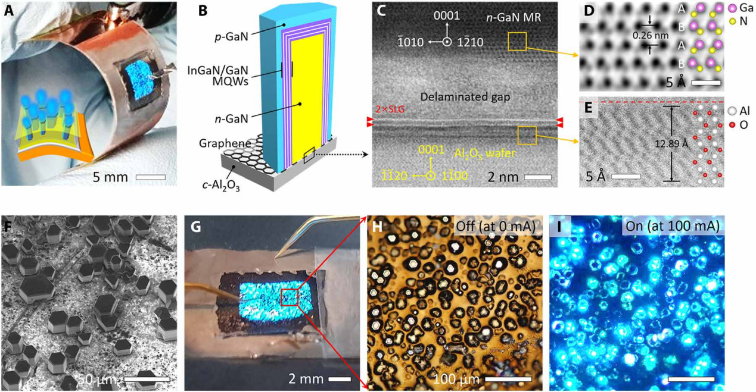
Figure 1 Remote heteroepitaxy of GaN MR heterostructures on c-Al₂O₃ across graphene.(A) Photograph of EL light emission from MR LED in a bent form. (B) Cross-sectional schematic of MR heterostructures grown on graphene-coated c-Al₂O₃ wafer. (C) Annular bright-field (ABF) STEM image of remote epitaxial heterointerface of GaN/graphene/c-Al₂O₃ focused on graphene. The location of the doubly stacked SLG is marked with red wedges. Atomic-resolution filtered ABF STEM images of (D) GaN MR and (E) c-Al₂O₃ taken around the heterointerface area. (F) Tilt-view FE-SEM image of as-grown MR LED arrays of radial p-n junction heterostructures. (G) Photograph of EL light emission from a 5 mm by 5 mm area MR LED in a flat form at 100 mA. Photomicrographs of MR LED (H) without and (I) with current injection of 100 mA, taken from the boxed area in (G). The off-state photomicrograph of (H) was taken under normal lamp illumination conditions [10].
Nonetheless, MBE’s primary drawbacks—low yield and high dislocation density—currently preclude its use in large-scale commercial applications [10].

Lattice Mismatch Management and Dislocation Suppression Strategies
Lattice mismatch and dislocation suppression present another major challenge beyond component regulation. InGaN, typically grown on sapphire, Si, or SiC substrates, encounters lattice mismatches with GaN, generating numerous screw dislocations and stress concentration zones that significantly diminish carrier recombination efficiency and light-emitting performance [9]. To alleviate stress buildup and curb dislocation propagation, researchers have suggested various buffer structures and substrate patterning strategies. Combining the GaN-on-Si platform with patterned substrates, Wu et al. utilized patterned mask (PSS) and epitaxial lateral overgrowth (ELO) techniques on a sapphire substrate to develop a GaN-on-Si epitaxial structure, achieving lateral screw dislocation termination and enhanced epitaxial layer thickness uniformity [9]. Their study integrated EBSD, XRD, and transmission electron microscopy (TEM) characterization to confirm this structure’s comprehensive benefits in reducing dislocation density and stress bending (wafer bow), making it especially apt for uniform growth of large-scale Micro-LED devices (Figure 2).
Regarding buffer layer design, Mouloua et al. suggested implementing a multi-period superlattice structure between InGaN and GaN layers as an alternating strain regulation zone, paired with AlN initial buffering, effectively suppressing interface mismatch stress and vertical screw dislocation rise [4]. This strategy employs periodic interface reconstruction to bolster overall epitaxial layer stability without sacrificing doping accuracy. This work structurally supports tackling crystal quality degradation in long-wavelength structures; however, the intricate multi-layer design still challenges growth uniformity control.

Stress Engineering and Local Structure-Induced Composition Control
Component tuning of InGaN materials remains a foremost technical hurdle. Particularly when targeting high indium content for green or red-light emission, material stability and the growth window narrow considerably. To address this, Pan et al. [5]proposed introducing microgroove defects to regulate the growth surface stress field. This method establishes a controllable defect array on the quantum well growth surface, inducing local strain distribution that markedly enhances In distribution uniformity and quantum well interface flatness. In high-indium-content red LEDs, a notable increase in light extraction efficiency was observed. This structure also modulates polarized electric field distribution, partially mitigating band tilt effects from polarization enhancement, offering a structural-level control pathway for the green gap mechanism. Unlike traditional superlattice buffer layers, this approach prioritizes local microstructure induction on the growth surface, maintaining high doping stability while preserving excellent lateral stress release capability. This facilitates In distribution control in red LEDs, effectively addressing composition segregation issues from high indium doping.
Beyond structural regulation, low-stress–low-power process routes have emerged as a key avenue for optimizing material quality. Baek et al. [3]proposed using low current density drive and a reduced thermal budget to achieve high-quality InGaN/GaN multi-quantum well epitaxial growth in blue μLED structures. This method curbs In volatilization and stress-induced behavior, significantly enhancing EQE and lattice uniformity without compromising crystal integrity, offering transferable validation for subsequent high-In composition structure designs (Figure 3). These findings suggest that current material control strategies are shifting from single-parameter optimization reliance toward an integrated control system grounded in the three-dimensional coordination of structure, process, and stress.
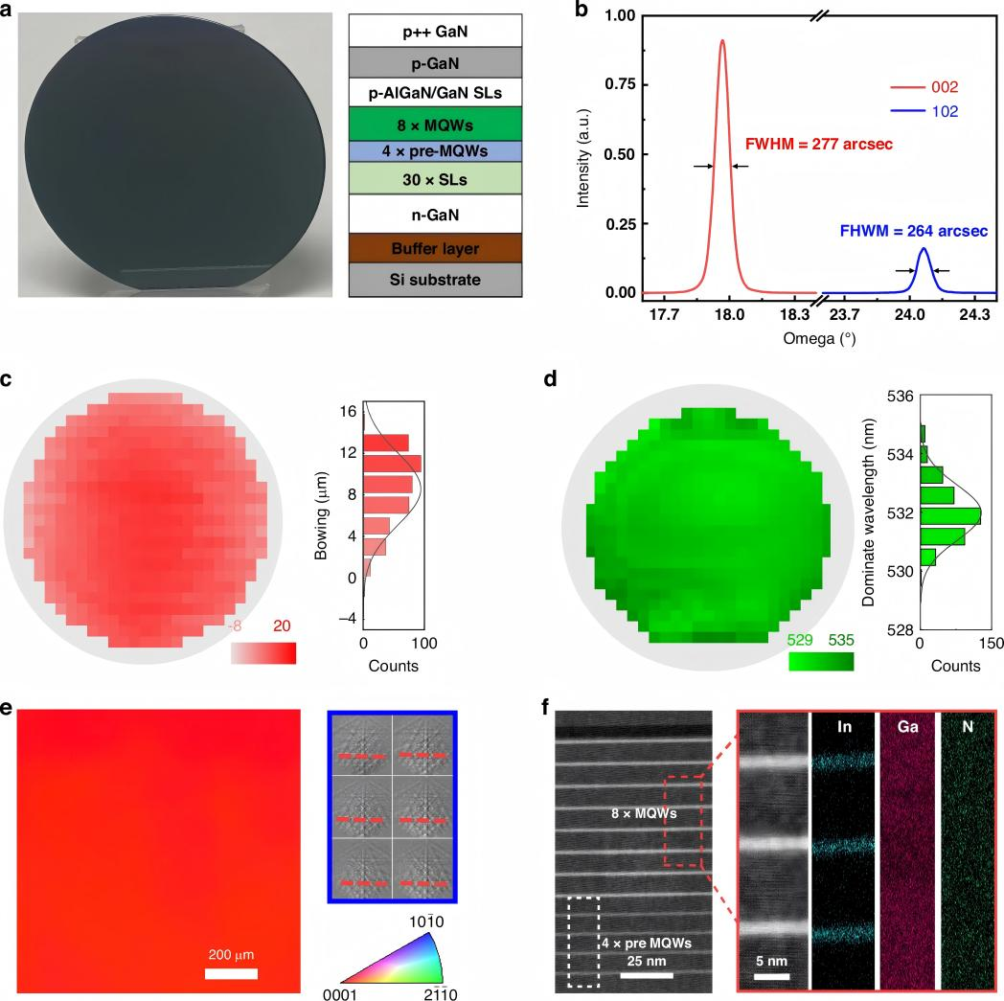
Figure 2 (a) Typical photograph of a 4-inch Si-based epitaxial wafer, where the epitaxial structure is shown on the right side. (b) High-resolution X-ray diffraction pattern of the epilayer grown on a Si (111) substrate, where the FWHM values of the rocking curves corresponding to (002) and (102) are measured to be 277 arcsec and 264 arcsec, respectively. (c) Mapping of the wafer bowing condition, which indicates convex bowing of 16.7 μm. (d) Wafer mapping of the dominant wavelength on the epilayer. € EBSD IPF mapping and EBSP of the epilayer across a 1×1 mm area. (f) High-resolution transmission electron microscope (HRTEM) image and element distribution of the GaN/InGaN MQW [9].
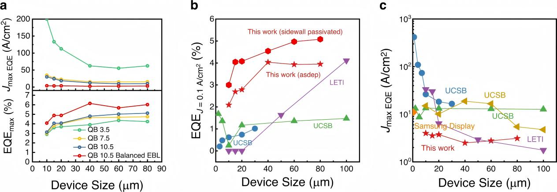
Figure 3 Summary and benchmark of the different epitaxy structures and state-of-the-art blue μLED devices.
a Comparison of maximum external quantum efficiency (EQE) and Jmax EQE of QB 3.5, QB 7.5, QB 10.5, and QB 10.5 Balanced EBL. Benchmark of b EQE at J = 0.1 A/cm² and c Jmax EQE for state-of-the-art blue μLED devices as a function of pitch size. (UCSB in blue4, UCSB in green5, UCSB in ocher7, LETI6, Samsung Display35). [3].

Device Structure Optimization for InGaN LEDs

Polarisation Field and Recombination Efficiency
In InGaN-based LED devices, due to the polar c-face epitaxial growth of GaN and InGaN, strong piezoelectric and spontaneous polarisation fields are generated at high In concentrations. This causes the quantum well band structure to tilt and separates electrons and holes spatially, thereby significantly reducing the radiative recombination probability. This phenomenon is known as the quantum-confined Stark effect (QCSE) and is a major cause of reduced internal quantum efficiency in green and red LEDs [2].
Researchers have proposed various structural modulation strategies to mitigate the reduction in recombination efficiency caused by polarisation fields. Pan et al. designed a localised trench stress-induced structure by introducing specific defects on the quantum well growth surface [7]. This altered the local stress distribution and regulated the direction and intensity of the polarisation field, effectively suppressing the QCSE. This strategy modulates the polarisation field through surface structure control, significantly enhancing light emission in high-in-doped red LEDs.
Additionally, Armitage et al. employed InGaN quantum wells grown in a semi-polar epitaxial direction, successfully weakening the influence of the polarization field on the quantum well band structure [10]. This increased the electron-hole wave function overlap, significantly improving the long-wavelength light-emitting efficiency. Non-polar and semi-polar epitaxial directions are considered the fundamental pathways to eliminate the polarization field; however, they currently face challenges such as high device defect density and complex epitaxial techniques.
In the traditional polar epitaxial growth path, some studies have attempted to introduce AlGaN potential barrier layers or strain-relief buffer layers to partially compensate for the polarisation field partially, thereby enhancing the quantum well radiative recombination rate [2]. Although such structures have achieved short-term success, they also introduce band discontinuities and new non-radiative recombination interfaces, requiring careful balancing.

Carrier injection efficiency and electron leakage
In InGaN LEDs, carrier injection efficiency (CIE) is one of the key factors affecting light-emitting efficiency. Under high current densities, the imbalance between electron and hole injection often leads to a significant number of electrons overflowing the active region, reducing radiative recombination efficiency and causing additional thermal losses and device degradation [6]. Additionally, quantum wells with high In content are more prone to mismatches between excessive electron injection and insufficient hole availability, further exacerbating efficiency degradation in the Green Gap region [7].
Researchers have addressed both the barrier and carrier injection layers to improve carrier injection efficiency. On one hand, Wu et al. introduced an AlGaN tunnelling layer in an InGaN/GaN multi-quantum well structure, successfully regulating the band alignment relationship and significantly enhancing the electron-hole recombination probability [9]. This structure suppresses electron leakage while improving quantum efficiency, with particularly notable enhancements in the green and red-light regions.
On the other hand, Liu et al. proposed using an AlGaN buffer layer to optimise the conductivity of the p-type region, thereby reducing the hole injection barrier [12]. By reasonably setting the Al composition and doping concentration, this strategy maintained a high external quantum efficiency even at high injection currents, demonstrating that barrier design and p-region modification can synergistically enhance the CIE.
Electron leakage is another major bottleneck, manifested as high-energy electrons crossing the active region and recombining in the p-type region or on the device surface to generate heat. Lee et al. employed a semi-polar GaN epitaxial structure to weaken the polarisation field, significantly reducing carrier leakage [4]. Additionally, nanostructures have been proven to effectively collect electrons, mitigate leakage current, and enhance light output [10].
Although these strategies have achieved significant improvements in carrier injection and leakage, their stability and durability under high current density and high In composition conditions remain to be verified. How to combine material modification and structural regulation to ensure that devices maintain high CIE and avoid severe heat accumulation under high-power modes remains a challenging problem for future research.

Micro-LED Structural Challenges and Structural Countermeasures for Device Miniaturisation
In micro-LEDs and other miniaturised devices, the lateral dimension reduction significantly exacerbates the effects of non-radiative recombination and thermal accumulation. Defect states caused by sidewall etching become the primary dissipation channels for carrier excitation, leading to size-dependent efficiency decay. Especially under high-excitation conditions, coupling structural stress and thermal effects significantly limits device stability and excitation density.
Baek et al. proposed a 'low stress–low power' synergistic structural design approach tailored for miniaturised devices to address these issues. Based on a multi-group InGaN/GaN MQW structure with varying quantum well barrier thicknesses, they achieved optimised external quantum efficiency (EQE) ranging from 17.6% to 25.4% in a 30-μm-sized blue Micro-LED [3]. The device maintains high luminous efficiency even at a low current density of 0.1 A/cm², and the EQE peak is delayed with increasing QB design, validating the structure's ability to mitigate thermal degradation under conditions of enhanced excitation density.
This study demonstrates that by combining structural stress regulation with a matching driving strategy, the opening of non-radiative pathways induced by thermal excitation can be effectively delayed, thereby enhancing the light-emitting stability of small-sized devices. Although the current strategy has achieved initial breakthroughs in blue Micro-LEDs, the band asymmetry and light extraction channel construction in high-indium-content structures remain technical challenges for further efficiency improvements.

Stress regulation and structural reliability enhancement pathways
In high-indium InGaN structures, lattice mismatch and differences in thermal expansion coefficients lead to strain accumulation and crack propagation during growth and operation, significantly affecting structural stability and reliability. Stress control has become one of the key strategies for improving device integration and optoelectronic performance.
Mouloua et al. developed a stress-release structure based on an InGaN/GaN superlattice buffer, alternately introducing strain-modulating layers on an initial AlN buffer layer to achieve layer-by-layer stress relief of the In component [4]. XRD measurements showed (002)/(102) crystal plane reflection half-widths of 277 and 264 arcsec, indicating that the structure significantly reduced dislocation density while maintaining crystal orientation consistency. Transmission electron microscopy images showed that the superlattice interface effectively blocked screw dislocation migration pathways, enhancing overall structural integrity. The device exhibited excellent photoluminescence intensity and epitaxial uniformity in green light emission.
Synergistic structural strategies such as periodic buffering and lateral growth have significantly improved stress mitigation and device reliability. However, balancing the stability of the In component, interface flatness, and stress control consistency remains a significant challenge in long-wavelength structure design.
Structural Optimization Summary and Future Prospects
Structural optimisation of InGaN-based LED devices has evolved from initial single-point performance improvements to a systematic design process targeting multi-physics fields, multi-dimensional interfaces, and multi-scale coordination. Previous studies have proposed targeted structural control strategies to address issues such as electron-hole separation induced by polarisation fields, carrier injection imbalance, sidewall defects caused by device scaling, and stress-induced structural damage. These approaches have improved device quantum efficiency, uniformity, and stability, and also driven breakthroughs in high-indium-content long-wavelength InGaN structures for green gap applications.
However, as LED devices evolve toward higher integration, miniaturisation, and improved wavelength stability, existing structural strategies still face significant bottlenecks in balancing electro-optical performance, thermal stability, and process compatibility. The process complexity, interface mismatch, and structural non-uniformity issues arising from multi-strategy synergistic optimisation have become core obstacles to mass production and consistency.
The core trend in future structural optimisation will focus on multifunctional integrated structure design, such as introducing quantum confinement effects through low-dimensional materials, constructing composite barrier structures to achieve tunable band gaps, and integrating mechanisms such as lateral epitaxy, growth stress self-regulation, and asymmetric stress release. This will establish a steady-state coupling relationship between composite efficiency, structural reliability, and large-area uniformity, providing a structural foundation for next-generation high-performance InGaN light-emitting devices.

References
- X. Zhao, Z. Jiang, T. Liu, X. Tang, C. Wang, Y. Huang, and Z. Liu, Adv. Photonics Res. 4, 2300061 (2023).
- C. Zhao, C. W. Tang, B. Lai, G. Cheng, J. Wang, and K. M. Lau, Photon. Res. 8, 750–754 (2020).
- W. J. Baek, J. Park, J. Shim, B. H. Kim, S. Park, H. S. Kim, and K.-H. Lee, Nat. Commun. 14, 1386 (2023).
- D. Mouloua, M. Martin, M. Beruete, C. Jany, K. Hassan, and T. Baron, Adv. Opt. Mater. 13, 2402777 (2024).
- Z. Pan, Z. Chen, H. Zhang, H. Yang, C. Deng, B. Dong, and J. Kang, Adv. Funct. Mater. 34, 2315781 (2024).
- Z. Liu, Y. Lu, H. Cao, G. I. M. Garcia, T. Liu, X. Tang, and Y. Zhang, Light Sci. Appl. 13, 117 (2024).
- Z. Liu, H. Cao, X. Tang, T. Liu, Y. Lu, Z. Jiang, and Y. Zhang, Light Sci. Appl. 14, 64 (2025).
- D.-G. Lee, Y. Choi, S. Jung, Y. Kim, S. Park, P. J. Choi, and S. Yoon, Appl. Phys. Lett. 124, 121109 (2024).
- H. Wu, X. Lin, Q. Shuai, Y. Zhu, A. Pan, Q. Zhang, and Y. Zhang, Light Sci. Appl. 13, 117 (2024).
- J. Jeong, Q. Wang, J. Cha, D. K. Jin, D. H. Shin, S. Kwon, and Y. J. Hong, Sci. Adv. 6, eaaz5180 (2020).
- V. Veeramuthu, S.-U. Kim, S.-W. Lee, J.-Y. Lee, D.-H. Ko, S. Jeong, and K.-H. Lee, Nat. Sci. Rev. 12, nwae306 (2024).
- R. Armitage, Z. Ren, M. Holmes, and J. Flemish, Phys. Status Solidi RRL 18, 2400012 (2024).

