Enhancing the Structural Integrity of Skin-frame Structures via Composite Materials Solutions
Siqi Zhang
Department of Physics, Shantou University, Shantou, 515063, China
22sqzhang@stu.edu.cn
Abstract. The process of additive production, also known as 3d printing, facilitates the creation of tangible objects that begin with digital design. In this technique, objects are constructed by depositing successive layers of material. In recent years, due to the convenience and customizability of 3d printing, more and more people have begun to use this technology. However, due to the need to completely fill the inside of the object in the conventional 3d printing so that the printed object can achieve the desired effect, how to maintain the physical properties of the object in the printing process while reducing material consumption has become an important problem. In the past, some experts have proposed an automated solution to design skin frame structures with the aim of reducing the material cost of printing a given 3D object. The frame structure is designed with an optimized scheme, which greatly reduces the material volume and ensures physical stability, geometric approximation and printability. In this paper, a method to optimize the integrity of the internal frame structure by comparing the mechanical properties of composite materials with those of commonly used printing materials is studied.

Introduction
With the increasing complexity of modern manufacturing, 3D printing technology has been widely used in biology, medicine, industrial manufacturing, construction, military and other fields [1]. The development of 3D printing technology has now emerged a lot of excellent structural design, of which Skin-Frame Structure is a more common structure, it is a composite structure by creating a lightweight Frame Structure to "hollow " the object, the structure consists of node grid and thin cylindrical pillars, the object has large voids inside[2]. With its excellent flexural, shear and torsional properties, this structure has been widely used in aerospace, automobile manufacturing and construction engineering. However, in 3D-printed skin structures, thermoplastic polymer materials are commonly used, which may result in the material strength not meeting the requirements, causing structural wear or breakage. Therefore, it is necessary to find a material that can meet the requirements for replacement.
Recently, numerous studies have explored the manufacturing methods and performance characteristics of fiber-reinforced thermoplastic composites, primarily focusing on traditional fabrication techniques such as thermoplastic prepreg tape placement, injection molding, and related processes[3]. These studies explore the possibility of using Continuous fiber reinforced polymer composites(CFRPCs) as new materials to replace common thermoplastic materials, thereby enhancing the strength of object structures. Continuous fiber reinforced polymer composites are advanced materials that use continuous fibers as reinforcement and a resin polymer as the matrix. Known for their lightweight nature, high strength, resistance to high temperatures, and corrosion resistance, these composites are extensively applied in industries such as aerospace, automotive, and healthcare[4]. However, since CFRPCs is relatively expensive, this article will explore a method that can take advantage of its high strength while maintaining a certain economy.

Current study
A systematic literature search was conducted in the Web of Science database using the topics "Continuous fiber reinforced polymer composites" and "3D printing" to identify publications from 2015 to 2023. Following a rigorous screening process involving duplicate removal, exclusion of conference abstracts, and elimination of irrelevant documents, 327 pertinent articles were ultimately selected. These publications demonstrated significant academic impact with a total citation count of 10,119 after excluding self-citations [5]. From the data presented above, it can be observed that since the year 2015, composite materials have emerged as a critical approach to enhancing the performance of 3D-printed structures. Due to their exceptional strength, low weight, and resistance to corrosion, carbon fiber-reinforced polymer (CFRP) composites provide design engineers with enhanced performance and greater durability. Their superior strength-to-weight ratio and low maintenance demands have enabled widespread adoption across engineering fields, progressively replacing metals in industries such as manufacturing, sports, and transportation [3]. Carbon fiber-reinforced polymer composites primarily consist of two components: a resin matrix and continuous fiber reinforcement. The resin matrix, characterized by its relatively low strength and modulus but high toughness, serves to distribute loads and protect the reinforcement material from corrosion, degradation, and wear. Continuous fiber reinforcement, typically composed of glass, carbon, or Kevlar fibers, significantly enhances the mechanical properties and stability of 3D-printed components, as shown in table 1 [5]. Meanwhile, some experts used carbon fiber as the reinforcement phase and ABS as the matrix to study its mechanism and performance [6]. The flexural strength and modulus of the printed composite sample were approximately 127MPa and 7.72GPa, which are almost six times that of the traditional FDM ABS sample and three times that of the injection molded sample. The most compelling evidence for the widespread adoption of this technology is its capability to produce intricate designs with minimal processing steps and to flexibly create reinforcements as required [7].
TABLE 1.Types of CFPRCs 3D Printing Materials and Physical Properties [5]
Materials |  | Characteristics
 |  | Density (g/cm²) | Diameter (μm) | Tensile modulus (GPa) | Bending Modulus (GPa)
Resin Matrix | PLA | 1.26 | 1750 | 2.25 | 2.39
Resin Matrix | ABS | 1.04 | 1750 | 1.0 | 2.4
Resin Matrix | PA | 1.10 | 1750 | 2.2 | 0.84
Resin Matrix | PEEK | 1.30 | 1750 | 3.7 | 3.6
Continuous fiber reinforcement | Continuous carbon fiber(CF) | 1.4/1.3 | 400 | 54 | 51
Continuous fiber reinforcement | Glass fiber(GF) | 2.4 | 300 | 21 | 22
Continuous fiber reinforcement | Kevlar fiber(KF) | 1.2 | 300 | 27 | 26
Continuous fiber reinforcement | Kevlar fiber(KF) | 1.5 | 200 | 27,4 | -

In studies on Skin-Frame Structures, readily available polymer materials such as PLA, ABS, and PETG are typically employed [2]. However, these polymers exhibit notable deficiencies when subjected to local stress concentrations and fatigue damage, indicating the need for alternative materials to enhance structural performance. As demonstrated in 1, there are significant discrepancies between these polymers and fiber-based materials regarding tensile and bending modulus. By integrating the two—combining polymers with fibers—and subsequently utilizing 3D printing techniques, it is possible to mitigate these issues to a considerable extent. Moreover, leveraging fiber tension during the fabrication process can enable support-free printing [8], thereby reducing material consumption and optimizing the overall design. However, this multi-material 3D printing method still has some difficulties. Researchers have consistently regarded the diminished adhesion at the junction of materials with differing chemical and physical characteristics as a key concern [9]. Therefore, this article provides the following methods to test the influence of defects between material surfaces on the overall structural strength.

Properties analysis of composite materials

Performance Testing of Materials
By conducting a series of experiments on the mechanical properties of polymer materials commonly used in 3D printing and materials formed by polymer materials, it is proven that the composite material has good advantages in mechanical properties. In the control of experimental variables, four different printing methods were selected to verify the performance difference between the three products. Plan A is to use a single nozzle to print material 1; Plan B is to use a single nozzle to print material 2; Plan C is to use a multi-nozzle to print material 1 + material 2 horizontally and Plan D is to use a multi-nozzle to print Material 1 + Material 2 vertically.
Material selection:
ABS is a thermoplastic material made of Acrylonitrile, Butadiene and Styrene, which has the characteristics of high temperature resistance, high strength and good toughness. In the 3D printing process, ABS prints are prone to shrinkage when cooled, resulting in warping deformation
CFPR refers to Carbon Fiber Reinforced Polymer and it consists of carbon fiber and ABS thermoplastic matrix.
The mechanical properties of composites and single materials are measured and compared by means of stretching and compression.
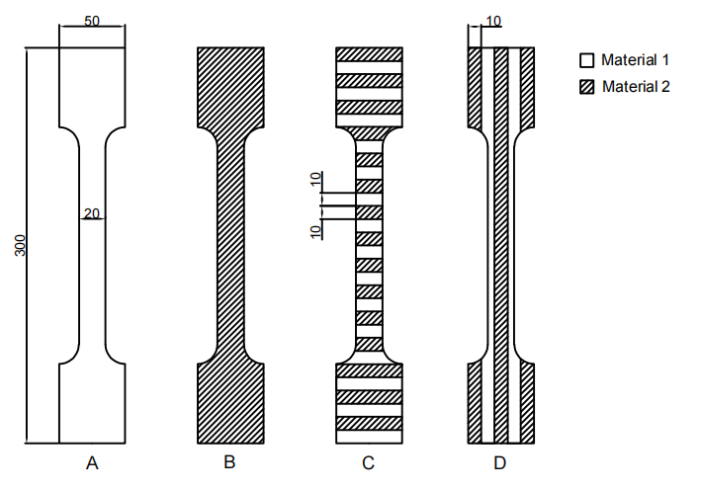
FIGURE 1.Tensile test
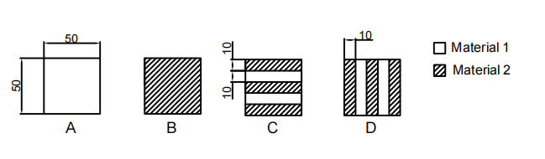
FIGURE 1.Compression Test(Picture credit : Original )

The products obtained by using composite materials showed better tensile and compressive properties than polymer materials; However, the product obtained by using the C method is better than the Polymer material but worse than the composite material. The reduction in properties, particularly tensile strength, is primarily attributed to the interfacial boundary created during the switching of active extrusion heads. This interface introduces greater discontinuity in the specimen compared to the inherent filament-to-filament interfaces formed between adjacent extrusion paths [10]. No significant differences in elastic modulus or hardness were observed between areas near the interface and those farther away, indicating that the macroscopic anisotropy likely arises from defects and imperfections at the boundaries [11]. However, because continuous fiber reinforced materials are relatively expensive, we can take advantage of the advantages of composite materials by linking the two materials in a certain relationship within the part, while improving the economy. The most talked-about topic when discussing the qualities obtained with manufactured parts is the weakness created at the interface bonding between materials during the manufacturing process. The fact that the two materials have different affinities contributes to this issue by lowering performance at the boundary interface. However, in this paper, ABS materials and CFPR materials are used, in which CFPR is a composite material made of ABS as one of the materials, which can improve the affinity between the two materials to a certain extent, thereby reducing the impact of the boundary interface on the overall performance.

Performance Testing of Composite Materials in Skin-Frame Structures
In order to verify that CFPR can achieve effects similar to those observed in the aforementioned experiments (Figure 1 and Figure 2) within Skin-Frame Structures, three distinct Frame Structures were designed for experimentation, as illustrated in Figure 2. Structures A, B, and C are respectively composed of unit cells D (Body-Centered Cubic), E (Diamond), and F (Face-Centered Cubic).
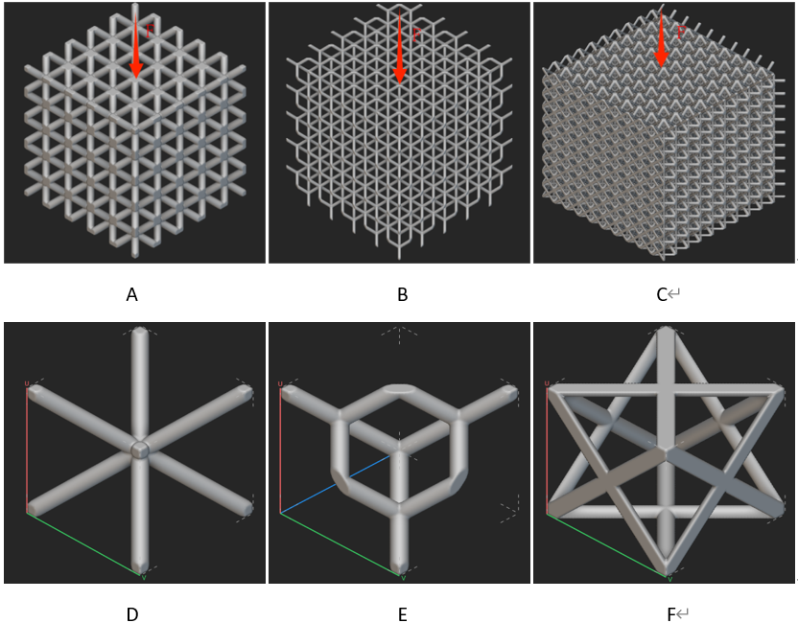
FIGURE 2.Common Skin-Frame Structures and their Unit Cell(Picture credit : Original )
Specific experimental steps：
Initially, the three structures were printed using ABS material, and a specified downward pressure was applied to their top surfaces during simulation experiments to identify regions with relatively concentrated deformation or stress. Subsequently, a multi-nozzle printing technique was employed to replace the ABS material in these critical areas with high-strength CFPR material, thereby achieving localized reinforcement effects. As shown in figure 3, the use of different materials in diamond structure, the white and black lines represent two different materials. By changing the distribution positions of the materials, the purpose of enhancing the structural performance can be achieved.
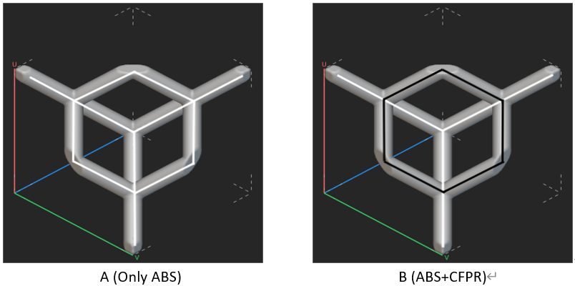
FIGURE 3.The Use of Different Materials in Diamond Structure(Picture credit : Original )
By integrating material optimization strategies into the 3D printing process, designers can tailor the internal structure of components to strengthen high-stress zones while reducing unnecessary material in low-stress areas. This not only leads to lighter and stronger parts but also maximizes material efficiency and reduces production costs. In practical applications, such as in the biomedical industries, this approach enables the creation of complex, high-performance frame structures that would be difficult or impossible to manufacture using traditional techniques. As a result, it paves the way for more sustainable, customizable, and high-integrity structural designs.
In addition, ultrasonic can also be used to improve the print quality. This approach can facilitate better impregnation of the polymer into the fiber bundle and strengthen the interfacial bonding between them. To achieve this, ultrasonic transducers may be mounted onto the printing platform to generate vibrations, which help minimize the staircase effect and enhance surface quality. A key benefit of using ultrasound is that it induces no chemical reactions throughout the process[12]. Therefore, research related to ultrasound therapy can be encouraged to continue to improve the mechanical properties of continuous fiber-reinforced composites in 3D printing.

CONCLUSION
Overall, using the composite material approach described in this paper can significantly improve the overall performance of printed objects. By optimizing the combination and distribution of materials, not only the strength and durability of the structure be improved, but also the deformation resistance and stability can be improved. In addition, the rational application of composite materials helps to optimize the balance of weight and performance, making printed objects more efficient and economical while meeting specific needs. Therefore, in the field of additive manufacturing, the reasonable selection and use of composite materials is of great significance to improve the quality and performance of the final product. As the technology matures, the synergy between material science and additive manufacturing will play a pivotal role in shaping the next generation of engineering innovations.

References
- . Kaur, R. Teharia, M. J. Akhtar, et al., 3D printing: a review of material, properties and application, Adv. Manuf. Ind. Eng. 2, 555–563 (2021).
- W. Wang, T. Y. Wang, Z. Yang, et al., Cost-effective printing of 3D objects with skin-frame structures, ACM Trans. Graph. 32(6), 1–10 (2013).
- X. Tian, T. Liu, Q. Wang, et al., Recycling and remanufacturing of 3D printed continuous carbon fiber reinforced PLA composites, J. Clean. Prod. 142, 1609–1618 (2017).
- N. Van de Werken, H. Tekinalp, P. Khanbolouki, et al., Additively manufactured carbon fiber-reinforced composites: State of the art and perspective, Addit. Manuf. 31, 100962 (2020).
- W. Su, B. Qian, J. Mao, et al., Research progress on 3D printing process of continuous fiber reinforced polymer composites, Aviat. Manuf. Technol. 68(Z1), 117–129+136 (2025).
- C. Yang, X. Tian, T. Liu, et al., 3D printing for continuous fiber reinforced thermoplastic composites: mechanism and performance, Rapid Prototyp. J. 23(1), 209–215 (2017).
- S. M. F. Kabir, K. Mathur, A. F. M. Seyam, A critical review on 3D printed continuous fiber-reinforced composites: History, mechanism, materials and properties, Compos. Struct. 232, 111476 (2020).
- K. Sugiyama, R. Matsuzaki, M. Ueda, et al., 3D printing of composite sandwich structures using continuous carbon fiber and fiber tension, Compos. Part A: Appl. Sci. Manuf. 113, 114–121 (2018).
- J. Yin, C. Lu, J. Fu, et al., Interfacial bonding during multi-material fused deposition modeling (FDM) process due to inter-molecular diffusion, Mater. Des. 150, 104–112 (2018).
- L. R. Lopes, A. F. Silva, O. S. Carneiro, Multi-material 3D printing: The relevance of materials affinity on the boundary interface performance, Addit. Manuf. 23, 45–52 (2018).
- J. Mueller, D. Courty, M. Spielhofer, et al., Mechanical properties of interfaces in inkjet 3D printed single-and multi-material parts, 3D Print. Addit. Manuf. 4(4), 193–199 (2017).
- S. Wickramasinghe, T. Do, P. Tran, FDM-based 3D printing of polymer and associated composite: A review on mechanical properties, defects and treatments, Polymers 12(7), 1529 (2020).

