Preface: International Conference “Advanced Mechanics: Structure, Materials, Tribology”, Samarkand 2025

The International Conference “Advanced Mechanics: Structure, Materials, Tribology” was held on 22–26 September 2025 in Samarkand. The conference constituted the third event in this ongoing international conference series jointly organized by Technische Universität Berlin and Samarkand State University. Building on the successful conferences conducted in 2023 and 2024, the 2025 meeting further consolidated this series as a stable platform for international scientific exchange in the fields of mechanics, materials science, and tribology.
The conference series formed part of a broader initiative aimed at fostering international academic cooperation in Samarkand, developed under the auspices of the Center of Advanced Studies in Mechanics, Tribology, Bio- and Nanotechnologies at Samarkand State University. The selection of Samarkand as the venue reflected both its historical significance and its contemporary role as a rapidly developing center of science and education. Historically situated along the ancient Silk Road, Samarkand has long served as a link between Europe and Asia, a role that is increasingly renewed in the context of modern international scientific collaboration.
The conference was devoted to interdisciplinary research on technical and biological systems, with particular emphasis on the interplay between mechanical behavior, material properties, and tribological processes. Contributions addressed fundamental and applied aspects of solid mechanics, materials science, contact mechanics, and tribology. Analytical, numerical, and experimental approaches were all represented. The primary objective of the conference was to review recent scientific developments, exchange research results, and identify key challenges and directions for future research.
The scientific program of the 2025 Conference covered the following main areas:
- Contact mechanics and tribology
- The Mechanics of Aerospace Materials
- Mechanics of deformable solids
- Materials science
- Computational methods in mechanics
- Vibrations and vibration protection of mechanical systems
- Soil mechanics and geomechanics

The program included keynote and invited lectures delivered by internationally recognized experts, as well as contributed oral and poster presentations. The conference provided a forum for intensive scientific discussion and facilitated direct interaction between senior researchers and early-career scientists, thereby contributing to the development of new international collaborations and research initiatives.
In addition to the scientific sessions, the conference program was complemented by laboratory visits and cultural activities. These events supported informal scientific exchange and reflected the long-standing tradition that productive scientific cooperation is fostered not only through formal presentations but also through personal interaction and discussion.
The International Conference “Advanced Mechanics: Structure, Materials, Tribology” 2025 brought together participants from more than 25 countries, representing Europe, Asia, Africa, and the Americas. This broad international participation underscored the global and interdisciplinary character of contemporary research in mechanics, materials science, and tribology.
The organizers express their sincere appreciation to all authors and participants whose contributions made the conference scientifically successful. Special thanks are extended to Samarkand State University for its excellent organizational support and hospitality. It is hoped that the results presented in these proceedings will contribute to further advances in the field and stimulate continued international cooperation.
More than 150 participants presented their work at the 2025 conference. Participants of this conference series came from Algeria, Armenia, Belarus, Bulgaria, China, Croatia, Denmark, Finland, France, Germany, India, Israel, Italy, Japan, Kazakhstan, Poland, Russia, Slovenia, Spain, Switzerland, Taiwan, Turkey, United Kingdom, United States, Uzbekistan.

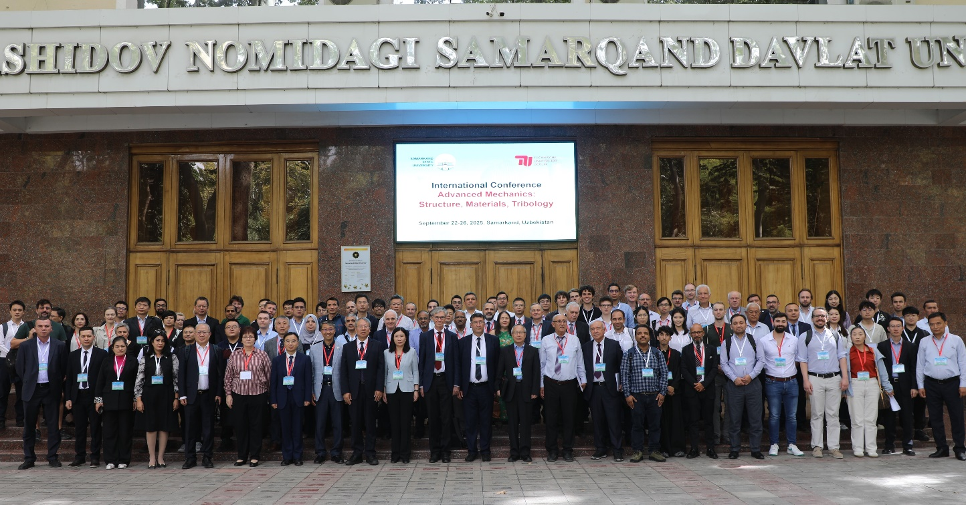
Participants of the International Conference “Advanced Mechanics: Structure, Materials, Tribology” 2025

Prof. Dr. Valentin L. Popov
Dr.-Ing. Jasminka Starcevic
Editors

