Research on Testing Method and Evaluation Framework for Multiscale Surface Quality of Honeycomb Composites
Wenjun Cao^{1,2}, Jinlei Liu³, Yiying Liang³, Xinman Yuan¹, Jie Xu³, Qizhong Yue³ and Feng Feng^{3, a)}
¹ AVIC Chengdu Aircraft Industrial (Group) Co., Ltd., Chengdu 610073, China
² School of Mechanical Engineering, Xi'an Jiaotong University, Xi'an 710049, China
³ Division of Intelligent Instrument and Equipment, Shenzhen International Graduate School, Tsinghua University, Shenzhen 518055, China

a) Corresponding author: feng.feng@sz.tsinghua.edu.cn
Abstract. Nomex honeycomb composites (NHCs) are extensively employed as core materials in aerospace sandwich structures owing to their exceptional specific strength and stiffness. However, the thin-walled hexagonal cellular architecture renders NHCs susceptible to machining-induced defects including burr formation, cell wall crushing, and geometric distortion, which compromise structural integrity and interfacial bonding performance. Accurate defect characterization is essential for quality assurance, yet remains challenging due to the multi-scale nature of damage manifestation: microscale burrs often elude detection, mesoscale damage patterns lack distinctive morphological signatures, while macroscale surfaces exhibit large dimensions and curvature that impede comprehensive evaluation. Conventional inspection methodologies are constrained to single-scale measurements, precluding integrated defect assessment across length scales. This study presents an integrated cross-scale measurement platform capable of acquiring high-resolution RGB-D data spanning micro-, meso-, and macroscales without hardware reconfiguration. A systematic multi-scale defect classification and quantitative evaluation framework is developed, encompassing diverse defect typologies and scale-specific metrics. Customized algorithms are formulated to automatically and robustly extract geometric features from the discontinuous, curved, thin-walled topology characteristic of NHCs. Experimental validation demonstrates superior measurement precision and computational efficiency, establishing a scalable quality assessment methodology applicable to NHCs and analogous discontinuous composite structures in engineering practice.

Introduction
Nomex honeycomb composites (NHCs) are lightweight cellular materials characterized by hexagonal cell configurations that emulate the geometric architecture of natural honeycombs [1-3]. The inherent discontinuous thin-walled topology [4-6] imparts exceptional mass efficiency and structural rigidity, resulting in superior specific strength and stiffness relative to conventional metallic alloys [7,8]. Beyond mechanical advantages, NHCs exhibit remarkable thermal insulation, flame retardancy, and dielectric properties [9], rendering them attractive for high-performance applications in aerospace, rail transportation, and civil infrastructure [10]. In structural assemblies, NHCs predominantly serve as core materials in sandwich configurations, bonded between composite or metallic facesheets [11-13]. However, the combination of thin cell walls (typically 50-100 μm) and limited out-of-plane stiffness renders NHCs susceptible to machining-induced defects including burr formation, cell wall tearing, crushing, and geometric distortion. Such defects can propagate along facesheet-core interfaces under service loads, precipitating premature structural failure [12]. Current inspection methodologies predominantly rely on manual assessment or single-scale measurement equipment [14], which prove inadequate for capturing the multi-scale nature of machining damage due to constrained resolution, limited field-of-view, and labor-intensive procedures. Consequently, there exists a critical need for integrated high-precision multi-scale measurement techniques capable of comprehensive defect characterization in discontinuous thin-walled structures.
Recent investigations have advanced the understanding of defect formation mechanisms and quality assessment protocols for machined NHCs, yet standardized defect taxonomies and quantitative evaluation frameworks remain underdeveloped. Wang et al. [15] elucidated the influence of tool rake angle on residual wall height and tearing defects through combined experimental and analytical modeling approaches. Jiang et al. [16] characterized the relationship between cutting force components and tool entry angle, proposing entry angle optimization strategies to mitigate tearing through finite element simulations. Building upon this foundation, Liu et al. [17] identified cutting width as a critical parameter governing tear propagation, establishing quantitative correlations between process variables and surface integrity. Microscopic examination by Zhang et al. [18] revealed cell wall deformation patterns aligned with tool feed direction, culminating in fracture-type defects. They proposed resin debonding area as a quantitative metric for adhesive failure assessment. Xu et al. [19-21] developed surface integrity evaluation methodologies incorporating subsurface damage depth and geometric complexity indices. However, these metrics necessitate manual measurement and statistical analysis, limiting their applicability to localized regions while lacking objectivity for comprehensive quality assessment.
Existing measurement paradigms typically employ disparate instrumentation across observation scales, hindering integrated defect characterization. Jaafar et al. [22] classified three distinct fiber tearing modes at the microscale using optical microscopy and scanning electron microscopy (SEM). For macroscale quantification, they employed white light interferometry with least-squares plane fitting for defect indexing. Nevertheless, the restricted measurement range and limited defect-type discrimination compromise its utility for large-area NHCs inspection. Jiang et al. [23] developed a fringe projection profilometry system for macroscopic three-dimensional defect visualization, optimizing projector-camera geometry to suppress spurious data and reconstruct high-fidelity surfaces in non-cellular regions. Qin et al. [24] introduced a hybrid strategy integrating burr classification with dimensionality reduction and iterative regression to eliminate extraneous burr artifacts, enhancing point cloud quality and geometric fidelity.
Despite substantial progress in NHC machining quality assessment, standardized evaluation protocols remain conspicuously absent compared to established practices for continuous fiber composites. This deficiency stems from two fundamental challenges. First, current evaluation methodologies are constrained by scale-dependent measurement modalities. Conventional approaches rely on single-scale optical techniques, whereas NHC machining defects manifest across multiple length scales—from microscopic fiber fracture (10-100 μm) to macroscopic geometric deviation (1-10 mm)—each relevant to distinct performance criteria. Furthermore, prevailing analysis procedures depend on manual inspection and statistical computation, resulting in low efficiency, operator-dependent variability, and impracticality for production-scale implementation. Second, unified defect classification schemes and objective evaluation criteria are lacking. Defect morphology and severity exhibit strong dependencies on material properties (cell size, wall thickness, resin content) and process parameters (cutting speed, tool geometry, feed rate), yet no consensus taxonomy exists for systematic categorization. Additionally, many employed metrics are qualitative or semi-quantitative, lacking sufficient sensitivity and reproducibility for reliable discrimination of surface conditions.
To address these critical gaps, this study establishes an integrated multi-scale measurement framework for comprehensive surface characterization of machined NHCs. A systematic methodology for quantitative quality assessment spanning micro-, meso-, and macroscales is developed. Scale-appropriate evaluation metrics are identified, and corresponding algorithmic implementations are formulated to enable objective, reproducible multi-scale quality evaluation of NHC structures. The proposed framework aims to provide a foundation for standardized quality assurance protocols in NHC manufacturing.

EXPERIMENT
This article focuses on the problem of surface data acquisition for NHCs and builds a non-contact 3D optical measurement system based on a three-coordinate displacement platform. The platform is shown in Figure 1. The system consists of a three-degree-of-freedom displacement platform and a high-resolution imaging module, which can obtain the three-dimensional morphology information of the measured surface through the combination of active projection and visual measurement. The imaging module can capture images containing depth information, while the displacement platform enables multi-position scanning. By combining the two, multi-scale analysis of the surface quality of honeycomb materials can be conducted. This system can be used for evaluating honeycomb images at a scale of 0.01 mm to 0.7 m.
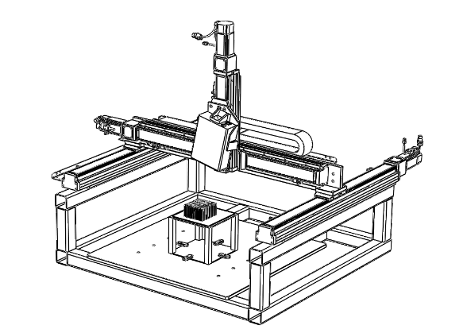
FIGURE 1. Non-contact 3D optical measurement platform for three coordinate displacement platform.

Figure 2 shows the measurement effectiveness. Three different features of honeycomb surfaces were selected for detection and reconstruction. The results indicate that the system can relatively fully restore the detailed features of ideal surfaces and accurately capture the morphological changes of surface damaged areas, verifying its applicability in surface data acquisition of NHCs.

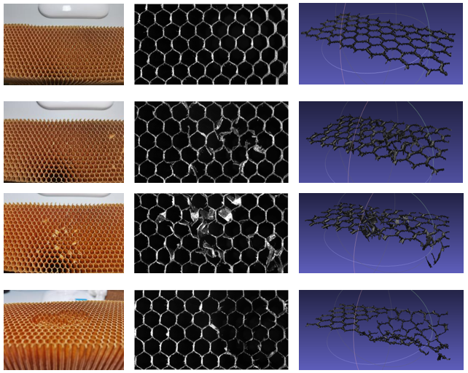
(b)
(a)
(c)
FIGURE 2. The reconstruction effect of the platform (a) ideal surface, (b) slightly defective surface, (c) severely defective surface.

Multi-scale Measurements for surface quality

Micro-scale Measurement
The main defect form on the surface of Nomex honeycomb material in a small-scale range is burrs, as shown in Figure 3. When there are fewer burrs, the contour of the wall can be found to be smooth; When there are many burrs, the contour of the wall is tortuous and complex. However, this intuitive feeling can only be used for qualitative analysis, and there is an urgent need to propose a fast and accurate quantitative evaluation method. In order to solve the quantitative evaluation problem of burr features, this article uses the geometric complexity index to evaluate: the smaller the value, the smoother and straighter the curve; The larger the value, the more tortuous and complex the curve will be.

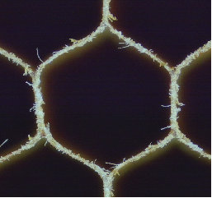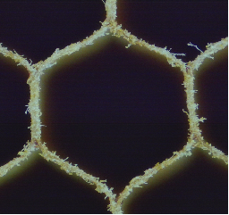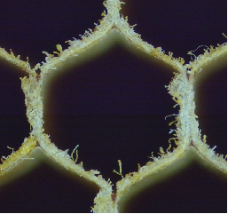
FIGURE 3. Burrs of different severity levels (a) fewer burrs (b) moderate burrs (c) more burrs.

Using this platform, according to the increasing severity of burrs, a total of 5 images of the surface of Nomex honeycomb material were taken, and then the local contours were extracted. The calculation results of the geometric complexity index of these 5 local contour curves are shown in Figure 4. Analyzing the above results, it can be found that as the burrs gradually become more severe, the contour curve becomes more curved and complex, and the corresponding geometric complexity index also increases, rising from 1.21 to 1.29, with a processing time of 25 seconds. In summary, the geometric complexity index is a quantitative indicator that can be used to measure the severity of burrs on the surface of Nomex honeycomb materials.

FIGURE 4. Geometric complexity index of different local contours.

Next, the burr feature quantification evaluation algorithm will be applied to a series of machined surfaces. Conduct surface processing experiments on Nomex honeycomb materials, simulating the production of the enterprise. A set of conventional experimental parameters was used, with a tool speed of 3000 r/min, a feed rate of 3000 mm/min, a tool cutting width of 1 mm, and a tool cutting depth of 2 mm. The experiment started with a new tool, cutting with each honeycomb cutting one layer and each cutting 90 m. 25 honeycomb blocks were cut, with a total cutting distance of 2250 m, leaving 25 surface samples. The size of each material is 300 mm × 300 mm × 50 mm. The effectiveness of the burr feature quantification evaluation algorithm is verified by observing and measuring the surface of these 25 materials. Using equipment to detect 5 positions on each sample, the detection results for each position are RGBD data containing approximately 50-hole grids. The detected depth map is then subjected to contour extraction to obtain a binary image reflecting the contour curve of the hole grids.
Draw a line graph with the sample number as the horizontal axis and the geometric complexity index calculated by the burr feature quantification evaluation algorithm as the vertical axis. Through the results, it can be found that firstly, there is a certain degree of repetition in the geometric complexity index lines at different positions, which proves that the geometric complexity index may be an evaluation index for the local representation of the whole. Secondly, as the cutting tool gradually wears out, the surface burrs become increasingly severe, and the geometric complexity index shows an overall upward trend, proving that the geometric complexity index can reflect the actual machining process and distinguish between surfaces with severe burrs and surfaces with fewer burrs.

Meso-scale Measurement
Unlike the small-scale burr features on the surface of Nomex honeycomb materials, the main mesoscale defects are crush defects. A collapse defect refers to a material that should not have been removed but is compressed into a collapsed sheet due to excessive vertical force. The area of crushing is generally large, but the quantity is very small, presenting a random occurrence state, which greatly affects the subsequent use of the material. Therefore, it is necessary to propose a detection algorithm for crushing defects. This section studies crushing defects and proposes a detection algorithm idea of splitting restoration.
The surface data of Nomex honeycomb material was obtained using platform equipment. Analyzing the surface morphology of Nomex honeycomb material, we found that there is a significant periodicity on its surface. Based on this characteristic, we can split an image to be detected into several basic periodic units - "Y-shaped structures". The size and shape of this structure are relatively stable, and the defects are more obvious and easier to distinguish. In summary, the algorithm's approach can be summarized as follows: firstly, the image to be detected is divided into several "Y-shaped structures"; Secondly, identify the defective parts of each "Y-shaped structure" separately and mark them; Finally, restore the subgraph to the initial image to be detected, achieving defect detection.
Applying the algorithm to crush defects for experimentation, it was found that the algorithm performed well and achieved good localization. The algorithm has good adaptability to crush defects of different degrees and shapes, as shown in Figure 5. This algorithm is based on Gaussian probability and has good adaptability to various types of defects, but its disadvantage is that it cannot determine the type of defect and can only achieve defect localization. We can count the number of color blocks in the final localization heatmap as a quantitative indicator for the mesoscale evaluation of Nomex honeycomb surfaces. The accuracy can reach 98%, with an average processing time of 20 seconds. This method has a high degree of automation, does not introduce subjective averaging by humans, and is highly efficient. It is very suitable for detecting mesoscale defects on the surface of large-area Nomex honeycomb materials.
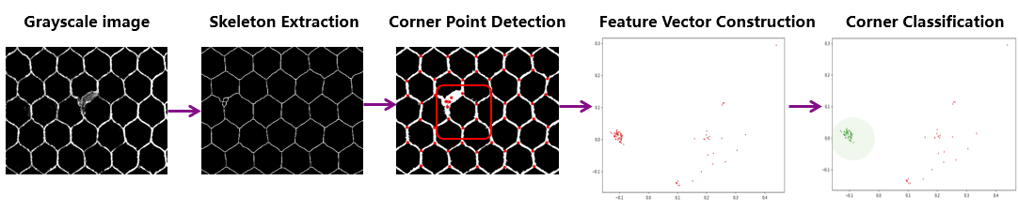
FIGURE 5． Algorithm Effect.

Macro-scale Measurement
The surface quality of Nomex honeycomb materials needs to be quantitatively evaluated not only at small and medium scales, but also at large scales. At present, the main quantitative evaluation index on a large scale is surface contour degree. Here, optical methods are used to measure the surface profile. Due to the influence of ambient light on measurement, some random noise is generated, and a certain method needs to be used to remove the noise and achieve an ideal measurement effect of the facial contour. This section uses photosensitive resin 3D printing to create a standard part with introduced errors and then measures the contour of the standard part surface using equipment. The standard part is a rectangular shape of 28 mm × 15 mm × 15 mm, and a machining error z is introduced on one of the 28 mm × 15 mm faces, as shown in Figure 6. The expression for z is:
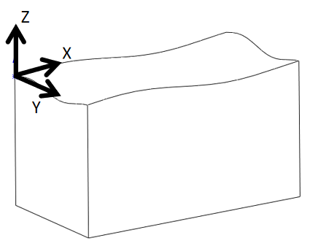
FIGURE 6． Standard Parts.

Among them, the highest point of the surface appears at (2 π, π), with a height of 1mm relative to the ideal plane; the lowest point of the surface appears at (6 π, 3 π), with a height of -1mm relative to the ideal plane. That is, the theoretical surface profile of the surface is 2 mm. The calculation formula for surface profile is:
.
Use the device to detect the surface and obtain point cloud data. However, due to optical effects, there is still a lot of noise information in the collected data. In order to remove noisy data, this paper proposes an adaptive denoising algorithm based on surface continuity and two-dimensional image entropy.
For a 5 × 5 domain around a certain point, for normal points on a continuous surface, the values of the surrounding points and their differences should not be very large, but the values of noisy points and their differences should be larger. Based on the continuous nature of surfaces, consider using a 5 × 5 convolution kernel to process data, namely:
.
By calculating the H of each point and setting a certain threshold, noise data can be removed, leaving behind real and useful information. However, setting a threshold manually is difficult to select a suitable number, the workload is very large, and the effect is not ideal. This article introduces the concept of two-dimensional entropy of images and implements adaptive threshold selection.
If point cloud data is viewed from a top-down perspective, its essence is a grayscale image. The two-dimensional entropy of an image is a statistical measure that reflects the amount of information contained in the image. For the calculation of two-dimensional entropy of an image, first define a feature binary (i, j), where i represents the pixel value of a certain point and j represents the average value of 8 pixels in the surrounding area. Then calculate the probability of a certain binary (i, j) occurring, that is:
.
Among them, N represents the frequency of occurrence of a certain binary, W is the width of the image, and H is the height of the image. Next, we can calculate the two-dimensional entropy of the image, which is:
.
So, we can obtain the maximum and minimum values of H for each point calculated previously and then traverse them at certain intervals as thresholds. The two-dimensional entropy is calculated for each threshold filtered result, and the threshold corresponding to the highest two-dimensional entropy is taken as the denoising threshold. This completes the adaptive selection of an appropriate threshold to complete denoising.
Visualize the results with threshold as the horizontal axis and two-dimensional entropy as the vertical axis, as shown in Figure 7. From the curve, there is a maximum value for two-dimensional entropy, which means that the image at this time contains the maximum amount of information, and the corresponding threshold is ideal. Using this threshold to complete denoising, the denoising result is shown in Figure 8. Through calculation, it was found that the maximum height difference of the point cloud is 2.0563 mm, which means that the surface contour of this surface is 2.0563 mm. The measured surface contour is very close to the theoretical surface contour of 2 mm, which reflects the full view of the surface well, and the detection results of the equipment are relatively ideal.
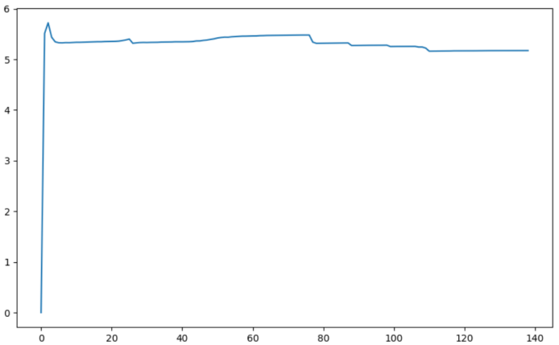
Figure 7. Two-dimensional entropy curve

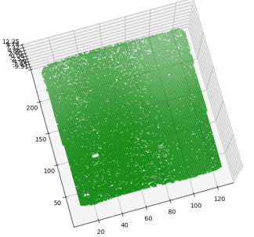 | 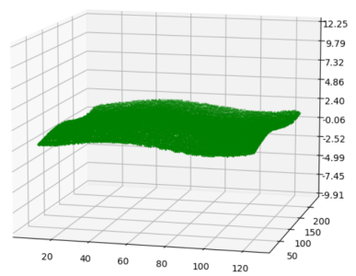
(a) | (b)
Figure 8. Denoising Effect (a) Top View (b) Side View.

Select two Nomex honeycomb material samples with significant differences in surface quality and calculate the surface profile at 25 locations. The calculation results are shown in Figure 9.

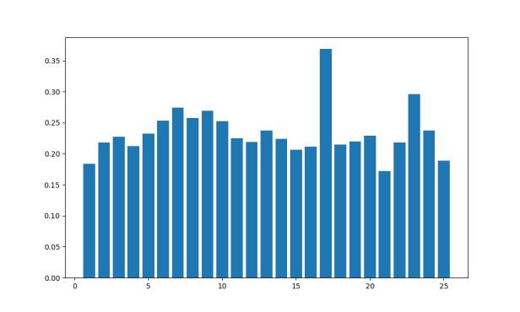 | 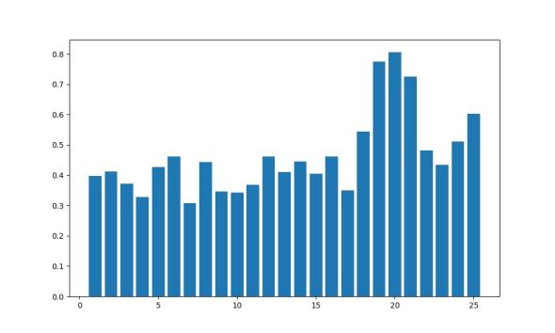
(a) | (b)
Figure 9. (a) The surface quality is slightly better. (b) The surface quality is slightly poor.

CONCLUSION
This study presents a comprehensive multi-scale surface quality evaluation methodology for machined Nomex honeycomb composites, enabling defect characterization across spatial scales spanning 0.01 mm to 0.7 m with validated cross-scale consistency. The principal contributions and findings are summarized as follows:
(1) Integrated Multi-Scale Measurement Platform: A novel inspection system specifically designed for discontinuous cellular structures is developed, capable of in-situ surface quality assessment at micro- (0.01-1 mm), meso- (1-100 mm), and macro-scales (100-700 mm). The platform architecture facilitates seamless cross-scale verification, enabling correlation of defect features across length scales without specimen repositioning or hardware reconfiguration.
(2) Microscale Burr Quantification: For microscale burr defects, a geometric complexity index is formulated as an objective quantitative metric for defect severity assessment. Experimental validation confirms the metric's effectiveness in discriminating burr intensity levels with high repeatability. The automated algorithm eliminates operator-dependent subjectivity, achieving robust performance with an average computational time of 25 seconds per region-of-interest, demonstrating suitability for production-scale implementation.
(3) Mesoscale Crushing Detection: A split-reconstruction algorithm is proposed for automated identification and quantification of cell wall crushing defects at the mesoscale. The algorithm achieves an overall classification accuracy of 98.9% across diverse deformation modes (elastic buckling, plastic collapse, and mixed-mode failure) and cell size configurations, while reducing evaluation time from several minutes to approximately 20 seconds per image—representing an order-of-magnitude improvement in inspection throughput.
(4) Macroscale Surface Profiling: For large-area curved surfaces, a denoising algorithm leveraging surface continuity constraints and two-dimensional image entropy minimization is developed to enable accurate topographic reconstruction. The method achieves 100% feature extraction success rate on planar regions and 80% on surfaces with moderate curvature (radius > 500 mm). Comparative evaluation against contour sampling-based approaches demonstrates 88.3% surface fitting accuracy with an average processing time of 27 seconds, confirming its efficacy for complex geometries characteristic of large-scale honeycomb components.
The proposed multi-scale evaluation framework addresses critical gaps in standardized quality assessment protocols for NHCs, providing objective, quantitative, and efficient defect characterization across application-relevant length scales. The methodology's modular architecture and algorithmic robustness render it adaptable to other discontinuous composite systems, including metallic honeycombs, lattice structures, and additively manufactured cellular materials. Future work will focus on establishing correlations between multi-scale defect metrics and mechanical performance degradation to enable predictive quality assessment and process optimization in honeycomb manufacturing.

Acknowledgments
This study was supported by the Shenzhen Science and Technology Program under Grant No. WDZC20231129101903002.

References
- Y. Liang, F. Feng, W. Cao, G. Song, X. Yuan, J. Xu, Q. Yue, S. Pan, E. Jiang, Y. Ma., P. Feng, Multi-Scale Study on Ultrasonic Cutting of Nomex Honeycomb Composites of Disc Cutters. Materials, 18, 3476 (2025). https://doi.org/10.3390/ma18153476
- J. Xu, B. Li, P. Feng, Q. Wang, F. Feng, A novel method for AFRPs burrs removal: Principle of mechanochemo-induced fiber fracture. Chinese Journal of Aeronautics 37, 522-538 (2024).
https://doi.org/10.1016/j.cja.2024.05.006
- C. Qi, F. Jiang, S. Yang, Advanced honeycomb designs for improving mechanical properties: a review. Composites, Part B 227, 109393(2021). https://doi.org/10.1016/j.compositesb.2021.109393
- J. Guo, J. Sun, H. Du, Y. Zhang, Z. Dong, R. Kang, Y. Wang, Cutting force reduction mechanism in ultrasonic cutting of aramid honeycomb. Int. J. Mech. Sci. 273, 109317 (2024). https://doi.org/10.1016/j.ijmecsci.2024.109317
- E. Jiang, Q. Yue, J. Xu, C. Fan, G. Song, X. Yuan, Y. Ma, X. Yu, P. Yang, P. Feng, F. Feng, A wear testing method of straight blade tools for nomex honeycomb composites machining. Wear 546–547, 205325 (2024). https://doi.org/10.1016/j.wear.2024.205325
- G. Sun, D. Chen, X. Huo, G. Zheng, Q. Li, Experimental and numerical studies on indentation and perforation characteristics of honeycomb sandwich panels. Compos. Struct. 184, 110–124 (2018).
https://doi.org/10.1016/j.compstruct.2017.09.025
- H. Lv, S. Shi, B. Chen, J. Ma, Z. Sun, Low-velocity impact response of composite sandwich structure with grid–honeycomb hybrid core. Int. J. Mech. Sci. 246, 108149(2023). https://doi.org/10.1016/j.ijmecsci.2023.108149
- J. Sun, Y. Wang, P. Zhou, M. Wang, R. Kang, Z. Dong, Equivalent mechanical model of resin-coated aramid paper of nomex honeycomb. Int. J. Mech. Sci. 240, 107935 (2023).
https://doi.org/10.1016/j.ijmecsci.2022.107935
- Y. Liang, P. Feng, Z. Song, S. Zhu, T. Wang, J. Xu, Q. Yue, E. Jiang, Y. Ma, G. Song, X. Yuan, F. Feng, Wear mechanisms of straight blade tool by dual-periodic impact platform. Int. J. Mech. Sci. 288, 110031 (2025). https://doi.org/10.1016/j.ijmecsci.2025.110031
- X. Yuan, B. Li, F. Feng, J. Xu, G. Song, Y. Liang, Y. Ma, C. Xu, F. Wang, P. Feng, False boss connection for precision machining of composites with soft and brittle characteristics. J. Compos. Sci. 8, 292 (2024). https://doi.org/10.3390/jcs8080292
- J. Guo, Z. Dong, M. Wang, H. Luo, Y. Wang, R. Kang, J. Sun, Mechanism of ultrasonic cutting aramid honeycomb using disc cutters with different blade shapes. Thin Walled Struct. 214, 113370 (2025). https://doi.org/10.1016/j.tws.2025.113370
- S. Ahmad, J. Zhang, P. Feng, D. Yu, Z. Wu, M. Ke, Processing technologies for nomex honeycomb composites (NHCs): A critical review. Compos. Struct. 250, 112545 (2020).
https://doi.org/10.1016/j.compstruct.2020.112545
- J. Xu, P. Feng, Y. Gong, J. Wang, H. Yang, F. Feng, Exploiting damage for inhibiting damage: a counterintuitive reasoning out of in-situ orthogonal cutting for brittle fiber composite. J. Mater. Process. Technol. 343, 118961 (2025). https://doi.org/10.1016/j.jmatprotec.2025.118961
- S. Ahmad, J. Zhang, P. Feng, D. Yu, Z. Wu, Experimental study on rotary ultrasonic machining (RUM) characteristics of nomex honeycomb composites (NHCs) by circular knife cutting tools. J. Manuf. Process. 58, 524–535 (2020). https://doi.org/10.1016/j.jmapro.2020.08.023
- Y. Wang, R. Kang, Y. Qin, Q. Meng, Z. Dong, Effects of inclination angles of disc cutter on machining quality of nomex honeycomb core in ultrasonic cutting. Front. Mech. Eng. 16, 285–297 (2021).
https://doi.org/10.1007/s11465-021-0631-9
- J. Jiang, Z. Liu, Formation mechanism of tearing defects in machining nomex honeycomb core. Int. J. Adv. Manuf. Technol. 112, 3167–3176 (2021). https://doi.org/10.1007/s00170-021-06603-8
- G. Liu, J. Yang, L. Zhang, Q. Gao, L. Qian, R. Zhang, Surface Quality Experimental Study on Rotary Ultrasonic Machining of Honeycomb Composites with a Circular Knife Cutting Tool. Crystals 12, 725 (2022). https://doi.org/10.3390/cryst12050725
- X. Zhang, Charization of surface microscopic of nomex honeycomb after ultrasonic assisted cutting. Journal of Mechanical Engineering 53, 90–99 (2017). https://doi.org/10.3901/JME.2017.19.090
- J. Xu, K. Zhang, H. Zha, J. Liu, X. Yuan, X. Cai, C. Xu, Y. Ma, P. Feng, F. Feng, Surface integrity of nomex honeycomb composites after ultrasonic vibration machining by using disc cutters. J. Manuf. Processes 102, 1010–1022 (2023). https://doi.org/10.1016/j.jmapro.2023.08.007
- J. Xu, Q. Yue, H. Zha, X. Yuan, X. Cai, C. Xu, Y. Ma, P. Feng, F. Feng, Wear reduction by toughness enhancement of disc tool in nomex honeycomb composites machining. Tribol. Int. 185, 108475 (2023). https://doi.org/10.1016/j.triboint.2023.108475
- J. Xu, C. Wang, P. Feng, E. Jiang, F. Feng, Meso-scale cracks initiation of nomex honeycomb composites in orthogonal cutting with a straight blade cutter. Composites Science and Technology 233, 109914 (2023). https://doi.org/10.1016/j.compscitech.2023.109914
- M. Jaafar, H. Makich, M. Nouari, A new criterion to evaluate the machined surface quality of the nomex (R) honeycomb materials. J. Manuf. Processes 69, 567–582 (2021). https://doi.org/10.1016/j.jmapro.2021.07.062
- H. Jiang, H. Zhao, X. Li, C. Quan, Hyper thin 3D edge measurement of honeycomb core structures based on the triangular camera-projector layout & phase-based stereo matching. Opt. Express 24, 5502 (2016). https://doi.org/10.1364/oe.24.005502
- Y. Qin, R. Kang, Z. Dong, Y. Wang, J. Yang, X. Zhu, Burr removal from measurement data of honeycomb core surface based on dimensionality reduction and regression analysis. Meas. Sci. Technol. 29, 115010 (2018). https://doi.org/10.1088/1361-6501/aae1c4

