Comprehensive Study of Plastic Deformation of Road Asphalt Concrete Pavement in Climatic Conditions of South Kazakhstan
Bagdat Teltayev^{1, a)}, Umir Kalybayev^{2, b)}, Yerbol Aitbayev^{1, c)},
Azamat Zhaisanbayev^{3, d)}
¹U. Joldasbekov Institute of Mechanics and Engineering, Almaty, Kazakhstan
²Kazakh Automobile and Road Institute named after L. B. Goncharov (KazADI), Almaty, Kazakhstan
³Road Research and Production Center, Almaty, Kazakhstan

a) Corresponding author: bagdatbt@yahoo.com
b) Lifeking_86@mail.ru
c) erbolae@mail.ru
d) azamatsz10@gmail.com
Abstract. This paper presents the results of a comprehensive study of rutting (plastic deformation) of an asphalt concrete road pavement in the climatic conditions of the south (Shymkent city) of Kazakhstan. By opening the road pavement structure, the geometric characteristics of rutting, types of materials and soils, and thicknesses of the road pavement layers were determined. The intensity and composition of the traffic flow were determined and analyzed. Using a special measuring system with sensors, non-stationary temperature regimes of the road pavement were determined. Using the solution of the problem of the elasticity theory for a multilayer system and the correlation model of the Asphalt Institute (USA), actual parameters of transport facilities loading and measured temperature values ​​in the layers of the road pavement, stresses and strains in the pavement structure were calculated, and destructive (rutting) effects of the transport facilities were established.
Keywords: asphalt concrete pavement, rutting, temperature, traffic flow, relative rutting effect.

Introduction
Rutting is one of the main types of failure of road asphalt concrete pavements [1-3]. Many years of road operation experience and the results of specialized comprehensive studies show that rutting is caused by several factors and their combinations:
- a weak pavement structure;
- low rutting resistance of asphalt concrete layers;
- heavy vehicle loads and their excessive numbers;
- high temperatures.
In Kazakhstan (especially in the south of the country), rutting has recently become a significant problem on both urban and public roads.
This paper presents some of the results of a comprehensive study of plastic deformation (rutting) on an ​​asphalt concrete pavement in the climatic conditions of southern Kazakhstan (in the city of Shymkent).
Shymkent is located in southern Kazakhstan. In summer, air temperatures rise to 45-47°С, and an asphalt concrete surface heats up to 65-67°С. The city has recently become a metropolis. It is developing rapidly. The population and the amount of heavy public and freight transport on the city's roads are growing rapidly. The combination of these factors is the main cause of rutting.

Experimental section
An experimental section for studying rutting was selected on the A2 highway connecting the city with its airport (Fig. 1).
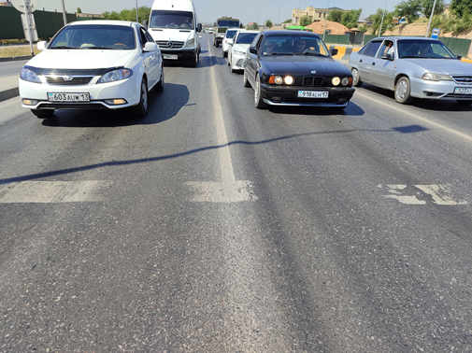
Figure 1. General view of the experimental section

A pavement structure on the experimental section was determined by opening it up (Fig. 2).

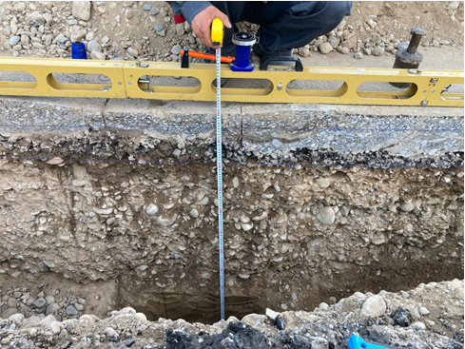
Figure 2. Measuring thicknesses of the pavement layers

The location of the pavement structure opening is shown in Fig. 3.

Figure 3. Peace of opening of the pavement structure of the experimental section

It has been established that the existing pavement structure on the experimental section has the following layers: 1 – old asphalt concretes, total thickness h₁=17 cm; 2 – a sand and gravel mixture, h₂=70 cm; soil - loam.
It can be seen that the existing pavement structure is very weak, and the asphalt concrete layers are old. As will be discussed later, this pavement structure does not meet the actual loading conditions (intensity and composition of the traffic flow).

RUT CHARACTERISTICS
Before opening the pavement structure on the experimental section rut depth values were measured. The rut depths were measured using a three-meter ruler on lines located perpendicularly at distances of 0, 5 m, 10 m, 15 m, 20 m, 25 m and 30 m from the stop line before the intersection.
Figure 4 shows the distribution curves of the rut depth along the wheelputch width at different distances. Figure 5 presents a histogram that shows the distribution of the rut depth values on intervals.

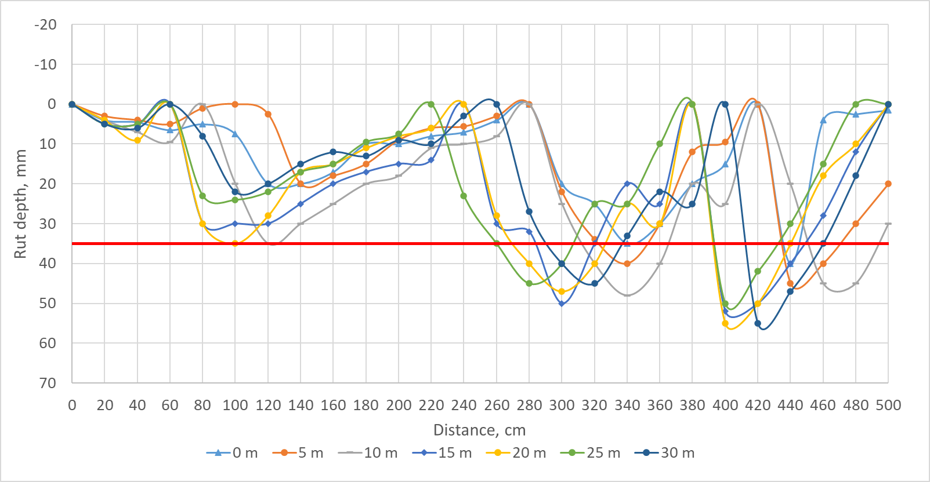
FIGURE 4. Graph of rut depth distribution on the asphalt concrete pavement surface at different distances

These figures show that on the outer wheelputch all the measured rut depths are greater than the permissible value of 35 mm [4], 60% of them are greater than 10 mm. In accordance with the requirements of the regulatory document [4], such road sections cannot be operated. They must be repaired immediately.
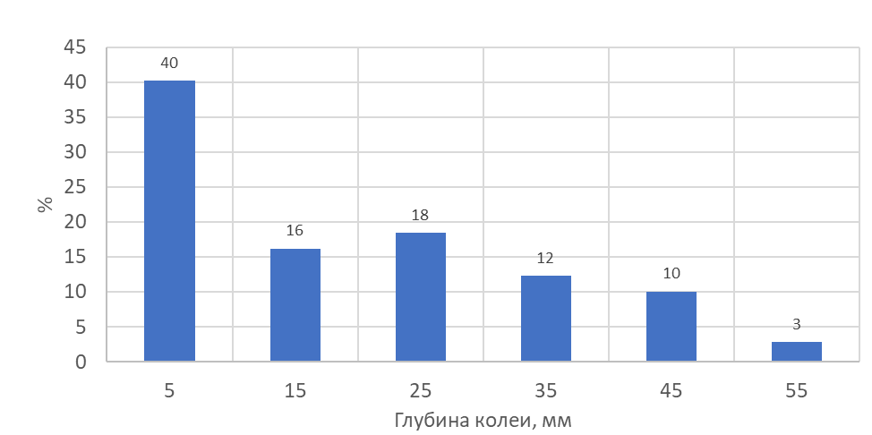
FIGURE 5. Histogram of distribution of rut depth on the asphalt concrete surface on the experimental section

traffic flow
The composition and intensity of the traffic flow were determined by recording them on a NEOLINE G-TECH X76 digital video camera. The measurement results were analyzed by the Traffic Flow Software.
On the experimental section in the direction of "Airport - Shymkent city" the intensity of the transport flow is 14533 units/day. The composition of the transport flow (Fig. 6): cars, minibuses, and motorcycles – 11936 units/day; buses – 253 units/day; single trucks – 1634 units/day; trucks with trailers – 181 units/day; trucks with semi-trailers – 509 units/day; tractors – 20 units/day.

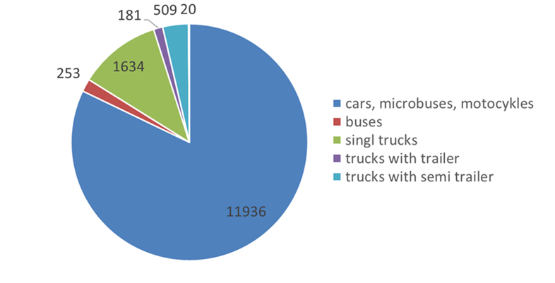
FIGURE 6. Composition of the traffic flow

The compositions of buses and single trucks are presented in Table 1.
TABLE 1. Compositions of buses and single trucks
Buses, units/day |  | Single trucks, units/day
middle | heavy | <2 tons | 2-5 tons | 5-10 tons | 10-20 tons | 20-40 tons
68 | 185 | 732 | 326 | 192 | 196 | 188
253 |  | 1634

As can be seen in Fig. 6 and Table 1, the number of trucks and buses in the traffic flow that cause rutting is 2,597 units/day (18%); the intensity of heavy trucks is 710 units/day. The existing pavement structure cannot withstand such loads.

new pavement STRUCTURE
A new pavement structure is proposed (Table 2) to ensure the passage of actual traffic flow.
TABLE 2. A new pavement structure
Layer number | Material | Thickness, cm
1 | Stone mastic asphalt concrete + polymer | 5
2 | Porous asphalt concrete + polymer | 6
3 | Upper part of base of treated materials | 40
4 | Lower part of base of a gravel and sand mix | 25
5 | Subgrade soil - loam | -

temperature
Figure 7 shows the temperature distribution graphs at the points of the pavement and soil base on July 6, 2025. The temperature values were obtained from the temperature and moisture monitoring system installed on the al-Farabi Street in 2024.
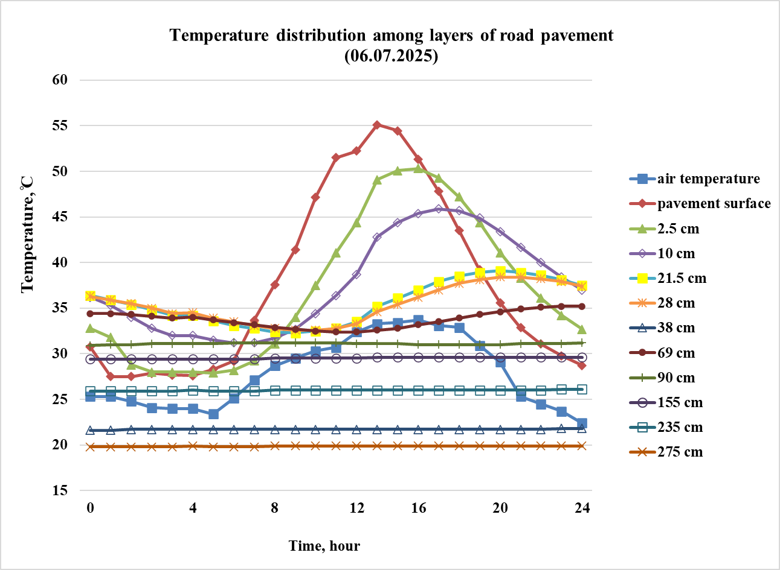
FIGURE 7. Temperature distribution at the pavement and soil base points on July 6, 2025

rut accumulation model
The rut depth values in the asphalt concrete layers of the new pavement structure are determined using the Asphalt Institute (USA) model [5]:
$ε_{p}\text{=}ε_{r}∙k_{1}∙{10}^{\text{-}3,4488}∙{\left(\frac{9}{5}∙T\text{+}32\right)}^{1,5606}∙N^{0,479244}$,
(1)

where
$ε_{p}$ - plastic strain;
$ε_{r}$ - elastic strain;
T – temperature;
N – number of equivalent axle;
k₁ – a coefficient that depends on the layer thickness and point depth.

model of multilayer deformable medium
To calculate the values of elastic strains in the two upper asphalt concrete layers with polymers in the new pavement structure under the action of the design load A1, trolleybuses, buses and trucks, a model of a multilayer deformable medium is used [6]. The design scheme of the multilayer pavement is presented in Fig. 8.
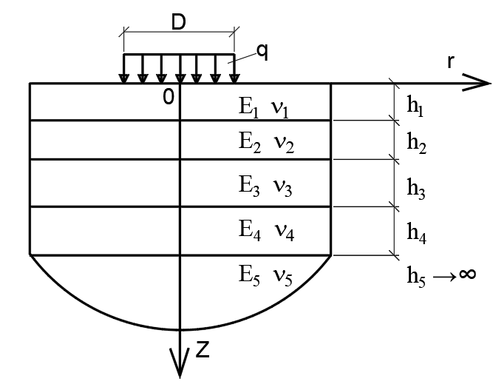
FIGURE 8. Design scheme of the pavement structure

According to this model, the materials of all layers of the pavement and soil are considered to be elastic and linearly deformable. Therefore, the mechanical behavior of the materials and soil is described by the following two characteristics: E is the modulus of elasticity, MPa; ν is the Poisson's ratio. The values of the mechanical characteristics of the materials of the pavement layers and soil are assigned according to the regulatory documents [5, 7]. The temperature values are assigned according to Fig. 7.
The layers of the pavement have a finite thickness: h₁, h₂, h₃, and h₄. The soil base is modeled as an elastic half-space, i.e., it has an infinite thickness: h₅ → ∞.
The surface of the first layer is subjected to a load (stress) q (MPa), which is evenly distributed within a circle of diameter D (cm).

calculation of rut accumulation
The following transport facilities were selected for calculating stresses and strains in the new pavement structure: design load A1, Youngman JNP6120GDZ trolleybus, Golden Dragon XML6185J13C bus, YUTONG ZK6118HGA bus, SAM AUTO LE 60 bus, Shahman truck, KAMAZ 65115 truck, and GAZEL truck.
Figure 9 shows the accumulation of ruts on the surface of the asphalt concrete pavement (the total depth of the ruts in the two upper asphalt concrete layers with polymers) of the new pavement structure.

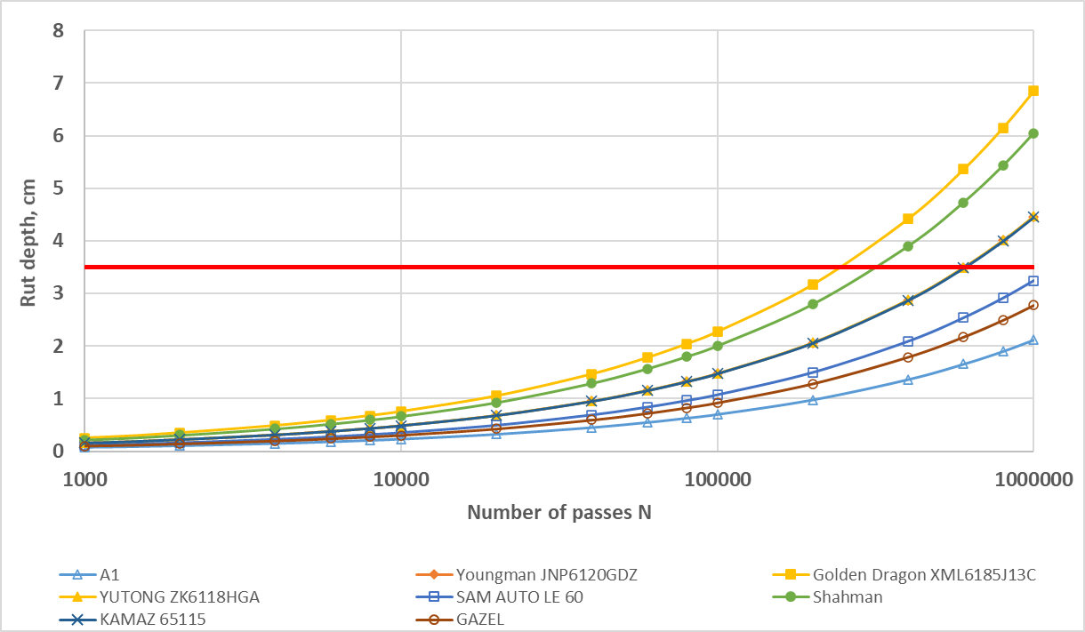
FIGURE 9. Graphs of the total rut on the surface of the asphalt concrete pavement
Figure 9 shows the permissible number of passes and the relative rutting effects (RRE) of the transport facilities considered, which are listed in Table 3.
TABLE 3. Permissible number of passes and relative rutting effects of transport facilities
Transport facilities | Permissible number of passes (rut depth of 3.5 cm) | Relative rutting effect (RRE)
Design load A1 | 710 000 | 1.00
Youngman JNP6120GDZ | 138 000 | 5.14
Golden Dragon XML6185J13C | 49 000 | 14.49
YUTONG ZK6118HGA | 145 000 | 4.90
SAM AUTO LE 60 | 287 000 | 2.47
Shahman | 76 000 | 9.34
KAMAZ 65115 | 150 000 | 4.73
GAZEL | 260 000 | 2.73

An analysis of the data in Table 3 shows that the Golden Dragon XML6185J13C bus has the greatest RRE of the transport facilities considered (RRE=14.49); the second largest RRE is the Shahman truck (RRE=9.34); the Youngman JNP6120GDZ trolleybus, the YUTONG ZK6118HGA bus and the KAMAZ 65115 truck have approximately the same the RRE values, which are 5.14, 4.9 and 4.73, respectively; the RRE of the SAM AUTO LE 60 bus (2.47) and the GAZEL truck (2.73) are almost the same.
The above-mentioned values of the relative rutting effects (RRE) of transport facilities are recommended for use in predicting the accumulation of ruts on asphalt concrete pavements.

Conclusions
1. The traffic conditions (load) of the transport flow on the experimental section are severe. In the transport flow, trucks and buses that cause rutting amount to 2597 units/day; the intensity of heavy trucks is 710 units/day.
2. On the wheelputch in the experimental section, all measured values of the rut depth are greater than the permissible value of 35 mm.
3. The existing pavement structure, consisting of old asphalt concrete layers with a total thickness of 17 cm and a base made of a mixture of sand and gravel with a thickness of 70 cm, is very weak and does not meet the actual loading conditions.
4. A new more durable pavement structure consisting of the following layers has been proposed: 1 – a stone mastic asphalt concrete with a polymer, 5 cm; 2 – a porous asphalt concrete with a polymer, 6 cm; 3 – an upper part of the base of treated materials, 40 cm; 4 – a lower part of the base of a gravel and sand mix, 25 cm
5. The Golden Dragon XML6185J13C bus has the greatest RRE of the transport facilities considered (RRE=14.49); the second largest RRE is the Shahman truck (RRE=9.34); the Youngman JNP6120GDZ trolleybus, the YUTONG ZK6118HGA bus and the KAMAZ 65115 truck have approximately the same the RRE values, which are 5.14, 4.9 and 4.73, respectively; the RRE of the SAM AUTO LE 60 bus (2.47) and the GAZEL truck (2.73) are almost the same.
The above-mentioned values of the relative rutting effects (RRE) of transport facilities are recommended for use in predicting the accumulation of ruts on asphalt concrete pavements.

References
- B. Teltayev, A. Iskakbayev, A. Massanov, Y. Aitbayev and A. Zhaisanbayev, Investigation Of Rut Formation In Asphalt Concrete Pavement, Proceedings of the 5th International Conference on Transportation Geotechnics (ICTG) 2024, Lecture Notes in Civil Engineering, Vol. 3 (Springer, 2025), DOI:10.1007/978-981-97-8221-5_7.
- B. Teltayev, Y. Aitbayev and A. Zhaisanbayev, To The Study Of Plastic Deformation Of Road Asphalt Concrete Pavement, AIP Conference Proceedings 3177, 050008-1–050008-6 (2025).
- B. Teltayev, Y. Aitbayev and A. Zhaisanbayev, Problems Of Rutting On Asphalt Pavements, Vibroengineering Procedia 55 (Sept. 2024). ISSN PRINT 2345-0533, ISSN ONLINE 2538-8479. DOI:10.21595/vp.2024.24088
- PR RK 218-27-2014, Instructions For Diagnosing And Assessing The Transport And Operational Condition Of Highways (Astana, 2014).
- Guide For Mechanistic–Empirical Design Of New And Rehabilitated Pavement Structures. Final Report. Part 3. Design Analysis. Chapter 3. Design Of New And Reconstructed Flexible Pavements, National Cooperative Highway Research Program, Transportation Research Board, National Research Council, Washington, DC (2004).
- A. K. Privarnikov, Spatial Deformation Of A Multilayer Base, in Stability And Strength Of Structural Elements (Dnepropetrovsk State University, Dnepropetrovsk, 1973), pp. 27–45.
- SP RK 3.03-104-2014*, Design Of Flexible Pavements (Astana, 2019).

