Is Griffith’ Energetic Criterion Applicable to Adhesive Viscoelastic Contacts?
Valentin L. Popov^{1,2, a)}, Ben Ole Brünner^{1, b)}
¹Department of System Dynamics and Friction Physics, Technische Universität Berlin, Berlin 10623, Germany
²Center of Advanced Studies in Mechanics, Tribology, Bio- and Nanotechnologies, Samarkand State University,

^{a)} Corresponding author: v.popov@tu-berlin.de
^{b)} bruenner@tu-berlin.de
Abstract. Adhesion plays a key role in the mechanics of soft matter, where materials are highly deformable and viscoelastic. Classical adhesion theories originate from Griffith’s (1921) concept of crack equilibrium, which balances elastic energy release with the work of adhesion needed to form new surfaces. This principle was later adapted by Johnson, Kendall, and Roberts (1971), who treated the boundary of adhesive contact as equivalent to a Griffith crack. Although elegant, the energy balance framework is strictly valid only for elastic bodies. In viscoelastic systems, additional work must be performed against dissipative forces, motivating the introduction of an “effective work of adhesion,” as in the velocity-dependent models of Barquins and Maugis. However, these treatments remain largely empirical. This paper uses a more physically grounded understanding of adhesion in viscoelastic contacts, based on the scale separation of the processes of detachment and relaxation of material. As an example, the adhesive contact of a parabolic indenter and a viscoelastic half-space is analyzed across a wide range of pull-off velocities. The results show that the relationship between normal force and contact radius remains universal and velocity-independent, matching the JKR form; however, it exhibits a strongly increased effective work of adhesion. In contrast, the force–indentation response exhibits strong velocity dependence: at high detachment speeds, the contact separates at positive indentation depths within the indentation “well.”

Introduction
High adhesion typically occurs in systems involving highly deformable materials – soft matter – that are generally viscoelastic in nature [1]. Therefore, when discussing adhesion, it is essential to consider the role of viscoelasticity. In 1921, Alan Griffith formulated a theory of cracks in elastic bodies [2]. His theory was based on the consideration of the energy balance of elastic energy getting free due to a small advancement of the crack tip and the work needed to create new fresh surfaces, the work of adhesion. 50 years later, in 1971, Johnson, Kendall and Roberts realized that the boundary of an adhesive contact is equivalent to the Griffith’ crack and applied the same criterion of energy balance to adhesive contacts [3]. In its original formulation, the energy balance criterion is strictly valid for purely elastic bodies. Nevertheless, owing to its conceptual simplicity and generality, it is often extended to describe crack propagation – or equivalently, the evolution of adhesive contacts – in dissipative media. In such cases, the true work of adhesion is replaced by an effective work of adhesion, which accounts not only for the energy required to create new surfaces but also for the additional work expended against dissipative mechanisms such as viscoelastic or plastic deformation. For example, Barquins and Maugis introduced the concept of an effective work of adhesion that depends on the crack propagation velocity [4]. In [5], it was argued that energetic criterion can be applied to viscoelastic contacts in the straightforward and rigorous way – under assumption of energetic (non-entropic) adhesive interactions in the interface. To address the contact mechanics aspect of the problem, the Method of Dimensionality Reduction (MDR) [6] was used in [5]. In the previous paper [5], the energetic criterion was only applied to quasistatic indentation and detachment. In the present paper, we investigate detachment with a finite velocity.

Model
We begin by briefly recalling the procedure of the Method of Dimensionality Reduction (MDR). Consider the contact between an axisymmetric indenter indenter with profile z=r²/(2R) and an elastic half-space. Here z is normal coordinate, r is the in-plane radius, and R the radius of curvature of the profile. In the first step, this three-dimensional shape is replaced by a plane shape z=g(x) using the Abel transformation:
.
This profile is indented by the depth d into one-dimensional elastic foundation – a series of springs with spacing Δx and stiffness Δk_{z} = E* Δx where E* is defined as: . E₁ and E₂ are Young’s moduli and ν₁ and ν₂ are Poisson numbers of contacting bodies. In the case of a contact with viscoelastic medium, the springs must be replaced by corresponding rheological elements [7]. In the present paper, we consider for simplicity the "standard viscoelastic body" [1] which in MDR is represented by rheological elements shown in FIGURE 1. G₀ is the instant (glass) modulus of the medium, while the static shear modulus is given by G₀G₁/(G₀+G₁). For real elastomers G₀>>G₁, so that their reaction to instant loading is very stiff and to static loading very soft.
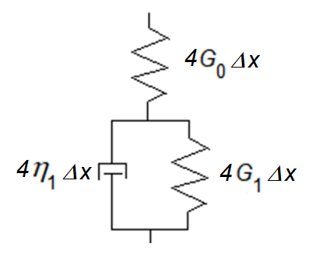
FIGURE 1. Rheological element corresponding to the "standard viscoelastic body".

The basic idea of application of energetic criterion to viscoelastic bodies was first formulated in [8] within the context of MDR. Equivalent idea has been suggested much earlier by Greenwood and Johnson [9] and elaborated in detail by Barthel [10]. It is based on the time scale separation of detachment and relaxation processes. For performing the work of adhesion, only energy can be used which can be relaxed almost instantly (on the molecular time scale), and this is the energy which is stored in the spring G₀ in Figure 1. A small decrease in contact radius by Δx corresponds in the MDR representation to detachment of two edge rheological elements. The released elastic energy 2·(1/2)·(4G₀Δx)u₀² should be equated to the work of adhesion Δγ·2πa∆x providing equation for the critical elongation
.
where a is the contact radius, Δγ is specific work of adhesion (per unit area), and u_{0,crit} is the critical elongation of the spring G₀ representing the glass modulus of the medium. At this point, we recall that the assumption of scale separation implies that the detachment process occurs on the molecular scale which suggests a "non-entropic interactions" between the contacting surfaces [8]. Even in the case of non-entropic interactions, there exist further applicability conditions analyzed in the paper [5], which, however, are mostly fulfilled during the detachment phase.
Let us consider the process consisting of indentation up to the depth d₀, followed by a long relaxation time and finally pull-off with a constant velocity v₀. In the following, as a reference state at t=0, we consider the starting time of detachment from the relaxed state at the depth d₀.
The elongation of the spring G₀ can be calculated analytically (see for detailed derivation in [8]):
.
where τ = η₁/(G₀+G₁). The detachment criterion (2) reads
.
Integrating forces of all rheological elements in contact according to general rules of the Method of Dimensionality Reduction [7], we get the total normal force
.
Introducing notation
.
we can rewrite equations (5) and (6) in the form
.
Note that these equations coincide with equations of the JKR theory [3],
.
(with E* being effective elastic modulus), provided we make the following substitutions:
,
For determining the dependence of the normal force on the contact area from (7), we eliminate the variable . This yields a universal relationship that is independent of the detachment velocity, since the latter appears only in the definition of ) in Eq. (6). The resulting dependence coincides with the JKR solution using the static (soft) modulus E* = 4G₀G₁/(G₀+G₁). and a significantly increased effective specific work of adhesion Δγ_{eff,2}=Δγ(G₀+G₁)/G₁ (see Fifure 2).
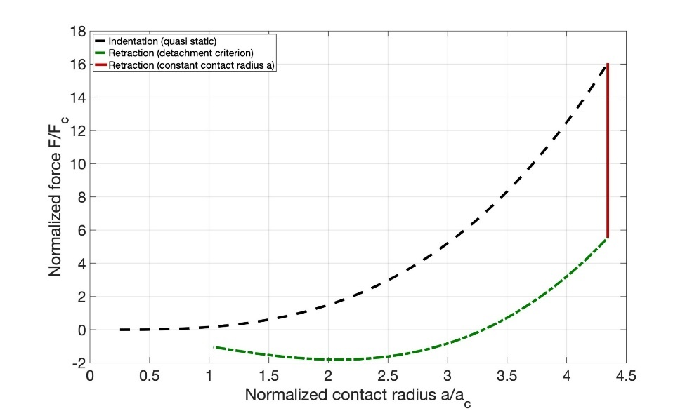
FIGURE 2. Normalized normal force vs normalized contact radius. The dashed line describes indentation (which is practically non-adhesive [5]). During detachment, the contact radius remains firstly constant (red line, corresponding to the "stick zone" [11]), followed by the JKR solution with very high effective work of adhesion (green line). Both parts of the detachment curve do not depend on the detachment velocity.

The dependence of the normal force on the indentation depth, on the contrary, strongly depends on the detachment velocity. Figure 3 shows an example of force-indentation dependence for a small detachment velocity. At reversing the indentation, first a very quick drop of the force is seen, followed by a linear dependency. A more detailed view provided by insert shows that both the drop and the linear part are not really vertical and linear dependencies but show continuous transition.
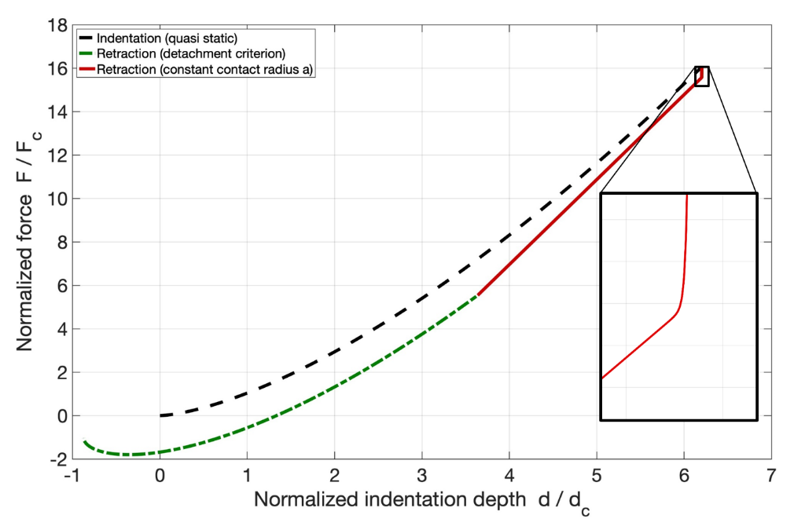
FIGURE 3. Normalized force vs normalized indentation depth. Simulations have been carried out in dimensional variables with the following parameters: d₀ = 5·10⁻³ m, R = 5·10⁻² m, G₀ = 10⁹ Pa, G₁ = 10⁶ Pa, τ = 10⁻⁷ s, γ = 0.2 J/m², v₀ = 1 m/s, η₁ = 100.1 Pa·s.
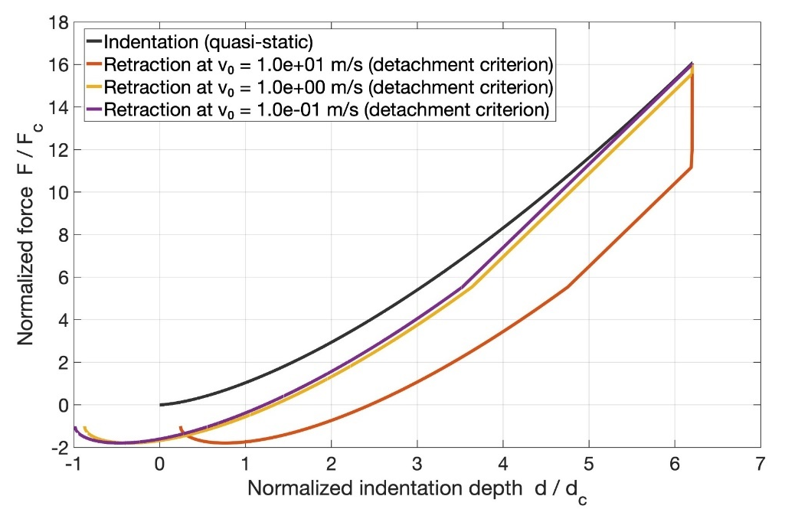
FIGURE 4. Normalized force vs normalized indentation depth for three different retraction velocities: At v₀ = 0.1 m/s, there is practically no initial drop (corresponds to almost quasistatic detachment); at v₀ = 1 m/s, a small initial drop of force is observed; for v₀ = 10 m/s a substantial drop is observed. Drop and linear stage both form the "sticking zone" where the contact radius does not change. The same parameters as in Figure 3 have been used in the simulation.

Note that at large pulling velocities detachment occurs at positive indentations (that means inside the "well" formed during the indentation phase) – see Figure 5. At even larger pulling velocities, the detachment will occur without changing the contact radius (as in the case of a flat-ended cylinder). This behavior is, in fact, almost self-evident. When the pull-off time is much shorter than the characteristic relaxation time of the elastomer, the material responds elastically. During such rapid detachment, the viscoelastic component of the deformation effectively behaves as a “frozen” or quasi-permanent deformation, analogous to plastic strain. The elastic displacement remains uniform across the entire contact area, leading to a detachment process equivalent to that of a flat-ended cylinder separating from an elastic half-space. Although the limiting behavior at high retraction velocities follows directly from these considerations, the present theoretical framework explicitly describes and quantifies the transition from the quasi-static to the dynamic pull-off regime.

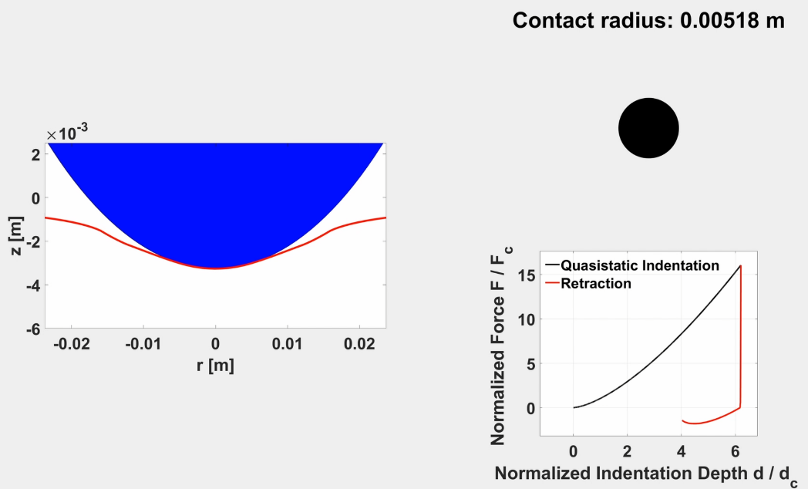
FIGURE 5. The last configuration of the contact before complete detaching in the case of very rapid detachment. In this case, the linear part of the force-indentation dependence disappears completely.

CONCLUSION
The present work uses an extension of the Griffith’ energetic criterion to adhesive contacts involving viscoelastic media. Method of Dimensionality Reduction (MDR) is used to reduce the three-dimensional problem to a problem of a plane contact with "viscoelastic foundation" – a series of independent viscoelastic elements. As an example, we considered contact between a parabolic indenter and an elastomer described with the standard linear viscoelastic model. Our analysis shows that while the force–contact radius relationship remains universal and independent of detachment velocity, the force–indentation behavior exhibits pronounced velocity dependence. At low retraction speeds, the response approaches the quasistatic JKR limit, whereas higher detachment velocities lead to force drops and eventual separation within the indentation “well.” These findings quantify the role of viscoelastic dissipation in adhesive contacts.
Future work may extend this approach to more complex rheological models and to cases involving entropic surface interactions, where additional dissipative mechanisms become significant.

Acknowledgments
V.L. Popov acknowledges financial support of the DFG (PO 810/74-1).

References
- V.L. Popov, Contact Mechanics and Friction. Physical Principles and Applications, Springer Berlin, Heidelberg, 2017. https://doi.org/10.1007/978-3-662-53081-8
- A.A. Griffith, The Phenomena of Rupture and Flow in Solids, Philosophical Transactions of the Royal Society of London, Series A, 221, 163–198 (1921). https://doi.org/10.1098/rsta.1921.0006
- K. L. Johnson, K. Kendall, A. D. Roberts, Surface Energy and the Contact of Elastic Solids, Proceedings of the Royal Society of London, Series A, 324: 301–313 (1971). https://doi.org/10.1098/rspa.1971.0141
- D. Maugis, M. Barquins, Fracture mechanics and adherence of viscoelastic solids, in Adhesion and Adsorption of Polymers, edited by L. H. Lee, Polymer Science and Technology, 12, Springer, Boston, MA, 1980.
https://doi.org/10.1007/978-1-4613-3093-6_17
- V.L. Popov, Energy Criterion for Attachment and Detachment in Viscoelastic Adhesive Contacts, Adhesives, 1, 9 (2025). https://doi.org/10.3390/adhesives1030009
- V.L. Popov, M. Heß, Method of Dimensionality Reduction in Contact Mechanics and Friction, Springer, Berlin, Heidelberg, 2015. https://doi.org/10.1007/978-3-642-53876-6
- V.L. Popov, M. Heß, E. Willert, Handbook of Contact Mechanics. Exact Solutions of Axisymmetric Contact Problems, Springer Berlin, Heidelberg, 2019. https://doi.org/10.1007/978-3-662-58709-6
- V.L. Popov, Energetic criterion for adhesion in viscoelastic contacts with non-entropic surface interaction, Reports in Mechanical Engineering, 2, 57–64 (2021). https://doi.org/10.31181/rme200102057p
- J.A. Greenwood, K.L. Johnson, The Mechanics of Adhesion of Viscoelastic Solids. Philosophical Magazine A, 43, 697-711 (1981). https://doi.org/10.1080/01418618108240402.
- E. Barthel, Adhesive Elastic Contacts: JKR and More, Journal of Physics D: Applied Physics, 41, 163001 (2008). https://doi.org/10.1088/0022-3727/41/16/163001.
- G. Violano, A. Chateauminois, L. Afferrante, A JKR-Like Solution for Viscoelastic Adhesive Contacts, Frontiers in Mechanical Engineering, 7, 664486 (2021) https://doi.org/10.3389/fmech.2021.664486

