Cyclic Freeze-Thaw Characteristics of Asphalt Concrete Pavement in Almaty Region
Bagdat Teltayev^{1, a)}, Aizhan Muta^{2, b)}, Yerbol Aitbayev^{1, c)},
Azamat Zhaisanbayev^{3, d)}
¹U. Joldasbekov Institute of Mechanics and Engineering, Almaty, Kazakhstan
²Kazakh National Women’s Teacher Training University, Almaty, Kazakhstan
³Road Research and Production Center, Almaty, Kazakhstan

^{a)} bagdatbt@yahoo.com
^{b)} Corresponding author: mutita@mail.ru
^{c)} erbolae@mail.ru
^{d)} azamatsz10@gmail.com
Abstract. The article experimentally (through a special temperature and moisture monitoring system) studies the characteristics (duration and minimum temperature) of freezing and thawing cycles (FTCs) of an asphalt concrete pavement on the section (58 km +895 m) of the “Almaty-Bishkek” highway located in the Almaty region (southern Kazakhstan). The characteristic periods and sub-periods, as well as the number and characteristics of FTCs, are determined. The obtained experimental data are processed using methods of the mathematical statistics and interpreted. A correlation was established between the duration and minimum temperature of the FTCs. The daily temperature distributions in the road pavement structures and subgrade on different days of the cold period under consideration are briefly described.
Keywords: pavement, subgrade, temperature, freeze-thaw cycles, duration, minimal temperature.

Introduction
Climate conditions have a significant impact on the strength and durability of roads, especially in regions with pronounced seasonal variability [1, 2]. Cyclic freezing and thawing processes significantly reduce the strength and service life of road surfaces. Asphalt concrete surfaces with reduced strength due to cyclic freezing and thawing (FTC) are vulnerable to both low-temperature cracking [3, 7, 9] and fatigue cracking [6, 10].
In view of the above, studying the temperature regime and the features of cyclic freezing and thawing in the layers of road pavement and in the subgrade soil of roads is a problem that is not only of scientific importance, but also of great practical significance.
The works of Teltayev et al. [4, 5, 8, 11, 12] are known, in which the changes and distribution of temperature in the road pavement structures and the subgrade of highways in several regions of Kazakhstan are experimentally investigated. But in them the FTC of layers of road pavements, including the asphalt concrete pavement, is not studied in detail.
In Kazakhstan, there is a standard [13] that sets requirements for the resistance of road asphalt concrete to FTC, and methods for testing their frost resistance [14]. However, it is unclear how accurately these requirements reflect the actual characteristics of FTC in asphalt concrete pavements.
In this article, the characteristics of FTC of the asphalt concrete pavement of a highway in the Almaty region (southern Kazakhstan) are studied experimentally (through a special temperature and moisture monitoring system).

Experimental section
To conduct a long-term monitoring of temperature and moisture in layers of a road pavement and its subgrade, an experimental section was selected not far from Almaty (at 58 km + 895 m) on the “Almaty-Bishkek” highway, where a set of sensors for temperature and moisture were installed.
The road pavement structure on the section consists of the following layers: layer 1 - fine-grained dense asphalt concrete, thickness, h₁ = 5 cm; layer 2 - coarse-grained porous asphalt concrete, h₂ = 10 cm; layer 3 - fine-grained dense asphalt concrete, h₃ = 6.5 cm; layer 4 - Coarse-grained porous asphalt concrete, h₄ = 15 cm; layer 5 - fine sand and gravel mix, h₅ = 25 cm; layer 6 - coarse sand and gravel mix, h₆ = 35 cm. Subgrade soil - heavy sandy clay loam, h₇ = 140 cm.

Temperature and moisture monitoring system
In order to carry out long-term monitoring of temperature and moisture on the selected road section, a special measuring system with temperature and moisture sensors was installed. The sensors are installed in the layers of the road pavement and in the points of the subgrade at different depths (3 cm, 11 cm, 22 cm, 45 cm, 78 cm, 111 cm, 145 cm, 180 cm, 240 cm, 300 cm) from the fine-grained dense asphalt concrete pavement surface. The system is powered by solar panels. Temperature and moisture values of air and in the specified locations are measured hourly and the measurement results are saved.

results and discussion

Freeze – Thaw Cycles
Figure 1 shows a graph of changes in air temperature (asphalt concrete surface) at the experimental section from October 2021 to March 2022. The graph highlights the periods of freezing and thawing: period I is a stable autumn-winter period of cyclic freezing and thawing; period II is an unstable spring period of cyclic freezing and thawing, which includes three sub-periods. Each of these sub-periods includes several cycles of freezing and thawing (FTC). The marked periods differ in duration and characteristics (number of FTCs and minimum temperatures) of temperature fluctuations.

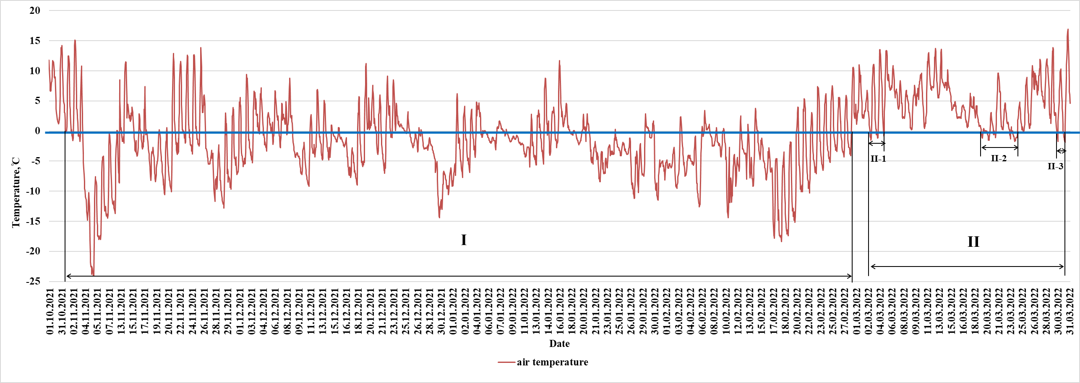
FIGURE 1. Graph of air temperature changes with highlighted periods and cycles of freezing and thawing

Figure 2 shows a histogram of the distribution of the duration of freezing cycles on the road surface. As can be seen from the graph, the vast majority (78.57%) of freezing cycles have a duration of no more than 40 hours. A more detailed view (inset) shows that the majority of cycles occur between 8 and 16 hours (43.63%) and 0 and 8 hours (32.73%), while cycles longer than 24 hours are extremely rare.
Figure 3 shows the cumulative curve of the duration of the freezing cycles, from which we can conclude that 85% of the freezing cycles were no longer than 47 hours.
Figure 4 shows the distribution of minimum temperatures in freezing cycles. More than 81% (specifically, 81.43%) of all cycles have minimum temperatures of at least -9°C. Additionally, 40% and 32.85% of cycles have temperatures between 0°C and -3°C, and between -3°C and -6°C, respectively.
Based on the cumulative curve (Fig. 5), the estimated minimum temperature in the freezing cycles is -8.6°C with an 85% confidence level.
Figure 6 shows the relationship between the minimum temperature and the duration of the freezing cycles. As the temperature decreases, the duration of the cycles increases. The linear approximation shows a high degree of correlation (R² = 0.7365), which confirms the existence of a stable relationship between the parameters under consideration. It should be noted that the correlation between the parameters is stronger for shorter cycles (up to approximately 50 hours). As the duration of the freezing cycles increases, the variation in the data also increases.

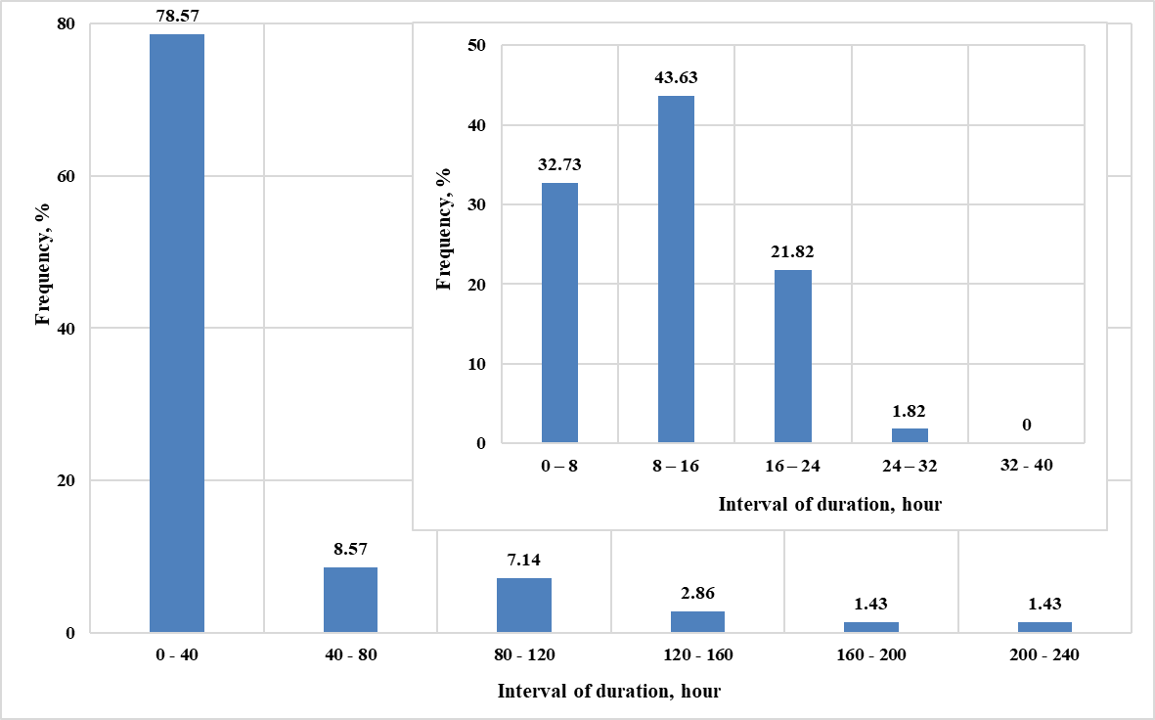
FIGURE 2. Distribution of duration of freezing cycles

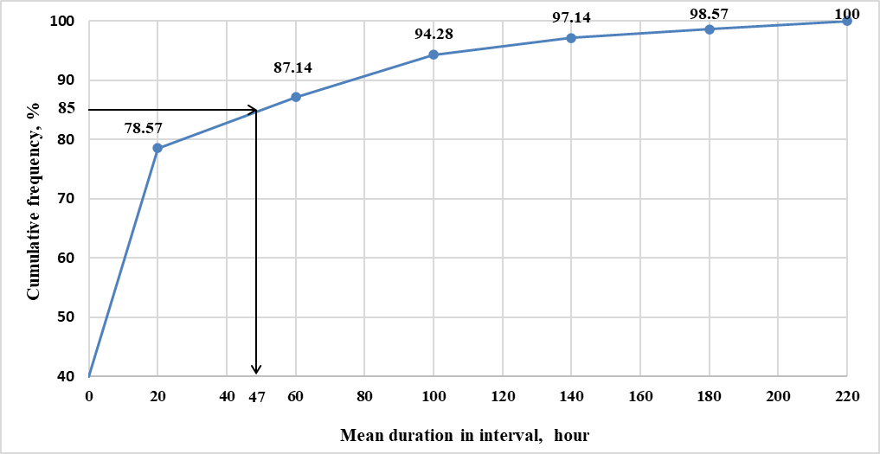
FIGURE 3. Cumulative curve of freeze cycles duration

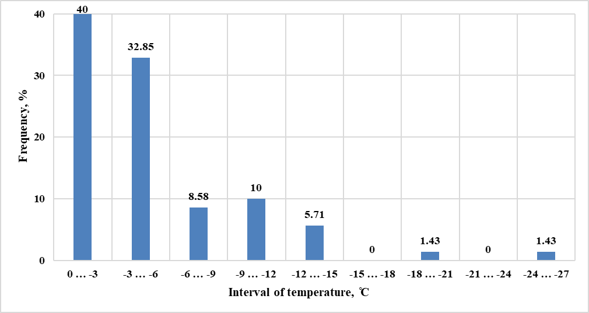
FIGURE 4. Distribution of minimum temperatures in freezing cycles

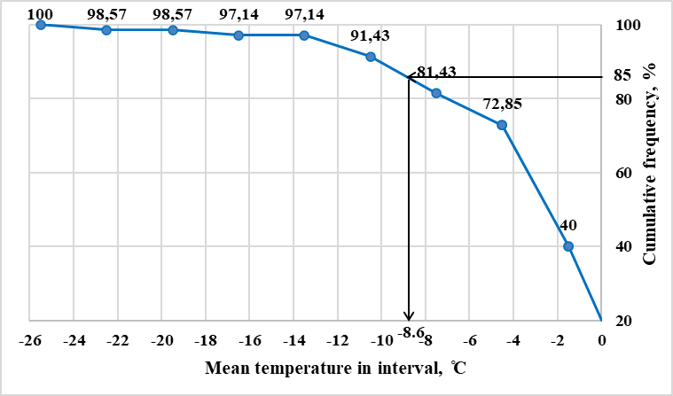
FIGURE 5. Cumulative curve of minimum temperatures in freezing cycles

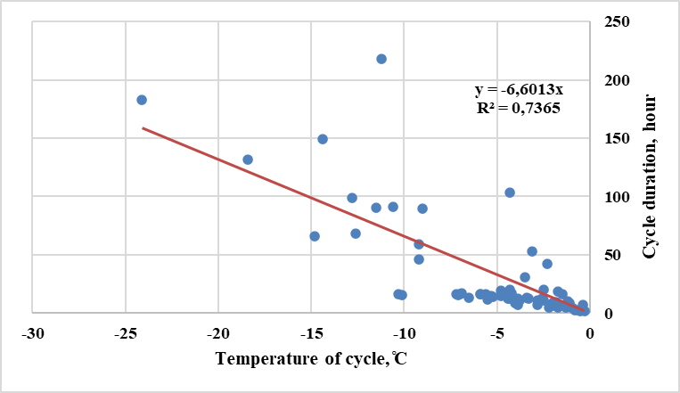
FIGURE 6. Relationship between durations and minimum temperatures of freezing cycles

Temperature on Different Days of the Cold Period
Figures 7–13 show the temperature change graphs in the layers of the road pavement and the subgrade soil on the experimental section on different days of the cold period under consideration.
Analysis of these graphs shows that, as expected, only the upper part of the road pavement structure (up to a depth of about 25 cm) is sensitive to daily changes in ambient (air) temperature. The rest of the road pavement structure and the subgrade soil are relatively stable in terms of temperature. Their temperature changes gradually and more slowly in a year cycle.
As a rule, only the asphalt concrete pavement (the upper asphalt concrete layer of the road pavement) is subjected to daily cyclic freezing. In this case, the temperature is negative at night and in the morning, and positive during the day.
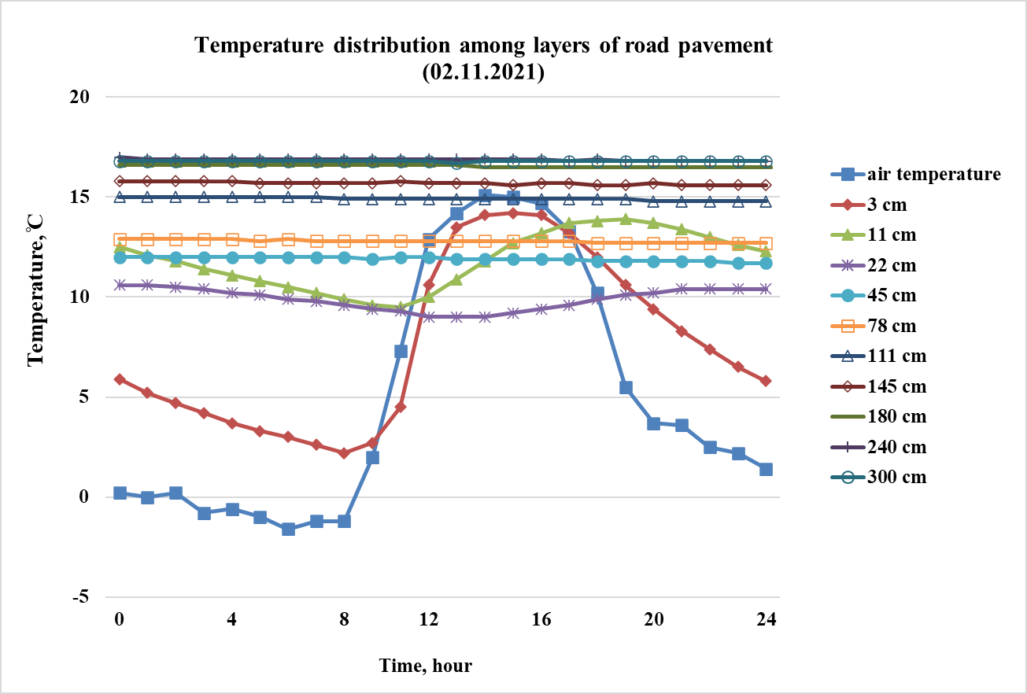
FIGURE 7. Daily temperature distribution in road pavement layers and subgrade (November 2, 2021)

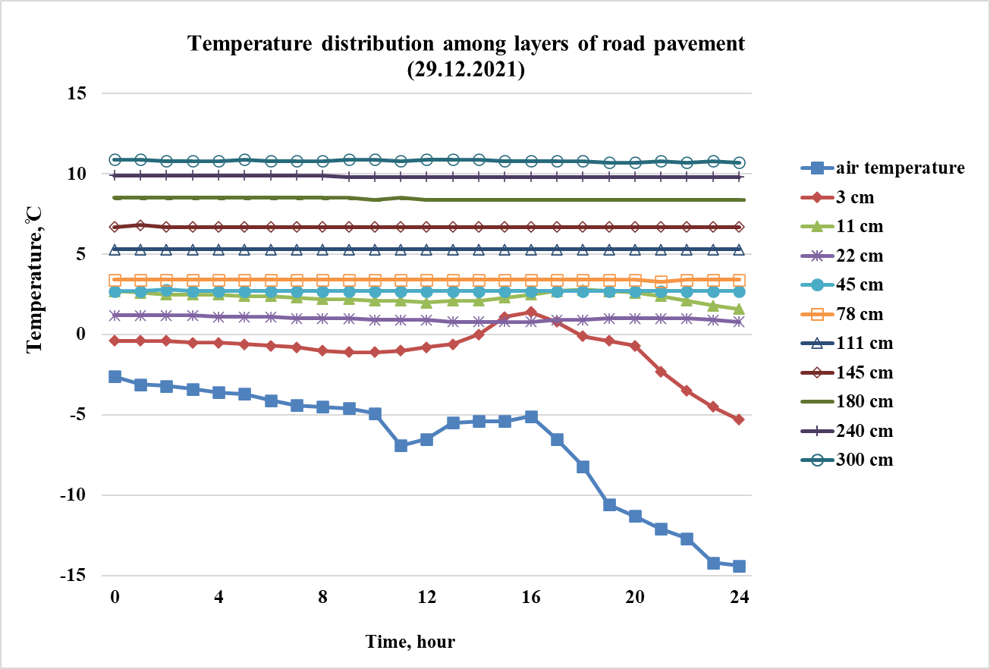
FIGURE 8. Daily temperature distribution in road pavement layers and subgrade (December 29, 2021)

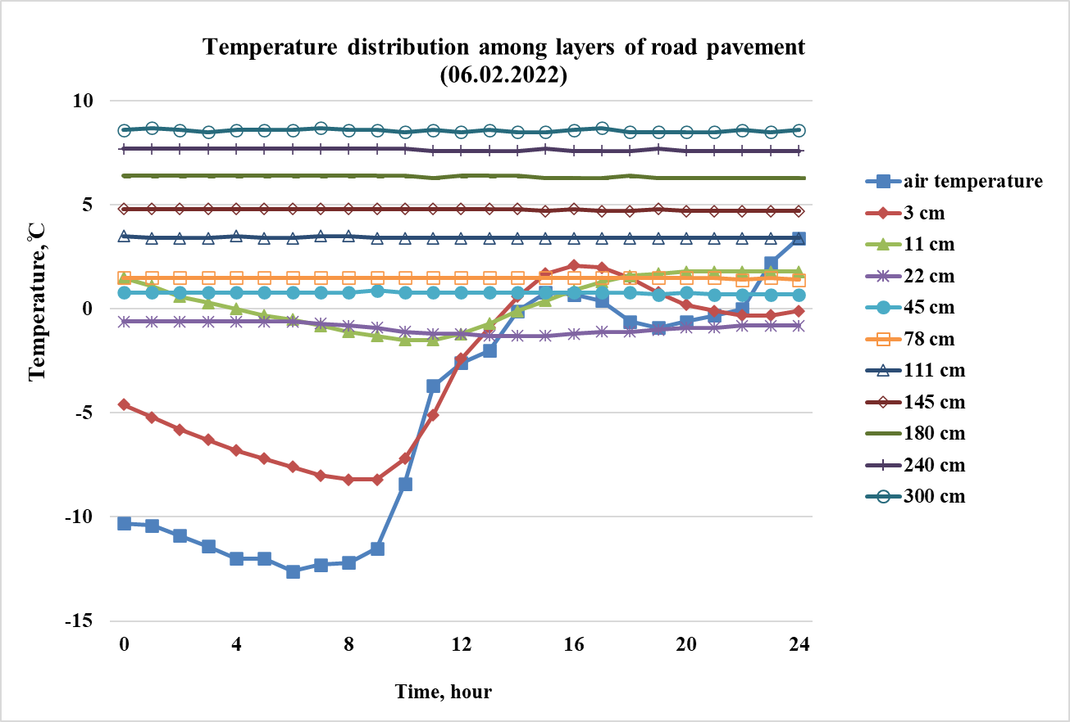
FIGURE 9. Daily temperature distribution in road pavement layers and subgrade (February 6, 2022)

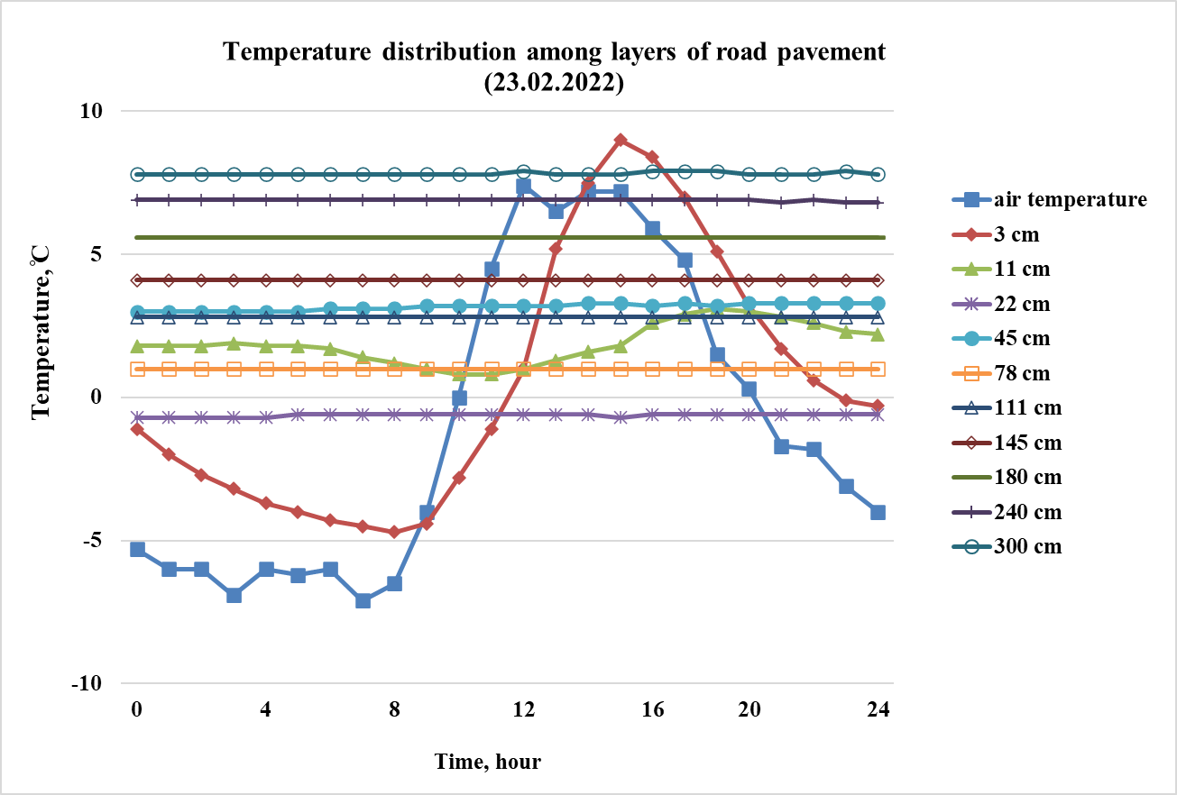
FIGURE 10. Daily temperature distribution in road pavement layers and subgrade (February 23, 2022)
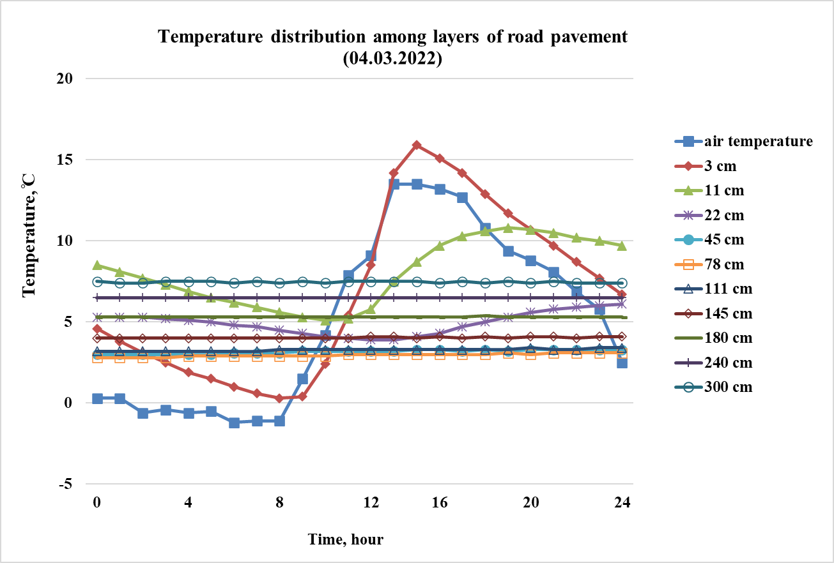
FIGURE 11. Daily temperature distribution in road pavement layers and subgrade (March 4, 2022)

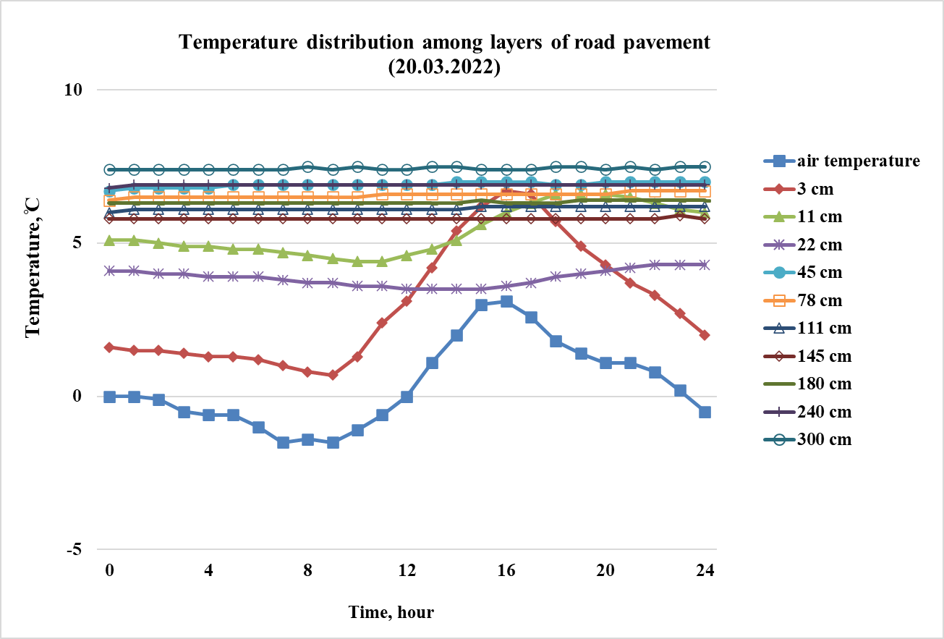
FIGURE 12. Daily temperature distribution in road pavement layers and subgrade (March 20, 2022)

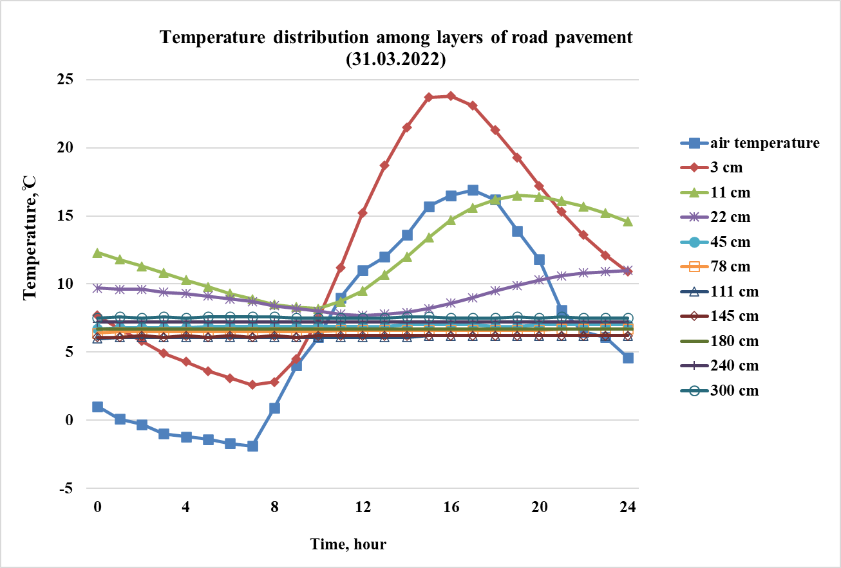
FIGURE 13. Daily temperature distribution in road pavement layers and subgrade (March 31, 2022)

Conclusions
1. During the cold season of 2021-2022, there were 70 cycles of freezing and thawing of the road asphalt pavement surface. Of these, 60 cycles occurred during the autumn and winter stable periods of cyclic freezing and thawing, while only 10 cycles occurred during the spring unstable periods of cyclic freezing and thawing.
2. Most (78.57%) of the freezing cycles were no longer than 40 hours. The most common cycles were short-term, lasting between 8 and 16 hours (43.63%).
3. More than 81% of the freezing cycles have a minimum temperature between 0 and -9 °C, while 72% of all cycles have a minimum temperature between 0 and -6 °C. Cycles with temperatures below -12 °C accounted for less than 9%.
4. There is a correlation between the characteristics (duration and minimum temperature) of the FT cycles. As the temperature decreases, the duration of the cycles increases. The correlation is stronger for cycles with a shorter duration (up to approximately 50 hours).

References
- E. J. Yoder and M. W. Witczak, Principles of pavement design (Wiley, New Jersey, 1975), pp. 1–736.
- A. T. Papagiannakis and E. A. Masad, Pavement design and materials (Wiley, New Jersey, 2008), pp. 1–560.
- B. Teltayev, Evaluation of Low Temperature Cracking Indicators of Hot Mix Asphalt Pavement, International journal of pavement research and technology, 7(5), pp. 343-351, (2014).
- B. Teltayev, A. Baibatyrov and E. Suppes, Characteristics of highway subgrade frost penetration in regions of the Kazakhstan, (15th Asian Regional Conference on Soil Mechanics and Geotechnical Engineering, ARC 2015: New Innovations and Sustainability, 2015), pp. 1664-1668.
- B. Teltayev and K. Aitbayev, Modeling of transient temperature distribution in multilayer asphalt pavement, Geomechanics and Engineering, 8(2), pp. 133-152, (2015).
- B. Teltayev and K. Aitbayev, Modeling of temperature field in flexible pavement, Indian Geotechnical Journal, 45(4), pp. 371-377, (2015).
- B. Teltayev and B. Radovskiy, Low temperature cracking problem for asphalt pavements in Kazakhstan, (RILEM Bookseries, 2016), 13, pp. 139-144.
- B. Teltayev and E. Suppes, Regularities for temperature variation in subgrade of highway, Geomechanics and Engineering, 13(5), pp. 793-807, (2017).
- B. Teltayev and B. Radovskiy, Predicting thermal cracking of asphalt pavements from bitumen and mix properties, Road Materials and Pavement Design, 19(8), pp. 1832-1847, (2018).
- B. Teltayev, J. Liu and E. Suppes, Distribution of temperature, moisture, stress and strain in the highway, Magazine of Civil Engineering, 83(7), pp. 102–113, (2018).
- B. Teltayev and E. Suppes, Temperature and moisture in a highway in the south of Kazakhstan, Transportation Geotechnics, 21, 100292, (2019).
- B. Teltayev, G. Loprencipe, G. Bonin, E. Suppes and K. Tileu, Temperature and moisture in highways in different climatic regions, Magazine of Civil Engineering, 100(8), (2020) doi:10.18720/MCE.100.11.
- ST RK 1218-2003. Materials based on organic bidders for road and airfield construction. Test methods. (Astana, 2003).
- ST RK 1225-2019. Road, airfield asphalt concrete mixtures and asphalt concrete. Technical specifications. (Astana, 2019).

