Impact of Nanostructuring Burnishing and Deformation Profiling of Lubricating Microcavities on Tribological Properties of AISI 3135 Steel Surfaces
Igor V. Tatarintsev^{1, a)}, Viktor P. Kuznetsov^{1, b)} and Kazokboy Mamosaliev²
¹Ural Federal University, 19 Mira St., Ekaterinburg, 620062, Russia
²Samarqand davlat arxitektura-qurilish universiteti, Lolasor, 70, Samarkand, 140143, Uzbekistan
^{a)} frunix@yandex.ru
^{b)} Corresponding author: wpkuzn@mail.ru
Abstract. This paper investigates the improvement of tribological properties of an AISI 3135 steel surface by using a multi-transition technology that forms a nanostructured surface with lubricating microcavities and includes finish turning, nanostructuring burnishing, deformation profiling of microgrooves by a honing stone, and flat-topped smoothing of microblades. After being subjected to nanostructuring burnishing, the surface had the roughness of Sa = 241 nm and microhardness of 650 HV_{0.025}. Creation of lubricating microcavities with the depth of 2 to 7 µm and width of 15 to 70 µm increased the oil absorption of the surface from Sv = 29 nm³/nm² to Sv = 322 nm³/nm² while reducing the bearing surface only by 10%. We assessed the changes in the coefficient of friction and wear rate of formed surfaces after 3 passes of nanostructuring burnishing and deformation profiling of lubricating microcavities. After a 24-hour thrust washer testing on a CETR UMT-3MT tribometer using a crown made of AISI 52100 tempered steel, we established that the formation of microcavities reduces the wear rate by 3.5 times. Specific surface wear rate after nanostructuring burnishing with three tool passes was k = 6.53*10⁻¹⁶ m³/Nm. This parameter of a similar surface with lubricating microcavities was k = 1.847*10⁻¹⁶ m³/Nm.

INTRODUCTION
One of the modern challenges of tribology and machine-building is the improvement of surface wear resistance of tribological assemblies made of construction steels. In this area of research—improvement of surface properties—combined finish machining that includes microprofile burnishing, hardening, and formation of lubricant-retaining microcavities shows a lot of promise. This machining method simultaneously hardens the surface layer and creates oil-filled microcavities that reduce wear. Recent studies have confirmed that a combination of burnishing with formation of a micro-texture can significantly increase wear-resistance of steels by lowering roughness, hardening the surface and improving the lubrication conditions.
Burnishing is a method of plastic deformation of the surface layer that uses a special tool with applied pressure [1], designed to significantly reduce the original roughness of and form a hardened layer with fine-grained nanocrystalline structure in the material. It has been experimentally demonstrated that this type of finish machining significantly increases microhardness and forms compression residual stresses in the surface layer, directly improving wear resistance [2]. Swirad et al. showed that ball burnishing of 42CrMo4 steel disks reduces average roughness by 85% and increases microhardness by 20% as compared with a sample subjected to milling shortly beforehand.
Burnishing hardens austenic steels and improves their wear resistance. Another article [3] reports that machining of AISI 316L steel by ball burnishing resulted in an increase of microhardness by ~31% and a decrease of roughness Ra by ~80%. This reduces the wear volume in a dry friction test by 53–62%. Nanostructuring burnishing of AISI 304 steel increases the surface layer microhardness by 50% in comparison with turning, and provides a two-fold reduction of roughness parameters. Increasing the number of tool passes from 1 to 5 reduces the wear intensity from 3*10⁻¹⁴ to 1*10⁻¹⁴ m³/N*m in dry friction and from 9,4*10⁻¹⁵ to 6*10⁻¹⁵ m³/N*m in lubricated friction [4].
Thus, nanostructuring burnishing creates beneficial conditions for the increase of steel wear resistance by improving both the microprofile and the mechanical properties of the surface layer.
Another way to improve wear resistance is to form microgrooves that retain the lubricant and wear products on the regular microrelief surfaces. This friction surface micro-texturing improves the lubricating conditions, especially those that involve boundary and mixed friction lubricant. Numerous works have shown that optimal micro-texture parameters significantly reduce the coefficient of friction and wear rate. For example, laser formation of microgrooves on the surfaces of steels and alloys reduced the coefficient of friction to 40–80% (depending on the density and shape of the micro-texture) in T8 steel/AISI 316L and YT-15/15-5PH friction pairs [5][6]. In their experiments with reciprocating sliding of Al₂O₃ samples on 52100 steel, Wei et al. [7] demonstrated that microcavities on the surface reduce the coefficient of friction in dry and lubricated conditions; furthermore, higher density of microgrooves decreased friction.
“Thrust washer,” a tribological testing method, is designed to assess the wear resistance of materials in sliding with areolar contact. This test sees one flat sample (for example, a plate or disk) being pressed against another flat sample with axial force and engaging in relative rotation [8]. This method imitates the working conditions of thrust bearings and allows the operator to change the coefficient of friction and wear rate of materials while maintaining the set pressure and speed of sliding [9]. As a rule, this test is conducted in accordance with ASTM D3702 [10].
This paper aims to establish the impact of combined machining of an AISI 3135 flat surface by nanostructuring burnishing and deformation profiling of lubricating microcavities on the material’s tribological properties in lubricated conditions.

MATERIALS AND METHODS
In our research, we used disks with the thickness of 15 mm made of hot-rolled industrial AISI 3135 wire with the diameter of 60 mm as workpieces. Chemical composition of AISI 3135 (C: 0.38%; Si: 0.19%; Mn: 0.53%; S: 0.006%; P: 0.013%; Cr: 0.71%; Ni: 1.06%). The workpieces were heated at 860°С, held for 1 hour and subsequently cooled in oil. This was followed by a low tempering at the heating temperature of 250°С for 2 hours and air cooling. Post-heat treatment hardness was 45 HRC.
Surfaces of two workpieces were subsequently machined in one setup in turning and milling modes on an MA-600 (Okuma, Japan) machining center. Preliminary finish turning was done using a ZCC WNMG080408 carbide blade with the cutting depth of 0.3 mm, speed of 140 m/min, and feed of 0.07 mm/rev. This was then followed by nanostructuring burnishing (Fig 1, a) with n_{p} = 3 working passes by a tool with a synthetic diamond indenter with the radius of R = 2 mm, which used a Rhenus (Germany) coolant under the normal force of 300 N, feed of 0.025 mm/rev., and tool sliding speed of 80 m/min. After nanostructuring burnishing, the disks’ surfaces were subjected to deformation profiling of lubricating microcavities by a special tool equipped with a honing stone with the length of 20 mm, width of 4 mm, grit of 250/200 (Fig 1, b), pressing force of 250 N, and tool movement speed of 30 m/min. After deformation profiling, in order to obtain a flat-topped microrelief, we subjected the surfaces with microcavities to finish burnishing by a tool with a diamond spherical indenter with the radius of 6 mm, force of 300 N, feed of 0.2 mm/rev., and sliding speed of 80 m/min.

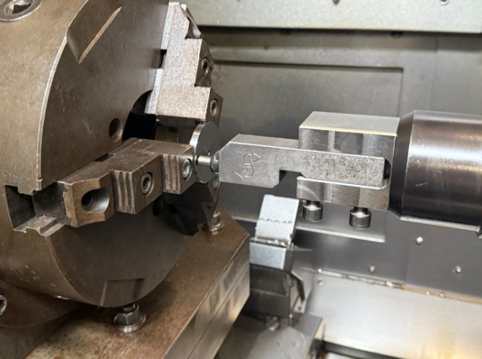 | 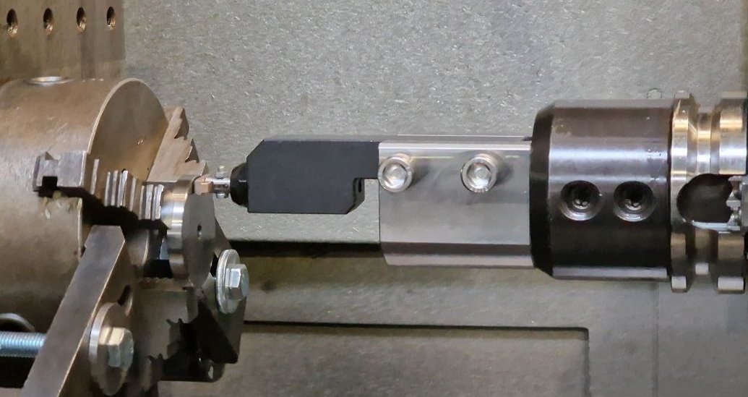
(a) | (b)
FIGURE 1. Nanostructuring burnishing (а) and deformation profiling of lubricating microcavities (b) on an MA-600 (Okuma, Japan) center.
Microhardness of the nanostructured disk surface was measured directly by using an AHOTECH ecoHARD XM1270C microhardness meter at the Vickers pyramid load of 0.25 N. The average values of microhardness were obtained from the results of 10 measurements on three sections of the disk.
Parameters of lubricating microcavities topography and linear wear of surfaces were analyzed using a Wyko NT-1100 3D-profilometer (the USA). Tribological properties of the nanostructured surface layer were studied by the thrust washer method that used a CETR UMT-3MT tribometer (the USA). An AISI 52100 crown with the external diameter of 36 mm, wall thickness of 3.5 mm, and hardness of 62 HRC was used as a counterbody. The tests were conducted in lubricated conditions, where the sample was submerged in a bath with SINTEC TM4 SAE 75W-90 transmission oil at 25°С (Fig. 2, а). Sintec 75W-90 is a synthetic API GL-5 class transmission oil. The disk rotated at the speed of ω = 0.04 m/s relative to the crown, at the normal load of F = 600 N for 24 hours, uninterruptedly.

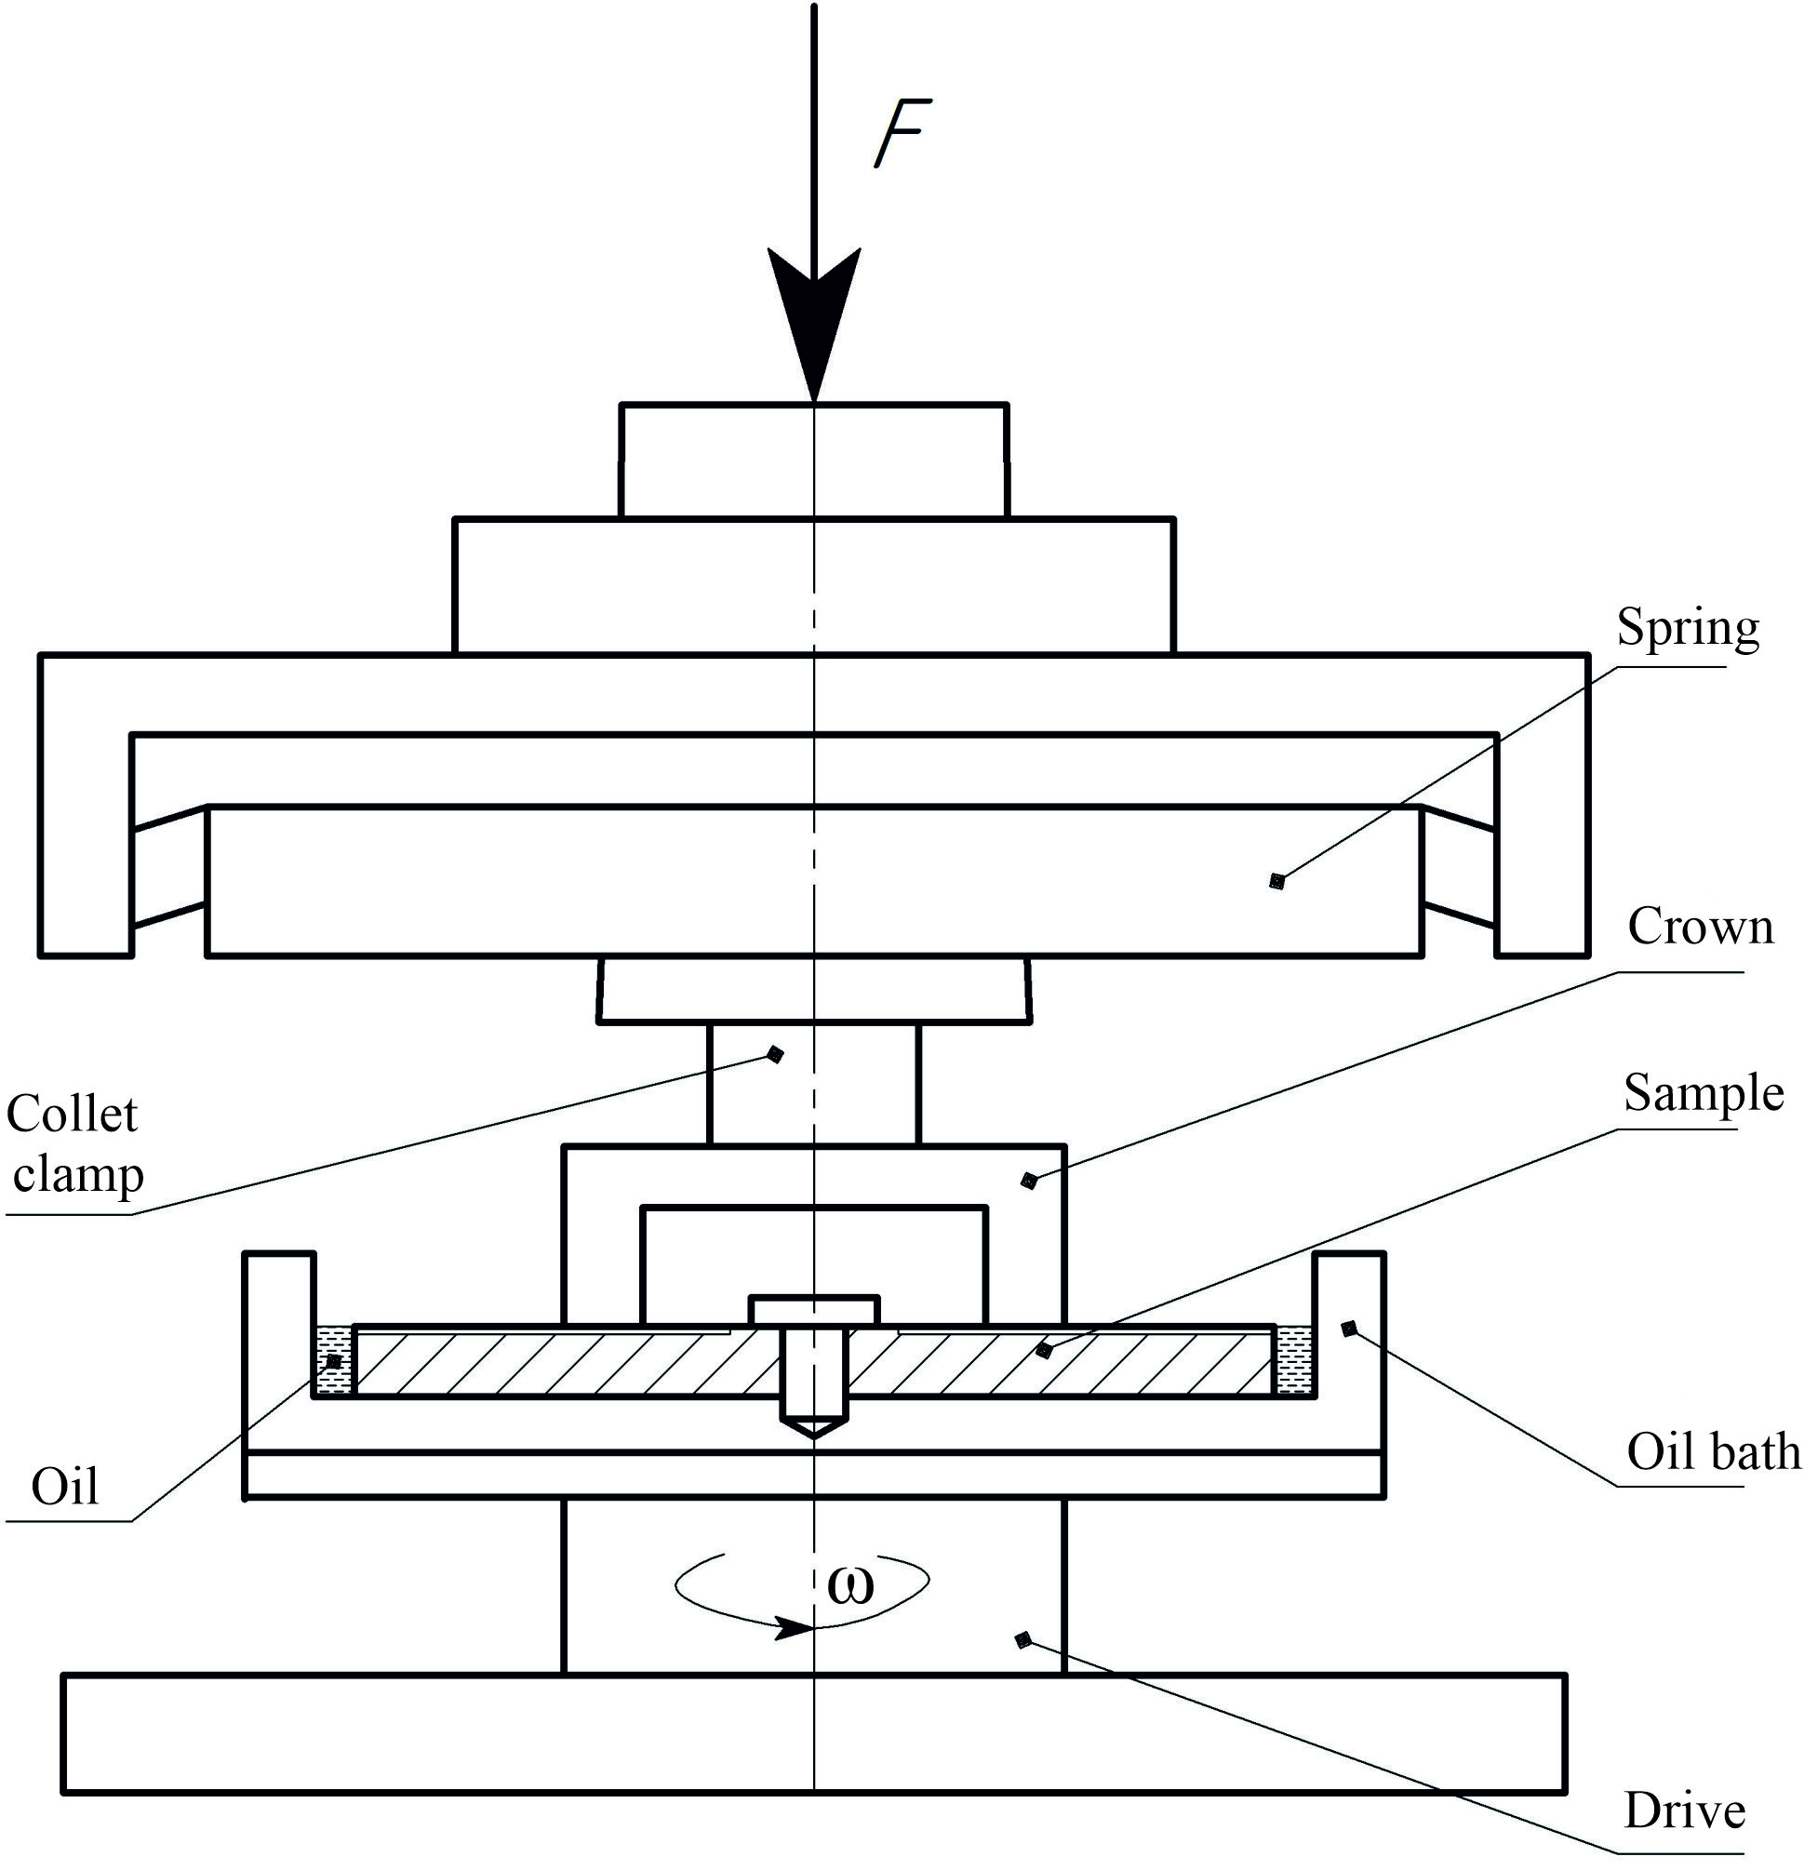 | 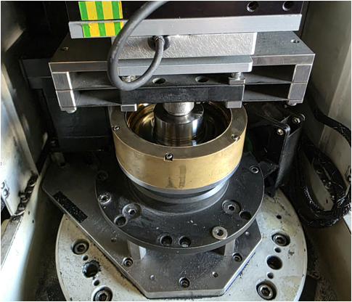
(a) | (b)
FIGURE 2. Experimental studies of tribological properties of disk surfaces in an oil environment on a CETR UMT-3MT (the USA) tribometer

Results of the test were processed via the Matlab, MountainMap, Wyko Vision, and Gwyddion software.
Determination of linear wear of the disk surfaces was done by 3D-scanning before and after tribological testing in order to obtain a clear digital image of the profile.

EXPERIMENTAL RESULTS
Initial microhardness after turning was measured at 545±5 HV_{0.025}; this parameter increased to 690±15 HV_{0.025} in the nanostructured surface. Surface topography after nanostructuring burnishing with three passes (Sn3) and the Abbott-Firestone curve are shown in Fig. 3.
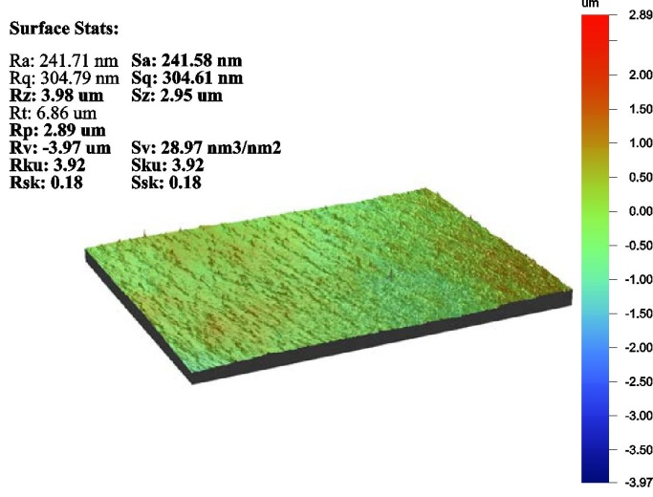 | 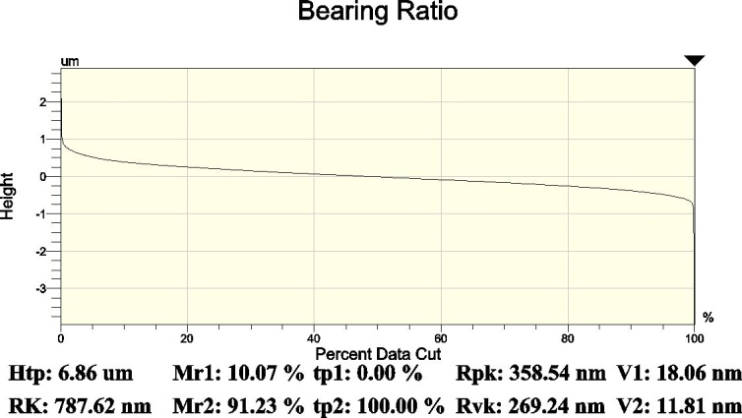
(a) | (b)
FIGURE 3. Topography and the bearing curve of the surface after nanostructuring burnishing.
The arithmetic mean of the area of microprofile heights was Sa=241 nm. The Ssk value is relatively low, which highlights the symmetry of the surface relative to the midline with slightly prevailing asperities.
The Abbott-Firestone curves indicate a high bearing capacity and sufficiently even distribution of microrelief elements; the bearing area occupied 81% (Fig. 3, b).
After a technological pass of the microcavity deformation profiling, the obtained surface Sn3LMC was characterized by height parameters Sa = 692 nm and Sq = 1.26 μm. The formation of lubricating microcavities by deformation profiling improved the surface’s oil-absorption capacity Sv. Fig. 4 (a, b) presents an example of a surface after deformation profiling and flat-topped smoothing. The Sku parameter rose to 12.23 and to 21.18 due to new cavities and asperities in the metal. This indicates a more developed surface topography.

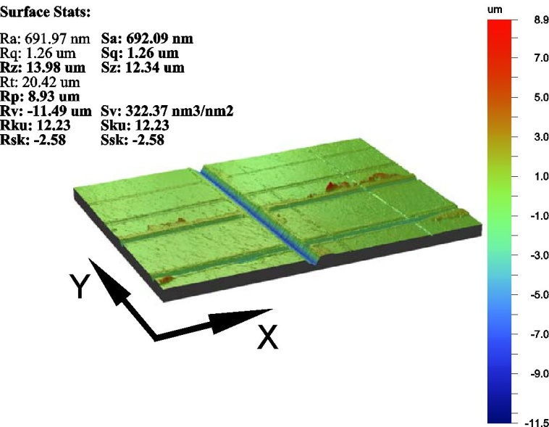 | 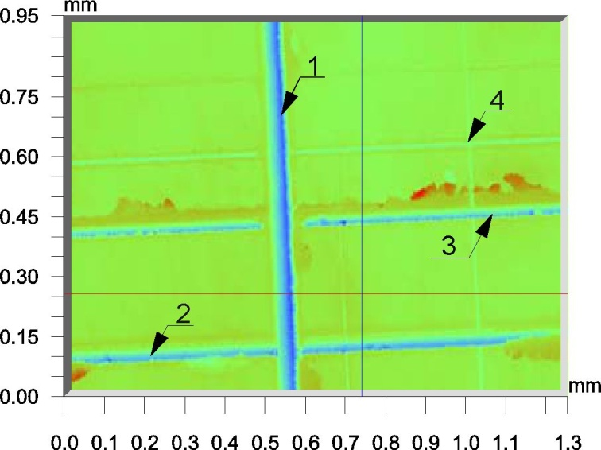
(a) | (b)
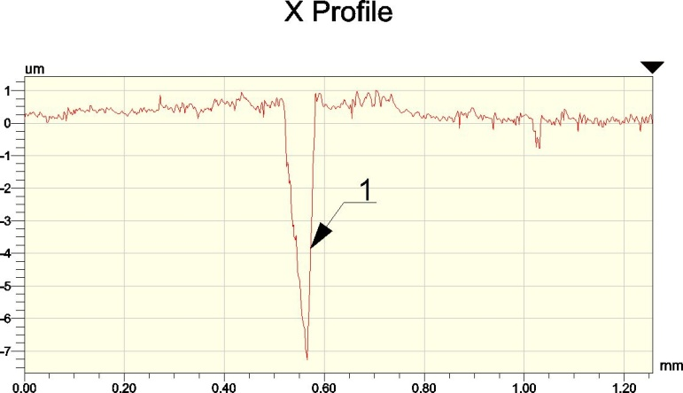 | 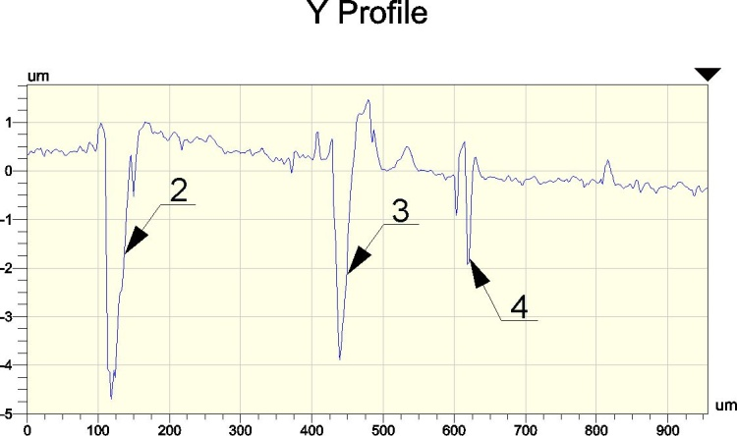
(c) | (d)
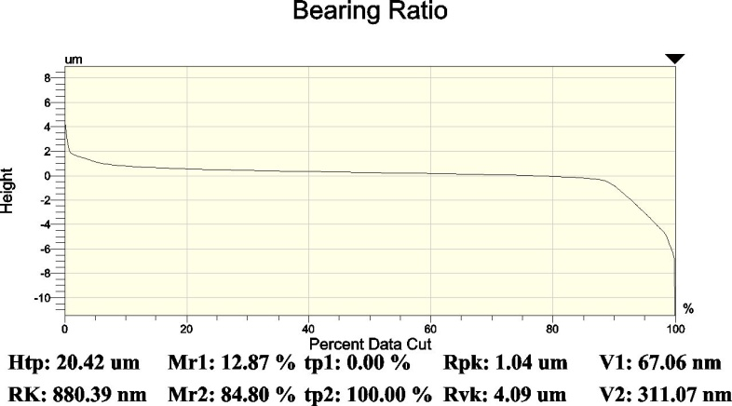
(e)
FIGURE 4. Surface topography after deformation profiling, 3D (а) and 2D (b), profilograms facing the axes Х (с) and Y (d), the Abbott-Firestone curve (е).
The depth of lubricating microgrooves was from 2 to 7 μm, their width was from 15 to 70 μm (Fig. 4 (c, d)). We observed that, after lubricating microcavities are formed on a hardened surface, it retains flatness and high bearing area values (72%) (Fig. 4, e).
Figure 5 shows photos of samples after the tribological testing of the nanostructured surfaces SFn3 (а) and the hardened surface with lubricating microcavities SFn3LMC (b). Four mutually perpendicular areas were selected on the wear tracks with the width of 3.5 mm, which is equal to the thickness of the crown wall. A series of five 3D-profilograms of each of those areas was then taken. The profilograms of each area were merged using the MountainMap software, which also calculated the volume of material that had been removed in contact interaction.

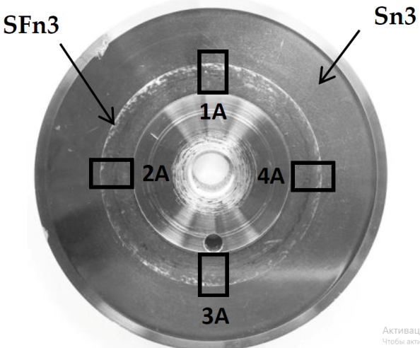 | 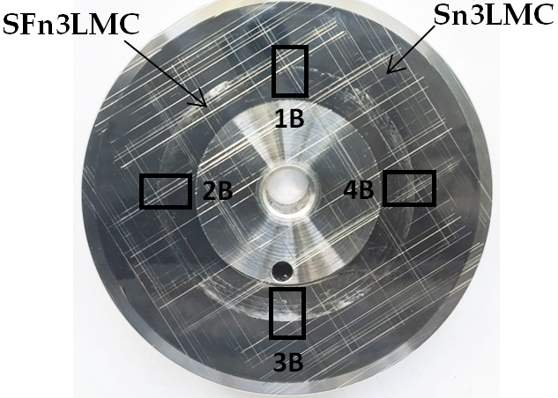
(a) | (b)
FIGURE 5. AISI 3135 steel samples after tribological testing of nanostructured surfaces SFn3 (а) and with lubricating microcavities SFn3LMC (b).

Mechanical equivalent radius of the crown was calculated using the following formula:
$R_{eff}\text{=}\frac{D_{o}\text{+}D_{i}}{4}$, (1)
where D_{o} and D_{i} are the inner and outer diameter of the counterbody crown, respectively.
Coefficient of friction (COF) was calculated using the moment T_{Z}, normal force F_{Z} and the R_{eff} parameter, as registered by the tribometer:
$COF\text{=}\frac{Tz}{R_{eff}∙F_{z}}$ (2)

Tribological assembly testing period of 24 hours is significantly longer than the system break-in time. This duration of the experiment allowed us to register not only initial transitional processes, but also stable friction state which is the stage when mechanisms that determine the wear resistance of the surface are manifested. Continued sliding in boundary friction conditions makes this experiment as strict as possible, providing an opportunity to discover long-term patterns of surface layer degradation. By using the discovered friction patterns, it is possible to assess the real wear resistance reserves of hardened surfaces and compare the effectiveness of different nanostructuring burnishing modes.
The normal load of 600 N on a ring contact area of 357 mm² generates specific pressure of p≈1.68 MPa, characteristic of bearing disks and friction-type bearings in transmission assemblies at low sliding speeds [12]. This means that the selected conditions, in fact, simulate real-life loads.
During the tribological experiments, we observed multiple specific stages that reflected the evolution of the coefficient of friction.
Figure 6 plots how the coefficient of friction changed depending on the time elapsed since the beginning of the tribological testing for surfaces formed by either nanostructuring burnishing or nanostructuring burnishing with deformation profiling of lubricating microgrooves.

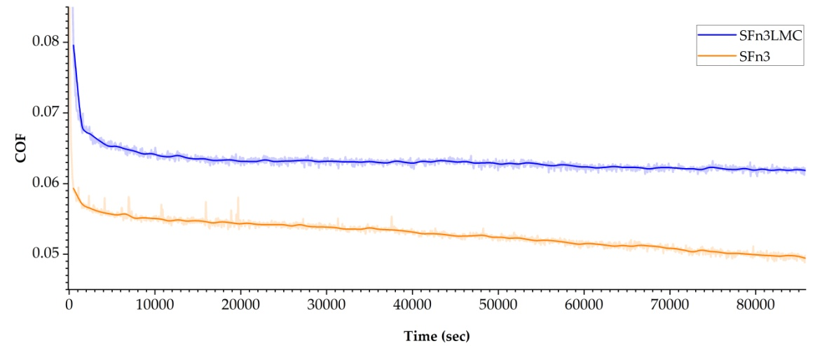
FIGURE 6. Evolution of an AISI 52100 crown’s coefficient of friction on a surface of AISI 420 steel modified by nanostructuring burnishing and deformation profiling of lubricating microcavities.

The area of the sample surface that was in contact with the counterbody mostly retained the initial microrelief formed by nanostructuring burnishing (Fig. 7, а). The surface that was in direct contact with the counterbody was partly deformed or severed. We observed abrasive wear tracks (the dominating wear type), which, however, were not catastrophic and only presented partial destruction and crumbling of the contact surface. Based on the data received from Mountain Maps and the Wyko NT-1100 (the USA) profilometer, we established the area parameters S_{w} and wear volume V_{w} of wear tracks, as well as the maximum and average cavity depth and asperity height (Table 1).

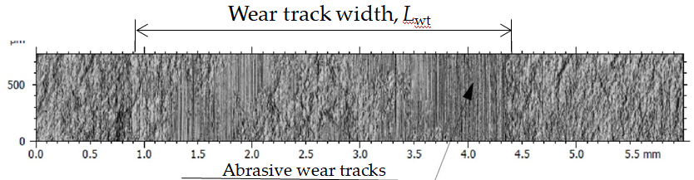
(a)
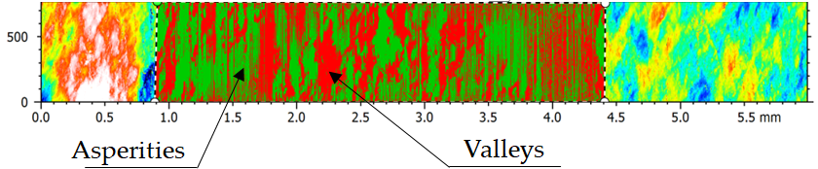
(b)
FIGURE 7. Surface area 3А of the SFn3 sample after the tribological testing.

The average depth of cavities formed in the process of wear was 0.36–0.41 μm, the maximum depth was ~2.27 μm (Fig. 7, b). The nature of the nanostructured surface wear demonstrates indicators of high resistance against plastic deformation. At the beginning of the testing, the surface was exhibiting limited destruction of contact peaks, without transition to the catastrophic wear phase. At this time, the foundation of the microrelief functions as a bearing structure, forming a robust lubricating film that allows for stable operation for prolonged periods, hindering the transition to the intensive wear mode. The specific average wear volume was 0.384 μm³/μm ².

Figure 8 presents a surface area with lubricating microcavities after 24 hours of tribological testing; this image was obtained by merging 5 profilometer pictures sized 0.95*1.3 mm.

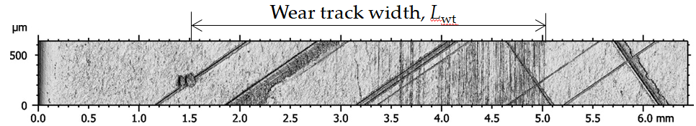
(a)
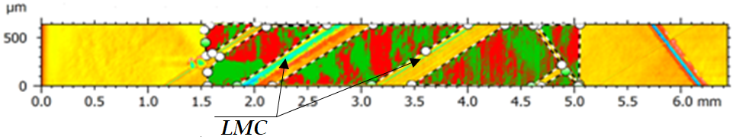
(b)
FIGURE 8. Surface area 3B of the SFn3LMC sample after tribological testing.

Along the entire friction track L_{wt}, there are tracks of abrasive action with the depth of 0.09 to 0.9 μm. Directions of wear tracks match that of the counterbody’s rotation. In addition to wear tracks, the surface exhibits local traces of micro-delamination. The specific volume of worn material was 0.1043 μm³/ μm² (Table 1). This indicates that lubricating microcavities provide for milder wear.
The specific surface wear rate was calculated using the classic Archard formula [13], which accounted for the established wear path l_{μ}, normal counterbody load F and worn material volume V_{μ}.
(3)
The worn material volume V_{μ} was calculated as the specific volume loss ω multiplied by the surface area of contact with the crown А. The specific volume loss ω was calculated as the lost volume V_{w} divided by the area S_{w}, which were determined by measuring the friction track surface profile with the width of L_{wt} on a 3D-profilometer.

TABLE 1. Friction track surface parameters in the analyzed area
Friction track parameters | Unit | SFn3 |  | SFn3LMC
Friction track parameters | Unit | Cavities | Asperities | Cavities | Asperities
Area S_{w} | μm² | 2,083,350 | 436,473.3 | 824,173 | 828,420
Volume V_{w} | μm³ | 799,775.5 | 72,558.75 | 85,964.3 | 88,088
Specific volume loss ω | mm³/mm² | 0.384 |  | 0.1043
Maximum depth/height | μm | 2.26175 | 1.81525 | 1.2737 | 1.308
Average depth/height | μm | 0.38055 | 0.163175 | 0.2887 | 0.1266
Specific wear rate, k | *10⁻¹⁶, m³/Nm | 6.53 |  | 1.847

CONCLUSION
This technology enables its users to implement a highly efficient process of hardening and wear resistance improvement of flat surfaces by the formation of a nanostructured state of the steel and oil-retaining microrelief on the workpiece in a single setup on a machining center. Owing to the higher hardness of the disk surface after nanostructuring burnishing (690 HV_{0.025}), the geometry of lubricating microcavities remains unaltered, which significantly reduces wear.
Lubricating microcavities hold the lubricant and feed it to the contact zone in a stable manner. Without microcavities, the lubricant is distributed less evenly, leading to local tears, thinning of the film and periodic transitions to dry friction.

Acknowledgments
Funding from the Ministry of Science and Higher Education of the Russian Federation (Ural Federal University, State Assignment No. 075-03-2025-258 dated 17.01.2025 (FEUZ-2024-0020)

References
- V. P. Kuznetsov, I. V. Tatarintsev, V. V. Voropaev, and A. V. Korelin, Facta Univer. Ser. Mech. Eng. 22(3), 459–471 (2024).
- S. Swirad, A. Gradzik, K. Ochał, and P. Pawlus, Sci Rep 13(1), 11315 (2023).
- H. Yilmaz and R. Sadeler, Surf. Coat. Tech. 363, 369–378 (2019).
- V. Kuznetsov, I. Tatarintsev, V. Voropaev and A. Skorobogatov, Mater. 17(22), 5656 (2024).
- Y. Wan and D.-S. Xiong, J. Mater. Process. Technol. 197, 96–100 (2008).
- X. Hao, H. Li, X. Song, L. Li and N. He, J. Micro Nano-Manuf. 6, 021001 (2018).
- Y. Wei, J. Resendiz, R. Tomkowski and X. Liu, Micromach. 13(1), 70 (2022).
- T. Wei, Z. Zhou, X. Ling, M. Lv, Y. Di, K. Qin and Q. Zhou, Metals 14(12), 1385 (2024).
- K. Qin, Q. Zhou, K. Zhang and M. Lv, Mater. 14(14), 3820 (2021).
- ASTM D3702 “Standard Test Method for Wear Rate and Coefficient of Friction of Materials in Self-Lubricated Rubbing Contact Using a Thrust Washer Testing Machine”.
- V. P. Kuznetsov, I. Yu. Smolin, A. I. Dmitriev and S. Yu. Tarasov, AIP Conf. Proc. 1683(1), 020119 (2015).
- R. G.Van Ryper and K. Murakami, SAE Techn. Paper. 109, 1152 (2000).
- J. F. Archard, J. Appl. Phys. 24(8), 981–988 (1953).

