Tribological Comparison of Engineering Polymers in Dry Contact With 6061-T6 Alloy
Safa Unal^{1, a)} and Haci Abdullah Tasdemir^{1, b)}
¹Department of Mechanical Engineering, Istanbul Technical University, Istanbul, Turkiye

^{a)} Corresponding author: unalsa23@itu.edu.tr
^{b)} tasdemirh@itu.edu.tr
Abstract. In this study, four widely used high-performance polymers polyoxymethylene copolymer (POM-C), polytetrafluoroethylene (PTFE), polyamide-6 (PA-6), and cast polyamide-6 (PA-6G) were systematically evaluated under dry sliding conditions when paired with 6061-T6 aluminum alloy as the tribological counterpart. Frictional properties were examined through tribometer measurements to determine the average coefficients of friction, while wear rates were analyzed using the optical profilometry method. The results showed that PA-6G exhibited the best overall tribological performance, having the lowest coefficient of friction (0.16) and the lowest wear rate (1.87%). PA-6 demonstrated the second-best performance with a friction coefficient of 0.22 and an approximate wear rate of 7.87%. Although PTFE exhibited a relatively low coefficient of friction (0.28), it showed a considerably high wear rate (22.10%). POM-C, compared to the other tested polymer samples, presented the highest coefficient of friction (0.34) and a high wear rate (25.84%), indicating poor tribological performance. The aluminum counterpart material (6061-T6) exhibited the highest wear rate of 42.32%. In this study, POM-C, PTFE, PA-6, and PA-6G polymers, which have been frequently reported in recent literature, were comparatively evaluated under identical test conditions to contribute to both industrial applications and the academic community.

INTRODUCTION
High-performance polymers such as polyoxymethylene copolymer (POM-C), polytetrafluoroethylene (PTFE), cast polyamide-6 (PA-6G), and polyamide-6 (PA-6) are widely used in fields such as aerospace, automotive, and mechanical engineering due to their numerous advantageous properties, including low friction coefficients, high wear resistance, and long service life in operational systems. In contemporary engineering applications, these materials have increasingly become preferred alternatives to conventional engineering components owing to their durability, ease of assembly and maintenance, and lightweight characteristics [1–4]. Therefore, the tribological evaluation of frequently utilized polymers such as POM-C, PTFE, PA-6G, and PA-6 is highly important both for industry particularly for R&D engineers involved in material selection during the design stage and for academia, as it contributes to the literature and provides insight into new solutions. However, a review of the literature reveals that although these polymers have been widely reported as commonly used materials, they have often been examined separately under different testing conditions. Consequently, a lack of comparability has emerged in the material selection and academic assessment processes [5–17]. In this context, the present study conducted tribological evaluations of high-performance polymers recently reported to be extensively used in industry under identical test conditions, and the obtained findings were systematically analyzed.

EXPERIMENTAL
In this study, all test specimens were meticulously prepared following the geometric and material specifications prescribed by the ASTM G133 standard. Pin samples, fabricated from 6061-T6 aluminum alloy, are detailed in terms of dimensions in Fig. 1a. The counterpart materials against which these pins were slid during tribological testing included PTFE, PA-6G, POM-C, PA-6, and 6061-T6 aluminum alloy, with their shapes and dimensions illustrated in Fig. 1b. These commercially obtained materials are well-established for their widespread application in various industrial settings. The hardness and surface roughness (R_{a}) values of each material, measured using an optical profilometer, are provided in Fig. 2. Throughout the experiments, the pin specimens were reciprocally slid against the selected counterface materials to simulate realistic frictional interactions under controlled conditions.

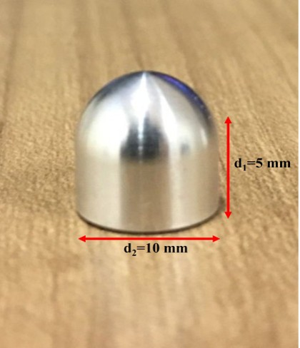 | 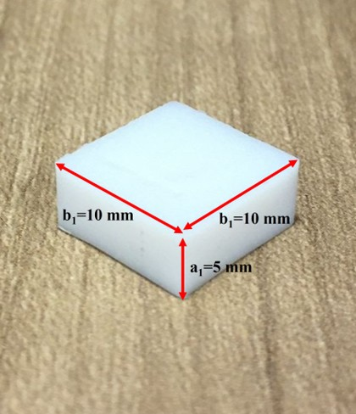
(a) | (b)
Figure 1. Specimen geometries used in this study: (a) cylindrical pin specimen; (b) rectangular prism-shaped counterface specimen.
Tribological tests were performed using a tribometer equipped with a linear reciprocating motion module (Fig. 3). Specimen surfaces were meticulously prepared both before and after each test. This preparation protocol aimed to minimize the influence of potential contaminants and surface impurities on the test outcomes. Initially, surface oils and particulate residues were removed using benzene cleaning, followed by an ultrasonic bath treatment with acetone to eliminate any remaining contaminants completely. This two-step cleaning procedure ensured that the specimen surfaces were thoroughly free of impurities, enabling reliable evaluation of tribological performance. Unless otherwise specified, this standardized cleaning protocol was consistently applied throughout all experiments.

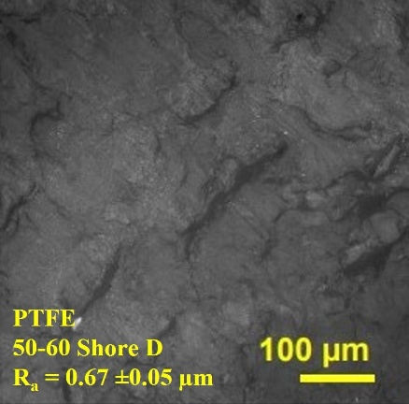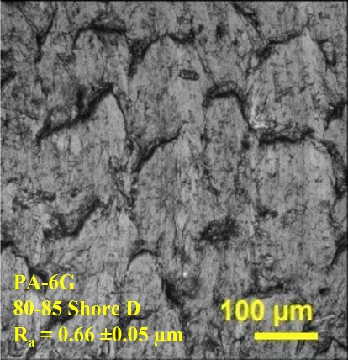
(a) (b)
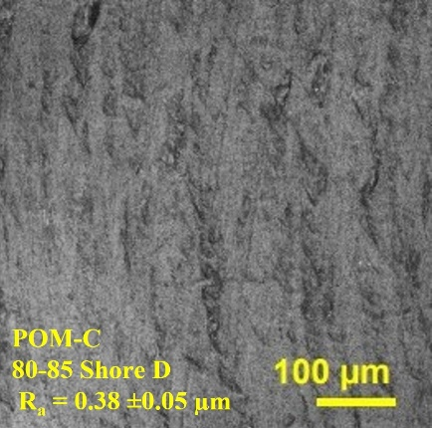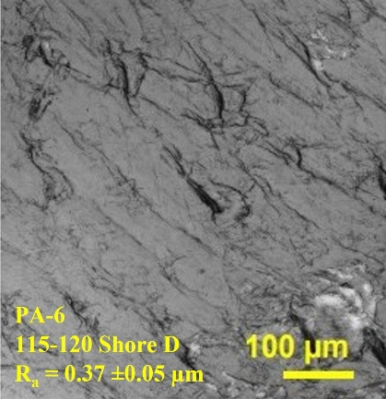
(c) (d)
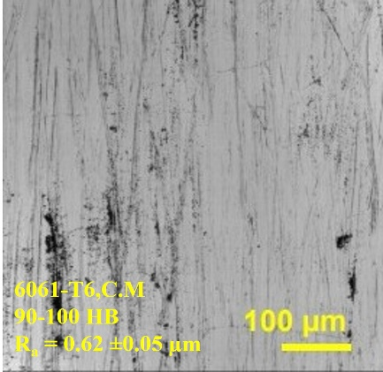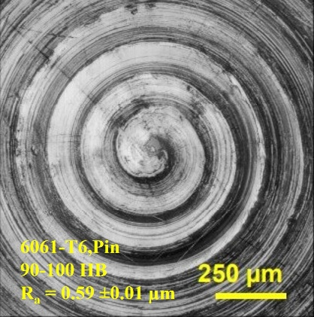
(e) (f)
FIGURE 2. Optical profilometer images and corresponding hardness and surface roughness (R_{a}) values of the tested materials: (a) PTFE (counter material), (b) PA-6G (counter material), (c) POM-C (counter material), (d) PA-6 (counter material), (e) 6061-T6 aluminum alloy (counter material), and (f) 6061-T6 aluminum alloy (pin material).

Tribological tests were carried out employing a reciprocating setup where a ball slid against a flat specimen. During the experiments, a constant normal load of 5 N was applied, and the reciprocating motion was driven at a frequency of 5 Hz, resulting in an estimated initial peak Hertzian contact pressure of approximately 107 MPa. The tests were performed at a steady sliding speed of 0.06 meters per second. Each test lasted for 1833 seconds, corresponding to a total sliding distance of 110 meters. To isolate the inherent tribological properties of the materials, all tests were conducted under dry conditions without lubrication. Environmental factors were strictly controlled, maintaining an ambient temperature of 24 °C and relative humidity at 39%. Each experimental condition was repeated four times to ensure the reliability and reproducibility of the results. Following the tests, wear tracks on the samples were examined using a Zeiss optical profilometer, providing detailed, high-resolution images of the wear morphology.

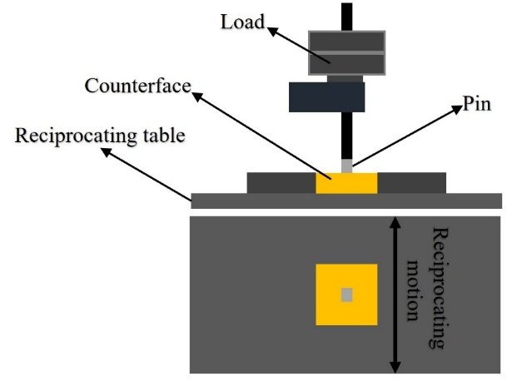
Figure 3. Tribometer setup employed in the tribological experiments, featuring a linear reciprocating motion module.

RESULT AND DISCUSSION
Figure 4a presents the steady-state coefficients of friction (COF) for PTFE, PA-6G, POM-C, PA-6, and 6061-T6, obtained from dry sliding tests against a 6061-T6 aluminum pin. In addition, Fig. 4b illustrates the variation in friction force over the course of the experiments, whereas Fig. 4c presents the mean force values together with their associated standard errors. The steady-state stage, defined as the period in which the interfacial conditions attained dynamic equilibrium [18], was marked by stable friction levels across all materials, with negligible oscillations. A distinct ranking in tribological performance emerged: PA-6G exhibited the lowest COF (~0.16) and mean friction force (~0.79 N), maintaining outstanding stability from the beginning to the end of the test. This behavior can be attributed to its semi-crystalline architecture and inherent lubricating ability, which mitigate adhesive junction formation and reduce frictional resistance [19–22]. PA-6 followed, with a COF of ~0.22 and a mean force of ~1.10 N, consistent with prior findings [23], where its elasticity and adaptive contact behavior were shown to distribute stresses more evenly and promote friction stability under unlubricated conditions [21]. PTFE displayed intermediate performance, with a COF of ~0.28 and mean force of ~1.41 N. Despite its low surface energy and lamellar structure, these values exceeded those of PA-6 and PA-6G, possibly due to limited transfer film formation or load-bearing constraints under dry contact [24]. Metallic 6061-T6 yielded a COF near 0.33 and an average force of ~1.65 N, exhibiting typical dry-sliding metallic trends with minimal temporal variation. POM-C recorded the highest COF (~0.34) and friction force (~1.69 N), reaching stability shortly after a brief running-in phase, in alignment with previous results for steel-based counterparts [25,26].
Wear analysis, obtained after tribometer testing via a Zeiss Smartproof 5 optical profilometer, further corroborates the frictional findings (Fig. 4d). Wear volumes measured on the counterface surfaces were converted into wear rates, revealing that the 6061-T6 aluminum counterface suffered the highest wear contribution, accounting for 42.32% of the total measured wear. In contrast, PA-6G demonstrated exceptional wear resistance, with only 1.87% of the total wear volume. The remaining materials POM-C, PTFE, and PA-6 contributed 25.84%, 22.10%, and 7.87%, respectively, underscoring the substantial variations in wear performance among the tested specimens. Taken together, these results indicate that microstructural characteristics, surface compliance, and surface energy jointly govern long-term dry-sliding tribological behavior. In practical terms, PA-6G and PA-6 emerge as strong candidates for lubrication-free applications, whereas POM-C and 6061-T6 would likely benefit from surface engineering or lubrication strategies to mitigate friction and wear-related energy losses.
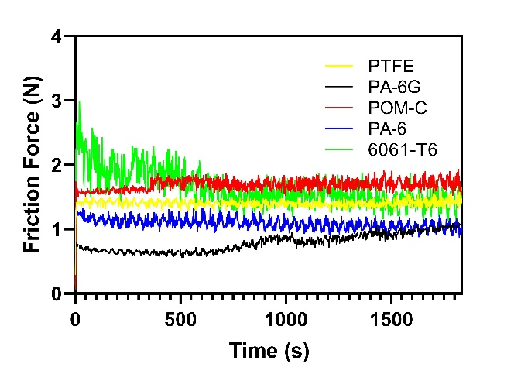
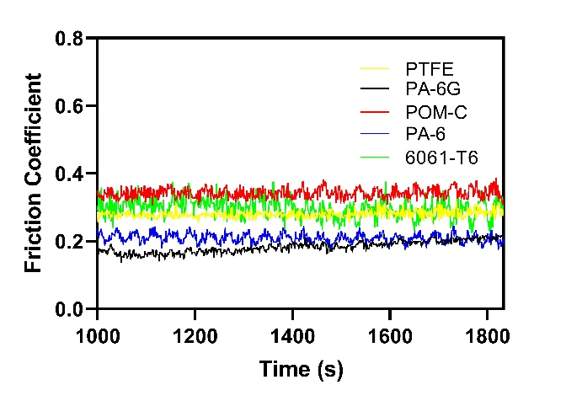
(a) (b)

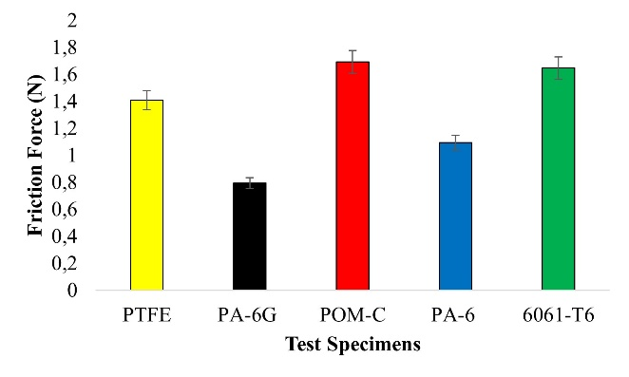
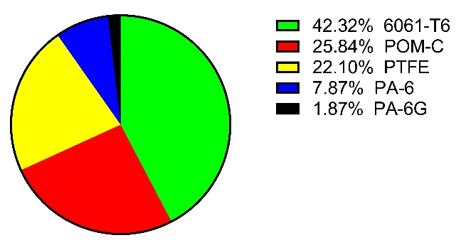

(c) (d)
FIGURE 4. (a) Comparison of steady-state friction coefficients (COF). (b) Temporal variation of friction force throughout the experiments, showing the transition from initial running-in to the stabilized friction regime. (c) Mean friction forces with associated standard errors for each material combination. (d) Wear contributions of the evaluated materials.

CONCLUSION
A comparative dry sliding wear assessment was conducted for four engineering thermoplastics POM-C, PTFE, PA-6, and PA-6G against 6061-T6 aluminum alloy under identical operational parameters. The results revealed distinct variations in tribological performance, influenced by inherent material properties, surface adaptability, and transfer film formation capacity. PA-6G demonstrated the most favorable behavior, combining a low coefficient of friction (0.16) with the smallest wear share in the total distribution (1.87%). PA-6 followed, exhibiting similarly low friction and a wear share of 7.87%, indicating its strong potential for dry, self-lubricating service conditions. PTFE presented intermediate friction values yet accounted for 22.10% of the wear share, suggesting that its low surface energy alone is insufficient to ensure minimal material loss under the given conditions. POM-C, despite its extensive industrial use, recorded the highest friction among the polymers and a wear share of 25.84%, implying the need for lubrication or surface modification in demanding dry sliding applications. The metallic counterpart, 6061-T6 aluminum alloy, displayed the largest wear share at 42.32%, underscoring the susceptibility of unlubricated metallic interfaces to significant wear accumulation. Overall, the findings establish a clear performance ranking among the tested materials under controlled conditions, filling a gap in comparative tribology literature. From a design perspective, PA-6G emerges as the most promising candidate for applications requiring low friction and minimal wear share, while POM-C and metallic surfaces may require targeted surface engineering to enhance operational longevity. These results highlight the critical role of informed material selection in ensuring mechanical system reliability and efficiency under dry contact conditions.

ACKNOWLEDGEMENTS
The authors sincerely acknowledge the financial support from Istanbul Technical University’s Scientific Research Projects Coordination Unit, which enabled this study under the conference-backed doctoral project MDK-2023-45201.

References
- M. Kohutiar, L. Kakošová, M. Krbata, R. Janík, J. J. Fekiač, A. Breznická, et al., “Comprehensive review: Technological approaches, properties, and applications of pure and reinforced polyamide 6 (PA6) and polyamide 12 (PA12) composite materials,” Polymers 17, 442 (2025). https://doi.org/10.3390/polym17040442
- M. Odrobina, T. Deák, L. Székely, T. Mankovits, R. Z. Keresztes, and G. Kalácska, “The effect of crystallinity on the toughness of cast polyamide 6 rods with different diameters,” Polymers 12, 293 (2020).
https://doi.org/10.3390/polym12020293.
- A. Altinsoy and Y. Arslan, “Investigation of the effects of deep cryogenic treatment on the structural and mechanic properties of polyoxymethylene copolymer (POM-C) materials,” Proc. Inst. Mech. Eng. Part E: J. Process Mech. Eng. 238, 2623–2632 (2024). https://doi.org/10.1177/09544089221139647
- E. Dhanumalayan and G. M. Joshi, “Performance properties and applications of polytetrafluoroethylene (PTFE)—A review,” Adv. Compos. Hybrid Mater. 1, 247–268 (2018). https://doi.org/10.1007/s42114-018-0023-8
- S. Unal and H. A. Tasdemir, “Tribological characterization of AlCrN, TiAlN, TiSiN and AlTiN coatings against mold steel,” Mechanics 31, 156–163 (2025). https://doi.org/10.5755/j02.mech.38122
- Z. Rymuza, “Tribology of polymers,” Arch. Civ. Mech. Eng. 7, 177–184 (2007). https://doi.org/10.1016/S1644-9665(12)60235-0
- S. K. Ray, A. Banerjee, B. K. Bhangi, D. Pyne, and B. Dutta, “Tribological analysis—general test standards,” in Tribology of Polymers, Polymer Composites and Polymer Nanocomposites, 17–50 (Elsevier, 2023). https://doi.org/10.1016/B978-0-323-90748-4.00001-7
- M. Oraibi Hasan, T. Khalaf Hasan, N.-S. Abdul Husain Naji, W. Ahmed Mohammed, H. Mossa Ali, H. Razzak Abbas Aljanabi, et al., “Effect of machining of aluminium alloys with emphasis on aluminium 6061 alloy – A review,” IOP Conf. Ser.: Mater. Sci. Eng. 1107, 012157 (2021). https://doi.org/10.1088/1757-899X/1107/1/012157
- A. Kareem, J. A. Qudeiri, A. Abdudeen, T. Ahammed, and A. Ziout, “A review on AA 6061 metal matrix composites produced by stir casting,” Materials 14, 175 (2021). https://doi.org/10.3390/ma14010175
- A. Abdelbary, Friction and Wear of Polymer and Polymer Composites (Springer, Singapore, 2021), pp. 33–54. https://doi.org/10.1007/978-981-16-3903-6_3.
- W. G. Sawyer, K. D. Freudenberg, P. Bhimaraj, and L. S. Schadler, “A study on the friction and wear behavior of PTFE filled with alumina nanoparticles,” Wear 254, 573–580 (2003). https://doi.org/10.1016/S0043-1648(03)00252-7
- P. D. Neis, N. F. Ferreira, J. C. Poletto, J. Sukumaran, M. Andó, and Y. Zhang, “Tribological behavior of polyamide-6 plastics and their potential use in industrial applications,” Wear 376–377, 1391–1398 (2017). https://doi.org/10.1016/j.wear.2017.01.090
- R. Keresztes, M. Odrobina, R. Nagarajan, K. Subramanian, G. Kalácska, and J. Sukumaran, “Tribological characteristics of cast polyamide 6 (PA6G) matrix and their composite (PA6G SL) under normal and overload conditions using a dynamic pin-on-plate system,” Compos. Part B: Eng. 160, 119–130 (2019). https://doi.org/10.1016/j.compositesb.2018.10.017
- Y. Sujuan and Z. Xingrong, “Tribological properties of PTFE and PTFE composites at different temperatures,” Tribol. Trans. 57, 382–386 (2014). https://doi.org/10.1080/10402004.2013.812759
- M. S. Rahman, U. Shaislamov, J. K. Yang, J. K. Kim, Y. H. Yu, S. Choi, et al., “Effects of electron beam irradiation on tribological and physico-chemical properties of polyoxymethylene copolymer (POM-C),” Nucl. Instrum. Methods Phys. Res. Sect. B: Beam Interact. Mater. Atoms 387, 54–62 (2016). https://doi.org/10.1016/j.nimb.2016.10.001
- J. Li, “Friction and wear properties of PTFE composites filled with PA6,” Polym. Compos. 31, 38–42 (2010). https://doi.org/10.1002/pc.20762
- J. Jozwik, K. Dziedzic, M. Barszcz, and M. Pashechko, “Analysis and comparative assessment of basic tribological properties of selected polymer composites,” Materials 13, 75 (2020). https://doi.org/10.3390/ma13010075
- X. Xiong, L. Hua, X. Wan, C. Yang, C. Xie, and D. He, “Experiment and simulation of friction coefficient of polyoxymethylene,” Ind. Lubr. Tribol. 70, 273–281 (2018). https://doi.org/10.1108/ILT-05-2016-0120 19.
- S. K. Sinha and B. J. Briscoe, Polymer Tribology (Imperial College Press, London, 2009). https://doi.org/10.1142/P560
- G. W. Stachowiak and A. W. Batchelor, Engineering Tribology, 4th ed. (Butterworth-Heinemann, Oxford, 2005), pp. 1–801. https://doi.org/10.1016/B978-0-7506-7836-0.X5000-7 21.
- D. Li, Y. Xie, W. Li, Y. You, and X. Deng, “Tribological and mechanical behaviors of polyamide 6/glass fiber composite filled with various solid lubricants,” Sci. World J. 2013, 320837 (2013). https://doi.org/10.1155/2013/320837
- A. Pogačnik, A. Kupec, and M. Kalin, “Tribological properties of polyamide (PA6) in self-mated contacts and against steel as a stationary and moving body,” Wear 378–379, 17–26 (2017). https://doi.org/10.1016/j.wear.2017.01.118
- H. Wang, X. Qi, Y. Dong, B. Fan, C. Liu, and Y. Zhang, “A formation mechanism and tribological properties of PTFE transfer film,” Research Square (2021). https://doi.org/10.21203/rs.3.rs-263448/v1 24.
- G. Kalácska, “An engineering approach to dry friction behaviour of numerous engineering plastics with respect to the mechanical properties,” Express Polym. Lett. 7, 199–210 (2013). https://doi.org/10.3144/expresspolymlett.2013.18
- H. Endo and E. Marui, “Fundamental studies on friction and wear of engineering plastics,” Ind. Lubr. Tribol. 56, 283–287 (2004). https://doi.org/10.1108/00368790410550697

