Tribological and Mechanical Evaluation of Polycarbonate Nanocomposites Reinforced with Halloysite Nanotubes and Precipitated Calcium Carbonate under Dry Sliding Conditions
Deniz Aktas^{1, a)} and Haci Abdullah Tasdemir^{1, b)}
¹Department of Mechanical Engineering, Istanbul Technical University, Istanbul, Turkiye

^{a)}aktasde@itu.edu.tr
^{b)} Corresponding author: tasdemirh@itu.edu.tr
Abstract. In this study, the dry sliding tribological and mechanical behavior of polycarbonate (PC) nanocomposites reinforced with halloysite nanotubes (HNT) and stearic acid coated precipitated calcium carbonate (PCC) was investigated. Polycarbonate nano-composites were prepared with 1, 3, and 5 wt% of each filler. A reciprocating ball on disc setup was used for wear testing under dry conditions, with a 10 N normal load, a 6 mm Al2O3 counterface ball, and a total sliding distance of 35 m. Friction coefficients were recorded continuously, and wear volumes were calculated based on profilometric measurements taken at ten locations per sample. Each result represents the average of three independent tests. The addition of HNT did not lead to a clear or consistent trend in friction behavior when compared to neat PC. Although the 5 wt% HNT sample exhibited relatively low and stable friction in the initial phase, the steady-state values remained comparable to those of the unfilled polymer. In contrast, PCC filled composites exhibited a more notable decrease in friction coefficient, particularly at 5 wt%, which may be attributed to the lubricating effect of the stearic acid surface modification. However, this improvement in frictional performance did not uniformly translate to wear resistance. Specifically, the 1 wt% PCC sample demonstrated a higher wear volume than neat PC, whereas wear resistance improved at higher PCC loadings. On the other hand, HNT-filled composites, particularly at 5 wt%, showed a reduction in wear volume of approximately 30% relative to the neat matrix, which is in agreement with the improved wear resistance and friction reduction attributed to tribofilm formation and the solid-lubricating behavior of halloysite nanotubes. These findings underscore the complex and sometimes non-linear relationship between filler content, morphology, and tribological response. The results indicate that while both fillers have potential for improving PC’s tribological performance, their effects are strongly dependent on filler type and concentration, as well as interfacial compatibility and dispersion quality within the matrix.

INTRODUCTION
Polycarbonate (PC) is a high-performance engineering thermoplastic recognized for its exceptional transparency, impact resistance, and ease of processing. Owing to this unique combination of properties, PC is extensively employed in diverse sectors, including automotive glazing, optical storage media, protective equipment, and biomedical devices [1,2]. However, under practical operating conditions, particularly in dry sliding contacts, PC components are often subjected to friction and wear that can significantly limit their service life. As a result, the improvement of PC’s tribological performance through the incorporation of functional fillers has remained a subject of considerable scientific and industrial interest [3].
Previous studies have shown that the mechanical and tribological behavior of PC is highly sensitive to filler type, morphology, and interfacial adhesion. For example, ZnO nanoparticle-filled PC composites demonstrated changes in hardness, ductility, and wear resistance depending on filler concentration, with the most favorable improvements observed at low loadings [4,5]. In another study, investigations into the intrinsic properties of PC have shown that yield strength and toughness alone do not directly govern friction and abrasive wear, suggesting that polymer network entanglements and microstructural factors play more decisive roles [6].
Among the wide variety of mineral and tubular fillers that have been tried in thermoplastics, two stand out in the context of polycarbonate. Halloysite nanotubes (HNT) are interesting because of their tubular geometry and relatively high aspect ratio. They are naturally occurring aluminosilicates, easy to source, and in many systems, they have shown some ability to improve load transfer and slow down plastic deformation under contact. Precipitated calcium carbonate (PCC), on the other hand, has a long history as a filler in polymers. When coated with stearic acid, its surface chemistry changes in a way that sometimes brings a lubricating effect at the sliding interface. Accordingly, both fillers appear promising for PC, but the mechanisms underlying their contributions are different. [7,8]. However, the comparative influence of these fillers on the tribological behavior of PC under dry sliding remains insufficiently explored.
The present study aims to investigate the dry sliding tribological performance of PC reinforced with HNT and stearic acid-coated PCC at varying loadings. By systematically comparing their effects on the coefficient of friction and wear resistance, this work seeks to clarify the role of filler type and concentration in tailoring PC for demanding tribological applications.

MATERIALS AND METHODS

Polymer material used in this study was a commercial bisphenol-A polycarbonate (Lexan EXL 9330, SABIC; ρ ≈ 1.19 g cm⁻³). Pellets were vacuum dried at 120 °C for 3 h to suppress hydrolytic degradation during melt processing. Halloysite nanotubes (HNT) were supplied by ESAN (ρ ≈ 2.45 ± 0.20 g cm⁻³, specific surface area ≈ 138 m² g⁻¹, average length ≈ 1.2 µm, inner/outer diameters ≈ 20/40 nm). Stearic acid-coated precipitated calcium carbonate (PCC) was supplied from ADAÇAL (ρ ≈ 2.70 g cm⁻³, specific surface area 18–24 m² g⁻¹). For each filler, nominal loadings of 1, 3 and 5 wt% were prepared.
Melt compounding was carried out on a co-rotating twin screw extruder (Gulnar, screw Ø 16 mm, L/D = 40). The screw speed was set to 150 rpm; the barrel profile was 240–260 °C from feed to die. Extrudates were pelletized and injection molded at a barrel temperature of 260 °C, mold temperature of 50 °C, and an injection speed of 100 mm s⁻¹. The details of the sample codes and filler ratios can be found in Table 1.
TABLE 1. Sample notation and compositions
Compositions | Sample Code | Nano filler ratio (wt%)
PC | 1 | 0
PC+HNT | 1A1 | 1
PC+HNT | 1A3 | 3
PC+HNT | 1A5 | 5
PC+PCC | 1C1 | 1
PC+PCC | 1C3 | 3
PC+PCC | 1C5 | 5

Surface hardness was evaluated on representative specimens using a Shore D durometer (MACRONA) in accordance with ISO 868. Ten measurements were taken at distinct locations per specimen, and arithmetic means were reported. The hardness dataset used herein is reproduced from our prior study for contextual comparison with tribological trends [9].
Dry-sliding tests employed a reciprocating ball on flat configuration (ball on disc type). The counterface was an alumina ball (Al₂O₃, Ø6 mm) under a normal load of 10 N. For each specimen, the total sliding distance was 35 m. The coefficient of friction was recorded continuously over the test duration. All measurements were repeated three times per composition; unless stated otherwise, results are presented as the mean of three independent runs. Wear tracks were profiled at a minimum of ten transverse positions, and volume loss was calculated by geometric integration of the cross-sectional areas.

RESULTS AND DISCUSSION
The friction-time responses are shown in Figure 1. Neat PC stabilizes at around 0.4 after a short running-in. The addition of HNT (1A1, 1A3, 1A5) does not provide a consistent friction-reducing trend. Although the sample with a 5% loading rate exhibits a relatively calm trace in the early stages, its steady-state values ultimately converge with those of the matrix. In contrast, the PCC-filled specimens (1C1, 1C3, 1C5) consistently form a lower COF group across most of the test. The effect is most pronounced at 5 wt% PCC (1C5), where the friction curve is not only lower but also markedly smoother. Such behavior can be attributed to a mild interfacial lubrication or transfer film effect arising from the stearic acid modified CaCO₃, together with the contribution of fine particulates at the contact interface. These observations indicate that PCC consistently shifts the friction response to a lower and steadier band, whereas HNT does not induce a systematic decrease and ultimately approaches the behavior of the neat matrix (Fig. 1).
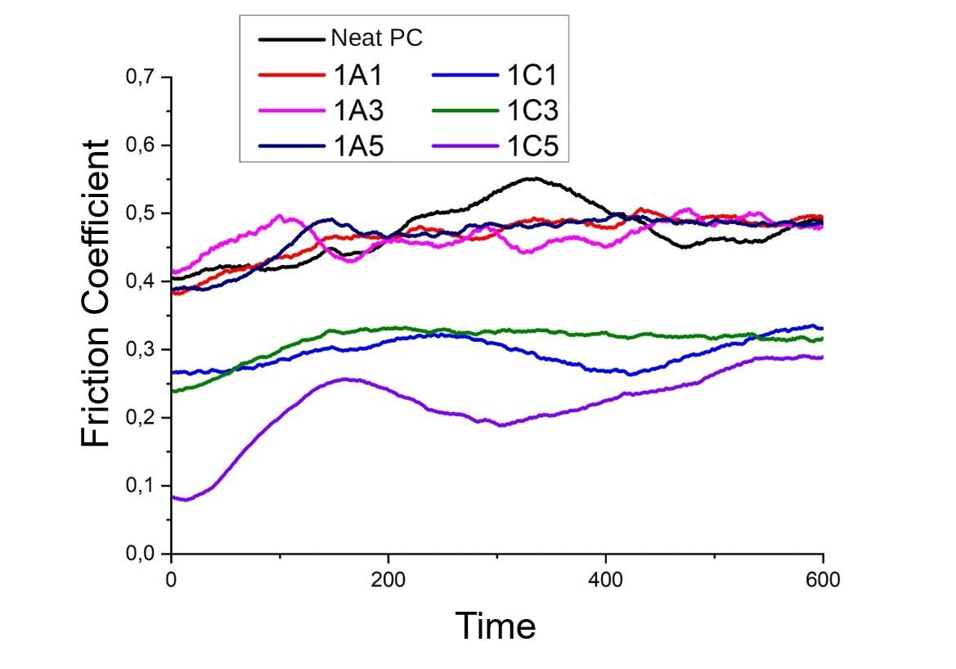
Figure 1. Variation of friction coefficient of neat PC and PC nanocomposites under dry sliding conditions.

Wear results for HNT and PCC series are summarized in Figures 2a and 2b. The largest volume loss is observed at 1 wt% PCC (1C1), exceeding that of neat PC. For the HNT series, wear decreases monotonically with loading, reaching approximately a ~30-40% reduction at 5 wt% (1A5) relative to neat PC. The improvement without a parallel COF drop indicates that HNT primarily enhances load sharing and crack-bridging at the subsurface, limiting material removal even when interfacial shear remains comparable.
The PCC series exhibits a non-monotonic trend: 1 wt% PCC (1C1) shows elevated wear versus the matrix, whereas 3–5 wt% recover and surpass the baseline, with 1C5 delivering the lowest wear among PCC grades. The initial deterioration at low loading is plausibly linked to insufficient dispersion and local debonding (acting as stress concentrators), while higher loadings favor a more continuous particulate network and steadier interfacial conditions. In summary, HNT produces a progressive reduction in wear with increasing loading most notable at 5 wt% while PCC exhibits a non-monotonic trend with a penalty at 1 wt% and a clear improvement at 3–5 wt% (Figs. 2a–2b).
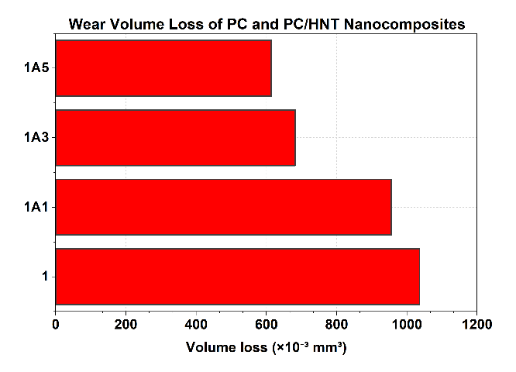
(a)
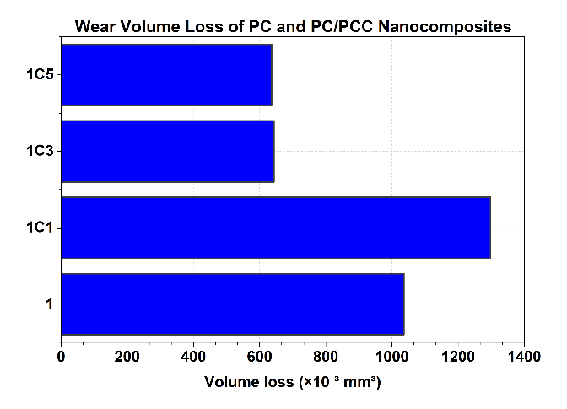

b)
Figure 2. Variation of friction coefficient under dry sliding conditions: (a) neat PC and PC+HNT nanocomposites; (b) neat PC and PC+PCC nanocomposites.

Shore D values (Figure 3) increase modestly for all composites relative to neat PC. The rise is particularly sharp for HNT at 3 wt%, and both fillers reach similarly high hardness levels at 5 wt%. This stiffness increment aligns with the reduced wear at higher filler contents, but the friction trends remain weakly coupled to hardness. This is consistent with polymer tribology, where interfacial shear and contact mechanics dominate COF, while bulk resistance to plastic deformation primarily influences wear. Accordingly, hardness is discussed here as context, not as the primary driver of the observed tribological changes.

Taken together, the modest hardness increase supports the wear trends at higher filler contents, but it does not control the frictional response, which remains governed by interfacial processes rather than bulk stiffness (Fig. 3).

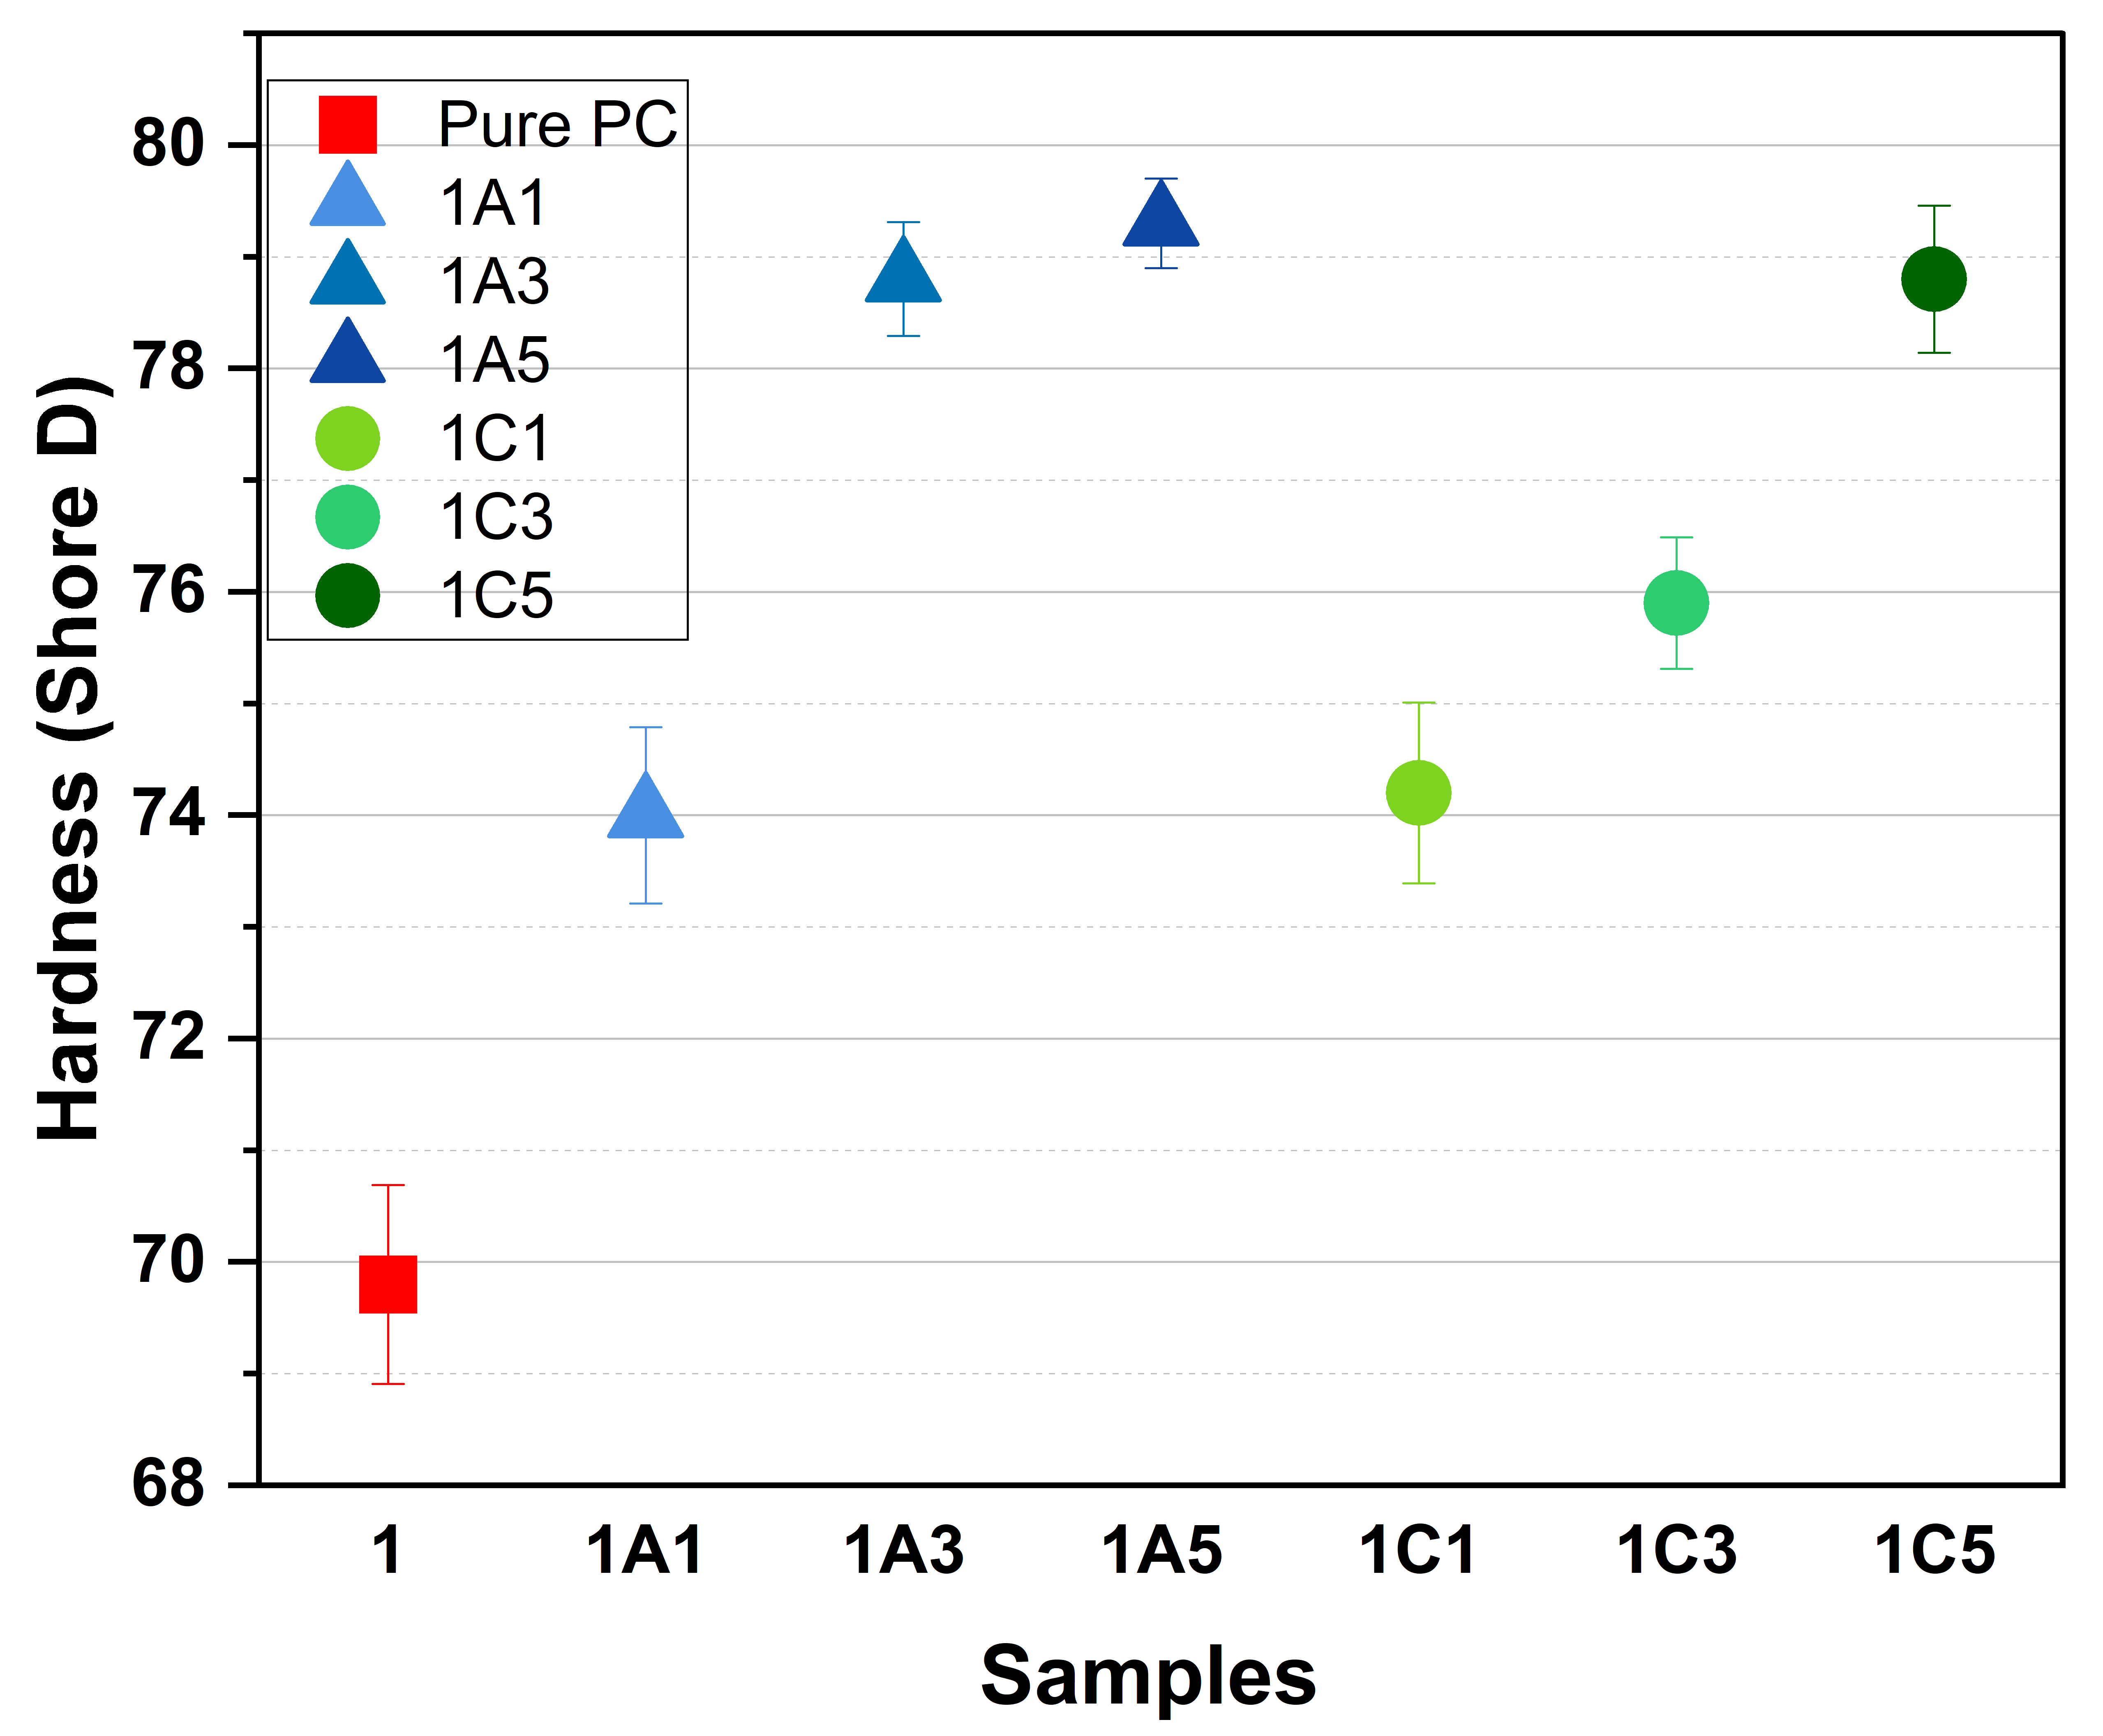
Fıgure 3. Shore D hardness values of neat PC and PC nanocomposites.

CONCLUSION
The present work shows that halloysite nanotubes and stearic-acid modified precipitated calcium carbonate act through different, largely complementary, mechanisms in polycarbonate under dry reciprocating sliding. PCC consistently lowered and stabilized the coefficient of friction, with the most pronounced effect at 5 wt%, whereas HNT did not yield a persistent friction reduction and approached the behavior of the neat matrix at steady state. In contrast, HNT produced a clear, loading dependent improvement in wear resistance; the 5 wt% composition reduced material loss by roughly one-third to 40% relative to neat PC. PCC exhibited a non-monotonic wear response, with a penalty at 1 wt% that was overcome at 3–5 wt%, indicating that dispersion quality and interfacial integrity must exceed a threshold before wear protection is realized. Shore D hardness increased modestly for all composites and was directionally consistent with the wear trends, but it did not govern frictional behavior, which remained dominated by interfacial processes.
Overall, the results suggest that HNT primarily enhances subsurface load-bearing and damage tolerance, thereby limiting material removal even when the interfacial shear stress remains comparable, while PCC at adequate loading conditions the sliding interface, promoting a lower and steadier friction regime. From a design standpoint, formulations can thus be tailored to the dominant requirement of the application: HNT for wear-limited contacts, and PCC (≥3–5 wt%) where a reduction in friction is critical. Future work should focus on measuring how well the fillers are dispersed and how strongly they bond with the matrix, in order to reduce the negative effect seen for PCC at low loadings. It should also include mapping the effects of load, speed, and temperature to define reliable operating ranges for both systems.

Acknowledgments
The authors would like to thank ESAN for kindly supplying the halloysite nanotubes (HNT) and ADAÇAL for providing the precipitated calcium carbonate (PCC) used in this study.

References
- J. M. Margolis, Engineering Thermoplastics: Properties and Applications, CRC Press, 1985.B.J.
- H. A. Tasdemir, E. Tinaztepe, and S. Unal. “Environmental stress cracking of silver‐coated polycarbonate.” Polymer Engineering & Science 65.1 (2025): 401-412.
- Briscoe, “Tribology of polymers: applications and implications,” Tribol. Int. 31, 121–126 (1998).
- M. Şengül, and H. A. Tasdemir. “The effect of mold release agents used in injection on environmental stress cracking behavior of polycarbonates.” Journal of the Faculty of Engineering and Architecture of Gazi University 38.1 (2023): 331-343.
- F.J. Carrión, J. Sanes, and M.D. Bermúdez, “Influence of ZnO nanoparticle filler on the properties and wear resistance of polycarbonate,” Wear 262, 1504–1510 (2007).
- Y.J. Mergler, R.J. van Kampen, W.J. Nauta, R.P. Schaake, B. Raas, J.G.H. van Griensven, and C.J.M. Meesters, “Influence of yield strength and toughness on friction and wear of polycarbonate,” Wear 258, 915–923 (2005).
- G. Rajeshkumar, K.C. Nagaraja, P. Ravikumar, S.M. Rangappa, and S. Siengchin, “Effect of halloysite addition on the dynamic mechanical and tribological properties of carbon and glass fiber reinforced hybrid composites,” Heliyon 10, e35554 (2024).
- S.J. Charde, S.S. Sonawane, S.H. Sonawane, and S. Navin, “Influence of functionalized calcium carbonate nanofillers on the properties of melt-extruded polycarbonate composites,” Chem. Eng. Commun. (2018). https://doi.org/10.1080/00986445.2017.1404459
- D. Aktas, H. A. Tasdemir, M. B. Alanalp, and A. Durmus, “Comparing the effects of halloysite nanotubes and precipitated calcium carbonate nanoparticles on the environmental stress cracking resistance and mechanical properties of polycarbonate,” Polymer Composites (2025). https://doi.org/10.1002/pc.70111

