A Novel Design of Mechatronic Simulator for Total Knee-Joint Prostheses Wear Testing
Vladimir Pakhaliuk^{a)}, Aleksandr Poliakov^{b)} and Aleksandr Ryzhkov^{c)}
Sevastopol State University, Universitetskaya str., 33, Sevastopol, Russia
^{a)} Corresponding author: pahaluk@sevsu.ru
^{b)} a.m.poljakov@sevsu.ru
^{c)} airyzhkov@sevsu.ru
Abstract. This paper discusses the development and manufacture of a mechatronic simulator new design prototype for certification wear testing of knee joint prostheses, allowing the creation of a complete production of knee joint prostheses in the Russian Federation. Ball screw mechanisms are used as drives in the simulator. The axial force is created by compressing the spring using a cam mechanism. Finite element calculations of the simulator frame structure are performed to achieve the required rigidity. The simulator is structurally universal in terms of the ability to test a number of sizes of prostheses, as well as their types.

INTRODUCTION
According to the World Health Organization, in 2019, about 528 million people worldwide suffered from osteoarthritis, which is 113% more than in 1990, and with a prevalence of 365 million, the knee joint is the most frequently affected joint. According to most experts, the best way to treat osteoarthritis in the late stages of development is joint replacement, and the number of such operations is growing year by year throughout the world [1]. In the United States, about 4.0 million adults live with knee prostheses, which is approximately 4.2% of the population over 50 years of age [2]. In Russia, according to the national registry, about 50.0 thousand knee replacement surgeries are performed annually [3]. Despite the fact that knee replacement surgery is one of the most high-tech and largely eliminates the development of periprosthetic pathologies, some of the prostheses fail prematurely, which leads to the need for re-prosthetics of the joint - a very traumatic and very expensive surgery. The knee replacement market is fragmented due to the presence of several key players, among which a significant share is occupied by several well-known foreign companies. In 2024, the global knee replacement market is estimated at $ 11.74 billion and is projected to reach $ 14.8 billion by 2029, with a compound annual growth rate of 4.73% during 2024-2029 [4]. Given the above data, it can be argued that the formation of a domestic knee replacement market in Russia is an important task of our time, the solution of which will not only contribute to improving the quality of life and restoring the motor activity of a large number of people, but also ensure the technological sovereignty of the country. To do this, first, it is necessary to ensure the development of our own production and the supply of high-quality knee replacements to the domestic market. According to most experts in the field of prosthetics, one of the most important indicators of the quality of prostheses is the minimum wear of friction pair materials during the entire lifespan. Wear parameters can be determined by modeling the operation of a joint with an implanted endoprosthesis [5], Including the use of different friction pair of materials [6]. However, for a more reliable assessment of materials wear, it is necessary to test friction pairs on specialized equipment capable of simulating the operation of a joint endoprosthesis in vitro, similar to natural conditions in the human body - in vivo. Because of the research and development work, a prototype mechatronic simulator (MS) was developed for wear testing of total knee prostheses (TKP) in accordance with the requirements of ISO standards in terms of movements’ kinematics and loading of test samples. A technical device of this type was developed in the Russian Federation for the first time.
The purpose of developing the new MS design was to provide a solution to an important technical problem with its help, consisting in the universalization of the simulator by creating the possibility of different size TPKS testing. At the same time, the simulator design should have minimal complexity, the necessary reliability, ease of readjustment depending on the size of the prosthesis and the requirements for their testing, and minimal cost. These qualities are a serious novelty in the simulator design. In addition, new technical solutions adopted at the design stage allowed the use of only mechatronic modules with controlled servomotors in the simulator, eliminating pneumatic and hydraulic drives and, consequently, the disadvantages associated with them. Specialized software was developed to control the MS, which made it possible to organize the synchronous operation of all mechatronic modules providing the required kinematic and force parameters of TKP tests.

MATERIALS AND METHODS
The TKP wear test is defined by three ISO standards [7‒9]. The simulators used to test the wear of TKP friction pair materials allow modeling the knee joint function, which is characterized by the hip flexion/extension movement – FE, the linear movement of the tibial component of the prosthesis anterior/posterior displacement – AP and its rotational movement tibial rotation – IOR (inward/outward rotation) around the vertical axis. For the standard [7], the control of the specified movements is carried out by means of the generated forces: AP force (APF) and tibial rotation torque (TRT). In addition, the TKP test samples are loaded with an axial force F during the tests, which simulates the effect of the functional load on the joint during human walking, around which the IOR rotates. The graphs of the functions FE=FE(t), F=F(t), regulated by [7], are shown in Fig. 1 and APF=APF(t), TRT=TRT(t) in Fig. 2. The graphs of the functions FE=FE(t) and F=F(t) for the standard [9] remain the same, and the graphs of the functions AP=AP(t), IOR=IOR(t) are shown in Fig. 3. To determine the design of the simulator, it is necessary to consider only two standards [7] and [9], since they set out the requirements that ensure their design implementation. At the same time, the first standard differs from the second in that it takes into account the force interaction (APF) when providing displacement (AP) and the moment (TRT) during tibial rotation IOR. The second standard considers only kinematic displacements AP and IOR.
The parameter change diagrams presented in the standards [7, 9] are tabulated in the form of tables, where the cycle length is presented for 100 equally spaced points. The parameter change ranges in the diagrams Fig. 1 according to the standard [7] are:
- Flexion angle extremes: minimum 0°, maximum +58° with an acceptable deviation of ±5% from the maximum value in degrees;
- Axial force extremes: minimum 168 N, maximum 2600 N with an acceptable deviation of ±5% from the maximum value in N;
- Anterior/posterior force (APF) extremes: minimum -265 N, maximum 110 N with an acceptable deviation of ±5% from the maximum value in N;
- Tibial rotation torque (TRT) extremes: minimum -1.0 Nm, maximum 6.0 Nm with an acceptable deviation of ±5% from the maximum value in Nm.
The parameter variation ranges in the diagrams in Fig. 2 according to the standard [9] are:
- AP displacement extremes: minimum -5.2 mm, maximum 0 mm with an acceptable deviation of ±5% from the maximum absolute value in mm;
- IOR rotation angle extremes: minimum -1.9°, maximum +5.7° with an acceptable deviation of ±5% from the maximum value in degrees.
The test cycle frequency for both standards is (1±0.1) Hz, and the temperature of the liquid test medium during testing is in the range of (37±2) °C.
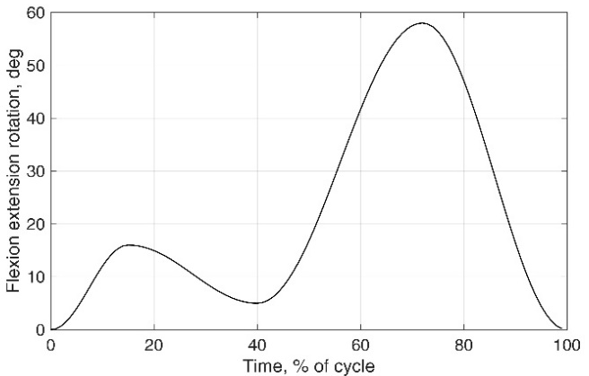 | 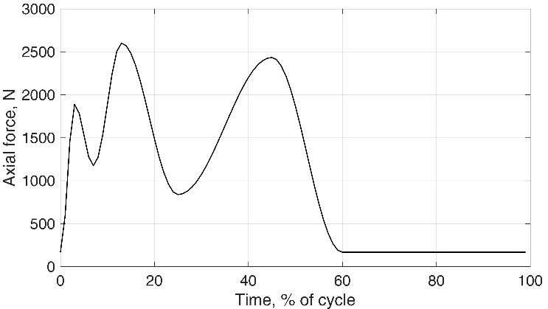
(a) | (b)
Figure 1. Variation with time of (a) flexion angle function FE=FE(t) and (b) axial force one F=F(t)

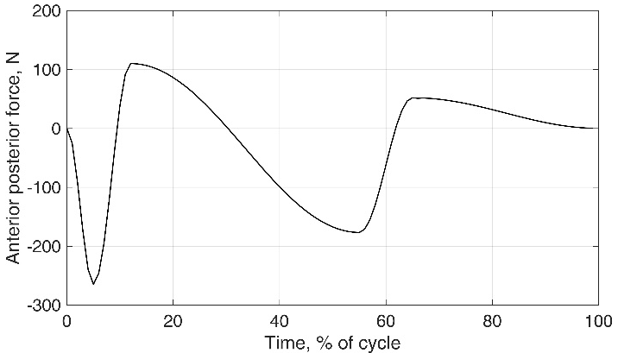 | 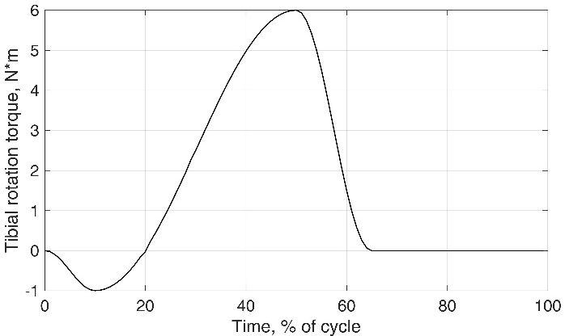
(a) | (b)
Figure 2. Variation with time of (a) anterior/posterior force function APF=APF(t) and (b) tibial rotation torque one TRT=TRT(t)

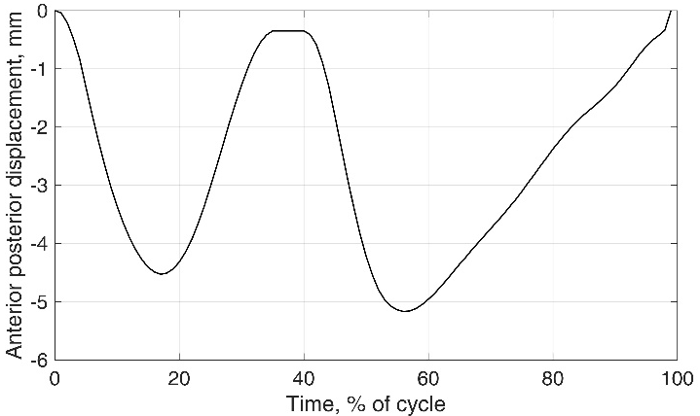 | 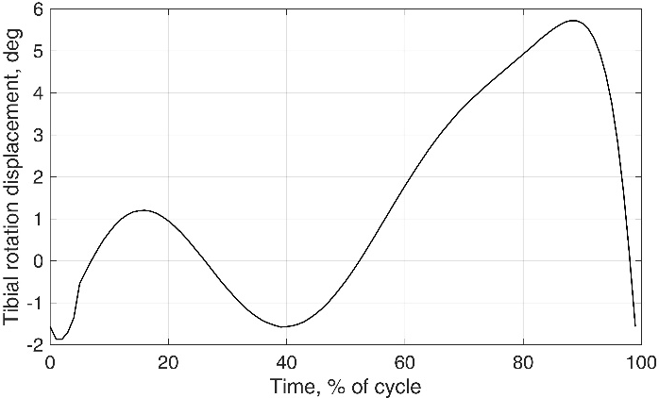
(a) | (b)
Figure 3. Variation with time of (a) anterior/posterior displacement function AP=AP(t) and (b) tibial rotation displacement one IOR=IOR(t)

In modern research centers, wear testing, as one of the most important factors directly affecting the quality of TKP, is given increased attention. For these purposes, many simulator designs have been created in recent years, allowing the human walking process to be simulated during testing, which are used for research and certification tests of TKP. These include simulator designs from EndoLab Mechanical Engineering GmbH (www.endolab.org), MTS Systems Corporation (www.mts.com) and other companies. High-quality simulators are very expensive products that are practically not supplied to the market and are used by manufacturing companies mainly to equip their own testing centers.
The MS is a welded frame structure 1 consisting of two test blocks arranged in parallel, the general appearance of the 3D model of which is shown in Fig. 4 and Fig. 5. Each block includes four stations, where three stations 2 are movable to ensure the movements specified in the standards and one stationary 3 is to check for soak in the case of using a plastic tibial plate in the prosthesis 4. The axial force is generated by a cam mechanism at four stations of each block at once by compressing a spring in a cup 5 of each station, the rod of which, through a ball bearing, contacts the cam of the frame rotary element 6, which is driven into rotation by an electric servomotor with a gearbox 7.
The axial force is transmitted via the vertical rod to the mechanism 8, with a linear electric drive with a ball screw pair, providing the AP movement, where a cradle 10 is mounted on a U-shaped bracket 9 with the possibility of swinging. On which a holder 11 of the prosthesis tibial component is placed in a cup (not shown) containing the tested prosthesis sample. The presence of the cradle is necessary to ensure self-centering of the tibial component with respect to the acetabular prosthesis component. Rotation of the tibial prosthesis component is provided by a mechanism 12 with a linear electric drive with a ball screw pair. The femoral prosthesis component is installed in a holder 13, secured in a frame mechanism 14 for providing flexion, where a drive 15 with an electric motor and a planetary gearbox is used to implement it at three stations at once. The prosthesis under test at each station is contained in a protected bath made of food-grade casting silicone, filled with a constant-temperature test fluid recirculated by a peristaltic pump from a tank. A thermostat is provided to maintain the required temperature of the test fluid.
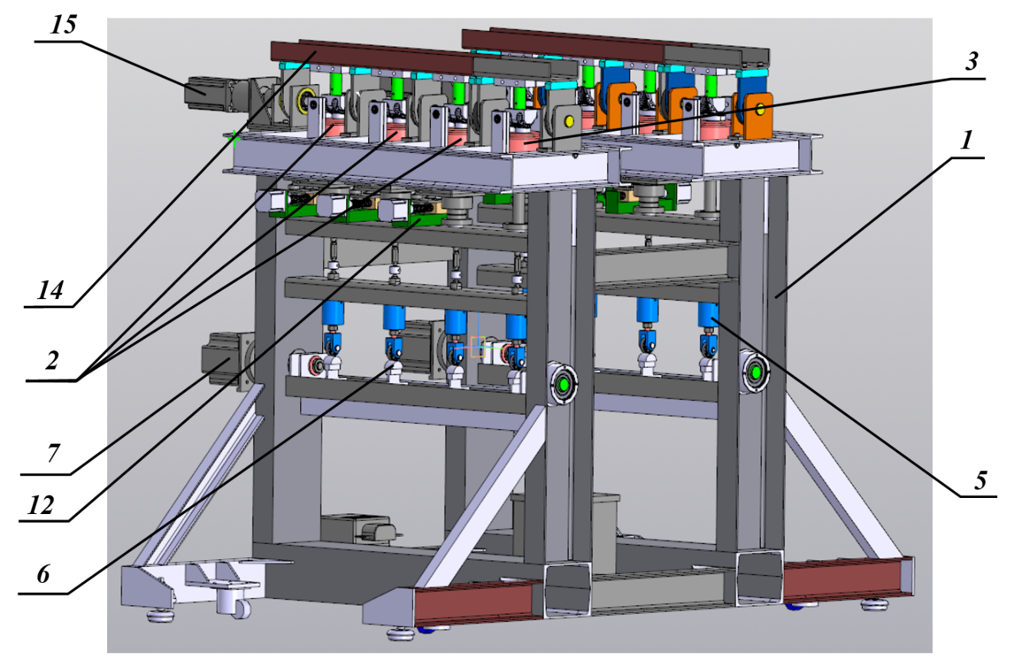
Figure 4. General view of the MS 3D model

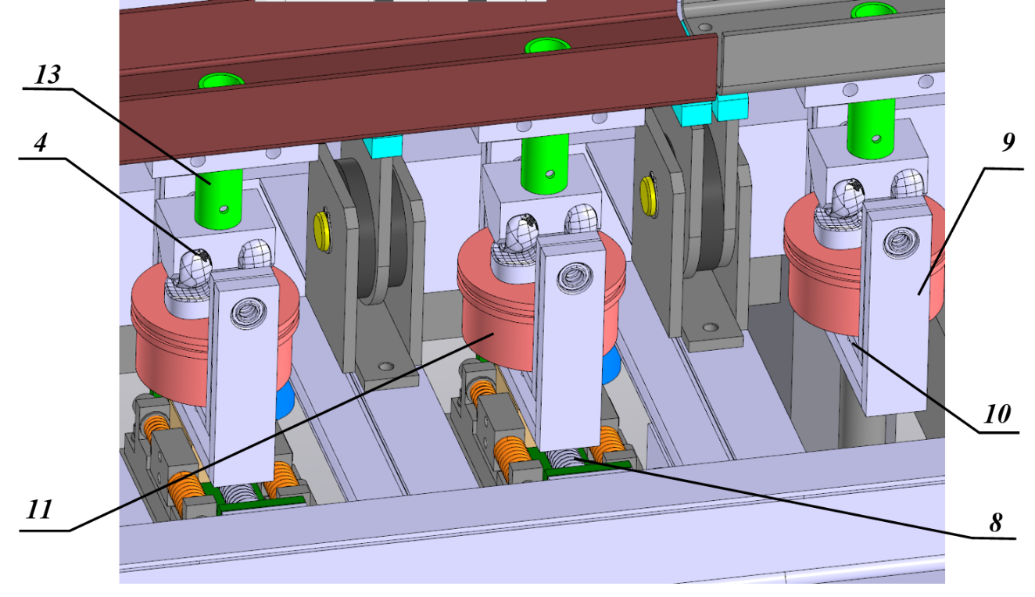Figure 5. View of the testing station with the prosthesis, the AP module with springs and the flexion unit

The developed design of the MS fully meets the requirements of the standard [7] for controlling movements by means of force, according to the diagrams Fig.1 and Fig.2, due to the use of springs with regulated rigidity in the design. The MS also meets the standard [9], where movement control is carried out by means of displacements, according to the diagrams Fig.3, when the effect of the said springs is simply eliminated during prosthesis testing. The design also provides for adjustment to ensure the possibility of testing prostheses in the existing range of their standard sizes. In this case, the value of the rotation radius of the prosthesis femoral component relative to the tibial component is adjusted so that the axis of this rotation coincides with the fixed flexion axis in the MS. This is accomplished both by vertical movement of the prosthesis tibial component by adjusting the thickness of the gasket under the mechanism for implementing the AP movement, and by vertical movement of the femoral component mount with its subsequent fixation using a clamp on the crossbars of the movable and fixed stations. Also, for this purpose, the horizontal prosthesis position is adjusted, which is carried out by horizontal movement of the linear drive carriage for the AP movement. In addition, the tibial prosthesis component is used for testing in the MS, both with and without a stem, which is provided for by the presence of a universal hole in the femoral component holder, for which an individual anti-rotation bushing is prepared for each type and size of the prosthesis. Thus, it is if after removing the tibial prosthesis component for wear measurement, it is installed at the station in the same position for continuing the test as it was when it was removed.
The frame rotary element 6 is developed based on a section of a channel and ensures the creation of an axial force simultaneously at four stations by means of its rotation by an electric motor with a gearbox 7 around the longitudinal axis due to the presence of cams in the design. According to the requirement of the standard [7], the error in the creation of an axial force is ±5% of its maximum value, equal to 2600 N. The shape of the cams is designed in such a way that this force value is ensured by compressing the spring by approximately 6.5 mm, therefore such an error should not exceed 130 N with a total deformation, which is 0.325 mm. Several designs of such a frame element were developed and their finite element analysis was performed in the Workbench ANSYS software environment. Fig. 6 shows a 3D model of one of the designs for the specified element, four cams loaded with an axial force for each of the four stations are shown and the vector of the maximum axial force is visualized on one of them. The result of calculating its total deformation in meters is shown in Fig. 7, where the brackets that are structurally rigidly fixed to the MS frame are shown in blue at the edges on the left and right. The maximum total deformation was 0.252 mm, which does not exceed the specified limit value of 0.325 mm, and such a design of the frame rotary element was adopted when designing the MS.
One of the main factors for the novelty of the MS design is the use of servo-stepper electric motors to perform the movements of the AP and tibial rotation, ensuring high speed for successful reproduction of the diagrams in Figs 2 and 3 with errors in modulus of no more 0.1 mm of linear movement.

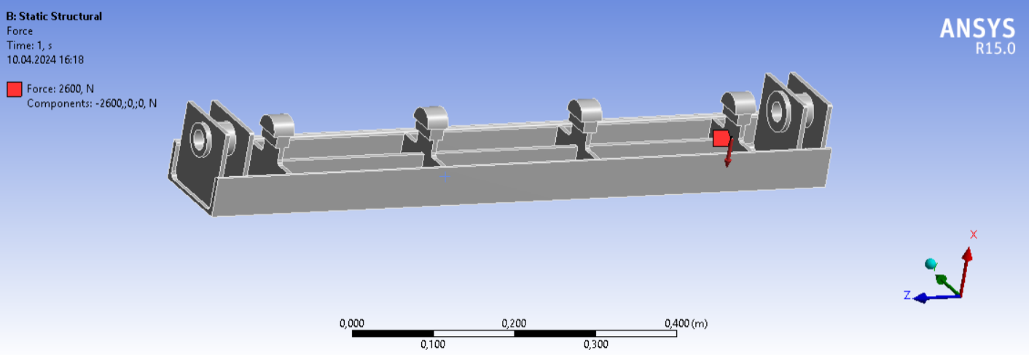
Figure 6. 3D model for one of the designs for the frame rotary element

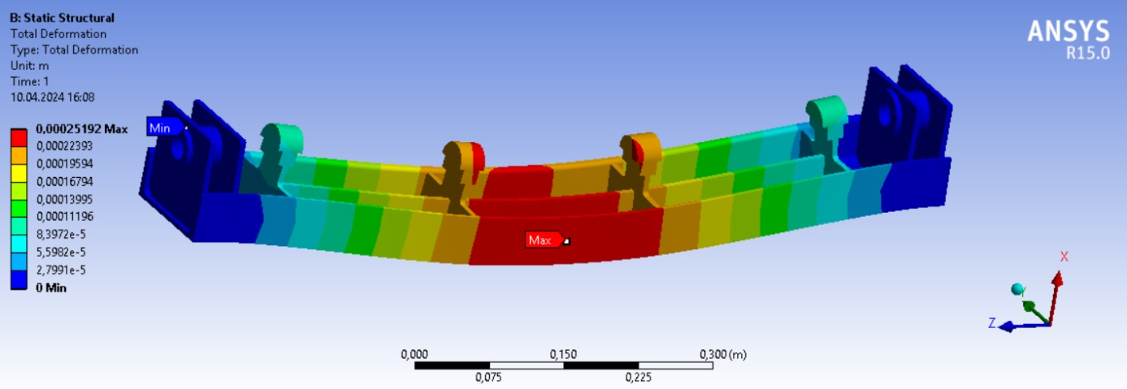
Figure 7. Result of the total deformation calculation for the frame element shown in Fig. 6, mm

Another factor in the novelty of the MS design is the method for creating an axial force using cams located on the frame rotary element. For this purpose, a cam mechanism is synthesized in the form of a law for changing the angle of rotation for the said frame element to create a law of changing the axial force at one station according to the diagram shown in Fig. 1b. For this purpose, a synthesis of the position function for cam mechanism is performed. In this case, the cam profiles are combinations of two surfaces: flat and cylindrical. The diagram of the cam mechanism for creating an axial force is shown in Fig. 8.
The cam mechanism is a movable connection of two links: the cam itself 1 and the cylindrical pusher 2. The input link is the cam, rotating according to the law ω=ω(t), and the output link is the reciprocating pusher with a speed of v=v(t).
The cam 1, as noted above, is a detail, part of the profile of which is plane BD, and the rest is limited by a cylindrical surface of radius r. Its center C is shifted relative to the center of rotation for the cam O by the value e (eccentricity). Therefore, the length of the flat section of the cam profile is also equal to e. The cylindrical pusher 2 is a roller of radius R.

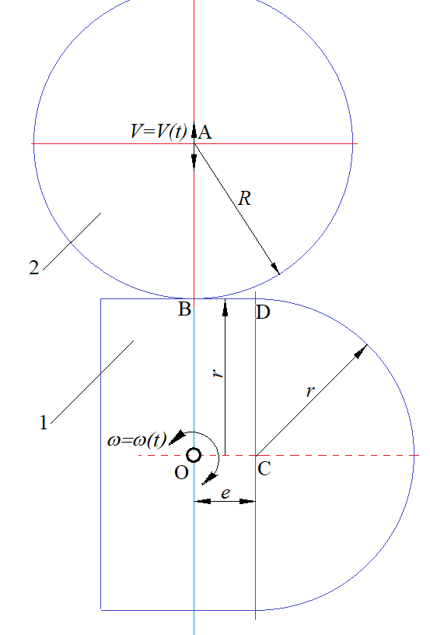
Figure 8. Diagram of the cam mechanism for creating an axial force in the initial position

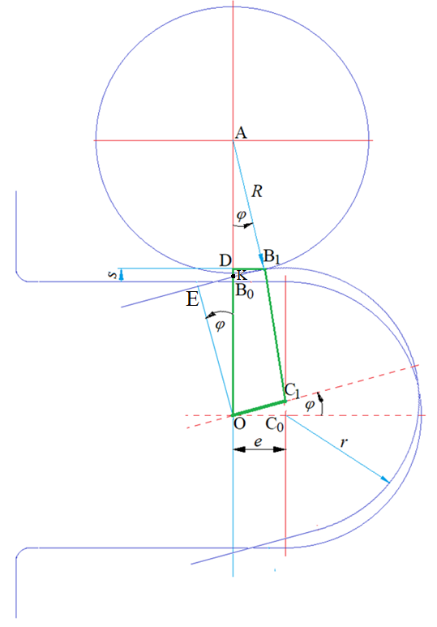 | 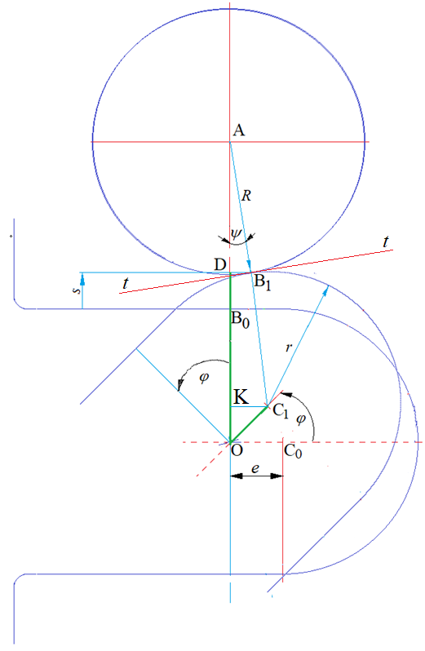
(a) | (b)
Figure 9. Scheme of the cam mechanism in contact with the pusher: (a) a flat surface (option 1), (b) a cylindrical surface (option 2)

This design of the cam mechanism leads to the fact that the contact point of the cam and pusher profiles moves in the plane of the links movement and its position depends on which part of the cam profile is in contact with the pusher. In this regard, two contact options are considered:
- Option 1: contact of a cylindrical pusher with a flat surface of a cam (Fig. 9a);
- Option 2: contact of a cylindrical pusher with a flat cylindrical surface of a cam (Fig. 9b).

In the first option, the plane $EB$ is perpendicular to $OE$ and $AB_{1}$. Consequently, the angles $EOB_{0}$ and $AB_{1}B_{0}$ are equal to the cam rotation angle $φ$.
Let the point $K$ lie at the intersection of lines $AO$ and $EB_{1}$. Then from Fig. 9b it follows that $\frac{r}{OK}\text{=}cosφ$ and $\frac{R}{AK}\text{=}cosφ$. Therefore, the center distance at the cam rotation angle $φ$ is determined by the dependence
$a\left(φ\right)\text{=}OK\text{+}AK\text{=}\frac{r\text{+}R}{cosφ}$ . (1)
When $φ\text{=}0$, $a\left(0\right)\text{=}r\text{+}R$ and the displacement of the pusher upon contact with the flat section of the cam is equal to
$s\left(φ\right)\text{=}a\left(φ\right)\text{-}a\left(0\right)\text{=}\left(r\text{+}R\right)\left(\frac{1}{cosφ}\text{-}1\right)$ . 2)
It should be noted that the projection of the segment $EB_{1}$ onto the horizontal plane is determined by the expression
${PR}_{EB_{1}}\text{=}rsinφ\text{+}Rsinφ\text{=}\left(r\text{+}R\right)sinφ$.
It follows that contact of the pusher with the flat surface of the cam will be possible only if the condition is met
$\left(r\text{+}R\right)sinφ≤e$,
or
$φ≤arcsin⁡(\frac{e}{r\text{+}R})$. (3)
When $\text{>}\frac{e}{r\text{+}R}$ , the contact of the pusher will occur with the cylindrical surface of the cam, which corresponds to option 2, which is discussed in detail below.
From Fig. 9b, it follows that $KC_{1}\text{=}ecosφ$. Therefore, taking into consideration the fact that the radii of the pusher $AB_{1}\text{=}R$ and the cam $C_{1}B_{1}\text{=}r$ lie on the same line perpendicular to the common tangent $t\text{-}t$, it turns out
$sinψ\text{=}\frac{KC_{1}}{AC_{1}}\text{=}\frac{e}{r\text{+}R}cosφ$. (4)
Thus:
$cosψ\text{=}\sqrt{1\text{-}\sin^{2}ψ}\text{=}\frac{\sqrt{{\left(r\text{+}R\right)}^{2}\text{-}e^{2}\cos^{2}φ}}{r\text{+}R}$ ,
$AO\text{=}AC_{1}cosψ\text{+}esinφ\text{=}\left(r\text{+}R\right)cosψ\text{+}esinφ$
or
$AO\text{=}\sqrt{{\left(r\text{+}R\right)}^{2}\text{-}e^{2}\cos^{2}φ}\text{+}esinφ$.
If we consider that at $\text{=}0$ $AO\text{=}r\text{+}R$, then the movement of the pusher upon contact with the cylindrical part of the cam profile
$s\left(φ\right)\text{=}\sqrt{{\left(r\text{+}R\right)}^{2}\text{-}e^{2}\cos^{2}φ}\text{+}esinφ\text{-}r\text{-}R$. (5)
The general functional dependence of the pusher movement with the cam rotation angle (position function) has the form
$s\left(φ\right)\text{=}\left\{\begin{matrix}\left(r\text{+}R\right)\left(\frac{1}{cosφ}\text{-}1\right),ifφ≤arcsin⁡(\frac{e}{r\text{+}R}) \\ \sqrt{{\left(r\text{+}R\right)}^{2}\text{-}e^{2}\cos^{2}φ}\text{+}esinφ\text{-}r\text{-}R,otherwise\end{matrix}\right.$ . (6)

With the cam mechanism dimensions: $r\text{=}40мм,R\text{=}40мм,e\text{=}8мм$, the graph of function (6) has the form shown in Fig. 10a. Given the spring stiffness of the drive creating the axial load $c\text{=}415230 \frac{N}{m}$, the required law of movement for the cam mechanism pusher is obtained, shown in Fig. 10b, and the obtained values ​​of the axial force coincide with the graph in Fig. 1b, according to the standard [7].
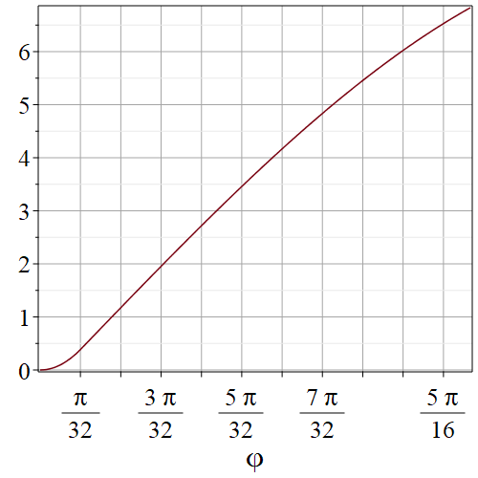 | 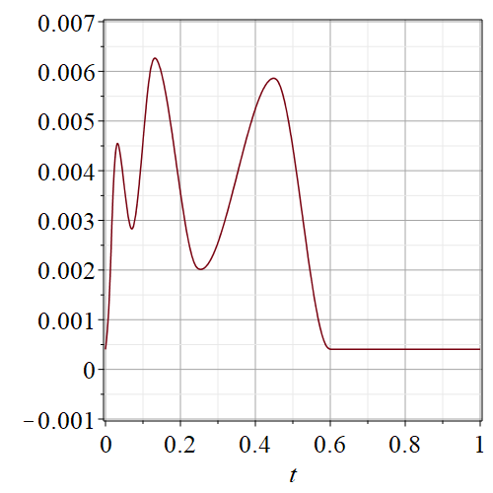
(a) | (b)
Figure 10. Graphs a) of the position function $s\text{=}s\left(φ\right)$ for the cam mechanism (mm), b) of the displacement for the pusher of the cam mechanism for creating axial force (m)

Thus, the presented method for creating the value of the axial force using the developed cam mechanism allows reducing the complexity of the MS design, its cost and ensuring the reliability of obtaining the specified diagram of the change in axial force for one test cycle.

RESULTS
Because of the research and development work, a prototype of a new MS design for TKP wear testing was manufactured, which is shown in Fig. 11, and Fig. 12 shows the test station bath, in which the TKP under test is located in the test liquid. Full-scale tests of the developed MS prototype confirmed its operability and functionality, meeting all the requirements for the standards [7, 9]. After minor modifications to the design and confirmation of the declared resource, the MS can be used to conduct certification tests of a large range of TKP various standard sizes. In addition, the MS can also be used for research purposes, for example, to assess the wear of friction pair materials during every day human activity.
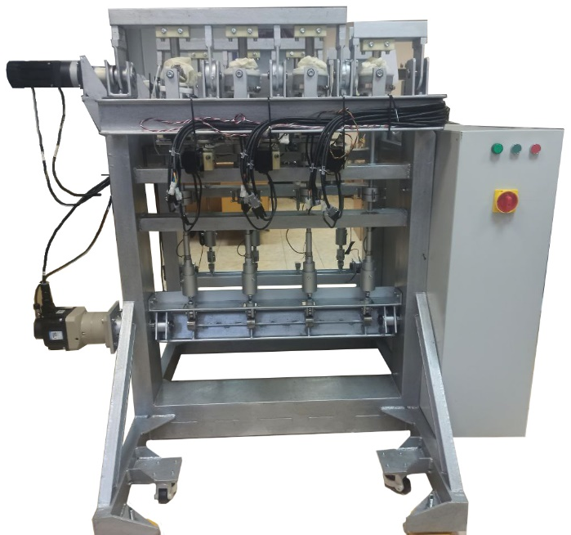 | 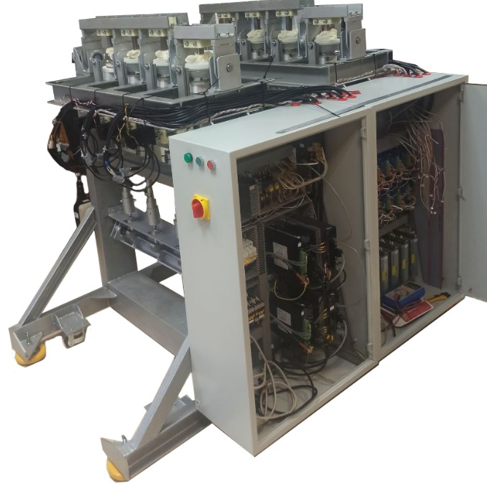
(a) | (b)
Figure 11. General view of the manufactured MS for TKP wear testing: a) front view, b) view of the box with the control system
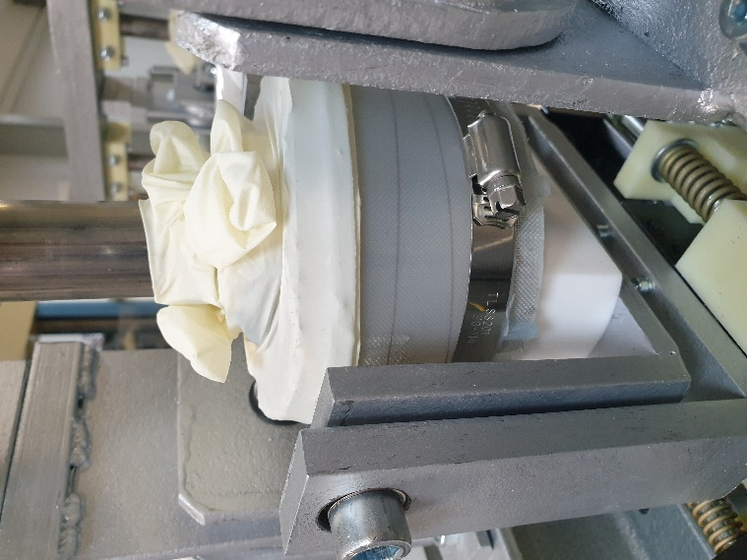
Figure 12. Test station bath with the prosthesis being tested inside

References
- A. M. Poliakov, V. I. Pakhaliuk and V. L. Popov, Current Trends in Improving of Artificial Joints Design and Technologies for Their Arthroplasty. Frontiers in Mechanical Engineering, 6, 4 (2020). https://doi.org/10.3389/fmech.2020.00004
- National Library of Medicine. https://www.nlm.nih.gov/
- P. M. Preobrazhensky, A. S. Fil, N. N. Kornilov, et al., Knee arthroplasty in clinical practice: analysis of 36,350 observations from the register of the R.R. Vreden National Medical Research Center of Traumatology and Orthopedics. Traumatology and Orthopedics of Russia, 29(3), 73-85 (2023). https://doi.org/10.17816/2311-2905-9349 .
- V. I. Pakhaliuk, A. M. Poliakov, M. I. Kalinin, Y. V. Pashkov and P. Gadkov, Modifying and expanding the simulation of wear in the spherical joint with a polymeric component of the total hip prosthesis. Facta Universitatis: Series Mechanical Engineering, 14(3), 301-312 (2016). https://doi.org/10.22190/FUME1603301P
- V. I. Pakhaliuk, A. M. Poliakov and I. Fedotov, The ceramic modular head improvement in the design of a total hip replacement. Facta Universitatis: Series Mechanical Engineering, 19(1), 67-78 (2021). https://doi.org/10.22190/FUME201212010P
- MORDOR Intelligence. Knee replacement market size and share analysis - growth trends and forecasts (2024- 2029). ‒ URL: https://www.mordorintelligence.com/ru/industry-reports/knee-replacement-market
- ISO 14243-1:2009 Implants for surgery — Wear of total knee-joint prostheses —Part 1: Loading and displacement parameters for wear-testing machines with load control and corresponding environmental conditions for test. Publication date: 2009-11. Edition: 2. Number of pages: 14. https://www.iso.org/44262.html
- ISO 14243-2:2016 Implants for surgery — Wear of total knee-joint prostheses —Part 2: Methods of measurement. Publication date: 2016-09. Edition: 3. Number of pages: 4. https://www.iso.org/69851.html
- ISO 14243-3:2014 Implants for surgery — Wear of total knee-joint prostheses —Part 3: Loading and displacement parameters or wear-testing machines with displacement control and corresponding environmental conditions for test. Publication date: 2014-11. Edition: 2. Number of pages: 16. https://www.iso.org/56649.html

