Hybrid Joining in Aircraft Assembly: Mathematical Modeling and Numerical Simulation
Sergey Lupuleac^{1, a)}, Artem Eliseev^{1, b)}, Alexander Koloskov^{1, c)}, Julia Shinder^{1, d)} and Nadezhda Zaitseva^{1, e)}
¹Peter the Great St. Petersburg Polytechnic University, Russia

^{a)} Corresponding author: lupuleac@mail.ru
^{b)} eliseev0@mail.ru
^{c)} koloskovao2001@gmail.com
^{d)} julia_shinder@mail.ru
^{e)} zaitseva.n.i@mail.ru
Abstract. The assembly process of modern aircrafts presents a very complicated technological procedure. During the assembly process many individual operations are performed such as assembled parts’ positioning, hole drilling/reaming, temporary/permanent fastening. In particular, during the fastening the free space between joined parts is filled with liquid adhesive (sealant) in order to ensure the quality and durability of the joint. Such a technique, when both fasteners and adhesive are used to join the parts, is usually classified as hybrid joining. Mathematical modeling of hybrid joining presents a challenging task due to flexibility and contact interaction of structural parts, fluidity of sealant and two-way interaction between the structural parts and the sealant, when both parts’ deformations and sealant flow affect each other. The numerical approach for resolving the two-way interaction during the hybrid joining of the aircraft parts is based on the partitioned technique, when structural and fluid problems are solved independently and special iterative procedure is applied to reach convergence. In this paper this approach is enhanced by taking into account the adhesion between sealant and structural parts. It is done by using the similar partitioned technique, when the effect of adhesion is coupled to the two-way interaction of the parts and sealant. Thus, the three-way interaction is resolved, which is done for the first time to the best of the authors’ knowledge. The presented paper covers both recent results obtained with the three-way model of the hybrid joining process and previously established ones for the two-way model.

Introduction
The assembly process in aircraft manufacturing requires very high precision. Quality is critical here, since residual gaps and stresses caused by assembly can lead to defects and even destruction of the structure during operation. Therefore, mathematical modeling of the assembly process of aircraft structures is a very relevant and at the same time complex problem, since it requires taking into account many factors from different areas of mechanics and applied mathematics [1]. Firstly, the assembled panels are usually large-sized and quite flexible, so their deformations and contact interactions must be taken into account. The length of the junction area for some parts can reach several meters. At the same time, the distance between the fasteners is about several centimeters. The number of fasteners in one junction area can reach several hundred. Secondly, the assembly technology must be the same for all assembled copies, which differ in individual deviations from the nominal value. Therefore, it is necessary to take into account the random deviations and their statistical analysis, that is, the variation simulation is used. In addition, it is necessary to take into account the rigidity of the fasteners, since it is necessary to exclude the effect of their weakening during the assembly process. In addition, a thin layer of liquid sealant or glue is applied between the assembled parts, which, spreading and hardening during the assembly process, affects the stress-strain state of the entire structure.
If parts are connected simultaneously by glue and mechanical fastening (bolts or rivets), such joint is called a hybrid bonded-bolted (HBB) joint. HBB joints are widely used not only in aircraft manufacturing, but also in shipbuilding, automobile manufacturing and other industries. With the correct selection of parameters, HBBs provide a significant increase in static and fatigue strength compared to both adhesive and bolted joints [2].
Most of the works on HBB joints are devoted to experimental studies of the strength of hybrid joints, details can be found in reviews [2] and [3]. From the point of view of mathematical modeling of assembly processes, the most interesting are the works of Yokozeki et al. [4] and Ricca et al. [5], containing measurements of the adhesive layer thickness after curing, as well as Flaig et al. [6], where various adhesive application patterns are used. These experimental results can be used to validate numerical models. The review by Zhang et al. [7] is devoted to the numerical simulation of hybrid joints. It is noted that most of the works investigate the performance of HBB joints under operational conditions using commercial finite element software packages, mainly Abaqus. In particular, it is indicated that the performance characteristics of HBB joints are determined by the thickness of the adhesive layer and the stresses caused by the assembly process. Estimation of these parameters requires modeling the assembly process of the hybrid joint. For most HBB joints, the adhesive is applied in a liquid state and cures during the assembly process, which makes the problem very complex. Additional difficulties arise due to the fact that the adhesive may not fill all the space between the glued parts, i.e. there is a free adhesive surface that changes during the assembly process. Thus, correct modeling of the assembly process of hybrid joints requires taking into account the two-way interaction of the liquid and the deformable parts (fluid-structure interaction, FSI), as well as taking into account the free surface of the liquid.
Let's look at several articles devoted to modeling the flow of glue under pressure and its interaction with the assembled structures. Burka et al. [8] use commercial CFD (Computational Fluid Dynamics) code Fluent to simulate the 2D squeeze flow of viscous adhesive in a narrow channel. The two-phase flow model includes air, accounted for by a standard VoF (volume of fluid) approach for modeling the interface of phases. Muller et al. [14] use CFD simulation by Fluent to validate the results obtained by the original method proposed in [13]. In the work of Huf et al. [9] Abaqus is used to model the hybrid joints. Two methods are considered for modeling the adhesive behavior: the coupled Euler-Lagrange method and the Smoothed Particle Hydrodynamics. The simulation results obtained by the coupled Euler-Lagrange method are in good agreement with experiment, but the approach is limited by the simplified fluid behavior provided by Abaqus. The use of commercial software packages for modeling the assembly process of adhesive or hybrid joints seems inefficient due to the large size of the parts and the small thickness of the adhesive layer, as this requires a very fine computational mesh, which leads to excessive computational costs.
One of the effective methods for modeling the glue flow is the use of the Reynolds equation of lubrication theory [15], which is derived from the Navier-Stokes equations in the thin-layer approximation. However, since the classical Reynolds equation assumes that the entire channel is filled with liquid (glue), which is not the case in this problem, direct application of this model is impossible. The modification of the Reynolds model proposed by Müller et al. [13] takes into account incomplete filling of the gap between the assembled parts with glue, offering an analogue of the VoF model for the Reynolds equation. The deformation of the structural parts is taken into account by introducing corrections to the gap thickness at small values. These corrections are calculated by solving the Boussinesq problem (on the deformation of a half-space under the action of a force) analytically. Thus, the proposed approach allows correct modeling of the assembly process only when gluing thick panels, which can be considered practically non-deformable.
In the work of Mato et al. [12], the deformation and contact interaction of the parts during the assembly process were taken into account by reducing the contact problem to a quadratic programming problem, as proposed by Lupuleaс et al. [11] and applied to model the "dry" assembly process in many works (see, for example, [10]). However, the effect of the adhesive flow was taken into account in [12] using correction force terms at the points corresponding to small gap values, obtained by analytically solving a simplified version of the Reynolds equation near these points.
Full-featured modeling of both the structural and adhesive parts using efficient computational models was proposed by Eliseev et al. [16]. The structural part is described by reducing the contact problem to a series of quadratic programming problems, and the adhesive part is described by the Reynolds equation of lubrication theory. The free surface of the liquid is modeled by introducing a deformable Lagrangian mesh. The adhesive curing is modeled by the viscosity dependence on time. This model turned out to be very efficient from a computational point of view and was used both to model small test joints [16, 17] and the entire process of fastening a full-size wing to a fuselage [18, 19]. However, the technological process of assembling the aircraft structures includes, in particular, the operation of replacing temporary fasteners with permanent ones [19]. Therefore, the fasteners are removed one by one, which can lead to decohesion of the sealant layer from one of the surfaces. This effect was not taken into account in the model of Eliseev et al. In this study, an adhesion model is added to the structural and liquid ones in the modeling of the assembly process to take this effect into account.
Adhesion models used in computational procedures can be divided into three large groups. The models of the first group (local material models) assume the introduction of an additional medium - an adhesive layer, at the interface of adhering bodies. In this case, the rheology of the adhesion effect is reduced to a rheological model of this medium, which, in most cases, corresponds to one of the models of mechanics of a deformable solid. The second group of models (local interface models) transfers the rheology of adhesion from a crack in the adhesive layer to the interface of the adhering bodies. The third group of models (global models) is based on averaging the local characteristics of the adhesive interaction over the surface of the rupture zone. Often, such models are based on analytically obtained results when considering special cases. A detailed description of the models of the first and third groups is given by Sauer in the survey [20].
For the purposes of this study, the models of the second group are the most suitable. In this case, the volumetric adhesion model is ignored, and ad hoc rheological models arise for the adhesion phenomenon. Often such models are implemented as a dependence of the adhesive forces $Ψ$ resisting decohesion on the gap size $g$ (traction-separation law). Such models, formulated in the context of specific problems, due to their simplicity and ease of implementation, find application in substantially different problems with variable physical sizes of the adhering surfaces, gaps and displacements, as well as internal parameters of the models. In some cases, they can also be combined, for example, for a separate description of the tangential and normal development of the decohesion effect. A good example is the model based on the integration of the Lennard-Jones potential for intermolecular interaction. It is applied by Sauer and Wriggers to the analysis of adhesive interactions on the nanoscale [21]. Also it is used by Sauer and Li for the description of the effect in macroscopic bodies [22].
Energy-based principles, such as the postulation of an adhesion potential or the inclusion of an adhesive work term in the energy balance, provide a fundamental framework for constructing and characterizing interface adhesion models. Sauer and De Lorentiz [23] propose a methodology for constructing potentials on the base of rheological laws of the type of traction-separation law described above. The problem of these laws is similar to the problem of describing the adhesion layer using elastic models: neglect of the dissipation phenomenon characteristic of adhesion. Taking this factor into account, it is useful to utilize the thermodynamic approach of Frémond [24-25]. Frémond's approach is based on two main ideas: the virtual power principle formulated by Germain and generalized by him in [26] to take into account the microstructure (for the adhesion model, in particular, the scalar parameter $β$, characterizing the adhesion intensity, acts as a characteristic of the microstructure); and the generalized standard material (GSM) model introduced by Halphen and Nguyen in [27], which proposes a standard for describing the rheology of a deformable solid using a pair of potentials: the Helmholtz free energy and the dissipative pseudopotential. The description of the dissipation effect by introducing a dissipative potential was first proposed by Moreau in [28]. This approach was later developed by Zeigler [29]. Within the general approach, Frémond himself constructed his own adhesive rheology, first proposed in [30], based on a fracture mechanics model. In [31–32], a methodology for selecting the internal parameters of the model was proposed based on solving an optimization problem. One of the characteristic features of the Frémond adhesion model is the neglect of the direct dependence of the rate of decohesion development on its value at a given moment. Locally, this can be written as $\dot{β̇}(u(β), β) = \dot{β̇}(u(β))$. An alternative rheological model within the Frémond model, taking into account the described dependence, was proposed by Raous [33]. The model was developed by adapting the contact problem with Coulomb friction to take into account the effect of adhesion, was first presented by Raous, Cangémi and Cocu in [34] and was subsequently named RCCM (Raous-Cangémi-Cocu-Monerie). Extensive results of the study of the decohesion dynamics described by the model, including an analysis of the influence of internal parameters of the model, as well as an analysis of problems arising in the calculations, are presented in [35-37].
In the present study, the Raous-Frémond model is used. Its main advantages are the inclusion of the dissipation phenomenon in the process of adhesive interaction, as well as the ease of integration into the contact model.

Theoretical background

Structural model
The structural problem is about finding the stress-strain state of the assembled parts under the external loading. In case of assembly simulation, it is also necessary to take into account the contact between parts that makes the structural problem non-linear. As it is shown in [38] the structural contact problem can be reduced to the quadratic programming problem, corresponding to the minimization of potential energy of the system constrained by geometric non-penetration conditions.
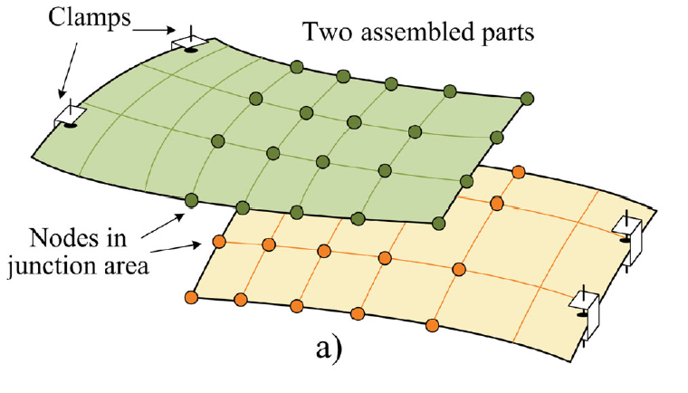
FIGURE 11. Structural model

Using Guyan reduction [39], the problem dimension can be reduced by considering only the displacements in the junction area (Fig. 1) that are constrained by the non-penetration conditions. At every time step, the non-stationary contact problem is reduced to the quadratic programming problem in order to minimize the following functional:
$\left\{\begin{aligned}\min\left({\frac{1}{2}u}_{j}^{T}Du_{j}-c_{j}^{T}u_{j}\right) \\ Au_{j}≤g\end{aligned}\right.$ (11)
Here $j$ is the index of current time layer; $u_{j}$ is the vector of constrained displacements in the junction area; $D$ is the equivalent reduced stiffness matrix; $c_{j}$ is the equivalent load vector that explicitly depends also on displacements, velocities, and accelerations on the previous time layer; $A$ is a linear operator that defines the contact pairs; $g$ is the vector of initial gap between the assembled parts.
So, the transient contact problem of structural dynamics is reduced to a series of quadratic programming problems that can be solved by the numerical methods developed for the stationary case (see [40]).

Fluid dynamics model
Sealant starts to flow when it is squeezed by the assembled parts during fastening. At the same time the internal pressure in sealant increases. This pressure may be high enough to notably oppose the relative motion of parts and this characteristic of sealant flow is of main interest in the corresponding fluid dynamics problem. For the description of the sealant flow the lubrication theory is used.
Using of thin layer approximation allows to derive the Reynolds lubrication equation [15], which describes pressure distribution of sealant. This equation strongly depends on the rheological model of sealant behavior under loading. Presently, the Newtonian model is used, and Reynolds equation has the following form:
$\frac{∂}{∂x}\left(\frac{∂p}{∂x}h^{3}\right)+\frac{∂}{∂y}\left(\frac{∂p}{∂y}h^{3}\right)=12μ\frac{∂h}{∂t}$ (22)
Here $p$ is the sealant pressure, $h$ is the local thickness of sealant layer, $μ$ is the viscosity of sealant.
Since in thin layer approximation the pressure does not change in transversal direction, only two longitudinal coordinates $x,y$ present in the equation.

Free surface determination
The pseudo-structural method [41] is selected for the assignment the position of free surface of sealant (Fig. 2 (a)). In this method an additional Lagrangian mesh is introduced, which is considered as an elastic medium with prescribed distribution of elastic properties. In other words, in this approach the edges of the mesh have their own stiffness, which could be varied in any reasonable way. This allows the consideration of the sealant encapsulated in an elastic casing as one more body in the structural problem (1) and enforce the non-penetration conditions between sealant and other parts automatically. In this formulation the sealant pressure is considered as a distributed load acting on the surface of this additional body.

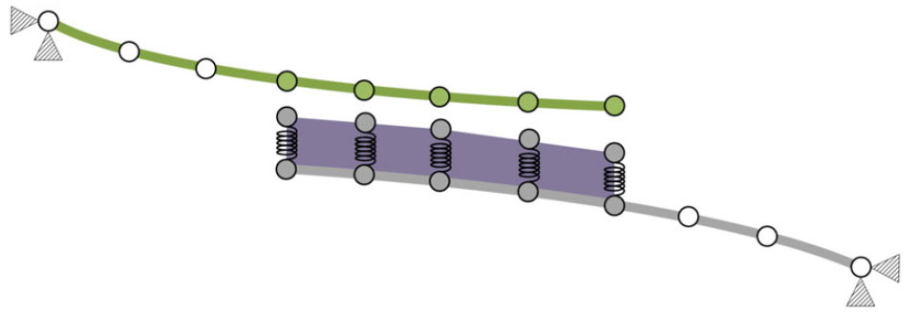 | 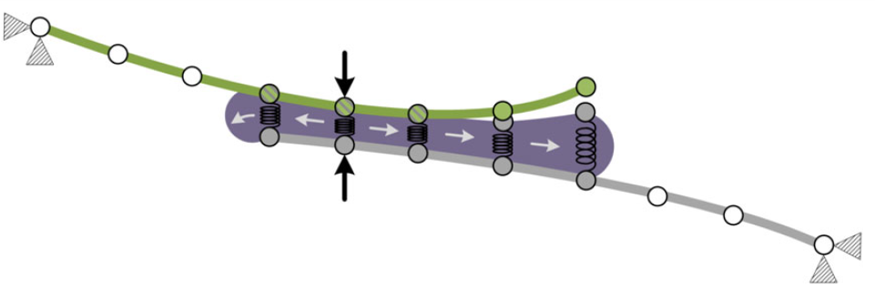
(a) | (b)
Figure 22. Fluid model with pseudo free surface
A typical solution of the considered fluid-structure interaction problem is presented schematically in Fig. 2 (b). Here one part of the assembly bends under the load from installed fastener (pictured by black arrow) and contacts with sealant layer causing the subsequent change of sealant pressure that acts on the part. The squeeze flow of sealant affects its free surface that is automatically resolved by the proposed approach.

Adhesion model
The adhesive component $Ψ$ of the contact force in the junction area, within the framework of the Frémond model [24], is determined as follows:

$\left\{\begin{aligned}Ψ^{i} = C{\left(g - Au\right)}^{i}{\left(β^{i}\right)}^{2} \\ {\dot{β}}^{i} = -\frac{1}{b}{\left[C{\left({\left(g - Au\right)}^{i}\right)}^{2} β^{i}- w\right]}^{+}\end{aligned}\right.$. (33)

Here $i$ is the index of computational node; ${\left[x\right]}^{+}=\frac{x+|x|}{2}$ is the positive part; $β∈[0, 1]$ is the adhesion intensity; $C$ is the adhesive contact rigidity; $w$ is the decohesion energy limit; $b$ is the adhesion viscosity [35,33].

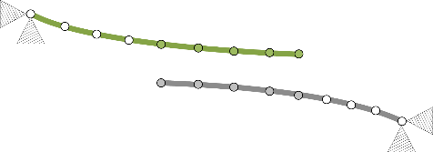 | 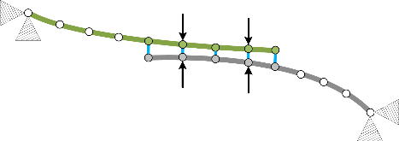 | 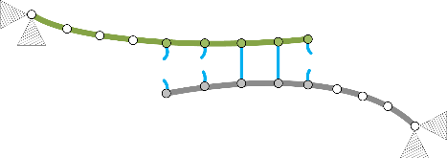
(a) | (b) | (с)
FIGURE 33. Adhesion model

The process of formation and rupture of adhesive bonds is shown schematically in Fig. 3. In the computational model under consideration, the adhesive bonds are regarded as nonlinear springs that are absent before the contact happens (a) and bind the computational nodes when in contact (b). These springs can break while the gap opens (c) when the decohesion energy limit is exceeded.
The adhesion force $Ψ$ depends on the displacements of the parts u and, in turn, is taken into account in the force vector c in the structural problem (1). One of the surfaces in the adhesive contact interaction can be the free surface of the sealant, modeled using a deformable Lagrangian mesh, as described in the previous paragraph.
The rigidity of the adhesive contact $C$ characterizes both the elastic rigidity and the brittleness of the adhesive interaction. Thus, at a sufficiently small $C$, the adhesive forces are small, while the intensity of adhesion does not decrease. With a consistent increase in $C$, decohesion evolution first appears, then, with an increase in the emerging forces, the decohesion process accelerates, up to the limiting case when an instantaneous separation of parts is accompanied by high resistance.

Modeling of three-way interaction with partitioned approach
The calculation procedure is based on the so-called partitioned approach, where each phenomenon (deformation and contact interaction of structural parts, sealant flow and adhesion) is modeled separately, and then the solutions are aligned during the iterative process at each time step. The general scheme of interaction between models during the calculation process at each iteration is presented in Fig. 4. This diagram reflects the general case of three-way interaction. But each of the "bottom" models (both hydrodynamic and adhesive) can be switched off. In this case, two-way interaction remains, which is also considered here (for the “structural-fluid” combination).
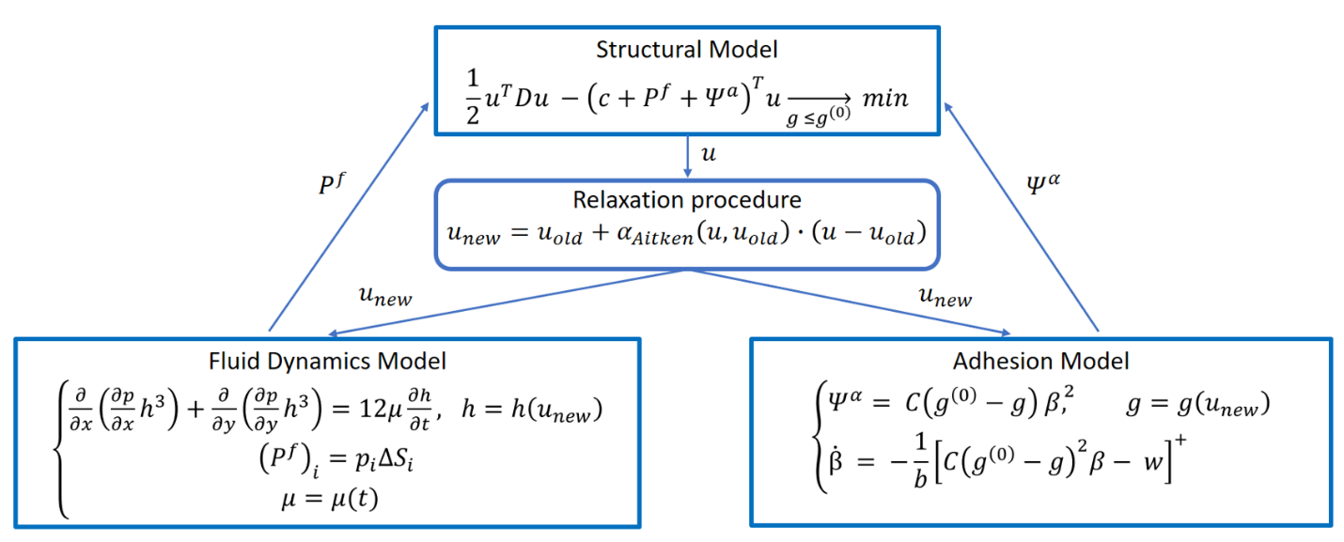
Figure 44. Scheme of interaction between models during the computational procedure
Aitken relaxation is used to improve the convergence of the numerical process. After each iteration of the structural solver, the "relaxed" displacement field is calculated. Then, the current gap between the parts is calculated, which is used in the hydrodynamic and adhesive solvers. In turn, based on the results of calculations in the "bottom" models, force terms are transferred into the structural solver. The calculation at each time step continues until the convergence of the iteration procedure is achieved.

Results and discussion

Description of the assembly model
For numerical experiments, a model is used whose geometric and mechanical parameters were chosen to simulate a part of the wing-fuselage joint of a typical aircraft. Previously, this model was used to study the effect of sealant on the assembly process without taking into account the adhesion [16,17]. The joint of two panels made of aluminum alloy is considered. The upper panel is reinforced with stringers. Its length is 1 m, width 0.6 m, thickness 5 mm. The thickness of the lower panel is 10 mm. The corresponding finite element model is shown in Fig. 5 (a). The mesh in the contact area is refined and contains 861 nodes on each panel in this zone. Gray triangles show the nodes in which all displacements and rotations are forbidden.
The liquid model has 861 degrees of freedom, which represent the pressure in the sealant. The deformable Lagrangian mesh (elastic shell for the sealant) also has 861 Degrees Of Freedom (DOFs). The adhesion model also has the same number of DOFs. The panels are fastened with 15 fasteners installed in pre-drilled holes (see Fig. 5 (b)). This approach uses a complex model of fasteners presented in [42]. This model takes into account the installation load, duration of the installation period and the rigidity of the fasteners.
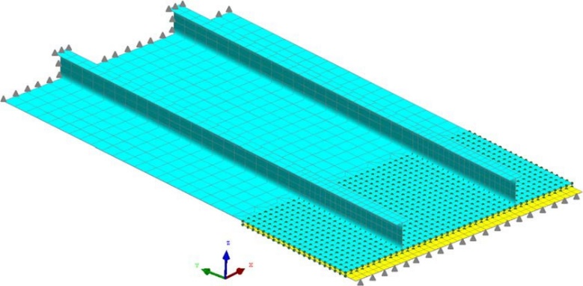 | 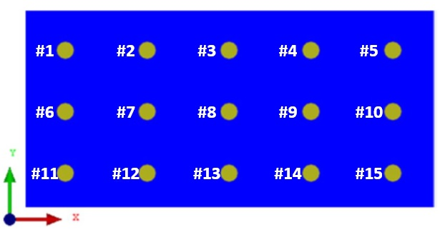
(a) | (b)
Figure 55. Finite element model (a) and fastener numbering (b)
Let us describe the used scenario of the assembly process. The initial gap between the panels is equal to 6 mm. A layer of sealant of constant thickness 0.15 mm and viscosity μ = 27 Pa$\text{⋅}$s is applied to one of the panels. The central fastener (# 8, see Fig. 5 (b)) is installed first at time T = 2 s. Then the fasteners are installed in pairs every 5 seconds - starting with T = 7, 12, 17 s etc. The installation time for each fastener is 5 seconds. During this time, the force gradually increases from 0 to 1000 daN according to a third-degree polynomial. Fastener stiffness is 1000 daN/mm. At time T=37 s, the last pair is installed, and at T = 42 s, all fasteners are installed completely.
Upon reaching time T = 100 s, the fasteners are removed in the same order and at the same intervals with which they were installed. During the removal the force in fastener gradually decreases to 0 over 5 s according to a third-degree polynomial. That is, firstly the first installed fastener (#8) is removed, then at T = 105 s - the second and the third (#3 and #13), at T = 110 s - the fourth and fifth (#2 and #14), and so on. As a result, at T = 135 s the removal of the last pair of fasteners starts, and at T = 140 s there are no more fasteners.
The installation and removal times for each fastener are given in the Table 1. The fasteners are numbered as shown in Fig. 5 (b).
TABLE 11 Fastener installation and removal schedule
Fastener number | Start  of installation, s | End  of installation, s | Start  of removal, s | End  of removal, s
#8 | 2 | 7 | 100 | 105
#3, #13 | 7 | 12 | 105 | 110
#2, #14 | 12 | 17 | 110 | 115
#7, #9 | 17 | 22 | 115 | 120
#4, #12 | 22 | 27 | 120 | 125
#11, #15 | 27 | 32 | 125 | 130
#6, #10 | 32 | 37 | 130 | 135
#1, #5 | 37 | 42 | 135 | 140

Two calculations were carried out – the first case is without adhesion and the second case is with adhesion. The following characteristics were selected for the adhesion model: the adhesive contact rigidity C = 1.3$\text{∙}$10¹¹ N/m³, the adhesion viscosity b = 2.5$\text{∙}$10¹⁶ N$\text{∙}$s/m and the decohesion energy limit w = 1 J/m².

Numerical results and discussion
The results are presented at four different points in time – T = 50 seconds, when all fasteners are already installed; T = 100 seconds, exactly before starting to remove fasteners; T = 150 seconds, when all fasteners are removed; and the final moment of T = 200 seconds.
The gap between parts at these four moments in time is shown in Fig. 6. At the moments of T = 50 s and T = 100 s presented gap distributions look almost the same for two considered cases. This is due to the fact, that during the fastener installation (and presence) sealant is squeezed almost everywhere in the junction area. It is not observed only near the borders of the junction, where the gap between panels is forced to open up. In these spots the adhesion model opposes the gap opening, which leads to significantly lower gap values.
After the completion of the fasteners’ removal (T = 150 s) the gap between parts returns to the initial value of 6 mm for the case without adhesion. Note, that the sealant thickness distribution does not appear to do the same, which is discussed later. For the simulation with adhesion quite complicated process is observed. When any fastener is removed, no mechanical load is applied locally near the fastener placement. So, the gap is forced to open up and, as a consequence, sealant occupies the appearing free space. Due to the sealant flow the gap distribution becomes more uniform with time, when maximal value of the gap decreases and, on the other side, the minimal value increases. Thus, taking the adhesion into account completely changes the dynamics of the disassembly process, which is resolved by the presented three-way model.

T = 50 s | 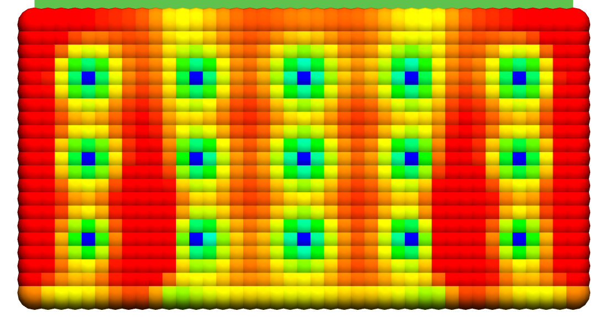 | 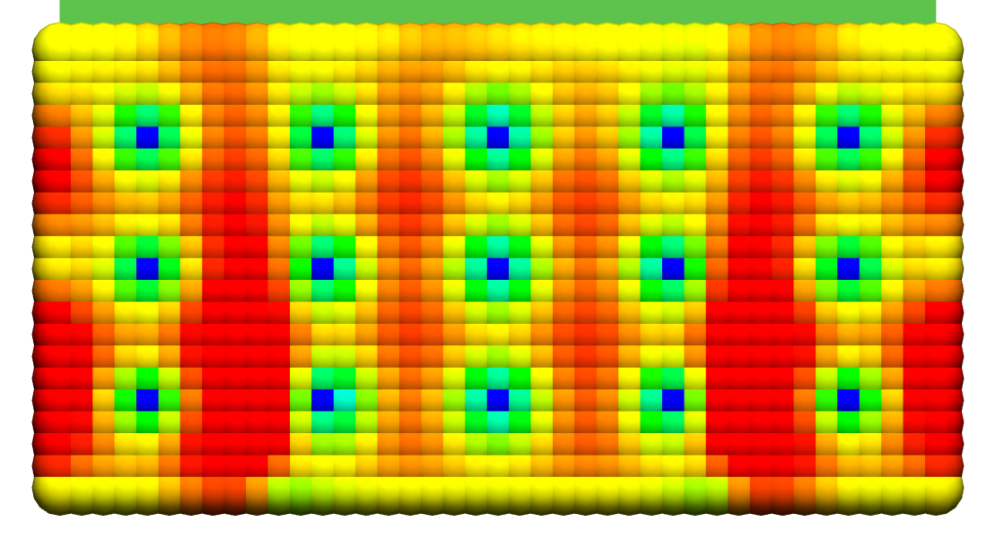 | 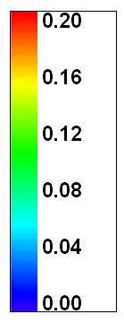
T = 100 s | 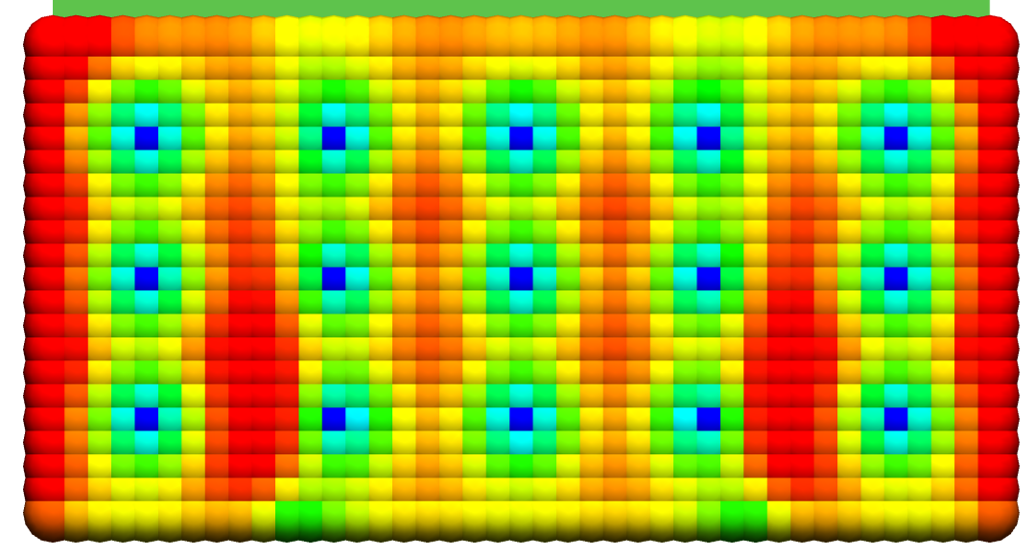 | 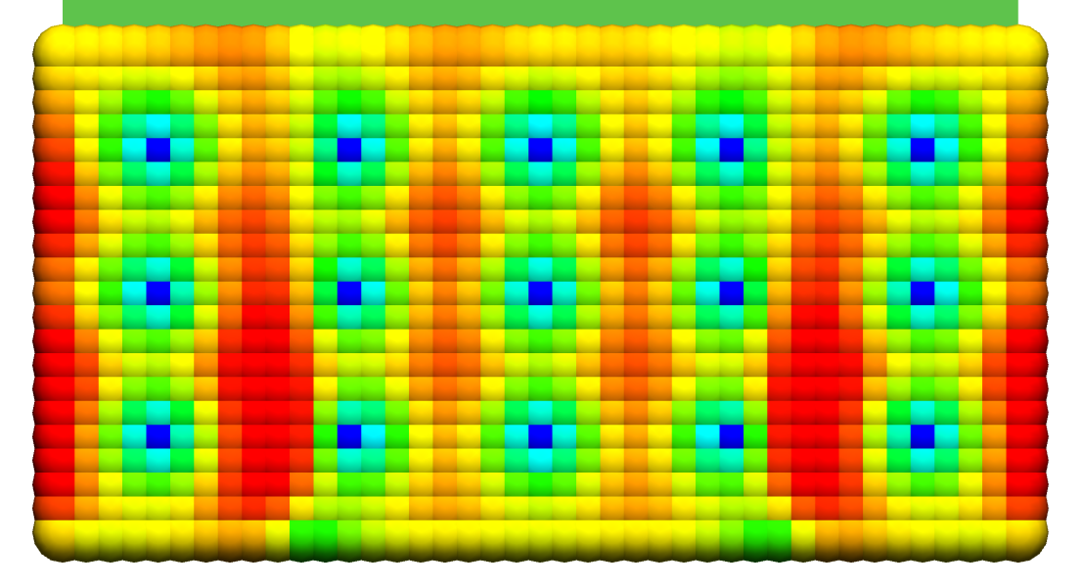
T = 150 s | 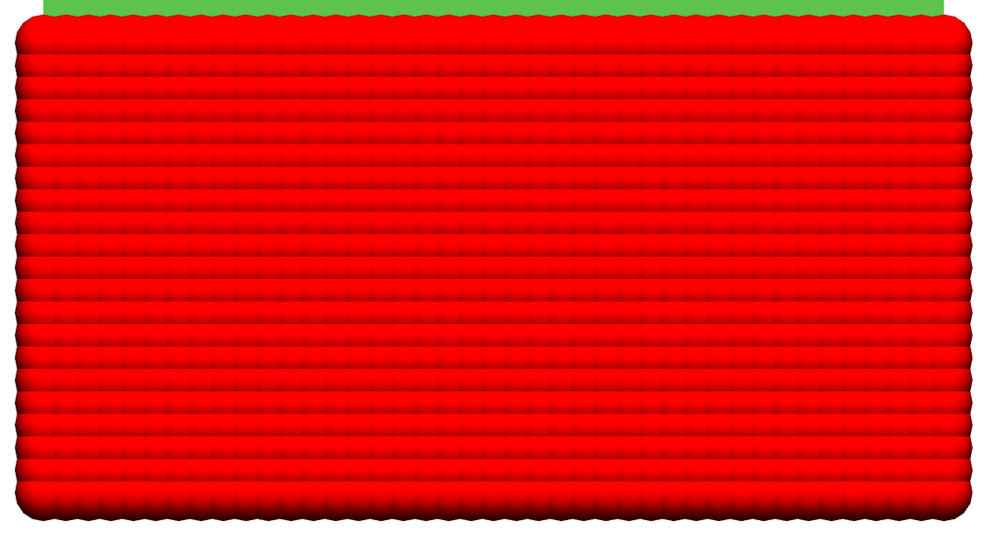 | 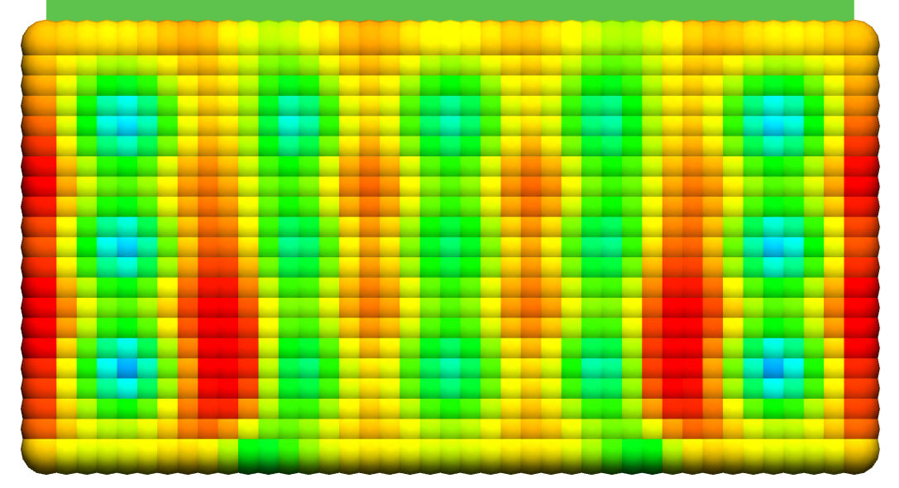
T = 200 s |  | 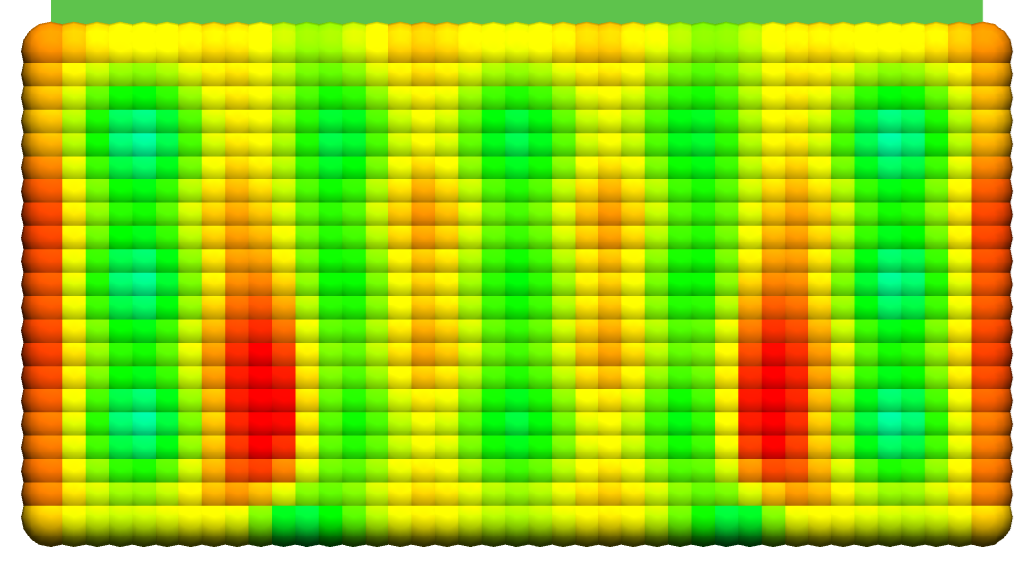
 | (a) | (b)
Figure 66. Gap between parts (in mm) at different points in time (T = 50, 100, 150 and 200 s):
(a) without taking into account adhesion (b) with taking into account adhesion
The following Fig. 7 pictures the sealant thickness distribution in the same fashion as previous Fig. 6. Noticeably, the thickness distribution does not change after the fasteners’ removal for the case without adhesion. It is explained by the fact that no load is applied to sealant in this case. All the observations made previously during the examination of gap between parts may be applied to the sealant thickness results. Installation of fasteners causes the squeeze of sealant and, to be precise, its complete squeeze out under the fasteners. Then, during (and after) the removal procedure, complicated sealant flow is observed for the case with adhesion, caused by stickiness between sealant and panels.
T = 50 s | 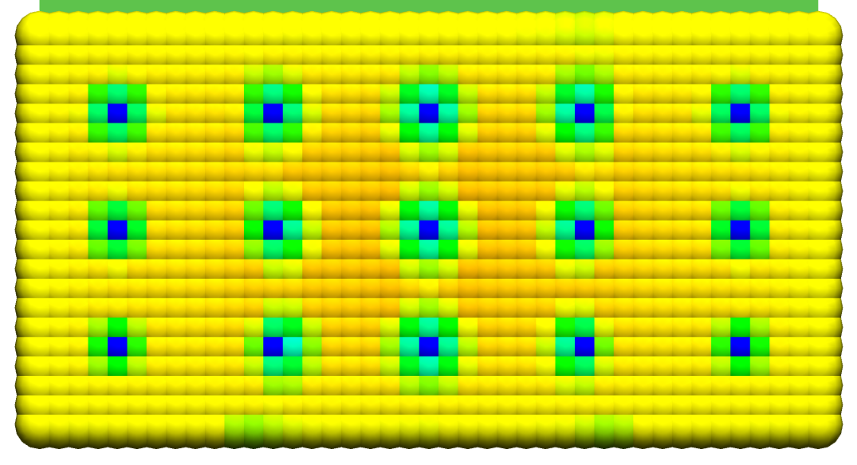 | 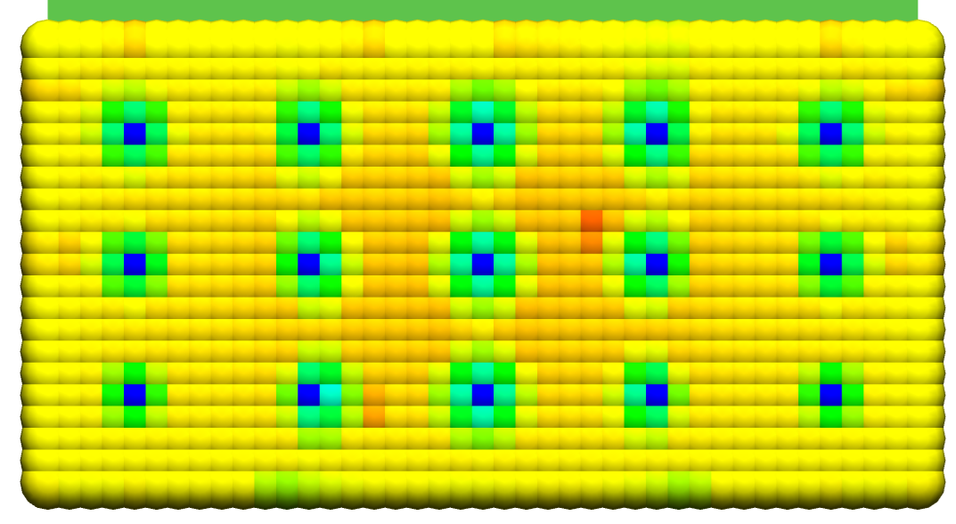
T = 100 s | 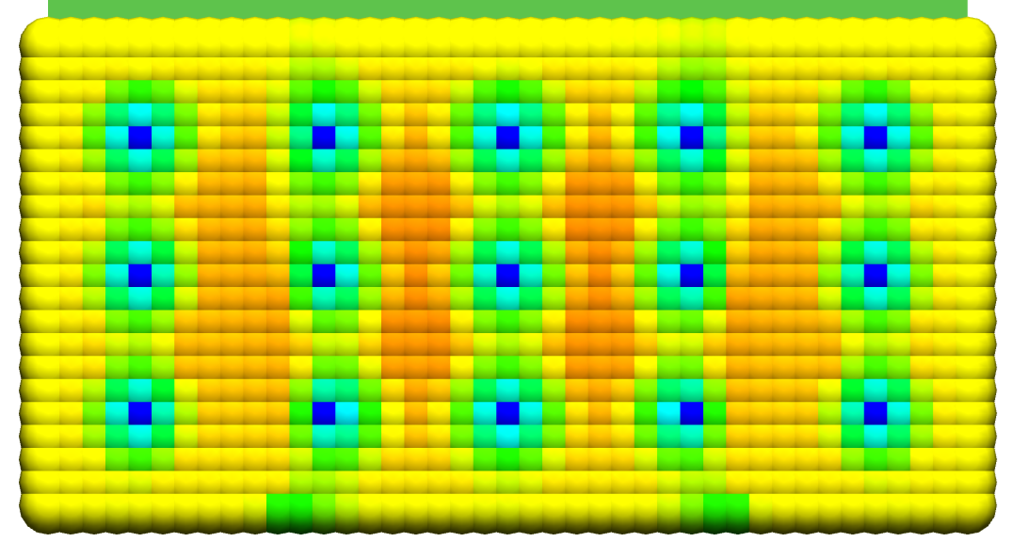 | 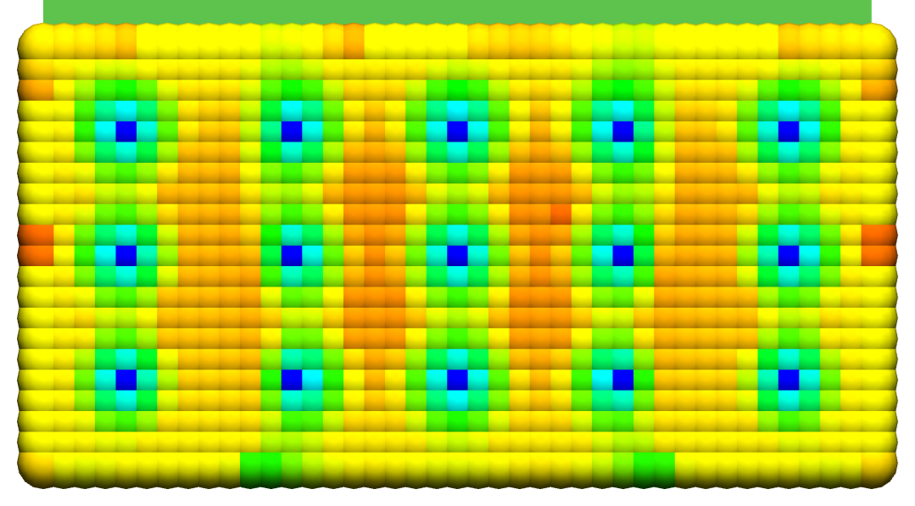
T = 150 s | 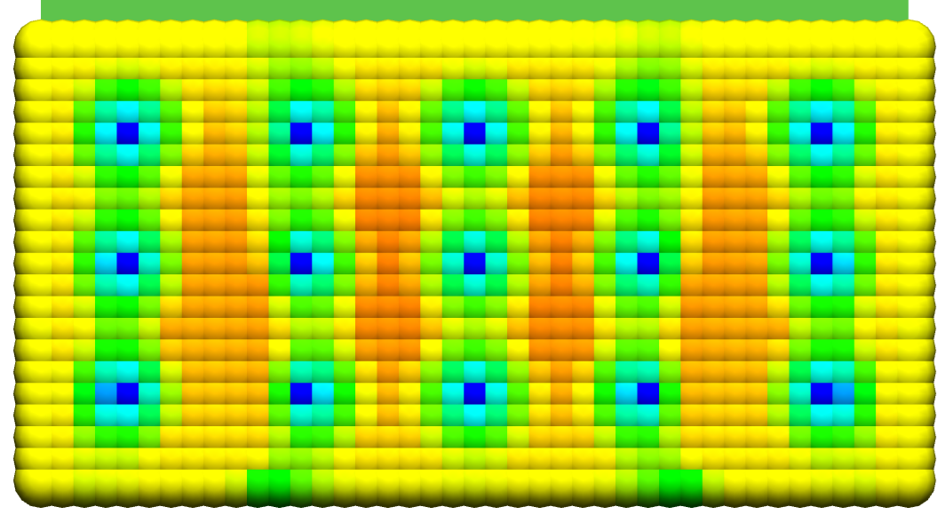 | 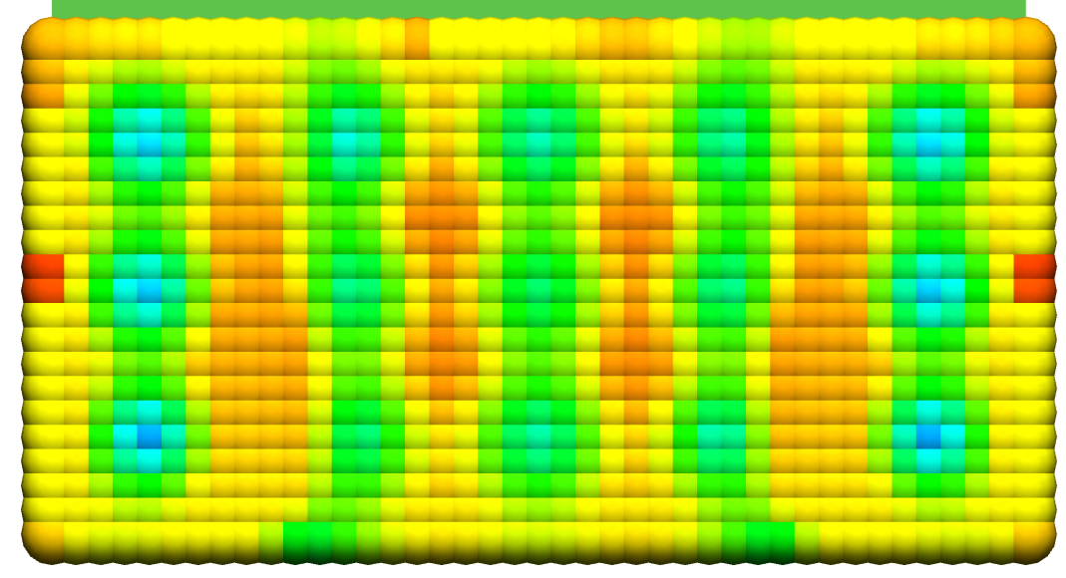
T = 200 s | 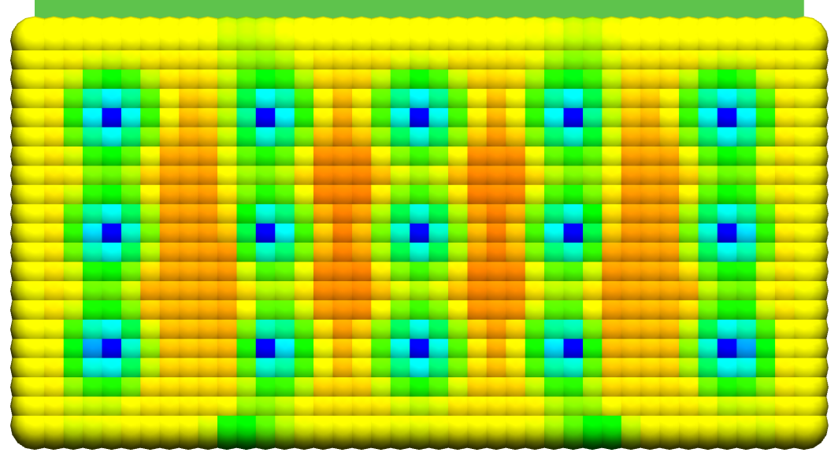 | 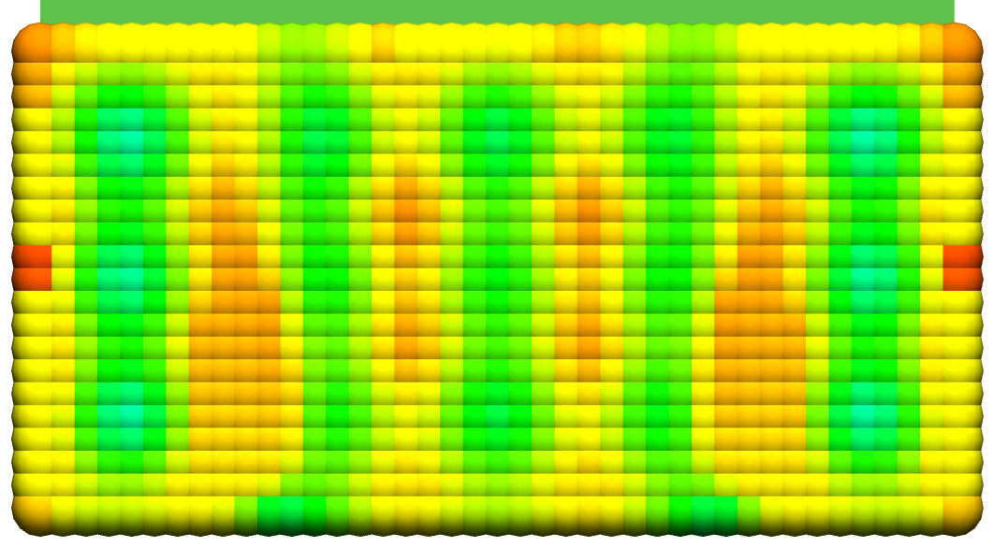
 | (a) | (b)
Figure 77. Thickness of the sealant layer (in mm) at different points in time (T = 50, 100, 150 and 200 s).
Figure 8 shows the sealant pressure at different points in time. During the presence of fasteners (T = 50, 100 s) sealant strongly opposes the applied mechanical load, so sealant pressure is positive everywhere in the junction area for both considered cases. Then, when no load is applied, the sealant pressure is equal to 0 for model without adhesion, and, on the other side, it demonstrates negative values near the places of fasteners removal for three-way case. Note that the values in Fig. 8 picture the pressure above the atmospheric, when 1 bar has to be added to obtain the physical pressure. The negative pressure values correspond to the increase of the sealant thickness, which is exactly what happens for the model with adhesion when fasteners are removed.

T = 50 s | 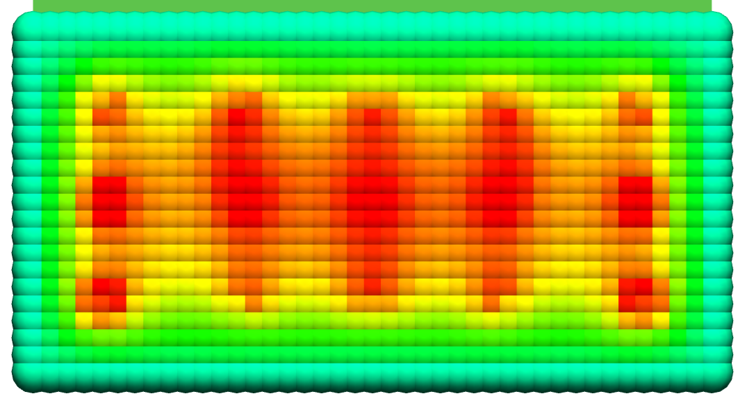 | 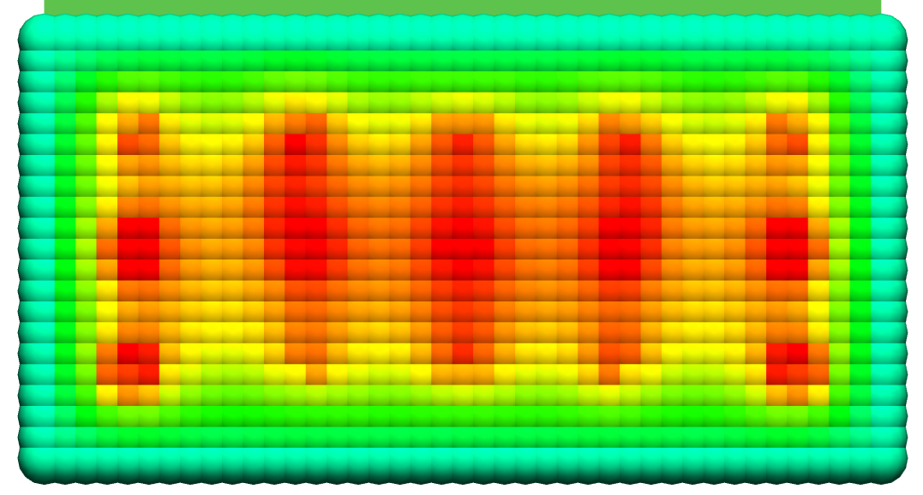 | 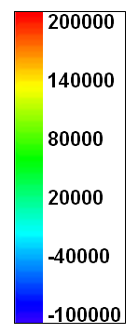
T = 100 s | 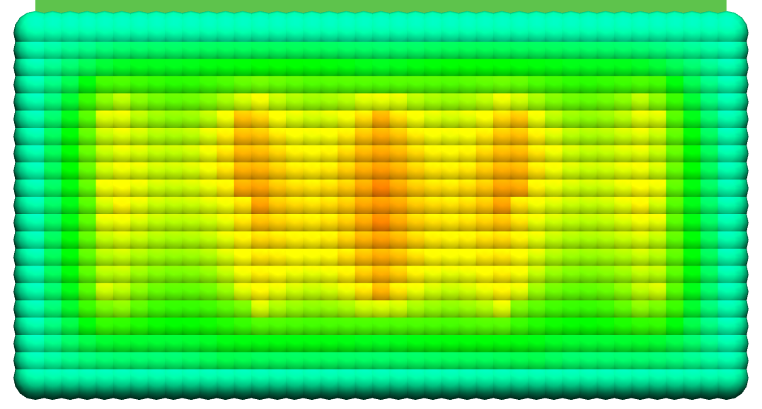 | 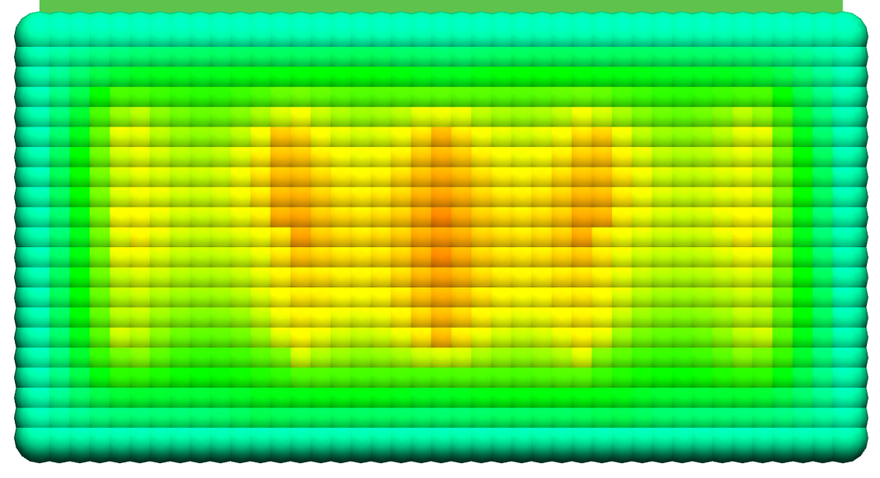
T = 150 s | 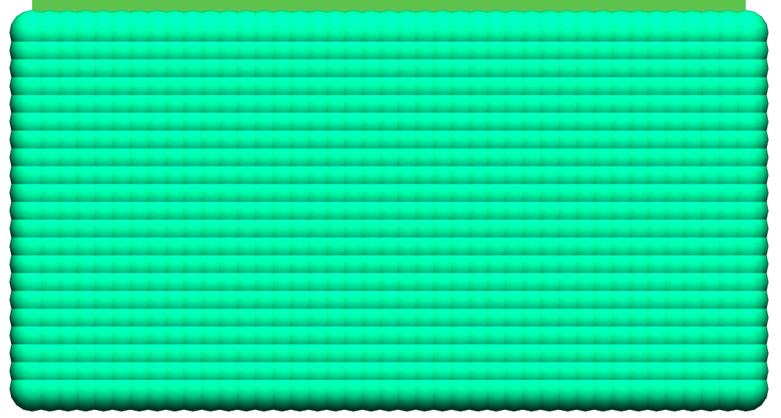 | 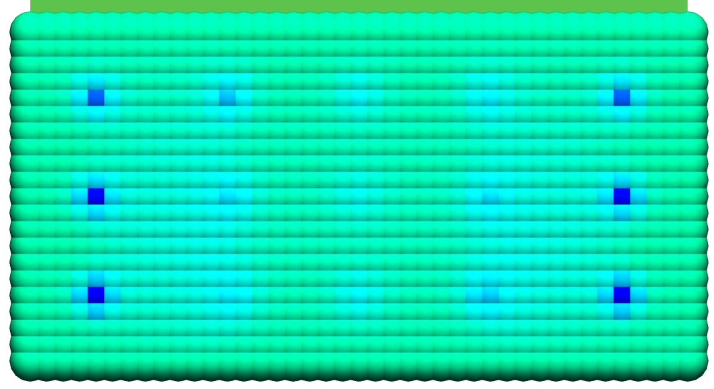
T = 200 s |  | 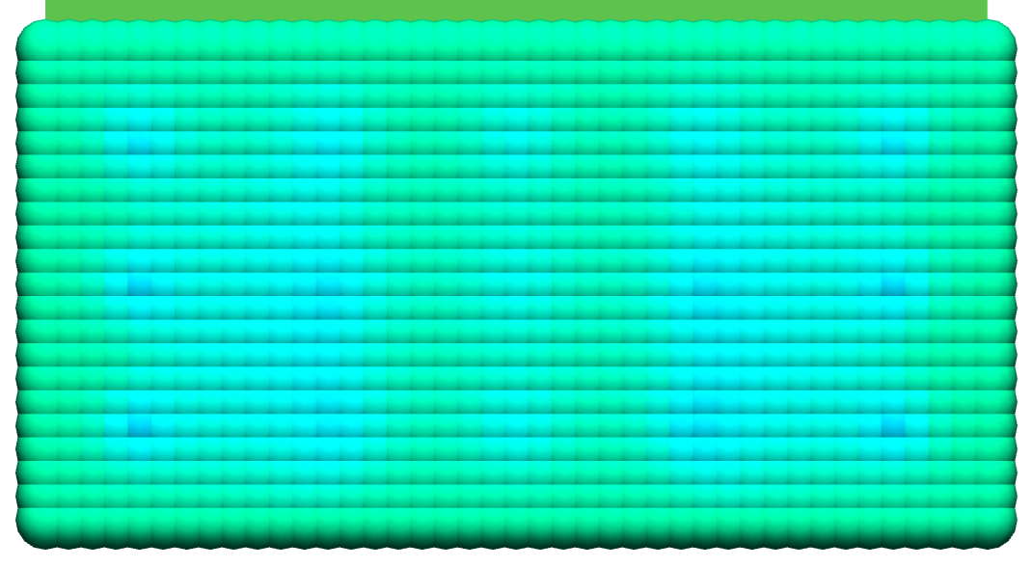
 | (a) | (b)
Figure 88. Sealant pressure (in Pa) at different points in time (T = 50, 100, 150 and 200 s).
The average thickness of the sealant layer depending on time is shown in Fig. 9. This value is obtained when the total amount of sealant in the joint is divided by the area of the junction. So, at the beginning of the simulation this value is equal to 0.15 mm, which is the height of the uniform sealant layer applied between the panels. The average sealant thickness gradually decreases for both considered cases up to the moment of approximately T = 140 s, when the removal of the fasteners is finished. Then, the significant differences are observed. For the model without adhesion, as it was discussed previously, nothing changes in the sealant after the fasteners’ removal. So, the average sealant thickness is constant up to the end of the simulation. On the contrary, the changes are observed for the case with adhesion, when the average thickness (or, equivalently, volume) of sealant increases. This is explained by the formulation of the boundary conditions used for the Reynolds equation (2). The condition of p=0 is used for both cases on the boundary of the junction area, which is equivalent for presence of infinite amount of sealant outside of the junction. It is acceptable, when fasteners are installed, since sealant flows only outside of the junction area. Then, when the removal starts, this condition leads to appearance of artificial amount of sealant in the junction. Thus, the boundary condition used for the Reynolds equation (2) has to be reformulated to improve the three-way model.
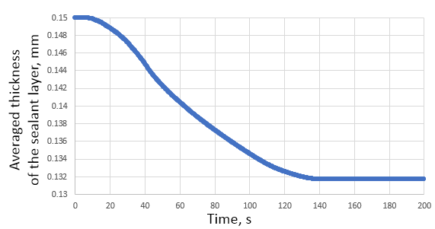 | 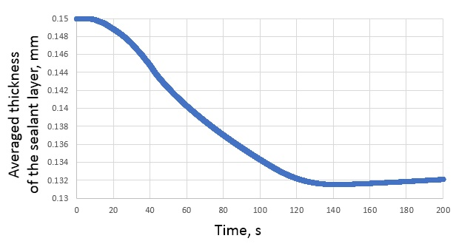
(a) | (b)
Figure 99. Average thickness (in mm) of the sealant layer: (a) for the case without adhesion, (b) for the case with adhesion
The dependence of the gap under the first installed fastener (#8 in Fig. 5 (b)) on time is shown in Fig. 10.

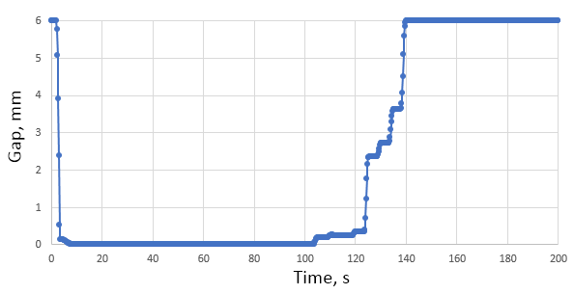 | 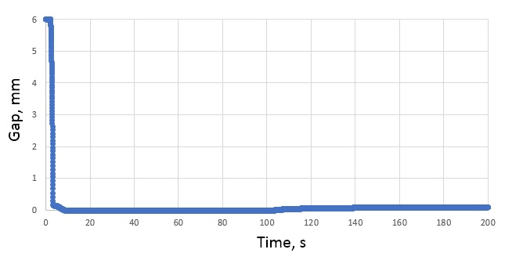
(a) | (b)
Figure 1010. Gap (in mm) under the first installed fastener: (a) for the case without adhesion, (b) for the case with adhesion,
Figures 10 (b) and 11 are the same graphs drawn to different scales. Fig. 10 (a) shows that the gap is reduced from 6 mm to 0 during the installation of the fastener. And Fig. 11 shows the growth of the gap after removing this fastener (starting from time T = 100 s) for the case with adhesion. Note that for the case without adhesion this growth is not so smooth (see Fig. 10 (a)). The gap increases because of the removal of the other fasteners for both considered cases, but in the model with adhesion the sealant flow significantly smooths the process.
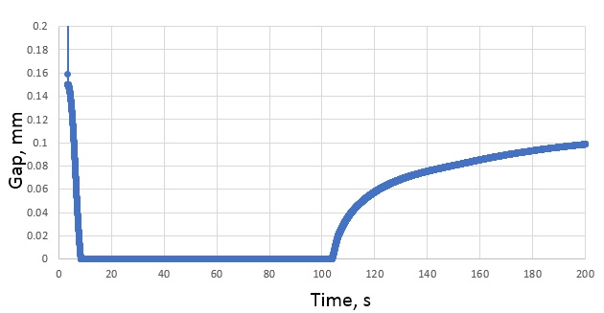
Figure 1111. Increasing gap (in mm) after the first fastener removal (the case with adhesion)
For the second case (with adhesion) adhesive force and adhesion intensity are shown in Fig. 12 (a) and 12 (b) correspondingly. Adhesive force (in N) is pictured in Fig. 12 (a) and the provided results show its significant contribution to the mechanical part of the problem. Adhesion intensity is equal to 0 or 1 for all moments of time because of the selected parameters of the adhesion model. When the intensity is equal to 0, adhesive force is also equal to 0 (see (3)). It explains presence of two large blue zones in the center of the junction area at the end of the simulation (T = 200 s). These places correspond to stringers attached to the upper panel, which prevent the gap between sealant and the part to close completely. Thus, the adhesion does not emerge and no adhesive force is presented.
T = 50 s | 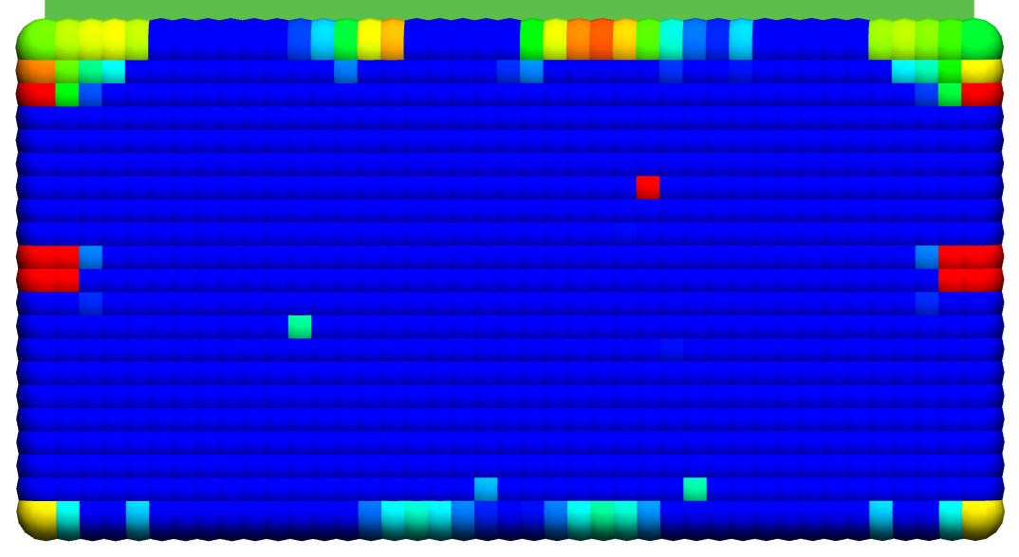 | 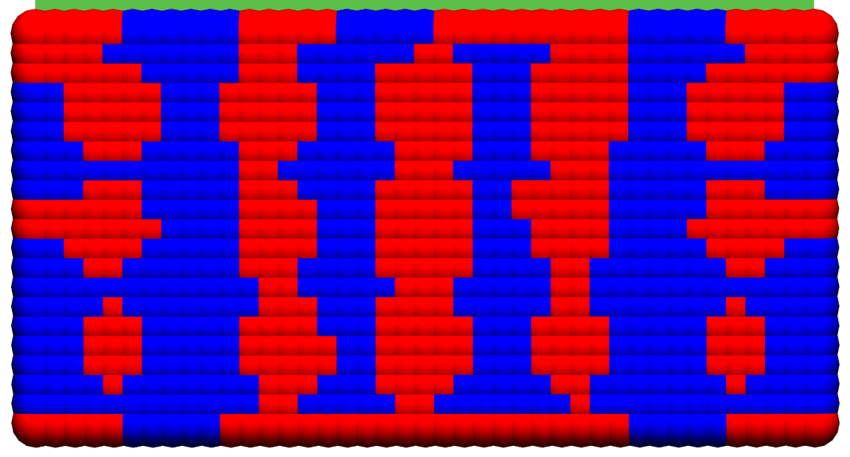
T = 100 s | 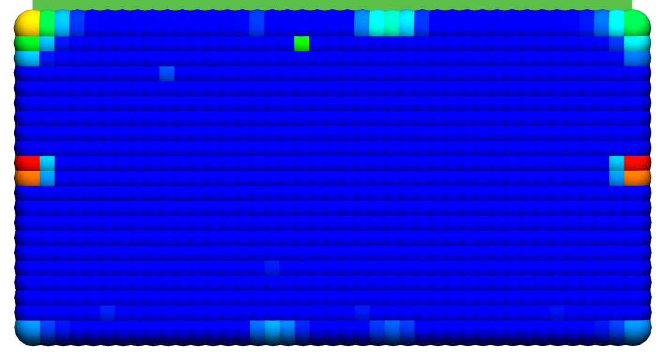 | 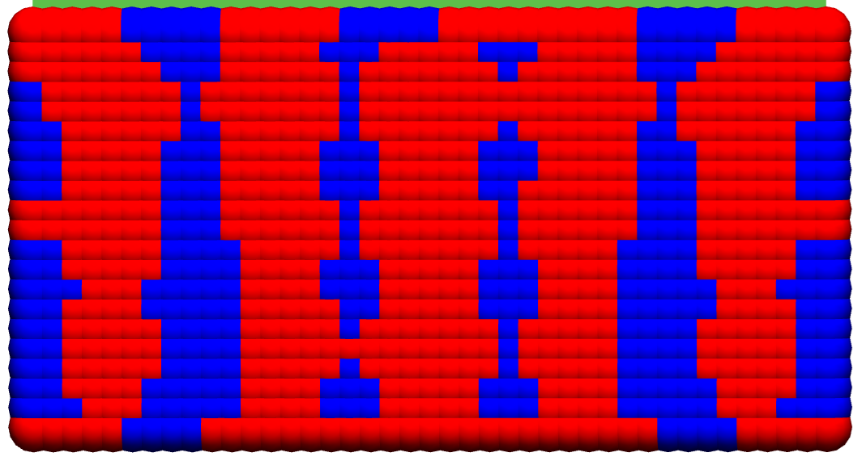
T = 150 s | 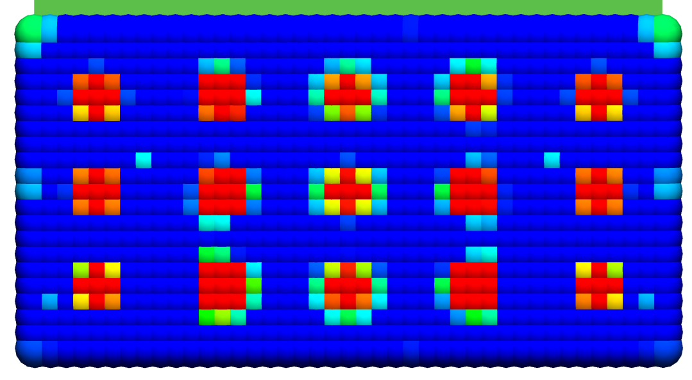 | 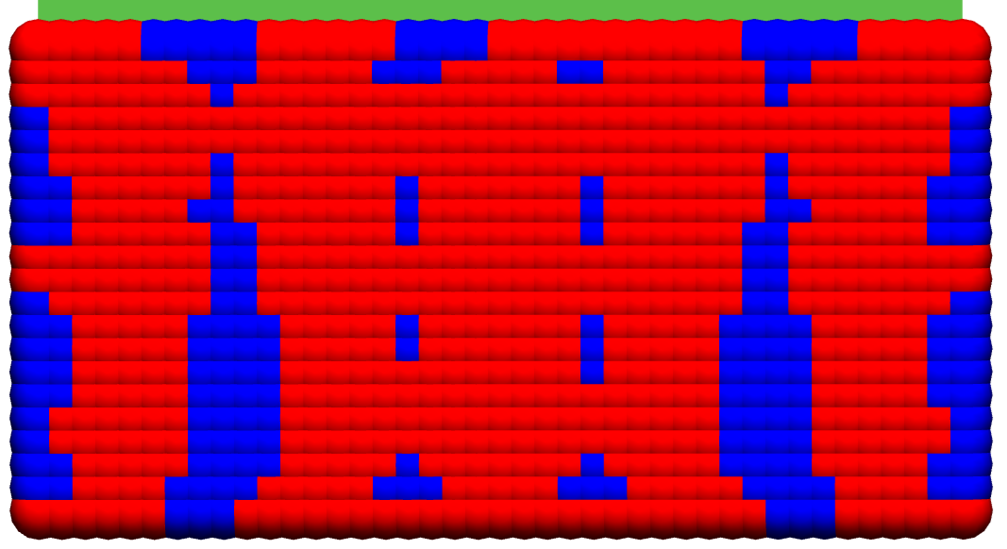
T = 200 s | 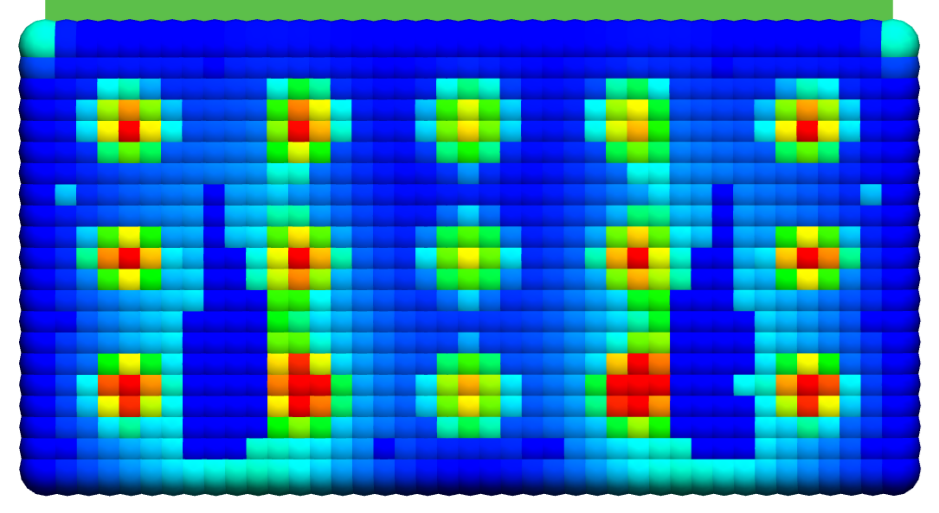 | 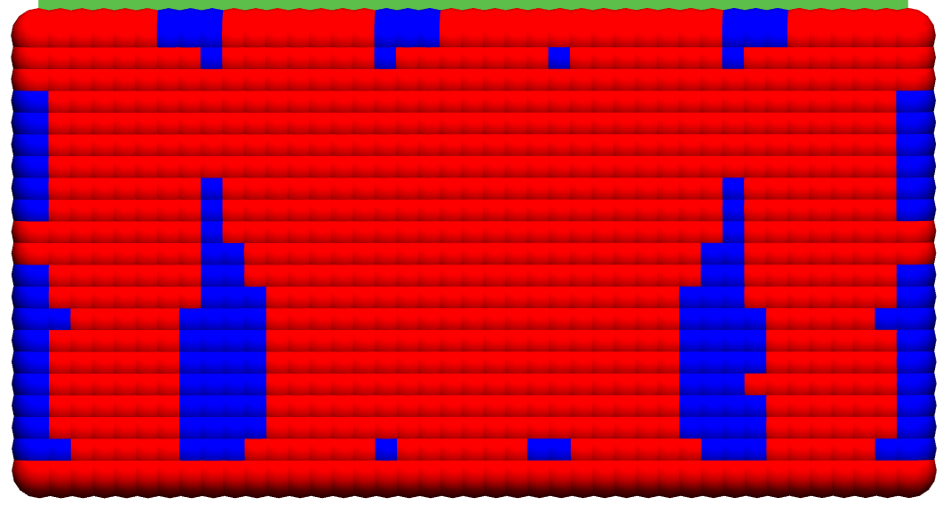
 | 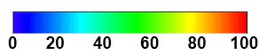 | 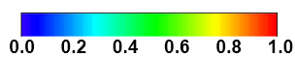
 | (a) | (b)
Figure 1212. Adhesive force (in N) (a) and adhesion intensity (-) (b) at different points in time (T = 50, 100, 150 and 200 s).

Conclusion
To the best of the authors' knowledge, this paper presents the first attempt to model the interaction of deformable panels with a flowing adhesive, taking into account the adhesion phenomenon. The complexity and diversity of the modeled phenomena generate computational difficulties in the operation of the numerical algorithm. To date, full convergence has not been attained across all computational scenarios. Further refinement of the method is expected to resolve these limitations. Moreover, in the given examples the calculation algorithm fully converged.
Another difficulty of this approach lies in the challenge of determining the adhesion model parameters (the adhesive contact rigidity $\text{C}$, the adhesion viscosity $\text{b}$ and the decohesion energy limit $\text{w})$ for the free surface of liquid sealant layer. The authors have not come across any experimental or theoretical works that would define or specify these parameters.
Nevertheless, the conducted studies demonstrate that simulating the assembly process, accounting for the interaction of deforming plates with the flowing sealant/adhesive, is also feasible when adhesion is considered. The calculations were performed for small test models. However, the computation time was comparable to that of simulating a two-way interaction (e.g., structure-fluid, structure-adhesion). This provides a basis to expect that in the future, after refinement of the computational model, it will be possible to simulate "three-way interaction" during the assembly of large-scale aircraft structures.
It may be feasible to apply this complex, comprehensive model only at specific stages of the assembly process (e.g., when removing temporary fasteners and replacing them with permanent ones), employing simpler models for the remaining stages. However, without simultaneously accounting for the flow of the sealant/adhesive and its adhesion to the surfaces of the joined panels, it is impossible to accurately model the entire cycle of aircraft structure assembly.

Acknowledgments
The research was supported by Russian Science Foundation (project No. 22-19-00062-П, https://rscf.ru/en/project/22-19-00062/).

References
- 1Y. Zhang, R. Hou, Q. Wang and Y. Ke, “A review on variation modeling of aircraft assembly,” International Journal of Robotics and Automation Technology, 10, 39–63 (2023). DOI: 10.31875/2409-9694.2023.10.05
- 2K. Bodjona and L. Lessard, “Hybrid bonded-fastened joints and their application in composite structures: a general review,” J Reinf Plast Compos 35(9), 764–778 (2016). DOI: 10.1177/0731684415627296
- 3S. Maggiore, M. Banea, P. Stagnaro et al., “A Review of Structural Adhesive Joints in Hybrid Joining Processes,” Polymers 13 (2021). DOI: 10.3390/polym13223961
- 4K. Yokozeki, T. Evers and T Vallée, “Hybrid joints consisting of pre-tensioned bolts and a bonded connection—The influence of adhesives on the load-bearing capacity,” Int J Adhes Adhes 132 (2024). DOI: 10.1016/j.ijadhadh.2024.103689
- F.5 Ricca, F.J. Galindo-Rosales, A. Akhavan-Safar, L.F.M. da Silva, T. Fkyerat, K. Yokozeki, T.Vallée and T. Evers, “Predicting the Adhesive Layer Thickness in Hybrid Joints Involving Pre-Tensioned Bolts,” Polymers 2024, 16, (2024). DOI: 10.3390/polym16162284
- 6F. Flaig, T. Fräger, M. Kaufmann, T. Vallée, H. Fricke and M. Müller, “A practical strategy to identify appropriate application patterns for adhesively bonded joints,” Article in PAMM (2023). DOI: 10.1002/pamm.202300080
- 7H. Zhang, L. Zhang, Z. Liu et al., “Numerical analysis of hybrid (bonded/bolted) FRP composite joints: A review,” Compos Struct 262 (2021). DOI: 10.1016/j.compstruct.2021.113606
- 8P. Burka, X. Liu, M. Thompson et al., “Modeling of adhesive bonding for aircraft structures applying the insertion squeeze flow method,” Compos B 50, 247–252 (2013). DOI: 10.1016/j.compositesb.2013.02.019
- 9M. Huf, T. Vallée, H. Fricke, “Numerical modelling and experimental validation of squeezing flows in the automobile production,” Int J Adhes Adhes 130 (2024). DOI: 10.1016/j.ijadhadh.2023.103616
- 10B. Lindau, S. Lorin, L. Lindkvist and R. Söderberg, “Efficient contact modeling in nonrigid variation simulation.,” ASME J. Comput. Inf. Sci. Eng., 16(1) (2016). DOI: 10.1115/1.4032077
- 11S. Lupuleac, M. Kovtun, O. Rodionova et al., “Assembly simulation of riveting process,” SAE Int J Aerosp 2, 193–198 (2010). DOI: 10.4271/2009-01-3215
- 12P.C. Mato, P. Webb, Y. Xu, Graham, D. et al., “Enhanced bondline thickness analysis for non-rigid airframe structural assemblies,” Aerospace Science and Technology, 91:434–441 (2019). DOI: 10.1016/j.ast.2019.05.024
- 13M. Müller, G. P. Ostermeyer and F. Bubser, “A contribution to the modeling of tribological processes under starved lubrication,” Tribol Int 64, 135–14 (2013). DOI: 10.1016/j.triboint.2013.03.011
- 14M. Müller, T. Yan, H. Fricke et al., “An efficient numerical model for the evaluation of compression flow of high-viscosity adhesives,” Int J AdhesAdhes 85, 251–262 (2018). DOI: 10.1016/j.ijadhadh.2018.05.023
- 15A.Z. Szeri, Fluid film lubrication, 2nd edition (New York, Cambridge University Press, 2011).
- 16A. Eliseev, S. Lupuleac, B. Grigor’ev and J. Shinder, “Numerical simulation of aircraft assembly process with presence of sealant”. In SAE Technical Paper (2021). DOI:10.4271/2021-01-0001
- 17A. Eliseev, S. Lupuleac, B. Grigor’ev and J. Shinder, “An approach to variation simulation of final aircraft assembly with presence of sealant,” J Comput Inf Sci Eng 22(4) (2022). DOI: 10.1115/1.4053000
- 18A. Eliseev, S. Lupuleac, J. Shinder and B. Grigor’ev, “Simulation of two-way interaction between sealant and structural parts as applied to large-scale aircraft assembly,” Int J Adv Manuf Tech. 132(11–12), 1–30 (2024). https://doi.org/10.1007/s00170-024-13535-6
- 19A. Eliseev, S. Lupuleac, J. Shinder, B. Grigor’ev and V. Khashba, “Modeling and analysis of hybrid bonded-bolted joining in large-scale aircraft assembly,” Int J Adv Manuf Tech. 135(11), 5715–5731 (2024). https://doi.org/10.1007/s00170-024-14839-3
- 20R. Sauer, “A survey of computational models for adhesion,” The Journal of Adhesion, 92(2), 81-120 (2016). https://doi.org/10.1080/00218464.2014.1003210
- 21R. Sauer, P. Wriggers, “Formulation and analysis of a three-dimensional finite element implementation for adhesive contact at the nanoscale,” Computer Methods in Applied Mechanics and Engineering 198(49–52), 3871–3883 (2009). https://doi.org/10.1016/j.cma.2009.08.019
- 22R. Sauer, S. Li, “A contact mechanics model for quasi‐continua,” International journal for numerical methods in engineering 71(8), 931–962 (2007). DOI:10.1002/nme.1970
- 23R. Sauer, L. De Lorentiz, “A computational contact formulation based on surface potentials,” Computer Methods in Applied Mechanics and Engineering 253, 369–395 (2013). DOI: 10.1016/j.cma.2012.09.002
- 24M. Frémond, Phase Change in Mechanics (Springer Berlin, Heidelberg, 2012).
- 25M. Frémond, Non-smooth thermomechanics (Springer Berlin, Heidelberg, 2001).
- P. 26Germain, “The Method of Virtual Power in Continuum Mechanics. Part 2: Microstructure,” SIAM Journal on Applied Mathematics 25(3), 556–575 (1973). https://doi.org/10.1137/0125053
- 27B. Halphen, Q. Nguyen, “Sur les matériaux standard généralisés,” Journal de Mécanique, 14(1) (1975).
- 28J. J. Moreau, Sur les lois de frottement, de plasticité et de viscosité (Comptes rendus hebdomadaires des séances de del’Académie des sciences, 1970).
- 29H. Zeigler, An introduction to thermomechanics (North-Holland Publishing, 1977).
- 30M. Frémond, Contact with Adhesion, (CISM Courses and Lectures, 1988).
- 31K. Benzarti, F. Freddi, M. Frémond, “A damage model to predict the durability of bonded assemblies. Part I: Debonding behavior of FRP strengthened concrete structures,” Construction and Building Materials 25(2), 547–555 (2011). DOI: 10.1016/j.conbuildmat.2009.10.018
- 32P. Argoul, K. Benzarti, F., Freddi, M. Frémond, T. Nguyen, “A damage model to predict the durability of bonded assemblies – Part II: Parameter identification and preliminary results for accelerated ageing tests,” Construction and Building Materials, 25(2), 556–567 (2011). DOI: 10.1016/j.conbuildmat.2009.12.014
- 33M. Raous, “Quasistatic Signorini problem with Coulomb friction and coupling to adhesion,” CISM Courses and Lectures. 384, 101–178 (1999). DOI: 10.1007/978-3-7091-2496-3_3
- 34M. Raous, L. Cangémi, M. Cocu, “A consistent model coupling adhesion, friction, and unilateral contact,” Computer methods in applied mechanics and engineering 177(3–4), 383–399 (1999).
- 35M. Raous, “A consistent model coupling adhesion, friction, and unilateral contact,” Comptes Rendus. Mécanique 339(7–8), 491–501 (2011). DOI: 10.1016/S0045-7825(98)00389-2
- PieroG. Del Piero, M. Raous, “A unified model for adhesive interfaces with damage, viscosity, and friction,” European Journal of Mechanics - A/Solids, 29(4), 496-507 (2010). DOI: 0.1016/j.euromechsol.2010.02.004
- 37M. Raous, M. Karray, “Model coupling friction and adhesion for steel concrete interfaces,” International Journal of Computer Applications in Technology 34(1), 42–51 (2009). DOI: 10.1504/IJCAT.2009.022701
- 38P. Wriggers, Computational contact mechanics (Springer Berlin, Heidelberg, 2003).
- R. J. 39Guyan, “Reduction of stiffness and mass matrices,” AIAA Journal, 3(2), 380–380 (1965). https://doi.org/10.2514/3.2874
- 40M. Stefanova, O. Minevich., S. Baklanov, M. Petukhova S. Lupuleac, B. Grigor’ev and M. Kokkolaras, “Convex optimization techniques in compliant assembly simulation,” Optimization and Engineering 21(2) (2020). https://doi.org/10.1007/s11081-020-09493-z
- 41J.N. Reddy, D.K. Gartling, The Finite Element Method in Heat Transfer and Fluid Dynamics, 3rd edition, (CRC Press, 2010).
- 42S. Lupuleac, A. Smirnov, J. Shinder, M. Petukhova, M. Churilova, E. Victorov and J. Bouriquet, “Complex Fastener Model for Simulation of Airframe Assembly Process,” Proceedings of the ASME 2020 International Mechanical Engineering Congress and Exposition, 2 (2020). DOI: 10.1115/IMECE2020-23588

