Verification of the Physical Model of Deformable Rock Mass from Equivalent Materials
Arthur Manko^{1, a)} and Ekaterina Muraveva^{1, b)}
¹ Moscow State University of Civil Engineering (National Research University), Yaroslavskoe sch., 26, Moscow, 129337, Russia.

^{a)} Corresponding author: arthur_manko@mail.ru
^{b)} MuravievaEA@mgsu.ru
Abstract. Currently, numerous projects are being developed for the reconstruction and construction of underground structures in seismically active areas where bedrock with irregular fracturing lies close to the surface or protrudes above ground. The problem with calculating such structures is that, given the variety of mathematical models for numerical calculations of rock masses and structures, there are no clear recommendations on their application in specific seismic conditions. This study has identified the key parameters for the creation of an equivalent material of deformable solids. This model represents the behavior of fractured rock. The proposed results can be applied to optimize strategies for the construction of underground structures. Prediction of rock pressure and prevention of rock mass collapses.

introduction
It is critically important to conduct a thorough and comprehensive study of the geomechanically behavior of fractured rock masses, especially in seismically active regions. Understanding the influence of fractures on the stress-strain state (SSS) of a rock mass is essential. Studying fracturing from microcracks to large faults is the key to safe and effective construction of underground structures. Solving this complex problem requires a comprehensive approach. Such an approach combines advanced numerical modelling methods and in-depth analysis of engineering-geological conditions. Verification of numerical models capable of adequately reproducing the real structure of fractured rock masses obtained under dynamic influences will make it possible to avoid the influence of the scale effect. It will also make it possible to obtain accurate estimates of the parameters necessary for the design of stable and reliable underground structures.
In recent years, issues related to modelling physical phenomena in rock masses in seismic areas have become particularly acute. Despite all the advances in science and technology, such problems still require solutions and verification. Assessing the stress-strain state of rock masses and technical structures allows us to identify patterns in their behavior under various conditions, as well as develop recommendations for the safe and efficient conduct of construction, mining operations, and the development of mineral deposits. G.Yu. Berdichevsky, A.N. Marchuk, N.N. Melnikov, and V.G. Orekhov [1-4] studied the stresses, strength, and stability of critical structures located in rock massifs. I.P. Dobrovolsky, A.A. Kozyrev, and D.G. Osik [5-8] devoted their work to establishing the principles of tectonic stress distribution in the Earth's crust, seeking to create a scientific basis for the geomechanical support of underground construction and safe exploitation of deposits. The list of researchers could go on. One thing remains paramount: a comprehensive study of geomechanical phenomena to ensure safety and reliability in any mining operations.
This article presents the results of the authors' scientific work within the framework of their dissertation research from 2022 to the present.
For a long time, only the elastic and deformation properties of rock masses were taken into account when calculating and modelling rock masses for seismic effects [9]. Over time, it became clear that physical and mechanical characteristics alone cannot be used to accurately calculate the stability of rock masses and underground structures. Physical experiments are necessary. As part of the research, one of the authors attempted to numerically model a three-axis compression experiment [10]. As a result, it was concluded that mathematical modelling can be applied in experiments with a transversely isotropic medium. Therefore, it was decided to conduct further research using physical experiments on equivalent materials. These materials were to replace real fractured rock masses in laboratory conditions.

MATERIALS AND METHODS

Selection of Equivalent Material
Research into fractured rock masses and their stability in seismic areas is extremely difficult. The problem is not so much that there are certain difficulties with traveling to the region. The main problem is delivering research equipment to hard-to-reach areas. And it is not possible to study rock samples in a laboratory under our conditions. Therefore, it was decided to conduct a physical experiment on equivalent materials.
Equivalent material is material whose physical and mechanical properties are in a certain ratio to those of the material under study. Doctor of Technical Sciences, Professor Georgy Nikolayevich Kuznetsov gave this material the name “equivalent” [11]. Equivalent material Similar approaches emerged around the turn of the 20th century and found extensive application in physical research from the early 1900s onward, continuing with Kuznetsov's work until the 1990s. Later, mathematical modeling gained prominence over its physical counterpart as computational capabilities advanced swiftly. Nevertheless, physical modeling retains significance in contemporary practice. [12, 13].
For the equivalent material recipe [14-16], further research will use G-16 sculptural gypsum, chalk (construction and molded), and fine sand without inclusions. Chalk is a brittle material in terms of its mechanical properties, while gypsum is plastic. Depending on the amount of sand, gypsum, and water, the resulting material should have elastic-plastic properties. In this case, sand is the material that creates the granular structure of the resulting equivalent material.
All subsequent tests were carried out in a laboratory environment. The tests were conducted using the SI ASIS GT 2.05-1 axial loading complex equipped with a GT 7.3.41-1 triaxial testing chamber manufactured by NPP GEOTEK LLC. Maximum equipment parameters: lateral compression – 10 kN, axial load – 10 kN. Geometric parameters of the cylindrical model: diameter – 50 mm, height – 100 mm. Approximately 40 experiments were conducted to find the optimal composition of the equivalent material. The most indicative results obtained during the research are presented below.
- Experiment No. 1. A mixture based on G-16 gypsum diluted in a ratio of 1:3 (one part water to three parts gypsum). The sand additive accounted for 3% of the total dry matter volume.
- Experiment No. 2. Cylindrical school chalk was used as an inclusion, placed vertically along the axis of the sample and fixed in the mold with G-16 sculptural gypsum (ratio 1:3). The sand content was 3% of the total volume of dry components.
- Experiment No. 3. School chalk, ground into fine fractions, was mixed with gypsum in equal proportions (50/50 ratio). Water was used for mixing in a ratio of 2 parts to 1 part of the dry mixture (1:2). The proportion of sand was 3% of the total volume of the dry mixture.
- Experiment No. 4. G-16 gypsum was mixed with MTD-2 construction chalk in a ratio of 75/25 percent, respectively, and then mixed with water in a ratio of 1:4. Sand was added in an amount of 3% of the total volume of the dry mixture.
Experiment No. 1 turned out to be the longest in terms of time. The test lasted almost four days. The sample failed at a vertical pressure of 5.33 MPa. Analysis of the results showed a linear failure pattern. This material demonstrated behavior close to elastic. Consequently, the resulting formulation is unsuitable for creating an elastic-plastic model.
Experiment No. 2 revealed that the introduction of brittle rod elements significantly reduces the strength limit of the equivalent material: R3сж decreased from 5.33 MPa to 0.73 MPa. At the same time, the material retained its elastic properties within the limits of Hooke's law.
Experiment No. 3 showed the ineffectiveness of the approach to creating an equivalent material based on the conglomerate principle. Complete destruction of the sample was recorded at a stress deviator of only 0.13 MPa. However, this experiment indicated the advisability of further using chalk in powder form, as well as the need to select the optimal proportion of G-16 sculptural gypsum and MTD-2 construction chalk powder to achieve elastic-plastic properties.
Figure 1 shows photographs of the results of triaxial destruction of the equivalent material in experiment No. 4. The sample was left in operation over the weekend, was destroyed in 30 hours, and by the time the sample was removed, it had become slightly saturated with distilled water from the volumetric compression flask due to a torn rubber cuff. Because of this, we believe that the sample has severe internal failure, although according to the readings, the volumetric deformation in this experiment was the smallest compared to similar ones.
Consequently, the elastic-plastic properties of the equivalent material can be obtained using the formula from experiment No. 4. However, the elasticity and plasticity properties of the material also depend on the amount of water in the equivalent material. They also depend on the drying time [17]. The next step of the experiment is aimed at selecting the moisture content (and drying time) in such a way as to obtain elastic-plastic deformation.

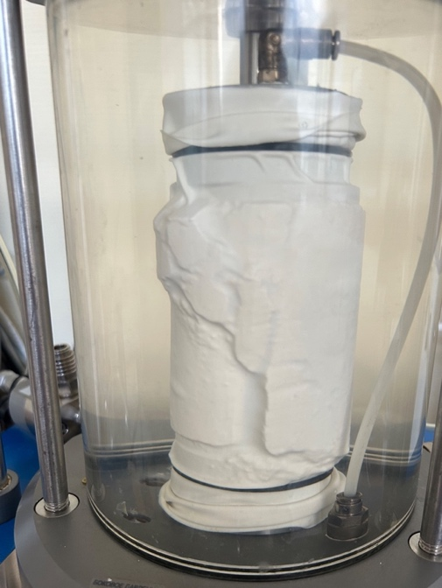 | 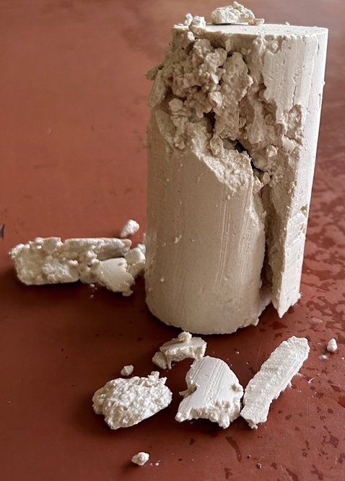
(a) | (b)
Figure 1. Results of experiment No. 4 on selecting a recipe for equivalent material: (a) view of the sample in the triaxial compression device after the end of the experiment, (b) view of the sample after removal from the device.

Refine the physical properties of the resulting physical model
Often, when mathematical models are applied to solve pressing problems, there is a discrepancy between what the theory predicts and how the system actually behaves in reality. If data obtained from field studies is available, the adequacy of the modeled results can be assessed. Otherwise, when it is not possible to directly compare the results of numerical modeling of the stress-strain state with field data, physical experiments are used. In situations where it is difficult to recreate the necessary experimental conditions in the laboratory, an alternative is physical modeling using equivalent materials. Physical modelling, used to determine the deformation and strength characteristics of structures, has a long history and remains relevant, particularly for verifying the results obtained during modelling [18, 19].

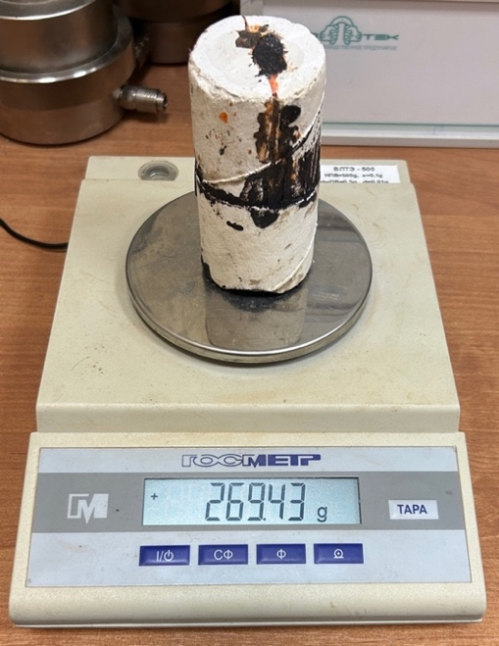
Figure 2. One of the model verification samples prior to the experiment

To conduct the experiment, five identical specimens were created from similar materials. After fabrication, each specimen was cut with perpendicular incisions at angles of 0° and 90° (see Fig. 2) to reproduce the defect. A low-melting compound was used to simulate the crack, similar to the work [20], which has similar deformation characteristics and physical and mechanical properties to clay. The specified values of the defect inclination angles were based on the study by D. Deere [21] and represent the maximum and minimum values at which defects have a noticeable effect on the structure of rocks.
After the artificial defects were applied, the specimens were subjected to various types of mechanical stress, simulating the conditions that occur in rock masses. In particular, uniaxial compression, biaxial compression with lateral restraint, and cyclic loads were applied to simulate dynamic processes such as blasting or seismic activity. Deformation, stress and failure indicators were recorded for each type of impact. Strain gauges installed on the surface of the specimens and an optical deformation analysis system were used to more accurately determine the stress fields near the defects.
The results of the experiments showed a significant influence of defect inclination angles on the strength and deformation characteristics of the workpieces. Thus, samples with 90° notches demonstrated greater resistance to uniaxial compression compared to samples with 0° notches. This is because vertical cracks effectively redistribute the load, preventing stress concentration at critical points. At the same time, under biaxial compression, the difference in strength between samples with different defect angles became less pronounced, as lateral confinement contributed to stabilising the structure and reduced the influence of individual cracks.
Under cyclic loading, accelerated development of fatigue cracks was observed in samples with notches at an angle of 0°. Apparently, horizontal notches served as stress concentrators, initiating failure under repeated loading. In samples with vertical notches, the fatigue failure process was slower, indicating higher resistance to cyclic loading.
The data obtained indicate the need to take into account the orientation of natural cracks and faults when designing mine workings and assessing the stability of rock masses. The main purpose of the tests was to identify the fundamental influence of the orientation of the cracks in the sample relative to the installation on the simulation results.
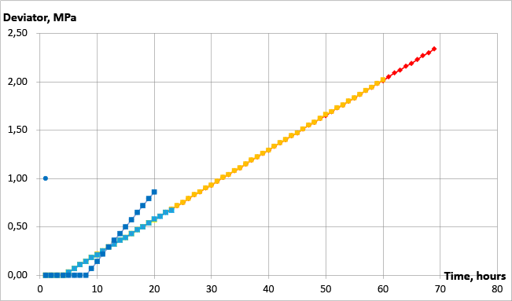

Figure 3. Graph of equivalent material research results

The main objective of the experiments was to determine the key impact of the location of cracks in the sample, relative to its fixation in the installation, on the results of the simulated calculations. The results obtained were compiled into a single graph, shown below (Fig. 3).
After creation, the samples were subjected to a drying process according to the following scheme:
- Samples No. 1 and No. 2 were kept under natural hardening conditions for 150 days;
- Sample No. 3 was autoclaved for 5 hours until a stable mass was achieved;
- Sample No. 4 was autoclaved for 8 hours;
- Sample No. 5 – after 8 hours of autoclave treatment, was rapidly cooled to a temperature of 16°C, then saturated with water by soaking, dried naturally for 3 days and re-treated in an autoclave for 4 hours.
Thus, with the exception of sample No. 5, the samples were made in pairs. The purpose of creating sample No. 5 was to achieve viscous failure. Samples Nos. 1 and 2 were intended to demonstrate elastic failure, and samples Nos. 3 and 4 – elastic-plastic failure. In all experiments, except for the experiment with sample No. 5, a pressure of 400 kPa was created in the triaxial compression chamber; for sample No. 5, it was increased to 800 kPa.
With the exception of experiment number five, the results of all tests, regardless of the method of fixing the sample in the test chamber (orientation of cracks relative to the device), hardening conditions, sample moisture level and other factors, demonstrate a linear relationship. The results of the fifth experiment, due to significant comprehensive compression, do not correlate with the others, but they also form a linear dependence, albeit at a different angle to the X-axis. Experiment No. 5 can be excluded from consideration when verifying the results.
The limit values of deviatoric stresses vary in the range from 0.67 MPa to 2.34 MPa, while the vertical deformation up to the moment of specimen failure ranges from 1 mm to 4 mm.
Thus, regardless of the location of the sample in the setup, the data obtained can be considered reliable, since the results of experiments 1 to 4 correspond to the Mises-Schleifer line, which indicates the correctness of the tests performed. Considering the presence of plastic flow according to Mises and the initial elastic stage described by Coulomb's law, it can be concluded that with this physical experiment scheme and the use of a single equivalent material composition, the average values of the results, regardless of the initial characteristics of the material, will demonstrate elastic-plastic behaviour.

results
A single inclined crack located at angles of 0, 5, 20, 45, and 60 degrees was taken as the basis for the single crack system. All these crack angles, except for 60 degrees, were taken from the work of D. Deere [16], and 60 degrees from the work of R.E. Goodman [22].
Based on the experiment planning matrix [23], the optimal number of basic physical experiments was determined, varying from 1 to 3 for each crack angle considered. The cracks themselves were formed by sawing into an already hardened sample that had reached the required strength. A low-melting material was used to fill the cracks, imitating the properties of clay soil in terms of deformation parameters and physical and mechanical characteristics. After the experiments, average graphs were constructed for each crack angle. For a clear comparison, the results were combined into a general graph, shown in Fig. 4.

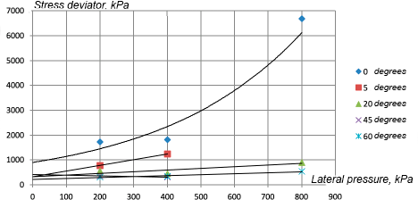
Figure 4. Single crack test results

Experiments with single cracks revealed abnormal behaviour of horizontal cracks (with an inclination angle of 0°). The results for this crack significantly exceeded the indicators of other single cracks, differing by several times. In this regard, further consideration of cracks with an angle of 0° was excluded. In addition, according to the RQD classification proposed by D. Dear [20], the presence of a horizontal fracture in samples less than 10 cm long significantly reduces the calculated strength of the rock, up to its complete loss.
The remaining tests showed similar characteristics: the stress deviator varied from 200 kPa to 1170 kPa, with an average value of about 600 kPa. Cracks with angles of 60° and 45° showed similar results at different lateral compression values. In turn, the crack with an angle of 20°, after reaching a lateral compression of 200 kPa, when the stress deviator approached the values of other cracks, began to show increased stability. Thus, when analysing orthogonal cracking, special attention should be paid to cracks with angles of 5°, 20° and 60°.
To study orthogonal cracks, samples of the same material described above were used. Orthogonal intersecting cracks were made in the samples, extending from the centre of the sample. The cracks were then filled with molten plasticine to simulate the ‘bonding’ of the sample parts. Samples with angles of 5°, 20°, 45°, 60° and 90(0)° were made. The 90° crack had not been studied previously; its introduction was due to the impossibility of creating two strictly orthogonal cracks at an angle of 0°. Thus, the 90(0)° variant represents a vertical crack perpendicular to the horizontal one.
After conducting 3-5 tests for each angle of inclination of the orthogonal cracks, the most representative results were selected. The results for angles of 5°, 20°, 60° and 90(0)° were of greatest interest. The results of these tests are shown in Fig. 5.

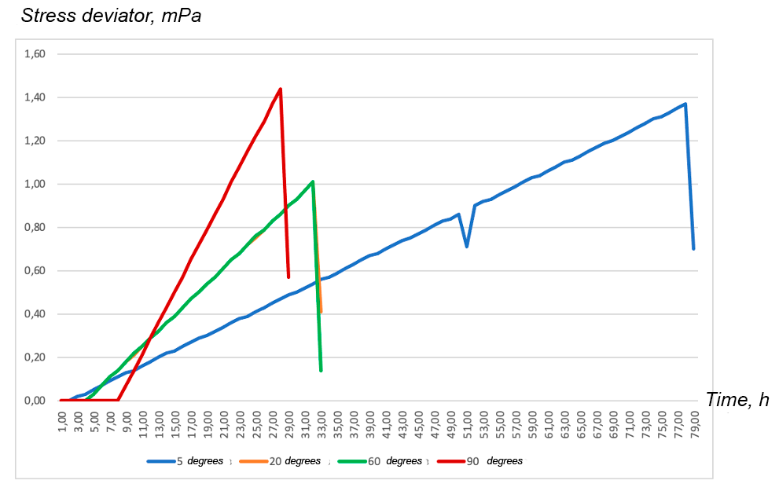
FIGURE 5. Results of some orthogonal crack tests

Analysis of the test results for orthogonal intersecting cracks showed that for cracks at angles of 20° and 60°, there was a coincidence not only in the time of failure, but also in the magnitude of the stress deviator. The crack at an angle of 5° showed the greatest resistance to failure: the deformation of the sample reached 32 mm, while the average deformation of the other samples was about 15 mm. The highest stress deviator value (1440 kPa) was recorded for an orthogonal crack at an angle of 90(0)°, but the time to failure of the sample was minimal.
As a result, the results of modelling a sample made of equivalent materials with orthogonal cracks at an angle of 90(0)° were used to create the first preliminary three-dimensional calculation scheme for mathematical modelling.

conclusion
Analysis of tests on orthogonal intersecting cracks showed that the data for cracks located at angles of 20 and 60 degrees were similar not only in terms of time to failure, but also in terms of stress deviator magnitude. The sample with a 5-degree crack showed the greatest resistance to failure: its deformation was 32 mm, while the average deformation of the other samples was about 15 mm. The maximum deviator value of 1440 kPa was recorded for an orthogonal crack at an angle of 90(0) degrees, but the failure time of this sample was the shortest.
Thus, for the initial three-dimensional calculation within the framework of mathematical modelling, the results of modelling a sample made of equivalent materials with orthogonal cracks located at an angle of 90(0) degrees were used.
Based on these results, stress-strain state (SSS) analysis of a sample with an orthogonal crack at an angle of 90(0) degrees was chosen as the starting point for constructing a three-dimensional model. This choice was made not only because of the maximum deviator value recorded for this configuration, but also because the orthogonal arrangement of cracks simplifies the procedure for constructing the finite element mesh and boundary conditions within the mathematical model. The simplicity of the simulation allows minimizing computational costs at the initial stage and focusing on verifying the adequacy of the selected failure model.
The resulting three-dimensional model allowed for a detailed analysis of the stress distribution in the vicinity of the crack tip. Stress concentration zones were identified, which correspond to the most likely locations for crack initiation. The model also allowed for an assessment of the influence of sample size and boundary conditions on the fracture process.
In the future, it is planned to expand the model to include an analysis of the influence of different crack angles, using the experimental data obtained for cracks located at angles of 5, 20, and 60 degrees. This will allow the creation of a more universal model describing the fracture of materials with orthogonal intersecting cracks under various loading conditions. The simulation results will be verified using experimental data obtained from the analysis of various crack configurations.

References
- G. Y. Berdichevskii and V. I. Shcherbina and M. S. Galyamina and L. E. Polyak. Information-diagnostics system-a mandatory component for monitoring the technical condition of water-development works (Power Technology and Engineering, 2009) pp. 275-279.
- A. N. Marchuk, Static operation of concrete dams (Energoatomizdat, Moscow, 1983), p.208.
- A. N. Marchuk and N. A. Marchuk, Dams and Geodynamics: Field Observations, (Association of Organizations and Employees in the Hydropower Industry, Hydropower of Russia, Saint Petersburg, 2020), p. 315.
- N.N. Melnikov and Yu. A. Epimakhov and N. N. Abramov, Scientifically-intensified large-span underground-structures construction in rock masses (Publishing House of the Kola Scientific Center of the Russian Academy of Sciences, Apatites, 2008), p. 221.
- V.G. Orekhov and M.G. Zertsalov, Mechanics of Engineering Structures and Mountain Massifs Destruction (DIA Publishing House, Moscow, 1999), p. 330.
- I.P. Dobrovolsky, Mathematical theory of preparation and prediction of a tectonic earthquake (Fizmatlit, Moscow, 2009), p. 236.
- D. G. Osika and V. I. Cherkashin, Energy and Fluid Dynamics of Seismicity (Russian Academy of Sciences, Dagestan Scientific Center, Institute of Geology, Moscow, 2008.), p. 243.
- A.A. Kozyrev and S.N. Savchenko, On the management of the stress-strain state of the rock mass during the sinking of mine workings in shock-hazardous conditions (Bulletin of the Moscow State Technical University, Moscow, 2014), pp. 221-224.
- L.V. Ershov and L.K. Liberman and I.B. Neiman, Rock mechanics (The bowels, Moscow, 1987), p. 192.
- D.A. Denisova and A.I. Koryagina and A.S. Malkova and E.A. Muraveva, On mathematical modeling of a physical experiment on triaxial compression of a model made of equivalent material (Economics of construction, 2024) pp. 292-294.
- G.N. Kuznetsov and M.N. Budko, Instruments and measurement methods used in the study of rock pressure on models using the equivalent materials method. In Presentation at the Workshop on Instruments Used in Rock Pressure Studies at the Skochinsky Geophysical Laboratory (VNIMI, Leningrad, 1962.), p.16.
- A.Zh. Zhusupbekov and B.O.Kaldanova, Investigation of the mechanical properties of the soil base using the equivalent material method (Bulletin of the N. Isanov Kyrgyz State University of Construction, Transport, and Architecture, 2016), pp. 392-396.
- A.N. Kholodilov and R.S. Istomin and V.I. Kirilenko, Improvement of the method for producing equivalent materials for modeling nonlinear geomechanical processes in underground mining (Mining information and analytical bulletin (scientific and technical journal), 2024), pp. 108-122.
- A.M. Kozina, The technique of modeling with equivalent materials (Ugletechizdat, Moscow, 1957), p. 27.
- V.V. Basov and S.V. Rib, Selection of equivalent material for physical modeling of geomechanical processes in the vicinity of coal mine preparation workings (Bulletin of the Siberian State Industrial University, 2016), pp. 32-35.
- Ko Den Ho, Research on equivalent materials for modeling rock pressure manifestations (Ugletechizdat, Moscow, 1958), p. 26.
- A. M. Kozina and E. P. Rutkovskaya, Guidelines for selecting and testing equivalent materials for modeling (Ministry of the Coal Industry of the USSR. USSR Academy of Sciences. A. A. Skochinsky Institute of Mining. Laboratory of Mining Pressure, Moscow, 1974), p. 40.
- V. A. Fedorov and E. G. Kholina and M. F. Bulatov and I. B. Kovalenko, Design of a Molecular Dynamics Model for High-Performance Computing of Conformational Changes in Microtubule Protofilaments Associated with the Anticancer Drug Taxol (Mathematical Biology and Bioinformatics, 2023), pp. 105-112.
- J. A. Zavadsky, Creating a model for contractual transactions using digital currencies of central banks for payment processing (Studies of the XII. inter-university scientific-practical interdisciplinary conference. Collection of articles by conference participants, Moscow, 2024), pp. 98-107.
- V.A. Hyamyalyainen and A.V. Uglianitsa and G.Ya, the USSR Patent No. 1154465 A1 (7 May 1985)
- D.U. Deere, Technical Description of Rock Cores for Engineering Purpose (Rock Mechanics and Engineering Geology, 1963), pp. 16-22.
- R.E. Goodman, Introduction to rock mechanics (Chichester, Brisbane, Toronto, Singapore: John Wiley & Sons, New York, 1989), p. 562.
- A.F. Boyko and E.Yu. Kudenikov, An accurate method for calculating the required number of repeated experiments (Bulletin of Belgorod State Technological University named after V.G. Shukhov, 2016), pp. 128-132.

