Comparison of Non-Linear and Equivalent-Linear Site Response Analysis for Two Representative Soil Profiles in Sofia City
Emil Oynakov, Radan Ivanov ^{a)}, Irena Aleksandrova, Mariya Popova and Petya Trifonova
National Institute of Geophysics, Geodesy, and Geography, Bulgarian Academy of Sciences, Acad. G. Bonchev St., bl. 3, 1113 Sofia, Bulgaria.

^{a)} Corresponding author: rivanov@geophys.bas.bg
Abstract. Site response analyses are widely used in modern engineering practice to assess the effects of local geological conditions on ground motions during earthquake. The present research focuses on assessing the performance of the two advanced versions of 1-D site response analysis - non-linear and equivalent linear. The background of 1-D site response analysis is presented including its basic assumptions, merits, shortcomings, software implementations and versions regarding soil constitutive behavior. Next, the geological conditions of Sofia city are presented, including historical and modern seismicity of the region, the specifics of the sediments and the underlying fault systems. Two sites were chosen for experimental measurement of ambient noise, namely, Loven Park and Manastirski Livadi. The measurements were carried out by seven accelerometers Etna 2, with sampling frequency of 100 samples per second, and duration of 30 min. HVSR (Horizontal to Vertical Spectral Ratio) curves were obtained for all recordings, which together with nearby borehole data served as a basis for computing the shear wave velocity profiles for the two sites by using two methods - the inversion of the HVSR curves, and the MSPAC (Modified Spatial Autocorrelation) method. All computations related to ambient vibration processing were carried out by the GEOPSY software. The obtained shear wave velocity profiles were used as input data for performing site response analysis by the DEEPSOIL software, whereby the computations were done in two different ways - true non-linear analysis assuming the soil to be a material with hysteretic behavior, and equivalent linear analysis, where the analysis is stepwise linear and the material properties are adjusted according to the shear strain levels. The computations also require an earthquake motion as input, so motions from two earthquakes which occurred near Sofia in 2008 and 2012 were selected and scaled as ground motion patterns of return periods 95 years and 475 years respectively. The obtained results were compared from two perspectives. First, the response spectra at bedrock level and surface level were used to get the amplification factor at each period in the range from 0.01 s to 10 s. Then, the PGA (peak ground acceleration) plots were produced for soil depth up to 60 m revealing the variation of acceleration through the soil profile. The most important findings are the following: The non-linear analysis leads to notably lower levels of PGA compared to the equivalent-linear analysis, and the difference increases with increasing input acceleration. For the Loven Park profile, the differences in the calculated PGA become significant for input acceleration levels of 0.36 g. For the stiffer profile in the Manastirski Livadi area, the deviations between the two methods are significant for input acceleration levels of 0.10 g through 0.36 g. For both profiles, it can be concluded that the equivalent-linear method is conservative approximation of the fully non-linear method, as it yields higher spectral accelerations for most spectral periods. There are a few exceptions for periods between 3 s and 10 s (Manastirski Livadi) and 4 s to 10 s (Loven Park), in which case the nonlinear response is slightly higher than the equivalent linear response.

introduction
Site response analyses are widely used in current routine engineering practice to assess the effects of local geological conditions on ground motion. The assumption that seismic waves arrive vertically—meaning the ray path or direction of wave propagation is perpendicular to the surface—allows for one-dimensional simulations of site response in horizontally layered soils. Site response software (e.g., SHAKE, STRATA, DEEPSOIL, SIREN) applies seismic motion in only one horizontal direction and implicitly assumes that both horizontal directions are independent.
Soil behavior during earthquakes can be nonlinear. When calculating site response, it is important to account for this nonlinear ground behavior. The effect of nonlinear soil behavior on site response and the resulting surface ground motion can be estimated using several methods. This study applies two of them: the equivalent-linear (EQL) method and the nonlinear (NL) method. DEEPSOIL, a one-dimensional site-response analysis program [1], was used to perform numerical analyses using both methods to investigate the effect of local soil properties on the characteristics of ground motions transferred to the surface.
The conceptual difference between equivalent linear and nonlinear site response methods lies in the following:
The EQL analysis uses linear elastic properties of soil layers and an iterative procedure to update the elastic properties based on the amount of calculated shear strain. The final iteration is still a fully linear elastic simulation with “equivalent” elastic parameters that approximate the nonlinear response of the soil layers. The NL method solves the dynamic wave equation directly using a nonlinear stress-strain relationship, accounting for actual stiffness during loading, unloading, or reloading according to Masing rules [2].
EQL and NL analysis require definition of soil shear wave velocity profiles; selection of appropriate shear modulus reduction and damping curves; specification of input bedrock motions [3], [4], [5], [6], [7]. The horizontal-to-vertical spectral ratio (HVSR) method for microtremor has been used in many studies to assess local seismic response in terms of soil fundamental frequency and site amplification, and to identify fundamental resonance frequencies and dynamic characteristics of structures at different frequencies [8], [9], [10], [11], [12].
The only limitation of the HVSR method compared to geophysical techniques is that it does not directly provide a shear wave velocity structure. This can be derived via HV inversion modeling of the spectral ratio curve [13], after which the depth-dependent shear wave velocity and other geotechnical parameters can be used in EQL and NL methods.
This study also uses the neighborhood algorithm by Sambridge [14] to derive the shear wave profile using SPAC (Spatial Autocorrelation) curves. This algorithm, along with HVSR curve modeling, was implemented in the software package Geopsy.
EQL and NL site response analyses e.g., [3], [5], [6], [7] can be performed for various earthquake scenarios, ranging from low to high seismicity. Site response analysis, which calculates the propagation of strong ground motions from the bedrock through the overlying soil layers to the ground surface, is a powerful tool for assessing the effect of local soil conditions (i.e., site-specific seismic response) on ground motion at the site [1], [5], [6].

Geologic Conditions
The capital city of Sofia is located within the Sofia Basin, which constitutes part of the Sub-Balkan graben system, characterized by a distinct pattern of geological evolution. The Sofia graben represents the westernmost extensional locus from a fault system formed at the Balkan range front [15]. The faults eastward from Sofia are associated with pronounced piedmont–range front junctions, as well as hanging wall basins that have axial trunk streams. The Sofia Basin is the only sedimentary basin along the whole range front, in which the main factor for deposition and erosion is a regional river that transversely crosses the basin headed toward the Balkan range front, already since the Late Miocene [16]. The main stream is the Iskar River. This river has a huge catchment upstream from Sofia. The major volume of the basin fill near Sofia was deposited in the Iskar fluvial fan, including a fan delta that was embedded in the subaerial layers during Pontian and Dacian times [16].
Preserved historical records indicate the occurrence of strong and destructive earthquakes in the region during the 15th to 18th centuries [17]. The first well-documented strong earthquake occurred in 1818, near the city of Sofia. The most powerful earthquake (M_{s} = 6.3) recorded in the vicinity of Sofia took place in 1858. The strongest seismic event near Sofia during the 20th century was the 1917 earthquake, with a magnitude of M_{s} = 5.3, [18] and [19].
Approximately a century later, on May 22, 2012, an earthquake (M_{s} = 5.6) occurred with an epicenter located about 25 km southwest of central Sofia, between the towns of Pernik and Radomir.

Data and Measurements
The study was conducted in two zones within the territory of Sofia City – Manastirski Livadi residential area and Loven Park. All measurements were carried out using seven mobile ETNA 2 accelerometers, with a sampling frequency of 100 samples per second. The X-axis of the accelerometers was oriented north, and the Y-axis west. In the Manastirski Livadi area, two measurement sessions were conducted (at 7 points), and in the Loven Park area, one session was carried out (also at 7 points). Each point was measured for a duration of 30 minutes. To model the subsurface environment, the inversion of the resulting HVSR curves and the autocorrelation of the SPAC results were supported by engineering-geological data obtained from the nearest boreholes in the Sofia Basin area, referenced from [20]. Borehole Bna16 is located approximately 400 meters from the studied area in Manastirski Livadi. Borehole Bna1 is located about 140 meters from the measurement site in Loven Park, see Fig. 1. Stratigraphic models of the boreholes, along with some of the geotechnical parameters used in the EQL and NL methods, are presented in Fig. 2.
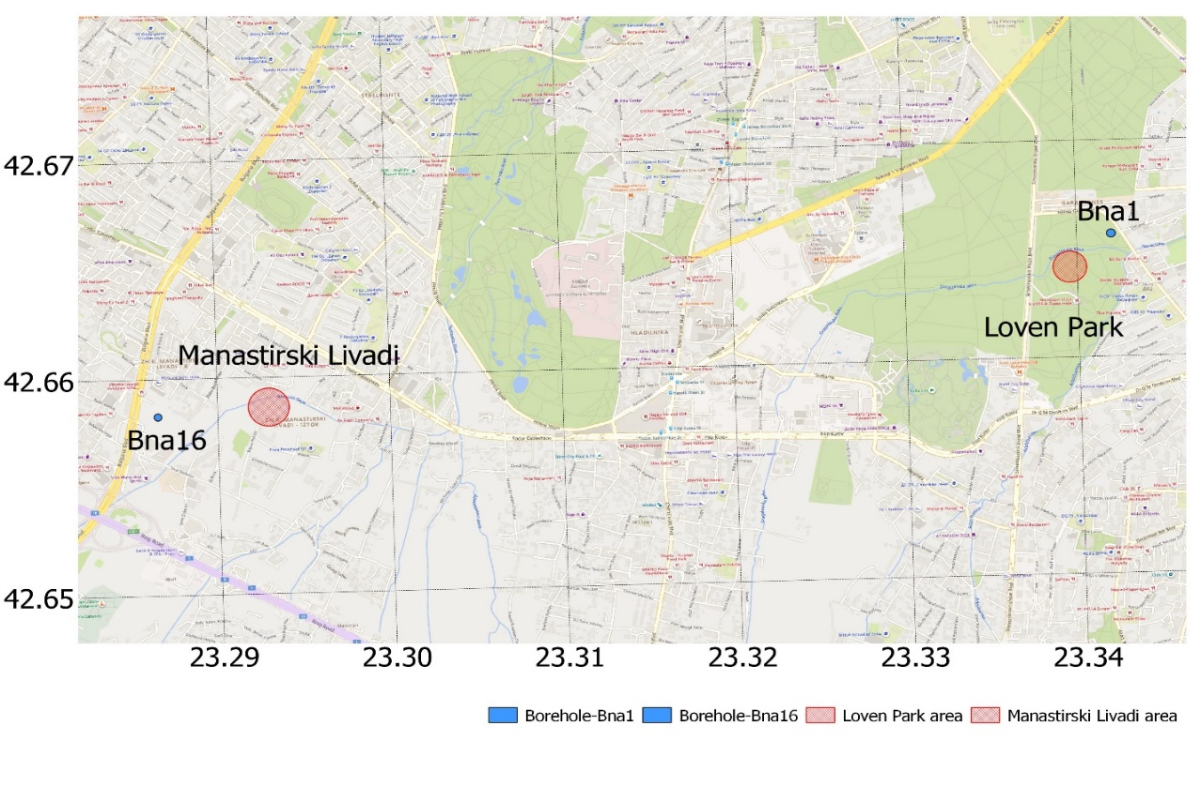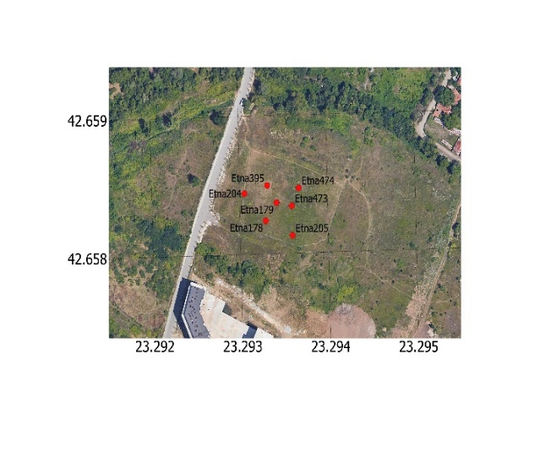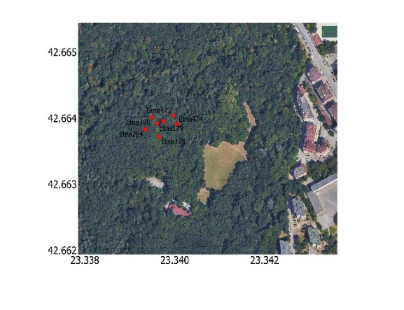
Figure 1. Spatial distribution of the measurement points and boreholes used for engineering-geological data.

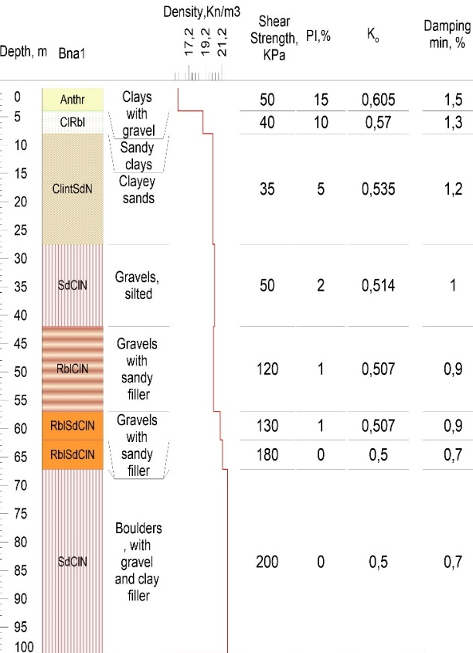 | 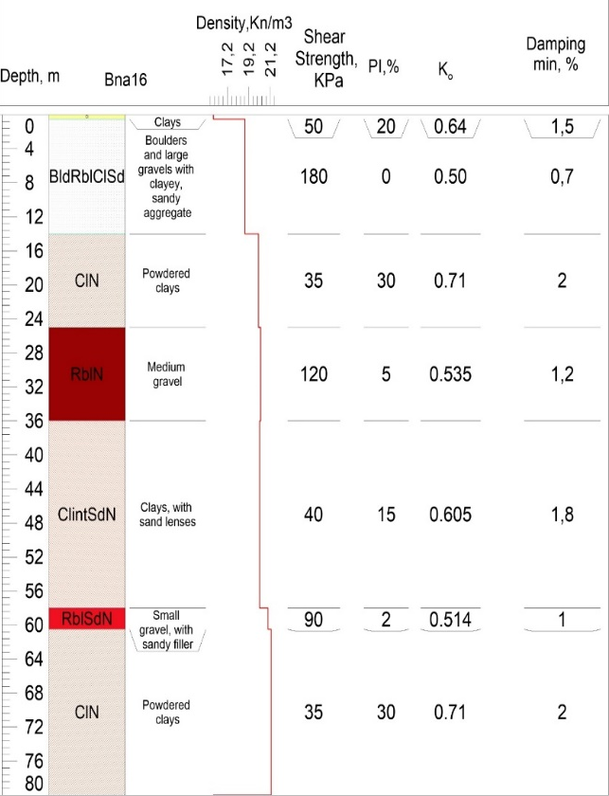
FIGURE 2. Soil stratigraphic models of boreholes Bna1 (Loven Park) and Bna16 (Manastirski Livadi). PI – Plasticity Index, K₀ – Coefficient of Earth Pressure at rest according to Darendeli [21].

Extraction of the soil velocity profiles
Soil profiles of the shear wave velocity were extracted using two methods – inversion of HVSR curves and MSPAC (Modified Spatial Autocorrelation) autocorrelation curves. The inversion process is a method of matching observed data with numerical models in order to find the optimal parameters that reproduce the best fit between theoretical and experimental results. The optimal model is defined as the one that minimizes the discrepancy between observed and calculated values, [22]. One of the inversion analysis methods used in HVSR is the analysis of the ellipticity curve of Rayleigh waves. The main idea of the method is to separate Rayleigh waves from other types of seismic waves through selection and processing of time windows of the microseismic signal. This is achieved by analyzing the polarization of ambient noise and using frequency filters.
For the isolated Rayleigh waves, the energy of the sum of the vertical and horizontal components of the recording in the selected time window is calculated. This energy serves as the basis for determining the ellipticity of the Rayleigh waves, which is, in turn, a function of frequency. Since the ellipticity of these waves depends on the subsurface structure, it contains valuable information about the distribution of shear wave velocity (V_{s}) and the thickness of sedimentary layers, [23]. Through inversion analysis of the HVSR curve and using additional constraints, e.g. geological data or other geophysical methods, a detailed model of the soil and bedrock velocity profile can be obtained. For the extraction and modeling of the subsurface lithology, the software Geopsy was used, which offers powerful tools for processing ambient seismic noise, analyzing wave polarization, and performing inversion analysis of HVSR curves. Figure 3 presents the measured spectral horizontal-to-vertical ratio curves obtained from the two sites.

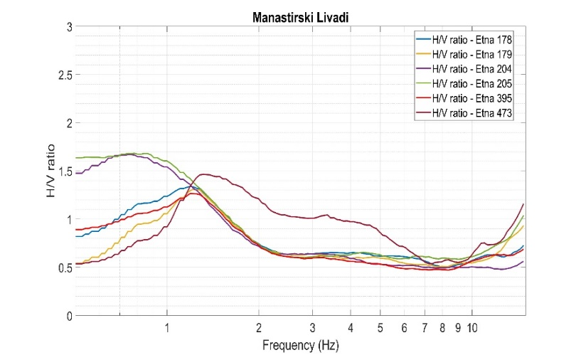 | 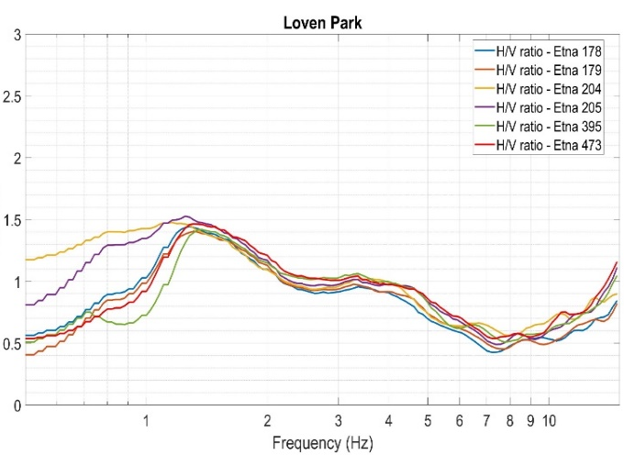
(a) | (b)
FIGURE 3. Dependence of the HV spectral ratio on frequency for the Manastirski Livadi (a) and the Loven Park (b) areas

The MSPAC method uses spatial autocorrelation curves to extract the dispersion curve of phase velocity, which is subsequently used to determine the shear wave velocity profile, [24]. For this purpose, the vertical components of ground motion excited by ambient noise were recorded at the surface using arrays of seven accelerometers. This system provides an acceptable response for frequencies between 0.25 Hz and 70 Hz. The array radii, r, range from 17 m to 59 m. Different radii were used in the Manastirski Livadi area – 17 m, 25 m, 34 m and 50 m, and in the Loven Park area – 18 m, 23 m , 38 m and 49 m. The longest wavelengths to be resolved by the MSPAC method are in the order of λ_{max} ~ 15 × r_{max} to 16 × r_{max}. The expected maximum investigation depth, z_{max}, lies between λ_{max} / 3 and λ_{max} / 2. The limitations of the SPAC method arise from the oscillatory nature of the Bessel function, which exhibits multiple solutions for arguments greater than approximately 3.6. Thus, dense azimuthal sampling of the wavefield is achieved, and the matching wavelength is approximately λ_{min} ~ 1.8 × r_{min}. Figure 4 shows the shear wave velocities extracted by both methods, as well as the averaged velocities for the two sites, which were subsequently used in the EQL and NL analyses.

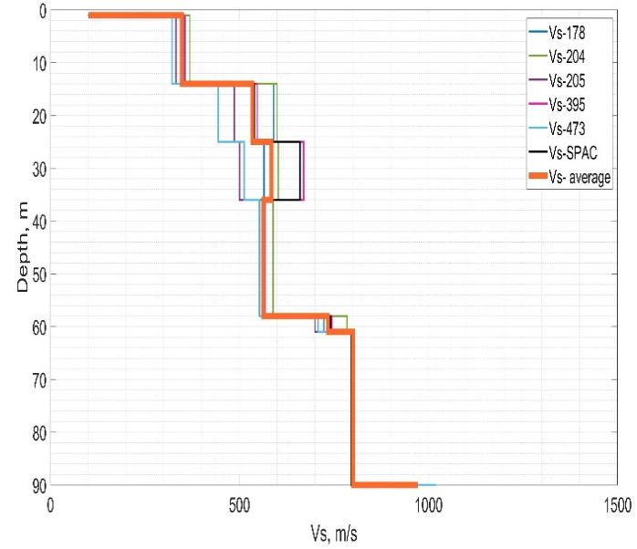 | 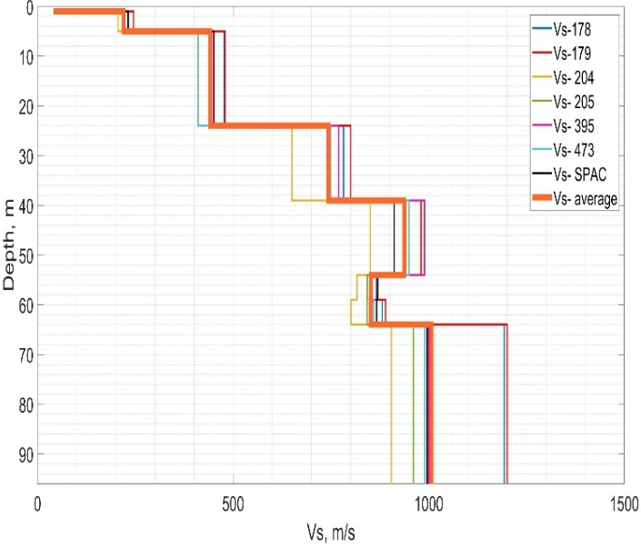
(a) | (b)
FIGURE 4. Shear wave velocity profiles obtained by the two methods – inversion of HVSR curves and MSPAC autocorrelation curves, (a) Manastirski Livadi area, (b) Loven Park area.

Nonlinear and Equivalent Linear Analysis
Each seismic event is characterized by a distinct ground motion, which can be defined by a site-specific seismic response spectrum that depicts the peak ground acceleration as a function of the shaking frequency for that event, [6]. For input motions of a seismic event with return periods of 95 years and 475 years, [25], accelerograms of the horizontal components (EW, NS) of two earthquakes recorded at the VTS (Vitosha) station were used. These earthquakes occurred on 15.11.2008 (t = 20:08:20 GMT; hypocenter: 42.66N/23.33E; M_{L} = 3.6; depth = 12 km) and 22.05.2012 (t = 00:00:33 GMT; hypocenter: 42.66N/23.01E; M_{w} = 5.2; depth = 10 km). Figure 5 shows the accelerograms of these events after being scaled with coefficients corresponding to seismic events with peak accelerations of 0.10 g and 0.36 g (95-year and 475-year return periods, respectively), and Fig. 5 shows their Fourier amplitude spectra. The records were also scaled to 0.20 g and 0.30 g to allow for a more detailed study.

(a) | (b)
(c) | (d)
FIGURE 5. Horizontal components of the earthquakes: (a), (b) 15.11.2008 scaled to 0.36 g; (c), (d) 22.05.2012 scaled to 0.10 g, both recorded at seismic station VTS.
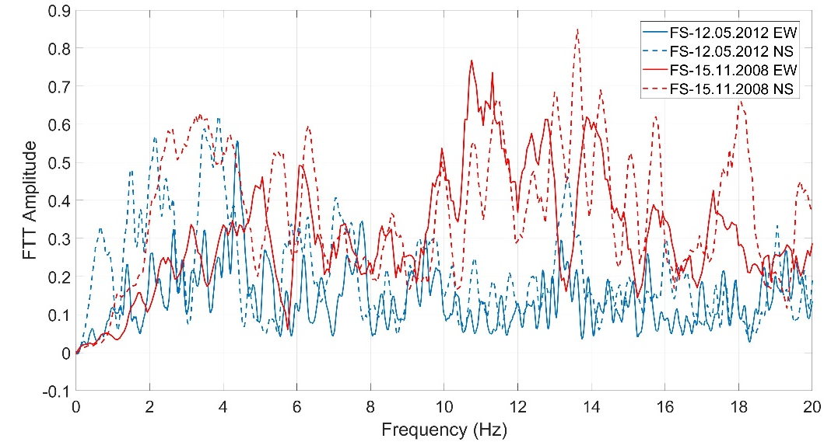
FIGURE 6. Normalized Fourier amplitude spectra of the earthquakes in Fig. 5.

The two soil profiles were modeled using the DEEPSOIL program, a widely used equivalent linear and nonlinear one-dimensional (1D) site response analysis software. The analyses were conducted in two modes: nonlinear time-domain (NL-TD) and equivalent linear frequency-domain (EL-FD) site response analysis. The Generalized Quadratic/Hyperbolic (GQH) model, which defines the shape of the basic stress-strain backbone curve proposed by Groholski, [26], was used in the analysis. Non-Masing hysteresis models were employed to reduce cycle size and achieve soil behavior similar to laboratory conditions. Empirical modulus reduction and damping curves proposed by Darendeli, [21] were used in the response analysis to represent soil behavior. The MRDF (Modulus Reduction and Damping Function) fitting procedure was applied to the modulus reduction and damping curves. For the site response analysis, the acceleration time history of the outcropping bedrock, propagated through the soil to the ground surface, is specified. The surface motion time history is then directly used to calculate the acceleration response spectrum at the ground surface. The result of the 1D equivalent linear (EQL) and nonlinear (NL) site response analyses is the site-specific response spectrum, expressed by the spectral acceleration at the ground surface (SSURF) and the amplification factor (AF) of the site. The amplification factor represents the ratio of the spectral acceleration at the soil surface (SSURF) to the spectral acceleration of the bedrock (SROCK) as a function of frequency, f:
(1)

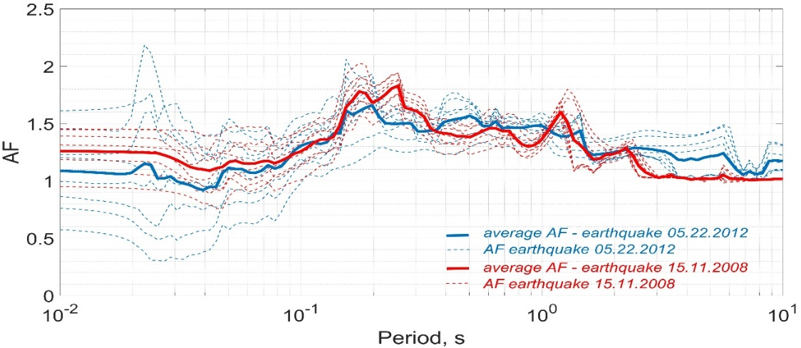
FIGURE 7. Amplification factors for the Manastirski livadi area: EQL

The results of the calculated amplification factors (AF) from both analyses for the two sites and the two input motions are shown in Fig. 7 and Fig. 8 for the Manastirski Livadi area and in Fig. 9 and Fig. 10 for the Loven Park area.
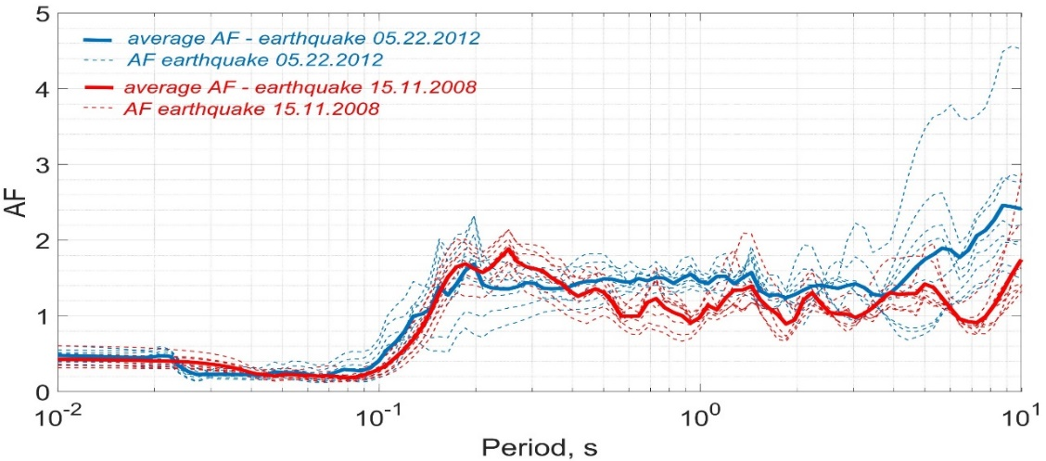
FIGURE 8. Amplification factors for the Manastirski livadi area: NL

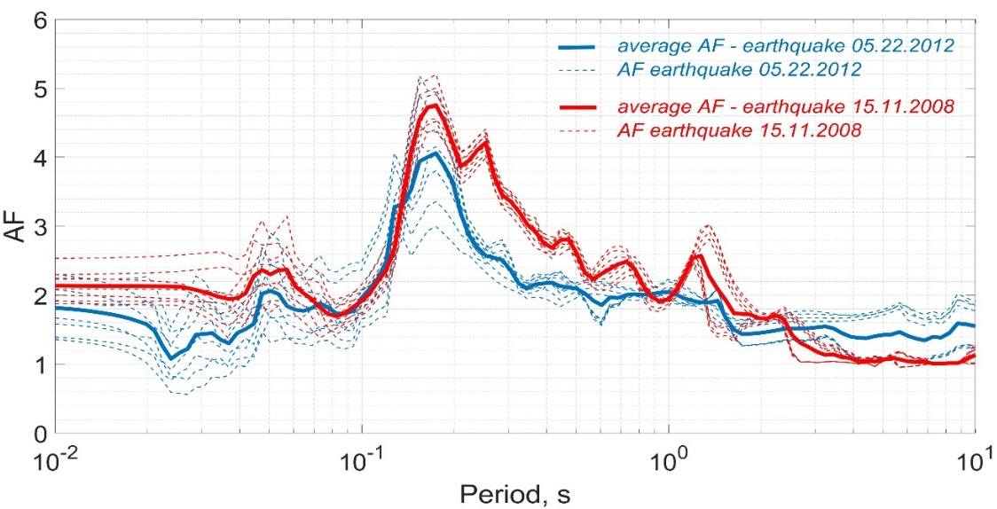
FIGURE 9. Amplification factors for the Loven park area: EQL

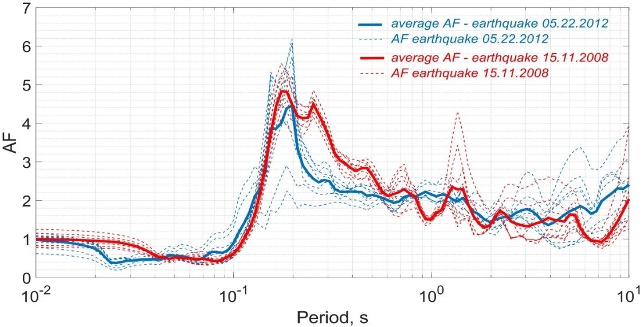
FIGURE 10. Amplification factors for the Loven park area: NL

Figures 11 and 12 show the propagation of the input ground motion from the bedrock level to the surface. The results of the input motion from the earthquake on 15.11.2008 are shown in red and blue for the EW and NS components, respectively. The results of the input motion from the earthquake on 22.05.2012 are shown in violet and ochre for the EW and NS components, respectively. The main amplification effects are observed in the upper soft surface soil layers. The bedrock layer is defined as an elastic half-space with a unit weight of 22 kN/m³, 2% damping, and V_{s} = 900 m/s for the site in the Manastirski Livadi area, and 22 kN/m³ and V_{s} = 970 m/s for the site in the Loven Park area.

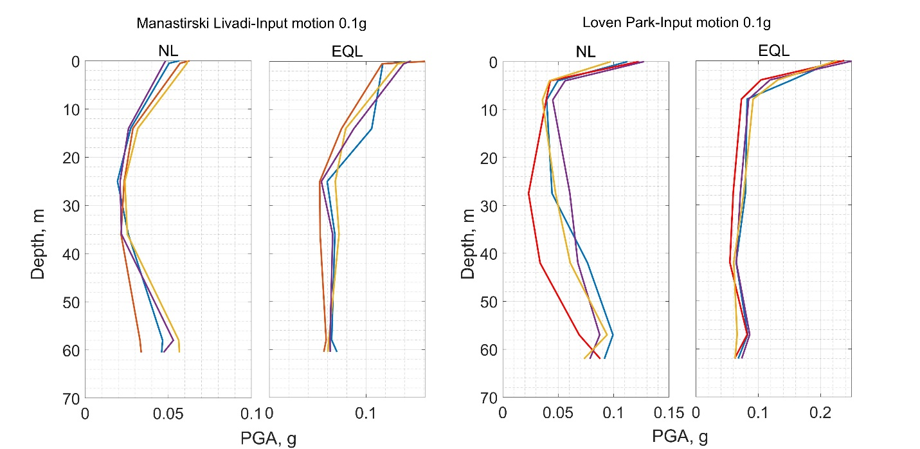
FIGURE 11. Distribution of PGA with depth for 0.10 g input motion.

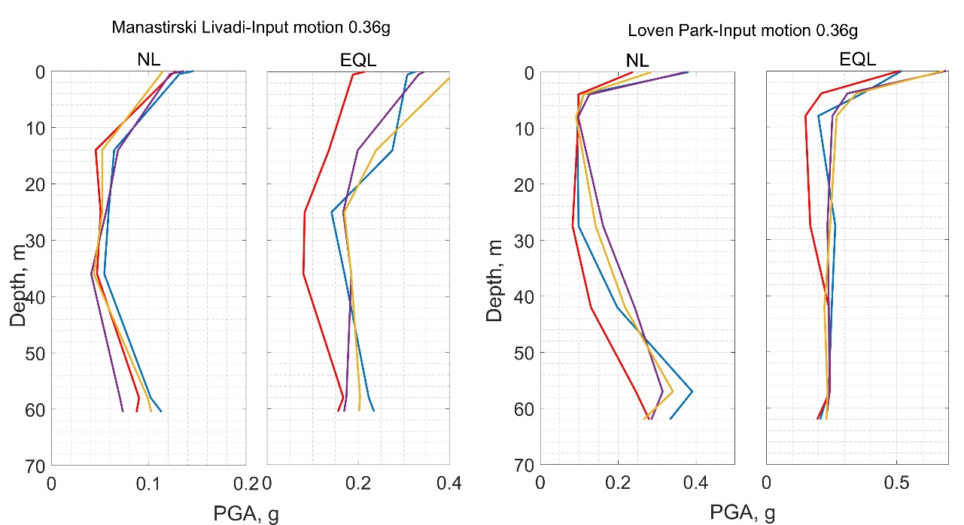
FIGURE 12. Distribution of PGA with depth for 0.36 g input motion.

discussion
The difference between equivalent linear and nonlinear responses varies depending on the soil profile and ground motion. In some cases, the differences between the two responses are negligible, while in others they are quite significant. The following can be observed by comparing equivalent linear and nonlinear responces:
The nonlinear method results in significantly lower PGA levels compared to the equivalent linear method. The differences increase with higher levels of input acceleration. For the Loven Park profile, the differences in calculated PGA become significant at input acceleration levels of 0.36 g. For the stiffer profile in the Manastirski Livadi area, deviations between the two methods are significant at both 0.10 g and 0.36 g input acceleration levels.
For both profiles, it can be concluded that the equivalent linear site response method is an approximation of the fully nonlinear method. The equivalent linear method tends to provide conservative estimates of spectral accelerations, yielding higher spectral accelerations for most spectral periods. There are a few exceptions for periods between 3 and 10 seconds (Manastirski Livadi) and 4 to 10 seconds (Loven Park), where the nonlinear response is slightly higher than the equivalent linear response.
Another important observation is on the relative influence of the soil profile and the ground motion shape on the amplification factors. The influence of the soil profile seems to be much more pronounced if we compare the difference of the individual average curve shapes of say Fig. 7 or Fig. 8 and the difference in the pairs of average curves for the same earthquake in Fig. 7 and Fig. 8. The same observation holds for the data presented in Fig. 9 and Fig. 10. This observation is encouraging in terms of earthquake preparedness and mitigation, as the soil profiles can be studied in any detail desired, while the knowledge of the variability of ground motions is very limited, especially in regions of low and moderate seismic activity. The Fourier spectra of the used accelerograms, Fig. 6, are sufficiently different, so the limited influence cannot be attributed to a similarity of the records.
The simulations carried out here show that for input acceleration levels higher than 0.10 g, nonlinear effects are noticeable for both the profiles in Manastirski Livadi area and the Loven Park area, Fig. 11 and Fig. 12, with the PGA at the surface level being consistently lower for the NL analyses compared to the EQL analyses. In the same figures we observe that the distribution patterns of PGA in depth also differ significantly between the NL and EQL cases. This means that not only an EQL analysis may prove too conservative in regard to the PGA at surface level, but it may be misleading and even more conservative as to the distribution of PGA in depth.
The distribution patterns in depth of the individual horizontal components (NS and EW) of the 2008 earthquake differ much more than those of the 2012 earthquake, Fig. 11 and Fig. 12. This can be interpreted as an indicator of stronger directivity effects present in the 2008 earthquake record for the studied areas.

conclusion
A comparison between nonlinear and equivalent-linear 1D site response analysis was carried out for two representative locations of the Sofia Basin.
The results indicate that apart from some rare exceptions the nonlinear analysis always yields less amplification both at surface level and in depth, so adopting it will result in more economical design solutions.
The effect of variability in bedrock motion on the site response is smaller than the effect of the variability of soil profiles. Therefore, it is imperative that the subsurface structure is studied in as much detail as possible before implementing site response analysis, at least for the Sofia Basin, where the soil layers are known to be far from uniform.
The distribution pattern of PGA with depth can expose directivity effects in the ground motion, so in this sense site response analysis can be used a tool for detecting directivity effects.

acknowledgments
The presented work was performed within the project Assessment of Earthquake Ground Motion Amplification in the Sofia Basin, funded by the Bulgarian National Science Fund, contract number KП-06-Н64/1 from 15.12.2022.

references
- Y. M. Hashash, D. Groholski, M. Musgrove, D. Park, C. Phillips and C. C. Tsai, DEEPSOIL V5. 0, Manual аnd Tutorial (Board of Trustees of University of Illinois at Urbana-Champaign, Urbana , IL, 2011).
- J. J. Bommer, H. Crowley and R. Pinho, A risk-mitigation approach to the management of induced seismicity. J. Seismol. 19, 623-646 (2015). https://doi.org/10.1007/s10950-015-9478-z
- J. P. Bardet, K. Ichii, and C. H. Lin, EERA: A Computer Program for Equivalent-Linear Earthquake Site Response Analyses of Layered Soil Deposits (University of Southern California, Department of Civil Engineering, 2000).
- I. M. Idriss, and H. B. Seed, Seismic response of horizontal soil layers. J. Soil Mech. Found. Div. 94(4), 1003-1031 (1968). https://doi.org/10.1061/jsfeaq.0001163
- I.M. Idriss and J.I. Sun, User’s Manual for SHAKE91 (Center for Geotechnical Modeling, Department of Civil Engineering, University of California, Davis, 1992).
- S. L. Kramer, Geotechnical Earthquake Engineering (Prentice-Hall Civil Engineering and Engineering Mechanics Series, New York, 1996).
- P. Schnabel, H. B. Seed and J. Lysmer, Modification of seismograph records for effects of local soil conditions. Bull. Seismol. Soc. Am. 62(6), 649-1664 (1972). https://doi.org/10.1785/bssa0620061649
- F. Del Monaco, M. Tallini, C. De Rose and F. Durante, HVNSR survey in historical downtown L'Aquila (central Italy): site resonance properties vs. subsoil model. Eng. Geol. 158, 34-47 (2013). https://doi.org/10.1016/j.enggeo.2013.03.008
- Y. Nakamura, E.D. Gurler, J. Saita, A. Rovelli and S. Donati, “Vulnerability investigation of Roman Colosseum using microtremor” in Proceeding 12th WCEE (International Association of Earthquake Engineering (IAEE), Tokyo, 2000), pp. 1-8.
- A. Gosar, Determination of masonry building fundamental frequencies in five Slovenian towns by microtremor excitation and implications for seismic risk assessment. Natural Hazards 62, 1059-1079 (2012). https://doi.org/10.1007/s11069-012-0138-0
- M. Herak, I. Allegretti, D. Herak, K. Kuk, V. Kuk, K. Marić, S. Markušić and J. Stipčević, HVSR of ambient noise in Ston (Croatia): comparison with theoretical spectra and with the damage distribution after the 1996 Ston-Slano earthquake. Bull. Earthq. Eng. 8, 483-499 (2010). https://doi.org/10.1007/s10518-009-9121-x
- F. Panzera, G. Lombardo, S. D'Amico and P. Galea, “Speedy techniques to evaluate seismic site effects in particular geomorphologic conditions: Faults, cavities, landslides and topographic irregularities”, in Engineering Seismology, Geotechnical and Structural Earthquake Engineering, edited by Sebastiano D'Amico (InTechOpen, London, 2013), pp. 101-145. https://doi.org/10.5772/55439
- M. Herak, ModelHVSR — A Matlab® tool to model horizontal-to-vertical spectral ratio of ambient noise. Computers & Geosciences 34(11), 1514-1526 (2008). https://doi.org/10.1016/j.cageo.2007.07.009
- M. Sambridge, Geophysical inversion with a neighbourhood algorithm—I. Searching a parameter space. Geophys. J. Int. 138(2), 479-494 (1999). https://doi.org/10.1046/j.1365-246x.1999.00876.x
- S. Bončev, Pourquoi le versant nord du Balkan Occidental et le versant sud du Balkan Central sont-ils plus abrupts que les versants respectifs opposes. Annuaire Univ. Sofia, Fac. Phys.-Math. 23(3), 157-180 (1927).
- B. Kamenov and E. Kojumdgieva, Stratigraphy of the Neogene in Sofia basin. Palaeontology, Stratigraphy and Lithology, BAS 18, 69-84 (1983).
- S. Watzof, Earthquakes in Bulgaria during XIX century (Central Meteorological Station, Imprimerie de l’État, Sofia, 1902).
- K. Kirov, Contribution to the study of earthquakes in the Sofia region. Ann. Main Dep. Geol. Min. Res. 5, 407-440 (1952).
- I. Petkov and L. Christoskov, On seismicity in the region of the town of Sofia concerning the macroseismic zoning. Ann. Sofia Univ 58, 163-179 (1965).
- V. Petrov, “Hydrogeology of the Pliocene aquifer in the Sofia Basin”, Ph.D. thesis, University of Mining and Geology St. Ivan Rilski, Sofia, 2004.
- M.B. Darendeli, „Development of a new family of normalized modulus reduction and material damping curves“, Ph.D. thesis, The University of Texas at Austin, 2001.
- M. Hobiger, “Polarization of surface waves: characterization, inversion and application to seismic hazard assessment”, Ph.D. thesis, Université de Grenoble, 2011.
- M. Hobiger, P. Y. Bard, C. Cornou and N. Le Bihan, Single station determination of Rayleigh wave ellipticity by using the random decrement technique (RayDec). Geophys. Res. Lett. 36(14), L143034 (2009). https://doi.org/10.1029/2009gl038863
- H. Okada and K. Suto, The Microtremor Survey Method (Society of Exploration Geophysicists, Monograph Series 12: Tulsa, Oklahoma, 2003). https://doi.org/10.1190/1.9781560801740.fm
- D. Solakov, S. Simeonova., P. Trifonova, I. Georgiev, P. Rajkova, M. Metodiev, I. Aleksandrova, Building Seismic Risk Management, Part 1 (Prof. Marin Drinov Publishing House of Bulgarian Academy of Sciences, Sofia, Bulgaria, 2019) pp. 13-110.
- D. R. Groholski, Y. M. Hashash, B. Kim, M. Musgrove, J. Harmon and J. P. Stewart, Simplified model for small-strain nonlinearity and strength in 1D seismic site response analysis. J. Geotech. Geoenviron. Eng. 142(9) 04016042 (2016). https://doi.org/10.1061/(asce)gt.1943-5606.0001496

