Modeling of Laser Strengthening Processes for α Ti Alloy Using the Laser Shock Peening Method
Jasur Erkinov^{1, a)}, Abdunabi Abdukarimov^{1, b)}, Nodira Shamsutdinova^{2, c)} Dilshod Kholikov^{2, d)}, Ibrokhim Madatov ^{3, e)}
¹ Samarkand branch of the Tashkent University of Information Technologies, Samarkand, Uzbekistan
² "ZARMED" Samarkand Campus, Samarkand, Uzbekistan
³ Samarkand State University, 140104, University blv. 15, Samarkand, Uzbekistan
^{a)} erkinovj110@gmail.com
^{b)} abdukarimov54@mail.ru
^{c)} nodira237@gmail.com
^{d)} Dilshodxoliqov2587gmail.com
^{e)} Corresponding author: ibrokhimmadatov@gmail.com
Abstract. This paper presents a numerical study of the processes occurring during laser shock peening (LSP) of α-titanium alloy. Based on the Fabbri model, the shock wave pressure distribution and its temporal evolution are calculated for different laser radiation intensities (10–25 Gwt/sm²). Using the finite element method (FEM), the dynamic deformation and thermal response of the material under the influence of a 15 ns laser pulse were simulated. It was shown that the formation of high-energy plasma leads to the emergence of shock waves with peak pressures of up to 20 GPa and the formation of residual compressive stresses (CRS) to a depth of up to 1.8 mm. Microstructural changes, including grain refinement, subgrain formation, and nanocrystalline structure, are caused by high-density dislocation processes. The results of the study confirm the effectiveness of LSP as a promising method for increasing the fatigue strength and wear resistance of titanium parts for aerospace applications.

Introduction
Laser Shock Peening (LSP) technology is a modern method of surface metal treatment based on the generation of high-energy shock waves during the interaction of short-pulse laser radiation with the material surface. Compared to conventional mechanical Shot Peening (SP), LSP provides deeper penetration of residual compressive stresses (up to 2 mm) and minimizes thermal damage. Of particular interest are α-titanium alloys, widely used in the aerospace and energy industries due to their high strength-to-density ratio and corrosion resistance. The main objective of this study is to numerically evaluate the dynamics of shock waves and microstructural effects induced by high-power laser pulses [1].

Methodology
In numerical modeling, the laser-induced shock wave is typically simplified to a time-varying load applied directly to the target surface. To evaluate the peak pressure of the laser shock wave, the formula derived by Fabbro et al. [2-5] was used, and the corresponding maximum pressure can be obtained as follows:
where P is the maximum pressure of the LSP, a is the coefficient of conversion of internal energy into thermal energy, typically 0.1, Z is the equivalent acoustic impedance, which is determined by the following formula:
where Z₁ and Z₂ are the shock-wave impedances of the target material and the retaining medium respectively, and α is the power density of the laser radiation, which can be calculated using the formula:
where γ – is the absorption coefficient, E is the laser pulse energy, usually taking a value of 0.7; τ is the pulse duration, and D is the spot diameter.
In the laser shock peening (LSP) process, a high-energy (Gwt/sm²) short-pulse (ns) laser beam passes through a transparent overlay and irradiates the ablative coating, resulting in instantaneous evaporation and ionization of the coating layer. This leads to the formation of high-temperature, high-pressure plasma, which rapidly expands from the target surface, as shown in Figure 1 (a). Due to the presence of the transparent overlay, the expanding plasma is confined and redirected towards the surface, resulting in a high-pressure (GPa) shock wave propagating within the target material. Based on the widely accepted Fabbro LSP model, the peak pressure P of the shock wave induced by the laser plasma is determined by the shock impedance (of the confining medium and target material) and the laser intensity I(t) [6]:
where L – is the length of the plasma interface, and a - is the ratio of thermal energy to internal energy of the plasma (ranging from 0.3 to 0.5). [5]. I(t) is determined by equations (3) and (6):
where I₀ – max is the maximum laser intensity, Q - is the pulsed laser energy, d- is the beam diameter, and t is the laser pulse duration.
The value of σ can be estimated from the effective duration of the laser FWHM (full width at half maximum), where FWHM is in ns, and FWHM = ns, .
Based on equations (4) - (7), the temporal evolution of shock wave pressure for different laser intensities is calculated as shown in Figure 1 (b). It can be seen that the shock wave pressure in CRS experiments rapidly reaches its peak value (GPa) within 20 ns, and then gradually decreases over time. As the shock wave propagates into the Ti block, the effective pressure decreases with increasing depth [4].
Once the shock wave pressure exceeds the Hugoniot elastic limit (σ_{HEL}) of the metal, which is determined by the magnitude of the elastic precursor of the shock wave and is related to the yield strength σ_{y} and Poisson's ratio ν of the material by equation (8), high-speed plastic deformation occurs beneath the irradiated area, accompanied by grain refinement and CRS induction.

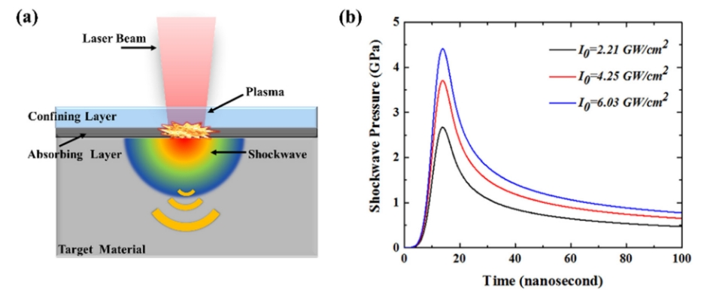
Figure 1. Temporal evolution of shock wave pressure for various laser intensities.

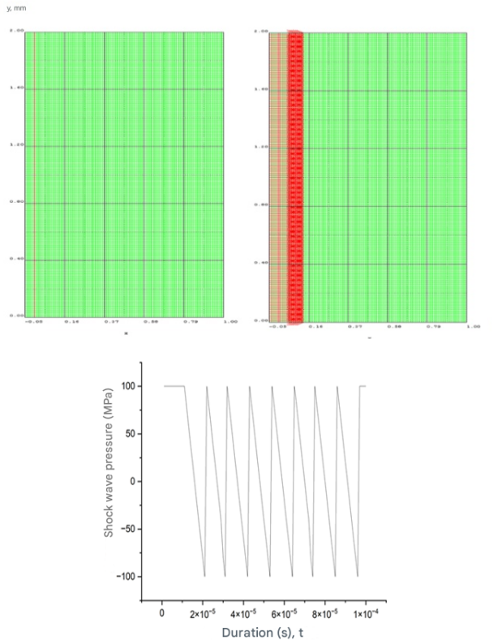
Figure 2. Finite element model for laser shock impact simulation. (a) mesh model for LSI modeling, sample thickness x₂ mm, loading area height y₂= 2 mm (b) laser wave propagation (c) shock wave pressure.

The degree of grain refinement from the matrix to the surface includes low-density dislocations, dense dislocations (or entanglement of dislocation lines), DW (dislocation walls), DC (dislocation cells), subgrain boundaries, and nanocrystals. The gradient movement of dislocations led to the formation of a gradient structure [7].
Notably, the thickness of the field formed during laser shock processing (LSP) can reach 1-2 mm, which is almost 5-10 times deeper than that of SP [8].

Modeling the impact of shock impulse on titanium alloy plates
A study on the deformation of alpha titanium alloy under the impact of a shock pulse with an amplitude of 20 GPa was conducted.

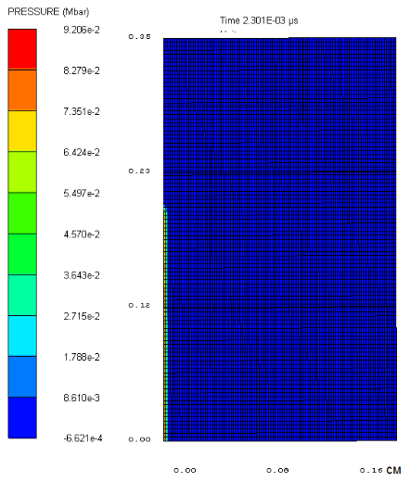
Figure 3. Initial pressure in the area of impact impulse application.

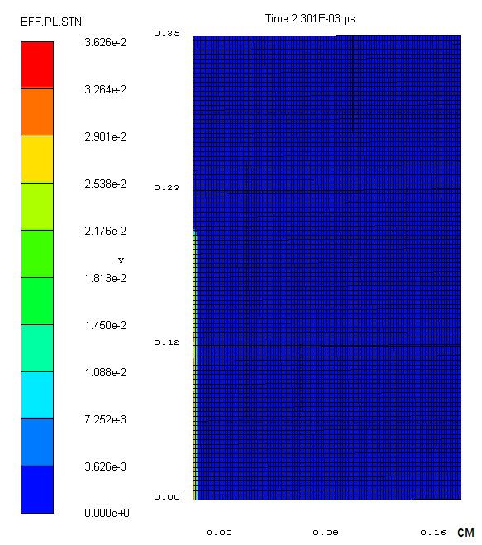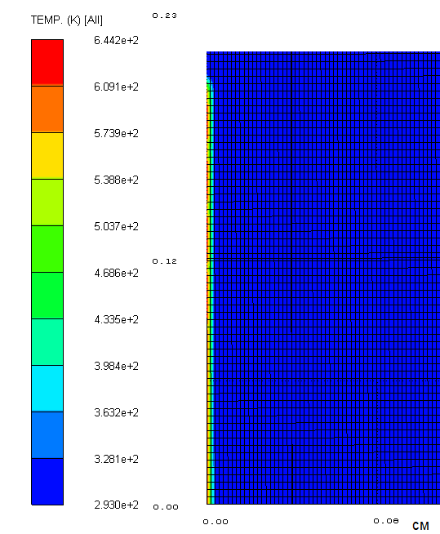
Figure 4. Initial distributions of equivalent plastic strain and temperature in the alpha titanium alloy region exposed to a shock pulse.

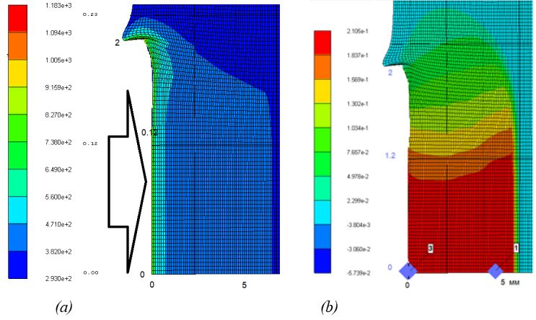
Figure 5. a) Temperature distribution in the alpha titanium alloy at 200 ns after exposure to a shock impulse b) Pressure distribution in the alpha titanium alloy plate at 200 ns after exposure to a shock impulse.

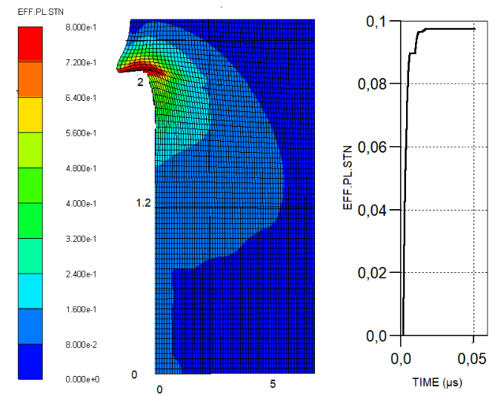
Figure 6. Pressure distribution in an alpha titanium alloy in a melt at a time of 200 ns when exposed to a shock pulse.

conclusion
Computational experiments were conducted to model shock impulses on thin CP-Ti Grade1 and Ti-6AI-4V plates. It was established that increasing the initial temperature of the plates to 450 K leads to a significant change in plastic deformation amplitudes. It has been shown that in the near-surface layers of materials, when exposed to shock impulses with an amplitude of 20 GPa, the temperature increases by several hundred K.
The calculated pressure distribution of the shock wave over time demonstrates a characteristic non-stationary peak - the pressure sharply increases to ~20 GPa during the first 18-22 ns, after which it decreases exponentially with a time constant of about 40 ns. The pressure dynamics agrees well with the predictions of the Fabbro model, which confirms the correctness of the selected laser pulse parameters and the geometry of the confining medium.
Numerical modeling showed that during laser-induced shock treatment, a pronounced stress gradient forms: maximum compressive stresses are observed near the surface (-0.7 GPa), gradually decreasing with depth to zero at a level of 1.8-2.0 mm. In this zone, a local temperature increase to 680-720 K is recorded, at which no melting of the material occurs, but thermoelastic and plastic relaxation processes are activated.
As a result of the interaction of high-energy plasma with the surface of the α-titanium alloy, a significant increase in dislocation density (up to 10¹⁴ m⁻²) and the formation of a substructure consisting of cells and subgrains with sizes of 100-300 nm are observed. This indicates the implementation of a dynamic recrystallization refinement mechanism. Plastic deformation modeling shows that the region of maximum plasticity accumulation coincides with the peak pressure zone, which confirms the correlation between pressure and the degree of nanostructuring.
Comparison of numerical data with available experimental results [4,6] shows good agreement both in peak pressure values (difference less than 6.5%) and in the depth of the induced plastic zone. Thus, the developed numerical model can be used to predict residual stresses and select optimal LSP parameters for processing titanium alloys of various compositions [9-11].
As a result of numerical modeling, it was established that laser-induced shock hardening of an α-titanium alloy forms stable residual compressive stresses up to 1.8 mm deep and causes intensive dislocation-plastic deformation while preserving the structural integrity of the material.
It has been shown that using the Fabbro model to describe plasma pressure allows for adequate prediction of the shock wave amplitude and its temporal evolution. At laser radiation intensities above 20 Gwt/sm², an optimal balance between the hardened layer depth, the CRS value, and the minimization of thermal effects is ensured.
Further development of the model involves including phase transformation phenomena and anisotropy of α-titanium properties in the calculation, which will increase the accuracy of residual stress prediction and expand the possibilities for practical application of LSP in the treatment of aviation, energy, and biomedical structural elements operating under cyclic and shock loads.

References
- L. Berthe, R. Fabbro, P. Peyre, L. Tollier, E. Bartnicki, Shock waves from a water-confined laser-generated plasma, Journal of Applied Physics, 82, 2826–2832 (1997). https://doi.org/10.1063/1.366113
- M. Cai, H. Li, H. Li, S. Shen, J. Lu, B. Zheng, Laser shock peening induced mechanical properties enhancement of 50CrVA alloy, Optics & Laser Technology, 169, 110180 (2024).
https://doi.org/10.1016/j.optlastec.2023.110180
- D.R. Chichilli, K.T. Ramesh, K.J. Hemker, The high-strain-rate response of alpha-titanium: experiments deformation mechanisms and modeling, Acta Materialia, 46, 1025–1043 (1998).
https://doi.org/10.1016/S1359-6454(97)00287-5
- J.R. Davis, Properties and selection: nonferrous alloys and special-purpose materials, ASM International, (1990). https://doi.org/10.31399/asm.hb.v02.9781627081627
- D. Devaux, R. Fabbro, L. Tollier, E. Bartnicki, Generation of shock waves by laser-induced plasma in confined geometry, Journal of Applied Physics, 74, 2268–2273 (1993). https://doi.org/10.1063/1.354710
- J. Williams, J. Chesnutt, Titanium Alloys. Thermomechanical Treatment. Pergamon Press Ltd, Encyclopedia of Materials Science and Engineering. (1986).
- R. Ding, Z. Guo, A. Wilson, Microstructural evolution of a Ti–6Al–4V alloy during thermomechanical processing, Materials Science and Engineering: A, 327, 233-245 (2002). https://doi.org/10.1016/S0921-5093(01)01531-3
- G. Lutjering, J.C. Williams, Titanium, Springer, Berlin, 2003. https://doi.org/10.1007/978-3-540-71398-2
- S. Malinov, W. Sha, Z. Guo, C. Tang, A. Long, Synchrotron X-ray diffraction study of the phase transformations in titanium alloys, Materials Characterization, 48, 279-95 (2002). https://doi.org/10.1016/S1044-5803(02)00286-3
- J. Tiley, T. Searles, E. Lee, S. Kar, R. Banerjee, J. Russ, Quantification of microstructural features in α/β titanium alloys, Materials Science and Engineering: A, 372, 191-198 (2004). https://doi.org/10.1016/j.msea.2003.12.008
- F.J. Gil, M.P. Ginebra, J.M. Manero, J.A. Planell, Formation of α-Widmanstätten structure: effects of grain size and cooling rate on the Widmanstätten morphologies and on the mechanical properties in Ti6Al4V alloy, Journal of Alloys and Compounds, 329, 142-52 (2001). https://doi.org/10.1016/S0925-8388(01)01571-7

