Simultaneous Action of Bending and Compression in Plates Supported by Thin-Walled Ribs.
Normat Melikulov, Sherzod Yakhshboyev^{a)}, Nilufar Shodmonkulova
Samarkand State Architecture and Construction University named after Mirzo Ulugbek, Uzbekistan

^{a)} Corresponding author: sherzodyaxshiboyev@mail.ru, yaxshiboyev.sherzod@samdaqu.edu.uz
Abstract. In this article, free oscillation of the plate is considered when the sides of $х\text{=}0$, a are hinged and other sides of $y\text{=}{±b}/2$ are free. Free sides connected with thin, open profile rods. Bending graphs of the plate's midsurface were obtained and analyzed using Fure transforms. Furthermore, the graphs are presented for various values of the parameter a, assuming a constant external load during plate bending.
Keywords. Compressed, compressed-bent, stretched, plates, elastic clamping, hinged support, torsional, bending, reinforced, unreinforced, edges.

INTRODUCTION
Problem Statement and Literature Review. It is known that considering constrained torsion in thin-walled open-profile ribs allows for a more thorough identification of the reserves for increasing the torsional stiffness of such ribs. Therefore, the influence of constrained torsion manifests in the increased degree of edge clamping of the plate when thin-walled open-profile ribs are used as supporting elements.
In the literature [2, 3, 4, 6], the following method for formulating boundary conditions along the contact line of the plate with the supporting ribs is described. The loads transmitted by the plate to the ribs (bars) are considered equal but opposite in direction to the forces in the corresponding sections of the plate. Then, kinematic conditions of equal displacements at the contact points of the supporting ribs with the plate are introduced into these force conditions.
In publications [1, 5], a methodology for establishing refined boundary conditions at the junction line of the plate with the rib is proposed, allowing for the consideration of the constraint of the deplanation of the end sections of the ribs. In this case, the degree of deplanation constraint is accounted for by a certain parameter $d_{k}$.

SOLUTION METHOD
As far as we know, a closed-form solution to the problem of a compressed-bent rectangular plate can be obtained in single trigonometric series only when two parallel edges are hinged on rigid supports, while the other two edges can be fixed arbitrarily (solution by M. Levi).
Consider the problem of a compressed-bent plate where the edges x=0, a are hinged on rigid supports, and the edges $y\text{=}±\frac{b}{2}$​ are rigidly connected to elastic thin-walled open-profile ribs ( Fig.1).

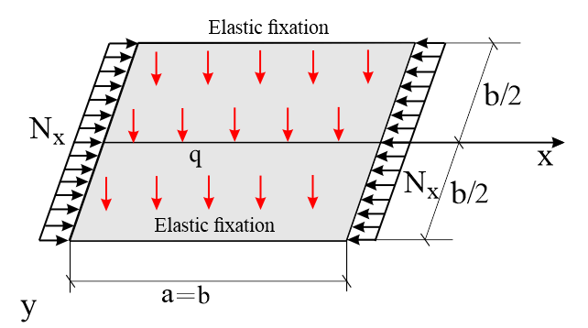
Figure 1. Compressed-bent plate.

Let the load$N_{x}$ be applied to the edges x=0, a. The governing equation for the problem can be expressed as follows
$D∇^{2}∇^{2}w\text{+}N_{x}\frac{∂^{2}w}{∂x^{2}}\text{=}q(x,y)$ (1)
The solution to equation (1), satisfying the boundary conditions of hinged supports at the edges x=0, has a known form.
The solution to equation (1), satisfying the boundary conditions of hinged supports at the edges x=0, has a known form.
$w\left(x,y\right)\text{=}\sum_{n\text{=}1.2}^{∞}{f_{n}(y)sinλ_{n}x},$ $λ_{n}\text{=}\frac{nπ}{a}$ (2)
The transverse load q(x,y) can be expressed in the form of a Fourier series as follows $sinλ_{n}x$
$q_{n}\left(x,y\right)\text{=}\sum_{n\text{=}1,2}^{∞}{q_{n}\left(y\right)}sinλ_{n}x$ (3)
where the coefficients of this series are
${ q}_{n}\left(y\right)\text{=}\frac{2}{a}\int_{a}^{0}{q(x,y)}sinλ_{n}xdx$ (4)
Substituting (2) and (3) into (1) will yield an equation for determining the function $f_{n}(y)$
${ f}_{n}^{IV}\text{-}2λ_{n}^{2}f_{n}^{II}\text{+}λ_{n}^{2}{(λ}_{n}^{2}\text{-}\frac{N_{x}}{D})f_{n}\text{=}\frac{q_{n}(y)}{D}$ (5)
In the future, for simplicity, we will assume q=constq = \text{const}q=const; then from (4) we will obtain
$$q_{n}\text{=}\frac{4q }{nπ}, (n\text{=}1,3….)$$
The solution to equation (5) depends on the nature of the roots of the characteristic equation. In this context, we will consider two cases below.
I option: Let $N_{x}\text{<}λ_{n}^{2}D$ be such that all roots of the characteristic equation derived from (5) are real, and therefore the solution can be expressed in the form
$f_{n}\left(y\right)\text{=}C_{1}chα_{n}y\text{+}C_{2}shα_{n}y\text{+}C_{3}chβ_{n}y\text{+}C_{4}shβ_{n}y\text{+}f_{ч.р}$ (6)
where the particular solution takes the form
$f_{ч.р}\text{=}\frac{4q}{[Dnπλ_{n}^{2}({(λ}_{n}^{2}\text{-}\frac{N_{x}}{D})]}$ (7)
In (6)
$α_{n}\text{=}λ_{n}\sqrt{1\text{+}\sqrt{\frac{N_{x}}{Dλ_{n}^{2}}}}$ $β_{n}\text{=}λ_{n}\sqrt{1\text{-}\sqrt{\frac{N_{x}}{Dλ_{n}^{2}}}}$ (8)
II. option: Let now $N_{x}\text{>}λ_{n}^{2}D$, then one pair of roots of the characteristic equation will be real, and the other will be imaginary. In this case, the solution of equation (5) has the form

$f_{n}\left(y\right)\text{=}C_{1}chα_{n}y\text{+}C_{2}shα_{n}y\text{+}C_{3}cosβ_{n}y\text{+}C_{4}sinβ_{n}y\text{+}f_{ch.p.}$ (9)
where
$β_{n}\text{=}λ_{n}\sqrt{\sqrt{\frac{N_{x}}{Dλ_{n}^{2}}}\text{-}1}$ (10)
The particular solution $f_{ch.p.}$ and the parameter $α_{n}$ are given by the formulas (7) and (8).
III option, since $N_{x}\text{=}λ_{n}^{2}D$ is not considered separately, it can be approached as closely as desired from either option I or II.
Now let’s impose boundary conditions on each of the functions $f_{n}\left(y\right)$ according to (6) and (7):
III option, when N is not considered separately, it can be approached as closely as desired from either option I or II.
Now let’s impose the boundary conditions on each of the functions $f_{n}\left(y\right)$according to (6) and (7):
Boundary conditions for elastic clamping at the edges $y\text{=}±\frac{b}{2}$ :
$f_{n}^{I}\text{=}\frac{μλ_{n}^{2}f_{n}{\text{-}f}_{n}^{II}}{t_{k}bλ_{n}^{2}}$, (11)
where
$t_{k}\text{=}\frac{C_{k}}{d_{k}}(1\text{+}\frac{λ_{n}^{2}}{k^{2}})$, $C_{k}\text{=}\frac{GJ_{k}}{Db}$, $k^{2}\text{=}\frac{GJ_{k}}{EJ_{ω}}$, (12)
$d_{k}\text{=}1 \frac{d^{2}θ}{{dx}^{2}}⃒_{x\text{=}0, a}\text{=}0$ (13)
$d_{k}\text{=}1\text{-}\frac{2ka}{n^{2}π^{2}{\text{-}k^{2}a}^{2}}\left\{\frac{[1\text{-}({\text{-}1)}^{n}]shka}{chka\text{-}1}\text{+}\frac{[1\text{+}({\text{-}1)}^{n}]ka(1\text{-}chka)}{2\left(chka\text{-}1\right)\text{-}kashka}\right\} by \frac{dθ}{dx}⃒_{x\text{=}0, a}\text{=}0$ (13a)
Boundary conditions for elastic support at the edges $y\text{=}±\frac{b}{2}$:
$f_{n}\text{=}\frac{f_{n}^{III}\text{-}\left(2\text{-}μ\right) λ_{n}^{2}f_{n}^{I}}{t_{u}bλ_{n}^{4}}$, (14)
where
$t_{u}\text{=}\frac{С_{u}}{d_{u}(1\text{+}λ_{n}^{2}\frac{k_{φ}}{k_{2}^{2}})}$, $С_{u}\text{=}\frac{EJ_{y}}{Db}$, $k_{2}^{2}\text{=}\frac{GF}{EJ_{y}}$, (15)
$d_{u}\text{=}1$ by $\frac{d^{2}w_{п.с.}}{dx^{2}}⃒_{x\text{=}0, a},\text{=}0,$ (16)
$d_{u}\text{=}1\text{-}\frac{16\text{+}8{\left(\text{-}1\right)}^{n}}{n^{2}π^{2}}$ by $\frac{ dw_{п.с.}}{dx}⃒_{x\text{=}0, a}\text{=}0$ . (16a)
To simplify the solution, we will use the symmetry of the problem and assume $C_{2}\text{=}C_{4}\text{=}0$ .
To simplify the solution, we will use the symmetry of the problem and assume $С_{1}, С_{3}:$
I option
$\left.\begin{aligned}С_{1}\left(A_{n}chξ\text{+}2t_{k}ψ^{2}ξshξ\right)\text{+}C_{3}\left(B_{n}^{\left(\text{-}\right)}chη\text{+}2t_{k}ψ^{2}ηshη\right)\text{=}μψ^{2}f_{ч.р} \\ С_{1}{t_{u}ψ}^{4}chξ\text{-}2C_{n}ξshξ{{)\text{+}C_{3}\left(t_{u}ψ^{4}chη\text{-}2D_{n}^{\left(\text{-}\right)}ηshη\right)\text{=-}t}_{u}ψ}^{4}f_{ч.р}\end{aligned}\right]$ (17)
II option
$\left.\begin{aligned}С_{1}\left(A_{n}chξ\text{+}2t_{k}ψ^{2}ξshξ\right)\text{-}C_{3}\left(В_{n}cosη\text{+}2t_{k}ψ^{2}ηsinη\right)\text{=}μψ^{2}f_{ч.р} \\ С_{1}(t_{u}ψ^{4}chξ\text{-}2C_{n}ξshξ{{)\text{+}C_{3}\left(t_{u}ψ^{4}cosη\text{-}2D_{n}ηsinη\right)\text{=-}t}_{u}ψ}^{4}f_{ч.р}\end{aligned}\right]$ (18)
In (17) and (18), the following notations are introduced
$A_{n}\text{=}4ξ^{2}\text{-}μψ^{2},$ $B_{n}\text{=}4η^{2}\text{+}μψ^{2},$ $ξ\text{=}\frac{α_{n}b}{2}$.
$B_{n}^{\left(\text{-}\right)}\text{=}4η^{2}\text{-}μψ^{2}$, $C_{n}\text{=}4ξ^{2}\text{-}\left(2\text{-}μ\right)ψ^{2},$ $η\text{=}\frac{β_{n}b}{2}.$ (19)
$D_{n}\text{=}4η^{2}\text{+}(2\text{-}μ)ψ^{2},$ $D_{n}^{\left(\text{-}\right)}\text{=}4η^{2}\text{-}(2\text{-}μ)ψ^{2},$ $ψ\text{=}λ_{n}b$
By finding the constants $C_{1}$ and $C_{3}$from (17) and (18), the expression for the deflection (2) can be presented in its final form
I option ($N_{x}\text{<}λ_{n}^{2}D$)
$w\left(x,y\right)\text{=}\frac{4qb^{4}}{π^{5}D}\sum_{n\text{=}1.3..}^{∞}{\frac{sinλ_{n}x}{n^{5}\left(1\text{-}\frac{4N_{x}a^{2}}{N_{э}n^{2}b^{2}}\right)}}×$
$×\{1\text{-}\frac{ψ^{2}[\left(B_{1}t_{u}ψ^{2}\text{+}B_{2}μ\right)chβ_{n}y\text{-}(B_{3}t_{u}ψ^{2}\text{+}B_{4}μ)chα_{n}y]}{B_{1}B_{4}\text{-}B_{2}B_{3}}\}$ (20)
where
$B_{1}\text{=}\left(4ξ^{2}\text{-}μψ^{2}\right)chξ\text{+}2t_{k}ψ^{2}ξshξ,$
$B_{2}\text{=}t_{u}ψ^{4}chξ\text{-}2\left[4ξ^{2}\text{-}\left(2\text{-}μ\right)ψ^{2}\right]ξshξ,$
$B_{3}\text{=}\left(4η^{2}\text{-}μψ^{2}\right)chη\text{+}2t_{k}ψ^{2}ηshη,$ (21)
$B_{4}\text{=}t_{u}ψ^{4}chη\text{-}2[4η^{2}\text{-}(2\text{-}μ)ψ^{2}]ηshη$.
II option ($N_{x}\text{>}λ_{n}^{2}D$): It reduces to the formula (20) by substituting in the last expression in curly braces with the following expression
$1\text{-}\frac{ψ^{2}[\left(B_{1}t_{u}ψ^{2}\text{+}B_{2}μ\right)cosβ_{n}y\text{+}(B_{5}t_{u}ψ^{2}\text{+}B_{6}μ)chα_{n}y]}{B_{1}B_{6}\text{+}B_{2}B_{5}}$ (22)
where
$B_{5}\text{=}\left(4η^{2}\text{+}μψ^{2}\right)cosη\text{+}2t_{k}ψ^{2}ηsinη,$
$B_{6}\text{=}t_{u}ψ^{4}cosη\text{-}2[4η^{2}\text{+}(2\text{-}μ)ψ^{2}]ηshη]$ (23)

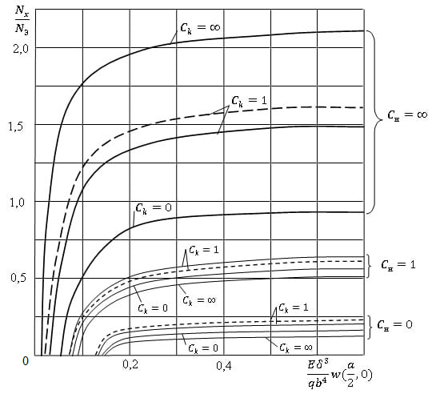
FIGURE 2. The graph of the deflection at the center of the plate as a function of the magnitude $N_{x}$ .

To illustrate the influence of longitudinal forces $N_{x}$ on the magnitude of deflections of a compressed-bent plate (under $q\text{=}const$), Fig. 2 presents a graph constructed based on (20) and (22) for various values of $C_{k }$ and ${ C}_{u}$. When constructing the graph, it is accepted that: $x\text{=}\frac{a}{2}, y\text{=}0, a\text{=}b , n\text{=}1, P\text{=}0, μ\text{=}0,3, ka\text{=}8.$ For all curves, it is assumed that $d_{u}\text{=}1$ represents the hinged support of the ends of the supporting rods. Solid lines refer to free end deflection of the rods, while dashed lines indicate their complete restraint
From the solution to the problem of the compressed-bent plate, it follows that for $N_{x}→N_{x}^{\text{*}}$ (where$N_{x}^{\text{*}}$ is the critical load value in the stability problem of the plate), $w\left(x,y\right)→∞.$ Considering that the problem is examined in a linear framework, the sufficiently accurate values of the curves in Fig. 2 (and in the following figures related to compressed-bent plates) are limited by the inequality $N_{x}≤0,9N_{x}^{\text{*}}.$
The last inequality ensures small deflections, which are assumed in the linear theory of plate bending.
From the graph in Fig. 2, it can be concluded that longitudinal forces increase the deflections at the center of the plate more significantly the lower the resistance of the supporting rods to the deflection of the longitudinal edges.
Moreover, if such resistance is completely absent ($C_{u}\text{=}0$), then the change in $C_{k}$ from zero to infinity has little effect on the quantitative relationship with $N_{x}\text{-}w\left(\frac{a}{2}, 0\right).$
Now, let us consider special cases of the general solutions (20) and (22). Suppose the stiffness in bending of the supporting rods is so great that the deflection of the edges of the plate $y\text{=}±\frac{b}{2 },$ can be neglected, i.e., we can assume $t_{u}\text{=}∞, 0≤t_{k}≤∞$ ( Fig. 3).
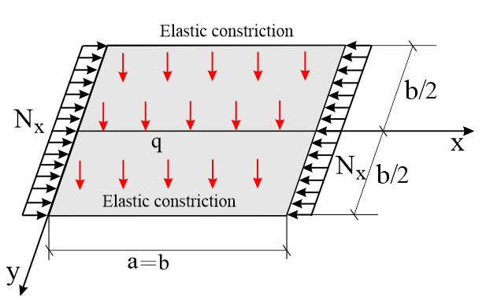
FIGURE 3. Compressed-bent plate.

In this case, the formulas for the deflections of the compressed-bent plate will take the form derived from (20) and (22).
I option ($N_{x}\text{<}λ_{n}^{2}D$)
$w\left(x,y\right)\text{=}\frac{4qb^{4}}{π^{5}D}\sum_{n\text{=}1.3..}^{∞}{\frac{sinλ_{n}x}{n^{5}\left(1\text{-}\frac{4N_{x}a^{2}}{N_{э}n^{2}b^{2}}\right)}}\left(1\text{-}\frac{B_{7}chβ_{n}y\text{-}B_{8}chα_{n}y}{B_{7}chη\text{-}B_{8}chξ}\right).$ (24)
II option ($N_{x}\text{>}λ_{n}^{2}D$)
$w\left(x,y\right)\text{=}\frac{4qb^{4}}{π^{5}D}\sum_{n\text{=}1.3..}^{∞}{\frac{sinλ_{n}x}{n^{5}\left(1\text{-}\frac{4N_{x}a^{2}}{N_{э}n^{2}b^{2}}\right)}}\left(1\text{-}\frac{B_{7}cosβ_{n}y\text{+}B_{9}chα_{n}y}{B_{7}cosη\text{+}B_{9}chξ}\right).$ (25)
In (24), (25) it is indicated
$B_{7}\text{=}4ξ^{2}chξ\text{+}2t_{k}ψ^{2}ξshξ,$
$B_{8}\text{=}4η^{2}chη\text{+}2t_{k}ψ^{2}ηshη,$ (26)
$B_{9}\text{=}4η^{2}cosη\text{+}2t_{k}ψ^{2}ηsinη.$
Under specific assumptions about the value of the coefficient $t_{k}$, the solutions (24) and (25) coincide with those known in the literature. For example, when $t_{k}\text{=}0$ matches $t_{k}\text{=}∞$ from [26].
Based on formulas (24) and (25), Fig. 4 presents the graph of the deflection at the center of the plate as a function of the magnitude $N_{x}$. When constructing the graph, $a\text{=}b, n\text{=}1, P\text{=}0, μ\text{=}0,3, ka\text{=}8.$ is assumed. As before, solid lines refer to free end deflection of the supporting rods, while dashed lines indicate complete restraint of deflection.
It should be noted that the differences in boundary conditions for deflection displacements at the ends of the supporting rods have a lesser effect on the values of the plate deflections than on the values of the critical load parameters.

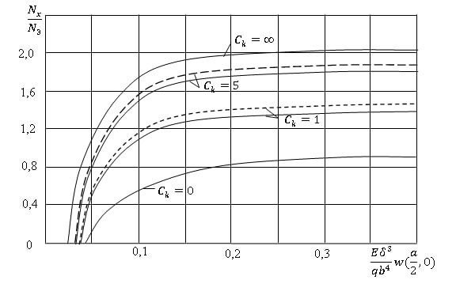
FIGURE 4. The graph of the deflection at the center of the plate as a function of the magnitude $N_{x}$

Now let us turn to another specific case, when the plate is hinged to elastic supporting rods, i.e. $t_{k}\text{=}0, t_{k}\text{=}∞$ (Fig. 5)
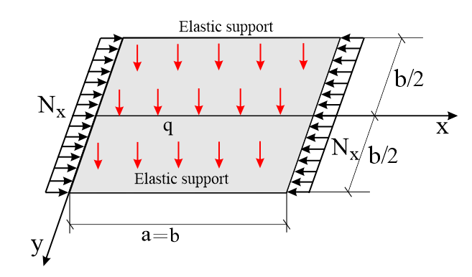
FIGURE 5. Compressed-bent plate.

The formulas for deflections (3.14) and (3.15) in this case will take the form
I option
$w\left(x,y\right)\text{=}\frac{4qb^{4}}{π^{5}D}\sum_{n\text{=}1.3..}^{∞}{\frac{sinλ_{n}x}{n^{5}\left(1\text{-}\frac{4N_{x}a^{2}}{N_{э}n^{2}b^{2}}\right)}}×$
$×\left(1\text{-}\frac{ψ^{2}[\left(B_{10}t_{u}ψ^{2}\text{+}B_{2}μ\right)chβ_{n}y\text{-}(B_{11}t_{u}ψ^{2}\text{+}B_{4}μ)chα_{n}y]}{B_{4}B_{10}\text{-}B_{2}B_{11}}\right).$ (27)
II option
$w\left(x,y\right)\text{=}\frac{4qb^{4}}{π^{5}D}\sum_{n\text{=}1.3..}^{∞}{\frac{sinλ_{n}x}{n^{5}\left(1\text{-}\frac{4N_{x}a^{2}}{N_{э}n^{2}b^{2}}\right)}}×$
$×\left(1\text{-}\frac{ψ^{2}[\left(B_{10}t_{u}ψ^{2}\text{+}B_{2}μ\right)cosβ_{n}y\text{+}(B_{12}t_{u}ψ^{2}\text{-}B_{6}μ)chα_{n}y]}{B_{6}B_{10}\text{+}B_{2}B_{12}}\right)$ (28)
Equations (27) and (28) introduce the notations
$B_{10}\text{=}\left(4ξ^{2}\text{-}μψ^{2}\right)chξ, B_{11}\text{=}\left(4η^{2}\text{-}μψ^{2}\right)chη$
$B_{12}\text{=}\left(4η^{2}\text{+}μψ^{2}\right)cosη$ (29)

Figure 6 presents the graph of the deflection at the center of the plate as a function of the magnitude $N_{x}$, based on formulas (27) and (28). In the construction, $a\text{=}b, n\text{=}1, P\text{=}0, μ\text{=}0,3$ is assumed. Solid lines correspond to the case where shear deformation is considered in the bending of the supporting rods ($k_{2}a\text{=}10$), while dashed lines are plotted without considering shear ($k_{2}a\text{=}∞$). The graph indicates that differences in boundary conditions at the ends of the rods (hinged support, i.e., $d_{u}\text{=}1$, or rigid clamping, i.e., $d_{u}\text{=}1\text{-}\frac{8}{π^{2}}$) significantly affect the deflection values. For instance, Figure 4 shows that to achieve the same relative deflection at the center of the plate (e.g., 0.2) with hinged support and clamping at the ends of the supporting rods, the compressive force must be increased by approximately 2 times in the latter case

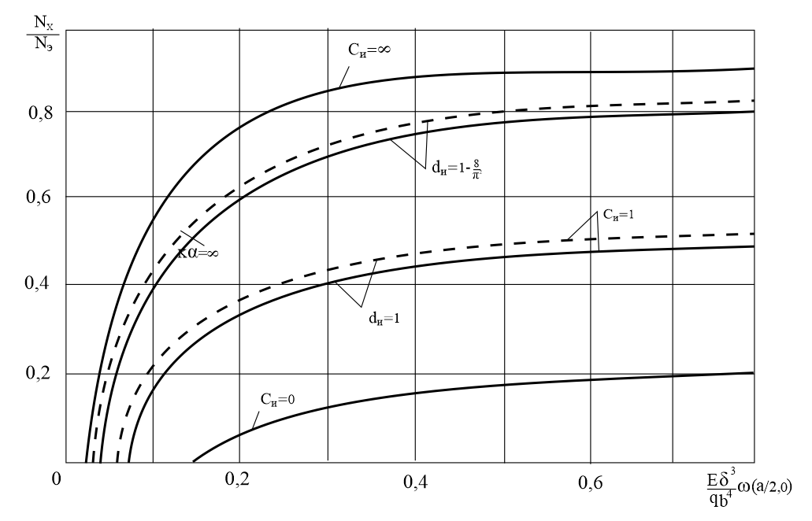
FIGURE 6. The graph of the deflection at the center of the plate as a function of the magnitude $N_{x}$

REFERENCES
- E. A. Beylin, N. M. Melikulov, On the stability of rectangular plates reinforced with thin-walled rods. – In: Structural Mechanics and Design of Structures: Scientific and Technical Journal. Moscow: Publishing House of Construction Literature, No. 5, pp. 38-42, (1980).
- F. Bleykh, Stability of Metal Structures. (Moscow: Fizmatgiz, 1959).
- B. M. Brody, Stability of Plates in Elements of Steel Structures. (Moscow: Mashstroyizdat, 1949).
- A. S. Volmir, Stability of Elastic Systems. (Moscow: Fizmatlit, 1967).
- N. M. Melikulov, Study of the Stability and Rigidity of Plates Reinforced with Thin-Walled Rods under Various Loading Conditions. – In: Structural Mechanics of Structures. Interuniversity Thematic Collection of Proceedings, Leningrad: LISI, pp. 76-85, (1980).
- S. P. Timoshenko, Stability of Elastic Systems. (Moscow: Gostekhizdat, 1955).
- F. V. Volkovich, Complex Bending of a Plate Fixed on Long Edges and Compressed or Tensioned Along Short Edges. – In: Proceedings of VNIITOOS, Vol. II, Issue 4, Leningrad: Chief Editorial Board of Shipbuilding Literature, (1938).
- H. Muszkowska, Rectangular Plates with Two Opposite Free Edges and the Remaining Edges Elastically Fixed. Scientific Papers of the Institute of Civil Engineering, Wrocław University of Technology, No. 11, (1973).
- R. H. Ferachian, Biaxial Compression of Long Rectangular Plates Elastically Restrained Along the Long Edges and Simply Supported Along the Short Edges. Proceedings of the Institution of Engineers, Part 2, Montreal, (1975).
- N. Razzakov, Sh. Yaxshiboyev, N. Razzakov, Sh. Buribaev, Modeling the operational state of suspended roofs with large spans and unique load-bearing elements E3S Web of Conferences 2024 Second International Conference on Sustainable Technologies in Civil and Environmental Engineering (ICSTCE 2024) https://www.e3s-conferences.org/ .
- Sh. R. Yaxshiboyev, Nonstationary transverse vibrations of a three-layer viscoelastic plate. ASEAN Journal on Science & Technology for Development Vol 39, No 4, 54-62, (2022). DOI 10.5281/zenodo.6457545
- N. Melikulov, Stability of Elongated Plates Reinforced Along the Contour with Thin-Walled Rods. International Journal of Advanced Research in Science, Engineering and Technology, Vol. 8, Issue 12, (2021).
- N. Melikulov, N. U. Shodmonkulova, Free Vibrations of a Plate Stretched Along the Reinforced Sides. International Journal of Innovative Analyses and Emerging Technology, Volume 1, Issue 5, (2021).
- N. Melikulov, U. Khushvaktov, Stability of Long Plates with Non-Symmetric Reinforcement of the Edges with Thin-Walled Rods. Middle European Scientific Bulletin, Volume 19, (2021).
- Z. Khudoyberdiyev, Sh. Khudoyberdiyeva, Sh.R. Yaxshiboyev, A. Begjanov, “Numerical Analysis of Transverse Forced Vibration of a Beam” International Conference “Advanced Mechanics: Structure, Materials, Tribology” AIP Conf. Proc. 3177, 050010-1–050010-6; https://doi.org/10.1063/5.0294897.
- M. M. Mirsaidov, O. M. Dusmatov, and M. U. Khodjabekov, “The Problem of Mathematical Modeling of a Vibration-Protected Rod Under Kinematic Excitations” in Proceedings of VII International Scientific Conference Integration, Partnership and Innovation in Construction Science and Education, November 11-14, (2020), Tashkent, https://doi.org/10.1088/1757-899X/1030/1/012069.
- M. M. Mirsaidov, O. M. Dusmatov, and M. U. Khodjabekov, Mode Shapes of Transverse Vibrations of a Rod Protected from Vibrations in Kinematic Excitations, Lecture Notes in Civil Engineering, 170, 217–227 (2022). doi.org/10.1007/978-3-030-79983-0_20.
- N. Melikulov, Sh.R. Yaxshiboyev, N.U. Shodmonqulova, “Stability of long plates hinged at two parallel edges and elasticy supported at the other two edges” International Conference “Advanced Mechanics: Structure, Materials, Tribology” AIP Conf. Proc. 3177, 050002-1–050002-7; https://doi.org/10.1063/5.0295294.
- K. Ismayilov, Critical Strains and Critical Stresses in the Steel Rod Beyond the Elastic Limit. European Science Review, Number 5-6, (2018).
- K. Ismayilov, K. Karimova, The Impact of Automobile Tires on the Environment from the Period of Raw Materials to the Disposal of Them. Retrieval Volume 8, Issue 3, (2019). Number: C4473098319/19©BEIESP, DOI: 10.35940/ijrte.C4473.098319.
- Kh. Khudoynazarov and Sh. R. Yaxshiboyev, The Mathematical Model of Transverse Vibrations of the Three-Layer Plate. IOP Conf. Ser.: Earth Environ. Sci. 614, 012062 (2020). DOI: 10.1088/1755-1315/614/1/012062.

