Experimental Analysis of the Bending of a Beam Laying on an Elastic Base
Dilshod Kholikov^{1,4,a)}, Kamola Khaydarova^{1,b)}, Khudaynazar Akhatov^{2,c)},
Ilhom Turayev ^{3,d)}Abror Egamkulov^{1,e)}

¹ Samarkand State University, 140104, University blv. 15, Samarkand сity, Uzbekistan.
²Urgut branch Samarkand State University, Uzbekistan.
^{3.} Samarkand State University of Architecture and Construction
⁴ Samarkand campus of Zarmed University

^{a)} dilshodxoliqov2586@mail.ru
^{b)} Corresponding author: xaydarovakamolaxakimovna@gmail.com
^{c)} khudoynazar92@gmail.com,
^{d)} turayev2020@gmail.com
^{e)} abroregamqulov298@gmail.com
Abstract. The article is devoted to the experimental determination and analysis of the deflection of a beam lying on an elastic foundation under the influence of a static force. In the experiment, a steel beam was installed in a free position on the foundation and subjected to a uniformly distributed static force. The settlement values ​​were determined theoretically based on the Winkler, Pasternak, Vlasov and elastic-plastic medium models (Coulomb-Mohr) and compared with the experimental results. The obtained results showed that the interaction between the beam and the elastic foundation is quite complex and that theoretical models need to be adapted to practical conditions. This study is of practical importance in assessing the stability of foundation structures and soil structures.
Keywords: grunt, beam, bed stiffness coefficient, Winkler model, Pasternak model, Vlasov models.

INTRODUCTION
Beams on elastic foundations are very common in engineering. Such structures include: building foundations, railway superstructures (rails and sleepers), and ship hulls. Several basic mathematical models are used to perform calculations that take into account the interaction of buildings with the foundation, each of which has its own advantages and disadvantages. The choice of a specific modeling method is a complex multifactorial task. The purpose of this article is to summarize the most common soil models for practical calculations and to clarify those using experimental results.
As we know, in practice, most construction projects use strip foundations as the foundation of buildings. When strip foundations are used for buildings, the force increases, that is, the force exerted on the foundation from the beginning to the end of construction (the ground part of the building, 1st, 2nd, 3rd floors, etc., in sequence). The main goal of the experiment is to study the interaction between the foundation and the soil, and the mutual influence of the foundation and the soil on each other in real conditions. For this purpose, a specially designed flatbed tray was developed in the laboratory. In it, a strip-shaped steel strip (foundation or beam) was placed on the soil embedded in the tray, adapted to apply force to it and measure its deflection. The main goal of the experiment was to determine the bending moment and shear forces generated in the beam because of the bending of the metal beam under the influence of concentrated forces and spreading forces. Before conducting the experiment, we determine the bending moment of a metal beam experimentally and analytically. To do this, we apply a force concentrated at the center of the beam, which is mounted on two supports, and measure the maximum deflection produced in it. We will gradually record the deflection of the beam in relation to the applied force. A graph of the relationship between the deflection of the beam and the applied force is drawn. The deflection of the beam should not be allowed to pass into the plastic zone. For the experiment, we will consider beams of different lengths and thicknesses.

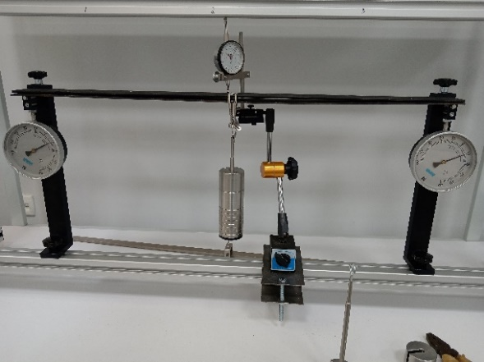
FIGURE 1. Experimental determination of the hardness of a metal beam

FORMULATION OF THE PROBLEM
The stiffness of a metal beam is determined by the following formula.
$EJ=\frac{Ebh^{3}}{12}$ (1)
Based on formula (1), we can calculate the deflection of the beam with the experimentally obtained values (Table 1). Here, EJ is the stiffness of the beam, P is the external load.
TABLE 1. Experimentally obtained values
The height of the beam (1 m)
Load [N] | tilt (m) | stiffness E [N/m2]
3.33 | 0.00062 | 135.6*10^9
22.95 | 0.00404 | 144.7*10^9
42.57 | 0.00654 | 165.87*10^9
62.195 | 0.00934 | 169.69*10^9
81.815 | 0.01228 | 169.77*10^9
101.43 | 0.0151 | 171.17*10^9
 |  | E_{ort}=159.48*10^9

In the experiment performed based on the figure shown (Figure 2), assuming gravel with a fraction of 10 mm as the soil, the geometric dimensions of the metal strip as the beam are l=1000 mm, width b=50 mm, and thickness h=5 mm. The soil layer height H=1300 mm.
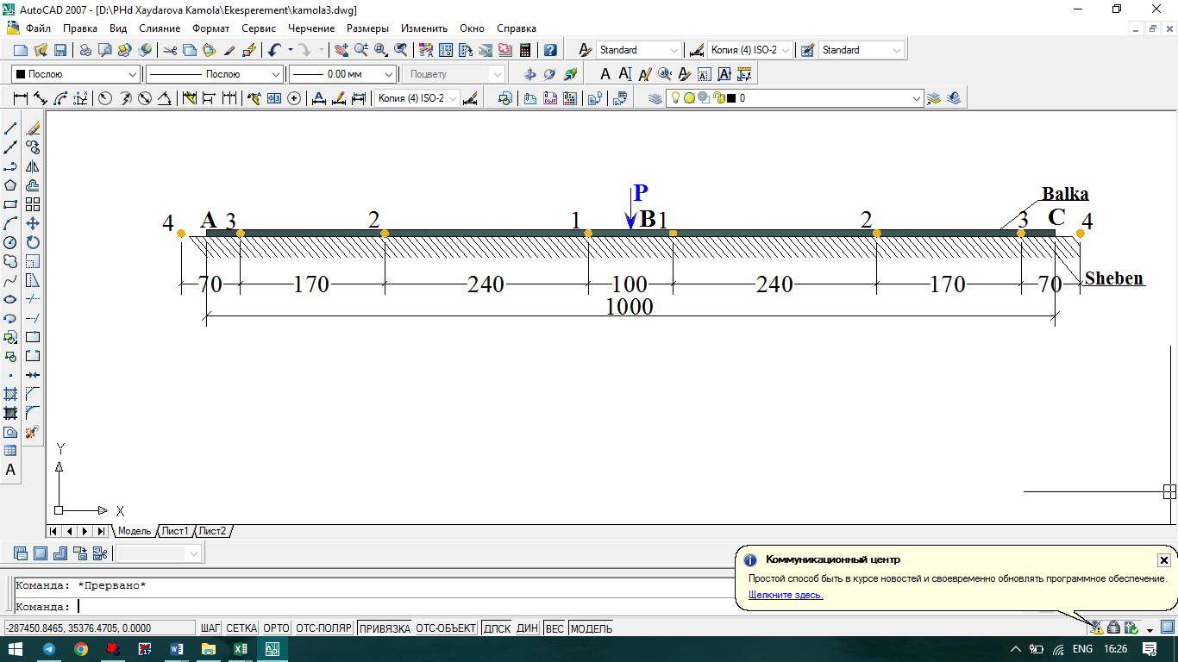
FIGURE2. Metal hammer with a base of soil

FIGURE3. Flexion of the beam

According to the results, the deflection of the beam increased steadily with increasing load. It is evident that at the initial load values (3.33–22.95 N), the deflection of the beam increases sharply, which indicates the stage of compaction of the upper layers of the soil. At subsequent loads (42.57–101.43 N), the deflection slows down relatively, which indicates the compaction of the soil layer. The average modulus of elasticity is Eₒrt = 159.48×10⁹ N/m², which indicates a high degree of elasticity of the metal beams.
Also, based on the experimental results, it was found that the deformation of the beam is directly proportional to the load. The natural compressibility of the soil determines the rate of settlement of the beam. The experimental results show that at loads in the range of 600–700 N, the deformation resistance of the soil increases and the deflection of the beam stabilizes. This allows us to determine the limit of soil behavior.

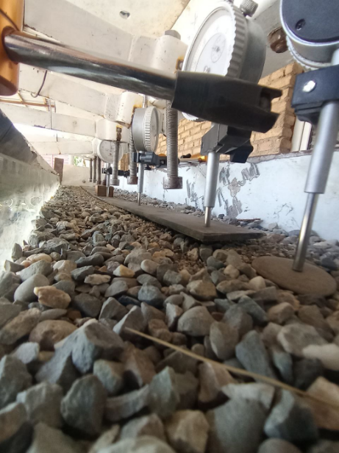 | 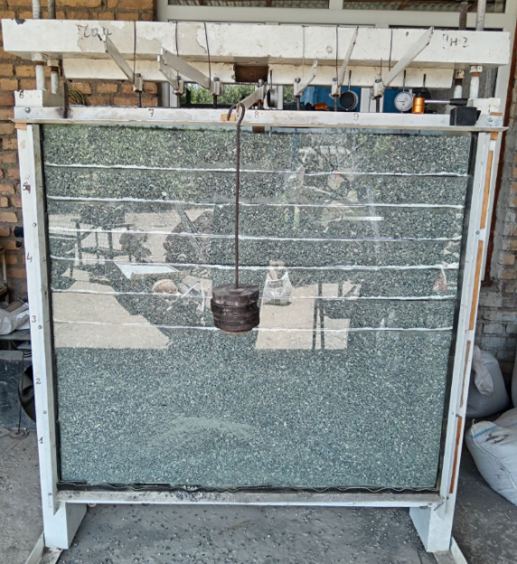
FIGURE4. Static analysis sheets for a 1-meter-long beam with a base of sheben soil

CONCLUSION
Based on the experimental and computational results, the following conclusions were drawn:
1. The deflection of metal beams located on the Sheben soil increases linearly with increasing load, which reflects the degree of soil compaction.
2. At high load values, the deformation slows down, indicating that the soil layer has reached a stable state.
3. The average modulus of elasticity Eₒrt = 159.48×10⁹ N/m², which confirms the high degree of elasticity of metal beams.
4. The results obtained are of practical importance in determining the performance of foundation structures and soil foundations. The results can be used as a key indicator in further analysis and modeling work.

References
- К. Джонсон, Механика контактного взаимодействия. М., Мир 189. 510 с.
- Л. А. Галин, О гипотезе Циммермана _Винклера для балок. Прикладная математика и механика. Т.7. вып.4. (1943).
- Б. Н. Жемочкин, А. П. Синицын, Практические методы расчета фундаментов балок и плит на упругом основании (без гипотез Винклера). Стройиздат, М., (1947).
- Г. И. Глушков, Расчет сооружений заглубленных в грунт. М.Стройиздат. (1977). 295.с.
- Т. Р. Б. Рашидов, С. В. Кузнецов, Б. М. Мардонов, И. Мирзаев, Прикладные задачи сейсомдинамики сооружений.Ташкент. (2019). 268 с.
- В. З. Власов, Н. Н. Леонтьев, Балки, плиты и оболочки на упругом основании.М. Изд. Физмат.лит. (1960). 490 с.
- Б. М. Будак, А. А. Самарский, А. Н. Тихонов, Сборник задач по математической физике. М.Физмат. лит (1956). 682 с.
- D. Kholiqov, J. Abdurazzoqov, R. Usmonov, K. Xaydarova, Free torsional vibration of an elastic thin-walled cylindrical shell with variable cross sectio, AIP 2024/11/27 060029-1. https://doi.org/10.1063/5.0241748
- B. Mardonov, K. X. Xaydarova, D. M. Ismatova, Горизонтально- вращательные колебания сооружений с фундаментом, взаимодействующим с основанием по билинейному закону при сейсмических воздействиях, Problems of architecture and construction 2 (3), 824-827
- X.K. Xakimovna, I.D. Maxmudovna, Prospects for the application of brick walls in modern housing construction under construction in Uzbekistan. Indonesian journal of law and economics review 19 (1), 10.21070/ijler. v19i1
- K. Xaydarova, Bir qatlamli elastik asosda joylashgan to‘sinning seysmik kuchlar ta’siridagi tebranishining V.Z. Vlasov usuli asosida analitik tadqiqi, Yashil iqtisodiyot va taraqqiyot, № 5-son, 148-152 b. (2025).
- B. Mardonov, K. Xaydarova, I. Turayev, E. Yadigarov, Dynamics of a rigid beam on an elastic single-layer foundation with mechanical characteristics varying with depth, Innovative: International Multi-disciplinary Journal ofApplied Technology (ISSN 2995-486X) V. 4 (2025).
- D. Kholikov, Z. Shukurov, E. Ismoilov, K. Xaydarova, Experimental determination of the intensified deformed state of elastic thin-walled shell, AIP Conf. Proc. 3177, 050020 (2025)
https://doi.org/10.1063/5.029593

