Researchers Develop Novel Self-Discharging Solar Collectors Using Confuser-Diffuser Technology
Zafar Fayziev^{1, a)}, Shohida Yuzbayeva^{2, b)} and Sherzod Yakhshiboyev^{3, c)}

^{1, 2 ,3)} Samarkand state architecture-construction university, 70 Lolazor street, Samarkand, Uzbekistan

^{a)} Corresponding author: fayziev.zafar@samdaqu.edu.uz
^{b)} yuzbayeva.shohida@samdaqu.edu.uz
^{c)} yaxshiboyev.shaerzod@samdaqu.edu.uz
Abstract. The climate of Uzbekistan is characterized by cold winters with negative temperatures of atmospheric air and hot summer periods of the year, when the air temperature reaches more than 40-45 º C. Therefore, when designing water solar installations for hot water supply and heating of buildings in the climatic conditions of the republic, it is necessary to ensure reliable protection of the Solar Collector from freezing of water in it in winter and from its boiling in summer. The phase transition of water in winter from a liquid to a solid state (ice) or in summer when water boils into a gaseous state (water vapor) is accompanied by a significant increase in its volume, which leads to mechanical damage to the heat exchange channels of the Solar Collector, as well as the distribution network of solar circuit pipelines. The Self-draining heliosystems currently used in practice are constantly being improved. Their energy efficiency and reliability are increased due to the improvement of the hydraulic configuration. For example, self-regulating hydrodynamic processes and self-regulating devices (SU) based on them can be used for this purpose [3], which are active elements in hydraulic pipelines. There are various hydraulic configurations of Self-draining systems [5], but only two of them will be considered within the framework of this dissertation from the point of view of improving the configuration of the thermal-hydraulic scheme of a self-draining solar plant with an active element in the form of a confuser-diffuser transition.
Keywords: Self-draining, solar collectors, active element, hydraulics, confuser-diffuser.

INTRODUCTION
Experience shows that the operation of standard drainback-type Self-draining heliosystems with two series-connected pumps [1] has energy costs for coolant circulation that are three or more times higher than the energy costs of an installation with one circulation pump running on antifreeze. If a circulation pump running on antifreeze has a power of only 85 W, then the total power of two series-connected pumps of the same size in a drainback-type Self-draining heliosystem is 260 W or more.
In order to eliminate these shortcomings of the known hydraulic configurations of the Self-draining heliosystem, self-draining solar circuits were developed under the supervision of prof. Yu.K.Rashidov based on the use of an active element in the form of a narrowing device – a Venturi pipe [3].

RESULT AND METHODS
Energy efficiency of Self-draining systems with Active Element in the form of a confuser-diffuser transition and with a thermo-hydraulic distributor it is possible to estimate the energy consumption of the circulation pump in comparison with a conventional SDG pump, in which the circulation of the coolant occurs with a flow break [3]
$Δ{\overline{E}}_{CD}=\frac{E_{о}-E_{CD}}{E_{о}}=1-{\frac{GΔp_{pump}^{CD}n}{ρη_{pump}}}/{\frac{GΔp_{pump}^{о}n}{ρη_{pump}}}=1-\frac{Δp_{pump}^{CD}}{Δp_{pump}^{о}}$ (1)
where $E_{о},E_{kd}-$the energy costs for driving the circulation pump in a conventional Self-draining systems and in a Self-draining systems with a confuser-diffuser type Active Element and with a thermo-hydraulic distributor , W⋅h/year; $Δp_{pump}^{о}, Δp_{pump}^{CD}-$pressure differences created by a pump in a conventional Self-draining systems and in a solar circuit with a confuser-diffuser type Active Element, Pa; n is the number of hours the pumps operate per year; $η_{pump}$is the efficiency of the pumping unit.
To establish the relationship between the pressure differences created by the pump and other parameters of the Self-draining systems, we will compile the D. Bernoulli equation for sections II and 2 (Fig.-1), written taking into account the operation of the circulation pump included in it $ΔР_{pump}$and the action of natural circulation. $ΔР_{nat}$
$Р_{a}+ρgh_{1}+α_{1}\frac{ρW_{1}^{2}}{2}+ΔР_{pump}+ΔР_{nat}=Р_{a}+ρgh_{2}+α_{2}\frac{ρW_{2}^{2}}{2}+ρg{Δh}_{w}$. (2)
From this equality we find the formula for calculating the required pressure drop developed by the pump $ΔР_{pump}$in a self-draining solar circuit
$ΔР_{pump}=ρgH+\frac{ρ}{2}\left(α_{2}W_{2}^{2}-α_{1}W_{1}^{2}\right)+ρg{Δh}_{w}-ΔР_{nat}$, (3)
Here $H=h_{2}-h_{1}$,$ΔР_{nat}= Δρgh_{3},$
$h_{3}-$vertical distance between the heating center (CH - the middle of the Solar Collector) and the cooling center (CO - the middle of the thermo-hydraulic distributor ).
Expressing in equation (3) the pressure losses due to friction and local resistance in the solar circuit $ρg{Δh}_{w}$through its resistance characteristic $S_{g}$
$ρg{Δh}_{w}=S_{г}G^{2}$ (4)
where
$S_{g}=S_{s}+S_{CD}=A_{c}\left(\frac{λ}{D}l+\sum{ζ_{s}}\right)$+ $A_{CD}ζ_{CD}=A_{s}ζ_{pr}+A_{CD}ζ_{CD};$ (5)
$A_{s}=\frac{16}{2ρπ^{2}D^{4}}$(2.6) $A_{CD}=\frac{16}{2ρπ^{2}d^{4}}$, (6)
and also using the relations: Δ
$G={ρF_{2}W}_{2}$(2.8) $W_{1}=\frac{F_{2}}{F_{1}}W_{2}$ (7)
we get the following equation
${ΔР}_{pump}=ρgH-\left(\frac{α_{1}}{F_{1}^{2}}-\frac{α_{2}}{F_{2}^{2}}\right)\frac{G^{2}}{2ρ}+{S_{g}G}^{2}-Δρgh_{3}.$ (8)

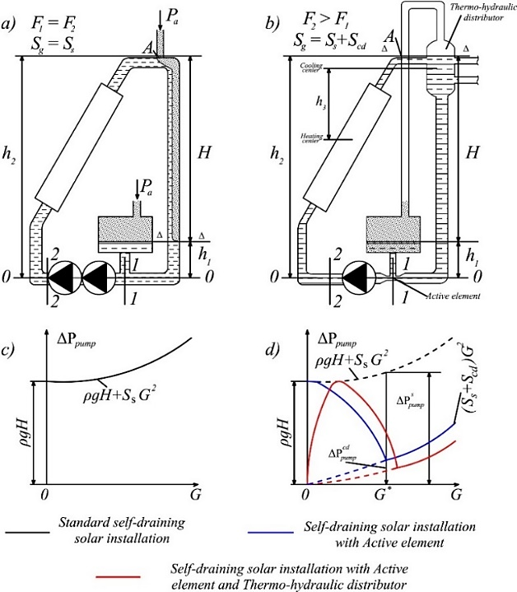
FIGURE 1. Calculation scheme and characteristics of the Self-draining heliosystem network: a, b – conventional; c, d – with Active Element of the confuser-diffuser type and with a thermo-hydraulic distributor
For a normal Self-draining systems without a restriction device $F_{1}=F_{2}$, $S_{g}=S_{s}$and $Δρ=0,$therefore equation (9) takes the form
${ΔР}_{pump}^{о}=ρgH+{S_{s}G}^{2}.$ 9)
The characteristics of the Self-draining heliosystems network are shown in Figure 1, c. Note that due to the flow break at the upper point A, located behind the solar collector, the pump ensures circulation in the solar circuit, raising the coolant to a height of H.
For a Self-draining systems in which the drainage tank is connected to a narrow section of the Active Element in the form of a confuser-diffuser transition, and after the SC there is a thermohydraulic distributor , equation (8) takes the form
${ΔР}_{pump}^{о}=\left\{\begin{aligned}ρgH-\left(\frac{α_{1}}{F_{1}^{2}}-\frac{α_{2}}{F_{2}^{2}}\right)\frac{G^{2}}{2ρ}+{{(S}_{s}+S_{CD})G}^{2}-Δρgh_{3 } G≤G^{*} \\ {(S}_{s}+S_{CD})G^{2} G≥G^{*}\end{aligned}\right.$ (10)
The characteristics of the solar circuit network with an Active Element, which is a converging-diffuser transition, are shown in Figure 1, g. At the initial stage, when the coolant flow through the Active Element (converging-diffuser transition) G is less than the calculated value G*, i.e. at G < G*, the coolant circulation by the pump in the solar circuit occurs with a break in the stream at point A (see Fig. 1, a). However, unlike a conventional Self-draining systems, due to the increase in the dynamic pressure in the Active Element throat, the filling level of the return pipeline Δ−Δ continuously increases with increasing flow. In this case, the gain in hydrostatic pressure exceeds the increase in hydraulic losses caused by the inclusion of a narrowing device in the circuit, which leads to a decrease in the characteristic curve.
When the coolant flow rate through the Active Element, which is a confuser-diffuser transition, reaches the calculated value G=G*, at which the ratio of diameters D/d of the wide and narrow sections of the Active Element is established, the solar circuit is completely closed. In this case, a further increase in flow rate does not lead to an increase in hydrostatic pressure. From this moment on, the characteristic curve begins to rise, since hydraulic losses in the circuit increase proportionally to the flow rate.
The calculated ratio of the diameters of the Active Element, presented in the form of a confuser-diffuser transition, in its wide and narrow sections is established in order to minimize the loss of hydrostatic pressure in the Self-draining systems.
$ρgH-\left(\frac{α_{1}}{F_{1}^{2}}-\frac{α_{2}}{F_{2}^{2}}\right)\frac{G^{2}}{2ρ}+{S_{2}G}^{*2}-Δρgh_{3 }=0$ (11)
Substituting into equation (2.13) the value of the calculated flow rate G* from formulas (7), after simple transformations, we find
$\frac{D}{d}=\sqrt[4]{\frac{α_{2}}{α_{1}}\left(1+\frac{2g\left(H-\frac{Δρ}{ρ}h_{3}\right)}{α_{2}W_{2}^{*2}}\right)}$. (12)
The non-uniformity of the flow velocity distribution over the Active Element cross-section in the form of a confuser-diffuser transition is usually low, so we can assume that $α_{1}=α_{2}=1$, from which we finally find
$\frac{D}{d}=\sqrt[4]{1+\frac{2g\left(H-\frac{Δρ}{ρ}h_{3}\right)}{W_{2}^{*2}}}$ (13)
Figure 2. shows a graph of the dependence of the calculated degree of narrowing of the coolant flow in the Active Element in the form of a confuser-diffuser transition D/d on the total height of the Self-draining systems H, constructed using formula (13).
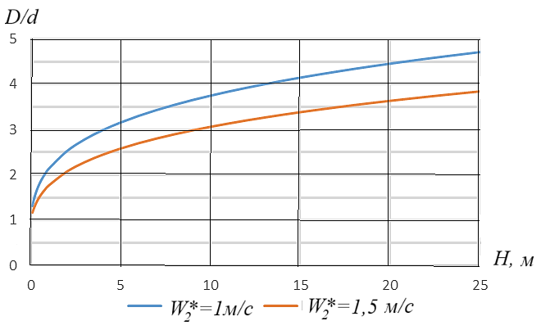
FIGURE 2. Graph of the dependence of the calculated degree of narrowing of the coolant flow in the Active Element in the form of a confuser-diffuser transition D/d from the total height of the Self-draining solar system H.
When creating a graph of the speed of movement of the coolant in a wide section of the Active Element in the form of a confuser-diffuser transition W*, it is accepted according to the permissible speeds of movement of the coolant in the pipelines of heat supply systems, i.e. equal to W* = 1; 1.5 m/s [2].
Substituting into formula (1) the values established for $Δp_{pump}^{о}, Δp_{pump}^{CD}$dependencies (10) and (11), taking into account relations (2.5) $÷$(2.9), we obtain a formula for calculating the share of relative energy savings expended by the pump in an Self-draining systems with an Active Element of the confuser-diffuser type
$Δ{\overline{E}}_{CD}=\frac{{\left(\frac{D}{d}\right)}^{4}\left(\frac{α_{1}}{α_{2}}-\frac{1}{α_{2}}{}_{кд}\right)-1}{\frac{α_{1}}{α_{2}}{\left(\frac{D}{d}\right)}^{4}+\frac{1}{α_{2}}{}_{prg}}$ (14)
further ignoring the unevenness of the flow velocity across the cross-section of the tapering element $α_{1}=α_{2}=1$and determining its resistance coefficient using an approximate relationship
${}_{CD}=\left(0,15÷0,20\right)\left[1-{\left(\frac{d}{D}\right)}^{4}\right],$ (15)
we find
${\overline{E}}_{CD}=\frac{{\left(\frac{D}{d}\right)}^{4}\left[1-a+a{\left(\frac{D}{d}\right)}^{4}\right]-1}{{\left(\frac{D}{d}\right)}^{4}+{}_{prg}}$ (16)
where a = 0.15 ÷0.20.
It should be noted that hydraulic losses in the Active Element can be further reduced by providing the smallest internal flowing surface of rotation of the converging device of the confuser-diffuser type, which will reduce the total pressure losses due to friction and vortex formation to 5-10% compared to an active element with normal geometry. Taking this circumstance into account , Figure-3 shows a graph of the dependence of the relative savings in energy resources for the circulation of the coolant in the Self-draining systems on the degree of narrowing of the flow in the confuser-diffuser transition, constructed according to formula (16) for a = 0.10.
It is evident that with an increase in the ratio D/d, the value ${\overline{E}}_{CD}$first increases sharply and the more significant, the smaller the reduced resistance coefficient of the solar circuit ζ_{prg} , and then stabilizes, asymptotically approaching the maximum value ${Δ\overline{E}}_{CD}^{max}=1-a.$
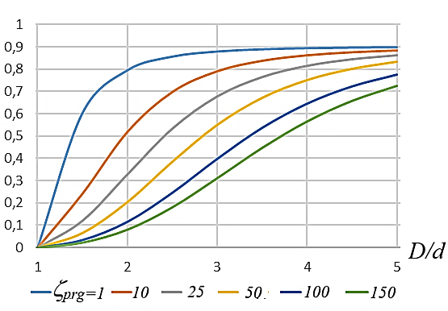
FIGURE 3. Graph of the dependence of the relative energy savings for the circulation of the coolant in the Self-draining solar system on the degree of narrowing of the flow in the Active Element in the form of a confuser-diffuser transition

In the general case described by dependence (15), the asymptote that determines the maximum share of electrical energy savings during pump operation will be equal to
${Δ\overline{E}}_{CD}^{max}=1-\frac{1}{α_{1}}{}_{CD}.$ (17)
or considering that α ₁ ≈1 we find
${Δ\overline{E}}_{CD}^{max}=1-{}_{CD}$ (18)

DISCUSSIONS
In the quest for more efficient and sustainable energy solutions, the configuration of the thermal-hydraulic circuit in self-draining solar power plants has seen significant advancements. A notable improvement involves the integration of an active element (Active Element) in the form of a confuser-diffuser transition, coupled with a thermo-hydraulic distributor. This innovative design not only optimizes the flow dynamics but also alleviates the need for the pump to generate a substantial initial hydrostatic pressure to elevate water to the upper point of the solar circuit (Solar Collector) [4]. One of the standout features of this enhanced configuration is its ability to leverage thermosiphon natural circulation. By strategically positioning the thermo-hydraulic distributor above the Solar Collector, the system can effectively utilize the natural buoyancy of heated water, promoting efficient circulation without the constant need for mechanical assistance [9]. This passive mechanism not only reduces energy consumption but also contributes to the overall reliability of the solar power plant.
The placement of the confuser-diffuser type Active Element in the pump suction zone emerges as a particularly economical choice. By optimizing this location, the system can achieve a lower hydrodynamic pressure in the transition throat, which translates to a reduced initial pressure requirement for closing the solar circuit. This configuration minimizes the energy expenditure associated with pumping, allowing for a more cost-effective operation while maintaining optimal performance [7].

CONCLUSION
In summary, the improved configuration of the thermal-hydraulic circuit in self-draining solar power plants, featuring a confuser-diffuser transition and a thermo-hydraulic distributor, represents a significant step forward in solar energy technology. By harnessing the benefits of natural circulation and optimizing pump dynamics, this innovative design not only enhances efficiency but also promotes sustainability in renewable energy systems. As we continue to refine these technologies, the potential for more effective and economically viable solar power solutions becomes increasingly attainable.

REFERENCES
- J. Daffi, U. Bekman, Fundamentals of solar thermal energy. Per. from English - Long pond: Publishing House "Intellect." (2013). 888 p.
- Z. Kh. Fayziev, Pressure losses in Venturi pipes, their rational forms and coefficients of local resistance. 2762. Scopus. (2022) https://doi.org/10.1063/5.0128505
- Y. K. Rashidov, Increase in Dependability and Efficiency of Self-Draining Water Systems of Solar Heat Supply. 2612. Scopus. (2023). https://doi.org/10.1063/5.0113036
- R. Botpaev, Y. Luovet, B. Peters, S. Furbo, K. Vajen, Drainback solar thermal systems: A review, Solar Energy, vol. 128, рр. 41-60, (2016).
- D. R. Muktasipov, E. U. Safiullina, Device for preventing the formation of liquid plugs in a gas collection system or in a non-straight gas well, Bulletin of the Tomsk Polytechnic University. Geo Assets Engineering, Vol. 335, Nr. 10, pp.. 111-119, (2024). doi: 10.18799/24131830/2024/10/4474
- J. Van 't Westende, A. Ajani, M. Kelkar, The use of surfactants for gas well deliquification: a comparison of research projects and developed models, Paper presented at the 18th International Conference on Multiphase Production Technology. – Cannes, France, pp. 161–182 (2017).
- Z. Abdulkhaev, Sh. Abdujalilova, M. Usmonov, Kh. Askarov and R. Nazirova, Determination of the useful working coefficient (UWC) of the heating system, BIO Web Conf., 84 (2024) 05040 DOI: https://doi.org/10.1051/bioconf/20248405040
- X. Shi, D. Li, A. Zhang, and J. Zhang, “Study on vibration characteristics of ship mining system under composite load,” Journal of Vibroengineering, Vol. 24, No. 7, pp. 1354–1363, (2022). https://doi.org/10.21595/jve.2022.22689
- M. Shoev, T. Safarov, S. Abdukhamidov and Z. Omonov, Numerical solution of the heat transfer equation using different schemes, E3S Web of Conf., 452 (2023) 04011
DOI: https://doi.org/10.1051/e3sconf/202345204011

