On the Forced Vibrations of a Two-particle System
Nikola Poljak^{1, a)} and Mirjana Bijelić^{1, b)}
¹Physics department, Faculty of Science University of Zagreb, Horvatovac 102a, 10 000 Zagreb, Croatia

^{a)} Corresponding author: npoljak.phy@pmf.hr
^{b)} mali.phy@pmf.hr
Abstract. We present a detailed analysis of forced vibrations in a simple mechanical system composed of two masses coupled by springs, where an external harmonic force acts only on the first mass. Such systems are common in practice — for example, in structural dynamics, molecular vibrations, coupled resonant circuits, but their complete analytical treatment is rarely presented in standard university textbooks, despite its significant practical importance (e.g., [1], [2]). The system in question lends itself to rigorous mathematical analysis. Using symmetry, we decouple the equations of motion of the masses, yielding two independent damped harmonic oscillators with distinct natural frequencies. Having obtained the modes of motion, we reproduce the overall response of each mass as a superposition of these modes, where both amplitudes and phases are functions of the external excitation frequency. The analysis reveals typical resonance phenomena, with dominant contributions from different modes near each natural frequency. However, at certain frequencies, destructive interference leads to minima in oscillation amplitudes, governed by the interaction between the modes. The phase relations exhibit nontrivial behavior, with multiple phase shifts as the driving frequency varies, reflecting complex energy exchange between the two masses. These results highlight the subtle interplay of coupling, damping, and external forcing in multi-degree-of-freedom systems. The analysis can be extended to more than two bodies, revealing similar phenomena. We believe these are essential for accurate modelling of practical devices but are often overlooked in elementary treatments. Also, we present possible means of measuring the obtained results in simple mechanical or electrical systems.

INTRODUCTION
Standard University textbooks present simple mechanical systems in which a single mass $m$ (which we will call a particle) is connected to an unmovable wall by an ideal elastic spring of elastic constant $k$ and is acted upon by a periodic external force $F_{0}cos⁡(ωt)$. It is assumed that while the particle is moving, a drag force proportional to its speed is present, which results in the well-known steady state oscillatory motion with the frequency of the external periodic force $ω$. The analytical solution describing the forced oscillation is given by
$u\left(t\right)\text{=}Acos\left(ωt\text{-}ϕ\right)$ (1)
with $A$ being the amplitude of oscillation and $ϕ$ the phase angle (lag) of the oscillator with respect to the periodic force. Both parameters are easily obtained by inserting the solution in the equation of motion, giving
$A\text{=}\frac{F_{0}}{m}\frac{1}{\sqrt{{(ω_{0}^{2}\text{-}ω^{2})}^{2}\text{+}{\left(2γω\right)}^{2}}} ,$ (2)
$tanϕ\text{=}\frac{2γω}{ω_{0}^{2}\text{-}ω^{2}} ,$ (3)
with $ω_{0}^{2}\text{=}k\text{/}m$ and $γ$ being the damping constant, defined by $2γ\text{=}b\text{/}m$, where $b$ is the constant of proportionality between the drag force and the speed of the oscillator. The dependence of the amplitude and the phase angle on the frequency of the periodic force exhibit a well-known resonance phenomenon. When the frequency of the periodic force $ω$ equals the natural frequency of the oscillator $ω_{0}$, the phase angle is equal to $π\text{/}2$ and the amplitude of the steady state solution of motion is large. Strictly speaking, the frequency at which the amplitude of motion is the largest possible is slightly smaller than $ω_{0}$ and depends on the amount of damping in the system. Here we will only analyze a weakly damped oscillator, for which $2γ≪ω_{0}$ and the amplitude becomes maximal when ${ω≈ω}_{0}$. The amplitude of motion and the phase angle are given in Fig. 1. for the case in which $2γ\text{=}\sqrt{0.05}ω_{0}$.

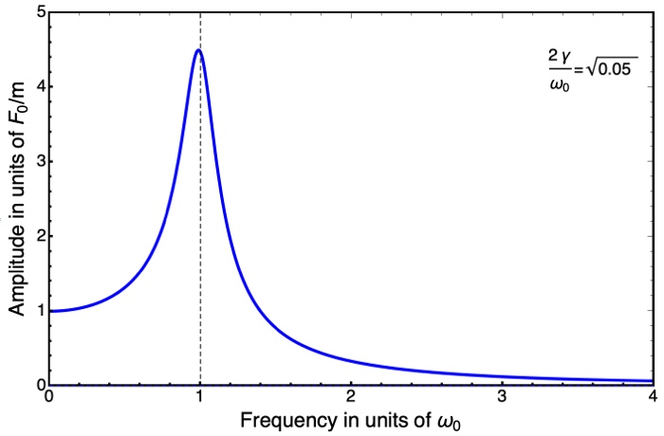 | 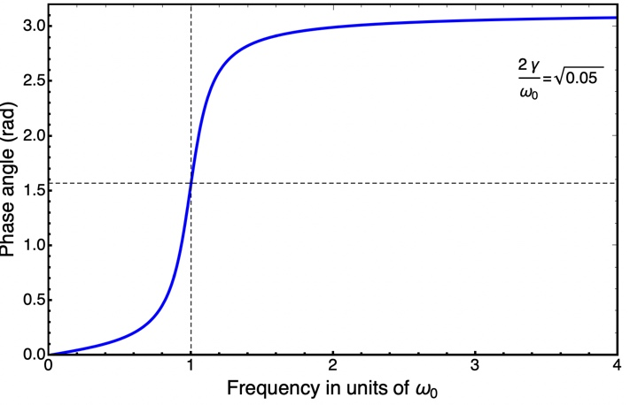
(a) | (b)
FIGURE 1. (a) The dependence of the oscillator amplitude on the frequency of the external periodic force. (b) The dependence of the oscillator phase on the frequency of the external periodic force.

This system only exhibits one resonance, as described earlier. A natural question to pose is whether this is also the case in a system with multiple bodies upon which we are free to act with external periodic forces.

Two-Mass system
A simple extension of the case we just discussed is given in Fig.2.
FIGURE 2. An external periodic force acting on one of the masses in a symmetrical two-body system.

In this system, two equal masses are connected by equal springs to immovable walls. An external periodic force of the same character as already discussed acts on one of the masses, again called a particle. The equations of motion of this system are given by
$\overset{¨}{u_{1}}\text{=-}\frac{k}{m}\left[u_{1}\text{+}\left(u_{1}\text{-}u_{2}\right)\right]\text{-}2γv_{1}\text{+}\frac{F_{0}}{m}cos⁡(ωt) ,$ (4)
$\overset{¨}{u_{2}}\text{=-}\frac{k}{m}\left[u_{2}\text{+}\left(u_{2}\text{-}u_{1}\right)\right]\text{-}2γv_{2} .$ (5)
This set of differential equations can be solved by various means. For example, one can add and subtract them and obtain two independent differential equations, each one in a single variable. After solving them, it is possible to revert to the displacements of the particles $u_{1}$ and $u_{2}$. The steady-state part of each of the displacements can be expressed as $u_{i}\text{=}A_{i}cos⁡(ωt\text{-}ϕ_{i})$, with the solutions for the amplitudes of motion satisfying
$A_{1}^{2}\text{=}{\left(\frac{F_{0}}{2m}\right)}^{2}\frac{{\left[{(ω^{\left(1\right)})}^{2}\text{+}{(ω^{\left(2\right)})}^{2}\text{-}2ω^{2}\right]}^{2}\text{+}4{(2γω)}^{2}}{\left({\left[{(ω^{\left(1\right)})}^{2}\text{-}ω^{2}\right]}^{2}\text{+}{(2γω)}^{2}\right)\left({\left[{(ω^{\left(2\right)})}^{2}\text{-}ω^{2}\right]}^{2}\text{+}{(2γω)}^{2}\right)} ,$ (6)
$A_{2}^{2}\text{=}{\left(\frac{F_{0}}{2m}\right)}^{2}\frac{{\left[{(ω^{\left(1\right)})}^{2}\text{-}{(ω^{\left(2\right)})}^{2}\right]}^{2}}{\left({\left[{(ω^{\left(1\right)})}^{2}\text{-}ω^{2}\right]}^{2}\text{+}{(2γω)}^{2}\right)\left({\left[{(ω^{\left(2\right)})}^{2}\text{-}ω^{2}\right]}^{2}\text{+}{(2γω)}^{2}\right)} .$ (7)
Here, ${(ω^{\left(1\right)})}^{2}\text{=}k\text{/}m$ and ${(ω^{\left(2\right)})}^{2}\text{=}3k\text{/}m$ correspond to the oscillations of modes of motion of the free system without damping. The behavior of the amplitudes of motion is given in Fig. 3.

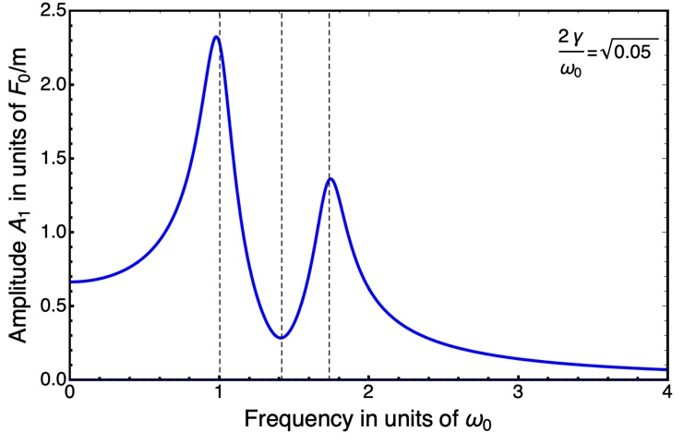 | 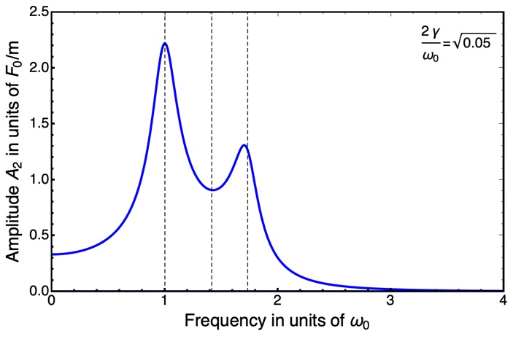
(a) | (b)
FIGURE 3. (a) The dependence of the amplitude of the particle being acted upon on the frequency of the external periodic force. (b) The dependence of the amplitude of the particle not being acted upon on the frequency of the external periodic force.

Discussion of resulting motion
We can clearly see that both the particles exhibit resonance phenomena near the frequencies of oscillations of free modes. What is interesting is that this happens for the particle upon which no external force acts. We can explain this in a relatively straightforward way: if we consider only the particle upon which the external force acts, we could expect a resonant behavior near the frequency ${(ω^{\left(1\right)})}^{2}\text{=}k\text{/}m$. If this particle achieves a steady-state motion, it will transfer energy to the second particle, since it provides an external force on it via the elastic spring. Naturally, this should disrupt the motion of the first particle, but apparently not in a drastic way. We can see that this is true by observing the amplitudes of motion of the particle being acted upon in the case when it is connected to the wall by a single spring and the case when two springs are attached to it. In the first case, the amplitude of the motion reaches approx. 4.2 (in units $F_{0}\text{/}m$), whereas in the latter case it only achieves an amplitude of approx. 2.3 (in units $F_{0}\text{/}m$). However, in this case the second particle achieves a comparable amplitude, as shown in Fig. 3(b). Notice that this has nothing to do with law of conservation of energy since dissipative forces are present in the system.
It is more difficult to explain the emergence of a second resonance in the system by a simple extension of the previously analyzed system. We must recall that a system which consists of two bodies has two natural degrees of freedom, each with its own frequency of motion, so it is natural to assume a second resonance will emerge near the frequency ${(ω^{\left(2\right)})}^{2}\text{=}3k\text{/}m$. This is indeed the case, as can be easily seen from Fig. 3. In the second normal mode of motion the particles are in anti-phase and the frequency of oscillation of motion is increased due to the additional elastic spring between the particles which is being stretched and compressed during motion. The resonance amplitudes of motion in this case are somewhat smaller, which we can attribute to the fact that the particles moving in anti-phase have, on average, larger speeds than the particles moving in phase. Thus, the average power of the damping force increases, and the resulting amplitudes of motion must decrease.
To provide more insight into the character of motion, we can also look at the phase angles of the particles with respect to the external force. These are given by
$tanϕ_{1}\text{=}\frac{\left(2γω\right)[{\left[{\left(ω^{\left(1\right)}\right)}^{2}\text{-}ω^{2}\right]}^{2}\text{+}{\left[{\left(ω^{\left(2\right)}\right)}^{2}\text{-}ω^{2}\right]}^{2}\text{+}2{\left(2γω\right)}^{2}]}{[\left({\left(ω^{\left(1\right)}\right)}^{2}\text{-}ω^{2}\right)\left({\left(ω^{\left(2\right)}\right)}^{2}\text{-}ω^{2}\right)\text{+}2γω][{\left(ω^{\left(1\right)}\right)}^{2}\text{+}{\left(ω^{\left(2\right)}\right)}^{2}\text{-}2ω^{2}]} ,$ (8)
$tanϕ_{2}\text{=}{\left(\frac{F_{0}}{2m}\right)}^{2}\frac{\left(2γω\right)[{\left[{\left(ω^{\left(2\right)}\right)}^{2}\text{-}ω^{2}\right]}^{2}\text{-}{\left[{\left(ω^{\left(1\right)}\right)}^{2}\text{-}ω^{2}\right]}^{2}]}{[\left({\left(ω^{\left(1\right)}\right)}^{2}\text{-}ω^{2}\right)\left({\left(ω^{\left(2\right)}\right)}^{2}\text{-}ω^{2}\right)\text{-}2γω][{\left(ω^{\left(2\right)}\right)}^{2}\text{-}{\left(ω^{\left(1\right)}\right)}^{2}]} .$ (9)
The dependence of these phase angles with respect to frequency of the external force is given in Fig. 4.

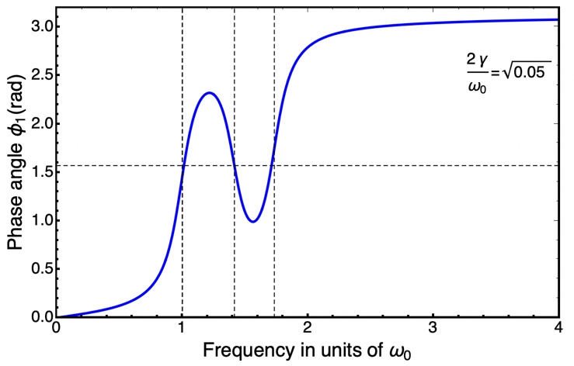 | 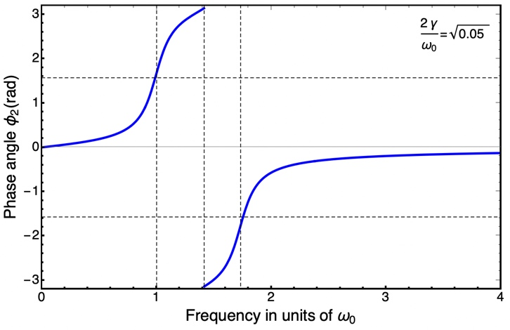
(a) | (b)
FIGURE 4. (a) The dependence of the phase angle $ϕ_{1}$on the frequency of the external periodic force. (b) The dependence of the phase angle $ϕ_{2}$on the frequency of the external periodic force.

By comparing Fig. 4(a) with Fig. 1(b) we can notice novel behavior which is related to the emergence of a second resonance. When analyzing this phase behavior, we should consider all the forces acting on the first particle. Comparing the forces to the case where only a single particle is present in the system, we can see that the total force in this case increases by $ku_{2}$, indicating that the phase delay of the first particle in relation to the external force is not as simple as in the case of an independent particle, since it depends on the displacement of the second particle. The phase angle in this case equals $π\text{/}2$ three times with increasing frequency. This might hint at the existence of three resonances, but in fact, only two resonances occur. The frequencies at which the $ϕ_{1}\text{=}π\text{/}2$ are equal to $ω^{\left(1\right)}\text{=}\sqrt{k\text{/}m}$, then an intermediate frequency $\sqrt{2k\text{/}m}$, and finally at $ω^{\left(2\right)}\text{=}\sqrt{3k\text{/}m}$.

When the frequency of the external force is much smaller than the frequency of the first free mode, the particle oscillates almost in phase with the external force, just as in the case when a force acts on a system with only one particle. Note that for small forcing frequencies the particles are approximately in phase with each other, so the behavior of the phase $ϕ_{1}$is like that of the phase of a system with only one particle. As the forcing frequency approaches the frequency of the first free mode, the phase lag increases towards $π\text{/}2$. Near the frequency of the first free mode, the displacement of the particle lags the force by $π\text{/}2$, so the velocity of the particle is in phase with the external force. As a result, the average power of the external force is maximized along with the amplitude of oscillations of the first particle. After the frequency of the external force becomes greater than $ω^{\left(1\right)}$, the behavior of the two-particle system begins to differ significantly from that of the single-particle system. The motion of the first particle can be described as the sum of the motions of the particle in two modes, both of which are acted upon by an external force, i.e. as
$u_{1}\left(t\right)\text{=}\frac{1}{2}\left[u^{\left(1\right)}\left(t\right)\text{+}u^{\left(2\right)}\left(t\right)\right].$ (10)
When the frequency of the external force is close to the frequency $ω^{\left(1\right)}$, the contribution $u^{\left(1\right)}$is maximized, while the contribution $u^{\left(2\right)}$is small. By increasing the frequency, the relative value of the contributions $u^{\left(2\right)}$and $u^{\left(1\right)}$increases. At a certain frequency between $ω^{\left(1\right)}$ and $ω^{\left(2\right)},$the relative ratio of the amplitudes of these contributions becomes equal to one. This frequency can be easily determined and is equal to $\sqrt{2k\text{/}m}.$ At this frequency, the phase angle of one particle's delay relative to the other particle (not to the external force) is equal to $π\text{/}2$, as we will see shortly. The spring that connects the first and second particle exerts a force that starts to reduce the phase delay of the first particle in relation to the external force, until it becomes $π\text{/}2$ again. We see that the fact that the amplitude of the particle at that frequency is not maximal, but locally minimal, is a complex consequence of the action of the external force and reaction force of the second particle on the first particle.
By further increasing the frequency of external force, the relative value of the contributions $u^{\left(2\right)}$and $u^{\left(1\right)}$ is additionally increased. The phase lag of the first particle at first decreases, and then increases again towards $π\text{/}2$ as now the contribution $u^{\left(2\right)}$ is maximized and the contribution $u^{\left(1\right)}$decreases. As a result, the amplitude of the oscillation of the first particle increases until the power of the external force on the first particle again becomes maximal. Finally, for frequencies much larger than $ω^{\left(2\right)}$ the system behaves similarly to a system with only one particle, and the response of the particle lags by $π$ with respect to the external force.
The second particle is not directly acted upon by the external force, but only by the spring connecting the first and second particle. Just as for the first particle, when the frequency of the external force is much lower than the frequency of the first normal mode, it vibrates almost in phase with the external force. When the frequency approaches the frequency of the first normal mode, the phase lag increases to $π\text{/}2$ and the amplitude of the oscillations of the second particle is maximized. As the frequency increases further, the phase lag continues to increase. When the contributions of both normal modes are equal, the second particle vibrates with a minimum amplitude. At first glance, it might seem that its oscillation amplitude is then zero, because we can write
$u_{1}\left(t\right)\text{=}\frac{1}{2}\left[u^{\left(1\right)}\left(t\right)\text{-}u^{\left(2\right)}\left(t\right)\right],$ (11)
but we should keep in mind that only the amplitudes of the modes are equal, while their phases are different. Therefore, the second particle vibrates with a minimum amplitude, and its phase delay is such that it also minimizes the oscillation amplitude of the first particle. Since the first particle lags behind the external force by $π\text{/}2$, the second particle lags behind the force by a phase of $π$ (which is equivalent to the value $\text{-}π$). As the frequency increases further, the phase lag increases further, so that near the frequency of the second free mode its module again becomes $π\text{/}2$ and the oscillation amplitude of the second particle is again maximized. Finally, when the force frequency is large, the first and second particles oscillate in a zig-zag configuration. Since the delay of the first particle in relation to the external force is equal to $π$, we conclude that the delay of the second particle is equal to $2π$, which is mathematically equivalent to the phase value of zero, so we can say that in that case the second particle oscillates in phase with external force.

CONCLUSION
We can conclude that the occurrence of resonances in a two-particle system is not a simple extension of resonances in simpler systems. The phase of the particle acted upon by an external force passes through $π\text{/}2$ three times, giving two amplitude maxima and one minimum. This is caused by an additional force provided by the spring connecting the particles. The spring effectively acts as a damper, despite not being of frictional nature. The particle that the external force is not acting on directly acts as an energy dissipator. These facts can be used in real systems to provide damping to specific parts of a vibrating system without the need to introduce new damping forces. Even though the phases described in the text are difficult to measure in mechanical systems, we can use simple designs of electrical systems which provide novel signal filtering methods by fine-tuning the parameters of the system.

References

- L. Meirovitch, Elements of Vibration Analysis, McGraw-Hill (1986).
- W. T. Thomson, M. D. Dahleh, Theory of Vibration with Applications, 5th ed., Prentice Hall (1997).

