Stress-Strain State of a Pipeline under Operational and Seismic Loads
Ekaterina An^{1, a)}, Ibrakhim Mirzaev^{1, 2, b)} and Elbek Kosimov^{1, c)}
¹Institute of Mechanics and Seismic Stability of Structures named after M.T. Urazbaev, Uzbekistan Academy of Sciences, Durmon yuli street 40, Tashkent, 100125, Uzbekistan
²Tashkent State Transport University, Temiryolchilar street, Tashkent, 100167, Uzbekistan
^{a)} Corresponding author: ekaterinaan1986@gmail.com
^{b)} ibrakhim.mir@mail.ru
^{c)} elbekqosimov1985@gmail.com
Abstract. The effect of seismic loads of varying intensity on the stress-strain state of a finite-length pipeline supported on two supports in a ravine zone is studied under gravitational and operational loads. The seismic load is specified as three-component seismograms of real earthquakes differing in frequency spectrum, amplitude, and duration. The problem is solved using finite element method, finite difference method and successive approximation method. The results are presented as graphs of displacements (axial, transverse and vertical) and maximum stresses of the pipeline allowing an analysis of the effect of earthquakes of varying intensity on the stress-strain state of the pipeline laid in the ravine zone. It was found that earthquakes with an intensity of 6 on the MSK-64 seismic scale are not dangerous for pipelines resting on supports in the ravine zone. However, earthquakes with an intensity of 9* on the MSK-64 seismic scale are extremely dangerous for the pipelines in question.

Introduction
Pipeline systems are characterized by significant lengths crossing a variety of geologically unstable areas such as ravines mountainous areas and landslides. Main gas pipelines are subject to significant operational loads, which cause significant mechanical changes in the pipeline structure, manifested in axial tension/compression and profile curvature. Therefore, studying the dynamics of pipelines located in geologically unstable areas taking into account various natural factors (e.g., earthquakes) and operational loads is relevant.
Seismic waves are complex: they are non-stationary and characterized by a various frequency spectrum, reaching different maximum amplitudes, and varying durations of action (from a few seconds to several minutes). The composition of seismograms in terms of frequency and amplitude varies significantly depending on a many factors, including the depth of the hypocenter, the amount of energy released, the geological structure between the source and the Earth's surface, and other aspects.
In [1], various types of pipeline damage and failure were analyzed using data from past earthquakes demonstrating the seismic response of pipelines in India. A detailed illustration was created to assess the vulnerability of existing and planned pipelines in India to future seismic impacts.
In [2], the main characteristics of the soil-pipeline system were assessed, including the length of the seismic soil displacement zone, the magnitude of this displacement, the shear stress at the soil-pipeline interface, the yield strength of the pipe steel and Young's modulus. New fragility functions were developed for analyzing the behavior of the pipeline under longitudinal tensile or compressive strain.
In [3], the influence of slenderness factors and pipe wall thickness on the behavior of long underground pipelines was considered in a seismic analysis. Seismic action was modeled as a random process. The results showed that the seismic response of pipelines with fixed and free ends demonstrates good agreement with a sufficiently high slenderness factor. For short pipes or pipes with a large outside diameter, boundary conditions must be taken into account. Axial stresses in the middle of the pipes decrease with increasing its wall thickness.
The reference [4] was devoted to the design of above-ground pipeline support structures—racks, channels and suspension elements. A methodology for assessing both vertical and horizontal loads acting on supporting structure elements was developed, and practical advice was provided on installing supports along pipeline routes and calculating loads on movable and fixed supports.
In [5], the dynamic response of a pipeline system under seismic loads was studied. It was found that the addition of support structures significantly increases the seismic resistance of the system. Seismic loads in regions with high seismic activity significantly affect the structural integrity of pipelines.
This work is devoted to the study of the stress-strain state of linear pipelines passing through a ravine zone and experiencing the impact of real earthquakes of varying intensity specified in the form of three-component seismograms.

Materials and methods
A finite-length pipeline is considered, the middle section of which is supported by two supports in a ravine zone, while the two end parts are buried in the soil. The pipeline is subject to gravitational, operational and seismic forces. The pipeline is considered as a rod with its ends fixed in the soil which subject to tension or compression, torsion, and bending.
Seismic forces propagating in the soil environment are transmitted to the straight pipeline using three-component seismograms of real earthquakes. A linear model is used to simulate the interaction of the pipeline with the surrounding soil [6, 7]. The unit weight of the pipeline and the weight of the gas are represented as a distributed external load [8, 9], the gas pressure and temperature difference are represented as a distributed longitudinal axial force [8].
To study the stress-strain state of a gas pipeline, FEM and implicit finite difference method [10–13] were used, and the method of successive approximations [14] was used to refine the longitudinal axial force in each pipeline element. The pipeline is divided into finite elements, for each element matrices of mass, stiffness and interaction are formed [15]. After this, the matrices of all elements are summed to obtain a general pipeline model [11]. Figure 1 shows the calculation model.
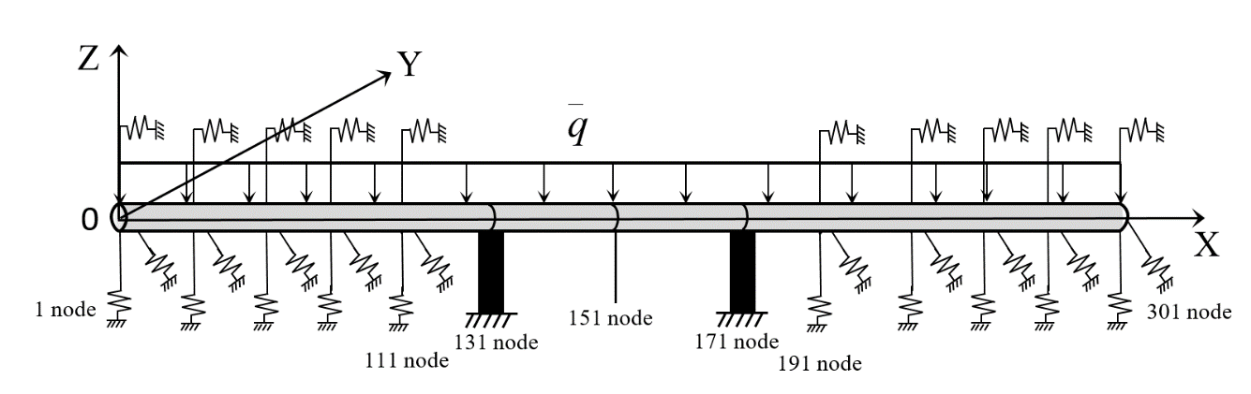
FIGURE 1. Calculation model

The boundary conditions: the pipeline ends rigidly connected to the soil and moves synchronously with the soil's movement. In the areas where the supports contact the pipeline, the horizontal and vertical displacements of these nodes are determined by the soil movements.
The initial conditions are the results of a static problem when only gravity and the operating load acted on the pipeline.
The maximum normal stress of the pipeline cross-section is reached at the pipeline's outer diameter at different points along its cross-section at different times.

Results and discussion
The following geometric and physical-mechanical parameters are used in the calculations: L=300 m; D_{Н}=1.42 m; E=2·10⁵ МPа; μ=0.3; ρ=7.8·10³ kg/m³; р=7.5 МPа; ΔТ=30°С; K_{ξ}=1.67·10⁷ N/m; K_{η}=K_{ζ}=4.33·10⁷ N/m; the distance between the supports is 40 m, the width of the ravine is 80 m.
The results are presented in Figs. 2-3 for the Arnissa and Gazli earthquakes, and Table 1 shows the vertical displacements and maximum absolute stresses for six earthquakes of varying intensities. Figs. 2-3 show the displacements and stresses of the pipeline, obtained in calculations for real earthquakes (Arnissa, 6 on the MSK-64 seismic scale, and Gazli, 9* on the MSK-64 seismic scale). The distance between the supports (40 m) affects the amplitude of oscillations in the direction of OY axis. The maximum earthquake amplitude along OY axis is
0.0026 m, but inertial forces lead to an increase of the amplitude of oscillations in the middle of the pipeline to the value 0.0065 m, i.e., almost threefold. And the maximum value of vertical displacement is 0.029 m. Fig. 2b and 2c show (also for Gazli in Fig. 3b and 3c), if the viscous attenuation of the pipeline material and soil is not taken into account, then after the passage of the seismic wave, the pipeline continues to carry out its own harmonic oscillations.

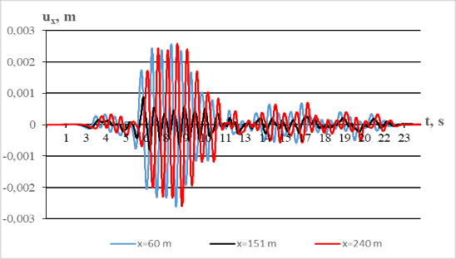 | 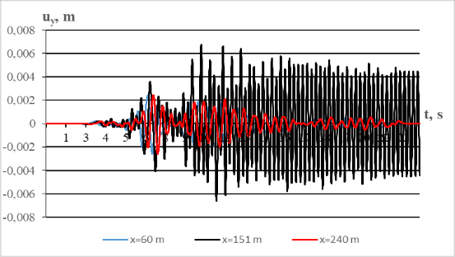
(a) | (b)
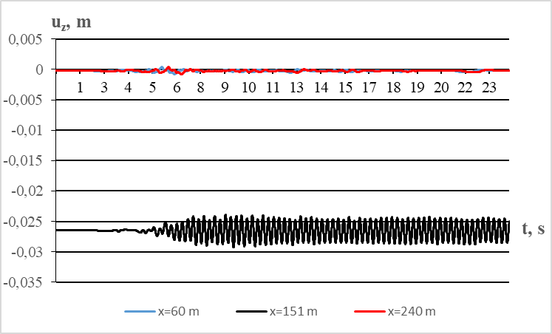 | 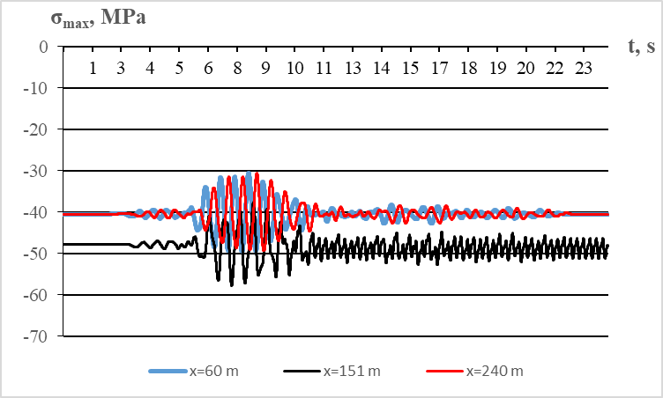
(c) | (d)
Figure 2. Changes in displacements and stresses of the pipeline under wave action based on the real recording of the Arnissa earthquake
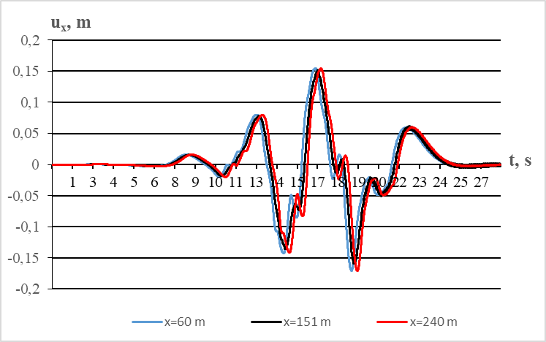 | 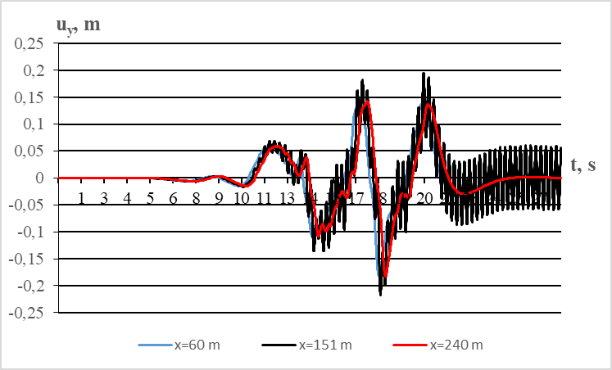
(a) | (b)
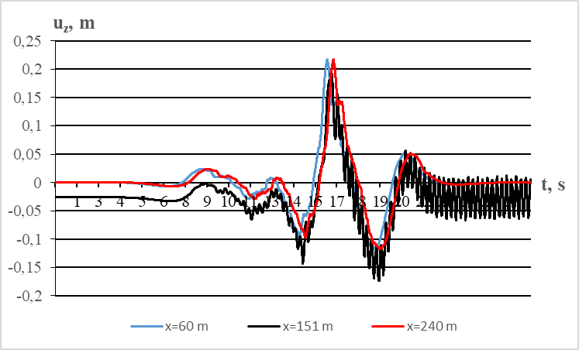 | 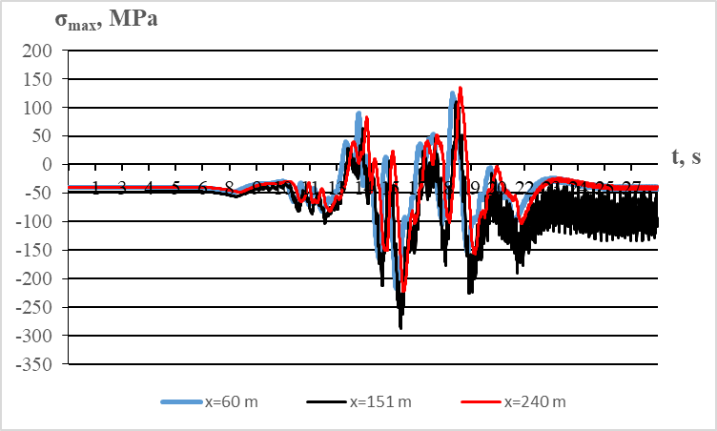
(c) | (d)
Figure 3. Changes in displacements and stresses of the pipeline under wave action based on the real recording of the Gazli earthquake
Table 1 presents the displacements and stresses at the ends, supports, and middle part of the pipeline under earthquakes of varying intensities. A comparison of the effects of earthquakes (Gazli, Alcyon, South Iceland, Tabas, Bucharest, Manjil, Lazio, and Arnissa) on the pipeline shows that earthquakes of 6-7 on the MSK-64 seismic scale produce moderate displacements and stresses in the pipelines. However, strong earthquakes of 9 and 9* on the MSK-64 seismic scale produce stresses exceeding the elastic limit of 185 MPa for steel grade Cт.3. This may cause damage to the pipeline due to the rapidly increasing axial force, which is consistent with the results of an analysis performed in reference [16], dedicated to the study of the stability of rod structures.
TABLE 1. Maximum absolute displacements and stresses in the pipeline under earthquakes of varying intensities.
The territory and intensity of the earthquake on the  MSK-64 seismic scale | Maximum value of soil acceleration W (m/s2) | u_{z}, m |  |  |  |  | σ_{max}, МPа
 | Maximum value of soil acceleration W (m/s2) | х=0 m | х=130 m | х=150 m | х=170 m | х=300 m | х=0 m | х=130 m | х=150 m | х=170 m | х=300 m
Gazli (Uzbekistan) 9* | 6.7 | 0.22 | 0.22 | 0.20 | 0.22 | 0.22 | 228 | 278 | 288 | 284 | 232
Alkion (Greece) 7 | 2.83 | 002 | 0.02 | 0.05 | 0.02 | 0.02 | 121 | 120 | 119 | 120 | 121
South Iceland (Iceland) 7 | 7.75 | 0.01 | 0.02 | 0.11 | 0.01 | 0.01 | 144 | 174 | 189 | 176 | 137
Tabas (Iran) 9* | 8.9 | 0.09 | 0.1 | 0.14 | 0.09 | 0.09 | 292 | 320 | 336 | 327 | 308
Bucharest (Romania) 9 | 1.94 | 0.03 | 0.02 | 0.06 | 0.03 | 0.03 | 218 | 200 | 201 | 200 | 220
Manjil (Iran) 6 | 1.26 | 0.01 | 0.02 | 0.04 | 0.01 | 0.01 | 80 | 95 | 98 | 95 | 81
Lazio (Italy) 6-7 | 0.97 | 0.0036 | 0.0049 | 0.034 | 0.029 | 0.0035 | 52 | 64 | 63 | 64 | 52
Arnissa (Greece) 6 | 0.42 | 0.00058 | 0.0016 | 0.029 | 0.0014 | 0.0006 | 52 | 59 | 58 | 59 | 52

Earthquakes significantly affect the stress-strain state of pipelines. This depends on the earthquake intensity, seismic wave direction, frequency spectrum, earthquake amplitude, and duration, as well as the physical and mechanical properties of the pipeline material, soil conditions, and soil wave propagation velocity. Comparison of calculation results for various earthquakes demonstrates the importance of taking these characteristics into account.

Conclusion
The stress-strain state of a gas pipeline, the middle part of which is supported by two supports in a ravine, was studied under earthquakes of varying intensity, determined using three-component seismograms. The seismic impact modeling took into account soil properties, seismic wave propagation velocity in the soil, frequency spectrum, earthquake amplitude and duration. In addition to the seismic load, the pipeline is subject to gravitational and operational forces. Numerical methods were used to solve the problem.
The results are presented in a table containing the maximum absolute displacements and stresses in the pipeline during earthquakes of varying intensities, ranging from 6 to 9 on the MSK-64 seismic scale. The results are also presented as graphs of displacements (longitudinal, transverse, and vertical) and maximum stresses in the pipeline. It was found that earthquakes with an intensity 6 on the MSK-64 seismic scale are not dangerous for pipelines supported on supports in the ravine zone. The maximum displacement is approximately 0.029 m, and the maximum absolute stress is approximately 59 MPa. In contrast, the earthquakes with an intensity 9 on the MSK-64 seismic scale are extremely dangerous for the pipelines. In this case, significantly greater vertical displacements and stresses were observed: 0.22 m and 288 MPa, respectively.

Acknowledgments
This investigation provided on the base of budget funding of the Institute of Mechanics and Seismic Stability of Structures named after M.T. Urazbaev, Uzbekistan Academy of Sciences.

References
- G.S. Nair, S.R. Dash and G. Mondal, Journal of Pipeline Systems Engineering and Practice 12(4), 04021053 (2021).
- C.A. Bain, T.D. O’Rourke, J.D. Bray and N.A. Abrahamson, Journal of Geotechnical and Geoenvironmental Engineering 151(5), 04025032 (2025).
- R. Xu, T.J. Qu and R. Jiang, Journal of Pipeline Systems Engineering and Practice 13(1), 04021069 (2022).
- D.M. Benin, Interactive Science 19, 1-5 (2017).
- J. Wang, Y. Wu and Z. Su, Engineering Failure Analysis 167, 109016 (2025).
- B.M. Mardonov, I. Mirzaev, G.H. Hojmetov and E. An, “Theoretical values of the interaction parameters of the underground pipeline with the soil,” in International conference on actual problems of applied mechanics 2022, AIP Conference Proceedings 2637, edited by K. Khudoynazarov (AIP Publishing, Melville, NY, 2022), 030009.
- T.R. Rashidov, Dynamic theory of seismic resistance of complex systems of underground structures (Fan, Tashkent, 1973), pp. 1–180.
- A.M. Shammazov, R.M. Zaripov, V.A. Chichelov and G.E. Korobkov, Calculation and Strength Ensuring of Pipelines in Complex Engineering-Geological Conditions (Inter, Moscow, 2005), pp. 1 – 705.
- E.M. Yasin and V.I. Chernikin, Stability of underground pipelines (Nedra, Moscow, 1968). pp. 1 – 120.
- O.C. Zienkiewicz and R.L. Taylor, The finite element (Butterworth-Heinemann, UK, 2000), pp. 1– 690.
- V.I. Myachenkov, V.P. Maltsev and V.P. Mayboroda, Calculations of mechanical engineering structures using the finite element method (Mashinostroenie, Moscow, 1989), pp. 1 – 520.
- O.C. Zienkiewicz and K.Morgan. Finite elements and approximation (A Wiley-Interscience Publication, New York, 1983), pp. 1–328.
- A. George and J.W-H Liu, Computer Solution of Large Sparse Positive Definite Systems (Prentice Hall, Inc., Englewood Cliffs, N.J, 1981), pp. 1–333.
- A.S. Filippov, Numerical Methods in Solid Mechanics (Moscow Publishing House, Moscow, 2016), pp. 1-256.
- B. Mardonov, I. Mirzaev, N. Nishonov, E. An, E. Kosimov, Study of the uplift of buried pipelines in liquefied soils based on the earthquake record in International Scientific Conference Transport Technologies in the 21st Century (TT21C-2024) “Actual Problems of Decarbonization of Transport and Power Engineering: Ways of Their Innovative Solution”, E3S Web of Conferences 515, edited by V.S. Kankhva (EDP Sciences, Rostov-on-Don, Russia, 2024), 04009.
- A.S. Volmir, Stability of elastic systems (Fizmatgiz, Moscow, 1963), pp. 1– 879.

