Assessment of the Stress-Strain State of Earth Dams Taking into Account Filtration and Other External Influences
Akhrorbek Numonov^{1, a)}, Mirziyod Mirsaidov ^{1,2, b)}
and Ziyoda Urazmukhamedova^{1,c)}
¹ Institute of Mechanics and Seismic Stability of Structures named after M.T.Urazbaev, Uzbekistan Academy of Sciences. Tashkent, Uzbekistan.
²Tashkent Institute of Irrigation and Agricultural Mechanization Engineers, National Research University. Tashkent, Uzbekistan.
^{a)} Corresponding author: a.t.numonov@gmail.com
^{b)} mirsaidov1948@mail.ru
^{c)} ziyoda-tiiame@mail.ru
Abstract. In a water environment, various stress sources act on the dam body together. The degree to which these factors are taken into account determines the proximity of the modeling results to real conditions and the degree of their application in engineering analysis. The fully water-filled nuclear earth dam was assessed under two different conditions. If in the first approach, the hydraulic impact was considered only as hydrostatic pressure, then in the second approach, it was more comprehensive, analyzing the volumetric forces arising from the filtration flow within the dam body, as well as the pore pressure. Calculations were performed using the MIDAS GTS NX software. This program allows for the joint assessment of the stress-strain state (SSS) of the soil and filtration processes, increasing the reliability of the modeling results. The Mohr-Coulomb model, widely used in geotechnics, served as the basis for describing the physical and mechanical properties of the soil.

INTRODUCTION
In recent years, the requirements for the stability and safety of hydraulic structures, in particular, earth dams, have been increasing. Natural disasters, fluctuations in water levels, filtration processes, and other external influences significantly affect the stability of dams. Accurate assessment of the stress-strain state of such structures is a key factor in their reliable design and safe operation. Filtration processes, external loads, and the maximum water level have a particularly significant impact on the dam's stability. Conducting a comprehensive analysis based on reliable mathematical models, taking these factors into account, is one of the main conditions for ensuring safety in engineering.
The first scientific ideas about water movement in the soil body were developed by Henry Darcy in the 18th century [1]. He was a French engineer who conducted research on water passage through soil and developed Darcy's law, named after him. Darcy’s Law describes how water moves through saturated soil and is the foundation of hydrogeology and soil physics.
By 1931, the American scientist L.A. Richards [2] developed the basic mathematical model for describing the movement of water in an unsaturated soil. In this model, it is determined how water moves under non-saturated conditions depending on the water potential in the soil and the water movement.
In works [3-5], the properties of soils, hydraulics, stability analysis, construction practices, soil permeability, filtration processes in dam structures, and factors affecting dam safety are described in detail.
In work [6] one of the main contributions to the study of soil physics and hydrology, especially to the modeling of unmoistened soils, was the Van Genuchten model, which proposed an empirical equation for predicting the hydraulic permeability of unmoistened soils based on groundwater pressure and saturation.
In the work [7], a simple method for determining the hydraulic permeability of unsaturated soil using moisture retention data is presented. By integrating the soil water retention curves with theoretical dependencies, the method allows for effective assessment of permeability without extensive experiments.
In the work [8], the importance of accurate forecasting models for determining the unsaturated hydraulic permeability (K) from groundwater retention data is emphasized, in which empirical expressions for describing the water retention curve are considered and a five-parameter equation adapted to different soil types is applied.
The works [9,10] are devoted to the models of soil deformation prone to moisture. It was observed that the degree of soil moisture influences its stress-strain state. The study demonstrated on mathematical models how the physical and mechanical properties of loess soils, including density and volumetric compression modulus, change depending on moisture content.
In the works [11,12], measures for planning construction work and preventing their deformation are considered based on soils that lose their volume and settle when saturated with water and tend to expand. In addition, technical solutions, experimental results, and methods that allow such soils to be strong and durable are presented.
[13] investigated the relationship between Gardner and Van Genuchten-Muallem models when describing relative water permeability in soil. He proposed new formulas and successfully applied them at an average saturation level.
The article [14] discusses the issues of determining filtration processes and operational parameters of phosphogypsum sludge storage facilities. The authors analyzed the physicochemical properties of phosphogypsum sludge and studied their influence on the filtration process.
[15] several laboratory models were created, in which the central clay core and various sizes and shapes of the lower horizontal filter were used. Models were tested on a hydraulic flume, and parameters such as filtration flow, pore pressure, and dam stability were analyzed.
The works [16,18] show the determination of filtration processes in dams using the finite element method. The water flow rate, material permeability, pressure impact, and erosion risk were analyzed, and the dam's hazardous zones were identified. Methods for reducing filtration by comparing different materials and design solutions have been proposed.
In the work [17], the stress-strain state of earth dams associated with filtration was studied. The authors analyzed the influence of water flow in the dam structure on mechanical stresses and deformations through mathematical modeling. It has been shown how filtration processes affect the strength and stability of the dam material, as well as the occurrence of critical deformation zones.
In the work [19], the issues of modeling the stress-strain state of earth dams, taking into account non-uniform states, are considered. In the work [20], three-dimensional states of earth dams were analyzed, and it was shown that the interactions between structural elements are an important factor determining stability. In the work [21-24], the deformation state and strength characteristics of earth dams under static loads were studied, and the main parameters influencing stability were determined.

Materials and methods
The research was conducted for the earth dam of the Tupalang reservoir, built in southern Uzbekistan, whose main geometric and structural features are: the Tupalang reservoir dam is composed of rocky soil, its height is
185 m, the width along the ridge is 10 m, and its length is 410 m. The upper slope m₁ = 2.0, and the lower slope
m₂ = 1.9. The anti-filtration element has the shape of a central core and is constructed from clay. Its width at the top is 6.0 m, at the base 102 m, the slope laying is m=0.23. Supporting prisms are built from rocks. The transition from nuclear material to supporting prisms is carried out through a two-layer filter. The upper slope of the dam is reinforced with large stones. The thickness of the fastening layer is 10 m.
The specific gravity of the dam core is γ= 17.2 kN/m³, the modulus of elasticity is E= 30 MPa, the Poisson's ratio is μ= 0.3, and the filtration coefficient is k_{x}=k_{y}= 0.017 m/day.
The specific weight of the upper and lower supporting prisms is γ= 20.4 kN/m³, the modulus of elasticity is
E= 60 MPa, the Poisson's ratio is μ= 0.3, and the filtration coefficient is k_{x}=k_{y} = 44.4 m/day.
The specific gravity of the filter, high-slope large stones, and the first base layer is γ= 23.2 kN/m³, the elastic modulus is E= 105 MPa, the Poisson's ratio is μ= 0.3, and the filtration coefficient is k_{x}=45, k_{y}= 50 m/day.
The specific weight of the dam base γ= 26.9 kN/m³, the elastic modulus E= 118.3 MPa, the Poisson's ratio μ=0.4, and the filtration coefficient k_{x}=k_{y} = 0.3 m/day
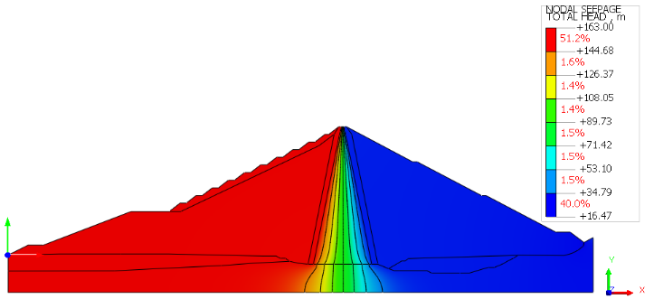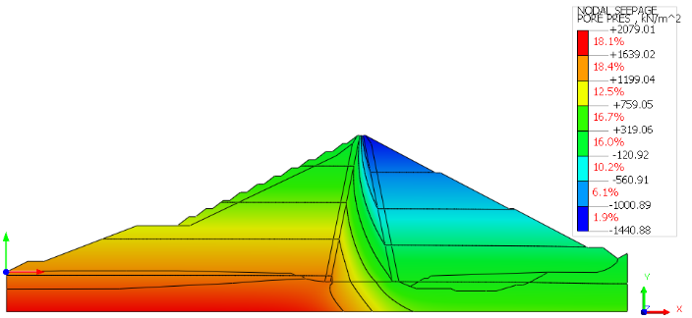
(a) (b)
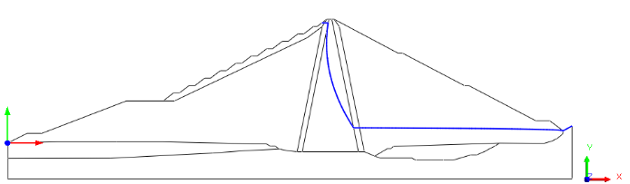
(c)
FIGURE 1. Representation of (a) full water head, (b) internal pore pressure, and (c) the phreatic line of seepage within the body of the Tupalang earth-fill dam
Figure 1a depicts the distribution of pressure in the dam body when the reservoir is fully filled (water level 163 m). Here, the maximum head is in the area marked with red, and it can be observed that the filtration pressure in the dam is also maximum in this area. The density of isolines gradually decreases from the center to the lower reach, forming a curve through green and blue contours. It curves from top to bottom and ends at the base of the dam. The pressure gradient increases as the distance between the isolines from the center increases, meaning the filtration rate decreases.
The obtained pore pressure isolines show a clear and stable distribution of the filtration process in the dam body (Fig. 1b). It has been established that the maximum pressure (≈ 2100 kN/m²) is formed in the lower layers of the reservoir's upper pool, and the pressure gradually decreases from left to right. It can be seen that the pressure gradient decreases along the curve, reaching the base of the dam's lower pool, and the pore pressure is minimal
(≈ -1450 kN/m²) in the upper part of the lower pool. Such a distribution serves as the basis for determining the degree of soil water saturation and effective stress, as well as for analyzing stability and designing drainage measures. (Fig. 1c) shows filtration analysis when the dam is completely fill ed with water. The curve, shown in blue, defines the boundary between the saturated and unsaturated zones in the dam body under steady state seepage conditions. The line begins near the water level in the upper reach, gradually deviates towards the lower part of the dam, and crosses near the lower reach.
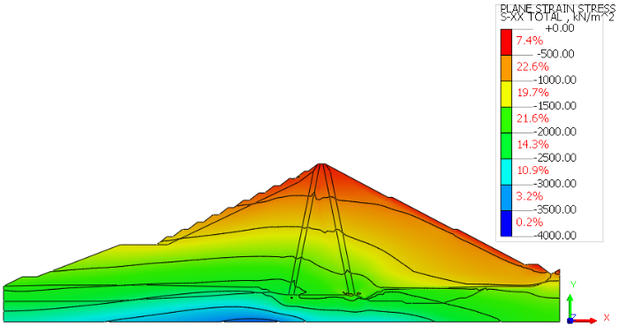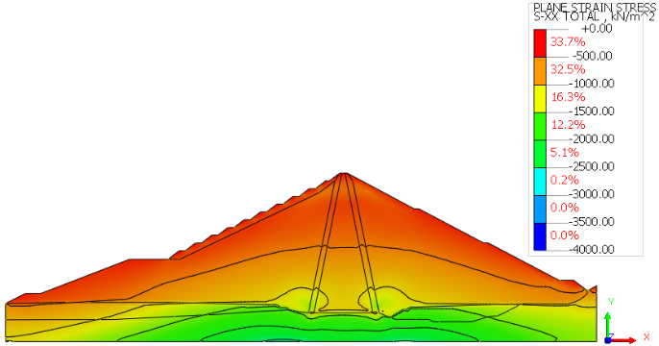
(a) (d)
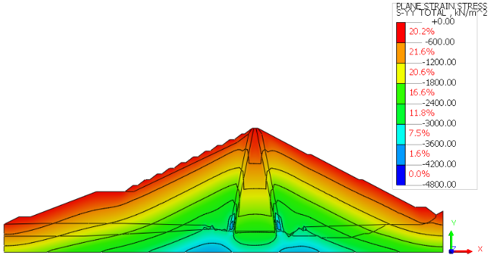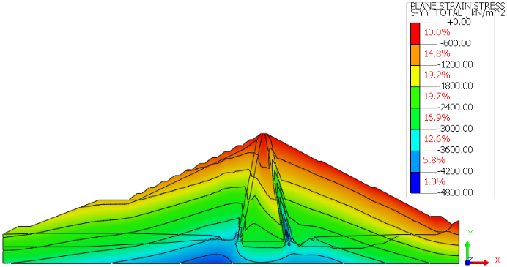
(b) (e)
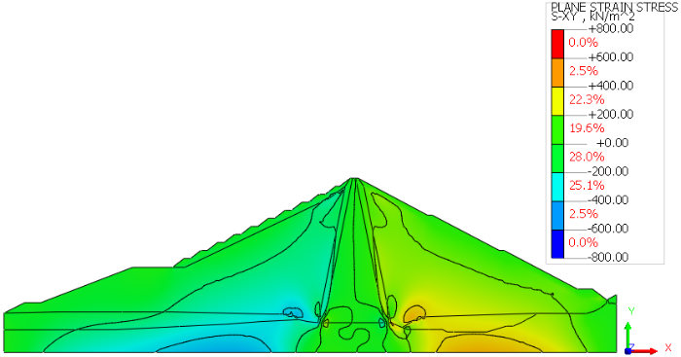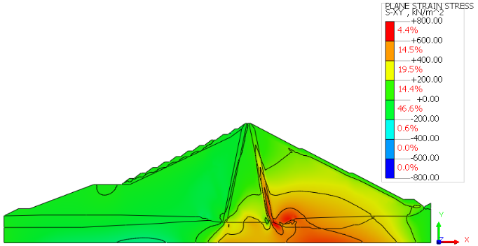
(c) $σ_{12}$ (f) $σ_{12}$
FIGURE 2. Isolines of equal distribution of stresses σ₁₁ (horizontal, a–d), σ₂₂ (vertical, b–e), and (shear, c–f) within the Tupalang earth-fill dam under fully impounded conditions. (a, b, c) — stress distribution resulting from self-weight and hydrostatic pressure; (d, e, f) — stress distribution resulting from self-weight, hydrostatic pressure, and seepage.
From the analysis of the obtained results, it is evident that:
The stresses arising in the dam body σ₁₁ (horizontal) and σ₂₂ (vertical) have an approximately symmetrical distribution relative to the central line of the dam core (Fig. 2, a and b). Their values increase from the upper part of the dam downwards and reach their maximum in the central lower part. The vertical stress σ₂₂ maximum in the center of the core and decreases towards the upper and lower befs - this is called the "arc effect." This mechanical state is due to the combination of nuclei, transition zones, and supporting prisms with different elastic modulus and material density. The tangential stress (cutting stress) also propagates symmetrically to both sides of the central line; in the core and transition zone, its values are practically zero, i.e., minimal (2-c figure). As it moves away from the center, σ₁₂ increases and reaches its maximum value near the foundation of the upper and lower prisms. The increase in σ₁₂ on the slopes around the dam's top indicates the soil's tendency towards shear deformation in these layers.
As a result of filling the Tupalang reservoir with water to a depth of 163 m relative to the dam base, the specific gravity of the earth dam, its full stress-strain state under the influence of hydrostatic water pressure and filtration, were assessed.
The analysis of the obtained results shows that, with the simultaneous consideration of the dam's own weight, hydrostatic pressure, and filtration effect, the σ₁₁, σ₂₂ formed in the dam body do not have a symmetrical character with respect to the center of the dam core (Fig. 2, d and e). In this case, the stress values in the area of the upper prism and the left side of the dam core will be significantly larger. This can also be observed by the arrangement of the isopole lines. The change in isolines across regions indicates the heterogeneity of the earth dam.
The maximum tangential stress in the area located near the base and core of the upper prism of the earth dam's interaction with the water at a water level of 163 meters in the reservoir (fully filled) is up to 0.25 MPa (Fig. 2f). In the lower prism, it can be observed that the values increase up to 1.5 times compared to the dry case. When comparing these results with the stressed state of the dam under its own weight, one can observe a decrease in tangential stresses in the upper prism to 50%.

Conclusion
Based on the results of these studies, the possibility of assessing the stress-strain state of the earth dam, taking into account hydrostatic pressure, filtration, and specific gravity, has been practically confirmed. When assessing the stress-strain state of earth dams, it is necessary to consider the structural features, physical and mechanical properties of the earth. It has been established that the degree of reservoir filling has a significant impact on the stress-strain state of the dam body, and the strongest impact occurs when the reservoir is fully filled. It was observed that the stresses σ₁₁, σ₂₂ arising in the dam body during a plane deformation state are approximately symmetrical with respect to the center of the core, and their values increase as they approach the base from the upper part of the dam. When approximately symmetrically distributed tangential stress σ₁₂ is distributed over the dam body in the core and transition zone, these values will be close to zero. As the distance from the core increases, the σ₁₂ stress values increase and reach their highest values in the areas close to the base of the upper and lower prisms. When the reservoir was fully filled with water, a variation in the nature and values of stress distribution σ₁₁, σ₂₂ and σ₁₂$σ_{12}$ across the dam body was observed. This means that during the operation of such structures, regular control and preventive measures must be carried out.

Acknowledgments
This article was supported by grant funding from the Institute of Mechanics and Seismic Stability of Structures named after M.T.Urazbaev, Academy of Sciences of the Republic of Uzbekistan.

References
- K. S. Sultanov and B. E. Khusanov, Soil Mechanics and Foundation Engineering 38(3), 80–86 (2001).
- K. S. Sultanov and B. E. Khusanov, Soil Mechanics and Foundation Engineering 39(3), 81–84 (2002).
- A. A. Mustafayev, Foundations on Sedimentary and Swelling Soils (Higher School, Moscow, 1989), pp. 25-126.
- A. Mustafayev, Fundamentals of Sedimentary Soil Mechanics (Stroyizdat, Moscow, 1978), pp. 132-141
- T. A. Ghezzehei, T. J. Kneafsey and G. W. Su, Water Resources Research 43(10), (2007). https://doi.org/10.1029/2006WR005339
- K. Fayziev, T. Sultanov, E. Toshmatov and A. Numonov, “Filtration and operational parameters determination of phosphogypsum sludge storage,” in IOP Conference Series: Materials Science and Engineering 1030, edited by P. Akimov et al. (IOP Publishing Ltd, 2021), 012143. DOI:10.1088/1757-899X/1030/1/012143
- S. Kumar, A. K. Sahu and M. Kumar, “Modeling the effect of the central impermeable core and the geometry of the downstream filter on filtration through earth dams,” in Ain Shams Engineering Journal 13, edited by A. M. Bahaa-Eldin et al. (Ain Shams University, 2022), 101510. DOI:https://doi.org/10.1016/j.asej.2021.05.024
- A. P. S. Abhilasha and T. G. Antony Balan, “Numerical analysis of seepage in embankment dams,” IOSR Journal of Mechanical and Civil Engineering (IOSR-JMCE) 4, 13–23 (2014).
- I. I. Lyashko, V. V. Skopetskii, V. S. Deineka and S. I. Rybachishin, Soviet Applied Mechanics 22(3), 239–244 (1986). DOI: 10.1007/BF00887245.
- Z. N. Alzamily and B. Sh. Abed, Materials Today: Proceedings 61(3), 998–1005 (2022). DOI: 10.1016/j.matpr.2021.10.283.
- T. Z. Sultanov, A. S. Bestuzheva, B. S. Yuldashev, B. Kh. Urinov and A. T. Numonov, “Modeling strain processes in earth dams with account for inhomogeneous features of a structure,” in IOP Conf. Series: Journal of Physics: Conf. Series 1425, edited by A. Valkov et al. (IOP Publishing Ltd, 2020), 012012. DOI: 10.1088/1742-6596/1425/1/012012.
- M. Mirsaidov, P. Matkarimov and D. Juraev, “Assessment of stress-strain state of earth dams considering the spatial operation of structures,” in International conference: “Ensuring seismic safety and seismic stability of buildings and structures, applied problems of mechanics”, AIP Conference Proceedings 3265, edited by R. A. Abirov (AIP Publishing, Melville, NY, 2025), 050020. DOI: 10.1063/5.0265149.
- D. J. Juraev, N. Vatin, T. Z. Sultanov and M. M. Mirsaidov, Magazine of Civil Engineering 118(2), 11810 (2023).
- Z. Urazmukhamedova, D. Juraev and M. Mirsaidov, “Assessment of stress state and dynamic characteristics of plane and spatial structure,” in Second International Conference on Advances in Physical Sciences and Materials 2021(ICAPSM 2021), Journal of Physics: Conference Series 2070, edited by Dr. S. Thangaprakash (IOP Publishing Ltd, 2021), 012156. DOI: 10.1088/1742-6596/2070/1/012156.
- D. Juraev and P. Matkarimov, “Stress-strain state and strength of earth dams under static loads,” in IV International Scientific Conference “Construction Mechanics, Hydraulics and Water Resources Engineering”, E3S Web of Conferences 365, edited by D.R. Bazarov (EDP Sciences, 2023), 03008. DOI: 10.1051/e3sconf/202336503008.
- M. M. Mirsaidov, T. Z. Sultanov and J. A. Yarashev, “Assessment of stress-strain state of earth dams considering elastoplastic properties of soils,” in VI International scientific conference construction mechanics, hydraulics & water resources engineering (CONMECHYDRO 2024), AIP Conference Proceedings 3286, edited by D.R. Bazarov (AIP Publishing, Melville, NY, 2025), 040008. DOI: 10.1063/5.0280103.

